**Student Name:** KARTHYAYENI P

**Registration No:** 22CSR089

**Course/Batch:** KONGU ENGINEERING COLLEGE (B.E COMPUTER SCIENCE AND ENGINEERING)

**CREATE AUTHENTICATION SERVICE THAT RETURNS JWT**

**Introduction:**

This Spring Boot application implements a basic **JWT-based authentication service**. It allows a client to send user credentials via HTTP Basic Auth to an /authenticate endpoint and receive a signed **JSON Web Token (JWT)** in response. The token can later be used to access protected resources securely.

**Objective:**

* To create a secure RESTful /authenticate endpoint that accepts user credentials via HTTP Basic Authentication.
* To validate the credentials and generate a JWT token using the io.jsonwebtoken (JJWT) library.
* To configure Spring Security to permit public access to the authentication endpoint while securing other routes.

**Implementation Breakdown:**

**JwtAuthApplication.java:**

package com.cognizant.jwt.jwt_auth;

import org.springframework.boot.SpringApplication;

import org.springframework.boot.autoconfigure.SpringBootApplication;

@SpringBootApplication

public class JwtAuthApplication {

public static void main(String[] args) {

SpringApplication.run(JwtAuthApplication.class, args);

}

}

**JwtUtil.java:**

package com.cognizant.jwt.jwt_auth;

import io.jsonwebtoken.Jwts;

import io.jsonwebtoken.SignatureAlgorithm;

import java.util.Date;

public class JwtUtil {

private static final String SECRET_KEY = "secret-key";

private static final long EXPIRATION_TIME = 1000 * 60 * 60;

public static String generateToken(String username) {

return Jwts.builder()

.setSubject(username)

.setIssuedAt(new Date(System.currentTimeMillis()))

.setExpiration(new Date(System.currentTimeMillis() EXPIRATION_TIME))

.signWith(SignatureAlgorithm.HS256, SECRET_KEY)

.compact();

}

}

**AuthenticationController.java:**

package com.cognizant.jwt.jwt_auth;

import org.springframework.http.ResponseEntity;

import org.springframework.web.bind.annotation.*;

import javax.servlet.http.HttpServletRequest;

import java.util.Base64;

@RestController

public class AuthenticationController {

@GetMapping("/authenticate")

public ResponseEntity<?> authenticate(HttpServletRequest request) {

String authHeader = request.getHeader("Authorization");

if (authHeader == null || !authHeader.startsWith("Basic ")) {

return ResponseEntity.status(401).body("Missing or invalid Authorization header");

}

String base64Credentials = authHeader.substring("Basic ".length());

String credentials = new String(Base64.getDecoder().decode(base64Credentials));

String[] values = credentials.split(":", 2);

String username = values[0];

String password = values[1];

if ("user".equals(username) && "pwd".equals(password)) {

String token = JwtUtil.generateToken(username);

return ResponseEntity.ok().body("{\"token\":\"" + token + "\"}");

} else {

return ResponseEntity.status(401).body("Invalid credentials");

}

}

}

**SecurityConfig.java:**

package com.cognizant.jwt.jwt_auth;

import org.springframework.context.annotation.Bean;

import org.springframework.context.annotation.Configuration;

import org.springframework.security.web.SecurityFilterChain;

import org.springframework.security.config.annotation.web.builders.HttpSecurity;

@Configuration

public class SecurityConfig {

@Bean

public SecurityFilterChain securityFilterChain(HttpSecurity http) throws Exception {

http

.csrf(csrf -> csrf.disable())

.authorizeHttpRequests(auth -> auth

.requestMatchers("/authenticate").permitAll()

.anyRequest().authenticated()

);

return http.build();

}

}

**Output:**

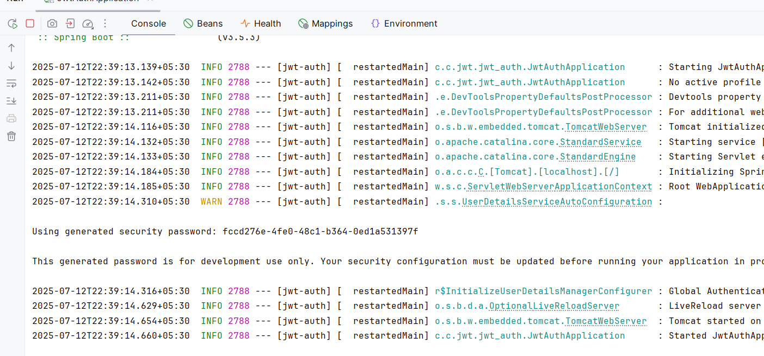

**Conclusion:**

This hands-on project demonstrates how to implement JWT-based stateless authentication in a Spring Boot application. It offers a solid foundation for securing REST APIs by issuing and verifying tokens, ensuring that only authenticated users can access protected resources. This approach is scalable, lightweight, and widely adopted in modern microservices and web applications.