Student Name: KARTHYAYENI P
Registration No: 22CSR089
Course/Batch: KONGU ENGINEERING COLLEGE (B.E COMPUTER SCIENCE AND ENGINEERING)

EXERCISE 1: TOGGLE BETWEEN PLAYER LISTS USING REACT

Introduction:

This React application showcases the use of conditional rendering and array operations through a toggle feature that switches between two different player lists. It helps beginners understand core React concepts like component-based structure, useState, and list rendering using map, filter, and forEach.

Objective:

- To learn React fundamentals like components, useState, conditional rendering.
- To practice array operations like filtering, mapping, and merging.
- To build a toggle feature between two different data views in a clean, modular way.

Implementation Breakdown:

Step 1: Create a React App
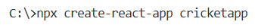
Navigating
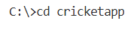
Step 2: Set Up Folder Structure
Inside src/, create a folder named Components/:
mkdir src/Components

Step 3: Create App.js
Inside src/, replace App.js with the following code:

App.js
import { useState } from 'react';
import './App.css';
import IndianPlayers from './Components/IndianPlayers';
import ListofPlayers from './Components/ListofPlayers';

const App = () => {
const [flag, setFlag] = useState(true);

return (
<div className="app">
<button className="toggle-button" onClick={() => setFlag(!flag)}>
Flag: {flag.toString()}
</button>
{flag ? <ListofPlayers /> : <IndianPlayers />}
</div>
);
};

export default App;

Step 4: Create ListofPlayers.js in Components folder
src/Components/ListofPlayers.js

ListofPlayers.js
const ListofPlayers = () => {
const players = [
{ name: "Jack", score: 50 },
{ name: "Michael", score: 70 },
{ name: "John", score: 40 },
{ name: "Ann", score: 61 },
{ name: "Elisabeth", score: 61 },
{ name: "Sachin", score: 95 },
{ name: "Dhoni", score: 100 },
{ name: "Virat", score: 84 },
{ name: "Jadeja", score: 64 },
{ name: "Raina", score: 75 },
{ name: "Rohit", score: 80 }
];

return (
<div className="container">
<h2 className="section-title">List of Players</h2>
<ul className="player-list">
{players.map((player, index) => (
<li key={index}>Mr. {player.name} {player.score}</li>
))}
</ul>

<h2 className="section-title">List of Players having Scores Less than 70</h2>
<ul className="player-list">
{players
.filter(player => player.score < 70)
.map((player, index) => (
<li key={index}>Mr. {player.name} {player.score}</li>
))}
</ul>
</div>
);
};

export default ListofPlayers;

Step 5: Create IndianPlayers.js in Components folder
src/Components/IndianPlayers.js

IndianPlayers.js

const IndianPlayers = () => {
const teamPlayers = ["Sachin1", "Dhoni2", "Virat3", "Rohit4", "Raina6", "Yuvaraj5"];

const oddPlayers = [];
const evenPlayers = [];

teamPlayers.forEach((player, index) => {
if (index % 2 === 0) {
oddPlayers.push(player);
} else {
evenPlayers.push(player);
}
});

const T20players = ["First Player", "Second Player", "Third Player"];
const RanjiTrophyPlayers = ["Fourth Player", "Fifth Player", "Sixth Player"];
const mergedPlayers = [...T20players, ...RanjiTrophyPlayers];

return (
<div className="container">
<h2 className="section-title">Odd Players</h2>
<ul className="player-list">
<li>First : {oddPlayers[0]}</li>
<li>Third : {oddPlayers[1]}</li>
<li>Fifth : {oddPlayers[2]}</li>
</ul>

<h2 className="section-title">Even Players</h2>
<ul className="player-list">
<li>Second : {evenPlayers[0]}</li>
<li>Fourth : {evenPlayers[1]}</li>
<li>Sixth : {evenPlayers[2]}</li>
</ul>

<h2 className="section-title">List of Indian Players Merged:</h2>
<ul className="player-list">
{mergedPlayers.map((player, index) => (
<li key={index}>Mr. {player}</li>
))}
</ul>
</div>
);
};

export default IndianPlayers;

Step 7: Run the Application
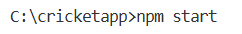

Output:

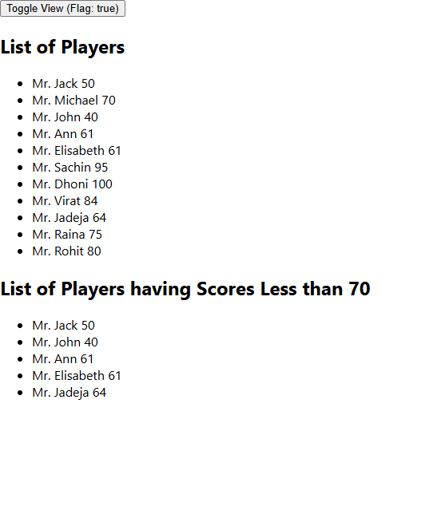
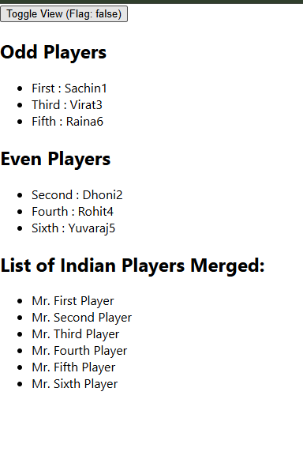
Conclusion:
By building this toggle-based player listing app, I practiced handling dynamic data views in React and learned how to separate logic into reusable components. The project provides a clear understanding of basic React functionalities in an interactive and structured manner.

EXERCISE 2: REACT PROJECT: OFFICE SPACE LISTING

Introduction:

This React application displays a list of office spaces with their name, rent, address, and image. It uses dynamic rendering and conditional styling to visually differentiate office rent values, helping users quickly identify affordable options.

Objective:
- To understand how to render lists in React using .map().
- To apply conditional CSS styling based on values (e.g., rent amount).
- To practice component-based architecture by creating a reusable OfficeCard component.
- To enhance UI formatting using minimal CSS.

Implementation Breakdown:
Step 1: Create a new React app
Navigating
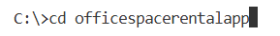
Step 2: Create file structure
Inside the src/ folder:
- Create a file named OfficeCard.js
- Use the existing App.js and App.css
Step 3: Create App.js
import React from 'react';
import './App.css';
import OfficeCard from './OfficeCard';

function App() {
const offices = [
{
id: 1,
name: "DBS",
rent: 50000,
address: "Chennai",
image:"https://www.investopedia.com/thmb/5bFijj2-KuQYQeL3KbtBy69IKW8=/1500x0/filters:no_upscale():max_bytes(150000):strip_icc()/office-space-5bfc152146e0fb0026d1986e.jpg"
},
{
id: 2,
name: "WeWork",
rent: 75000,
address: "Bengaluru",
image: "https://images.unsplash.com/photo-1593642532973-d31b6557fa68"
}
];

return (
<div className="App">
<h1>Office Space, at Affordable Range</h1>
{offices.map(office => (
<OfficeCard key={office.id} office={office} />
))}
</div>
);
}
export default App;

Step 4: Create reusable component OfficeCard.js
import React from 'react';
import './App.css';

const OfficeCard = ({ office }) => {
const rentClass = office.rent <= 60000 ? 'textRed' : 'textGreen';

return (
<div className="office-card">
<img src={office.image} alt={office.name} />
<h2>Name: {office.name}</h2>
<h3 className={rentClass}>Rent: Rs. {office.rent}</h3>
<h3>Address: {office.address}</h3>
</div>
);
};
export default OfficeCard;

Step 5: Write CSS styles in App.css
.App {
text-align: center;
font-family: Arial, sans-serif;
}

.office-card {
border: 1px solid #ccc;
padding: 16px;
margin: 20px auto;
width: 80%;
box-shadow: 0 2px 8px rgba(0, 0, 0, 0.1);
border-radius: 12px;
background-color: #f9f9f9;
}

.office-card img {
max-width: 100%;
height: auto;
border-radius: 8px;
}

.textRed {
color: red;
font-weight: bold;
}

.textGreen {
color: green;
font-weight: bold;
}
Step 6: Run the application
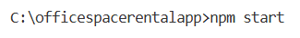

Output:
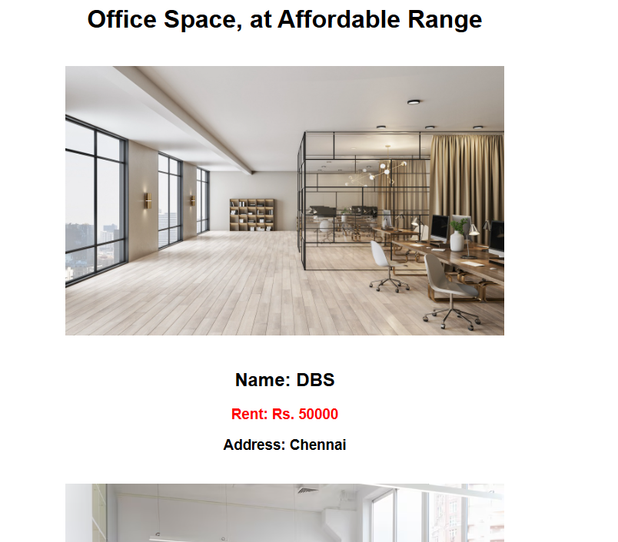
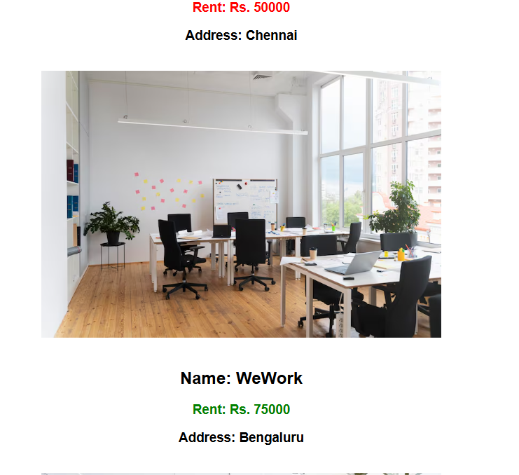

Conclusion:
This project helped to practice rendering lists in React, applying conditional class styling, and structuring reusable components. It's a simple and clean example that builds confidence in building dynamic and responsive user interfaces.

EXERCISE 3: COUNTER AND CURRENCY CONVERTER APP

Introduction:
This React application combines two interactive components: a counter with custom alerts and a currency converter that converts Indian Rupees (INR) to Euros (EUR). It demonstrates basic React hooks, event handling, forms, and user interaction.
Objective:
- To implement useState hook for managing state (like count and input).
- To understand event handling in React (clicks, form submit, synthetic events).
- To perform a simple currency conversion calculation and display the result.
- To apply basic styling and create a responsive, interactive UI.
Implementation:
Step 1: Create the React App
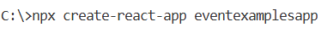
Navigating
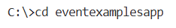
Step 2: Set up Folder Structure
Inside src/, create a new file:
CurrencyConvertor.js
Step 3: Main App Component – App.js
import { useState } from 'react';
import './App.css';
import CurrencyConvertor from './CurrencyConvertor';

function App() {
const [count, setCount] = useState(0);

const increment = () => {
setCount(prev => prev + 1);
sayHello();
};

const decrement = () => {
setCount(prev => prev - 1);
};

const sayHello = () => {
alert("Hello! Counter was incremented.");
};

const sayMessage = (msg) => {
alert(msg);
};

const handleSyntheticEvent = (e) => {
e.preventDefault();
alert("I was clicked");
};

return (
<div className="App">
<h1>{count}</h1>

<button onClick={increment}>Increment</button>
<button onClick={decrement}>Decrement</button>

<br /><br />
<button onClick={() => sayMessage("Welcome!")}>Say welcome</button>

<br /><br />
<button onClick={handleSyntheticEvent}>Click on me</button>

<br /><br />
<CurrencyConvertor />
</div>
);
}
export default App;

Step 4: Currency Converter Component – CurrencyConvertor.js
import { useState } from 'react';

function CurrencyConvertor() {
const [rupees, setRupees] = useState('');

const handleSubmit = (e) => {
e.preventDefault();
const conversionRate = 0.011; // 1 INR ≈ 0.011 EUR
const euros = parseFloat(rupees) * conversionRate;
alert(`Converting to Euro. Amount is €${euros.toFixed(2)}`);
};

return (
<div>
<h2 style={{ color: "green" }}>Currency Convertor!!!</h2>
<form onSubmit={handleSubmit}>
<label>Amount:</label>
<input
type="number"
value={rupees}
onChange={(e) => setRupees(e.target.value)}
placeholder="INR"
/>
<label> Currency: </label>
<input type="text" value="Euro" readOnly />
<button type="submit">Submit</button>
</form>
</div>
);
}

export default CurrencyConvertor;

Step 5: Add Styling in App.css
.App {
text-align: center;
font-family: Arial, sans-serif;
margin: 40px;
}

button {
margin: 10px;
padding: 10px 20px;
}
Step 6: Run the Project
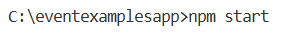

Output:
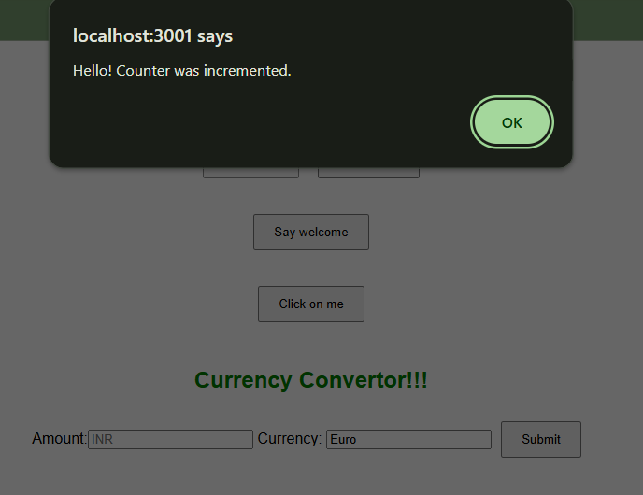
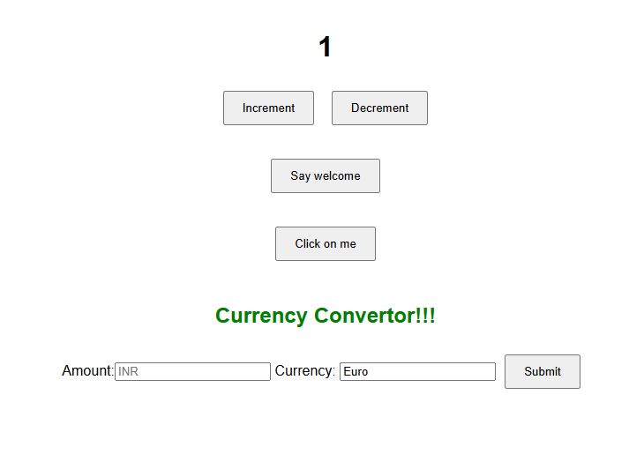
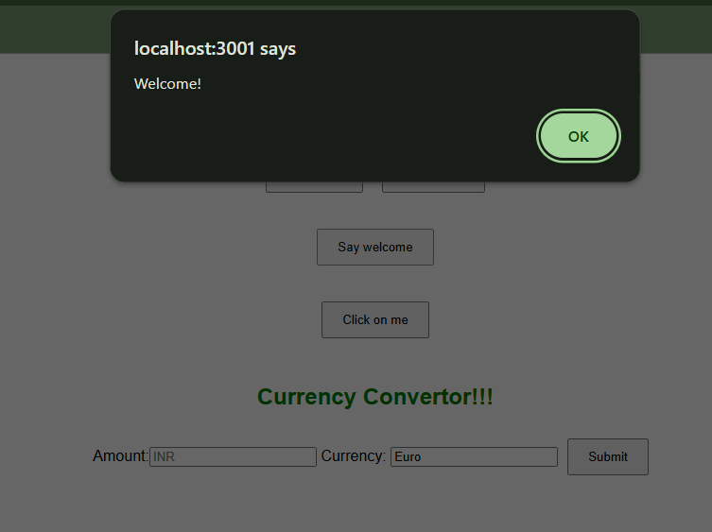
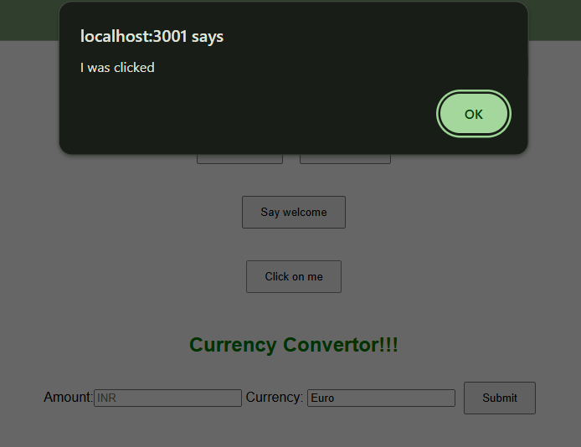
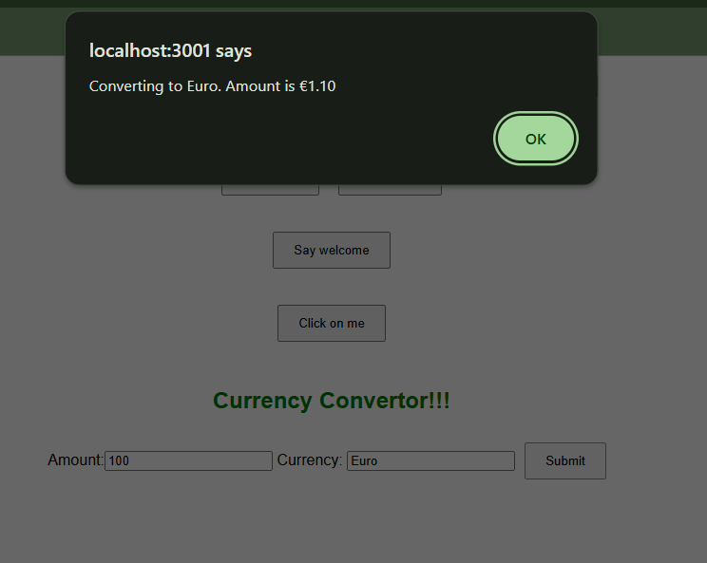

Conclusion:
This mini project effectively demonstrates the use of React state management, event handling, and basic form operations. It combines a simple counter with a real-world use case of currency conversion, making it a great beginner-friendly exercise in interactive UI development using React.

EXERCISE 4 : TICKET BOOKING APP
Introduction:
This React application simulates a basic flight ticket booking system. It displays user or guest messages conditionally based on login state and presents a list of available flights in a well-formatted, responsive table layout. The app is interactive, clean, and styled for both desktop and mobile screens.
Objective:
- To demonstrate conditional rendering using useState.
- To separate concerns using reusable components like User, Guest, and FlightDetails.
- To display tabular flight data dynamically using .map().
- To implement responsive design for seamless viewing on all devices.

Implementation:
Step 1: Create the React App
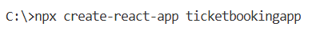
Navigating
Step 2: Create Component Files
In src/Components, create:
- User.js
- Guest.js
- FlightDetails.js

Step 3: Create User.js
const User = () => (
<div>
<h2>Welcome User</h2>
<p>You can now book your flight tickets.</p>
</div>
);
export default User;

Step 4: Create Guest.js
const Guest = () => (
<div>
<h2>Welcome Guest</h2>
<p>Please login to book your flight tickets.</p>
</div>
);
export default Guest;

Step 5: Create FlightDetails.js
const flights = [
{ flightNumber: 'AI101', route: 'New Delhi ✈ New York', date: '2025-08-05', time: '09:30 AM', price: '₹85,000' },
{ flightNumber: 'BA202', route: 'London ✈ Tokyo', date: '2025-08-06', time: '11:15 AM', price: '₹78,000' },
{ flightNumber: 'EK303', route: 'Dubai ✈ Sydney', date: '2025-08-07', time: '01:00 PM', price: '₹92,000' },
{ flightNumber: 'SQ404', route: 'Singapore ✈ San Francisco', date: '2025-08-08', time: '02:45 PM', price: '₹1,05,000' },
{ flightNumber: 'LH505', route: 'Frankfurt ✈ Mumbai', date: '2025-08-09', time: '10:20 AM', price: '₹67,000' },
{ flightNumber: 'QF606', route: 'Melbourne ✈ Bangkok', date: '2025-08-10', time: '08:50 PM', price: '₹49,000' }
];

const FlightDetails = () => (
<div>
<h3>Available Flight Details</h3>
<table border="1" cellPadding="10" style={{ borderCollapse: 'collapse', marginTop: '10px' }}>
<thead>
<tr>
<th>Flight No.</th>
<th>Route</th>
<th>Date</th>
<th>Time</th>
<th>Price</th>
</tr>
</thead>
<tbody>
{flights.map((flight, index) => (
<tr key={index}>
<td>{flight.flightNumber}</td>
<td>{flight.route}</td>
<td>{flight.date}</td>
<td>{flight.time}</td>
<td>{flight.price}</td>
</tr>
))}
</tbody>
</table>
</div>
);
export default FlightDetails;

Step 6: Update App.js
import { useState } from 'react';
import './App.css';
import FlightDetails from './Components/FlightDetails';
import Guest from './Components/Guest';
import User from './Components/User';

function App() {
const [isLoggedIn, setIsLoggedIn] = useState(false);
const handleLogin = () => setIsLoggedIn(true);
const handleLogout = () => setIsLoggedIn(false);
return (
<div className="App">
<h1>Ticket Booking App</h1>
{isLoggedIn ? (
<button onClick={handleLogout}>Logout</button>
) : (
<button onClick={handleLogin}>Login</button>
)}
{isLoggedIn ? <User /> : <Guest />}

<FlightDetails />
</div>
);
}
export default App;

Step 7: Add Styling in App.css
body {
margin: 0;
padding: 0;
font-family: 'Segoe UI', Tahoma, Geneva, Verdana, sans-serif;
background-color: #f3f4f6;
color: #1f2937;
}

.App {
max-width: 960px;
margin: 40px auto;
background-color: #ffffff;
padding: 30px 40px;
border-radius: 16px;
box-shadow: 0 10px 25px rgba(0, 0, 0, 0.08);
}

h1 {
text-align: center;
color: #1e40af;
margin-bottom: 30px;
}

h2 {
color: #111827;
margin-top: 20px;
}

h3 {
color: #1e3a8a;
margin-top: 40px;
}

p {
font-size: 1rem;
color: #374151;
}

button {
display: inline-block;
background-color: #3b82f6;
color: white;
border: none;
border-radius: 8px;
padding: 10px 20px;
font-size: 1rem;
cursor: pointer;
transition: background-color 0.3s ease;
margin-bottom: 20px;
}

button:hover {
background-color: #2563eb;
}

table {
width: 100%;
border-collapse: collapse;
margin-top: 20px;
font-size: 0.95rem;
}

th, td {
text-align: left;
padding: 12px 16px;
border-bottom: 1px solid #e5e7eb;
}

thead {
background-color: #eff6ff;
color: #1e3a8a;
text-transform: uppercase;
font-size: 0.85rem;
letter-spacing: 0.5px;
}

tbody tr:hover {
background-color: #f9fafb;
}
table, thead, tbody, th, td, tr {
display: block;
}

thead {
display: none;
}

tr {
margin-bottom: 15px;
}

td {
padding-left: 50%;
position: relative;
}

td::before {
position: absolute;
top: 12px;
left: 16px;
width: 45%;
padding-right: 10px;
font-weight: bold;
white-space: nowrap;
color: #6b7280;
content: attr(data-label);
}
}
Step 8: Run the Application
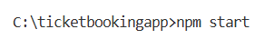

Output:
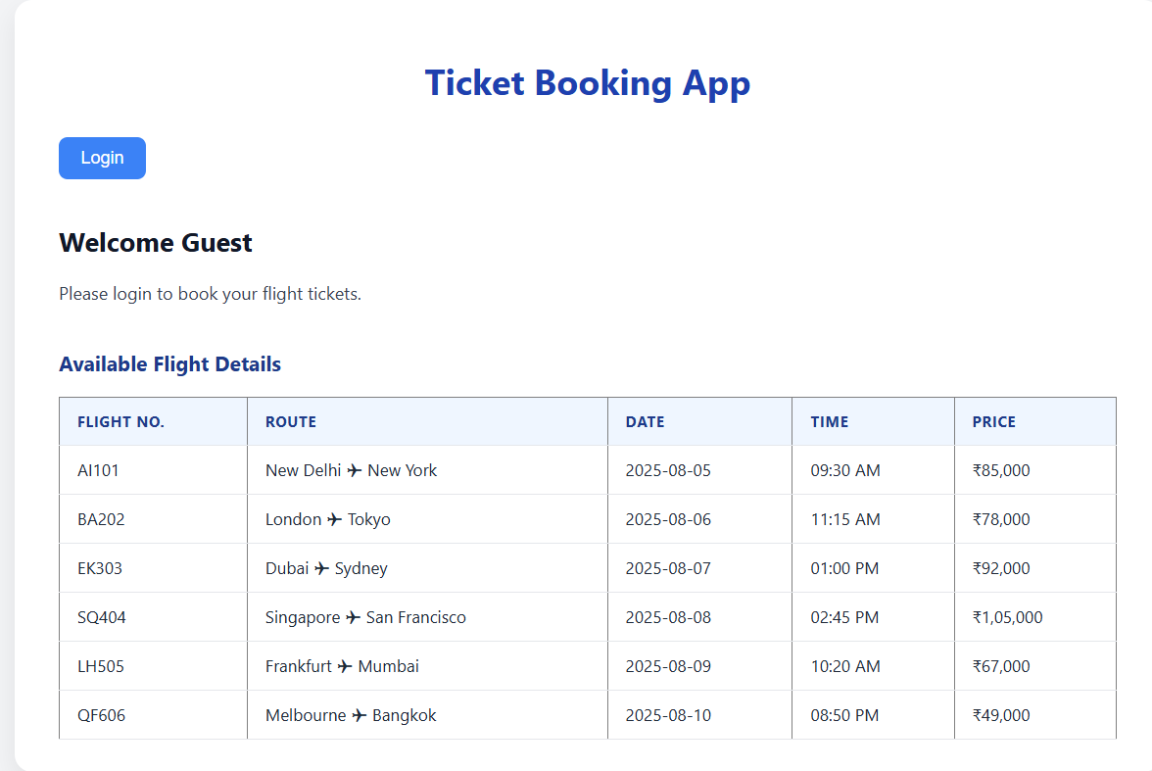
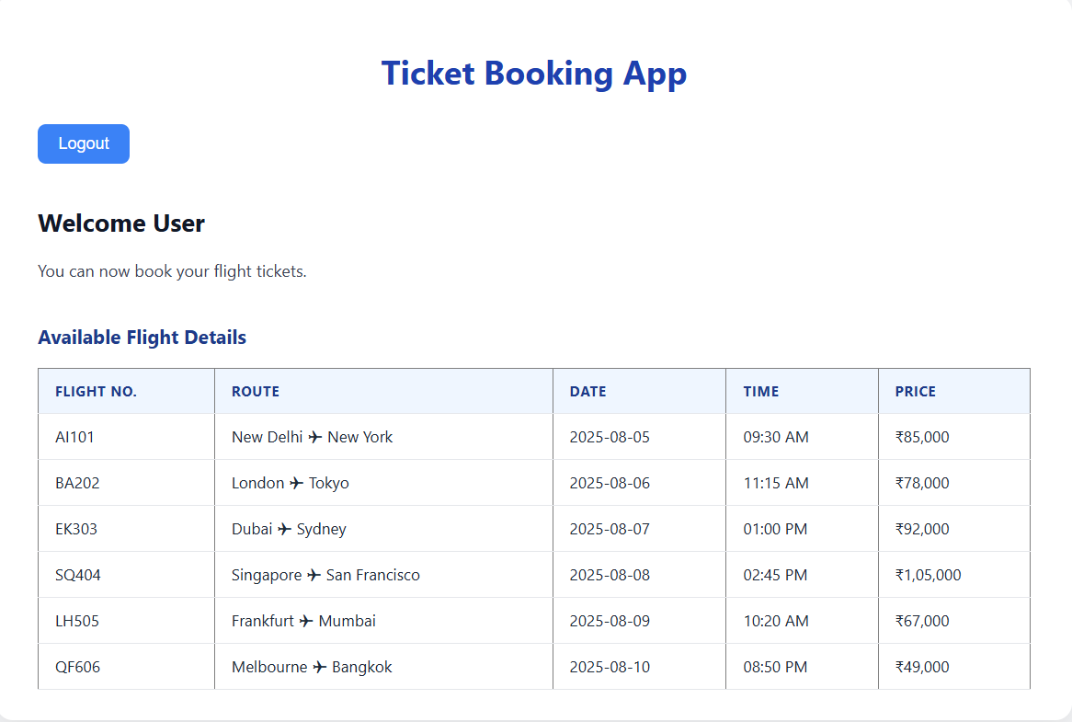

Conclusion:
This Ticket Booking App demonstrates essential React concepts like state management, conditional rendering, and dynamic data display. With clean components and a responsive layout, it offers a strong foundation for building more advanced user-based applications in React.

EXERCISE 5 : BLOGGER APP

Introduction:
The Blogger App is a beginner-friendly React project that allows users to toggle between different types of content: books, blogs, and courses. It demonstrates key React concepts such as state management, component-based structure, and conditional rendering, making it a great learning tool for new React developers.

Objective:
- To build a modular and dynamic React application.
- To understand how to use useState and conditional rendering effectively.
- To display structured data from arrays through reusable components.

Implementation:

Step 1: Create a React Project
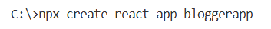
Navigating
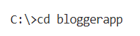

Step 2: Create Components Folder and Files
Inside the src/ directory:
- Create a components/ folder.
- Add three files: BookDetails.js, BlogDetails.js, and CourseDetails.js.

Step 3: Create App.js
import React, { useState } from 'react';
import BookDetails from './components/BookDetails';
import BlogDetails from './components/BlogDetails';
import CourseDetails from './components/CourseDetails';
import './App.css';

function App() {
const [selected, setSelected] = useState('book');

let detailComponent;
if (selected === 'book') detailComponent = <BookDetails />;
else if (selected === 'blog') detailComponent = <BlogDetails />;
else detailComponent = <CourseDetails />;

return (
<div className="App">
<h1>📚 Blogger App</h1>
<div>
<button onClick={() => setSelected('book')}>Book</button>
<button onClick={() => setSelected('blog')}>Blog</button>
<button onClick={() => setSelected('course')}>Course</button>
</div>
{detailComponent}
<p>Currently showing {selected.toUpperCase()} Details</p>
</div>
);
}

export default App;

Step 4: Implement BookDetails.js

const books = [
{ id: 1, title: "React Basics", author: "Dan Abramov", pages: 120 },
{ id: 2, title: "Learn JavaScript", author: "Kyle Simpson", pages: 350 },
];
function BookDetails() {
return (
<div>
<h2>📘 Book Details</h2>
<ul>
{books.map(book => (
<li key={book.id}>
<strong>{book.title}</strong> by {book.author} - {book.pages} pages
</li>
))}
</ul>
</div>
);
}

export default BookDetails;

Step 5: Implement BlogDetails.js

const blogs = [
{ id: 1, title: "Understanding Hooks", author: "Sophia", date: "2025-08-01" },
{ id: 2, title: "State vs Props", author: "James", date: "2025-08-02" },
];

function BlogDetails() {
return (
<div>
<h2>📝 Blog Details</h2>
<ul>
{blogs.map(blog => (
<li key={blog.id}>
<strong>{blog.title}</strong> by {blog.author} - {blog.date}
</li>
))}
</ul>
</div>
);
}

export default BlogDetails;

Step 6: Implement CourseDetails.js

const courses = [
{ id: 1, name: "React Fundamentals", instructor: "Jordan", duration: "4 weeks" },
{ id: 2, name: "Full Stack Dev", instructor: "Marie", duration: "8 weeks" },
];

function CourseDetails() {
return (
<div>
<h2>🎓 Course Details</h2>
<ul>
{courses.map(course => (
<li key={course.id}>
<strong>{course.name}</strong> by {course.instructor} - {course.duration}
</li>
))}
</ul>
</div>
);
}

export default CourseDetails;

Step 7: Style with App.css

.App {
text-align: center;
font-family: Arial, sans-serif;
margin: 40px;
}

button {
margin: 10px;
padding: 10px 20px;
border: none;
background-color: #3498db;
color: white;
cursor: pointer;
border-radius: 5px;
}

button:hover {
background-color: #2980b9;
}

h2 {
color: #2c3e50;
}

Step 8 : Run the Application
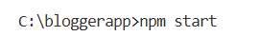

Output:

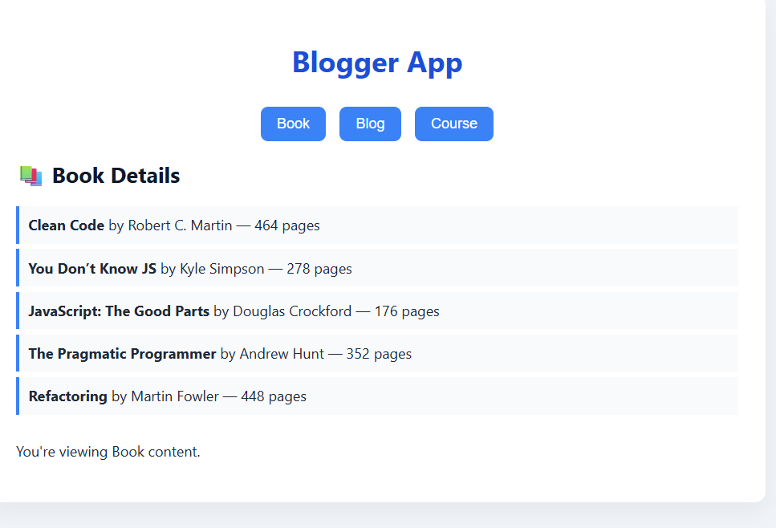
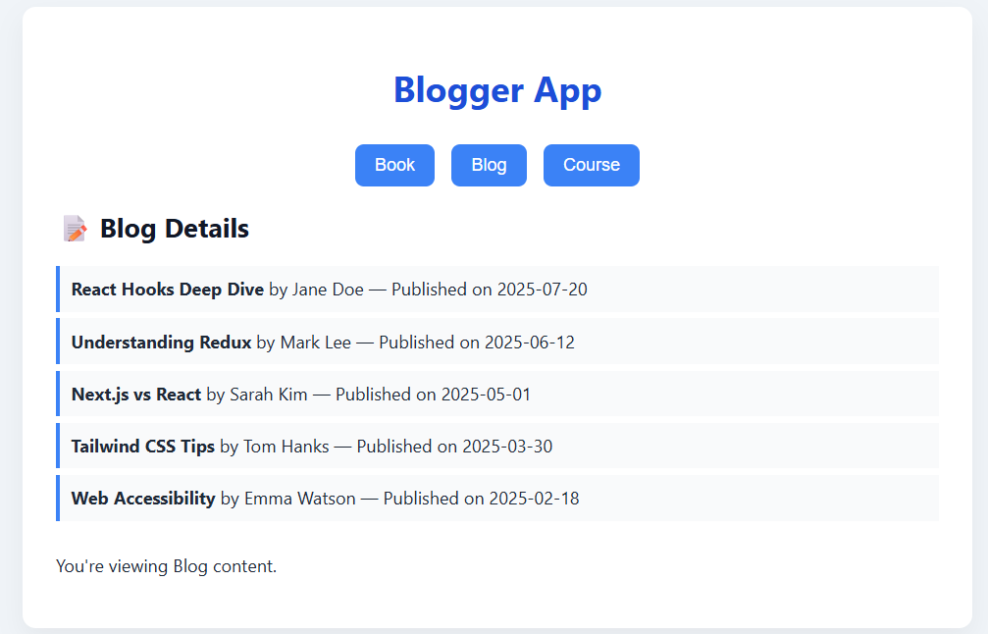
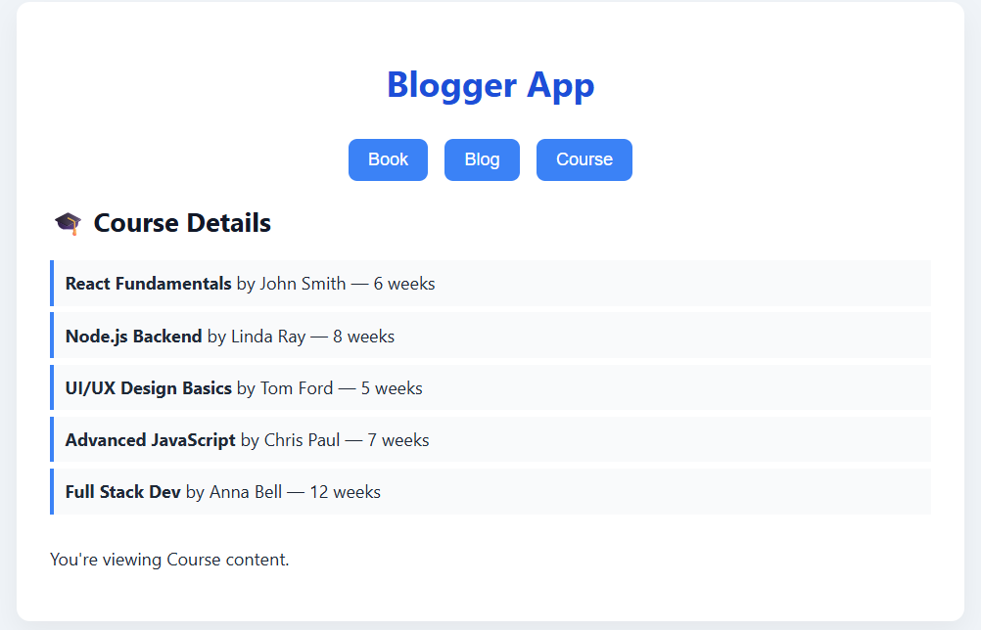

Conclusion:
This Blogger App demonstrates how to use React’s useState hook and conditional rendering to switch between components dynamically. With clean structure and separation of concerns, this project is a great example of building modular, maintainable, and interactive React apps — ideal for beginners exploring component-based design.

