Student Name: KARTHYAYENI P
Registration No: 22CSR089
Course/Batch: KONGU ENGINEERING COLLEGE (B.E COMPUTER SCIENCE AND ENGINEERING)

EXERCISE 1: GIT-HOL-1

Introduction:

This comprehensive Git hands-on laboratory provides practical experience with fundamental version control operations using Git and GitLab. The lab guides learners through essential Git workflows including repository setup, configuration management, and basic file operations within a source control environment.

Objective:

- Configure Git Environment: Setup machine-level Git configuration with user credentials and integrate Notepad++ as the default text editor for Git operations.
- Master Core Git Commands: Gain proficiency in essential Git commands including git init, git status, git add, git commit, git push, and git pull for effective repository management.
- Implement Source Control Workflow: Learn to add files to source code repositories, track changes, and synchronize between local and remote repositories using GitLab.

Implementation Breakdown:

Step 1: Setup your machine with Git Configuration

To create a new repository, signup with GitLab and register your credentials
Login to GitLab and create a “GitDemo” project

- To check if Git client is installed properly: Open Git bash shell and execute

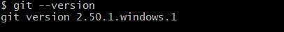

If output shows Git with its version information that indicates, that Git Client installs properly.

- To configure user level configuration of user ID and email ID execute

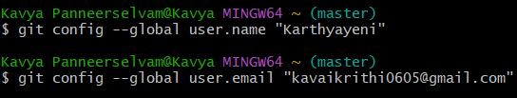

- To check if the configuration is properly set, execute the following command.

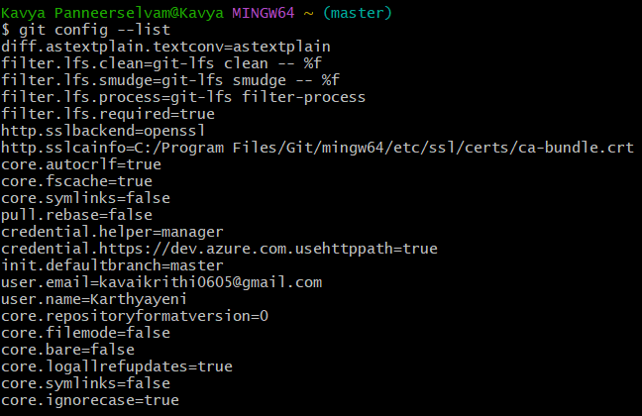
Step 2: Integrate notepad++.exe to Git and make it a default editor

- To check, if notepad++.exe execute from Git bash

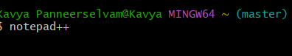
If Git bash could not able to recognize notepad++ command that implies notepad++.exe is note added to the environment path variable.

To add path of notepad++.exe to environment variable, go to control panel -> System -> Advanced System settings. Go to Advanced tab -> Environment variables -> Add path of notepad++.exe to the path user variable by clicking on “Edit”

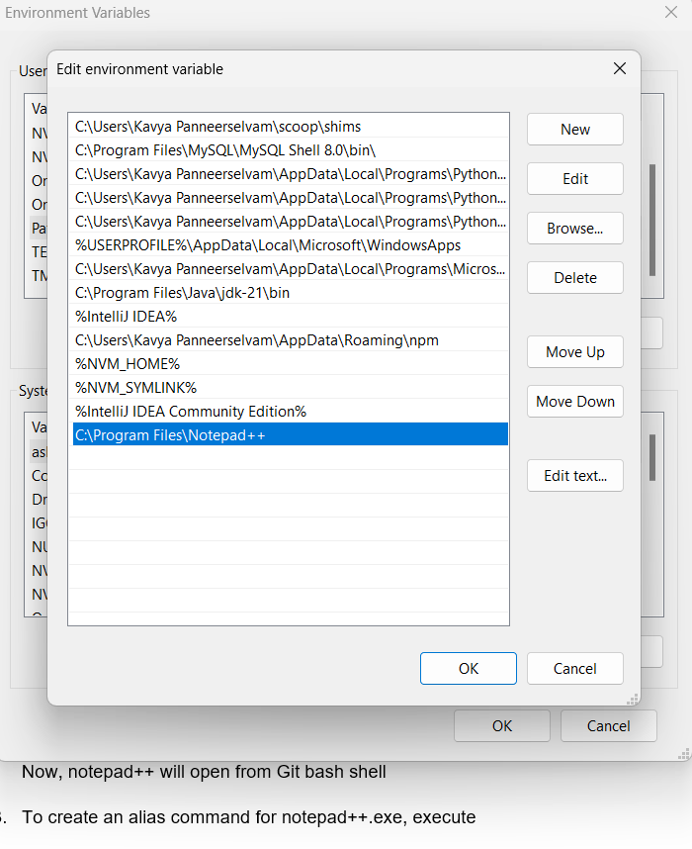

- Exit Git bash shell, open bash shell and execute



Now, notepad++ will open from Git bash shell

- To create an alias command for notepad++.exe, execute

It will open notepad++ from bash shell, and create a user profile by adding the line in notepad++

- To configure the editor, execute the command

- To verify if notepad++ is the default editor, execute the command
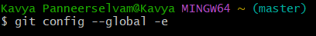
Here ‘-e’ option implies editor
It will show the entire global configuration as shown below,
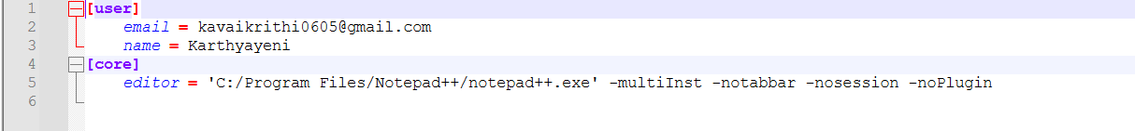

Step 3: Add a file to source code repository

- Open Git bash shell and create a new project “GitDemo” by executing the command

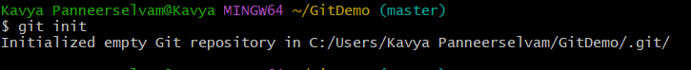

- Git bash initializes the “GitDemo” repository. To verify, execute the command
It will display all the hidden files in the Git “working directory”.

- To create a file “welcome.txt” and add content to the file, execute the command

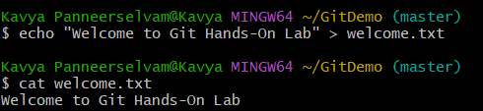

- To verify the content, execute the command



- Check the status by executing
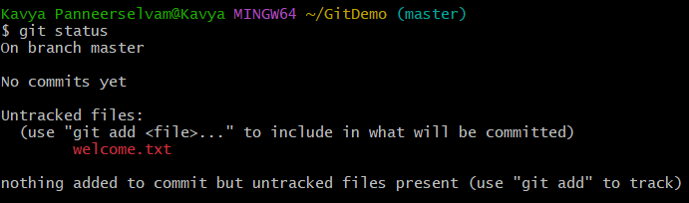

Now the file “welcome.txt” is available in Git “working directory”

- To make the file to be tracked by Git repository, execute the command
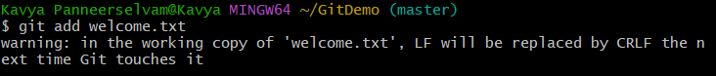

- To add multi line comments, we are opening default editor to comment. Execute the command

Notepad++ editor will open and to add multi-line comment with default editor

- To check if local and “Working Directory” git repository are same, execute git status

welcome.txt is added to the local repository.

- Signup with GitLab and create a remote repository “GitDemo”

- To push the local to remote repository, execute

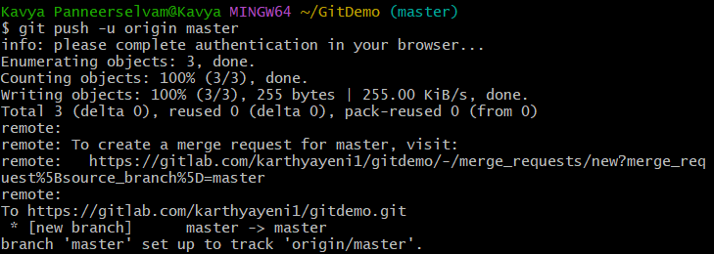

- Gitlab
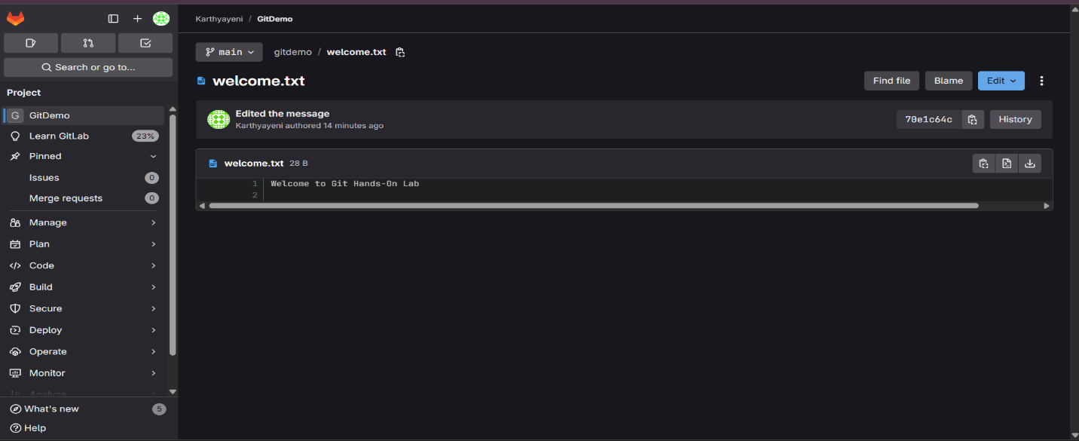

Conclusion:
This hands-on lab establishes a solid foundation in Git version control by combining theoretical knowledge with practical implementation. Students will have successfully configured their development environment, created their first Git repository, and performed basic file tracking operations, preparing them for collaborative software development workflows.

EXERCISE 2: GIT-HOL-2

Introduction:

This specialized Git laboratory focuses on file exclusion management through the .gitignore mechanism, a critical skill for maintaining clean repositories. The lab demonstrates how to selectively exclude unwanted files and directories from version control tracking, ensuring only relevant code and assets are committed to the repository.

Objective:
- Understand Git Ignore Concepts: Learn the fundamental principles of .gitignore functionality and its importance in maintaining clean repository structures.
- Implement File Exclusion Patterns: Create and configure .gitignore files to exclude specific file types (.log extensions) and directories (log folders) from Git tracking.
- Verify Exclusion Behavior: Test and validate that the .gitignore rules are properly applied by checking git status across working directory, local repository, and remote repository states.

Implementation Breakdown:
Step 1: Create a test repo and initialise
Step 2 : Create the files/folders the lab asks to ignore
Check status:
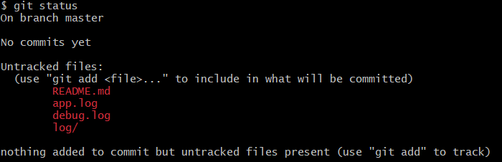
Step 3 : Create .gitignore to ignore .log files and log folder
Open or create .gitignore and add:
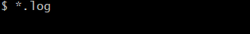
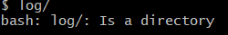
Command-line write:
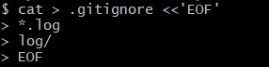
- *.log ignores any file ending with .log in any folder.
- log/ ignores the directory named log and everything inside it.
- To ignore only a top-level log directory you could use /log/

Step 4 : Stage & commit

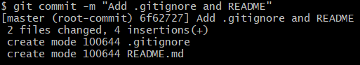

After this commit, run:
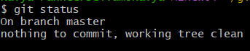
Step 6 : Push to remote
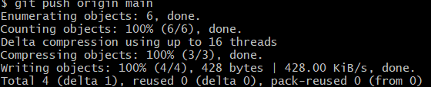
Conclusion:
This hands-on lab equips students with essential repository hygiene skills by mastering the .gitignore functionality for selective file tracking. Upon completion, learners will confidently manage which files should be version-controlled and which should remain local, ensuring cleaner and more professional repository management practices.

EXERCISE 3: GIT-HOL-3

Introduction:
This advanced Git laboratory explores the powerful concepts of branching and merging, fundamental techniques for parallel development and collaborative workflows. The lab provides hands-on experience with creating feature branches, implementing changes in isolation, and integrating those changes back into the main codebase using both command-line operations and visual merge tools.
Objective:
- Master Branch Operations: Learn to create, switch between, and manage Git branches including listing local and remote branches, and understanding branch pointer mechanics.
- Implement Parallel Development: Practice making changes in isolated branches, committing modifications, and maintaining separate development streams without affecting the main trunk.
- Execute Merge Workflows: Perform branch merging operations using both command-line diff tools and visual P4Merge tool, followed by proper branch cleanup and logging verification.
Implementation:
Step 1 : Start (clone)
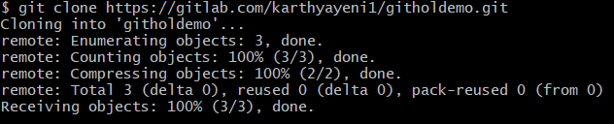
Step 2 : Create the branch GitNewBranch and switch to it
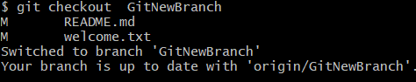
Step 3 : List branches (local & remote)
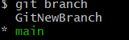
Step 4 : Make changes on the branch, stage & commit
Example: add a file, stage and commit:
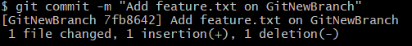
Check status:
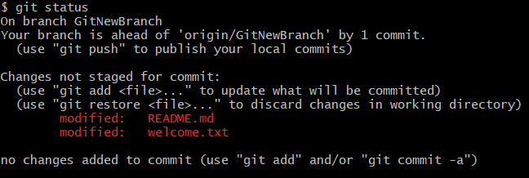
Pushing:
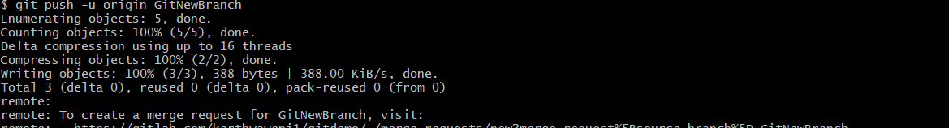
Step 5 : Switch back to trunk (main)
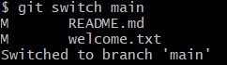

Step 6 : See differences (command-line)
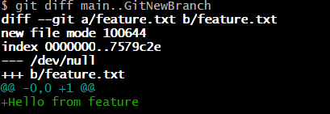
Step 7 : Merge the source branch into trunk
Fast, non-fast-forward-safe merge:
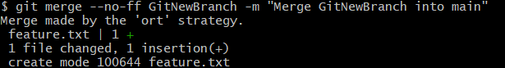
If conflicts happen
git status to list conflicted files.
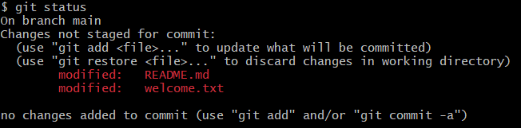
Mark resolved:
Finish the merge (if merge):
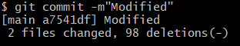
Step 8 : Inspect merge history
After merge:
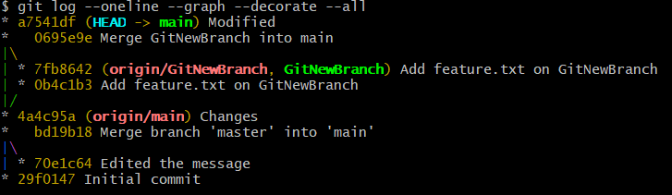
Step 9 : Delete the branch (local and remote)
After confirming everything is merged:
Local delete:
Remote delete:
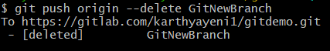

Step 10 : Push trunk changes to remote
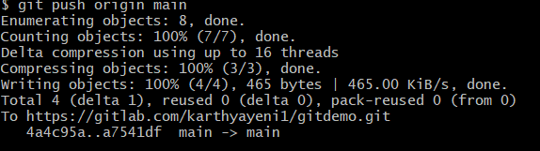

Conclusion:
This comprehensive branching and merging lab provides essential skills for collaborative software development by mastering parallel development workflows. Students will gain confidence in creating feature branches, managing code isolation, and safely integrating changes back to the main branch, establishing the foundation for professional team-based development practices.

EXERCISE 4 : GIT-HOL-4
Introduction:
This critical Git laboratory addresses one of the most challenging aspects of collaborative development: merge conflict resolution. The lab simulates real-world scenarios where multiple developers modify the same files simultaneously, creating conflicts that must be manually resolved using both command-line tools and visual merge utilities.
Objective:
- Understand Conflict Scenarios: Learn how merge conflicts arise when multiple users modify the same files in different branches, and identify conflict markers and indicators in Git status outputs.
- Master Conflict Resolution Tools: Utilize both Git's built-in diff tools and advanced 3-way merge tools like P4Merge to visualize, understand, and resolve complex file conflicts effectively.
- Implement Complete Resolution Workflow: Execute the full conflict resolution process including conflict identification, manual resolution, proper commit procedures, and post-resolution cleanup including .gitignore updates and branch management.
Implementation:
Step 1 : Set Up a Local Folder
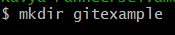
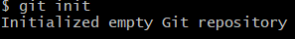
Step 2 : Link Local Repo to GitHub
- Copy the repository URL from GitHub (HTTPS).
- In Git Bash:
Step 3 : Create First File and Push
Create file:
Stage & Commit:
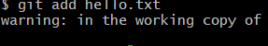
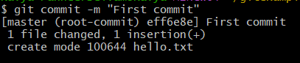
Push:
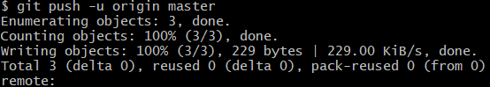
Step 4 : Edit hello.xml in Master Branch
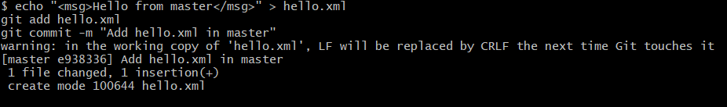
Step 5 : Create a New Branch and Modify hello.xml
Create branch:
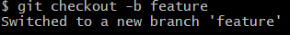
Edit hello.xml with a different message:
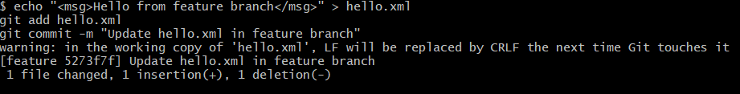
Step 6 : Switch Back to Master and Modify hello.xml
Switch to master:
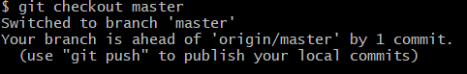

Update file differently:
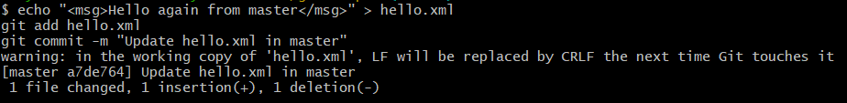

Step 7 : Merge and Resolve Conflict
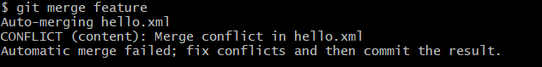
Conflict Solving:
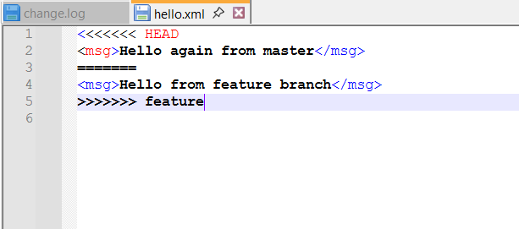
Stage the resolved file:
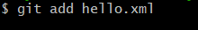
Commit the merge:
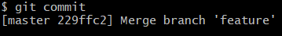
Step 8 : Pushing the changes
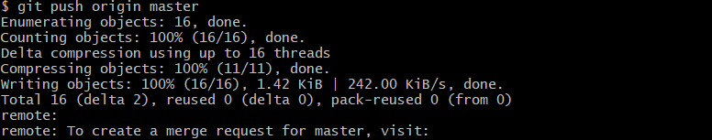
Conclusion:
This hands-on conflict resolution lab equips students with crucial problem-solving skills for collaborative development environments where code conflicts are inevitable. Upon completion, learners will confidently handle merge conflicts using professional-grade tools and workflows, ensuring smooth team collaboration and maintaining code integrity in multi-developer projects.

EXERCISE 5 : GIT-HOL-5

Introduction:
This final Git laboratory focuses on repository maintenance and remote synchronization, essential practices for maintaining clean and up-to-date collaborative development environments. The lab emphasizes proper cleanup procedures and demonstrates how to effectively synchronize local changes with remote repositories while maintaining repository integrity.
Objective:
- Validate Repository State: Learn to verify the cleanliness of the master branch and assess the current state of all local and remote branches before performing synchronization operations.
- Execute Remote Synchronization: Master the process of pulling latest changes from remote repositories and pushing pending local modifications to ensure all team members have access to the most current codebase.
- Verify Remote Integration: Implement verification procedures to confirm that local changes have been successfully integrated into the remote repository and are visible to other team members.

Implementation:

Step 1: Verify Master Branch is in Clean State
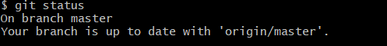

Step 2: List All Available Branches
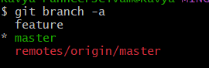

Step 3: Pull the Remote Git Repository to Master

Step 4: Push Pending Changes to Remote Repository
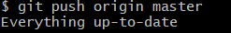

Step 5: Observe Changes in Remote Repository
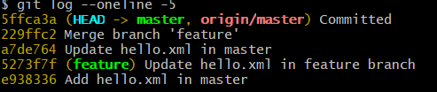
Check on Gitlab
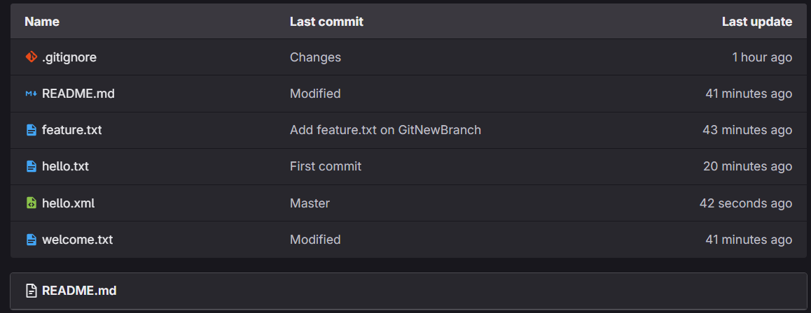

Conclusion:
This repository cleanup and synchronization lab completes the Git learning journey by establishing best practices for maintaining healthy collaborative repositories. Students will master the essential workflow of cleaning, synchronizing, and verifying repository states, ensuring they can effectively contribute to team projects while maintaining code quality and accessibility standards.

