Snake RL: learning notes
  - Reinforcement learning from tabular Q to deep RL, one tryout per chapter
Table of Contents

01 · Tabular Q-learning on Snake

Summary
We trained a one-step Q-learning agent (Watkins, 1989; Watkins & Dayan, 1992) to play 12×12 Snake. Its state is 11 binary features: danger ahead/right/left, heading, and food direction. The Q-table has 2048 rows, but only 256 can ever occur.
Over the first 100 epochs (1 epoch = 100 episodes), the greedy score on 500 held-out seeds rose from 0.04 to 20.0. After that it plateaued at 19–22 across three training seeds. That is the same level as a ten-line hand-written heuristic (20.4). The agent never filled the board on 12×12. On 6×6 it won once in 13,500 evaluation games.
The algorithm worked. The state is the bottleneck: about 90% of deaths are self-collisions, and nothing in the 11 features can describe free space beyond the next cell. This note derives the theory behind every line of the training loop, shows where each assumption holds or breaks for Snake, and uses the failure to motivate tryout 02.
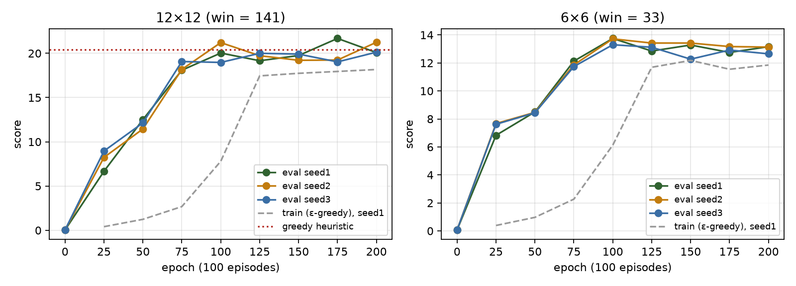
Greedy evaluation score on 500 held-out seeds at each checkpoint, three training seeds.

1. Snake as a Markov decision process
A finite MDP is a tuple $(S,A,P,R,γ)$:
- $S$ is the set of states.
- $A$ is the set of actions.
- $P(s^{′}∣s,a)$ gives the transition probabilities.
- $R(s,a,s^{′})$ is the reward.
- $γ∈[0,1)$ is the discount factor (Puterman, 1994; Sutton & Barto, 2018, ch. 3).
The Markov property requires that the next state and reward depend only on the current state and action:
$$Pr(S_{t+1}=s^{′},R_{t+1}=r∣S_{t},A_{t},S_{t−1},A_{t−1},…)=Pr(S_{t+1}=s^{′},R_{t+1}=r∣S_{t},A_{t}).$$
The true Snake state is the ordered body (a path of cells), the heading, the food cell, and the step counter used for timeouts. With the body as a self-avoiding path on a 12×12 grid, the number of states is astronomically large, far beyond any table. Food placement is the only source of randomness: after eating, the next food cell is drawn uniformly from the free cells by a seeded mulberry32 generator. That makes $P$ stochastic, but every episode is exactly reproducible from its seed.
Actions are relative: $A=\{\text{straight},\text{right},\text{left}\}$. Relative actions remove the illegal 180° reversal by construction. They also make the policy symmetric under rotation, so “turn toward the food” means the same thing whichever way the snake faces.
Rewards: $+1$ for eating, $−1$ for dying, and $0$ otherwise. Rewards are deliberately sparse and sign-coded. Any shaping (§6) is an experiment, not a default.
Episodes end in two different ways, and the difference matters for learning:
- Termination: hitting a wall or the body, or filling the board. The episode ends because the MDP really ended. The value of the next state is $0$.
- Truncation: going $100×\text{length}$ steps without eating. The environment didn’t end; we stopped watching. Treating truncation as termination teaches the agent that circling is fatal, when it is merely boring. That mis-specifies the value function (Pardo et al., 2018).
The engine reports them separately (terminated, truncated), as in Gymnasium. The update bootstraps through truncation.
Self-check. A looping agent is cut off by the 100×length timeout. What target should the last transition use?
- r + 0, because the episode is over
- r + γ·max_a Q(s’, a), because the state was not terminal
- −1, to punish looping
Answer: (b). Truncation is a property of our training loop, not of the MDP. Using r + 0 would encode “this state has value 0”, which is false and biases Q downward near loops (Pardo et al., 2018). If looping is undesirable, that belongs in the reward or the time limit, stated explicitly.

2. Returns, value functions and Bellman equations
The return from time $t$ is the discounted sum of future rewards:
$$G_{t}=\sum_{k=0}^{∞}{γ^{k}}R_{t+k+1}=R_{t+1}+γG_{t+1}.$$
The recursion on the right is the whole trick of dynamic programming.
For a policy $π(a∣s)$, the state-value and action-value functions are
$$v_{π}(s)=E_{π}[G_{t}∣S_{t}=s], q_{π}(s,a)=E_{π}[G_{t}∣S_{t}=s,A_{t}=a].$$
Bellman expectation equation. Substitute $G_{t}=R_{t+1}+γG_{t+1}$ and use the Markov property, which lets $E[G_{t+1}∣S_{t+1}=s^{′}]$ be written as $v_{π}(s^{′})$:
qπ(s,a)&=E[Rt+1+γGt+1∣St=s,At=a]&=s′​P(s′∣s,a)R(s,a,s′)+γa′​π(a′∣s′) qπ(s′,a′).
Bellman optimality equation. An optimal policy acts greedily with respect to its own values, so the inner average over $a^{′}$ becomes a maximum:
q*(s,a)=s′​P(s′∣s,a)R(s,a,s′)+γmaxa′q*(s′,a′).
Why a solution exists and is unique. Define the Bellman optimality operator
(Tq)(s,a)=s′​P(s′∣s,a)R+γmaxa′q(s′,a′).
For any two Q-functions $q_{1}$ and $q_{2}$:
|(Tq1)(s,a)−(Tq2)(s,a)|≤γs′​P(s′∣s,a) |maxa′q1(s′,a′)−maxa′q2(s′,a′)|≤γ ∥q1−q2∥∞.
This uses $|maxf−maxg|≤max|f−g|$. So $T$ is a $γ$-contraction in the sup norm. By Banach’s fixed-point theorem it has a unique fixed point $q_{*}$, and iterating $q_{k+1}=Tq_{k}$ (value iteration) converges to it geometrically:
$$∥q_{k}−q_{*}∥_{∞}≤γ^{k}∥q_{0}−q_{*}∥_{∞}.$$
Q-learning is a sampled, asynchronous version of this iteration.
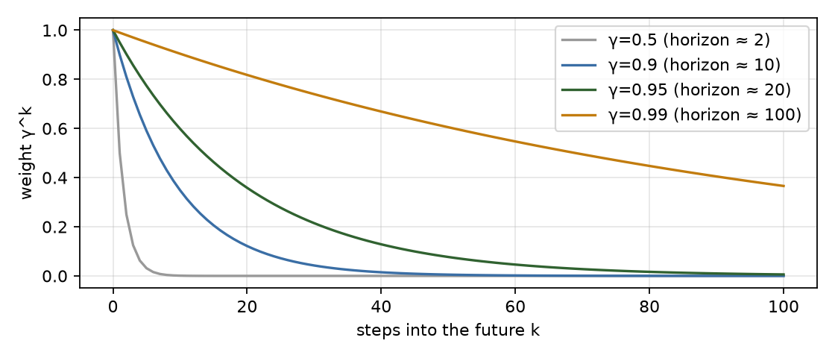
Discount weights and effective horizon 1/(1−γ).
Reading γ for Snake. The effective horizon is about $1/(1−γ)$ steps: 20 steps at $γ=0.95$ and 100 at $0.99$.
- On a 12×12 board the nearest food is typically 5–15 steps away, so $γ=0.95$ “sees” the next apple.
- Avoiding a self-trap can require planning dozens of steps ahead, around the whole body. A short horizon is one reason a myopic agent coils into dead ends.
- A long horizon does not help when the state can’t represent the trap (§5), which the γ sweep below confirms.

3. From dynamic programming to temporal-difference learning
We don’t know $P$. Monte Carlo methods estimate $q_{π}(s,a)$ by averaging complete returns. That is unbiased, but the variance is high and you must wait until the episode ends.
Temporal-difference (TD) methods (Sutton, 1988) replace the unknown expectation with one sampled transition and bootstrap from the current estimate.
The Q-learning update for a transition $(s,a,r,s^{′})$ is
$$Q(s,a)←Q(s,a)+α \underset{δ = \text{TD error}}{\underset{⏟}{\left[ r+γ\max_{a^{′}}Q(s^{′},a^{′})−Q(s,a) \right]}},$$
with $\max_{a^{′}}Q(s^{′},a^{′}):=0$ when $s^{′}$ is terminal.
- The bracketed quantity is a sample of $(TQ)(s,a)−Q(s,a)$.
- Its expectation over $s^{′}$ is exactly the Bellman residual.
- The update is a stochastic-approximation step toward the fixed point of $T$.
Q-learning is off-policy. The target uses $\max_{a^{′}}$, the greedy action, whatever action the behaviour policy takes next. So we can explore with $ε$-greedy and still learn about the greedy policy. SARSA uses the action actually taken next and learns the value of the exploring policy instead.
Convergence (Watkins & Dayan, 1992; Jaakkola, Jordan & Singh, 1994; Tsitsiklis, 1994). Tabular Q-learning converges to $q_{*}$ with probability 1 if:
- the process is a finite MDP;
- every $(s,a)$ pair is updated infinitely often;
- the step sizes satisfy the Robbins–Monro conditions t​αt(s,a)=∞ and t​αt2(s,a)<∞;
- rewards are bounded.
Our run breaks two of these on purpose:
- Constant α = 0.1. This violates $∑α^{2}<∞$. The table never settles; it tracks recent experience. That is useful if the environment changes, but it shows up as checkpoint-to-checkpoint jitter (§8).
- The process we learn on is not an MDP in the feature space (§5). The guarantee simply doesn’t apply.
[Interactive figure “q_update”: open the HTML version of this note.]
Self-check. In the update, why is the target r + γ·max Q(s’,·) and not r + γ·Q(s’, a_next), where a_next is the ε-greedy action actually taken?
- It is cheaper to compute
- max makes the target the greedy (optimal) policy’s value, so learning is off-policy
- a_next is not known yet
Answer: (b). Using the action actually taken gives SARSA, which learns q for the ε-greedy behaviour policy itself. Q-learning’s max learns q* while behaving exploratorily. The cost of that is maximisation bias with noisy estimates, which Double Q-learning fixes (van Hasselt, 2010).

4. Exploration
ε-greedy takes a uniformly random action with probability $ε$ and otherwise the greedy one. With $ε$ decaying to 0 and all pairs visited infinitely often (GLIE: greedy in the limit with infinite exploration), the behaviour policy itself becomes optimal (Singh et al., 2000).
We decay linearly from $1.0$ to $0.01$ over the first 50% of episodes, then hold at $0.01$.
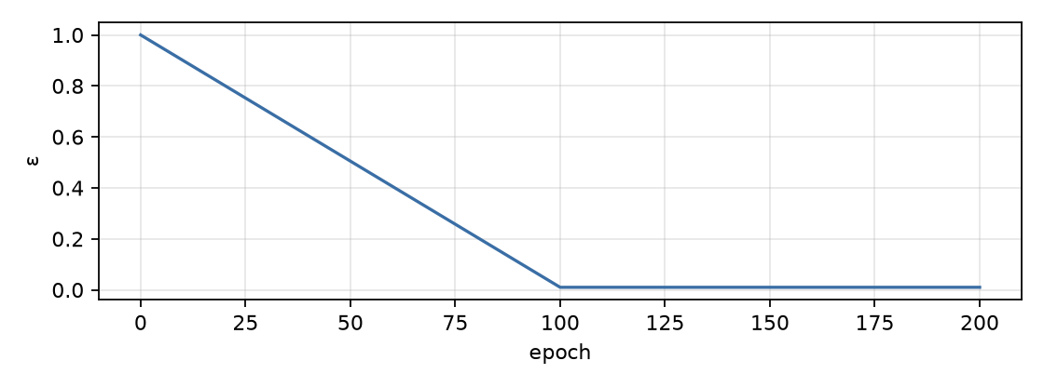
ε-greedy schedule used in the run.
Exploration costs the most in Snake when the snake is long. A single random turn next to the body is fatal. That is why the training score at $ε=0.01$ (18.2) stays below the greedy evaluation score (20.1), and why the training curve is a poor measure of policy quality. Always evaluate greedily, on held-out seeds.

5. The state we actually learn on, and why it limits everything
The agent never sees the true state. It sees an 11-bit observation $o=ϕ(s)$:
Bits | Meaning
0–2 | danger if moving straight / right / left (wall or body, tail excluded because it moves)
3–6 | heading one-hot (R, D, L, U)
7–10 | food is left / right / up / down of the head
Only 256 rows of the 2048 can occur. Heading is one-hot, so 4 of the 16 patterns are possible. Food direction has 8 valid combinations: at most one of left/right and one of up/down is set, and the food is never under the head. Danger has 8. So $8×4×8=256$. The agent visited exactly 256 rows by epoch 125, which is a nice sanity check that exploration covered the reachable table.
State aliasing. Many true states map to the same observation. “Body ahead-left, food up-right” looks identical whether the free region on the right is 100 cells or 2 cells. The second case is a death trap, but the observation can’t say so. Formally the agent faces a partially observable MDP (POMDP; Kaelbling, Littman & Cassandra, 1998).
Q-learning on observations treats $o$ as if it were Markov, and that has known consequences (Singh, Jaakkola & Jordan, 1994):
- the best memoryless deterministic policy can be arbitrarily worse than the optimal one;
- Q-learning need not converge to it;
- values can chatter as the mix of underlying states behind each $o$ shifts with the policy.
[Interactive figure “aliasing”: open the HTML version of this note.]
That is the root cause of the plateau. With this observation, a near-optimal memoryless policy is “go toward the food unless the next cell is deadly”. The learned table agrees with exactly that heuristic on 87.6% of the states the heuristic visits, and scores the same (20.1 vs 20.4).
The same property has an upside. The features are size-invariant, so the 12×12 table plays other board sizes unchanged:
Board | 10×10 | 16×16 | 20×20
Q-table | 18.4 | 25.4 | 29.7
Heuristic | 17.9 | 24.5 | 28.0
(300 seeds each.)
Self-check. The agent has visited all 256 reachable rows, ε is 0.01, and it has trained for another 10,000 episodes. Will more training eventually stop self-collisions?
- Yes, Q-learning converges to the optimal policy given enough data
- No: the information needed (free space beyond one cell) is not in the observation
- Only if α is decayed
Answer: (b). Convergence theorems are about the MDP whose state you observe. Two situations that need opposite actions share one table row, so no table entry can be right for both. Decaying α would only freeze the compromise. The fix is a richer state: reachable-area features or the raw grid fed to a CNN (tryout 02).

6. Reward design and shaping
The reward defines the task. Anything you add changes the task unless it has a special form.
Ng, Harada & Russell (1999) proved that potential-based shaping, of the form
$$F(s,s^{′})=γ Φ(s^{′})−Φ(s),$$
leaves the optimal policy unchanged for any potential $Φ$. The reason is that the shaping terms telescope inside the return:
k​γkF(St+k,St+k+1)=−Φ(St)+limK→∞γKΦ(St+K)=−Φ(St).
So every action’s value shifts by the same state-dependent constant.
An ad-hoc “+0.1 for moving closer to food, −0.1 for moving away” is almost this with $Φ=−\text{distance}$. But without the $γ$ on $Φ(s^{′})$ and the $Φ(\text{terminal})=0$ convention, it rewards back-and-forth oscillation, a classic case of specification gaming (Krakovna et al., 2020).
The Python environment offers shaping="potential" with $Φ(s)=−∥\text{head}−\text{food}∥_{1}/2n$. Tryout 01 used no shaping: the ±1 reward is dense enough here, and adding shaping would confound the representation finding.

7. How the theory maps to the code
tools/train_tabular.js (Node) runs the same engine as the browser game, line for line:
Theory | Code
$o=ϕ(s)$, 11 bits → table row | S.basicStateIndex(g) packs basicFeatures into an integer 0–2047
$ε$-greedy behaviour | rng.nextU32()/2**32 < eps ? rng.int(3) : argmax(q[s])
terminal ⇒ no bootstrap | r.terminated ? 0 : gamma * Math.max(...q[s2])
truncation ⇒ bootstrap | timeouts return terminated:false, truncated:true, so the max term stays
TD update with step size α | q[s][a] += alpha * (target - q[s][a])
greedy evaluation, held-out | S.evaluate(greedy, {seeds: 100000…100499}) at every checkpoint
reproducibility | engine RNG (mulberry32) seeded per run; the same seed gives the identical run (verified: 2,173,663 steps twice)
Experimental protocol.
- One epoch is 100 episodes. We checkpoint every 25 epochs, so there are 8 checkpoints in 200 epochs (20,000 episodes, about 2.2 M environment steps, about 2 s of CPU).
- Hyperparameters: α = 0.1, γ = 0.95, ε from 1.0 to 0.01 over the first 100 epochs.
- Every checkpoint evaluates the greedy policy on the same 500 held-out seeds, so checkpoints are directly comparable.
- Three training seeds on 12×12 and three on 6×6.
- Baselines on the same 500 seeds: random play scores 0.17; the greedy heuristic scores 20.4.

8. Results
12×12, seed 1 (win = score 141)
epoch | ε | train mean (max, wins) | eval mean | median | p90 | max | wins/500 | wall / self / timeout
0 | 1.0 | – | 0.04 | 0 | 0 | 1 | 0 | 100% / 0% / 0%
25 | 0.753 | 0.41 (4, 0) | 6.67 | 6 | 13 | 23 | 0 | 28% / 51% / 21%
50 | 0.505 | 1.24 (7, 0) | 12.51 | 12 | 19 | 28 | 0 | 8% / 92% / 0%
75 | 0.258 | 2.68 (14, 0) | 18.09 | 18 | 27 | 40 | 0 | 8% / 92% / 0%
100 | 0.01 | 7.8 (37, 0) | 20.03 | 19 | 29 | 49 | 0 | 8% / 92% / 0%
125 | 0.01 | 17.45 (46, 0) | 19.16 | 19 | 28 | 40 | 0 | 9% / 91% / 0%
150 | 0.01 | 17.74 (46, 0) | 19.75 | 20 | 29 | 41 | 0 | 6% / 94% / 0%
175 | 0.01 | 17.95 (43, 0) | 21.68 | 21 | 31 | 42 | 0 | 8% / 92% / 0%
200 | 0.01 | 18.17 (47, 0) | 20.08 | 20 | 28 | 39 | 0 | 12% / 88% / 0%
6×6, seed 1 (win = score 33)
epoch | ε | train mean (max, wins) | eval mean | median | p90 | max | wins/500 | wall / self / timeout
0 | 1.0 | – | 0.07 | 0 | 0 | 2 | 0 | 100% / 0% / 0%
25 | 0.753 | 0.39 (4, 0) | 6.83 | 6 | 11 | 15 | 0 | 26% / 74% / 0%
50 | 0.505 | 0.97 (6, 0) | 8.5 | 8 | 13 | 18 | 0 | 12% / 88% / 0%
75 | 0.258 | 2.27 (13, 0) | 12.13 | 12 | 18 | 26 | 0 | 26% / 74% / 0%
100 | 0.01 | 6.13 (25, 0) | 13.75 | 14 | 19 | 28 | 0 | 33% / 67% / 0%
125 | 0.01 | 11.69 (33, 2) | 12.85 | 12 | 19 | 30 | 0 | 38% / 62% / 0%
150 | 0.01 | 12.18 (28, 0) | 13.28 | 13 | 19 | 28 | 0 | 23% / 77% / 0%
175 | 0.01 | 11.55 (33, 1) | 12.75 | 13 | 18 | 24 | 0 | 23% / 77% / 0%
200 | 0.01 | 11.85 (33, 1) | 13.16 | 13 | 18 | 29 | 0 | 21% / 79% / 0%
12×12, seed 1:
- Eval mean goes 0.04 → 6.67 → 12.51 → 18.09 → 20.03 by epoch 100, the point where ε reaches its floor.
- After that the checkpoints read 19.16, 19.75, 21.68 and 20.08.
- Wins: 0 in 20,000 training episodes and 4,500 evaluation games.
- The best single game filled 36% of the board (score 49).
Watch the trained table play any of the held-out evaluation seeds. The heatmap colours every free cell by $\max_{a}Q$, as if the head were standing there with the current heading. Notice that the colours depend only on the 3-cell neighbourhood and the food direction, never on how much room is left.
[Interactive figure “replay”: open the HTML version of this note.]
Is the late jitter meaningful? The spread of eval scores is about 6.3. That is estimated from the percentiles: p10 = 12 and p90 = 28, and for a roughly normal distribution $σ≈(p_{90}−p_{10})/2.56$. With 500 games, the standard error of the mean is about $6.3/\sqrt{500}≈0.28$.
Swings of ±1.6 are therefore larger than sampling noise. They are real changes in the greedy policy, caused by the constant step size continually rewriting the table (§3), not measurement noise. Across three seeds the final means are 20.1, 21.3 and 20.1. Report the band, not the best checkpoint (Henderson et al., 2018; Agarwal et al., 2021).
6×6 (win = score 33). The plateau is at about 13. Across all seeds the run produced a handful of wins during training and 1 evaluation win in 13,500 games. Those wins happen when food happens to land conveniently, not from planning.
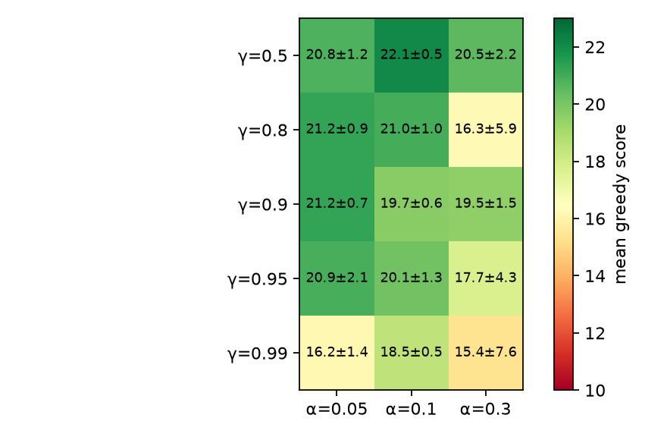
γ × α sweep (10k episodes, seeds 11-13, 300 eval games each); mean ± sd over seeds.
γ and α sweep (10k episodes, 3 seeds × 300 evaluation games per cell):
- Every setting with γ ≤ 0.95 and α ≤ 0.1 lands at 19–23.
- γ = 0.99 is worse and much less stable (seed spread 10–24 at α = 0.3). A longer horizon can’t help when the trap isn’t observable. It only propagates noisy, aliased values further.
- Large α amplifies the chattering predicted for aliased states.

9. Failure analysis
- Self-trapping (~90% of deaths). Root cause: there is no information about free space beyond one cell. Fix: add reachable-area features per action (flood fill), or give a CNN the whole grid.
- Early loops (epoch 25: 21% of games timed out). Unvisited rows hold ties at 0. argmax breaks ties toward “straight”, and some feature patterns lead to cycles. This disappears once the table fills. Lesson: tie-breaking and the time limit are part of the algorithm.
- Wall deaths still 8–12%. These come mostly from forced situations where all three moves are blocked, plus aliasing: a row learned mostly from safe cases occasionally fires in an unsafe one.
- No convergence, by construction. Constant α plus a non-Markov observation gives a policy that keeps moving. If a stable artefact is needed, decay α, or keep the best checkpoint by evaluation on separate validation seeds, never by test-set score.
- Not a GPU problem. The table has 2048×3 floats (24 KB dense, 8 KB as sparse JSON). Training takes 2 seconds on one CPU core. PyTorch would add overhead and nothing else, which is why this tryout uses none.

10. What this sets up
- The algorithm was never the bottleneck; the observation was. Tryout 02 keeps Q-learning but:
  - feeds the whole grid (body recency, head, food, walls) to a small CNN, so the Q-function can see traps;
  - replaces the table with a neural network, which needs experience replay and a target network to stay stable (Mnih et al., 2015).
- Expect sample efficiency to drop. The table needs about 2 M steps; a CNN DQN typically needs tens of millions. That is where vectorised environments on the GPU earn their keep.

Self-check
Self-check. Why is the effective number of table rows 256, not 2048?
- Exploration did not reach the rest
- One-hot heading (4 of 16) × valid food directions (8) × danger patterns (8)
- The engine forbids some states
Answer: (b). The feature encoding has structural constraints. Recognising unreachable rows is a quick sanity check on exploration coverage and on bugs in feature code.
Self-check. Training score at ε = 0.01 is 18.2 while greedy evaluation gives 20.1. Which statement is right?
- The evaluation is overfitting the eval seeds
- Even 1% random actions are costly when the snake is long, so training scores understate the policy
- The two numbers come from different policies, so the gap is noise
Answer: (b). In Snake one random turn beside the body is fatal, and long episodes contain hundreds of such moments. Evaluate greedily, on held-out seeds, with enough episodes to put a standard error on the mean.

References
- Agarwal, R., Schwarzer, M., Castro, P. S., Courville, A., & Bellemare, M. G. (2021). Deep reinforcement learning at the edge of the statistical precipice. NeurIPS.
- Henderson, P., Islam, R., Bachman, P., Pineau, J., Precup, D., & Meger, D. (2018). Deep reinforcement learning that matters. AAAI.
- Jaakkola, T., Jordan, M. I., & Singh, S. P. (1994). On the convergence of stochastic iterative dynamic programming algorithms. Neural Computation, 6(6).
- Kaelbling, L. P., Littman, M. L., & Cassandra, A. R. (1998). Planning and acting in partially observable stochastic domains. Artificial Intelligence, 101.
- Krakovna, V., et al. (2020). Specification gaming: the flip side of AI ingenuity. DeepMind blog.
- Mnih, V., et al. (2015). Human-level control through deep reinforcement learning. Nature, 518, 529–533.
- Ng, A. Y., Harada, D., & Russell, S. (1999). Policy invariance under reward transformations: theory and application to reward shaping. ICML.
- Pardo, F., Tavakoli, A., Levdik, V., & Kormushev, P. (2018). Time limits in reinforcement learning. ICML.
- Puterman, M. L. (1994). Markov Decision Processes: Discrete Stochastic Dynamic Programming. Wiley.
- Singh, S. P., Jaakkola, T., & Jordan, M. I. (1994). Learning without state-estimation in partially observable Markovian decision processes. ICML.
- Singh, S., Jaakkola, T., Littman, M. L., & Szepesvári, C. (2000). Convergence results for single-step on-policy reinforcement-learning algorithms. Machine Learning, 38.
- Sutton, R. S. (1988). Learning to predict by the methods of temporal differences. Machine Learning, 3.
- Sutton, R. S., & Barto, A. G. (2018). Reinforcement Learning: An Introduction (2nd ed.). MIT Press. Chapters 3–6.
- Tsitsiklis, J. N. (1994). Asynchronous stochastic approximation and Q-learning. Machine Learning, 16.
- van Hasselt, H. (2010). Double Q-learning. NeurIPS.
- Watkins, C. J. C. H. (1989). Learning from Delayed Rewards. PhD thesis, University of Cambridge.
- Watkins, C. J. C. H., & Dayan, P. (1992). Q-learning. Machine Learning, 8, 279–292.

02 · Deep Q-Networks on Snake (CNN on the board, CUDA)

Summary
Tryout 01 showed that the algorithm wasn’t the bottleneck; the observation was. Tryout 02 keeps Q-learning and changes two things:
- The state is the whole board. It is a 4-channel 14×14 image: body recency, head, food, and the wall ring. The agent can finally see where its body is.
- The table becomes a neural network. It is a small CNN with about 0.32 M parameters, trained with the two stabilisers from Mnih et al. (2015): an experience replay buffer and a target network. It also uses Double-DQN targets (van Hasselt et al., 2016).
The environment runs as 128 games stepped together as tensors on the GPU, and the replay buffer lives there too. The benchmark section measures where the GPU helps on this machine and where the CPU wins.
All numbers in this note come from results.json, which python/train_dqn.py writes (these runs: a laptop with a GTX 1650 Ti). If a figure below is empty, the run hasn’t been done yet.
item | value
model | dqn_cnn_12x12_long: 319,779 params, 1.28 MB fp32
device | cuda:0 NVIDIA GeForce GTX 1650 Ti, 4.0 GiB, sm_75, torch 2.14.1+cu130 (CUDA 13.0)
replay | 200,000 transitions, 317 MB
best by validation | epoch 65: test mean 24.54, max 45, wins 0

1. From a table to a function
A table stores one number per (state, action). With the board as the state, that is hopeless: there are astronomically many board configurations. Function approximation replaces the table with $Q_{θ}(s,a)$, a network with parameters $θ$, and the network generalises across states that look alike.
Semi-gradient Q-learning minimises the squared TD error with the target held fixed:
$$L(θ)=E_{(s,a,r,s^{′})}[\left(\underset{y, \text{treated as a constant}}{\underset{⏟}{r+γ\max_{a^{′}}Q_{\overset{‾}{θ}}(s^{′},a^{′})}}−Q_{θ}(s,a))^{2}\right], ∇_{θ}L=−2 E\left[(y−Q_{θ}(s,a)) ∇_{θ}Q_{θ}(s,a)\right].$$
This is not the gradient of any fixed objective. The target $y$ depends on $θ$ too, and we ignore that dependence, hence “semi-gradient” (Sutton & Barto, 2018, §9.3). With a table, the update reduces exactly to tryout 01’s rule, where $∇_{θ}Q$ is a one-hot vector.
The deadly triad (Sutton & Barto, 2018, §11.3). Combining
- function approximation,
- bootstrapping, and
- off-policy data
can diverge even on tiny problems (Baird, 1995; Tsitsiklis & Van Roy, 1997). DQN has all three. Its engineering choices are best read as ways to keep the triad in check.

2. Experience replay
Consecutive Snake frames are highly correlated, and SGD assumes roughly i.i.d. samples. Replay (Lin, 1992) stores transitions $(s,a,r,s^{′},\text{terminal})$ in a ring buffer and trains on uniform random minibatches from it. This does three things:
- breaks temporal correlation;
- reuses each transition many times (better sample efficiency);
- averages the behaviour policy over many past policies, which damps feedback loops.
Replay ratio. Each vectorised step adds 128 transitions and runs one gradient step on a batch of 512, so each transition is sampled about $512/128=4$ times on average while it is in the buffer.
What’s stored. The pre-reset next state, info["next_obs"], and terminal. The truncated flag is deliberately not stored, so timeouts still bootstrap (tryout 01, §1).
Memory, measured rather than guessed. Observations are stored as uint8. Every value in the grid is $k/255$-exact for snakes up to 255 cells. 200 k transitions × 2 observations × 784 bytes ≈ 314 MB. That is the largest thing on the GPU; the network weights are about 1.3 MB. The “512 MB–1 GB VRAM budget” is therefore a replay-buffer budget, not a model budget.

3. Target network
If $y$ uses the same $θ$ we are updating, every step moves the target as well, and errors can chase themselves. DQN computes $y$ with a frozen copy $\overset{‾}{θ}$, synced every 1,000 gradient steps:
$$y=r+γ (1−\text{terminal}) \max_{a^{′}}Q_{\overset{‾}{θ}}(s^{′},a^{′}).$$
Between syncs this turns learning into a sequence of supervised regression problems against a fixed target. That is the fitted-Q-iteration view of DQN (Riedmiller, 2005).

4. Overestimation and Double DQN
Even if every estimate is unbiased, $Q(s^{′},a^{′})=q(s^{′},a^{′})+ϵ_{a^{′}}$ with $E[ϵ]=0$, the max is biased upward by Jensen’s inequality:
$$E\left[\max_{a^{′}}Q(s^{′},a^{′})\right] ≥ \max_{a^{′}}E\left[Q(s^{′},a^{′})\right]=\max_{a^{′}}q(s^{′},a^{′}).$$
For $m$ actions with i.i.d. noise $N(0,σ^{2})$ and equal true values, the bias is $σ E[\max_{i}Z_{i}]$: about $0.85σ$ for $m=3$. Bootstrapping feeds that bias back into the next target.
Double Q-learning (van Hasselt, 2010) decouples selecting the action from evaluating it. Double DQN (van Hasselt, Guez & Silver, 2016) uses the networks DQN already has:
$$y^{\text{Double}}=r+γ(1−\text{terminal}) Q_{\overset{‾}{θ}}\left(s^{′}, arg\max_{a^{′}}Q_{θ}(s^{′},a^{′})\right).$$
When the selection noise is independent of the evaluation noise, $E[Q_{\overset{‾}{θ}}(s^{′},\hat{a})]=q(s^{′},\hat{a})≤\max_{a}q(s^{′},a)$. The bias is gone, and slight underestimation is the price.
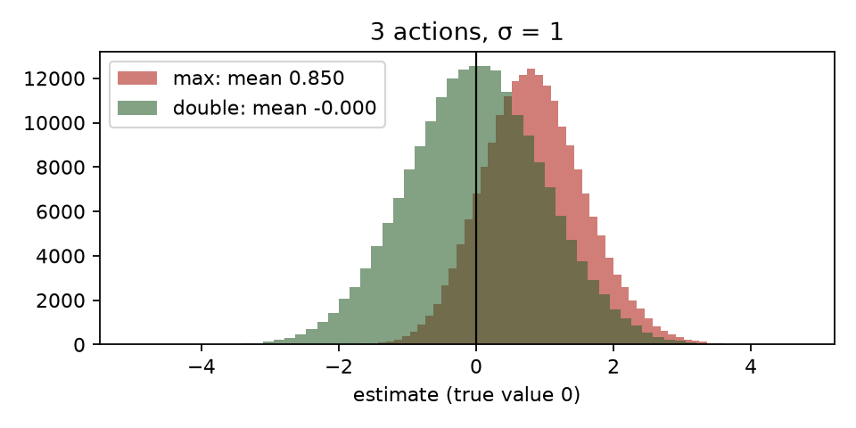
Maximisation bias vs the Double estimator (Monte Carlo).
Dueling heads (Wang et al., 2016) are available with --dueling. They split the head into $V(s)$ and $A(s,a)$, combined as $Q=V+A−\overset{‾}{A}$. This helps when many states have actions of nearly equal value, which in Snake is most of open space. Tryout 03 is a good place for the ablation.

5. A state that can see the body
Channel | Content | Why
0 | body recency: head $=1$, …, tail $=1/L$ | shape and direction of motion; which cells free up soonest
1 | head one-hot | makes the egocentric reference explicit
2 | food one-hot | the goal
3 | wall ring (padding = 1) | lets convolutions see the boundary as “body-like danger”
The network: Conv(4→32, 3×3) → Conv(32→64, 3×3, stride 2) → Conv(64→64, 3×3, stride 2), each followed by ReLU, so the 14×14 input shrinks to 7×7 and then 4×4. Then a dense layer from 1024 to 256 with ReLU, and a final dense layer to 3 Q-values.
- Parameters: 319,779, of which 82% sit in the 1024→256 dense layer.
- Receptive field: after three 3×3 convolutions with two of stride 2, each unit sees a 9×9 window. The dense layer then combines all 4×4 positions, so the Q-values depend on the whole board.
- Tied to board size: the dense layer fixes the input to 12×12. A board-size-agnostic variant would end with global pooling, which is a deliberate trade-off.
Ablation: --obs basic trains the same DQN on tryout 01’s 11 features with a 5 K-parameter MLP. If the thesis is right, it plateaus near 20, like the table. If the CNN clearly beats about 20, the improvement is attributable to the state, not to “deep RL”.

6. Vectorised environments on the GPU, and what the GPU is actually for
snake_rl/vec_env.py steps N games as tensors:
- The body is an age grid: each body cell stores how many ticks it remains occupied. Moving decrements every cell and writes the new head; eating skips the decrement.
- Food placement reproduces the scalar engine’s RNG bit for bit: mulberry32 in int64, with the “k-th free cell” found by a cumulative sum.
- tests/test_parity.py checks it step by step against the Python engine. That engine is in turn checked against traces from the JavaScript game.
Why bother? A small CNN at batch 1 is dominated by kernel-launch and synchronisation overhead on a GPU (tens of µs per call). The CPU often wins there. The GPU only pays off when each call carries enough work: many environments per step, and large training batches. The benchmark makes that concrete on this laptop.
model | device | threads | latency (µs, batch 1)
mlp 11→64→64→3 | cpu | 1 | 46.2
mlp 11→64→64→3 | cpu | 8 | 46.4
mlp 11→64→64→3 | cuda |  | 190.4
cnn 4x14x14 | cpu | 1 | 260.8
cnn 4x14x14 | cpu | 8 | 266.7
cnn 4x14x14 | cuda |  | 512.0
mlp 11→64→64→3 | onnxruntime-cpu | 1 | 15.4
cnn 4x14x14 | onnxruntime-cpu | 1 | 72.7

model | device | batch | ms/step | samples/s
mlp 11→64→64→3 | cpu | 64 | 1.174 | 54,511
mlp 11→64→64→3 | cpu | 256 | 1.281 | 199,871
mlp 11→64→64→3 | cpu | 1024 | 1.756 | 583,278
mlp 11→64→64→3 | cpu | 4096 | 3.181 | 1,287,848
mlp 11→64→64→3 | cuda | 64 | 2.124 | 30,135
mlp 11→64→64→3 | cuda | 256 | 1.977 | 129,504
mlp 11→64→64→3 | cuda | 1024 | 1.94 | 527,952
mlp 11→64→64→3 | cuda | 4096 | 1.945 | 2,106,432
cnn 4x14x14 | cpu | 64 | 8.852 | 7,230
cnn 4x14x14 | cpu | 256 | 27.327 | 9,368
cnn 4x14x14 | cpu | 1024 | 106.078 | 9,653
cnn 4x14x14 | cpu | 4096 | 413.872 | 9,897
cnn 4x14x14 | cuda | 64 | 2.859 | 22,385
cnn 4x14x14 | cuda | 256 | 6.175 | 41,454
cnn 4x14x14 | cuda | 1024 | 18.187 | 56,303
cnn 4x14x14 | cuda | 4096 | 64.046 | 63,954

env | device | n_envs | steps/s
scalar python | cpu | 1 | 321,114
torch vec (grid obs) | cpu | 1 | 824
torch vec (grid obs) | cpu | 64 | 31,062
torch vec (grid obs) | cpu | 256 | 58,426
torch vec (grid obs) | cpu | 1024 | 199,705
torch vec (grid obs) | cpu | 4096 | 187,602
torch vec (grid obs) | cuda | 1 | 144
torch vec (grid obs) | cuda | 64 | 8,312
torch vec (grid obs) | cuda | 256 | 44,468
torch vec (grid obs) | cuda | 1024 | 189,427
torch vec (grid obs) | cuda | 4096 | 747,672
How to read it.
- Compare the CUDA and CPU rows at batch 1 (the live game) and at batch 512–4096 (training).
- For the 5 K-parameter MLP, expect the CPU to win at small batches.
- For the CNN, expect CUDA to win from a few hundred samples per batch.
- Environment throughput on CUDA should grow almost linearly with N until the GPU saturates.

7. How the theory maps to the code
Theory | Code (python/train_dqn.py)
ε-greedy behaviour, ε 1 → 0.02 over 40% of steps | explore = torch.rand(n) < eps; act = torch.where(explore, random, greedy)
replay buffer (Lin, 1992) | Replay.add/sample, uint8 on the training device
target $y$ with frozen $\overset{‾}{θ}$ | target(o2), target.load_state_dict(net.state_dict()) every 1,000 updates
Double DQN | a2 = net(o2).argmax(1); q2 = target(o2).gather(1, a2)
terminal vs truncated | y = r + γ(1 − term)·q2; trunc is not stored as terminal
Huber loss (Mnih et al., 2015) | F.smooth_l1_loss(q, y), gradients clipped at norm 10
evaluation protocol | greedy on the same 500 test seeds as tryout 01; “best” chosen on 200 separate validation seeds

8. Results
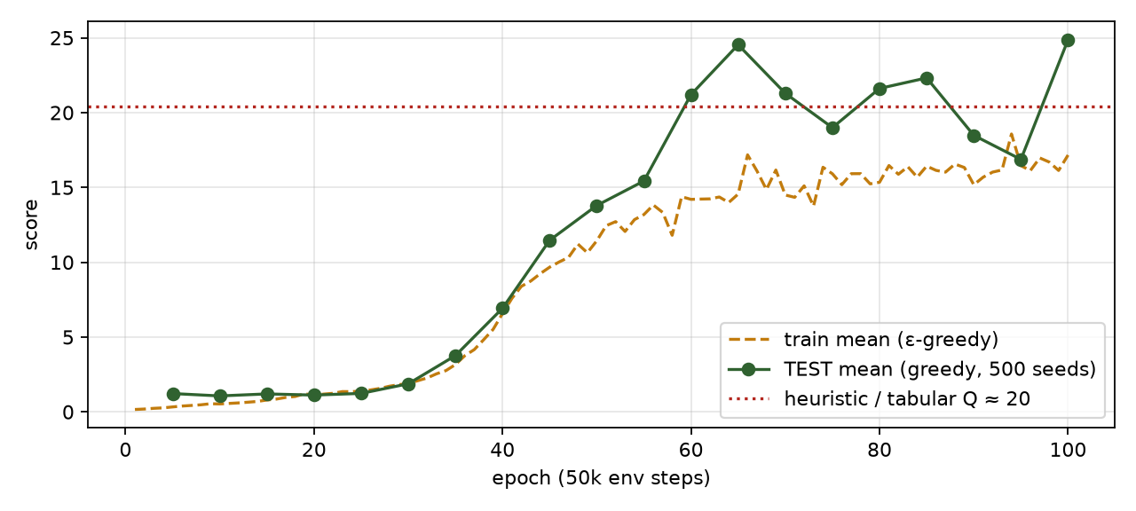
DQN learning curve on 12×12.
epoch | env steps | ε | train mean (max, wins) | TEST mean | median | p90 | max | wins | Δ test | val mean
5 | 0.25M | 0.8775 | 0.33 (4, 0) | 1.22 | 1 | 3 | 5 | 0 | – | 1.24
10 | 0.50M | 0.755 | 0.53 (3, 0) | 1.07 | 1 | 2 | 4 | 0 | -0.16 | 1.00
15 | 0.75M | 0.6325 | 0.79 (4, 0) | 1.20 | 1 | 2 | 4 | 0 | +0.13 | 1.19
20 | 1.00M | 0.51 | 1.11 (4, 0) | 1.12 | 1 | 2 | 5 | 0 | -0.08 | 1.05
25 | 1.25M | 0.3875 | 1.38 (4, 0) | 1.23 | 1 | 2 | 5 | 0 | +0.11 | 1.09
30 | 1.50M | 0.265 | 1.90 (5, 0) | 1.88 | 2 | 4 | 6 | 0 | +0.64 | 2.03
35 | 1.75M | 0.1425 | 3.16 (7, 0) | 3.76 | 4 | 6 | 10 | 0 | +1.88 | 3.71
40 | 2.00M | 0.02 | 6.57 (13, 0) | 6.92 | 8 | 11 | 14 | 0 | +3.16 | 7.23
45 | 2.25M | 0.02 | 9.67 (19, 0) | 11.47 | 12 | 16 | 22 | 0 | +4.54 | 11.13
50 | 2.50M | 0.02 | 11.43 (26, 0) | 13.79 | 15 | 22 | 28 | 0 | +2.33 | 13.80
55 | 2.75M | 0.02 | 13.18 (33, 0) | 15.43 | 15 | 28 | 40 | 0 | +1.64 | 15.48
60 | 3.00M | 0.02 | 14.20 (38, 0) | 21.21 | 22 | 34 | 43 | 0 | +5.78 | 20.86
65 | 3.25M | 0.02 | 14.56 (45, 0) | 24.54 | 26 | 37 | 45 | 0 | +3.33 | 24.58
70 | 3.50M | 0.02 | 14.49 (42, 0) | 21.29 | 20 | 37 | 49 | 0 | -3.25 | 23.07
75 | 3.75M | 0.02 | 15.91 (40, 0) | 19.00 | 17 | 36 | 43 | 0 | -2.29 | 19.33
80 | 4.00M | 0.02 | 15.35 (44, 0) | 21.62 | 22 | 39 | 46 | 0 | +2.62 | 20.84
85 | 4.25M | 0.02 | 16.42 (45, 0) | 22.32 | 24 | 36 | 46 | 0 | +0.70 | 22.75
90 | 4.50M | 0.02 | 15.18 (44, 0) | 18.48 | 18 | 34 | 43 | 0 | -3.84 | 20.65
95 | 4.75M | 0.02 | 16.46 (40, 0) | 16.87 | 16 | 33 | 44 | 0 | -1.61 | 16.62
100 | 5.00M | 0.02 | 17.16 (43, 0) | 24.87 | 25 | 37 | 47 | 0 | +8.00 | 23.41
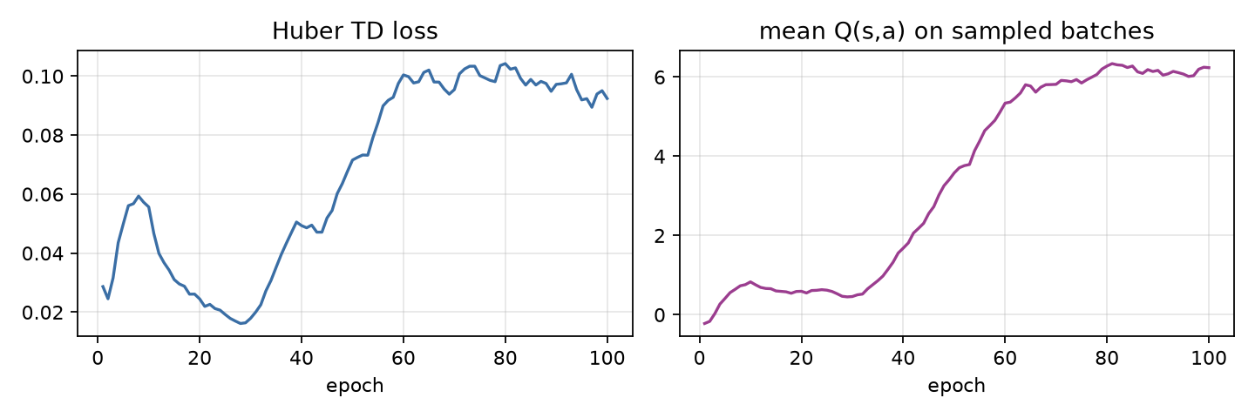
Training health: loss and predicted Q.
Analysis. The run shown above is the repaired setup trained for 5 M steps (dqn_cnn_12x12_long; the first, failed run is §8b). The four questions, in order:
- Does the CNN beat the tabular agent and the greedy heuristic (both about 20)? Marginally, and not reliably. The best checkpoint by validation score (epoch 65, validation 24.6) has test mean 24.5, median 26, p90 37, max 45. But the last eight checkpoints on the test seeds read 24.5, 21.3, 19.0, 21.6, 22.3, 18.5, 16.9, 24.9: mean 21.1, spread about ±2.7. The best-checkpoint number is a maximum over 20 noisy evaluations, so it is optimistic; the honest summary is “about 21, roughly level with tabular and the MLP (20.9)”, on one training seed. The spread between three seeds at 1 M steps (§8b: 14.3 to 18.2) is of the same size as the gap to 20.
- Did the cause of death shift away from self-collision? No, it grew. At the best checkpoint 443 of 500 games end by self-collision, 39 by wall and 18 by timeout; timeouts fell from 357 of 500 at 0.5 M steps to under 50. The agent stopped circling and walling itself in early but still traps itself once the body is long. Winning (filling all 144 cells) never happened; the best fill reached 33–36% of the board.
- Did Q-values blow up? No. The mean Q of the sampled action rose from about 0 to 6 by epoch 80 and then stayed flat at 6.0–6.3, while the Huber loss settled near 0.1. No sign of divergence or of the deadly triad at this scale. (Q is a discounted value, so it is not directly comparable to the food count.)
- Is the best checkpoint the last one? No. The best by validation is epoch 65 of 100; the final epoch 100 scored 24.9 on test but 23.4 on validation, and epochs 90 and 95 dipped to 18.5 and 16.9. With a constant learning rate and no target-network or learning-rate decay, the policy keeps wandering at roughly the same level between checkpoints. A learning-rate schedule, or averaging evaluations over several checkpoints, would make the late-training curve smoother; neither is implemented.

8b. The first CNN run failed: diagnosis, and reward shaping
The first 1 M-step run (CPU and, identically, CUDA) did not learn: mean food 0.15 → 0.9, loss ≈ 0.002, $Q≈0$, against about 20 for the tabular agent. A failed run is useful data, so it is kept here.

What the logs said
Evidence | Reading
CPU and CUDA runs show the same curve, 7 656 gradient updates in 1 M env steps | Not a device bug. Same algorithm, same failure.
Greedy evaluation: 500 of 500 games end by timeout | The greedy policy circles until the starvation limit. Circling is safe, and nothing in the reward punishes it.
7 656 updates ÷ 1 000 (--target-every) = 7 target-network syncs | Bootstrapping advanced about 7 steps of horizon in total. The $+1$ for food could not propagate back more than a few steps.
Same code, --obs basic (11-feature MLP): test mean 20.9 at epoch 10 | The replay, target network, Double-DQN and loss are correct. The problem is specific to the CNN-on-grid run.
CNN with 4× the updates (batch 128, 4 updates per step, target sync every 500) and 3-step returns: test mean 1.9 → 4.4 → 11.0 → 16.8, timeouts 265 → 52 of 500 | The main cause was too few optimiser steps and too few target syncs, not the observation.
So hypotheses 1 (too few updates) and 4 (target-network schedule) were confirmed, and 2 (the circling local optimum) was confirmed as the symptom. The weaker suspicion that the grid hides the heading (actions are relative turns and the grid has no direction plane) is not the main cause. It may still explain why the CNN lags the MLP.
Two implementation facts matter for any change to the reward. A starvation timeout is a truncation: the stored transition has disc = γᵏ, so it still bootstraps from the next state. Only a death or a win is a terminal and sets the bootstrap to 0. And the stored next state is the one before auto-reset.

Potential-based shaping
Define a potential on states, $Φ(s)=−k \frac{|x_{h}−x_{f}|+|y_{h}−y_{f}|}{2S}$ (Manhattan distance to the food, scaled so $Φ∈[−k,0]$), and add
$$F(s,s^{′})=γ Φ(s^{′})−Φ(s)$$
to the reward. A move toward the food gives $F>0$, a move away gives $F<0$. This is the “reward moving closer, hurt moving away” idea, in the one form that is safe.
Theorem (Ng, Harada & Russell, 1999). For any $Φ$, the shaped MDP has the same optimal policies as the original one. Sketch: along any trajectory $s_{0},s_{1},…,s_{T}$ the shaping terms telescope,
$$\sum_{t=0}^{T−1}{γ^{t}}F(s_{t},s_{t+1})=\sum_{t=0}^{T−1}{γ^{t}}\left(γΦ(s_{t+1})−Φ(s_{t})\right)=γ^{T}Φ(s_{T})−Φ(s_{0}).$$
Taking the expectation of the shaped return from $(s,a)$ gives $Q^{′}(s,a)=Q(s,a)−Φ(s)$, because $Φ(s_{0})$ does not depend on the action and $γ^{T}Φ(s_{T})→0$ (or is 0 by choice at a terminal). Subtracting a function of $s$ alone from every action’s value leaves the $arg\max_{a}$ unchanged. $◼$
The conditions that make the proof go through are exactly the implementation details:
- $Φ(\text{terminal})=0$ for death and for a win. Otherwise the telescoping leaves a $γ^{T}Φ(s_{T})$ that depends on where the snake died and biases the policy.
- After eating, $s^{′}$ contains the new food, so $Φ(s^{′})$ is measured to the new food. The snake is not rewarded for “arriving” at food that has just vanished.
- A timeout is not a terminal. $s^{′}$ is a real state, so $Φ(s^{′})$ is kept and bootstrapping continues.
- $γ$ in $F$ must be the training $γ$.
python/tests/test_env.py checks the telescoping identity on a real trajectory ($∑γ^{t}F=−Φ(s_{0})$ when the episode ends in death) and that the torch vec env and the scalar engine give the same shaped rewards.

Why the naive version is not safe
“+$c$ if closer, $−c$ if farther” is not of the form $γΦ(s^{′})−Φ(s)$, so none of the above applies. The sign of the reward depends only on the distance to the food, never on whether the move is wise:
- Bias. A long snake often must move away from the food to avoid sealing itself in. Naive shaping charges a fee for every such detour, so the optimum of the shaped problem is a more reckless snake than the true optimum. With $γΦ$ the same detour is repaid when the snake comes back, because the telescoped total is path-independent.
- Exploitable loops. A reward that depends on the sign of a distance change, with no discount-consistent offset, can pay differently on the approach and on the retreat of the same cycle (for example when the food moves or the path is asymmetric). The agent will find whichever cycle pays most.
- Scale. $±1$ per move would dominate the food reward ($+1$) over a ten-step approach. The runs below use $c=0.1$, which is already large next to the potential’s per-step change of about $k/(2S)=0.04$.

The timeout loophole is a different fix
Potential shaping preserves the optimal policy, so it cannot by itself remove an optimum that the original reward already allows: with a reward of 0 per step and $−1$ for death, circling forever has value 0 and is a legitimate local optimum. Closing that loophole means deliberately changing the task. The fourth arm adds a reward of $−1$ on a starvation timeout (--timeout-penalty 1). That is a change of problem, not a shaping term, and the notes keep the two ideas separate.

Ablation
Four arms on CUDA, same seed, 1 M env steps, CNN on the grid, the same repaired training setup (32 envs, batch 128, 4 updates per env step, target sync every 500 updates, 3-step returns, Double DQN). Only the reward differs. Test mean is over the 500 held-out seeds, for the checkpoint with the best validation score.
# | Reward | Test mean | Median | p90 | Max | Deaths (wall / self / timeout, of 500)
1 | baseline ($+1$ food, $−1$ death) | 16.83 | 18 | 29 | 36 | 112 / 336 / 52
2 | naive $±0.1$ per move | 12.99 | 14 | 19 | 24 | 48 / 397 / 55
3 | potential, $k=1$ | 11.63 | 13 | 19 | 26 | 56 / 351 / 93
4 | potential, $k=1$, timeout $−1$ | 12.26 | 14 | 20 | 25 | 73 / 329 / 98
Learning curves (test mean at epochs 5, 10, 15, 20, i.e. every 250 k steps):
# | 0.25 M | 0.50 M | 0.75 M | 1.0 M
1 baseline | 1.8 | 4.4 | 11.0 | 16.8
2 naive | 2.5 | 8.2 | 13.0 | 12.5
3 potential | 1.7 | 4.6 | 10.0 | 11.6
4 potential + timeout | 1.6 | 4.8 | 11.1 | 12.3
Reading, with the caveats up front. This is one seed per arm, and between-run spread in this kind of training is often several points, so differences of 1–4 points here are not established.
- Once the update schedule is repaired, shaping did not help within 1 M steps. The baseline is the best arm at the end.
- Naive shaping learned fastest early (8.2 at 0.5 M against 4.4), consistent with a denser signal, and then stalled and drifted down (13.0 → 12.5). Its deaths shifted from wall to self-collision (397 of 500), which fits the bias argument: the agent is paid to chase the food and does not plan around its own tail. One seed cannot prove that mechanism.
- Potential shaping did not speed up early learning in this run. The potential’s per-step reward ($≤0.04$) is small next to the noise in the Q-estimates at this stage, so its effect would show up later, if at all.
- The timeout penalty did not reduce timeouts (98 against 93 for arm 3). Timeouts were already falling in every arm as the policy improved (baseline: 265 → 52), so the loophole shrinks as a side effect of learning to eat, without the penalty.
- The larger lever by far was the update schedule, not the reward: the same reward went from a test mean under 1 to 16.8.
More seeds, baseline against potential only (same 1 M-step setup; test mean of the best checkpoint):
Seed | 1 baseline | 3 potential, $k=1$
0 | 16.83 | 11.63
1 | 18.23 | 12.16
2 | 14.30 | 11.37
mean | 16.45 | 11.72
The baseline is ahead in all three seeds (by 5.2, 6.1 and 2.9 points), and the ranges do not overlap (14.3 to 18.2 against 11.4 to 12.2). Three seeds is still modest evidence, but it supports the reading that, here, potential shaping with $k=1$ slowed learning within 1 M steps instead of speeding it up. That does not contradict the theory: shaping keeps the optimum, it does not promise faster learning, and a poorly scaled $Φ$ adds noise to the targets.
Not run: other values of $k$, annealing $k→0$ (--shape-anneal is implemented), shaping on the 5 M-step run, and the naive and timeout arms on more seeds (those two rest on a single seed).

9. Watch it play
The replays below are re-simulated by the game engine from the seed and the recorded actions, so they are exact. The bars show the network’s Q-values at every step.
[Interactive figure “replay”: open the HTML version of this note.]
To run the network live in the game, export it first with run.ps1 export. Then open game/index.html, go to Models → Choose file, and pick models/dqn_cnn_12x12_best.json.

10. Failure modes to watch for
- Divergence. Q-values grow without bound and the loss spikes after a target sync. Remedies: lower the learning rate, sync the target less often, use Huber loss, clip gradients.
- Catastrophic forgetting. Once the agent is good, the buffer fills with long late-game episodes and early-game skills decay. Watch for test scores that rise and then fall.
- Looping. A cautious agent circles forever. Timeouts cut this off as truncation, which is correct, but a high timeout rate means the agent is valuing safety over food. Reward shaping or a smaller γ can trade this off.
- Overfitting to seeds. Training uses millions of distinct food sequences, so this is unlikely. That is still why test and validation seeds are disjoint.

Self-check
Self-check. Why does DQN compute the TD target with a separate, periodically copied network?
- To halve GPU memory
- So the regression target does not move with every gradient step, which stabilises bootstrapping with function approximation
- Because the online network cannot evaluate s’
Answer: (b). With function approximation a single update changes Q everywhere, including at s’. A frozen target turns each sync interval into an ordinary regression problem (fitted Q-iteration).
Self-check. Each Q estimate for 3 actions has zero-mean noise. Why is r + γ·max Q(s’,·) biased upward?
- Because γ < 1
- E[max of noisy estimates] ≥ max of their means (Jensen), and bootstrapping propagates the excess
- Because rewards are positive
Answer: (b). The max preferentially picks whichever estimate got lucky. Double DQN selects with one network and evaluates with the other, so the selection’s luck is not reused in the evaluation.
Self-check. On a GTX 1650 Ti, which is most likely faster for choosing ONE action with a 5 K-parameter MLP?
- CPU (PyTorch with 1 thread, or ONNX Runtime)
- CUDA, because GPUs are always faster for neural networks
- It makes no difference
Answer: (a). At batch 1 the work is a few thousand multiply-adds. GPU time is dominated by kernel launches, synchronisation and host-device copies, so the CPU finishes before the GPU has started. The benchmark in §6 measures this on your laptop.

References
- Baird, L. (1995). Residual algorithms: reinforcement learning with function approximation. ICML.
- Hessel, M., et al. (2018). Rainbow: combining improvements in deep reinforcement learning. AAAI.
- Lin, L.-J. (1992). Self-improving reactive agents based on reinforcement learning, planning and teaching. Machine Learning, 8.
- Mnih, V., et al. (2013). Playing Atari with deep reinforcement learning. arXiv:1312.5602.
- Mnih, V., et al. (2015). Human-level control through deep reinforcement learning. Nature, 518, 529–533.
- Riedmiller, M. (2005). Neural fitted Q iteration. ECML.
- Schaul, T., Quan, J., Antonoglou, I., & Silver, D. (2016). Prioritized experience replay. ICLR.
- Sutton, R. S., & Barto, A. G. (2018). Reinforcement Learning: An Introduction (2nd ed.), §9.3, §11.3. MIT Press.
- Tsitsiklis, J. N., & Van Roy, B. (1997). An analysis of temporal-difference learning with function approximation. IEEE Transactions on Automatic Control, 42(5).
- van Hasselt, H. (2010). Double Q-learning. NeurIPS.
- van Hasselt, H., Guez, A., & Silver, D. (2016). Deep reinforcement learning with double Q-learning. AAAI.
- Wang, Z., Schaul, T., Hessel, M., van Hasselt, H., Lanctot, M., & de Freitas, N. (2016). Dueling network architectures for deep reinforcement learning. ICML.

03 · Upgrading the DQN: Double, dueling, prioritized replay, action masking

Summary
Tryout 02’s CNN agent plateaued at a test mean of about 21 (best checkpoint 24.5) on 12×12. About 88% of its deaths were self-collisions: the snake coils itself into a dead end. This tryout adds, one at a time and then all together, four well-known upgrades to the same agent and measures each on the same 500 held-out seeds, with several training seeds per arm:
Idea | One line | Paper
Double DQN | choose the next action with the online net, score it with the target net | van Hasselt et al. 2016
Dueling head | $Q=V+(A−\overset{‾}{A})$: learn “how good is this state” separately from “which action is better” | Wang et al. 2016
Prioritized replay | replay surprising transitions more often, correct the bias with importance weights | Schaul et al. 2016
Action masking | never choose (or bootstrap through) a move that kills the snake on the next tick | Huang & Ontañón 2020
The baseline already has Double DQN and 3-step returns on (§8b of tryout 02 explains why), so “+Double” is the baseline itself.
item | value
model | t03_long_full: 582,436 params
device | cuda:0 NVIDIA GeForce GTX 1650 Ti, 4.0 GiB, sm_75, torch 2.14.1+cu130 (CUDA 13.0)
components | Double DQN + dueling + prioritized replay + action masking, 3-step returns
training | 5.0 M env steps, 219 min
last checkpoint (test) | mean 19.37, median 20, max 45
best by validation | epoch 100: test mean 19.37, max 45, deaths {‘wall’: 21, ‘self’: 414, ‘timeout’: 65}

1. What limits the tryout-02 agent?
Look at how it dies. In the best checkpoint 443 of 500 games end by self-collision, 39 by hitting a wall, 18 by starvation. Two quite different failure types hide under “self”:
- Instant mistakes: the agent turns into its own body when a safe move existed. A 1-step lookahead would have prevented it.
- Traps: every move is safe right now, but the snake has already coiled itself into a region it cannot leave. Only planning many steps ahead prevents this.
Action masking can only fix type 1. The other three upgrades improve how well the value function is learned, which is what type 2 needs. Measuring the two types apart is part of the analysis in §8.

2. Double DQN: the max operator is biased upward
Q-learning’s target is $y=r+γ\max_{a^{′}}Q(s^{′},a^{′})$. Suppose the estimates are $Q(s^{′},a^{′})=q^{*}(a^{′})+ϵ_{a^{′}}$ with zero-mean noise $ϵ$. Then
$$E\left[\max_{a^{′}}\left(q^{*}(a^{′})+ϵ_{a^{′}}\right)\right] ≥ \max_{a^{′}}E\left[q^{*}(a^{′})+ϵ_{a^{′}}\right]=\max_{a^{′}}q^{*}(a^{′})$$
by Jensen’s inequality ($max$ is convex). The same noisy estimate is used to pick the action and to score it, so a lucky overestimate is selected precisely because it is lucky. The bias is positive, and bootstrapping feeds it back into the next target.
Double DQN separates selection from evaluation:
$$y=r+γ Q_{θ^{−}}​\left(s^{′}, arg\max_{a^{′}}Q_{θ}(s^{′},a^{′})\right).$$
If the two networks’ errors are independent, the selected action’s score has zero-mean error again. The cost is one extra forward pass. With only 3 actions the bias is small (the expected maximum of $m$ i.i.d. noise terms grows slowly with $m$), which is why this tryout does not expect a large gain from it on Snake.

3. Dueling: $Q=V+A$ is not identifiable
Write $Q(s,a)=V(s)+A(s,a)$ with the advantage $A(s,a)=Q(s,a)−V(s)$. A network that outputs a scalar $V$ and a vector $A$ and simply adds them has a degeneracy: $(V+c, A−c)$ gives the same $Q$ for any constant $c(s)$, so $V$ and $A$ are not determined by $Q$. The fix (Wang et al.) forces a convention:
Q(s,a)=V(s)+A(s,a)−1|A|a′​A(s,a′).
The centred advantages sum to zero, so V(s)=1|A|a​Q(s,a) is now the mean of the action values and the split is unique. (The paper’s first form subtracts $\max_{a}A$ instead, which makes $V=\max_{a}Q$; the mean version is smoother in practice.)
Why it can help: in most Snake positions the three moves have almost the same value (nothing is near the head), and what matters is the state: is the snake in an open area or squeezed? A plain Q-head has to learn this separately for each of the three outputs, and each update only touches the output of the action taken. In the dueling head every update moves $V$, shared by all three actions. The price is a bigger head: here 582 k parameters against 320 k, because the value and advantage streams each get their own 256-unit dense layer.

4. Prioritized experience replay
Uniform replay wastes updates on transitions the network already predicts well. Prioritized replay samples transition $i$ with probability
P(i)=piαk​pkα, pi=|δi|+ε,
where $δ_{i}$ is its latest TD error (here the 3-step TD error) and $α∈[0,1]$ interpolates between uniform ($α=0$) and greedy-by-error ($α=1$). New transitions get the current maximum priority so each is replayed at least once.
The bias and its correction. Sampling non-uniformly changes the distribution the gradient is averaged over, so the update no longer follows the gradient of the intended loss. Importance sampling restores it. With weights
$$w_{i}=(1/{N⋅P(i)})^{β}, \text{normalised by }\max_{j}w_{j}\text{ for stability},$$
the expected update is i​P(i) wi gi∝i​P(i) 1(NP(i))β gi, which for $β=1$ equals 1Ni​gi, the uniform-replay gradient. Because the correction matters most near convergence, $β$ is annealed from $β_{0}=0.4$ to $1$ over training; with $β<1$ it is a partial correction that trades some bias for lower variance.
On a GPU. The original uses a sum-tree for $O(logN)$ sampling. Here the 200 k priorities live in a tensor and torch.multinomial samples a whole batch at once. A sampling step costs about 1.2 ms against 0.3 ms for uniform, which is 2 ms on a ~10 ms update (measured in python/train_dqn.py, §7).

5. Action masking
Let $A_{\text{safe}}(s)⊆A$ be the moves that do not hit a wall or body segment on the next tick (the engine already computes this: it is the “danger” part of the 11 features). Masking restricts the policy to $A_{\text{safe}}(s)$ wherever it is non-empty:
- Acting: greedy picks $arg\max_{a∈A_{\text{safe}}}Q$; exploration draws uniformly from $A_{\text{safe}}$.
- Targets: the bootstrap uses $\max_{a^{′}∈A_{\text{safe}}(s^{′})}Q(s^{′},a^{′})$ (and the same restriction for Double DQN’s argmax).
- Evaluation and the game: the exported model carries mask: true, and the game applies the same rule.
Does it change the optimal policy? No, and the argument is short. An instant-death move yields reward $−1$ and ends the episode, so its value is exactly $−1$. Any move that survives has value at least $−γ$ (the worst case is dying on the next step, which is discounted), and $−γ>−1$. So whenever a safe move exists, the optimal policy of the original MDP already prefers it, and masking only removes moves the optimal policy never takes. What it changes is learning, not the optimum: the network no longer has to discover “do not turn into the body”, exploration is not wasted on suicide, and Q-estimates are not dragged down by transitions the agent would never choose. (When every move kills, the mask is lifted, since the game is lost anyway.)
Masking against learned avoidance. A learned policy has to spend capacity and samples on a rule the engine already knows, and it can still slip up. A mask gives a guarantee for free but needs access to the simulator’s rule at decision time, so the deployed agent is the network plus the mask. That is why the game applies the mask for models that declare it.
Two honest limits. A mask is a 1-step lookahead: it cannot prevent traps (§1, type 2). And in a task where the safety rule is not known in advance, masking is not available at all.

6. How each piece maps to the code
Piece | Where | Flag
Double DQN target | td_loss in python/train_dqn.py | on by default, --no-double to turn it off
Dueling head | QNet(dueling=True) in python/snake_rl/nets.py; the JS op dueling in the game | --dueling
Prioritized replay | Replay(per=True): priorities, multinomial sampling, IS weights, update_priorities | --per --per-alpha 0.6 --per-beta0 0.4
Action masking | TorchSnakeVecEnv.danger(), safe_moves, NStep carries the mask of the bootstrap state | --mask

7. Setup
All arms: CNN on the 4×14×14 board image, 12×12, 3-step returns, batch 128 with 4 gradient steps per vector step, target sync every 500 updates, Adam 2.5e-4, ε decays over the first 40% of training, 1 M env steps, seeds 0–2, greedy evaluation on 500 held-out seeds (validation on 200 other seeds picks the checkpoint). The baseline arm is tryout 02’s repaired DQN. The final arm combines everything and is then trained for 5 M steps.

8. Results
arm | seeds | test mean per seed | mean ± sd | max | deaths wall / self / timeout (mean per 500)
baseline (Double, 3-step) | 3 | 16.8, 18.2, 14.3 | 16.5 ± 2.0 | 36 | 96 / 363 / 42
+ dueling | 3 | 11.1, 13.0, 11.3 | 11.8 ± 1.1 | 25 | 35 / 382 / 83
+ dueling + PER | 3 | 7.4, 7.8, 7.1 | 7.5 ± 0.4 | 18 | 44 / 302 / 154
+ masking only | 3 | 15.2, 14.0, 14.2 | 14.5 ± 0.7 | 38 | 9 / 336 / 155
+ dueling + PER + masking | 3 | 13.5, 11.2, 11.5 | 12.1 ± 1.2 | 35 | 12 / 306 / 181
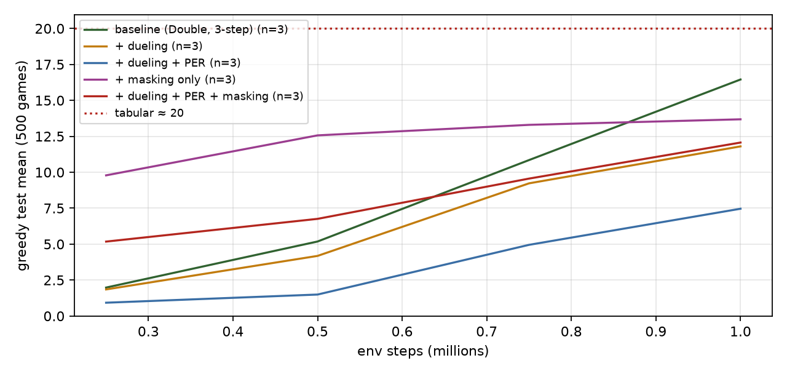
Ablation: mean test score over seeds at each checkpoint.
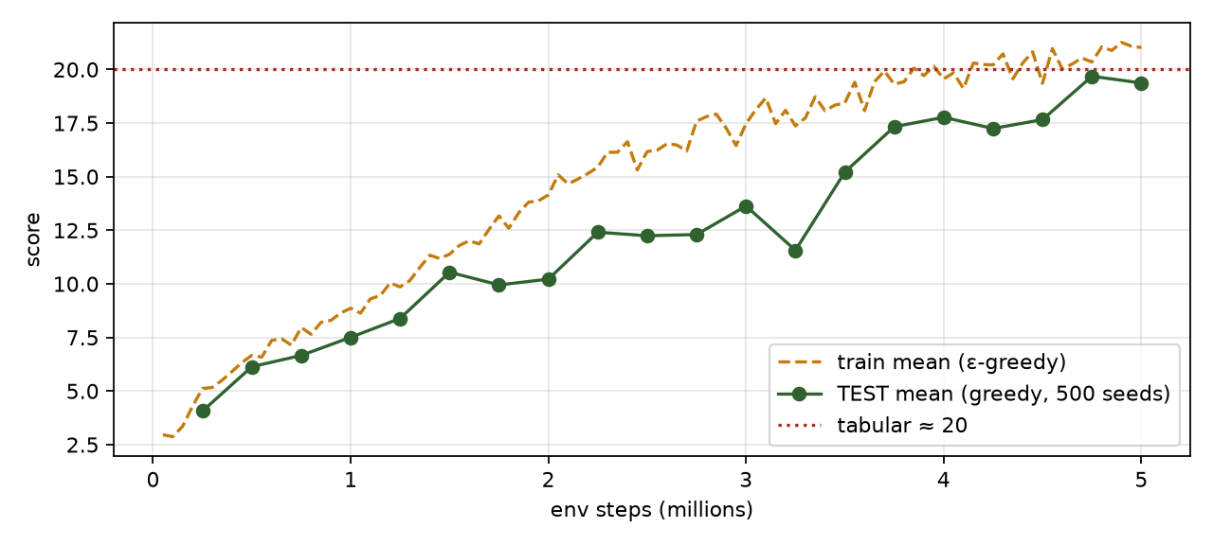
Long run of the full combination.
Analysis. Three training seeds per arm, 1 M steps each, everything else identical (CNN on the board image, 3-step returns, Double DQN, 32 envs, batch 128, 4 updates per step).
Arm | Seeds (test mean) | Mean ± sd | Deaths wall / self / timeout
baseline | 16.8, 18.2, 14.3 | 16.5 ± 2.0 | 96 / 363 / 42
+ dueling | 11.1, 13.0, 11.3 | 11.8 ± 1.1 | 35 / 382 / 83
+ dueling + PER | 7.4, 7.8, 7.1 | 7.5 ± 0.4 | 44 / 302 / 154
+ masking only | 15.2, 14.0, 14.2 | 14.5 ± 0.7 | 9 / 336 / 155
+ dueling + PER + masking | 13.5, 11.2, 11.5 | 12.1 ± 1.2 | 12 / 306 / 181
- No upgrade beat the baseline, and the ordering is the same in every seed. The ranges of the baseline (14.3–18.2) and of each other arm do not overlap except for masking alone (14.0–15.2), which sits at the bottom of the baseline’s range. The honest reading is: at these hyperparameters and this training budget, none of the four additions helps, and dueling and PER hurt clearly.
- Dueling lost about a third of the score (11.8 against 16.5). The dueling network has 582 k parameters against 320 k (two dense streams instead of one), and in a run limited to 1 M steps the extra capacity has to be trained before it pays off. The argument for dueling (a shared state value learned from every update) matters when many actions are close in value; with three actions, most of which are close in value in most positions, the saving is small and the cost is a slower head.
- Prioritized replay lost another third (7.5 on top of dueling). The most likely contributors are the untuned defaults used here ($lpha = 0.6$, $eta_0 = 0.4$ annealed to 1, new transitions at maximum priority, sampling with replacement) and the 3-step TD errors, which are noisy priorities in a game where most transitions have reward 0. It is also a lot more machinery in a training loop that was only just repaired (tryout 02, §8b). This tryout did not tune any of it, so it cannot say PER cannot help here, only that it did not at the defaults.
- Masking changed how the agent fails, not whether it does. Wall deaths fall from 96 to 9 of 500 (the mask removes them), but timeouts rise from 42 to 155. With no instant deaths to be punished for, a greedy policy that is unsure circles until the starvation limit, which costs nothing. Self-collisions barely move (363 → 336), which is the point of §1: they are mostly slow traps, and a one-step mask cannot see those.
- At 5 M steps the picture is the same. The combined agent (DQN+) reaches a best-checkpoint test mean of 19.4 (one seed); tryout 02’s plain CNN, trained with the same recipe for the same 5 M steps, reached 24.5. One seed each, so only the direction is meaningful.
- Why this is still a useful result. Each upgrade is a published improvement on its own benchmark, and none of them transferred automatically to this problem. Reporting that, with the seeds, is more informative than a table where everything helps. The next experiments to run, not done here, are: tuning $lpha$ and the learning rate for PER, a wider (not deeper) plain head to separate “dueling” from “more parameters”, and a longer training budget.

9. Interactive: priorities, sampling probabilities, importance weights
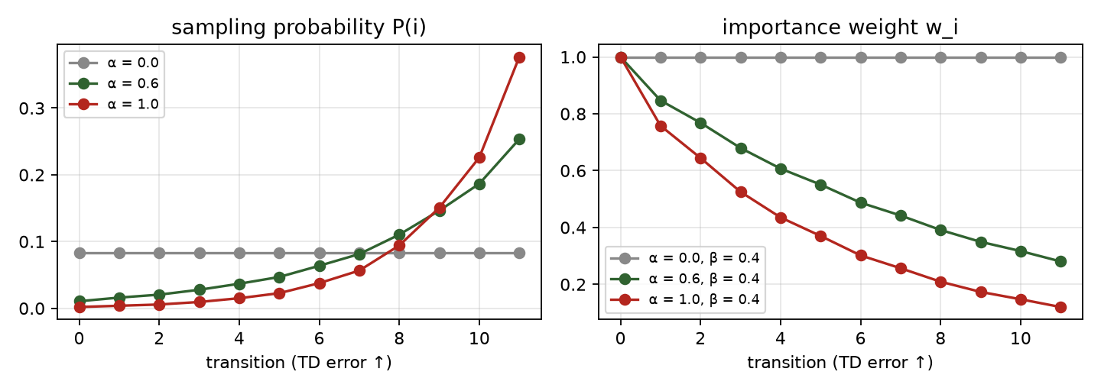
Prioritized replay: larger TD errors are sampled more often and weighted less.

10. Failure modes to watch for
- PER on a tiny buffer or with $α→1$ concentrates on a few high-error transitions (often noisy ones) and starves the rest.
- A mask that disagrees with the engine silently trains the wrong policy. The mask must come from the same rule as step; tests/test_env.py checks the vec env against the scalar engine.
- Masking changes the policy the game must run. An exported masked network played without the mask can walk into walls, which is why mask is part of the model file.
- Comparing arms with one seed. Seed-to-seed spread in these runs is several points; only differences that survive across seeds count.

Self-check
Self-check. In prioritized replay with $β=1$, why does the expected update equal the uniform-replay gradient?
- Because the priorities are normalised
- Each sample is sampled with probability $P(i)$ and weighted by $1/(NP(i))$, so i​P(i)⋅1NP(i) gi=1Ni​gi
- Because the TD errors average to zero
Answer: (b). Importance weights are exactly the ratio of the target distribution (uniform, $1/N$) to the sampling distribution $P(i)$.
Self-check. Why does action masking not change the optimal policy of the Snake MDP, as long as a safe move exists?
- Because dying is rare
- An instant-death move has value $−1$, any surviving move has value at least $−γ>−1$, so the optimum never picks the former
- Because the mask is learned
Answer: (b). The mask removes only actions that are strictly worse than some alternative, so the argmax is unchanged. It still changes how fast and how well the network learns.

References
- Huang, S., & Ontañón, S. (2020). A closer look at invalid action masking in policy gradient algorithms. arXiv:2006.14171.
- Schaul, T., Quan, J., Antonoglou, I., & Silver, D. (2016). Prioritized experience replay. ICLR.
- van Hasselt, H., Guez, A., & Silver, D. (2016). Deep reinforcement learning with double Q-learning. AAAI.
- Wang, Z., Schaul, T., Hessel, M., van Hasselt, H., Lanctot, M., & de Freitas, N. (2016). Dueling network architectures for deep reinforcement learning. ICML.
- Hessel, M., et al. (2018). Rainbow: combining improvements in deep reinforcement learning. AAAI.

04 · Policy gradients and PPO on Snake (batched environments on the GPU)

Summary
Tryouts 01–03 learned a value function $Q(s,a)$ and acted greedily on it. This tryout learns the policy $π_{θ}(a∣s)$ directly, together with a value function that is used only to reduce variance (an actor-critic). The algorithm is PPO (Schulman et al. 2017) with the usual implementation details: a shared CNN trunk, generalized advantage estimation, the clipped surrogate objective, value-loss clipping, an entropy bonus, advantage normalisation and orthogonal initialisation. An optional arm adds invalid-action masking (Huang & Ontañón 2020).
PPO is on-policy: it learns from the data its current policy just produced and then discards it. That needs a lot of data and little reuse, which is the opposite of DQN’s replay buffer, and it is exactly what a batched GPU environment is good at.
item | value
model | t04_ppo_mask_s1: 582,436 params (shared CNN trunk)
device | cuda:0 NVIDIA GeForce GTX 1650 Ti, 4.0 GiB, sm_75, torch 2.14.1+cu130 (CUDA 13.0)
setup | 256 envs × 64 steps = 16,384 per update, 4 epochs × 8 minibatches, lr 0.00025, γ 0.99, λ 0.95, clip 0.2, entropy 0.01, action masking
training | 9.5 M env steps in 48 min
last checkpoint (test) | mean 26.33, median 30, max 50
best by validation | epoch 16: test mean 26.33, max 50, deaths {‘wall’: 23, ‘self’: 379, ‘timeout’: 98}

1. The policy gradient theorem
Let the return of a trajectory $τ=(s_{0},a_{0},r_{0},s_{1},…)$ be G(τ)=t​γtrt and the objective $J(θ)=E_{τ∼π_{θ}}[G(τ)]$. The probability of a trajectory factorises into environment terms, which do not depend on $θ$, and policy terms:
pθ(τ)=p(s0)t​πθ(at∣st) p(st+1∣st,at).
Use the log-derivative trick $∇_{θ}p=p ∇_{θ}logp$:
∇θJ=∫∇θpθ(τ) G(τ) dτ=EτG(τ) ∇θlogpθ(τ)=EτG(τ)t​∇θlogπθ(at∣st).
The environment’s dynamics have vanished: the gradient can be estimated from sampled games, without knowing the transition model. Because an action at time $t$ cannot affect rewards before $t$, each term can use only the reward-to-go Gt=k≥t​γk−trk:
∇θJ=Et​∇θlogπθ(at∣st) Gt. (policy gradient theorem)
REINFORCE is the Monte-Carlo estimate of this: play episodes, then step $θ$ along t​Gt∇logπ(at|st). It is unbiased and slow, because $G_{t}$ is a sum of many random rewards: in Snake, one lucky meal early changes the return of every later step, and the gradient is dominated by noise.

2. Baselines and the advantage
Subtract anything that does not depend on the action. For any function $b(s)$,
Ea∼πb(s) ∇θlogπθ(a∣s)=b(s)a​∇θπθ(a∣s)=b(s) ∇θa​πθ(a∣s)⏟=1=0,
so replacing $G_{t}$ with $G_{t}−b(s_{t})$ leaves the expected gradient unchanged while it can shrink the variance a lot. The natural baseline is the value function $V^{π}(s)$, giving the advantage $A^{π}(s,a)=Q^{π}(s,a)−V^{π}(s)$: how much better this action is than the policy’s average action in this state. Actions with a positive advantage get more probable, negative ones less.

3. Actor-critic and generalized advantage estimation
We do not know $V^{π}$, so a second head of the network, the critic $V_{ϕ}(s)$, learns it by regression. Using the critic to bootstrap gives a family of advantage estimators with the TD residual $δ_{t}=r_{t}+γV(s_{t+1})−V(s_{t})$:
At(1)=δt (low variance, biased by critic errors), At(∞)=l≥0​γlδt+l=Gt−V(st) (unbiased, high variance).
GAE (Schulman et al. 2016) takes an exponentially weighted mixture of the $k$-step estimators, controlled by $λ∈[0,1]$:
$${\hat{A}}_{t}^{\text{GAE}(γ,λ)}=\sum_{l=0}^{∞}{(}γλ)^{l} δ_{t+l}.$$
Derivation. The $k$-step advantage is ${\hat{A}}_{t}^{(k)}=\sum_{l=0}^{k−1}{γ^{l}}δ_{t+l}$ (the sum telescopes the value terms: ${\hat{A}}_{t}^{(k)}=−V(s_{t})+r_{t}+γr_{t+1}+…+γ^{k}V(s_{t+k})$). Weight ${\hat{A}}^{(k)}$ by $(1−λ)λ^{k−1}$:
(1−λ)k≥1​λk−1l=0k−1γlδt+l=(1−λ)l≥0​γlδt+lk≥l+1​λk−1=l≥0​(γλ)l δt+l.
$λ=0$ gives the one-step TD residual, $λ=1$ gives the Monte-Carlo advantage. $λ≈0.95$ is the usual compromise. In code it is a backwards recursion over the rollout, ${\hat{A}}_{t}=δ_{t}+γλ(1−d_{t}){\hat{A}}_{t+1}$, where $d_{t}$ marks the end of an episode.
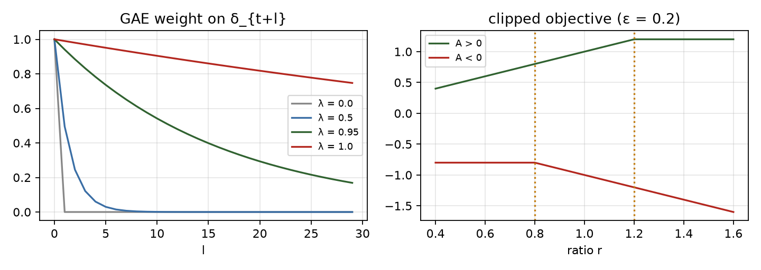
Left: GAE weights for several λ. Right: PPO’s clipped surrogate.
Timeouts are not terminals. Snake ends an episode by starvation after $100⋅$length moves without food. That is an artefact of the time limit, not a property of the state, so the value of the state after a timeout is not zero. The code folds $γV(s^{′})$ into the last reward for a truncated step and then cuts the GAE trace, which is the same truncation-versus-termination rule used for DQN in tryout 02. Only deaths and wins bootstrap from zero.

4. From TRPO to PPO: why clip?
A policy-gradient step is only trustworthy near the policy that collected the data. Reusing a batch for several gradient steps pushes $π_{θ}$ away from $π_{θ_{\text{old}}}$, and the estimated gradient stops being valid. The surrogate objective with an importance ratio $r_{t}(θ)=π_{θ}(a_{t}|s_{t})/π_{θ_{\text{old}}}(a_{t}|s_{t})$,
$$L^{\text{PG}}(θ)=E_{t}\left[r_{t}(θ) {\hat{A}}_{t}\right],$$
is correct to first order at $θ=θ_{\text{old}}$ but unbounded away from it. TRPO (Schulman et al. 2015) maximises it subject to a trust-region constraint $E[KL(π_{\text{old}}∥π_{θ})]≤δ$, which needs a second-order (conjugate-gradient) step. PPO gets a similar effect with a first-order objective by clipping the ratio:
$$L^{\text{CLIP}}(θ)=E_{t}\left[min\left(r_{t}{\hat{A}}_{t}, clip(r_{t}, 1−ϵ, 1+ϵ) {\hat{A}}_{t}\right)\right].$$
Reading the $min$: for ${\hat{A}}_{t}>0$ the objective rises with $r_{t}$ only until $r_{t}=1+ϵ$, after which the gradient is zero, so there is no incentive to make a good action much more likely than it was. For ${\hat{A}}_{t}<0$ it stops at $r_{t}=1−ϵ$. The pessimistic $min$ keeps the unclipped term when it is worse, so a policy that has moved the wrong way is still pushed back.
The clip is a heuristic, not a guarantee: a single step can still overshoot $1±ϵ$, and what keeps the update safe in practice is the small number of epochs and the small learning rate. The code logs the approximate KL and the fraction of clipped samples to watch this.

5. The full loss and the implementation details
$$L(θ,ϕ)=−L^{\text{CLIP}}+c_{v} L^{V}−c_{e} H[π_{θ}].$$
Part | What it does | Setting
Clipped surrogate | trust-region-like step | $ϵ=0.2$​
Value loss $L^{V}$ | critic regression to ${\hat{R}}_{t}={\hat{A}}_{t}+V_{\text{old}}(s_{t})$, with the new value clipped to $V_{\text{old}}±ϵ$ and the larger of the two squared errors used | $c_{v}=0.5$​
Entropy bonus $H$ | keeps the policy stochastic, so it keeps exploring | $c_{e}=0.01$​
Advantage normalisation | per-minibatch zero mean, unit variance, so the policy-gradient scale does not depend on the reward scale | on
Orthogonal init | gain $\sqrt{2}$ in the trunk, $0.01$ on the policy output (the first policy is almost uniform), $1$ on the value output | on
Learning rate | Adam, $2.5⋅{10}^{−4}$, decayed linearly to 0
Gradient clip | global norm 0.5
Rollouts | 256 envs × 64 steps = 16 384 transitions per update, 4 epochs over 8 minibatches

6. Invalid-action masking
Snake has a rule the agent can read from the board: some moves kill at once. With masking, the logits of those moves are set to $−∞$ before the softmax, so they have probability exactly 0:
$$π_{θ}(a∣s)=softmax(z(s)+m(s))_{a}, m_{a}=0\text{ if safe}, −∞\text{ otherwise}.$$
Two consequences matter. The gradient of a masked action’s logit is zero, because its probability does not depend on it: the network is never pushed to “unlearn” a move that is not in the distribution. This is the point of Huang & Ontañón’s analysis, which shows that masking is a valid policy gradient on the restricted action set, whereas penalising invalid actions with a negative reward leaves the network wasting probability on them. And the entropy is computed over the valid moves only. The mask must be identical in the rollout (when sampling) and in the update (when recomputing $logπ$): the code stores it with each transition. If every move kills, the mask is lifted.

7. On-policy versus off-policy, and why PPO fits this machine
 | DQN (off-policy) | PPO (on-policy)
Learns from | a replay buffer of old transitions from any past policy | the last rollout, from the current policy only
Data reuse | each transition is replayed many times | 4 epochs, then discarded
Sample efficiency | higher | lower
Needs | a Q-function; a target network; replay | many parallel environments for a decorrelated, big batch
Cost per env step on this machine | one gradient step per ~8 env steps, 3 forward passes each | one forward pass; the 4 epochs of updates are amortised over 16 k steps
The batched torch environment steps hundreds of thousands of games per second on the GPU, so data is nearly free and the update is the cost. That reverses the usual situation, in which the simulator is the bottleneck and sample efficiency matters most. On this machine PPO’s lower sample efficiency is paid for by its higher throughput: one job runs about 7 000 env steps/s against about 900 for the DQN.

8. Throughput lesson: how many jobs should share one small GPU?
The obvious bottleneck for several training jobs on a 4 GB GPU looks like VRAM. It is not. Each job here holds only a few hundred MB, but a GTX 1650 Ti has few multiprocessors and the CPU cores that launch its kernels are shared, so compute saturates long before memory does, and past that point extra jobs slow each other down. The sensible way to schedule them is to measure: run $k=1,2,3,…$ identical jobs, record the aggregate steps/s, GPU utilisation, memory and CPU load, and stop adding jobs when the aggregate stops rising.
family | jobs | steps/s per job | aggregate steps/s | speed-up | GPU util % | CPU util % | GPU memory in use (MB)
PPO | 1 | 6,976 | 6,976 | 1.00× | 79 | 30 | 2161
PPO | 2 | 3,440 / 3,458 | 6,898 | 0.99× | 99 | 23 | 2640
PPO | 3 | 2,410 / 2,414 / 2,445 | 7,268 | 1.04× | 100 | 25 | 3021
DQN | 1 | 892 | 892 | 1.00× | 48 | 28 | 2161
DQN | 2 | 754 / 772 | 1,527 | 1.71× | 98 | 30 | 2601
DQN | 3 | 518 / 494 / 507 | 1,518 | 1.70× | 99 | 31 | 3038
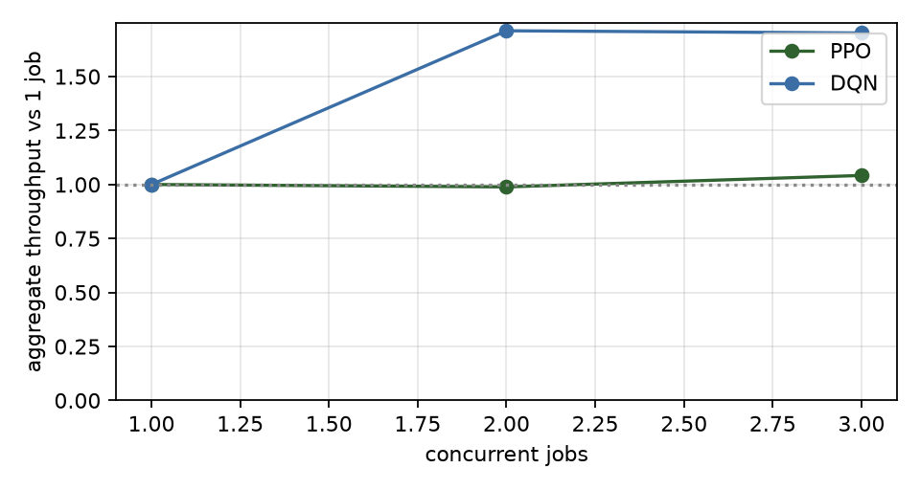
Aggregate throughput against the number of concurrent jobs.

9. Results
arm | seeds | test mean per seed | mean ± sd | max | deaths wall / self / timeout (mean per 500)
PPO | 3 | 21.4, 18.7, 7.9 | 16.0 ± 7.1 | 49 | 8 / 204 / 289
PPO + action masking | 3 | 26.5, 26.3, 25.7 | 26.2 ± 0.4 | 51 | 20 / 404 / 76
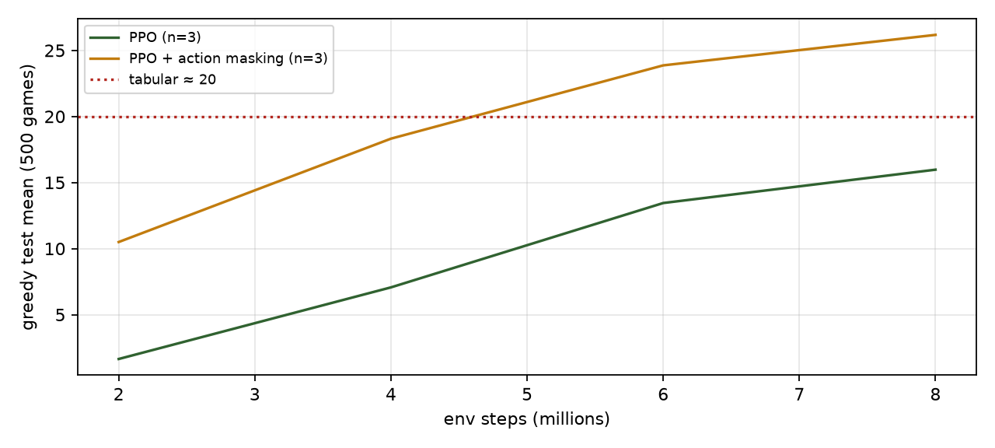
PPO learning curves (mean over seeds).
Analysis. Two arms, three training seeds each, 10 M environment steps per run, the same 500 held-out games as every other tryout, best checkpoint chosen on 200 separate validation games.
Arm | Seeds (test mean) | Mean ± sd | Best game | Deaths wall / self / timeout (mean of 500)
PPO | 21.4, 18.7, 7.9 | 16.0 ± 7.1 | 49 | 8 / 204 / 289
PPO + invalid-action masking | 26.5, 26.3, 25.7 | 26.2 ± 0.4 | 51 | 20 / 404 / 76
- Masking is the difference between an unreliable agent and a reliable one. The masked arm lands at 26.2 in all three seeds (range 25.7–26.5); the unmasked arm ranges from 7.9 to 21.4. The unmasked runs mostly fail by circling: 289 of 500 games end by starvation, against 76 for the masked arm. A policy that is trying to avoid walls and its own body while its probabilities are still near uniform spends many steps in loops that cost nothing, and the entropy bonus keeps it from committing out of them. The mask removes the unsafe options outright, so the policy has fewer ways to be indecisive.
- Masked PPO is the best learned agent on the standard 12×12 board in this repository: 26.2 ± 0.4 (three seeds, 10 M steps) against 24.5 for the CNN DQN (one seed, 5 M steps, best checkpoint) and the tabular agent’s 20. Caveats that matter: PPO had twice the environment steps; the two used different recipes tuned by hand to a different degree; and the DQN figure is a best-over-checkpoints value from a single seed, which flatters it. The gap to DQN is small and is not a clean win for the algorithm.
- Throughput, not sample efficiency, is where PPO wins on this machine. A PPO run of 10 M steps took about an hour on the shared GPU (about 2.6 k environment steps/s with other jobs running, about 7 k/s alone); the 5 M-step DQN run took 98 minutes (about 0.9 k/s). DQN needs fewer samples for a given score; PPO collects them far faster here because the batched environment makes data nearly free (§7).
- The remaining deaths are slow traps. For the masked arm, 404 of 500 games end in self-collision. The mask removes instant deaths and wall hits (20 of 500), but a long snake still coils itself into a dead end. The next tryout (05) asks what it takes to avoid that.
- What is not claimed. One hyperparameter set, no tuning of $λ$, learning rate or the entropy coefficient, a fixed horizon of 64 steps, and a policy evaluated greedily (always the most likely move). A greedy evaluation of an entropy-regularised policy can loop where a sampled one would not, which probably lowers the unmasked arm’s numbers.

10. Failure modes to watch for
- Entropy collapse: the policy becomes deterministic too early and stops exploring (entropy → 0, return flat).
- Value-loss domination: a large critic loss with a shared trunk can swamp the policy gradient; watch the value loss and clip fraction.
- Too many epochs or too high a learning rate: approximate KL jumps and the clip fraction climbs; performance can collapse.
- Mask mismatch between rollout and update silently breaks the importance ratio.
- Treating a timeout as a terminal, which teaches the critic that waiting is “free of future”.

Self-check
Self-check. Why is subtracting a state-dependent baseline $b(s)$ from the return safe for the policy gradient?
- Because $b$ is small
- Ea∼π[∇θlogπ(a|s)]=∇θa​π(a|s)=∇θ1=0, so any $b(s)$ adds zero in expectation
- Because the baseline is learned
Answer: (b). The baseline only changes the variance of the estimate, never its mean, as long as it does not depend on the action.
Self-check. In PPO’s clipped objective with ${\hat{A}}_{t}>0$ and $r_{t}>1+ϵ$, what is the gradient with respect to the policy?
- positive, so the action keeps becoming more likely
- zero, the clipped term is the minimum and it does not depend on $θ$
- negative
Answer: (b). $min(r\hat{A},(1+ϵ)\hat{A})=(1+ϵ)\hat{A}$ when $r>1+ϵ$, a constant. The step has already used up its allowance for this sample.

References
- Schulman, J., Levine, S., Abbeel, P., Jordan, M., & Moritz, P. (2015). Trust region policy optimization. ICML.
- Schulman, J., Moritz, P., Levine, S., Jordan, M., & Abbeel, P. (2016). High-dimensional continuous control using generalized advantage estimation. ICLR.
- Schulman, J., Wolski, F., Dhariwal, P., Radford, A., & Klimov, O. (2017). Proximal policy optimization algorithms. arXiv:1707.06347.
- Williams, R. J. (1992). Simple statistical gradient-following algorithms for connectionist reinforcement learning. Machine Learning, 8.
- Sutton, R. S., McAllester, D., Singh, S., & Mansour, Y. (2000). Policy gradient methods for reinforcement learning with function approximation. NeurIPS.
- Huang, S., & Ontañón, S. (2020). A closer look at invalid action masking in policy gradient algorithms. arXiv:2006.14171.
- Engstrom, L., et al. (2020). Implementation matters in deep policy gradients: a case study on PPO and TRPO. ICLR.
- Andrychowicz, M., et al. (2021). What matters in on-policy reinforcement learning? A large-scale empirical study. ICLR.

05 · The win challenge: can reinforcement learning fill the whole board?

Summary
Every agent so far scores around 20 on the 12×12 board. A win means filling all 144 cells (141 foods), and none of them has ever done it. This tryout asks whether a learned agent can win at all, how far up in board size it gets, and what separates it from a trivial planning algorithm that always wins.
An honest framing first. Winning Snake is a long-horizon planning problem. The reward for the final bite arrives hundreds of steps after the decisions that made it possible, and a policy that has never won has never seen the big reward. Pure RL on a laptop GPU is a stretch goal here. The plan is a curriculum from small boards to large ones, so there is a chance to see wins at all, and a non-RL reference (a Hamiltonian-cycle follower) to show what winning looks like.
board | run | start from | win rate | mean score (fill %) | max | wins / games | deaths wall / self / timeout | steps
6×6 | t05_6x6_win5_s0 | scratch | 83.4% | 29.9 (91%) | 33 | 417 / 500 | 1 / 22 / 60 | 4.5 M
6×6 | t05_6x6_win6_s0 | scratch | 97.4% | 32.4 (98%) | 33 | 487 / 500 | 0 / 8 / 5 | 6.0 M
8×8 | t05_8x8_win6_s0 | 6x6 | 0.8% | 25.4 (42%) | 61 | 4 / 500 | 103 / 215 / 178 | 11.5 M
8×8 | t05_8x8_win6_scratch | scratch | 88.6% | 55.6 (91%) | 61 | 443 / 500 | 3 / 22 / 32 | 11.5 M
8×8 | t05_8x8_win6_trap_s0 | 6x6 | 49.6% | 47.0 (77%) | 61 | 248 / 500 | 9 / 120 / 123 | 7.5 M
10×10 | t05_10x10_win6_cont | scratch | 63.0% | 75.9 (78%) | 97 | 315 / 500 | 30 / 114 / 41 | 15.5 M
10×10 | t05_10x10_win6_scratch | scratch | 0.0% | 61.4 (63%) | 92 | 0 / 500 | 3 / 444 / 53 | 15.5 M
10×10 | t05_10x10_win6_trap_s0 | scratch | 0.0% | 34.3 (35%) | 86 | 0 / 500 | 57 / 232 / 211 | 3.0 M
12×12 | t05_12x12_ext | 12x12 (24 M steps) | 68.0% | 120.1 (85%) | 141 | 340 / 500 | 19 / 140 / 1 | 135.0 M
12×12 | t05_12x12_win6_scratch | scratch | 0.0% | 68.5 (49%) | 120 | 0 / 500 | 11 / 428 / 61 | 23.5 M
Reference, non-RL Hamiltonian cycle: 6×6 100% · 8×8 100% · 10×10 100% · 12×12 100%

1. Why wins are hard
Three things stack up.
- A rare event. A random policy essentially never fills a board. If a learner never wins, the win bonus never appears in its data, and nothing pulls it toward winning.
- A long horizon. A 6×6 win takes about 300 steps; a 12×12 win takes about 4 800 (the Hamiltonian agent below needs that many). A reward arriving after $T$ steps contributes $γ^{T}R$ to the value of the start state.
- Credit assignment. The mistake that dooms a long snake (coiling into a region too small to survive in) happens many steps before the death, and a cell-level mistake looks identical to a good move at the time.

The effective horizon
With discount $γ$, a reward $T$ steps away is weighted by $γ^{T}$, and the weights sum to $1/(1−γ)$. That sum is the effective horizon: roughly how many steps ahead the agent can “see”. With $γ=0.99$ it is 100 steps; with $0.995$, 200; with $0.999$, 1 000.
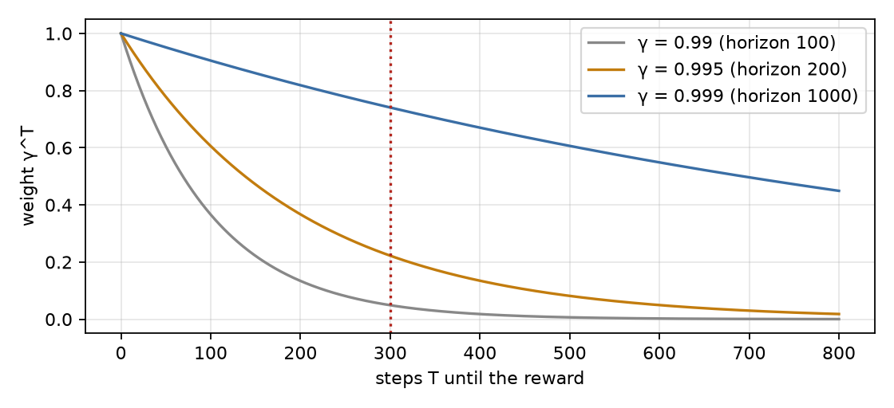
A reward T steps away is weighted by γ^T; the dotted line marks a 6×6-sized win (T ≈ 300).
A win bonus of 10 after $T=300$ steps is worth $10⋅{0.99}^{300}≈0.5$ at the start with $γ=0.99$ but $10⋅{0.995}^{300}≈2.2$ with $γ=0.995$. This is why the runs here use $γ=0.995$, and why a bigger $γ$ is not free: it also raises the variance of every return estimate, which GAE ($λ$) then has to control.

2. The setup
Algorithm. PPO with invalid-action masking, the fastest learner in tryout 04 (masked PPO reached a test mean above 12 within 2 M steps while unmasked PPO was still circling). It uses the batched GPU environment with 256 parallel games.
Observation: a size-agnostic canvas. The network sees a fixed 14×14 canvas whatever the board size; the board sits inside it and everything outside is wall. Channels:
Channel | Meaning | Why
0 | tail order: age / length, so how long until each body cell frees | the one thing the snake can wait for: a cell next to the tail is safe soon
1 | head
2 | food
3 | wall (everything outside the board)
4 | length / number of cells, a constant plane | tells the net how crowded the board is
5 | (ablation) cells reachable from the head through empty cells | the flood-fill feature a planner would compute
Because the input shape never changes, the same weights can be trained on 6×6 and then fine-tuned on 8×8, 10×10 and 12×12 (a fully convolutional net would also do this; a fixed canvas is simpler and keeps the tryout-04 architecture).
Rewards. +1 per food, −1 on death, and a win bonus of 10 on filling the board. A starvation timeout stays at $100×$length steps without food, which already scales with the snake and is far above the cycle time on these boards. A timeout remains a truncation, not a terminal, exactly as in tryouts 02 to 04.

3. Curriculum learning
Train first on a board where winning is reachable, then reuse the weights on a bigger one (Bengio et al. 2009; Narvekar et al. 2020 survey the RL version). Here the “task difficulty” is the board size:
$$6×6 → 8×8 → 10×10 → 12×12.$$
Why it can help: on 6×6 a decent policy sees wins often enough for the win bonus to shape the value function; the 8×8 stage then starts from a policy that already avoids trapping itself. Why it can hurt: weights that fit a small board can encode board-size-specific shortcuts (negative transfer), so every stage is compared with a from-scratch control on the same board.

4. When learning stalls: a shield with a little planning inside
On 8×8 the plain masked agent plateaued at about 68–73% fill and never won a single held-out game in 12 M steps. Its deaths were almost all slow traps: the mask stops the snake from turning into a wall or its body this tick, but not from coiling into a region it cannot leave a dozen moves later. That is a planning failure, and a policy network that sees one board image per step is poorly placed to fix it.
The remedy used here is a shield: besides the instant-death mask, the environment also blocks a move when the snake could not survive in the region that move leads to. The check is a time-aware flood fill from the cell the head would enter:
- a free cell can be entered at any time; a body cell can be entered at move $m$ once its age is at most $m$ (the tail keeps freeing cells as the snake moves, so most of the body unwinds in time);
- expand the reachable set for $K=⌈extcells/2ceil+2$ moves;
- call the move a trap if the reachable area is smaller than the snake’s length (one more if the move eats).
If every move is a trap, only instant deaths are blocked; if every move kills, nothing is blocked. The same rule is implemented three times (vectorised on the GPU, in the scalar Python engine, and in the game’s JavaScript) and the three agree on every state tested (1 315 states between the GPU version and the Python version; 417 between Python and JavaScript).
What this means for how to read the result. A shielded agent is learning plus a hand-written safety check. The network still has to learn where to go, but part of what stops it from dying is planning that the environment supplies. It is not pure RL, and the game labels these agents “+ trap shield” so nobody mistakes them for it. The comparison that matters is the same setup with and without the shield, from the same starting weights.

5. A planner that never loses: the Hamiltonian cycle
A Hamiltonian cycle visits every cell exactly once and returns to its start. A snake that simply follows one can never run into itself (the cell ahead of its head is always either empty or the tail’s vacating cell) and passes through every cell, so it eats every food and fills the board, on every seed.
On an even $n×n$ board a cycle always exists. A simple construction (used in python/snake_rl/hamilton.py, and mirrored in the game): run along the top row, zigzag through the remaining rows using columns $1…n−1$, then return up the first column.
Board | Cells | Hamiltonian agent: wins / 500 | mean steps to win
6×6 | 36 | 500 | about 300
8×8 | 64 | 500 | about 900
10×10 | 100 | 500 | about 2 500
12×12 | 144 | 500 | about 4 800
This is the contrast between planning and learning. The cycle agent uses the rules of the world (it knows the geometry exactly) and no learning at all, and it is perfect and slow (it never takes a shortcut). A learned policy gets no such prior: it has to discover the idea of “do not trap yourself” from a reward that, for a long time, says nothing about it. The agent is in the game’s dropdown, clearly labelled not RL, as the upper bound to measure everything against. (Real strong Snake players combine the two: they follow a cycle but take shortcuts when they are provably safe. Learning such shortcuts on top of the cycle is a natural next experiment, not done here.)

6. Results
board | run | start from | win rate | mean score (fill %) | max | wins / games | deaths wall / self / timeout | steps
6×6 | t05_6x6_win5_s0 | scratch | 83.4% | 29.9 (91%) | 33 | 417 / 500 | 1 / 22 / 60 | 4.5 M
6×6 | t05_6x6_win6_s0 | scratch | 97.4% | 32.4 (98%) | 33 | 487 / 500 | 0 / 8 / 5 | 6.0 M
8×8 | t05_8x8_win6_s0 | 6x6 | 0.8% | 25.4 (42%) | 61 | 4 / 500 | 103 / 215 / 178 | 11.5 M
8×8 | t05_8x8_win6_scratch | scratch | 88.6% | 55.6 (91%) | 61 | 443 / 500 | 3 / 22 / 32 | 11.5 M
8×8 | t05_8x8_win6_trap_s0 | 6x6 | 49.6% | 47.0 (77%) | 61 | 248 / 500 | 9 / 120 / 123 | 7.5 M
10×10 | t05_10x10_win6_cont | scratch | 63.0% | 75.9 (78%) | 97 | 315 / 500 | 30 / 114 / 41 | 15.5 M
10×10 | t05_10x10_win6_scratch | scratch | 0.0% | 61.4 (63%) | 92 | 0 / 500 | 3 / 444 / 53 | 15.5 M
10×10 | t05_10x10_win6_trap_s0 | scratch | 0.0% | 34.3 (35%) | 86 | 0 / 500 | 57 / 232 / 211 | 3.0 M
12×12 | t05_12x12_ext | 12x12 (24 M steps) | 68.0% | 120.1 (85%) | 141 | 340 / 500 | 19 / 140 / 1 | 135.0 M
12×12 | t05_12x12_win6_scratch | scratch | 0.0% | 68.5 (49%) | 120 | 0 / 500 | 11 / 428 / 61 | 23.5 M
Reference, non-RL Hamiltonian cycle: 6×6 100% · 8×8 100% · 10×10 100% · 12×12 100%
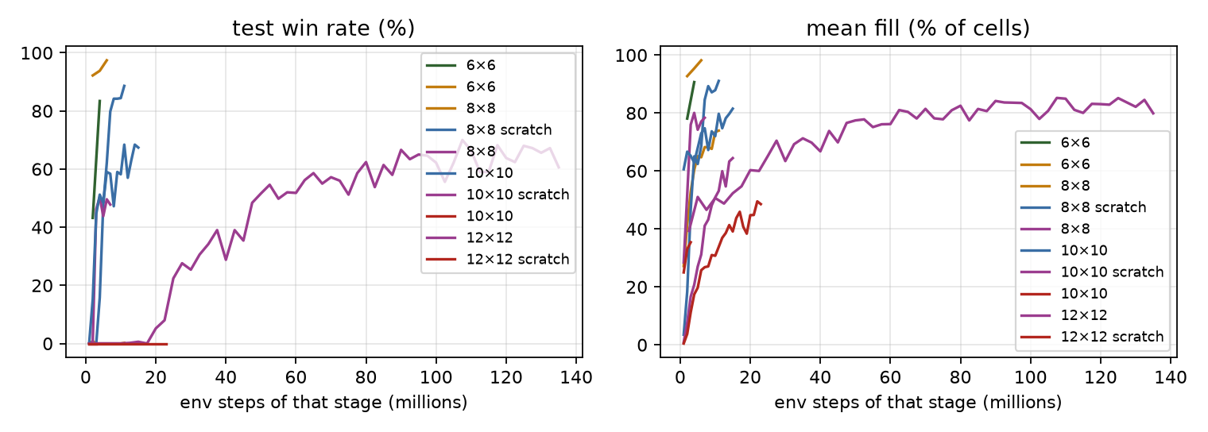
Win rate and fill during training, per curriculum stage.
[Interactive figure “win_replay”: open the HTML version of this note.]
Analysis. All numbers are greedy play on the 500 held-out games of that board size, for the checkpoint chosen on 200 separate validation games (the choice prefers more validation wins, then a higher mean). Every run below is a single training seed; the win rates fluctuate by 10–20 points from one checkpoint to the next, so read them as ranges.
Board | Agent (training) | Win rate | Mean fill | Notes
6×6 | masked PPO + reachable-area channel, from scratch, 6 M steps | 97.4% (487/500) | 98% | 92% already at 2 M steps
6×6 | same without the reachable-area channel (control), 4 M steps | 83.4% (417/500) | 91% | 43% at 2 M steps
8×8 | masked PPO, from scratch, 12 M steps | 88.6% (443/500) | 91% | first wins at 4 M steps
8×8 | initialised from the 6×6 agent, 12 M steps | 0.8% (4/500) | 42% | the checkpoint chosen on validation is from 2 M steps; later checkpoints fill 70–75% of the board but win 0–1 games
8×8 | 6×6 start + trap shield, 8 M steps | 49.6% (248/500) | 77% | shielded, see §4
10×10 | masked PPO, from scratch, 16 M steps | 0% at the selected checkpoint (1/500 at 15 M) | 63% | best game 97 of 97
10×10 | the same run continued for 16 M more steps | 63.0% (315/500) | 78% | 342/500 at two other checkpoints
12×12 | masked PPO, from scratch, 24 M steps | 0% | 49% | best game 120 of 141
12×12 | the run above continued (extended run, stopped by the plateau rule at 135 M further steps; validation-selected checkpoint) | 68.0% (340/500) | 85% | first win at 12.5 M further steps; 70.0% (350/500) at best on the test set
any | Hamiltonian cycle (not RL) | 100% | 100% | 6×6 to 12×12
- Pure reinforcement learning wins small boards reliably, and the win rate drops with the size of the board. 97% on 6×6, 89% on 8×8, 63% on 10×10 (after 32 M steps in total), and, after the extended run described below, 68% on 12×12 (340 of 500) at the end of writing. The cost of a win grows quickly: a 12×12 win means 141 consecutive correct meals, and the training signal for the last few dozen only arrives in games that have already gone almost perfectly.
- The reachable-area channel matters most when training is young. On 6×6 it roughly doubled the win rate at 2 M steps (92% against 43%) and the gap narrowed to about 10 points by 4 M (94% against 83%). It gives the network, as an input, what a planner would compute (how much free space is still connected to the head). It is information, not a rule, so the agent is still learning; it just learns faster.
- Starting from the smaller board hurt on 8×8 in this run. The agent initialised from the 6×6 weights won 4 of 500 games at its validation-selected checkpoint (2 M steps) and at most one game at any later checkpoint over 12 M steps; the same recipe from scratch won 89%. A fine-tuned policy can carry habits that suit the small board (here, probably a tendency to circle) and be harder to un-learn than to never learn. This is one seed per variant, so it is an observation, not a finding about curricula in general; the size-agnostic canvas makes the transfer possible, it does not make it useful. The fair way to test curriculum learning would be several seeds of each, which this tryout did not run.
- The trap shield rescued the curriculum run but did not beat plain learning. With the shield the 6×6 start reached about 50% on 8×8, far better than without (0.2%), yet below the from-scratch run’s 89%. A hand-written safety check removes a failure the learner would otherwise have to discover (§4) at the cost of being part of the agent: the agent is not “pure RL” any more, and the game labels it so. In this experiment it did not turn out to be the best option.
- The remaining failures are slow traps. On 10×10 the final deaths are 114 self-collisions, 30 wall hits and 41 timeouts out of 500; on 12×12, 428 of 500 end by self-collision. The agent usually fills most of the board and then runs out of room: the planner’s guarantee, that the route can always be completed, is exactly what it lacks.
- More training kept paying on 10×10. Continuing the 16 M-step run (with the learning rate restarted) took the win rate from 0–1 wins to 47–68% over the next 16 M steps, with a lot of checkpoint-to-checkpoint noise. The first run’s learning rate had decayed to zero, which probably capped it.
- 12×12 was won, after a long extension. The 24 M-step run did not win a single held-out game (best game 120 of 141 cells). Continuing it with the same recipe, with 1 024 parallel environments instead of 256 (the throughput study in tryout 04, §8), produced the first win after 12.5 M further steps, and the win count then rose quickly:
Further steps | Mean score | Mean fill | Best game | Wins of 500
2.5 M | 55.5 | 39% | 112 | 0
5 M | 71.9 | 51% | 123 | 0
7.5 M | 65.7 | 47% | 122 | 0
10 M | 71.4 | 51% | 128 | 0
12.5 M | 68.7 | 49% | 141 | 1
15 M | 73.8 | 52% | 141 | 3
17.5 M | 77.1 | 55% | 136 | 0
20 M | 85.0 | 60% | 141 | 26
22.5 M | 84.6 | 60% | 141 | 40
25 M | 91.9 | 65% | 141 | 112
37.5 M | 98.4 | 70% | 141 | 195
50 M | 109.2 | 77% | 141 | 258
62.5 M | 114.2 | 81% | 141 | 281
80 M | 116.3 | 83% | 141 | 312
90 M | 118.7 | 84% | 141 | 333
107.5 M | 120.1 | 85% | 141 | 350 (highest)
125 M | 120.1 | 85% | 141 | 340 (published)
135 M (end) | 112.7 | 80% | 141 | 303
This is a single run (one seed). The win rate rose quickly up to about 50 M further steps, then slowly, and from about 90 M further steps it moved between 55% and 70% from one evaluation to the next (the standard error of a win rate measured on 500 games is about 2 percentage points, and the checkpoints themselves differ, so swings of this size are partly noise and partly real changes in the policy). The plateau rule stopped the run at 135 M further steps because neither the fill (85.1% against 85.2% before) nor the win rate (68.2% against 70.0%) had gained over the last 25 M steps. The published agent is the checkpoint with the best validation score (340 of 500 test wins, 68.0%); the single best test evaluation of the run was 350 of 500 (70.0%), which is not used as the headline because choosing the maximum over 50 noisy evaluations would flatter the result. Almost all remaining failures are self-collisions after the agent has filled most of the board (140 of 500 at the published checkpoint). The full evaluation-by-evaluation table is in docs/12x12_trajectory.md. What it shows is that pure reinforcement learning, a masked PPO policy with a reachable-area input, can fill the full 12×12 board on a laptop GPU, but it took on the order of 150 M environment steps in total for about two-thirds of the games, against none at all for the Hamiltonian cycle’s route to the same result (which learns nothing).
What the Hamiltonian cycle adds to this picture. It reaches 100% on every size with zero learning, but it takes the long way (about 4 800 steps for a 12×12 win), and it needs the rules and an even board. The learned agents are shorter and more general in what they need to be told, but they are not close to reliable beyond 8×8. Neither is “better”: they answer different questions (what can be learned from reward, and what can be computed with the rules).

7. What to try next
- Search on top of the learned value function (AlphaZero-style tree search, or even a short rollout with the flood-fill check): planning supplies the lookahead that the network lacks.
- Imitation, then RL: pretrain on the Hamiltonian agent’s trajectories (a strong, safe policy) and let RL improve on its speed.
- Reward shaping by free area: a potential $(s) = $ reachable-area fraction, which keeps the optimal policy (Ng et al. 1999) while rewarding the behaviour a planner would.
- More compute: the hardest stages are limited by training time on a 1650 Ti, not by the idea.

8. Failure modes to watch for
- Win rate hides a collapse in fill. Track mean length and fill % too, and the causes of death.
- Catastrophic forgetting between stages: re-evaluate the new weights on the previous board size.
- A mask is not planning. It stops instant deaths only; the main killer of long snakes is the slow trap.
- Counting a lucky seed as a result. The win rate is over 500 held-out seeds, and each stage has a from-scratch control.

Self-check
Self-check. With γ = 0.99 and a win bonus of 10 arriving 400 steps after a decision, roughly how much does that bonus add to the value of the decision?
- About 10
- About 0.18, since 0.99^400 ≈ 0.018
- Exactly zero
Answer: (b). Rewards are weighted by γ^T. At γ = 0.99 the effective horizon is only 100 steps, so a distant bonus is almost invisible, which is why a larger γ is used for this task.
Self-check. Why can a snake that follows a Hamiltonian cycle never trap itself?
- Because it moves very fast
- The cycle visits every cell once; the snake’s body always occupies a contiguous stretch of it, so the next cell is empty or the vacating tail
- Because it avoids food
Answer: (b). Knowing the whole geometry in advance is planning. The agent needs no learning, only the rules.

References
- Bengio, Y., Louradour, J., Collobert, R., & Weston, J. (2009). Curriculum learning. ICML.
- Narvekar, S., Peng, B., Leonetti, M., Sinapov, J., Taylor, M. E., & Stone, P. (2020). Curriculum learning for reinforcement learning domains: a framework and survey. JMLR, 21.
- Ng, A. Y., Harada, D., & Russell, S. (1999). Policy invariance under reward transformations: theory and application to reward shaping. ICML.
- Pardo, F., Tavakoli, A., Levdik, V., & Kormushev, P. (2018). Time limits in reinforcement learning. ICML.
- Schulman, J., et al. (2016). High-dimensional continuous control using generalized advantage estimation. ICLR.
- Silver, D., et al. (2016). Mastering the game of Go with deep neural networks and tree search. Nature, 529.
- Sutton, R. S., & Barto, A. G. (2018). Reinforcement Learning: An Introduction (2nd ed.). MIT Press.

