**DIC’s**

**Terrace Farming Robot for Hilly Areas**

Inter IIT Tech Meet, IIT Roorkee

December 20 - 22, 2019

**Design Report**



**Indian Institute of Technology Jodhpur**

**Abstract**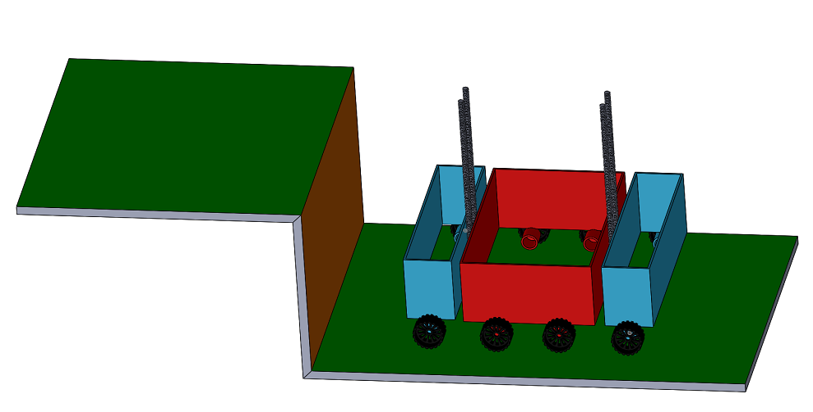

The terrace farming done in hilly areas is not properly mechanized and a lot of challenges are faced by those farmers practicing the same. To solve these problems and help those farmers, an autonomous robot can serve as a boon. The aim of our team is to design and build a light-weight robot that can be used for terrace farming in areas having hilly terrain. Our design aims to achieve an all-in-one solution for various farming requirements by having activity-specific modules that can be fitted onto a robot. The robot would be able to perform these agricultural tasks in all weather conditions, without or with less human involvement. The robot is designed keeping in mind that it has to perform on narrow and steep paths, preventing the use of heavy machinery and animal power. The design decided is a three-compartment design which contains lead screws that facilitate the climbing of the robot up and down the stairs of given height. The dimensions of the robot are decided keeping in mind the various circumstances that may arise while climbing the stairs of given dimensions mentioned in problem statement. The material has been decided on the basis of various factors which can be seen in the report. A reliable navigation plan for autonomous navigation of the robot in the field has been provided keeping in mind the arena described in the problem statement. The objective mentioned in the problem statement has been studied thoroughly and accordingly, to demonstrate the basic idea of the mechanism used by our robot, a prototype of the robot has been manufactured. The robot, on an overall basis, is designed to optimize the cost and serve the sole purpose, aid the farmers in terrace farming to the best possible extent.

# **Four-View Drawing of the Proposed Design**

# 

# **Contents**

1. **Introduction**

1.1 Objective

1.2 Background Research on Challenges

1.3 Real Field Study

1.4 Necessity of an Autonomous Robot

1.5 Existing and Explored Designs

1. **Design**

2.1 Design Specifications

2.2 Mechanism and Working

2.3 Novelty in the proposed design

1. **Analysis**

3.1 General Analysis

3.2 Static Structural Analysis

1. **Approach for Automation**

4.1 Background Research

4.2 Proposed Approach

1. **Prototype**

5.1 Specifications

5.2 Mechanism and Working

1. **Cost Analysis**

6.1 Product

6.2 Prototype

1. **Conclusion**
2. **Future Work**
   * + 1. **Introduction**

**1.1 Objective**

The problem statement of *DIC’s Terrace Farming Robot for Hilly Areas* reveals the objective in a very clear manner which can be stated in points as below:

* To develop a lightweight robot that can climb up and down through the steps and perform at least one farming activity among watering, seeding, harvesting and so on
* To provide a reliable navigation plan of the robot for autonomous navigation in the field and demonstrating it using a prototype or a proof-of-concept

**1.2 Background Research on Challenges**

Terrace Farming has the following challenges

* Narrow and limited land for agriculture
* Increased labor: Difficult mechanization
* Impractical to use heavy machinery or animal power
* Restricted access to farming requirements and amenities such as electricity
* Large amount of time required to move a machine up and down a terrace

**1.3 Real Field Study**

**1.4 Necessity of an Autonomous Robot**

The following points answer the question on necessity of an autonomous robot for terrace farming:

* Perform agricultural activities without or with less human involvement.
* Intelligent concentration detection to detect weeds, pests, cut down the usage of pesticides and fertilizers which reduces the negative effects on health and lowers costs
* Perform agricultural tasks in all weather conditions
* Perform on narrow and steep paths, preventing the use of heavy machinery and animal power
* Save time for more significant work by automating tedious tasks
  1. **Existing and Explored Designs**

**1.5.1 Caterpillar track mechanism**

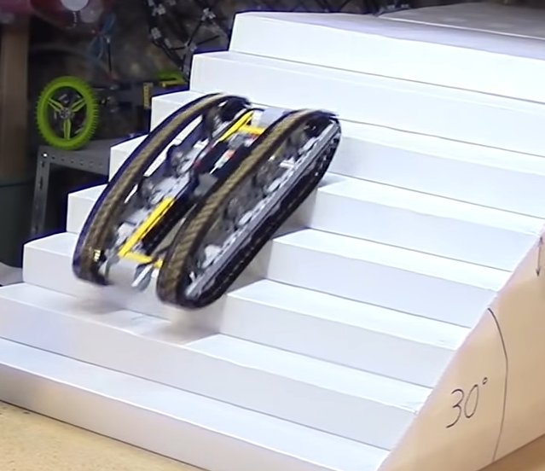

*Source: https://youtu.be/iHyJX5UxPy8

There are some favorable points that this mechanism brings before us.

*Power efficiency* - Compared with wheels, continuous tracks have high power efficiency and optimized traction system.

*Traction* - The traction is high even on slippery surfaces like snow or wet concrete.

*Moving on rough terrain* - A robot with continuous tracks, can operate on rough terrain while the wheels can get stuck. The continuous band of treads can ascend and descend stairs, surmount obstacles or cross ditches.

*Ground impact* - A robot that moves on rubber tracks transmits lower pressure on the ground as the contact area is more and weight remains distributed over the robot. That means a less impact on the ground, especially when the robot is heavy.

Some unfavorable points are as listed below.

*Long Caterpillar Track -* To make this design function, the belt should be touching at least three step edges at some point of time. This is so because, if we consider the robot to have the length such that it touches only 2 step edge at maximum then as soon as it will move forward to go to another step it will be in contact with only one step edge which would make it to fall.

Thus, having contact with 3 steps is the minimum balancing conditions for the robot. This allows the robot to get balanced on at least two steps at all times.

In the given problem statement, it is stated that the length of the step is 100 cm and height is 40 cm

Thus, edge to edge length is 107.70 cm approximately.

Thus, this mechanism requires our robot to have at least (107.7) x 3 cm = 323.11 cm of length.

*High risk of slipping back -* The robot should have a firm grip on the surface to prevent toppling. The surface of stairs in contact with the robot is very less (merely 2 edges).

Even after applying a high friction coefficient material the frictional force could vary with the soil type, texture, atmospheric conditions. So, it will be very difficult to maintain grip on the stairs. The risk of slipping back is very high.

*Damage to step edges -* The entire pressure of the robot would fall merely on the edges of the soil. Thus, multiple runs on the steps would cause the soil from the steps to come apart, get flattened and get ruined.

**1.5.2 Rocker bogie mechanism**

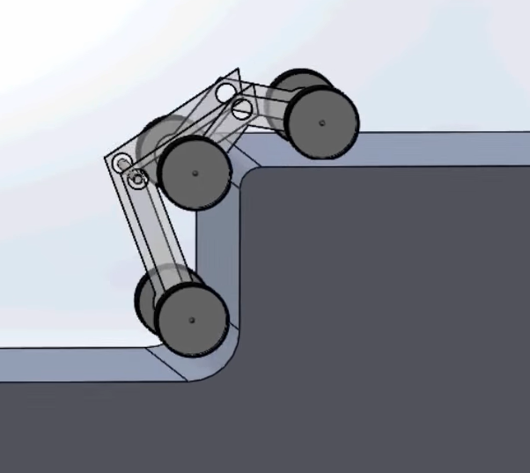

*Source: https://youtu.be/bP7p5Bd2d50

The rocker-bogie suspension system is a passive springless and symmetric mechanism.

Some favourable points that this system offers are listed as under.

*Even distribution of load*– The loadon each wheel can be kept nearly identical.

*Identical traction* – This mechanism has no axles or springs which helps to maintain equal traction force on all the wheels.

*Overcoming sizable obstacles* – A robot with this mechanism can climb over blocks twice the height of the wheel while keeping all 6 wheels on the ground.

Some unfavourable points of this mechanism are listed below.

*Head on collisions with obstacles* – The robot undergoes head on collisions with the obstacles. This produces impulsive force on components. This may not affect a robot with low mass but for a heavy robot this force would be very large. Thus, in a long run, the components may undergo failure.

*High power required for climbing* - At some point of time the front wheels are completely vertical on the step. Thus, to drive the robot upward the rear wheel has to generate a lot of torque to make the robot climb up.

*Risk of toppling -* Now when the front part has climbed up, the rear part is tilted backward. Since most of the components of robot would be fitted between the front and rear wheels, the robot is likely to topple backwards. As with any suspension system, the tilt stability is limited by the height of the center of gravity. This problem can be solved if we increase the dimensions of the robot in proportion to the step. Though this would make maneuvering about the steps very easy but then the robot would not be able to move through any individual step.

*Lack of friction -* The robot may fail to climb up due to lack of friction. In a real world one cannot predict the type of weather and its effect on the soil. It may be noted that while bringing the robot reverse to step it down, the rear part of the robot would fall down suddenly with a thud. This would not only damage the components but also the soil track at that place. Long runs like this may result in components falling off.

**1.5.3 House cleaning robot mechanism**

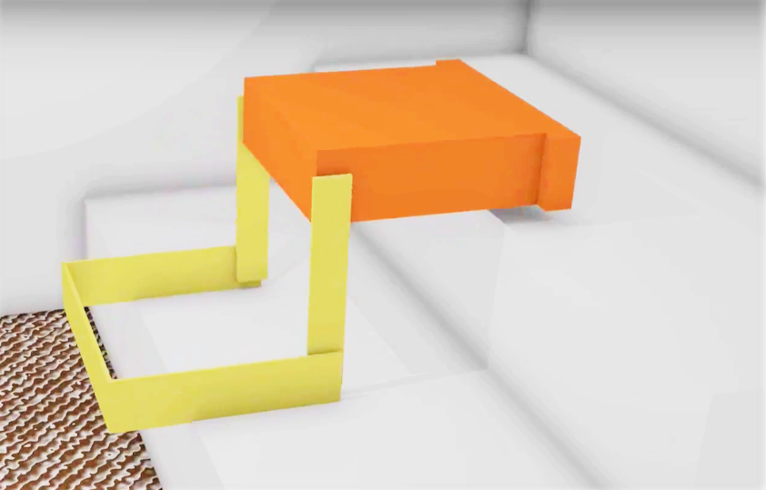

*Sourcehttps://youtu.be/8DSh4Y_wyK)

Some favourable points of this mechanism are as under.

*Eliminates the friction* *related challenge*– This robot solves the problem of requirement of sufficient friction to climb up as it directly lands upon the step and does not take support of the vertical wall.

*Easy maneuvering*– The robot has cuboidal design with the center of gravity being low which offers exceptional stability.

Some unfavourable points are listed as under.

*High torque required to lift -* The motors have to generate a lot of torque to get that robot up.

Assuming the robot to be 50*(9.81) = 490.5 N heavy (evenly distributed mass)

The minimum necessary torque to lift the robot is (70/100). (1/2) * 490.5 N = 171.675 Nm. This torque has to be applied to both the motors so that the robot can maintain its horizontal level.

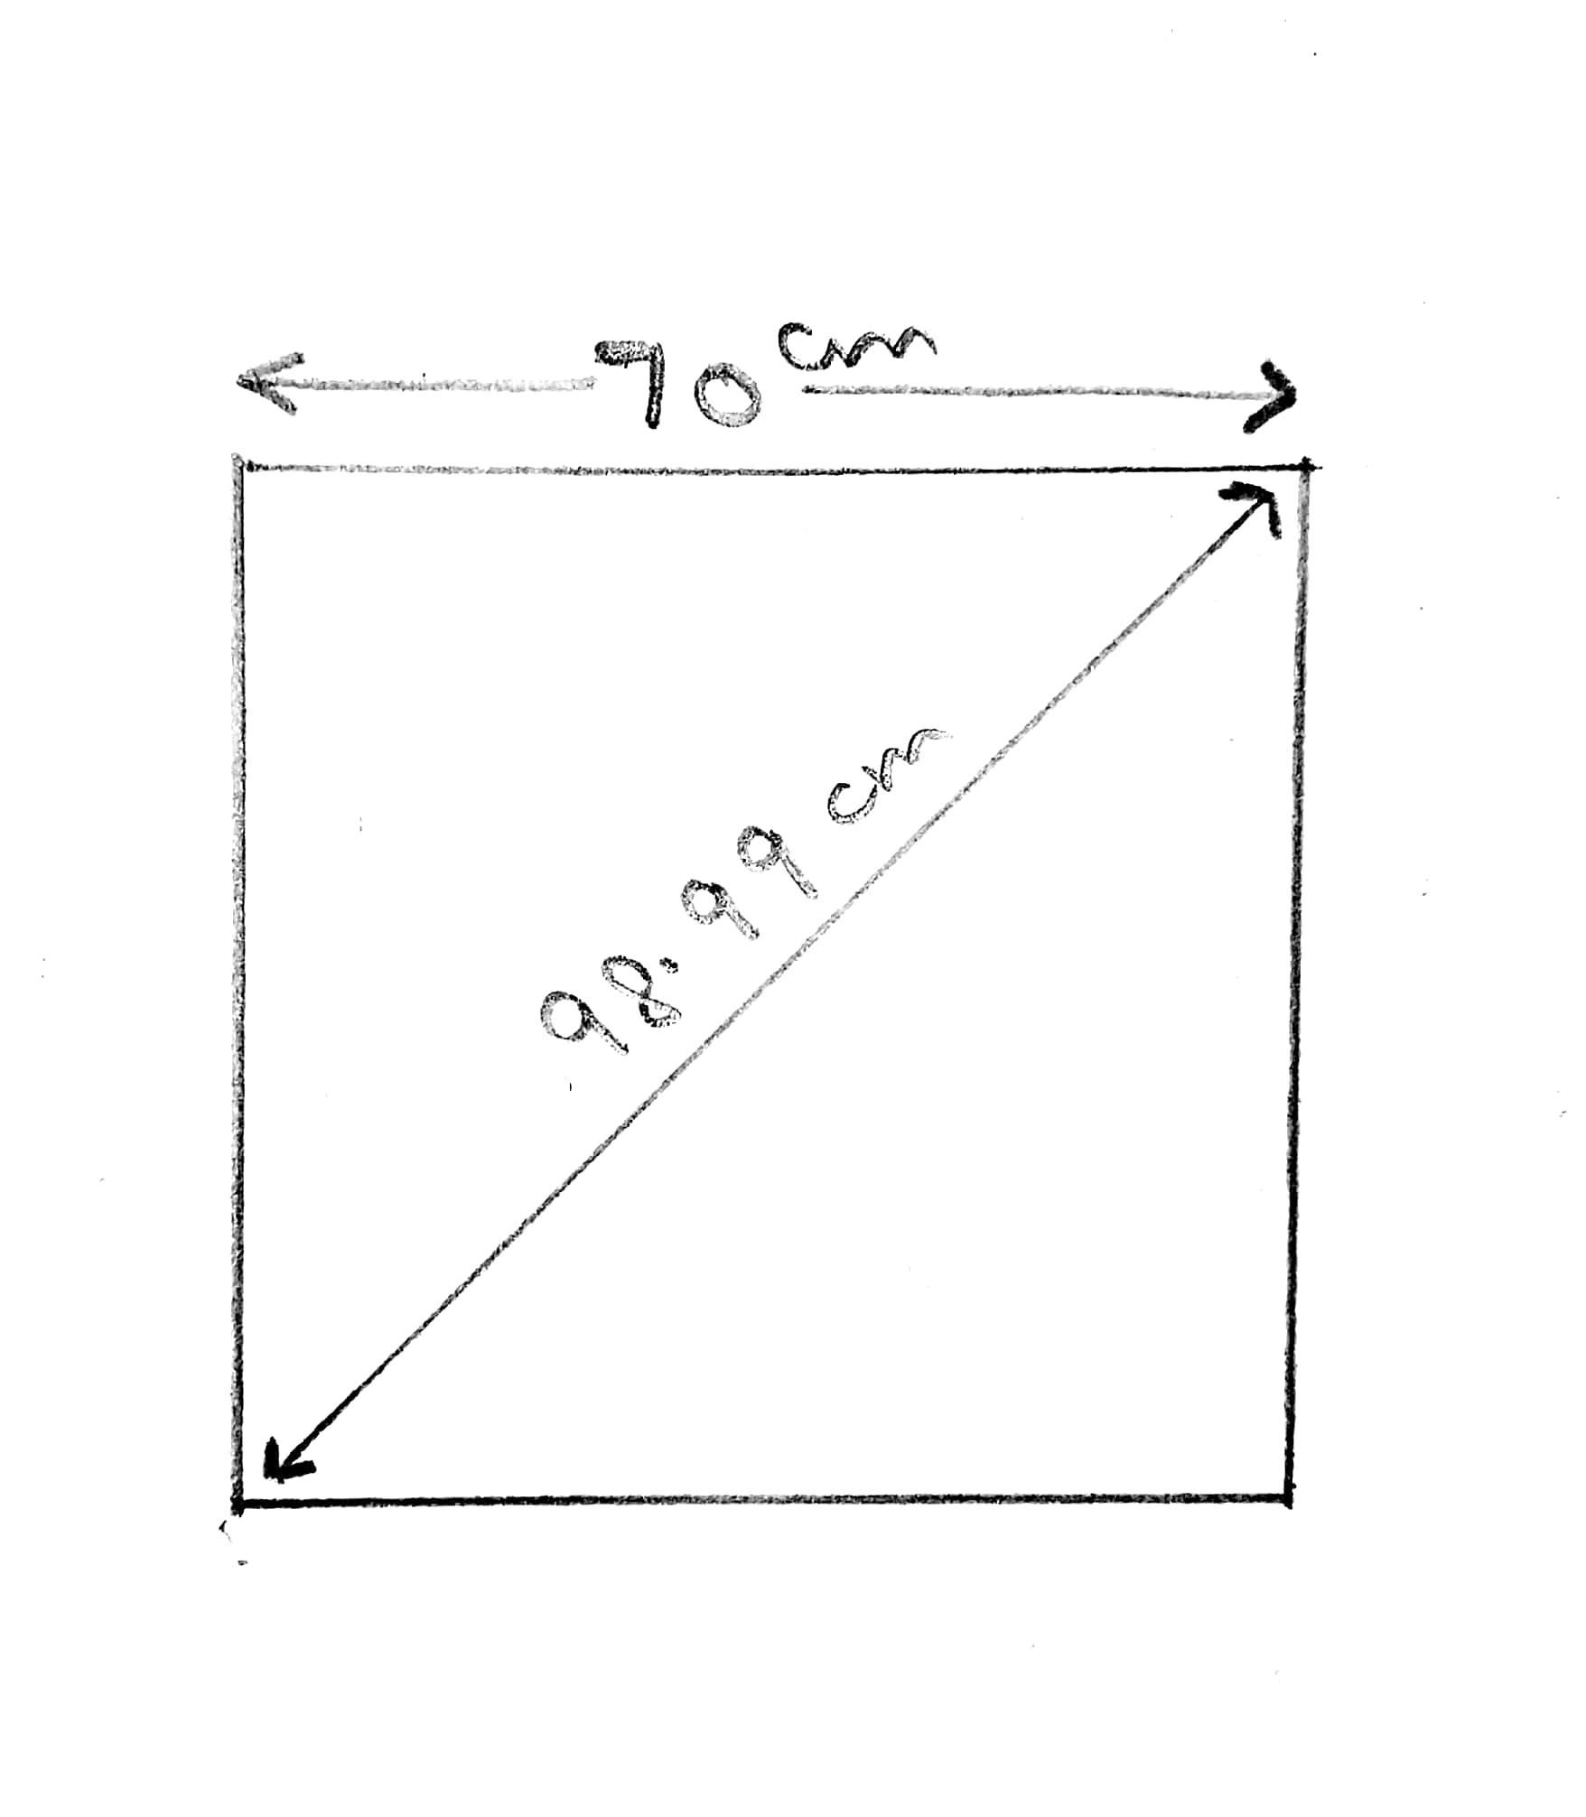

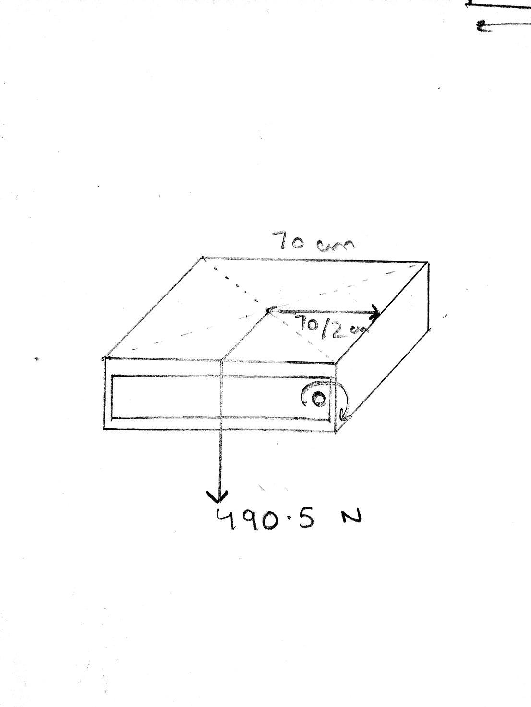

**1.5.4 Lead Screw Extending Design**

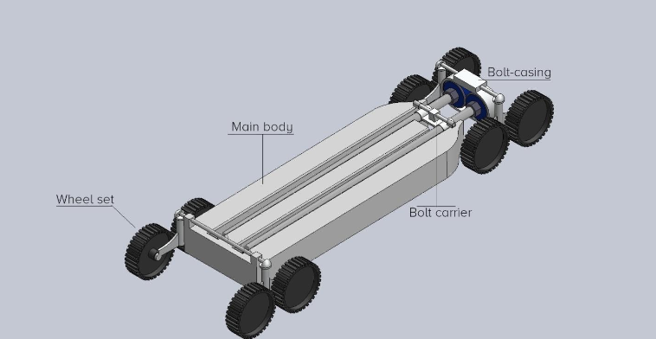

This robot has been designed by our own team along with the proposed design.

**Components**

The robot is divided in two sections the main body and the rear axle. Front part of the main body is connected with 2 pairs of wheels for better traction and stability. The wheels on the main body are connected to a connecting rod using pivot joint. This allows free rotation of the wheels about an axis perpendicular to connecting rod. Also, the main body has a bolt carrier attached to it with a pivot joint. The bolt carrier is for the lead screw to rest on the main body and also has groves that match the lead screws. The pivot joint allows the rotation between the main body and the rear part. This joint is connected with a torsional spring to limit its movement. The rear axle also has 2 pairs of wheels connected to it. A bolt-casting placed on the rear part houses two motors that connects the lead screws and rotates them. The power of the motor is also transferred to the set of rear wheels. Front end tyres are equipped with a separate motor for power. The tyres are coated with a high friction coefficient material.

**Mechanism and Working**

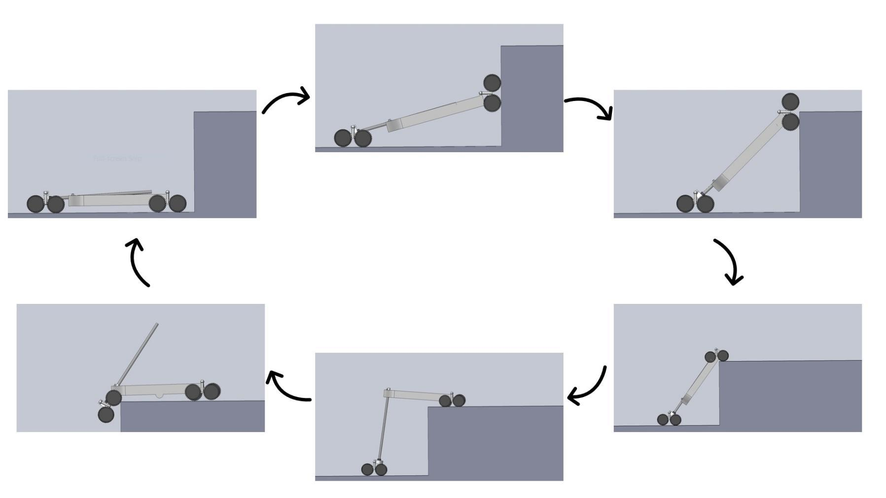

The robot has a simple and compact design with capabilities of climbing up different shapes of stairs. Multiple repeating parts allow a cost effective and easily maintainable design. Different parts can be attached to it which perform farming activities making its use repetitive and economic.

The pivot joint that joins the two sections of the robot, which is provided with a torsional spring to restrict its unnecessary movements while moving, creates a restoring torque. This creates an extra opposing force on the motors. The robot completely relies on the frictional force to climb up and one cannot predict the soil texture at all times. Thus, this mechanism can fail on slippery surfaces. The rear wheels need to create a lot of torque to initiate the vertical motion of the front wheels on the step wall.

**2. Design**

**2.1 Design Specifications**

Our robot is inspired by the fork-lift mechanism. Our proposed design has three individual compartments which are lifted individually up and down the stairs through lead screws. The body is made up of wooden ply of thickness about 1.5 cm.

The dimensions of our robot are-

* Central compartment: 60cmX30cm
* Front compartment: 60cmX15cm
* Back compartment: 60cmX15cm

Six tyres (four in the central compartment and two each in the front and

the back compartment respectively) of about 11 cm in diameter. Eight brushed DC motors of 100rpm are used in the tyres which are controlled

by a motor driver and Arduino Uno.

4 Lead Screws of length 500 mm, 8 mm thread and 2 mm pitch would be used for the vertical-translational lift of the individual compartments.

All the components are powered through a 6500mAh Lipo-Battery.

The proposed design of the robot contains seeding-mechanism and watering mechanism fitted in the slot as shown in the image of the central compartment.

LIDAR Technology would be used for automation.

All the components are controlled using the microcontroller Arduino UNO.

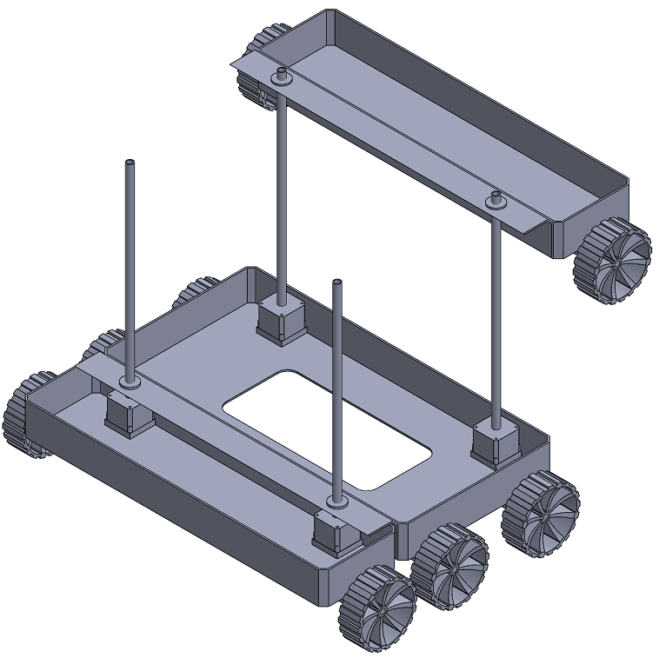

**2.2 Mechanism and Working**

**Climbing Mechanism:**

Our robot can be divided into three compartments, front middle and rear. The front and the rear compartments are identical to each other in design and dimensions. The front part of the middle compartment and the front part of the rear compartment has a pair of lead screws on it. The front and the rear part are provided with a set of wheels each and the middle part has 2 sets of wheels.The motors are connected to microcontroller through motor drivers. A proximity sensor is installed on the front end to detect step walls. Plough is attached below the central compartment so that own weight of the robot can be used for ploughing. Seeding is done by using air pumps. The pressurized air is shot out towards the soil which creates a hole in the ground and then the seed is dropped into it. One seed at a time is dropped into that hole.

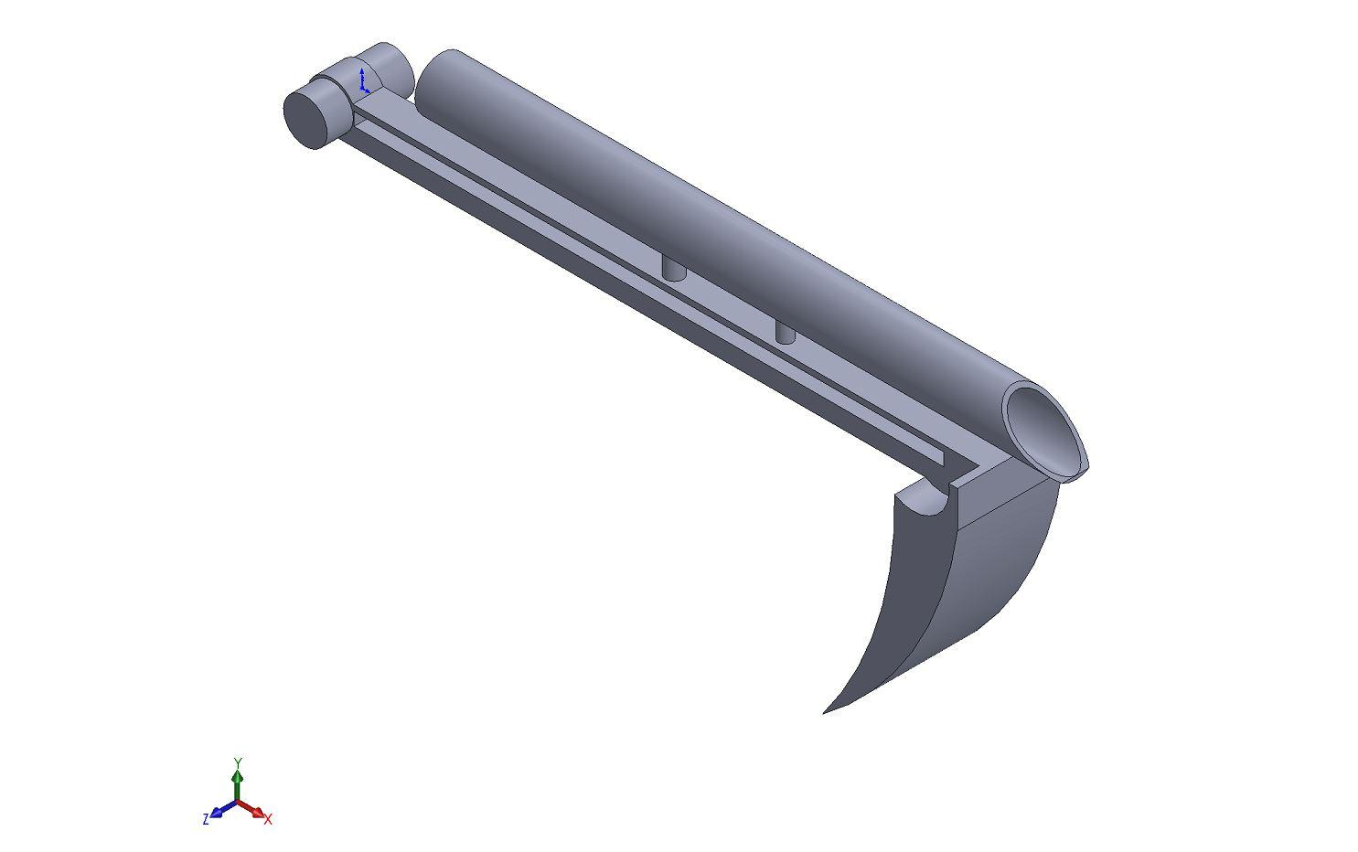

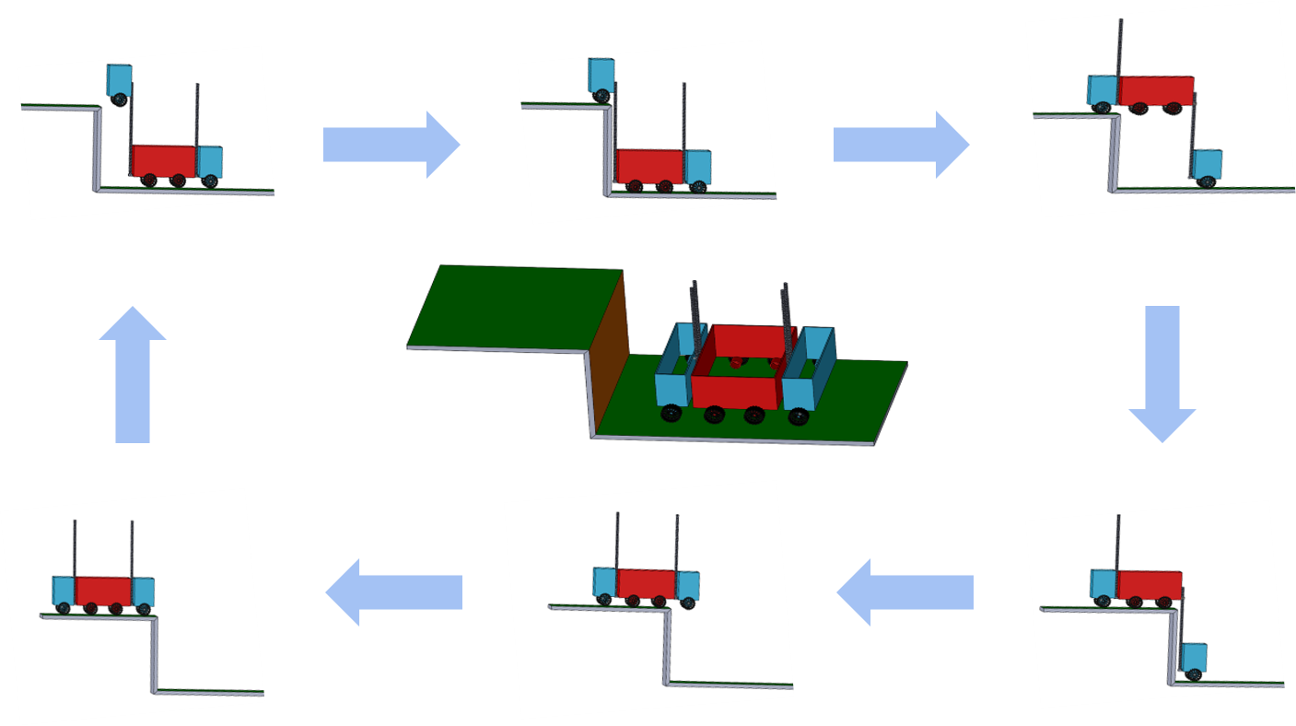

**Working**

When the front part has attained the required height to climb the step , the main compartment of the robot, as well as the whole body moves closer to the step making the part which is at the height, to land on the upper step. The front and the rear lead screws rotate in opposite sense so as to lift the middle compartment. When it gains required height the robot again moves closer to the walls and the middle component also climbs up the immediate step. Now, when the front and middle segments have successfully landed on the upper step, the rear lead screws are again rotated to lift the rear part. This process is repeated to climb up the stairs. When the robot is on the stairs the tyres helps in easy maneuvering. The vacant pace provided in the middle compartment can be installed with different mechanisms to do different farming activities.

**Features**

Our design overcomes most of the challenges present in the currently available solutions.

The proposed design does not take the support of vertical wall while climbing the steps. This makes the robot independent from the constraints imposed due to friction on the vertical wall of step (a crucial requirement for the contemporary solutions). Various activity-specific modules (inspired from Current Farming Methodologies) can be fitted onto the robot, making it an all-in-one solution for various farming requirements. This design also eliminates the problem of damaging or eroding the banks or the edges of the terraces as the design lands normally to the terrace at all times.

The probability of the robot getting toppled is almost eliminated as the center of mass would never fall out of base of support as we have heavier side on the ground. The design assumes uniform mass distribution over three individual compartments with 2:7:2 or 1:4:1 as the ratio of mass distribution.

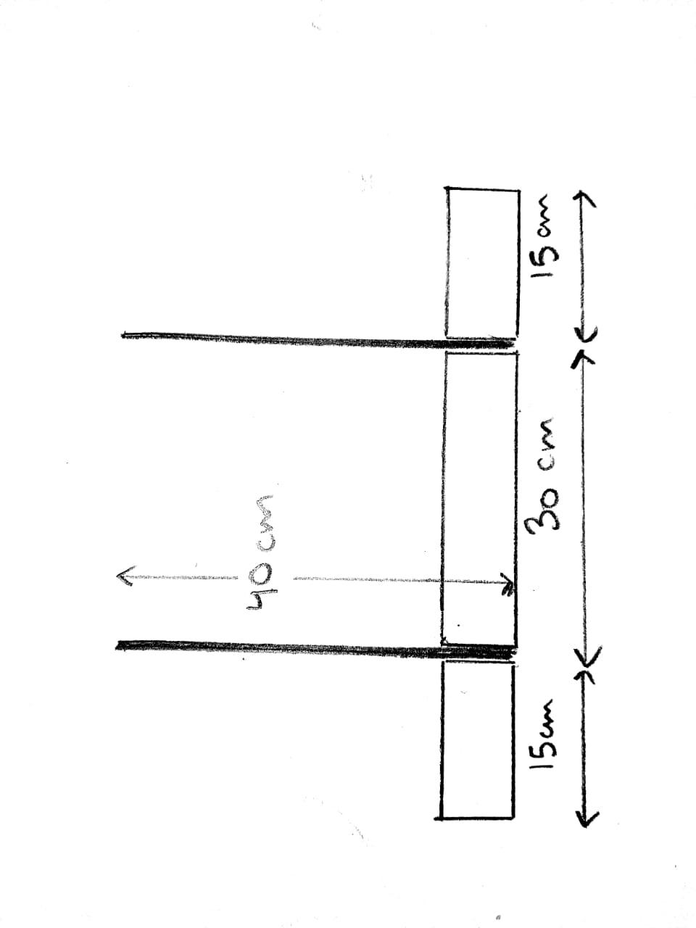

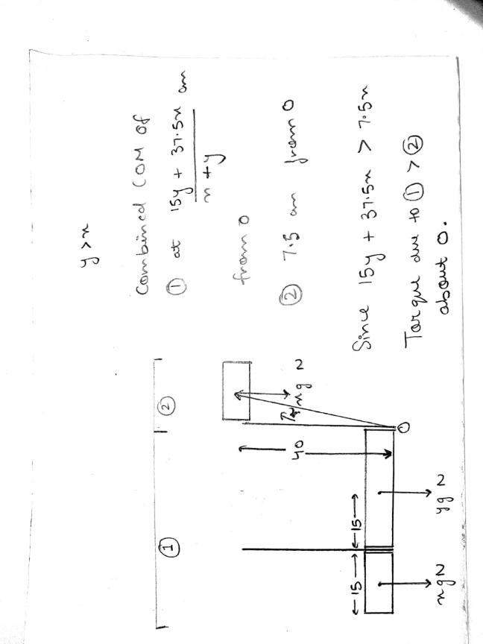

Consider the case of lifting the front compartment in order to climb the step, the Centre Of Mass (shifted at its maximum in this position) would never fall out of the base of support due to the assumed weight distribution. We can use the weight force of the robot itself as an advantage such that by lifting the rear and the middle compartments up and then connecting a plough tool in such a way that major part of the weight is transferred to it so that it digs the soil.

**Seeding Mechanism:**

**Watering Mechanism:**

**2.3 Novelty in the proposed design**

**3. Analysis**

**3.1 General Analysis**

Our design overcomes most of the constraints present in the

currently available solutions. The proposed design does not take the support of vertical wall while climbing the steps. This makes the robot independent from

the constraints imposed due to friction on the vertical wall of a step

(a crucial requirement for the contemporary solutions). Various activity-specific modules (inspired by Current Farming Methodologies) can be fitted onto the robot, making it an all-in-one solution for various farming requirements.

This design also eliminates the problem of damaging/eroding the banks of the terraces as the design lands normally to the terrace every time. The probability of the robot getting toppled is almost eliminated as the design assumes uniform mass distribution over three individual compartments with 2:5:2 or 1:3:1 as the ratio of mass distribution.

**3.2 Static Structural Analysis**

The static structural analysis of the robot was performed in ANSYS R15.0 keeping in mind the different orientations it would undergo during the climbing process. Also, the velocity of climbing is not that large so static analysis has been done. The different cases along with their results are shown as below.

The front compartment and the rear compartment are assumed to be of mass 2 kg while the middle or the central compartment is assumed to be of mass 5 kg. This mass has also been verified while weighing the prototype. The material of the lead screws was taken as structural steel while their dimensions was taken to be the same as specified.

The yield strength of structural steel is around 209 MPa whereas the ultimate tensile strength is around 586 Mpa.

Case 1: When the front compartment is at its maximum height and other two are on ground

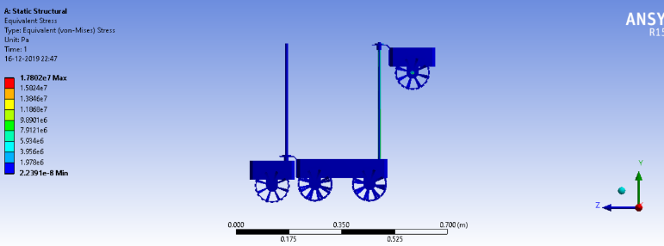

Case 2: When the front compartment has rested on the upper stair, the rear compartment is still on ground and middle compartment is climbing:

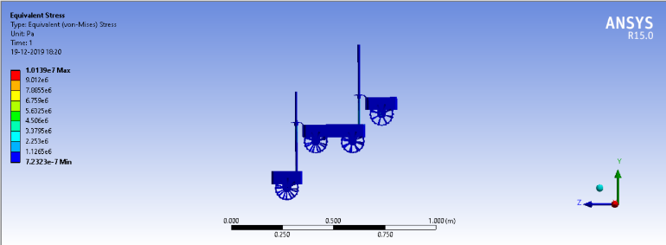

Case 3: When the front and the rear compartments are resting and the middle compartment is at the maximum height:

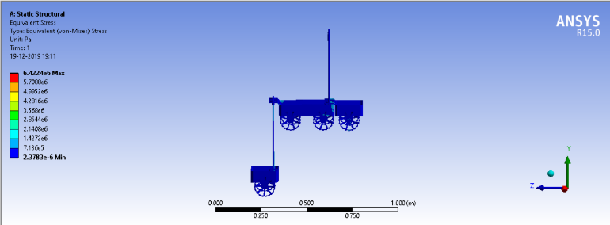

Case 4: When the front and the middle compartments are resting on the upper stair and the rear compartment has started to climb:

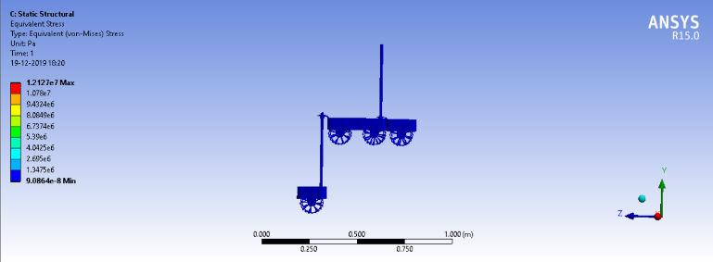

Case 5: When the front and the middle compartments are resting on the upper stair and the rear compartment is at its maximum height:

The results obtained from the above analysis are tabulated below:

|  |  |
| --- | --- |
| **Case** | **Maximum Stress (MPa)** |
| 1 |  |
| 2 |  |
| 3 |  |
| 4 |  |
| 5 |  |

**4. Approach for Automation**

**4.1 Background Research**

LiDAR technology has penetrated most of the industries with the major ones being construction and automotive. Because of its precise data collection and accuracy, it is one of the most preferred remote sensing technologies in the world today.

### Advantages of using LiDAR

*Data can be collected quickly and with high accuracy:* LiDAR is an airborne sensing technology which makes data collection fast and comes with extremely high accuracy as a result of the positional advantage.

*Can be used day and night:* LiDAR technology can be used day and night thanks to the active illumination sensor. It is not affected by light variations such as darkness and light. This improves its efficiency.

*It has minimum human dependence*: LiDAR technology, unlike photogrammetry and surveying has minimum human dependence since most of the processes are automated. This also ensures valuable time is saved especially during the data collection and data analysis phase.

*Can be used to map inaccessible and featureless areas*: LiDAR technology can be used to map inaccessible featureless areas such as high mountains and thick snow areas.

### Disadvantages of LiDAR

*High operating costs in some applications:* Although LiDAR is cheap when used in huge applications, it can be expensive when applied in smaller areas when collecting data.

*Very large datasets that are difficult to interpret*: LiDAR is a technology that collects very huge datasets that require high level of analysis and interpretation. For this reason, it may take a lot of time to analyze the data.

*Ineffective during heavy rain or low hanging clouds:* LiDAR pulses may be affected by heavy rains or low hanging clouds because of the effects of refraction. However, the data collected can still be used for analysis.

70% accuracy at getting depth values out to about 30m. LIDARs get near 100% depth accuracy with ranges from 100m to 300m depending on the type of LiDAR, and this level of range is crucial for highway driving. 30m is not even enough for city driving

Following are the advantages of GPS:

* The GPS signal is available anywhere on the globe. Hence user will not deprive of GPS facility anywhere.
* There is no charge to utilize the GPS service as US Defence bears cost of GPS system. It is maintained and upgraded by US Department of Defence. It is cheaper compare to other navigational systems.
* The GPS system gets calibrated by its own and hence it is easy to be used by anyone.
* It provides user with location-based information. This will be helpful in various applications such as mapping (used in cars), location (geocaching), performance analysis (used in sports), GIS etc. Example: Google Earth Application.
* GPS helps find retail outlets in new visitor location.

Following are the disadvantages of GPS:

* GPS chip is power hungry which drains battery in 8 to 12 hours. This requires either battery replacement or recharge.
* GPS signal does not pierce through the solid walls or structures. Moreover, it is affected by large buildings or structures. Due to this, user will not be able to utilize GPS service in indoors or under water or in dense tree regions or in underground stores or places etc.
* GPS accuracy depends on sufficient received signal quality. GPS signal gets affected due to multipath, atmosphere (i.e. ionosphere), electromagnetic interference etc. This leads to error of about 5 to 10 meters in GPS signal.
* Though currently system is managed by US DoD and users are utilizing the system free of cost, it is in the hand of US to allow or deny the GPS service at any time.
* It is better not to rely completely on GPS system. Backup travel maps with directions will help in the event of GPS system failure.

**4.2 Proposed Approach**

From the above-mentioned background research and analysis, we have proposed to use the LIDAR Technology for automation.

**5. Prototype**

**5.1 Specifications**

Prototype using Ultrasonic and infrared sensors

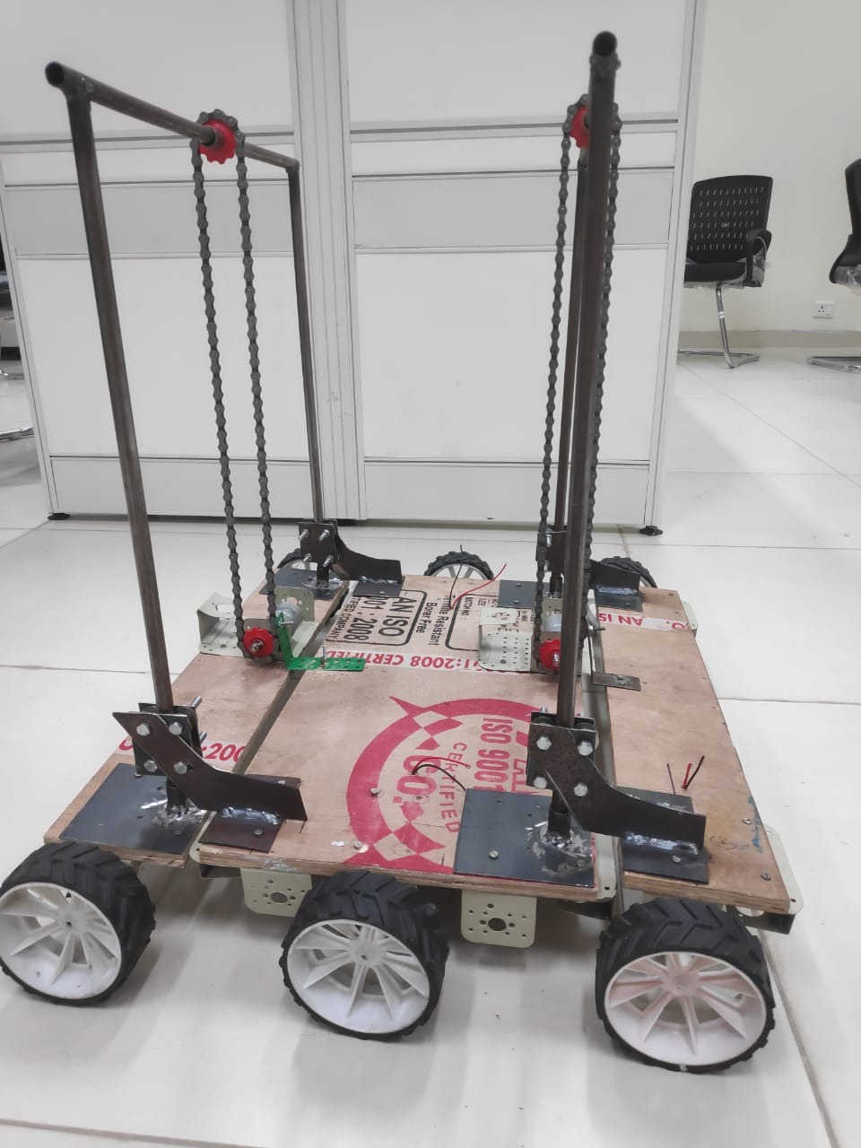

* 1. **Mechanism and Working**

**6. Cost Analysis**

* 1. Product

6.2 Prototype

**7. Conclusion**

1. **Future Work**

For Design Optimization, the following ideas are thought of to be verified and implemented:

* To use the tool of Topology Optimization to optimize the design according to the needs
* To explore various novel materials for the main body of the robot
* To include the dynamic analysis of the robot in the design optimization process
* To explore the idea of Roll cage for the main body

For Automation, the use of LiDAR along with camera and gradually phasing out the dependency on LiDAR by improving computer vision algorithms is the further plan