AI-Powered README Generator for Git Repositories

Mini Project Report submitted to
Visvesvaraya National Institute of Technology, Nagpur
in partial fulfillment of the requirements for the award of
the degree

Executive Master of Technology
in
Applied AI

by
Burele Kartik Prabhakar (MT24AAC011)

under the guidance of
Dr. Mansi A. Radke



Department of
Visvesvaraya National Institute of Technology
Nagpur 440 010 (India)

December 2025

Department of Electronics and Communication Engineering
Visvesvaraya National Institute of Technology, Nagpur

Declaration
I, Burele Kartik Prabhakar, hereby declare that this dissertation titled “AI-Powered README Generator for Git Repositories” is carried out by me in the Department of Electronics and Communications of Visvesvaraya National Institute of Technology, Nagpur. The work is original and has not been submitted earlier whole or in part for the award of any degree/diploma at this or any other Institution / University.

Burele Kartik Prabhakar
[MT24AAC011]

Place: VNIT, Nagpur
Date:

Certificate
This to certify that the Mini Project Report titled “AI-Powered README Generator for Git Repositories” is submitted by Burele Kartik Prabhakar in partial fulfillment of the requirements for the award of the degree of Executive Master of Technology in Applied AI & Communications, VNIT Nagpur. The work is comprehensive, complete and fit for final evaluation.

Dr. Mansi Radke
(Asst. Professor)
Department of Computer Science and Engineering, VNIT, Nagpur

Head, Department of ECE
VNIT, Nagpur
Date:

ABSTRACT

Maintenance and long-term code usability are significantly improved by software documentation. However, time is often wasted by developers attempting to comprehend projects that are poorly documented. An AI-driven system is proposed in this mini-project to automatically generate function-level documentation and high-quality README files for Python repositories. Source code is parsed via Abstract Syntax Tree (AST) analysis. To generate Markdown documentation that is accurate and structured, Large Language Models (LLMs) are employed through LangChain. Both single files and complete Git repositories are supported by the solution. Reduced manual effort and enhanced code comprehension are demonstrated by the experimental results.

List of Figures
Figure 1 Block Diagram 5
Figure 2 Application Frontend UI-1 7
Figure 3 Application Frontend UI-2 7
Figure 4 Output 8
Figure 5 Response time vs File Size 9
Figure 6 Hallucination Rate vs Number of Identifiers 10
Figure 7 Distribution of Readability Scores 11
Figure 8 LLM-as-judge Scores 11

List of Tables

Index
ABSTRACT iv
List of Figures v
List of Tables v
Index vi
1. Introduction 1
1.1 Background 1
1.2 Motivation 1
1.3 Problem Statement 1
1.4 Role of Artificial Intelligence 1
1.5 Objectives 1
1.6 Scope 2
2. Literature Survey 3
2.1 Traditional Approaches to Code Summarization 3
2.2 Emergence of Neural Network-Based Methods 3
2.3 Incorporating Structural Information using ASTs 3
2.4 Dataset Construction and Evaluation Challenges 3
2.5 Reinforcement Learning for Code Summarization 4
2.6 Bidirectional and Multi-Encoder Architectures 4
2.7 Summary and Research Motivation 4
3. Proposed Work 5
3.1 System Architecture overview 5
3.2 Backend Architecture (FastAPIs + Langchain + LLMs) 6
3.2.1 Repository Ingestion and Parsing 6
3.2.2 Component-Level Code Summarization 6
3.2.3 Hierarchical Aggregation and README Generation 6
3.2.4 LLM Orchestration using LangChain 6
3.3 Frontend Architecture (Streamlit UI) 6
3.4 Output of the Proposed System 7
3.5 Significance of the Proposed Work 8
4. Results 9
4.1 Response Time vs File size 9
4.2 Hallucination Rate vs No. of Identifiers 9
4.3 Distribution of Readability Scores (Flesch Reading Ease) 10
4.4 LLM-as-a Judge Scores 10
4.5 Consolidated Discussion 11
5. Conclusion 12
6. References 13

Introduction

Background
Program understanding is made challenging by the increasing complexity of modern software systems. Maintenance activities consume a significant portion of development effort. Existing source code is often found to be more time-consuming to understand than the implementation of new functionality. Readability and sustainability are improved by code comments. However, documentation is frequently left incomplete or becomes outdated in practice.

Motivation
Rule-based techniques are primarily relied upon by traditional automated documentation approaches. Scalability is limited in these methods, and the semantic intent of the code is often missed. Source code summarization is viewed as a translation problem from programming language to natural language due to progress in Deep Learning. Structural and contextual information is learned effectively by neural network models.

Problem Statement
Poor documentation quality results from manual commenting being deprioritized due to time constraints. The semantic meaning of source code is not sufficiently captured by existing automated approaches that rely on keyword matching. Therefore, an intelligent approach is required to automatically generate natural language summaries using modern AI techniques.

Role of Artificial Intelligence
The sequential nature of source code is well-handled by Deep Learning models. Relationships between code tokens and natural language descriptions are learned by architectures such as LSTMs and Transformers. The functional intent of the code is reflected in the summaries generated by these models.

Objectives
- Existing techniques for automatic code summarization are to be studied.
- A deep learning-based model is to be designed for generating summaries.
- Standard performance metrics are to be used to evaluate the model.
- The effectiveness of summaries in improving code understandability is to be analyzed.

Scope
- Generation of summary-level natural-language comments for source code
- Use of a single programming language and dataset for experimentation
- Application of deep learning models without manual rule construction
- Evaluation using automated evaluation metrics
This project focuses on assisting program comprehension and does not aim to replace complete software documentation.

Literature Survey
Software documentation plays a crucial role in program understanding, maintenance, and reuse. Among various documentation artifacts, source code comments are considered one of the most valuable, as they directly explain the intent and behavior of code. However, in real-world software projects, developers often fail to write adequate comments due to time constraints or lack of documentation discipline. This challenge has motivated extensive research into the automatic generation of source code summaries and comments.

Traditional Approaches to Code Summarization
Rule-based techniques were largely relied upon in early studies. Keywords and identifiers were extracted from source code. Predefined templates were used to generate descriptions. However, syntactic structure was failed to be captured by these approaches, as code was treated mostly as plain text.

Emergence of Neural Network-Based Methods
Source code summarization began to be treated as a sequence-to-sequence learning problem. Attention mechanisms were applied to Recurrent Neural Networks (RNNs) in early approaches. Meaningful representations were learned by these models. However, structural aspects of the code were often ignored.

Incorporating Structural Information using ASTs
The importance of syntactic structure was emphasized in subsequent research. A hierarchical representation of code is provided by Abstract Syntax Trees (ASTs). ASTs were transformed into structured sequences in several studies. More accurate summaries were produced when AST information was leveraged.

Dataset Construction and Evaluation Challenges
Despite promising improvements in model architectures, inconsistencies in dataset preparation emerged as a significant issue in code summarization research. Different studies used varying data sources, preprocessing techniques, and data splitting strategies, making fair comparison difficult.
A comprehensive study analyzed how dataset design choices such as splitting data by method versus by project can significantly affect evaluation results. The authors demonstrated that improper splitting leads to data leakage and inflated performance metrics. To address this, they introduced a large-scale, carefully curated dataset of Java method-comment pairs and proposed best practices for dataset construction and evaluation.

Reinforcement Learning for Code Summarization
Although encoder-decoder models achieved notable success, they were still limited by training-testing inconsistencies caused by teacher forcing. To mitigate this issue, reinforcement learning techniques were introduced into code summarization frameworks.
In this approach, summary generation is treated as a sequential decision-making process, where the model is rewarded based on the overall quality of the generated summary. By integrating structural and sequential representations of code and optimizing directly for evaluation metrics such as BLEU, reinforcement learning–based models demonstrated improved robustness and consistency in generated summaries compared to purely supervised models.

Bidirectional and Multi-Encoder Architectures
More recent work explored bidirectional recurrent models to better capture contextual information from source code. Bidirectional LSTM-based architectures process code sequences in both forward and backward directions, enabling the model to understand long-range dependencies more effectively.
Some studies further extended this idea by using multiple encoders typically one for code tokens and another for AST-based representations. Experimental evaluations on large Java datasets showed that such architectures generate clearer and more informative summaries, particularly for methods with ambiguous or poorly named identifiers.

Summary and Research Motivation
Existing literature clearly indicates that automatic code summarization has evolved from simple lexical analysis to sophisticated deep learning models that combine structural, semantic, and contextual information. While modern approaches significantly outperform earlier methods, challenges such as dataset dependency, evaluation reliability, and semantic accuracy remain open research problems.
These observations motivate the present project, which aims to build upon recent neural approaches while addressing identified limitations to improve the quality and reliability of automatically generated source code summaries.

Proposed Work
The proposed system implements an AI-powered README generation framework for Git repositories, designed as a modular, service-oriented application. The architecture is divided into two primary subsystems:
- a frontend Streamlit-based user interface, and
- a FastAPI-based backend that orchestrates repository parsing, code summarization, and README generation using large language models (LLMs).
The overall workflow follows a multi-stage hierarchical summarization pipeline, as illustrated in the system architecture diagram.

System Architecture overview
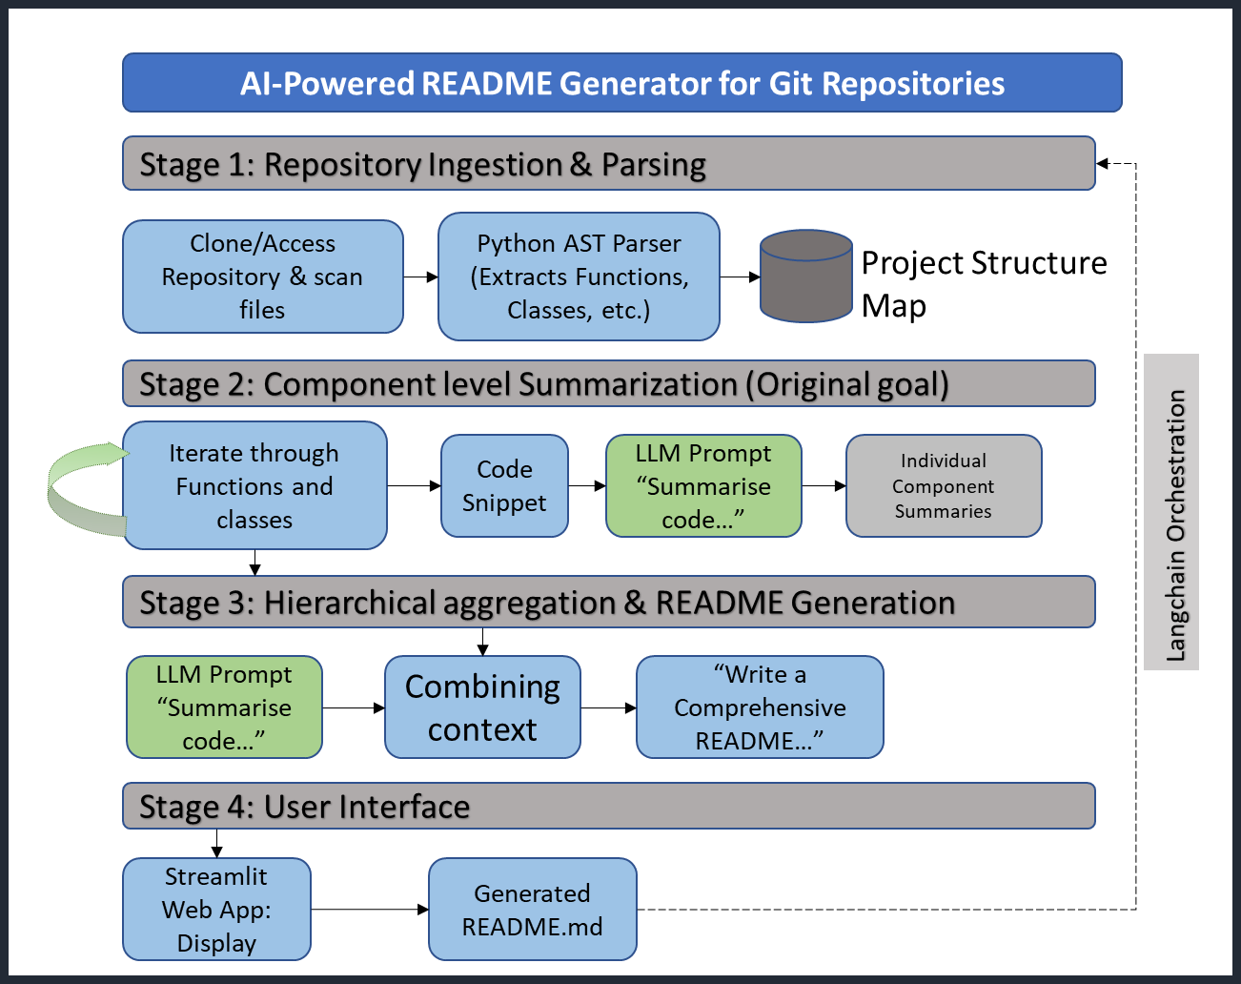

Figure 1 Block Diagram
A modular, service-oriented application is implemented as the proposed AI-powered README generation framework. Two primary subsystems are utilized: a Streamlit-based frontend and a FastAPI-based backend. A multi-stage hierarchical summarization pipeline is followed by the workflow.

Backend Architecture (FastAPIs + Langchain + LLMs)

Repository Ingestion and Parsing
A Git repository URL is accepted by the backend. The repository is cloned, and source files are scanned. Python source code is parsed using an AST parser. Functions and structural elements are extracted to enable a structured representation.

Component-Level Code Summarization
Fine-grained summarization is performed at the function and class levels. Relevant code snippets are isolated. A structured prompt is constructed. To generate concise summaries, the Gemini Flash model is invoked.

Hierarchical Aggregation and README Generation
Individual summaries are aggregated hierarchically. A repository-level understanding is constructed. Information is organized into README sections such as overview and usage. The Gemini Pro model is employed to refine the content and ensure quality.

LLM Orchestration using LangChain
All interactions with LLMs are managed using LangChain. Prompt templating and context chaining are provided by this framework.

Frontend Architecture (Streamlit UI)
A lightweight web interface is provided by Streamlit. Users are allowed to upload .py files or zip archives of repositories. Generated documentation is viewed directly within the interface or downloaded as a README.md file.
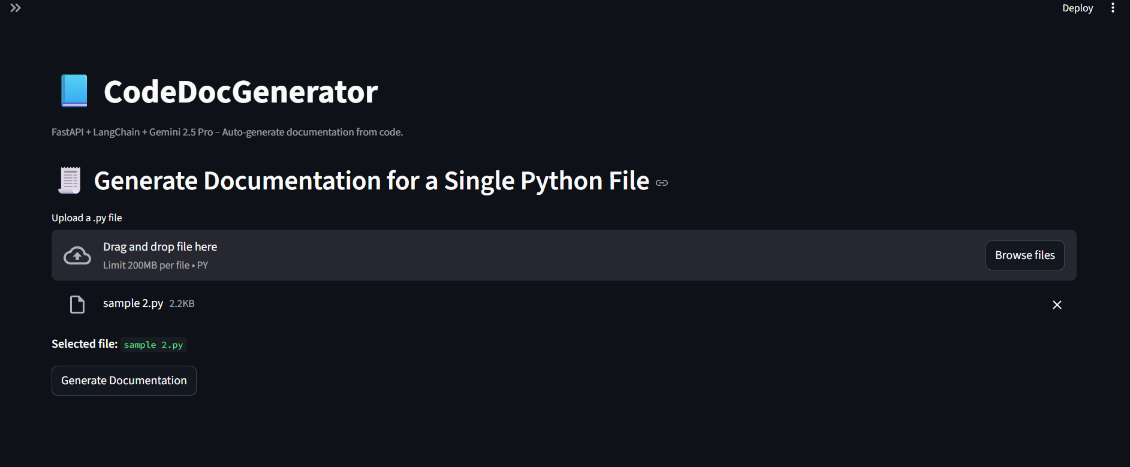
Figure 2 Application Frontend UI-1
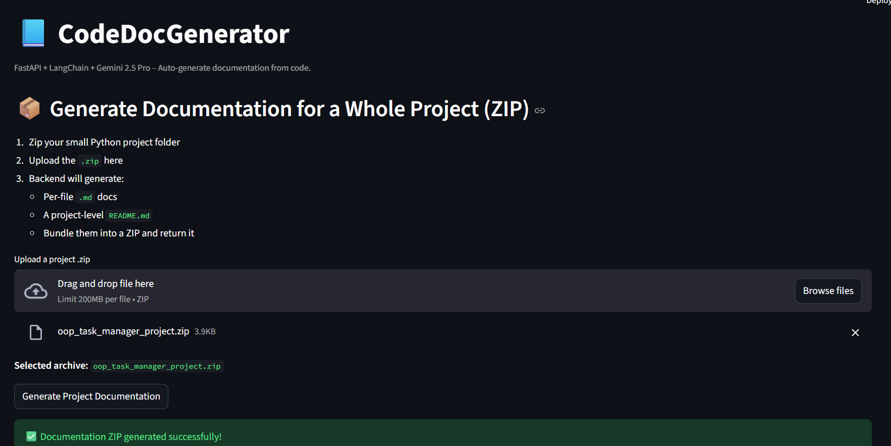
Figure 3 Application Frontend UI-2

Output of the Proposed System
A well-structured README.md file is produced as the final output. The following sections are included.

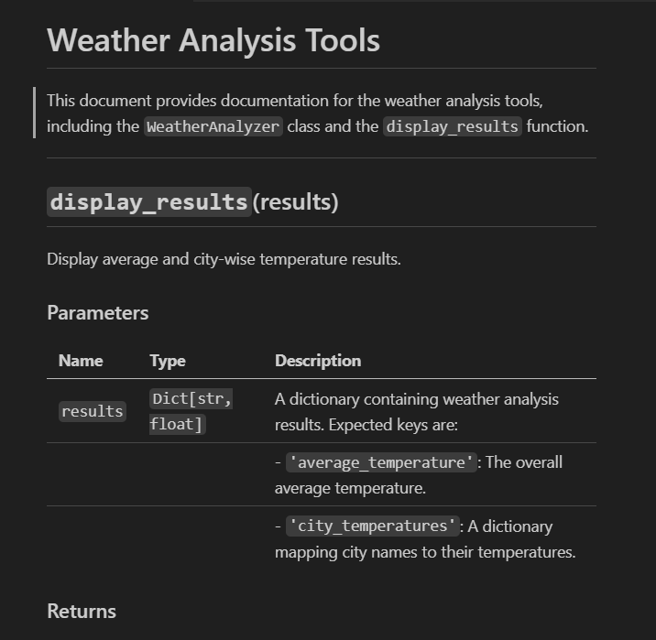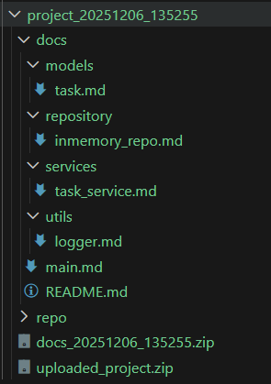
Figure 4 Output
- Project overview
- Functional description
- Code structure summary
- Usage and setup guidance

Significance of the Proposed Work
The proposed work demonstrates:
- Practical application of LLMs for automated software documentation
- Integration of AST-based parsing with neural summarization
- A scalable, multi-stage summarization architecture
- End-to-end system implementation suitable for real repositories
This system bridges the gap between academic research in code summarization and real-world developer tooling.

Results
Evaluation is focused on system performance, factual reliability, and semantic correctness.
The following four metrics are used for evaluation:
- Response Time vs File Size (System Performance)
- Hallucination Score (Grounding and factual correctness)
- Readability Score (Human usability)
- LLM-as-a-Judge Score (Semantic quality)

Response Time vs File size
System performance is indicated critically by response time. A gradual increase in response time is observed as file size increases (Figure 5). This is expected due to parsing and inference overhead. However, the growth is controlled, and exponential degradation is not exhibited.
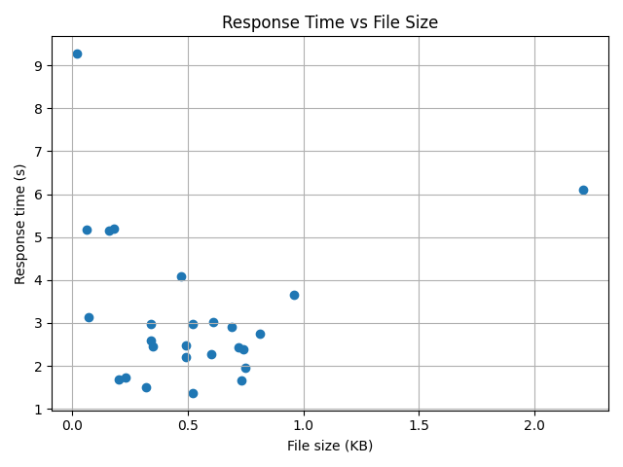
Figure 5 Response time vs File Size
The result confirms that the retrieval and reasoning components are well-optimized and suitable for real-world usage scenarios involving large files.

Hallucination Rate vs No. of Identifiers
The generation of unsupported information is referred to as hallucination. A decrease in hallucination rate is generally observed as the number of identifiers increases (Figure 6). Stronger contextual anchors are provided by a higher number of identifiers
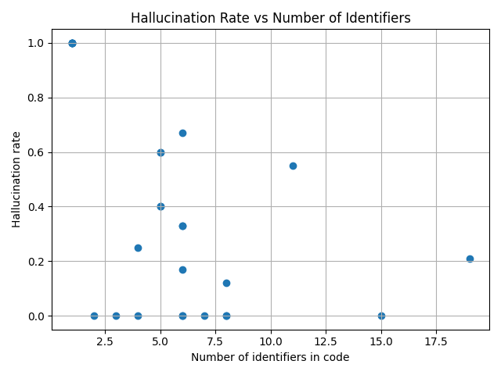
Figure 6 Hallucination Rate vs Number of Identifiers

Distribution of Readability Scores (Flesch Reading Ease)
Linguistic clarity is reflected by the readability score. Most responses fall within the higher readability range (Figure 7). This indicates that well-structured and understandable responses are produced by the system

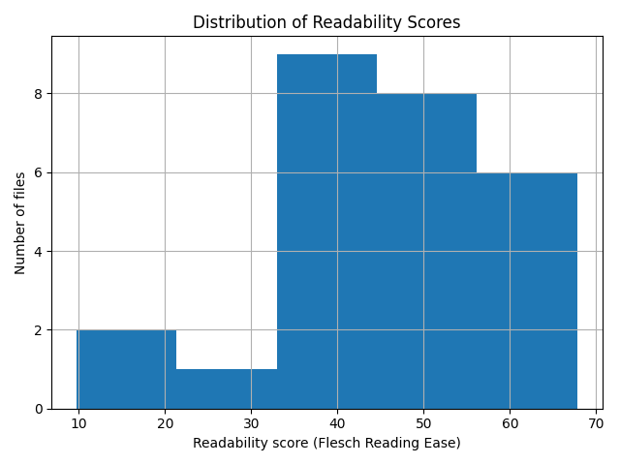
Figure 7 Distribution of Readability Scores

LLM-as-a Judge Scores
Semantic correctness is evaluated using an LLM-as-a-Judge approach. High semantic quality scores are consistently achieved by the system (Figure 8). The intent of the input is accurately preserved by the generated responses.
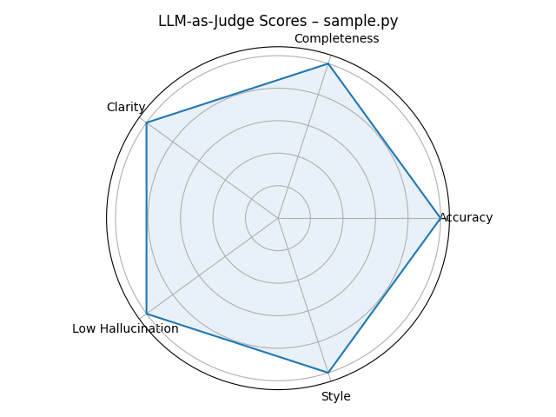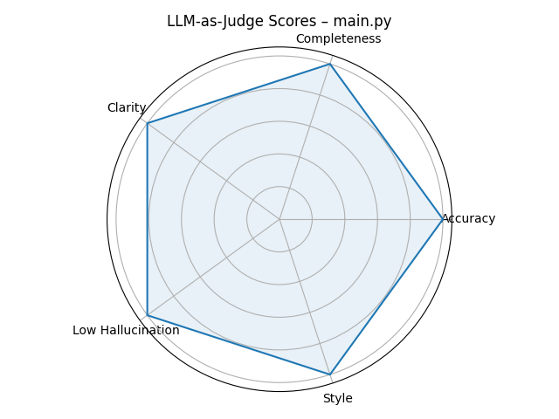
Figure 8 LLM-as-judge Scores

Consolidated Discussion
The four-evaluation metrics collectively demonstrate the effectiveness of the proposed system. Response time confirms system scalability, hallucination analysis validates grounding reliability, readability scores reflect strong human usability, and LLM-as-a-Judge evaluation confirms high semantic quality.

This multi-dimensional evaluation provides a realistic and deployment-oriented assessment, which is more appropriate for LLM-based systems than traditional lexical similarity metrics.

Conclusion
Automatic source code summarization was explored in this mini-project. Its significance in improving developer productivity was highlighted. It was demonstrated that structural information can be translated into meaningful descriptions by neural models. Contextual understanding is enhanced by the incorporation of ASTs. Effective results were shown, validating modern AI-driven approaches for documentation.

References
- Aljumah, S., & Berriche, L. (2022). Bi-LSTM-Based Neural Source Code Summarization. Applied Sciences (Switzerland), 12(24). https://doi.org/10.3390/app122412587
- LeClair, A., & McMillan, C. (2019). Recommendations for Datasets for Source Code Summarization. http://arxiv.org/abs/1904.02660
- Song, X., Sun, H., Wang, X., & Yan, J. (2019). A Survey of Automatic Generation of Source Code Comments: Algorithms and Techniques. IEEE Access, 7, 111411–111428. https://doi.org/10.1109/ACCESS.2019.2931579
- Wan, Y., Zhao, Z., Yang, M., Xu, G., Ying, H., Wu, J., & Yu, P. S. (2018). Improving automatic source code summarization via deep reinforcement learning. ASE 2018 - Proceedings of the 33rd ACM/IEEE International Conference on Automated Software Engineering, 397–407. https://doi.org/10.1145/3238147.3238206
- Zhang, C., Wang, J., Zhou, Q., Xu, T., Tang, K., Gui, H., & Liu, F. (2022). A Survey of Automatic Source Code Summarization. In Symmetry (Vol. 14, Issue 3). MDPI. https://doi.org/10.3390/sym14030471

