CSL 456 – Software Engineering

Secate

By -

Kartik Gupta (2013CSB1015)

Rahul Agrawal (2013CSB1024)

Rajat (2013CSB1025)

Ramanjot Singh(2013CSB1026)

**Overview**

The project “Secate” aims to give the students of IIT Ropar a swift and improved experience at the Main Entry Gate of the institute .It will do so by the use of a barcode scanning application to supersede the existing system . The existing system involves students in making manual entries in a register , but the application trie to harness the power of  current mobile technologies to make this system better. The platform used for the app is decided to be android. The project also has a secondary objective which is to give the members of the team exposure to how a real project is done and they will do so by incorporating the various principles of software engineering learnt in class.

**Requirements**

1. **Problem**: Maintaining Entry-Exit register is a tedious job for the Guards sitting at the entry gate and for the college also. This process ends up using a lot registers and ink which is simply a waste. It is also causes a lot of inconvenience for the students.

**2. Functional Requirements**:

* Software to scan the College Id card’s of the students at the entry gate.
* Software should scan only college Id card’s i.e. it should not read any other barcode. In case it scans any other id barcode it should notify that the id is invalid.
* Software should able be send the scanned data to the server (database) at small regular intervals of time.
* Software should notify if the scanning is successful.
* Web portal containing all the scanned data at the entry gate.
* Web portal should use filters to filter out data based on batch, gender, Entry no etc.
* Web portal should also provide data visualization to analyze and get some inference from this data.
* Web portal should be responsive i.e. it should be very well accessible from all the hand held devices.

3. **Non – Functional Requirements** :

* Scanning software should be extensible to add any new features in the software.
* Software should not crash if the no of scans is increased per day say for 1000 scans per day.
* Software should be available all the time.
* Software should be reliable i.e. it should not send any false entries to the database.
* Web portal also should be reliable and available all the time.
* User should be authenticated before accessing the data.

4. **Architectural Design** :

(i) System Architecture

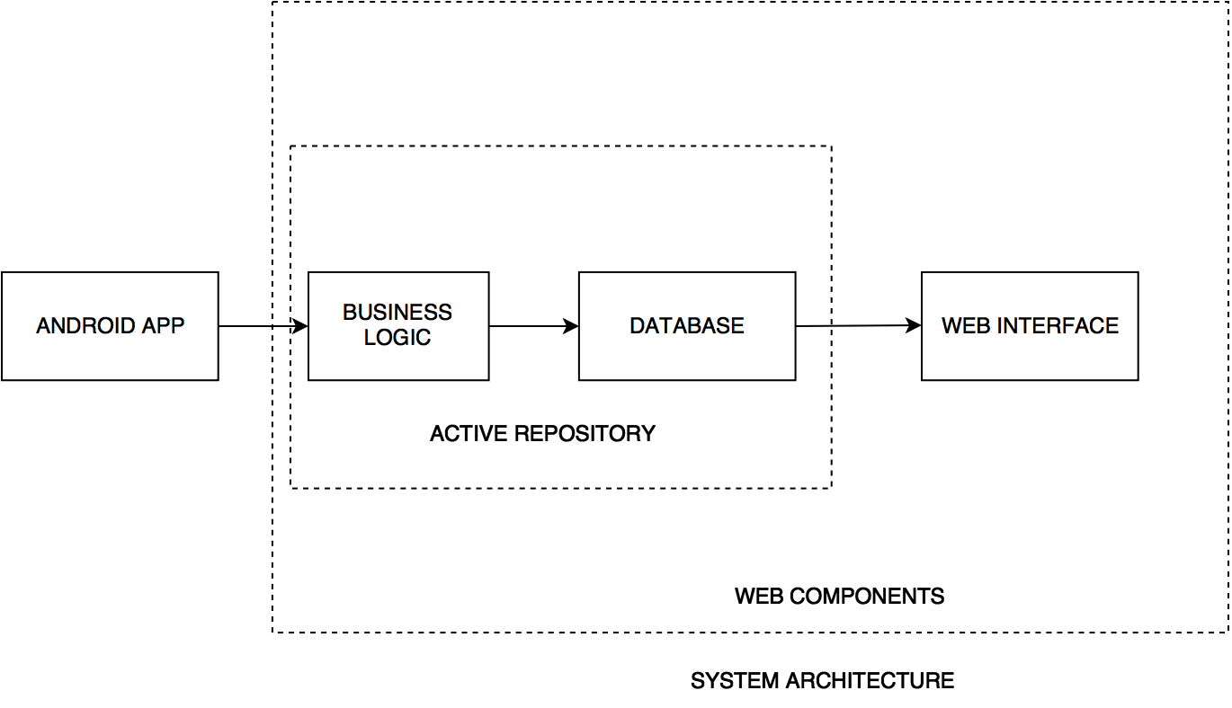

(ii) **Secate App Architecture – MVC**

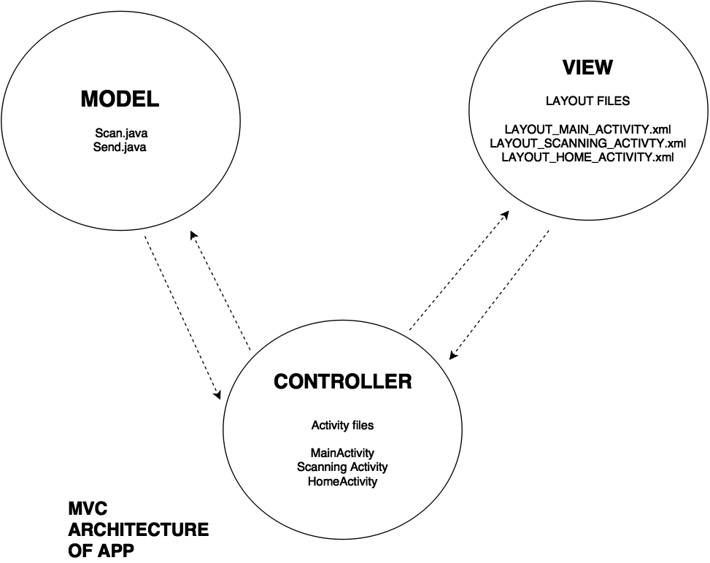

(ii) **Secate Web-Portal Architecture:**



5. **Logical Views** :

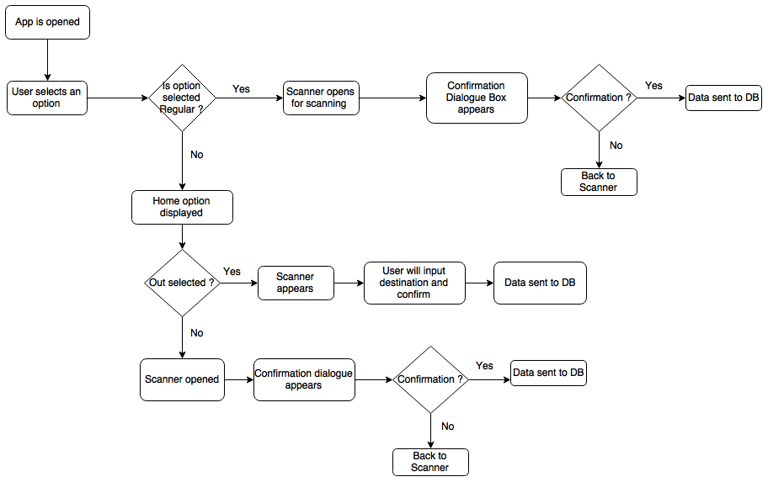



This view shows how the software is decomposed for development, that is, it shows the breakdown of the software into components that are implemented by a single developer or development team. This view is useful for software managers and programmers.



This view shows the key abstractions in the system as objects or object classes. It is possible to relate the system requirements to entities in this logical view. This view is very effective when it comes to understanding how the system will function. Such a logic enables the better functioning of the requirements and also leads to a clear view of the design of the system. It also helps to implement the desired architectural design patterns.

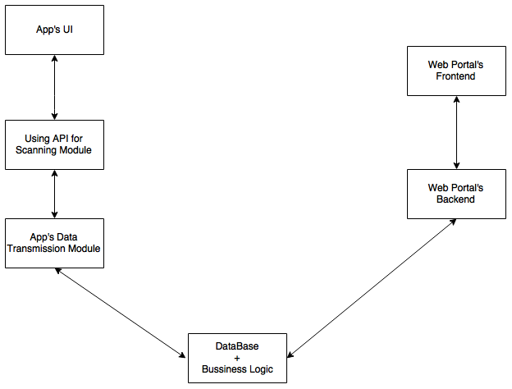

**6. Database:**

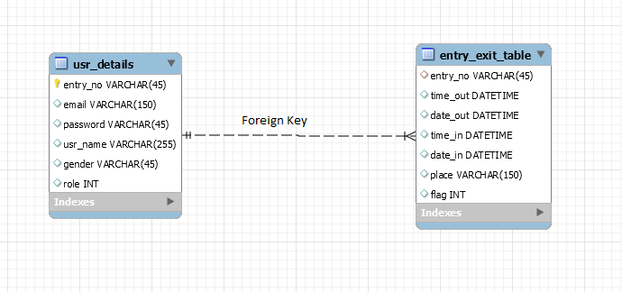

**7. Technical Overview:**

* Technology used for developing Android application is Android Studio.
* Google vision barcode API is used for barcode scanning. The Barcode API detects barcodes in real-time, on device, in any orientation. It can also detect multiple barcodes at once. It automatically parses QR Codes, Data Matrix, PDF-417, and Aztec values etc.
* Languages used for building web portal are CSS, HTML, PHP, JavaScript.
* D3.js is used for data visualization. **D3.js** is a JavaScript library for manipulating documents based on data. **D3** helps you bring data to life using HTML, SVG, and CSS. D3’s emphasis on web standards gives you the full capabilities of modern browsers without tying yourself to a proprietary framework, combining powerful visualization components and a data-driven approach to DOM manipulation.