**BUSSINESS MODEL**

Kartik Sharma

11/05/2024

# INTRODUCTION

The rapid growth of the ride-hailing industry has revolutionized urban transportation, granting consumers unparalleled access to mobility services. Yet, amidst this convenience, users face a labyrinth of challenges: opaque pricing structures, fluctuating fares, and the hassle of navigating multiple apps for fare comparison. Moreover, hidden fees, surge pricing, and driver cancellations add layers of complexity, while safety concerns loom large for both riders and drivers.

In response to these challenges, an AI-powered solution emerges as a beacon of clarity and convenience. Imagine an application seamlessly integrating fare rates from all ride-hailing services, along with comprehensive feedback and ratings from previous customers. This innovative platform empowers users with access to a diverse range of ride options and transparent pricing information. Real-time fare estimates, updated to reflect current pricing dynamics, enable users to make informed decisions and secure rides at optimal rates.

Notably, this solution transcends urban boundaries, catering to riders across prominent locations beyond metropolitan hubs in India. This ambitious endeavour involves the development of sophisticated APIs and integration modules to aggregate real-time fare data from multiple sources. Cutting-edge algorithms analyse and compare ride fares, accounting for dynamic pricing factors like surge pricing and distance-based charges. Machine learning models leverage historical ride data and external variables to predict fare fluctuations, enabling personalized recommendations and timely notifications for users.

Moreover, by harnessing the power of machine learning, the application forecasts future fare changes with precision, considering user preferences, time-sensitive variables, and market trends. This predictive capability not only aids consumers in making savvy ride scheduling decisions but also enables ride-hailing service providers to optimize operations and enhance resource allocation efficiency.

Market Segmentation:

Market segmentation is a fundamental concept in marketing that involves dividing a heterogeneous market into smaller, more homogeneous segments based on certain characteristics such as demographics, psychographics, behaviour, or geographic location. By identifying and understanding the distinct needs, preferences, and behaviours of various customer segments, companies selling EV can tailor their products, services, and marketing strategies to effectively target and serve each segment.

1. **BUSSINESS IDEAS**

To sustain a business model, it is necessary to have monetization on the website or application, so some of ideas for monetization in cab fare compare business are:

* 1. ADS CHARGING MODEL EXPLANATION:

Implementing an ads charging model involves offering advertising space within the application to third-party businesses. This can include display ads, sponsored listings, or targeted promotions tailored to user preferences and behaviour. By partnering with relevant advertisers, such as local businesses, restaurants, or travel agencies, we can generate revenue through ad placements. Advertisers pay for exposure to our user base, while users benefit from discovering relevant services or deals within the app.

* 1. COMMISION FROM CAB BOOKINGS:

A key revenue stream for our platform involves charging a commission fee for every cab booking made through our application. Upon successful completion of a ride booked via our platform, we can levy a commission ranging from 0.5% to 1.5% of the total fare. This commission model incentivizes cab companies to collaborate with us, as they gain access to a larger customer base and increased bookings. Additionally, after establishing our platform's credibility and stability over the first year, we can negotiate higher commission rates with cab companies, ranging from 1.5% to 3% of the total fare amount, thus enhancing our revenue potential.

* 1. SUBSCRIPTION MODEL:

We can have a subscription model where the user of over application will pay in advance for a few months, or for a year to enjoy some beneficial premium services like:

* USER INPUT AND SCHEDULING

Users can set up recurring trips by specifying Pick-up and Drop-of locations(e.g., home to office), preferred travel days and times, car type preferences(e.g., sedan, hatchback).

* SEAMLESS PAYMENT

Payments would be automatically deducted from the user's linked payment method within the app, eliminating the need for manual transactions during each ride.

* AUTO-BOOKING

The platform would monitor cab fares from various providers in real-time based on the user's preferences. When a ride falls within the user's scheduled timeframe and the fare from the cheapest provider meets their budget (which can also be set by the user), the platform automatically books the cab. Users would receive notifications about confirmed bookings with details like driver information, estimated arrival time, and fare.

* GUARANTEED AVAILABILITY

For an additional fee within the subscription, users could opt for guaranteed cab availability during their scheduled trips. This would be useful in high-demand periods.

* 1. PARTNERSHIPS AND SPONSERSHIPS:

Forge strategic partnerships with brands, events, or local businesses to sponsor rides or offer co-branded promotional campaigns. Partnering with events, festivals, or conferences to provide sponsored rides to attendees can enhance brand visibility and generate sponsorship revenue. Additionally, collaborate with corporate clients or travel agencies to offer specialized ride-hailing services tailored to their needs, such as employee transportation solutions or travel packages.

* 1. AFFILIATE MARKETING:

Partner with e-commerce platforms, travel agencies, or other relevant businesses and earn commissions for referring users to their services. For example, integrate affiliate links within the app for hotel bookings, flight reservations, or local attractions. Whenever a user makes a purchase through these affiliate links, the platform earns a commission from the transaction. Affiliate marketing provides an additional revenue stream without directly selling products or services.

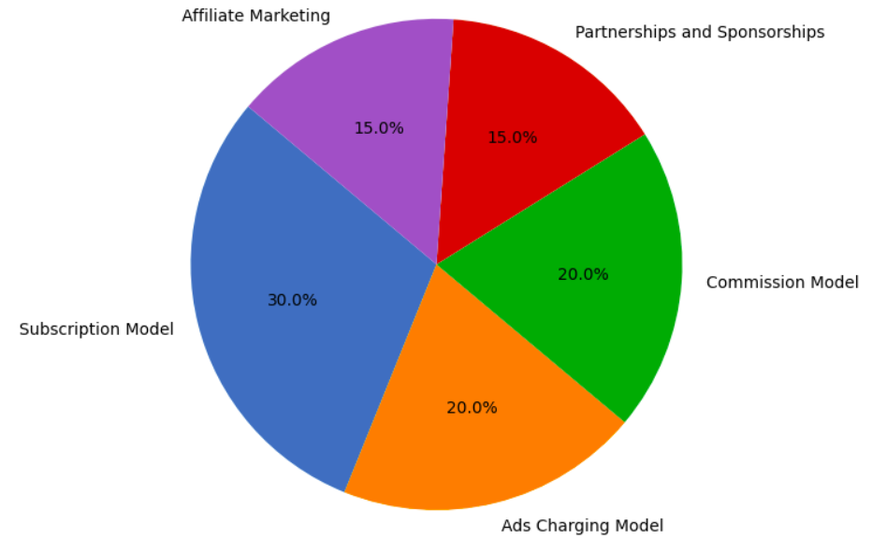

## DATA COLLECTION

## For the purpose of conducting market segmentation analysis in the cab industry to understand the importance of cab fare compare in future, a dataset was collected from Kaggle. The dataset contains information on 154235 cab bookings and includes the following 16 features:

* **ID** - Unique Identifier
* **vendor_id** - Taxi data providing vendor; 1 = TaxiTech Inc. 2 = DataCollectors Inc.
* **pickup_loc** - Location ID from where passenger was picked up
* **drop_loc** - Location ID where passenger was dropped
* **driver_tip** - Tip given to driver
* **mta_tax** - Automatically triggered tax amount
* **distance** - Distance covered in the trip
* **pickup_time** - Date/Time when meter started
* **drop_time** - Date/Time when meter stopped
* **num_passengers** - Cab passenger count
* **toll_Amt** - Toll paid in the booths
* **payment_Method** - Method of payment symbolised by a numeric code (1 = Credit Card, 2 = Cash, 3 = Free ride, 4 = Disputed, 5 = Unknown, 6 = Void trip)
* **rate_code** - Rate code for the trip (1 = Standard, 2 = Airport, 3 = Connaught Place, 4 = Noida, 5 = Negotiated Fare, 6 = Pooled ride)
* **stored_flag** - Flag which signifies whether trip data was immediately sent to Chh-OLA’s database or not (Y=Yes, N=No, because of connection error)
* **extra_charges** - Miscellaneous charges
* **improvement_charge** - Charge levied for improvement in infrastructure

The dataset provides a comprehensive overview of customer preferences on cabs, and their needs to book a cab as well.