1)

Object-Oriented Programming (OOP) Notes

1. History and Evolution
- Mathematical Foundations (1930s): Early programming paradigms originated mathematically through lambda calculus and the Turing machine.
- Origin of OOP (1966): The term Object-Oriented Programming was coined by Alan Kay around 1966 during his graduate studies.
- Early Inspirations (1961–1962): The Sketchpad application served as a primary early inspiration for constructing object-based systems.
- First OOP Concepts (1965): The Simula language introduced foundational OOP concepts, including classes, subclasses, inheritance, and virtual methods.

2. Advantages of Object-Oriented Programming (OOP)
- Modularity through Classes: Organizes code into distinct, manageable modules.
- Code Reusability: Allows developers to reuse code across different modules without duplication.
- Encapsulation: Bundles data and methods into a single unit while restricting direct access.
- Inheritance: Enables child classes to inherit attributes and methods from parent classes.
- Abstraction: Hides implementation complexities and exposes only essential features.
- Polymorphism: Provides flexibility by enabling standard interfaces to execute distinct behaviors.
- Data Maintenance and Security: Enhances system security and simplifies maintenance.
- Design Advantages: Supports structured software architecture and scalable system designs.

3. Classes and Objects in C++
- Core Paradigm: Programs in C++ are designed around the interaction between classes and objects.
- Definition of an Object: An object encapsulates both:
  - State: The data/attributes associated with the object.
  - Behavior: The functionality/methods that operate on the data.
- Runtime Instantiation: Objects are instantiated dynamically at runtime.
- Class vs. Object Example: A blueprint concept like a Cylinder acts as a class, while specific instances created from that design represent individual objects.
2)

4. Fundamentals of Objects in C++
- Definition: An instance of a class used to access all class members (e.g., Time T1;).
- Types of Entities:
  - Physical (Tangible): Real-world items like chairs, bikes, pens, or cars.
  - Logical (Intangible): Abstract systems like a banking system.
- Core Characteristics:
  - State: Represents the data values of an object (e.g., Pen color = "Golden").
  - Behavior: Represents functionality or actions (e.g., deposit(), write()).
  - Identity: Unique identifier distinguishing objects (e.g., memory address or hash map ID).

5. Fundamentals of Classes in C++
- Definition: A blueprint or template used to create a group of similar objects.
- Key Components:
  - Member data (fields/variables)
  - Member functions (methods)
  - Constructors
  - Blocks and nested classes

Object Identity: C++ vs. Java
In object-oriented programming, object identity determines whether two variables refer to the exact same instance in memory, regardless of whether their internal state or data values match.

Key Definitions
- Java Virtual Machine (JVM): The runtime execution engine that runs Java bytecode. It manages memory and garbage collection automatically while abstracting away raw physical memory addresses.
- HashCode: An integer value returned by Java's hashCode() method (or System.identityHashCode()) that acts as an object's unique identifier within Java's identity tracking system.

Comparison Matrix
Feature | C++ Object Identity | Java Object Identity
Underlying Basis | Physical memory address allocated to the object. | Internal reference ID managed by the JVM via Identity Hashmap.
Memory Access | Direct access to memory pointers. | Indirect reference; memory addresses are abstracted by the JVM.
Identity Check | Compare memory addresses via the address-of operator (&obj1 == &obj2). | Compare object references using obj1 == obj2 (or System.identityHashCode()).  image_8fc9fb.jpg
State Check | Compare member variables using overloaded == operators. | Compare state values using the .equals() method.

Detailed Breakdown

1. C++ Object Identity
- Mechanism: Object identity is bound directly to the object's physical location in system memory.
- Verification: Checking if two pointers or references point to the exact same object is done by comparing their memory addresses using &obj1 == &obj2.

2. Java Object Identity
- Mechanism: The JVM tracks instances using references and generates an identity hash code for each object (System.identityHashCode(obj)).
- Verification:
  - Identity Comparison (==): Checks if two reference variables point to the exact same memory instance.
  - State Comparison (.equals()): Checks if the actual data contents inside two separate objects are logically equivalent.
3)
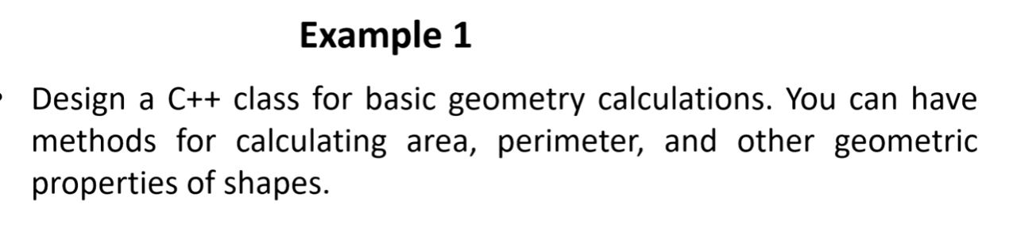
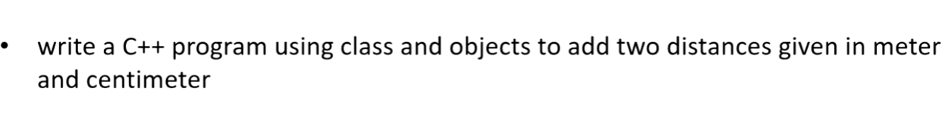
4)

Write a c++ program to add two complex number .

Motivation for Class Design in C++
- Overview: Object-oriented programming (OOP) uses objects and classes to effectively model and solve complex real-world problems.

Key Scenarios & Applications
- Library Management System:
  - Classes: Books, users, loans, staff members.
  - Attributes: Book titles, due dates.
  - Behaviors: Borrowing or returning books.
- Banking System:
  - Classes: Customers, accounts, transactions.
  - Behaviors: Deposit, withdrawal, balance inquiry.
- Chess Game:
  - Classes/Objects: Game board (holds pieces), pieces (pawn, king, queen).
  - Behaviors: Specific piece movements and game rules.
- Traffic Simulation:
  - Classes/Objects: Vehicles, roads, traffic lights.
  - Behaviors: Simulating movement and traffic flow dynamics.
- Data Structures (Linked Lists, Stacks, Queues, Trees):
  - Classes: Nodes and structural containers.
  - Behaviors: Adding, removing, or manipulating data.
- Neural Networks:
  - Classes: Layers, neurons, connections.
  - Behaviors: Forward propagation, backpropagation, model training.
7)

Static Variable Notes

Key Concept
- Ordinary Variable: Scope and lifetime are restricted to the local block/function where it is defined. It gets re-initialized on every function call.
image_3d8e5f.png+ 1
- Static Variable: Lifetime extends throughout the entire execution of the program. It is initialized only once and retains its modified value across multiple function calls.
image_3d8e5f.png+ 1

Comparison Code Examples

1. Ordinary Variable (Re-initialized Every Call)
C
#include <stdio.h>

int func() {
int count = 0; // Re-initialized to 0 on each call
count++;
return count;
}

int main() {
printf("%d", func()); // Output: 1
printf("\n%d", func()); // Output: 1
return 0;
}
```[cite: 17]

### 2. Static Variable (Retains State Across Calls)
```c
#include <stdio.h>

int func() {
static int count = 0; // Initialized only once
count++;
return count;
}

int main() {
printf("%d", func()); // Output: 1
printf("\n%d", func()); // Output: 2
return 0;
}
```[cite: 16]

8)
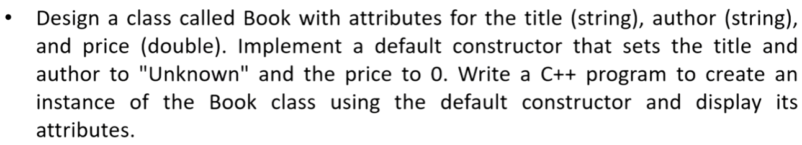
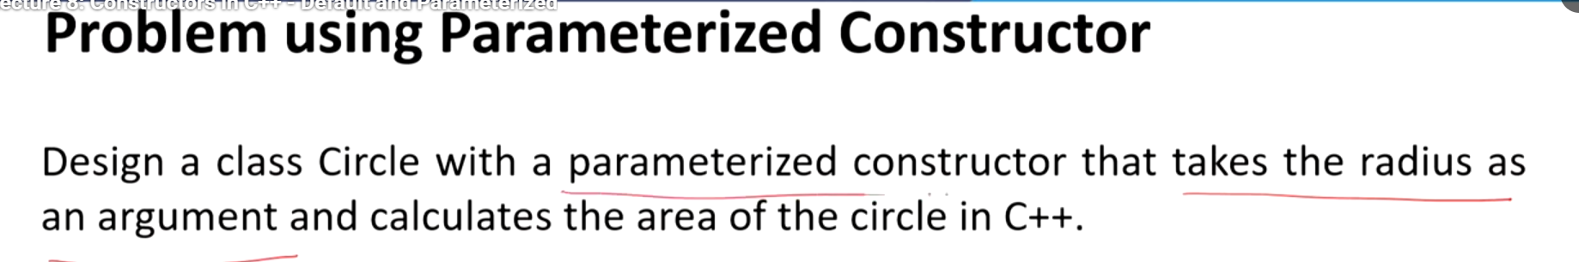
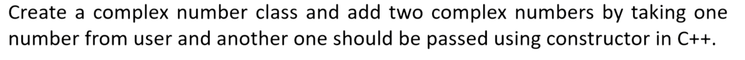
9)

1. What is a Constructor?
- Definition: A special member function that is automatically executed when an object of a class is created.
- Purpose: Used to initialize the data members of a new object.
- Naming: Must have the exact same name as the class or structure.

Syntax Declarations
- Declaration inside class: <class-name>(list-of-parameters);
- Definition inside class: <class-name>(list-of-parameters) { // constructor definition }
- Definition outside class: <class-name>::<class-name>(list-of-parameters) { // constructor definition }

2. Defining Member Functions Outside Class
Member functions declared inside a class can be defined outside using the scope resolution operator (::).
C++
#include <iostream>
using namespace std;

class MyClass {
public:
void printMessage(); // Function declaration inside class[cite: 5]
};

// Function definition outside the class[cite: 5]
void MyClass::printMessage() {
cout << "Hello from MyClass!" << endl;[cite: 5]
}

3. Types of Constructors

A. Default Constructor
- Takes no parameters.
- Automatically invoked during simple object declaration.
C++
#include <iostream>
using namespace std;

class Employee {
public:
Employee() { // Default constructor[cite: 3]
cout << "Testing Default Constructor" << endl;[cite: 3]
}
};

int main() {
Employee e1; // Triggers Default Constructor[cite: 3]
return 0;
}

B. Parameterized Constructor
- Accepts arguments to initialize data members with specific values.
C++
#include <iostream>
using namespace std;

class Employee {
public:
int id;[cite: 4]
string name;[cite: 4]
float salary;[cite: 4]

// Parameterized constructor[cite: 4]
Employee(int i, string n, float s) {
id = i;[cite: 4]
name = n;[cite: 4]
salary = s;[cite: 4]
}
};

C. Copy Constructor
- Initializes an object using another existing object of the same class.
- Syntax accepts a reference parameter: <class-name>(&object_name).
C++
#include <iostream>
using namespace std;

class Example {
public:
int a;[cite: 6]

Example(int x) { a = x; } // Parameterized constructor[cite: 6]

Example(Example &ob) { // Copy constructor[cite: 6]
a = ob.a;[cite: 6]
}
};

4. Destructor in C++
- Definition: A special member function called automatically when an object goes out of scope or is destroyed.
- Syntax: Represented by a tilde symbol (~) preceding the class name (e.g., ~Employee()).
C++
#include <iostream>
using namespace std;

class Employee {
public:
Employee() { // Constructor[cite: 7]
cout << "Constructor Invoked" << endl;[cite: 7]
}

~Employee() { // Destructor[cite: 7]
cout << "Destructor Invoked" << endl;[cite: 7]
}
};

10)
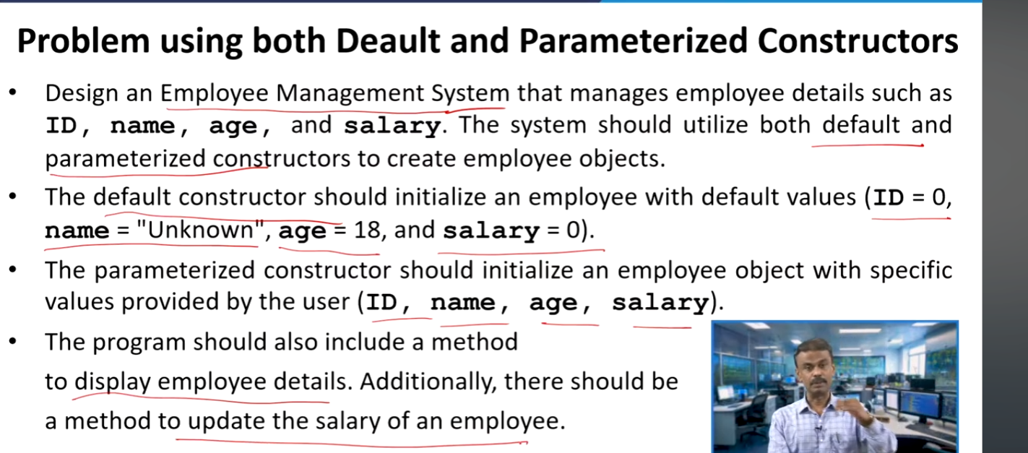
11)

1. Access Specifiers in C++
Access specifiers control the visibility and accessibility of class members (variables and functions).
image_e73307.jpg+ 3
Access Specifier | Scope & Accessibility
public | Accessible from anywhere (inside or outside the class).  image_e73307.jpg
private | Accessible only within the declaring class and by friend functions.  image_e73307.jpg+ 1
protected | Accessible within the class and its derived (child) classes.  image_e72f61.jpg+ 1

Example Code: Access Specifiers
C++
#include <iostream>
using namespace std;

class Base {
public:
int publicVar = 1; // Accessible anywhere[cite: 8]

private:
int privateVar = 2; // Accessible ONLY within Base class[cite: 8, 10]

protected:
int protectedVar = 3; // Accessible within Base and derived classes[cite: 9, 11]
};

int main() {
Base obj;
cout << obj.publicVar << endl; // Works[cite: 8]
// obj.privateVar; // Error: private[cite: 8, 10]
// obj.protectedVar; // Error: protected[cite: 9]
return 0;
}

Inheritance

1. Core Concepts
- Definition: Inheritance allows a derived class (subclass) to inherit attributes (data fields) and functions (methods) from a base class (superclass).
- Key Benefits:
  - Code Reusability: Avoids repeating code by sharing common features across classes.
  - Class Relationships: Establishes clear hierarchical structures between classes.
  - Function Overriding: Enables derived classes to redefine behaviors defined in the base class.

2. Single / Simple Inheritance
- Definition: A type of inheritance where a derived class inherits directly from only one base class.
- Hierarchy:
  - Base Class: Class A (The class being inherited from)
  - Derived Class: Class B (The class that inherits from Class A)

3. Key Rules & Syntax Patterns
- Inheritance Declaration Syntax:
class DerivedClass : access_specifier BaseClass
- Member Access:
Objects created from the derived class automatically gain access to all public data fields and methods defined inside the base class.

