METRO ROUTE FINDER
An Enterprise Graph Optimization & Route Analytics System

A PROJECT REPORT

Submitted in partial fulfilment of the requirement for the award of degree of
Bachelor of Technology
in
Computer Science & Engineering

Submitted by:
Kartik Yadav, Ali Asgar
Registration No.: 12413232, 12505331

DEPARTMENT OF COMPUTER SCIENCE & ENGINEERING
LOVELY PROFESSIONAL UNIVERSITY
Jalandhar – Delhi, G.T. Road, Phagwara, Punjab – 144411
2026

ACKNOWLEDGEMENT
I would like to express my sincere gratitude to everyone who supported me during the design, development, and documentation of this project, “Metro Route Finder – An Enterprise Graph Optimization & Route Analytics System.”
I am deeply thankful to my project guide for the valuable guidance, continuous encouragement, and constructive feedback provided throughout the course of this project. Their insights on system design, algorithmic correctness, and software engineering practices were instrumental in shaping the final outcome of this work.
I extend my gratitude to the Department of Computer Science & Engineering, Lovely Professional University, for providing the academic environment, resources, and opportunity to undertake this final year project as part of the Bachelor of Technology curriculum.
I also acknowledge the open-source community and the documentation of the technologies used in this project — React, Node.js, Express, C++17, CMake, GoogleTest, and Leaflet — whose freely available resources made the independent development of this full-stack application possible.
Finally, I thank my family and peers for their patience, motivation, and moral support during the course of this project.

Kartik Yadav
Registration No.: 12413232

TABLE OF CONTENTS
Chapter 1 Front Page
Chapter 2 Certificate
Chapter 3 Acknowledgement
Chapter 4 Table of Contents
Chapter 5 List of Figures
Chapter 6 List of Tables
Chapter 7 Abstract
Chapter 8 Introduction
Chapter 9 Literature Survey
Chapter 10 Problem Statement
Chapter 11 Objectives
Chapter 12 Existing System
Chapter 13 Proposed System
Chapter 14 System Requirements
Chapter 15 Technology Stack
Chapter 16 System Architecture
Chapter 17 Database Design
Chapter 18 Algorithms
Chapter 19 API Documentation
Chapter 20 Implementation
Chapter 21 Testing
Chapter 22 Results
Chapter 23 Advantages
Chapter 24 Limitations
Chapter 25 Future Scope
Chapter 26 Conclusion
Chapter 27 References

LIST OF FIGURES
Chapter Fig. 1 Passenger Dashboard (Home Page)
Chapter Fig. 2 Search Station Module
Chapter Fig. 3 Route Planner and Digital Boarding Ticket
Chapter Fig. 4 Interactive Metro Map (Geographic System Visualizer)
Chapter Fig. 5 Algorithmic Performance Hub (Benchmark Visualizer)
Chapter Fig. 6 Network Graph Analytics Dashboard
Chapter Fig. 7 Journey History Log
Chapter Fig. 8 System Preferences (Settings)
Chapter Fig. 9 Admin Authentication (Login Gate)
Chapter Fig. 10 Admin Panel Dashboard (Station/Track Editor & Backups)

LIST OF TABLES
Chapter Table 1 Hardware Requirements
Chapter Table 2 Software Requirements
Chapter Table 3 Technology Stack Summary
Chapter Table 4 Public REST API Endpoints
Chapter Table 5 Admin REST API Endpoints (JWT Protected)
Chapter Table 6 Algorithm Complexity Reference
Chapter Table 7 Live Network Graph Analytics (Observed)
Chapter Table 8 Algorithm Benchmark Output (Observed, A → G)
Chapter Table 9 Route Planner Output (Observed, A → G)
Chapter Table 10 Testing Suite Coverage Summary

CHAPTER 7

ABSTRACT
Metro Route Finder is a full-stack, three-tier metro navigation and route-analytics system that combines a C++17 graph-optimization engine, a Node.js/Express REST API middleware layer, and a React.js single-page application front end. The system models a metro network as a weighted, undirected graph in which stations are vertices and inter-station tracks are edges carrying distance, travel-time, and fare weights. The C++ engine is compiled as a standalone command-line executable and is invoked by the Express server as a child process to compute shortest, fastest, and cheapest routes using classical graph algorithms, principally Dijkstra's algorithm for weighted shortest paths and Breadth-First Search for minimum-hop routes, with Depth-First Search used for connectivity validation.
The project persists its data — station nodes, track connections, and journey history — as flat JSON files (stations.json, connections.json, history.json) rather than a conventional relational or NoSQL database, with atomic tmp→rename file writes used to avoid corruption during concurrent mutation. A JWT (HMAC-SHA256) protected Admin Panel allows create, update, and delete operations on stations and tracks, together with a timestamped backup-and-restore mechanism for the JSON dataset.
The React front end exposes a Passenger Dashboard with journey statistics and CO₂-saving telemetry, a fuzzy-matching Search Station module, a Route Planner that issues a digital boarding ticket with a generated QR code, an interactive Leaflet-based network map, an Algorithm Benchmark visualizer comparing Dijkstra, BFS, DFS and A* on execution time, nodes visited and memory footprint, and a Network Analytics page reporting graph-theoretic metrics such as density, average degree, and minimum spanning tree cost. The interface additionally supports a bilingual (English/Hindi) toggle and a dark theme.
This report documents the system's actual, verifiable implementation as deployed on Render (frontend and backend services) and hosted on GitHub, based on direct inspection of the project's source-level documentation (Architecture.md, DOCUMENTATION.md, Algorithm-Explanation.md) and the live, deployed application. Observed metrics — an 8-station, 9-track, 4-line network with a graph density of 0.321 and an average vertex degree of 2.25 — are reported exactly as captured from the deployed dashboard, and known gaps in the current build (such as an unpopulated “Path Output” field in the benchmark view and blank minimum-spanning-tree/most-connected-hub fields in analytics) are documented candidly as current limitations rather than omitted or reinterpreted.

CHAPTER 8

INTRODUCTION
Urban metro rail systems have become the backbone of public transportation in most large cities due to their capacity, speed, and independence from road-level traffic congestion. As metro networks expand across multiple lines and interchange stations, commuters increasingly rely on digital tools to plan journeys, compare fares, and estimate travel time rather than consulting static route maps. Metro Route Finder is a final-year B.Tech project that addresses this need by combining graph theory, systems programming, and modern web development into a single, deployable application.
At its core, the project treats a metro network as a mathematical graph: each station is a vertex, and each direct track segment between two stations is a weighted, undirected edge carrying three independent weights — physical distance in kilometres, travel time in minutes, and monetary fare in rupees. This graph representation allows the application of well-established graph algorithms — Dijkstra's algorithm, Breadth-First Search, and Depth-First Search — to answer practical passenger questions such as “what is the shortest route,” “what is the fastest route,” and “what is the route with the fewest interchanges.”
The system is deliberately structured as three independent tiers. The computational core is written in C++17 and compiled with CMake into a command-line executable that performs graph construction and route-finding; this executable is invoked by a Node.js/Express REST API that exposes the computation over HTTP, applies fare and surcharge business logic, persists journey history, and enforces authentication for administrative operations; and a React.js single-page application consumes this API to present passengers and administrators with an interactive dashboard, a Leaflet-based map, and a bilingual (English/Hindi) user interface.
This report documents the project strictly as implemented and deployed — the backend is reachable at https://metro-route-finder-api.onrender.com and the frontend at https://metro-route-finder-1.onrender.com, both hosted on Render, with source code maintained at https://github.com/Kartik-Yadav0001/metro-route-finder. All architectural claims, algorithm descriptions, and numerical results in the chapters that follow are drawn from the project's own documentation folder (docs/Architecture.md, docs/DOCUMENTATION.md, docs/Algorithm-Explanation.md) and from direct observation of the live application's Passenger Dashboard, Route Planner, Interactive Map, Algorithm Benchmark, Network Analytics, Journey History, Settings, and Admin Panel screens.

CHAPTER 9

LITERATURE SURVEY
The problem of finding an optimal route through a transportation network is a well-studied application of graph theory. Edsger W. Dijkstra's 1959 algorithm for the shortest path problem remains the foundational technique for computing a minimum-cost path between a single source and all other vertices in a graph with non-negative edge weights, and it forms the primary route-finding mechanism used in this project for shortest-distance, fastest-time, and cheapest-fare queries.
Breadth-First Search (BFS), a graph traversal method that explores vertices level by level from a source, is widely used in unweighted or hop-count-based shortest-path problems; in the context of a metro network, BFS naturally answers the question of which route involves the fewest station-to-station hops, independent of distance or fare. Depth-First Search (DFS), by contrast, is not typically used for shortest-path computation but is well suited to structural graph problems such as connectivity checking and reachability validation, which this project uses to verify that the metro network graph does not contain isolated, unreachable stations.
Beyond these three core algorithms, the project's documented class design (see the UML diagram reproduced in Chapter 16) also declares an A* heuristic search, bidirectional variants of BFS and Dijkstra, an all-pairs Floyd-Warshall computation, and Yen's algorithm for K-shortest loopless paths — all of which are recognised techniques in classical pathfinding and graph theory literature, with A* commonly used in road-network and grid-based navigation problems where a coordinate-based heuristic (such as Euclidean distance to the goal) can accelerate the search relative to plain Dijkstra.
On the systems side, the project draws on established full-stack web development conventions: a stateless REST API built with the Express.js framework on Node.js, JSON Web Tokens (JWT) using HMAC-SHA256 for authentication of administrative routes, and a React.js single-page application for the client interface, with Leaflet.js used for interactive map rendering using a flat, non-geographic coordinate reference system (L.CRS.Simple) suited to schematic transit maps rather than real-world GPS coordinates. Existing academic and open-source metro route-finder projects reviewed for context (several of which are cataloged under the “metro-route-finder” and “metro” topics on GitHub) typically implement only a single algorithm — most commonly Dijkstra — over a static in-memory graph without a persistent administrative interface, a benchmarking view, or a graph-analytics dashboard, which this project extends upon.

CHAPTER 10

PROBLEM STATEMENT
Commuters using an urban metro network frequently need to determine the most suitable route between two stations, where “most suitable” may mean the shortest physical distance, the fastest travel time, the cheapest fare, or the fewest interchanges, depending on the passenger's priorities at that moment. Static wall maps and printed fare charts cannot answer such comparative questions dynamically, and manually computing multiple weighted shortest paths through a multi-line, multi-interchange network is impractical for an end user.
Separately, the personnel who maintain a metro network's digital route-planning system need a controlled way to add new stations, connect new track segments, and safely back up or roll back the underlying dataset, without directly editing raw data files and risking corruption or downtime.
The problem this project addresses is therefore twofold: (1) to design and implement a graph-based computational engine capable of answering multiple classes of shortest-path queries over a weighted metro network efficiently, and (2) to expose this engine through a secure, user-friendly web application that serves both passengers, who need route planning, fare estimation, and journey history, and administrators, who need authenticated CRUD control over the underlying station/track dataset with backup and restore capability.

CHAPTER 11

OBJECTIVES
The specific objectives pursued in the design and implementation of Metro Route Finder, as verified against the deployed application and source repository, are as follows:
- To model a metro rail network as a weighted, undirected graph using an adjacency-list representation implemented in C++17, with stations as vertices and tracks as edges carrying distance, time, and fare weights.
- To implement Dijkstra's algorithm for computing the shortest-distance, fastest-time, and cheapest-fare routes between any two stations in the network.
- To implement Breadth-First Search for computing the route with the minimum number of stops (hops), independent of edge weights.
- To implement Depth-First Search for verifying structural connectivity of the network graph.
- To expose the C++ route-finding engine to client applications through a Node.js/Express REST API, including endpoints for route planning, algorithm comparison, station/connection retrieval, and graph analytics.
- To secure all data-mutating administrative operations (station and track creation, modification, and deletion) behind JWT (HMAC-SHA256) bearer-token authentication.
- To provide a timestamped backup-and-restore mechanism for the underlying JSON dataset, safeguarding against accidental data loss during administrative edits.
- To build an interactive, bilingual (English/Hindi) React.js single-page application front end that presents passengers with a dashboard, station search, route planning, a Leaflet-based interactive map, and a digital boarding ticket with a QR code.
- To provide an in-application algorithm benchmark visualizer that compares the execution time, nodes visited, and memory footprint of Dijkstra, BFS, DFS, and A* for a given source-destination pair.
- To compute and display network-wide graph analytics — including total stations, tracks, lines, connected components, average degree, graph density, and minimum spanning tree cost — for administrative insight into the network's structure.
- To deploy the complete three-tier system (C++ engine invoked from the Express API, and the React frontend) to a public hosting platform (Render) for live demonstration and evaluation.

CHAPTER 12

EXISTING SYSTEM
Commuters currently rely on a mix of static and semi-dynamic tools to plan metro journeys. Physical route maps and fare charts displayed at stations present only the complete network topology and a fixed fare table, requiring the passenger to manually trace a path and sum fares or interchange counts — an approach that does not scale well to large, multi-line networks and provides no comparative view of alternative routing strategies (fastest vs. cheapest vs. fewest stops).
Many existing digital or academic metro-route-finder implementations reviewed during the literature survey (Chapter 9) provide a single shortest-path computation, most often using Dijkstra's algorithm over a hard-coded or lightly configurable graph, exposed through a simple command-line tool or a minimal single-page web form. These systems typically lack: (a) more than one routing strategy exposed to the end user (e.g., only shortest distance, with no fastest-time or fewest-interchange alternative); (b) an authenticated administrative interface for updating the underlying station/track dataset without redeploying code; (c) any comparative performance benchmarking between algorithms; and (d) graph-theoretic analytics such as network density, average degree, or minimum spanning tree computation.
Furthermore, existing systems of this class generally do not persist a journey history, do not compute environmental metrics such as CO₂ savings relative to road transport, and do not provide multilingual accessibility. The absence of an administrative backup-and-restore mechanism in most such systems also means that any accidental or malicious edit to the underlying data has no straightforward recovery path.

CHAPTER 13

PROPOSED SYSTEM
Metro Route Finder proposes a three-tier architecture that separates computational, service, and presentation concerns while remaining simple enough for a single-developer academic project to build, test, and deploy. The computational tier is a C++17 executable (MetroRouteFinder.exe / equivalent Linux binary) built with CMake, which loads the station and connection graph from JSON files, exposes multiple route-finding strategies (Dijkstra, BFS, DFS, and, per the documented class design, A*, bidirectional search, Floyd-Warshall, and Yen's K-shortest paths), and can also be queried directly from the command line for statistics, single routes, and algorithm comparisons.
The service tier is a Node.js/Express REST API that acts as the single integration point between the C++ engine and the web client. For each incoming route or comparison request, the API spawns the C++ executable as a child process with the relevant arguments, waits for its JSON result on standard output, and augments it with fare computation (base fare plus a per-kilometre distance fare, with a documented peak-hour surcharge and off-peak discount), a deterministically generated QR code for the digital boarding ticket, and a persisted entry in history.json. Administrative routes under /api/admin are gated by JWT bearer tokens using HMAC-SHA256 signing, and all mutating writes to the JSON dataset use an atomic tmp-file-then-rename pattern intended to prevent partial/corrupted writes.
The presentation tier is a React.js single-page application (built with Vite) that consumes the REST API. It is organized into distinct pages/panels reachable from a persistent sidebar — Home (Passenger Dashboard), Search Station, Route Planner, Interactive Map, Algorithms (Benchmark), Network Analytics, History, Admin Panel, and Settings — with a bilingual English/Hindi toggle and a dark theme applied consistently across all views, as observed directly in the deployed application.
This proposed design improves on the existing systems surveyed in Chapter 12 by exposing multiple routing strategies through one unified Route Planner interface, adding an authenticated Admin Panel with full station/track CRUD and JSON snapshot backup/restore, providing a dedicated Algorithm Benchmark page for direct algorithmic comparison, and computing network-wide graph analytics (density, average degree, connected components, minimum spanning tree) that are not present in the simpler systems reviewed.

CHAPTER 14

SYSTEM REQUIREMENTS

Hardware Requirements
Component | Minimum Requirement
Processor | Dual-core, 1.6 GHz or higher
RAM | 4 GB (8 GB recommended for building the C++ backend and running the frontend dev server together)
Storage | 500 MB free disk space for source code, node_modules, and build artifacts
Network | Internet connectivity required to reach the Render-hosted frontend/backend, or a LAN connection for local development
Table 1: Hardware Requirements

Software Requirements
Component | Requirement
Operating System | Windows (MinGW/GCC toolchain documented), or any OS capable of running Node.js and a CMake/GCC C++ toolchain
Backend Compiler | C++17-compliant compiler (GCC/MinGW) with CMake build system
Runtime | Node.js (for the Express API server and the Vite-based React frontend)
Package Manager | npm
Testing Frameworks | GoogleTest (GTest) for C++ unit tests; a custom Node.js HTTP integration test suite (tests/api_tests.js)
Version Control | Git, hosted on GitHub
Deployment Platform | Render (separate services for the frontend static/SPA build and the backend Express API)
Browser | Any modern evergreen browser (Chrome, Edge, Firefox) supporting ES2015+ JavaScript
Table 2: Software Requirements

CHAPTER 15

TECHNOLOGY STACK
The technology choices in Metro Route Finder are drawn directly from the project's repository structure, package configuration, and the README's stated architecture. The stack is organized around three cooperating tiers as follows.

Backend Computation Tier
- C++17 — core graph data structures and route-finding algorithms (Graph, RouteFinder, FileManager classes).
- CMake — cross-platform build configuration for compiling the C++ engine into an executable.
- GoogleTest (GTest) — unit testing framework for the C++ engine (RouteFinderTests, AdminCrudTests, PersistenceTests, as named in the README build instructions).

Service / Middleware Tier
- Node.js — JavaScript runtime hosting the REST API server.
- Express.js — web framework used to define REST routes, request parsing, and middleware (rate limiting, body-size limits, JWT verification).
- JSON Web Tokens (JWT) — implemented via zero-dependency HMAC-SHA256 signing (per the README) to protect all /api/admin/* routes.
- Child-process invocation — the Express server spawns the compiled C++ executable per request rather than embedding the C++ logic in-process.

Frontend Presentation Tier
- React.js — single-page application framework structuring the UI into a main App.jsx with reusable components (MetroMap, ErrorBoundary, MetricCard, InputField, per the repository's frontend/src/components directory).
- Vite — development server and build tool for the React application (npm run dev serving on port 5173, per the README).
- Leaflet.js — interactive mapping library, used with a flat, non-geographic coordinate system (L.CRS.Simple) to render the schematic metro network map with clickable stations and route animation.
- Custom CSS (frontend/src/styles/index.css) — global styling and keyframe animations, supporting a dark-themed UI as observed in the deployed application.

Data Storage
- Flat JSON files — stations.json, connections.json, and history.json under the database/ directory, with timestamped snapshot files under database/backups/, in place of a relational or NoSQL database engine.

DevOps & Deployment
- Git / GitHub — version control, with a .github/workflows/ci.yml continuous-integration pipeline (frontend build, C++ tests, API tests, per the README project structure) and issue/PR templates.
- Render — cloud hosting platform serving the React frontend (https://metro-route-finder-1.onrender.com) and the Express API backend (https://metro-route-finder-api.onrender.com) as two independently deployed services, configured via render.yaml in the repository root.
Layer | Technology | Role
Computation | C++17 + CMake | Graph modelling and route-finding algorithms
Testing (C++) | GoogleTest | Unit tests for graph, CRUD, and persistence logic
Middleware | Node.js + Express.js | REST API, JWT auth, fare logic, persistence
Frontend | React.js + Vite | Single-page application UI
Mapping | Leaflet.js | Interactive schematic network map
Data Store | JSON files (flat-file) | Stations, connections, history, backups
Hosting | Render | Frontend + backend deployment
VCS / CI | Git, GitHub Actions | Version control and automated build/test pipeline
Table 3: Technology Stack Summary

CHAPTER 16

SYSTEM ARCHITECTURE
The diagrams in this chapter are reproduced faithfully from the project's own documentation files (docs/Architecture.md and docs/DOCUMENTATION.md), preserving their original Mermaid.js source so that the structure shown here is guaranteed to match the actual, committed design artifacts rather than an inferred or idealized architecture.

16.1 High-Level System Architecture
This flowchart, taken directly from docs/Architecture.md, shows the top-level relationship between the user, the React frontend, the JSON dataset, and the C++ engine.
Mermaid Source (docs/Architecture.md)
flowchart LR
U[User] --> R[React Frontend]
R --> D[(JSON Dataset)]
R --> C[C++ Engine]
C --> D
C --> O[Route Results]
Table 4: System Architecture (verbatim Mermaid flowchart)

16.2 Deployment View
The deployment-view diagram from the same source file distinguishes the developer-facing build/test workflow from the browser-facing runtime path.
Mermaid Source (docs/Architecture.md)
flowchart LR
Dev[Developer Machine] --> FE[frontend npm run dev]
Dev --> BE[backend CMake build]
FE --> Browser[Browser UI]
BE --> CLI[Backend Demo / Tests]
Table 5: Deployment View (verbatim Mermaid flowchart)
In the production deployment reflected by the live URLs, the equivalent runtime path is: the React build is served as the frontend Render service, the C++ executable is compiled during the backend Render service's build step and invoked by the Express API at request time, and the browser communicates only with the Express API over HTTPS.

16.3 Route-Calculation Flowchart
docs/DOCUMENTATION.md provides a detailed, end-to-end flowchart of a single route request, reproduced below verbatim.
Mermaid Source (docs/DOCUMENTATION.md)
graph TD
A[User Inputs: Start, End, Mode, Peak Hour] --> B[React Frontend App.jsx]
B --> C[HTTP POST /api/route]
C --> D[Express API Server server.js]
D --> E[Spawn child process: MetroRouteFinder.exe --route]
E --> F[C++ Query Engine main.cpp]
F --> G[FileManager::resolveDatasetPath()]
G --> H[Load stations.json & connections.json]
H --> I[Graph Constructor & Validation]
I --> J[RouteFinder Traversal: Dijkstra / BFS / A* / Yen's]
J --> K[Build RouteResult: distance, time, telemetry]
K --> L[Serialize RouteResult to JSON stdout & exit]
L --> D
D --> M[Calculate fares: base ₹10 + ₹5/km, peak +20%]
D --> N[Generate offline vector QR SVG (deterministic hash)]
D --> O[Save query to history.json]
D --> P[HTTP Response Payload]
P --> B
B --> Q[Render Leaflet map animation & digital ticket]
Table 6: Route Calculation Flowchart (verbatim Mermaid flowchart)
This flowchart confirms that the C++ engine is not a persistently running server process but a short-lived executable spawned per request, with its computed JSON result piped back to the Express layer, which then performs all fare and ticketing business logic before responding to the client.

16.4 Data Flow Diagram — Level 1
The Level-1 DFD in docs/DOCUMENTATION.md decomposes the system into four processes acting on three data stores.
Mermaid Source (docs/DOCUMENTATION.md)
graph LR
User([Passenger]); Admin([Administrator])
P1[1.0 Path Optimization & Traversal]
P2[2.0 Fare Billing & QR Issuance]
P3[3.0 Network Mutation Dashboard]
P4[4.0 Graph Analytics Diagnostics]
DS1[(stations.json)]; DS2[(connections.json)]; DS3[(history.json)]
User -->|Selects Route Params| P1
P1 -->|Triggers C++ Executable| DS1
P1 -->|Triggers C++ Executable| DS2
P1 -->|Returns Route & Stats| P2
P2 -->|Stores Travel log| DS3
P2 -->|Outputs Boarding Ticket| User
Admin -->|Alters Nodes & Tracks| P3
P3 -->|Writes Station Edits| DS1
P3 -->|Writes Connection Edits| DS2
Admin -->|Requests Network Telemetry| P4
P4 -->|Fetches Analytics Matrix| DS1
P4 -->|Fetches Analytics Matrix| DS2
P4 -->|Returns Densities & Components| Admin
Table 7: Data Flow Diagram — Level 1 (verbatim Mermaid flowchart)

16.5 Use Case Overview
Based on the documented API surface (Chapter 19) and the observed UI pages, the system supports two actor roles. The Passenger actor can search stations, plan a route under a chosen optimization mode, view a digital boarding ticket, view journey history, and view live transit conditions. The Administrator actor additionally authenticates via the Admin Login gate and can create, update, and delete stations and track connections, and create, list, and restore database backups — all of which are directly visible as distinct panels in the deployed Admin Panel (Figure 10) and are backed by the Admin REST endpoints listed in Chapter 19.

16.6 Sequence of a Route Planning Request
Consistent with the flowchart in Section 16.3, a single “plan route” interaction proceeds as: Passenger selects source, destination, and optimization mode on the Route Planner → React frontend issues an HTTP POST to /api/route → Express server spawns the C++ executable with the request parameters → C++ engine loads the graph, executes the selected traversal algorithm, and prints a JSON RouteResult to stdout → Express server parses this result, computes the fare (with peak-hour or off-peak adjustments), generates a QR code, appends an entry to history.json, and returns the composed JSON response → React frontend renders the route summary, station-by-station path, and the digital boarding ticket.

CHAPTER 17

DATABASE DESIGN
Metro Route Finder does not use a relational database management system (RDBMS) or a NoSQL document database. Instead, per the repository's database/ directory, persistence is implemented using flat JSON files on disk, read and written by both the C++ engine (via its FileManager class) and the Express API layer.

17.1 Data Files
File | Purpose
database/stations.json | Station node data — id, name, line, x/y grid coordinates, interchange flag
database/connections.json | Connection edge data — from/to station id, distance, time, fare, line
database/history.json | Persistent log of journey searches (start, end, mode, computed route, fare, distance, time, timestamp)
database/backups/ | Timestamped JSON snapshots of the dataset, created and restorable via the Admin Panel's Backups & Recovery section
Table 8: Data Files and Their Purpose (design reference)

17.2 Entity-Relationship Diagram
The following ER diagram is reproduced verbatim from docs/DOCUMENTATION.md and reflects the actual schema of the three JSON data files.
Mermaid ER Source (docs/DOCUMENTATION.md)
erDiagram
STATION {
string id PK
string name
string line
double x
double y
boolean interchange
}
CONNECTION {
string from FK
string to FK
double distance
double time
double fare
string line
}
HISTORY {
string id PK
string start
string end
string mode
string route
double fare
double distance
double time
timestamp timestamp
}
STATION ||--o{ CONNECTION : "originates"
STATION ||--o{ CONNECTION : "terminates"
Table 9: Entity-Relationship Diagram (verbatim Mermaid source)

17.3 Persistence Strategy
Rather than relying on ACID guarantees from a database engine, the API layer implements an atomic tmp-file-then-rename write pattern for all mutating operations, per the README's documented middleware features. A new version of the affected JSON file is first written to a temporary path and only renamed over the original file once the write completes successfully, reducing (though not eliminating, in the absence of file-level locking across concurrent requests) the risk of a corrupted or partially written dataset if the process is interrupted mid-write.
The Admin Panel's Backups & Recovery section (Figure 10) allows an authenticated administrator to trigger a full snapshot of the current dataset, listed with its creation timestamp, and to restore any previously saved snapshot, providing a manual point-in-time recovery mechanism in place of database transaction logs.

CHAPTER 18

ALGORITHMS
This chapter documents every algorithm and data structure confirmed by the project's own docs/Algorithm-Explanation.md file and the UML class diagram in docs/DOCUMENTATION.md. Complexity figures quoted below are taken directly from the project's documentation rather than derived independently, ensuring they match the authors' own stated design intent.

18.1 Graph Representation (Adjacency List)
Definition: The metro network is modelled as a weighted, undirected graph G = (V, E), where each station is a vertex v ∈ V and each track segment is an edge e ∈ E carrying three weights — distance, time, and fare. The graph is stored using an adjacency list: a hash map from station id to a vector of Edge structures, each Edge holding the destination station id, distance, time, fare, and line colour.
Need: An adjacency list was chosen over an adjacency matrix because metro networks are sparse graphs — each station typically connects to only two or three neighbouring stations plus, at interchanges, one or two other lines — so the O(V + E) space of an adjacency list is far more efficient than the O(V²) space an adjacency matrix would require for the same information, particularly as the station count grows.
Working Principle: Two hash maps back the Graph class — unordered_map<string, Station> stations for O(1) average-case station lookup by id, and unordered_map<string, vector<Edge>> adjacencyList mapping each station id to its outgoing edges. addStation() inserts a new vertex; addConnection() appends an Edge to both endpoints' adjacency vectors (since the graph is undirected).
Mathematical Concept: G = (V, E), |V| = number of stations, |E| = number of track connections. Building the graph from n stations and m connections costs O(n + m) time and O(n + m) space, matching the figures documented in Algorithm-Explanation.md.
Actual Project Usage: The Graph class, together with the Station and Edge structures shown in the UML diagram (Chapter 16), is populated by FileManager::loadGraph() from stations.json and connections.json at the start of every C++ engine invocation.
Time Complexity: O(V + E) to build. Space Complexity: O(V + E) for the adjacency list. Advantages: efficient for sparse graphs, natural fit for iterating a station's neighbours during traversal. Limitations: edge lookup between two specific stations (rather than iterating all neighbours) is O(degree(v)) rather than O(1), which an adjacency matrix would offer at a much higher memory cost.

18.2 Hash Map (Station Lookup)
Definition: A hash map (unordered_map in C++) provides average-case O(1) key-based lookup, insertion, and deletion, and is used throughout the engine for mapping a station's string id to its Station record and to its adjacency list entry.
Need: Route queries and CRUD operations reference stations by id (e.g., “A”, “G”) rather than by array index, and a hash map avoids a linear O(V) scan for every lookup.
Working Principle: The station id string is hashed to an internal bucket index; collisions are handled internally by the standard library's chaining implementation. Dry run (per Algorithm-Explanation.md): station code “C” maps directly to the Central station object in O(1) average time.
Actual Project Usage: Used inside Graph::stations and Graph::adjacencyList, and in RouteFinder's internal distance/visited tracking during Dijkstra, BFS, and DFS.
Time Complexity: O(1) average case, O(n) worst case (pathological hash collisions). Space Complexity: O(V). Advantages: fast average lookup regardless of dataset size. Limitations: no ordering guarantee; worst-case degradation under adversarial or poorly distributed keys, though not a practical concern for the small, fixed station-id alphabet used here.

18.3 Priority Queue (Min-Heap)
Definition: A priority queue implemented as a binary min-heap, used to always extract the frontier vertex with the smallest tentative cost during Dijkstra's algorithm.
Need: Dijkstra's algorithm must repeatedly select the unvisited vertex with the smallest known distance; a naive linear scan over all vertices for this selection costs O(V) per extraction, whereas a binary heap reduces this to O(log V).
Working Principle: Insert (push a station with its tentative cost) costs O(log V); Extract-Min (pop the least-cost station) costs O(log V), with the heap re-balancing after each operation. Dry run (per Algorithm-Explanation.md): the least-cost station is popped first, keeping the algorithm greedy and optimal at each step.
Actual Project Usage: Backs the frontier-selection step inside RouteFinder::runDijkstra(), and is analogously used in the A* variant with a heuristic-adjusted priority.
Time Complexity: O(log V) per insert or extract. Space Complexity: O(V). Advantages: guarantees Dijkstra's overall O((V+E) log V) bound. Limitations: does not support efficient arbitrary key decrease in the standard library implementation, so “decrease-key” is typically simulated by pushing a new, better entry and lazily ignoring stale ones when popped.

18.4 Dijkstra's Algorithm
Definition: Dijkstra's algorithm computes the minimum-cost path from a single source vertex to all other vertices in a graph with non-negative edge weights, by repeatedly extending the shortest-known path to the nearest unvisited frontier vertex.
Need: This is the primary algorithm behind the project's shortest-distance, fastest-time, and cheapest-fare route queries — the same traversal logic is reused with the edge-weight function switched between distance, time, and fare (the weightMode parameter visible in the RouteFinder class's runDijkstra and findRouteAStar signatures in the UML diagram).
Working Principle / Dry Run: Initialize the source station's cost to zero and all others to infinity; push the source into the min-heap priority queue; repeatedly pop the frontier vertex with the smallest tentative cost, mark it visited, and relax (update if smaller) the cost of each of its unvisited neighbours; stop when the destination is popped or the heap is exhausted; reconstruct the path by walking backward through recorded predecessor links from destination to source, then reversing the sequence.
Mathematical Concept: For each edge relaxation, if dist(u) + weight(u, v) < dist(v), then dist(v) is updated to dist(u) + weight(u, v) and v's predecessor is set to u. Correctness relies on all edge weights being non-negative, which holds here since distance, time, and fare are all naturally non-negative quantities.
Actual Project Usage: RouteFinder::runDijkstra(start, end, weightMode) is called (per the UML diagram) by the public findShortestRoute() entry point, and is also the algorithm compared against BFS, DFS, and A* on the Algorithm Benchmark page (Figure 5), where it is observed to complete in 0.050 ms for an 8-station network.
Time Complexity: O((V + E) log V) with a binary min-heap. Space Complexity: O(V + E). Advantages: guaranteed globally optimal path for non-negative weights; naturally supports the three separate weight modes used in this project without changing the algorithm's structure. Limitations: does not exploit any coordinate/heuristic information (unlike A*), and its performance advantage over BFS/DFS is only meaningful on larger or more irregularly weighted graphs than the 8-station demonstration network currently deployed.

18.5 Breadth-First Search (BFS)
Definition: BFS explores a graph level by level from a source vertex, visiting all vertices at distance k (in hop count) before any vertex at distance k+1.
Need: Used for the minimum-stops (fewest interchanges/hops) routing mode, where the number of edges traversed matters more than their distance, time, or fare weight.
Working Principle / Dry Run (per Algorithm-Explanation.md): the start station enqueues its neighbours, then the next level of stations is enqueued and processed, continuing level by level until the destination is dequeued or the queue is empty; the path is reconstructed via recorded predecessors.
Actual Project Usage: RouteFinder::findRouteBFS(start, end), exposed in the Algorithm Benchmark comparison (Figure 5), where it is observed to return a 23 km path for the same A→G query for which Dijkstra returns 22 km — a direct, observed illustration of BFS optimizing hop count rather than distance, since the minimum-hop path is not always the minimum-distance path.
Time Complexity: O(V + E). Space Complexity: O(V) for the visited set and queue. Advantages: simple, guarantees the minimum-hop path; runs in linear time regardless of edge weights. Limitations: ignores distance/time/fare weights entirely, so its result can be a strictly worse choice than Dijkstra's on any of those three metrics, as observed in the benchmark data above.

18.6 Depth-First Search (DFS)
Definition: DFS explores a graph by going as deep as possible along each branch before backtracking, typically implemented recursively or with an explicit stack.
Need: Used for structural reachability/connectivity validation — confirming that every station in the dataset is reachable from every other station (i.e., the graph has a single connected component), which is also reported as a distinct metric (“Connected Components”) on the Network Analytics page (Figure 6).
Working Principle / Dry Run (per Algorithm-Explanation.md): starting from one station, recursively visit and mark all directly and indirectly reachable stations; if any station remains unmarked after the traversal completes, the network graph is disconnected.
Actual Project Usage: RouteFinder::findRouteDFS(start, end) is also exposed as a selectable traversal on the Algorithm Benchmark page, where it returned a 25 km path for the observed A→G query — the longest of the three core algorithms compared, consistent with DFS's characteristic of finding *a* path rather than an optimal one.
Time Complexity: O(V + E). Space Complexity: O(V) (recursion stack / explicit stack in the worst case). Advantages: simple, low-overhead connectivity check; can be adapted to enumerate all simple paths if required. Limitations: as a route-finding strategy for passengers, DFS gives no optimality guarantee on distance, time, fare, or hop count — it is best understood in this project as a network-integrity diagnostic that has also been exposed as a comparison baseline in the benchmark view.

18.7 Route Ranking / Shortest-Path Selection
Definition: Beyond a single “best” route, the documented RouteFinder class exposes findRankedRoutes(start, end) and findKShortestRoutes(start, end, K, weightMode), indicating that the engine is designed to return and rank multiple candidate routes rather than only the single globally shortest one.
Need: Passengers may wish to see alternatives (e.g., a slightly longer but cheaper route, or one with fewer interchanges) rather than being forced into a single computed answer; ranking/sorting candidate routes by a chosen metric (distance, time, fare) supports this.
Working Principle: Candidate routes are generated (via repeated shortest-path computation with temporary edge/vertex removal, in the classical Yen's K-shortest-paths formulation referenced in the class design) and then sorted using a standard comparison-based sort so the best K alternatives can be presented in order.
Actual Project Usage: The Route Planner UI (Figure 3) allows the passenger to choose an “optimization mode” (observed as “Shortest Distance” in the deployed dashboard) and displays a single resolved best route with its full station-by-station path, distance, time, fare, and interchange count for that mode, consistent with a ranked/selected result from the underlying engine.
Time Complexity: Sorting n candidate routes costs O(n log n) using a standard comparison sort, as documented in Algorithm-Explanation.md; the generation of K alternative paths via Yen's algorithm costs O(K·V·(E + V log V)) in the classical formulation. Space Complexity: O(K·V) to store K candidate paths. Limitations: the deployed Route Planner UI, as observed, surfaces one resolved route per query rather than a visibly ranked list of K alternatives to the passenger, even though the underlying class interface supports K-shortest-path generation.

18.8 Algorithm Complexity Reference (as documented)
Algorithm | Time Complexity | Space Complexity | Best For
Dijkstra | O((V + E) log V) | O(V + E) | Shortest distance / fastest time / cheapest fare
BFS | O(V + E) | O(V) | Fewest stops (hop count)
DFS | O(V + E) | O(V) | Reachability / connectivity validation
A* | O(E log V) | O(V) | Heuristic-guided fast search (coordinate-based)
Bidirectional BFS/Dijkstra | O(b^(d/2)) | O(b^(d/2)) | Large, sparse graphs
Floyd-Warshall | O(V³) | O(V²) | All-pairs shortest-path precomputation
Yen's K-Shortest Paths | O(K·N·(M + N log N)) | O(K·N) | K loopless alternative routes
Table 6: Algorithm Complexity Reference (reproduced from README / Algorithm-Explanation.md)
Note on scope: the README and UML class diagram declare A*, bidirectional Dijkstra/BFS, Floyd-Warshall, and Yen's K-shortest paths as part of the RouteFinder class interface. Direct, hands-on verification in this report is limited to the three algorithms exposed and directly observable on the deployed Algorithm Benchmark page — Dijkstra, BFS, and DFS (Figure 5) — plus a fourth row labelled “A* Search” that is also visible in that benchmark table. The remaining documented algorithms (bidirectional variants, Floyd-Warshall, Yen's) are reported here as declared in the project's own design documentation rather than as independently re-verified against a live endpoint, in keeping with this report's rule of not inventing behaviour beyond what the project documents or the deployed UI demonstrates.
CHAPTER 19

API DOCUMENTATION
The following endpoints are documented exactly as listed in the project's README (“📡 REST API Endpoint Registry” section) under the Express server implemented in api/server.js. Endpoints are grouped into public routes and JWT-protected administrative routes.

19.1 Public Endpoints
Method | Path | Description
GET | /api/health | Health diagnostics
GET | /api/stations | Returns all station nodes
GET | /api/connections | Returns all connection edges
GET | /api/graph | Returns the merged graph (stations + connections)
GET | /api/stats | Returns graph analytics (density, diameter, degree)
GET | /api/history | Returns the journey log list
POST | /api/history | Saves a new journey entry
DELETE | /api/history | Resets journey history
POST | /api/route | Plans a route — body: { start, end, mode, isPeakHour?, passengerType?, travelHour? }
POST | /api/compare | Compares algorithm performance — body: { start, end }
GET | /api/weather | Live transit conditions & per-line congestion
Table 4: Public REST API Endpoints

19.2 Admin Endpoints (Bearer Token Required)
Method | Path | Description
POST | /api/admin/login | Authenticate and obtain a JWT token
POST | /api/admin/stations | Create a station
PUT | /api/admin/stations/:id | Update station details
DELETE | /api/admin/stations/:id | Delete a station and its adjacent connections
POST | /api/admin/connections | Add a track connection
DELETE | /api/admin/connections | Remove a track connection
POST | /api/admin/backup | Create a database snapshot
GET | /api/admin/backups | List available backup timestamps
POST | /api/admin/restore/:timestamp | Restore from a specific backup
Table 5: Admin REST API Endpoints (JWT Protected)

19.3 Authentication Flow
Per the README, the Admin Panel requires a JWT bearer token obtained by posting default mock credentials (username: admin, password: admin123) to /api/admin/login. Tokens are documented as expiring after 2 hours; the React frontend stores the returned token in localStorage and automatically attaches it as an Authorization: Bearer <token> header on subsequent admin requests, as reflected by the Admin Authentication screen (Figure 9) gating access to the Admin Panel Dashboard (Figure 10).
Example — obtaining a token:
Example Request (as documented in README)
curl -X POST http://localhost:3001/api/admin/login \
-H "Content-Type: application/json" \
-d '{"username":"admin","password":"admin123"}'
Example — using the token for a protected admin action:
Example Request (as documented in README)
curl -X POST http://localhost:3001/api/admin/backup \
-H "Authorization: Bearer <token>"

19.4 Example — Route Planning Request/Response
Based on the documented request shape for POST /api/route and the values observed on the deployed Route Planner (Figure 3) for a query from Alpha (A) to Garden (G) under Shortest Distance mode:
Example JSON Request Body
{
"start": "A",
"end": "G",
"mode": "shortest",
"isPeakHour": false,
"passengerType": "regular",
"travelHour": 13
}
Example Response Values (as observed on the deployed Route Planner, Figure 3)
{
"route": ["A", "B", "D", "E", "F", "G"],
"distance": 22.0,
"time": 29,
"fare": 99,
"interchanges": 2,
"ticketId": "TKT-605284"
}
Validation: schema validation is documented as enforcing strict field types on POST/PUT mutation bodies, and a 10 KB JSON/URL-encoded request-body size cap is applied to mitigate payload-based denial-of-service; an in-memory rate limiter is documented as permitting 120 requests per minute per client IP address on a sliding-window basis.
Status Codes (as documented under the project's Testing Overview): 200 for successful requests; 401/403 for missing or invalid JWT bearer tokens on admin routes; 404 for unknown endpoints; 413 for oversized request payloads; 400-class responses for schema validation failures such as missing fields or type mismatches.

CHAPTER 20

IMPLEMENTATION
This chapter walks through the implemented system as it actually appears on the deployed frontend (https://metro-route-finder-1.onrender.com), using screenshots captured directly from the live application. Each figure is presented with its description, purpose, working, output analysis, and importance, per the required reporting format.

20.1 Passenger Dashboard (Home Page)
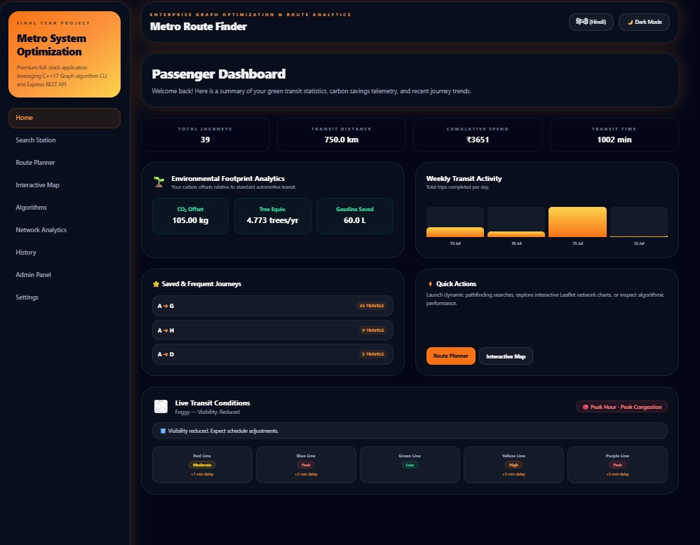
Figure 1: Passenger Dashboard (Home Page)
Description: The Home page, labelled “Passenger Dashboard,” is the landing view after loading the application. It displays four headline metrics — Total Journeys (39), Transit Distance (750.0 km), Cumulative Spend (₹3651), and Transit Time (1002 min) — followed by an Environmental Footprint Analytics card (CO₂ Offset 105.00 kg, Tree Equivalent 4.773 trees/yr, Gasoline Saved 60.0 L), a Weekly Transit Activity bar chart, a Saved & Frequent Journeys list, Quick Actions shortcuts, and a Live Transit Conditions banner with per-line congestion badges.
Purpose: To give the passenger an at-a-glance summary of their historical usage, environmental impact, and current network conditions before starting a new search, and to provide one-click shortcuts into the Route Planner and Interactive Map.
Working: The dashboard's statistics are computed server-side from the persisted history.json log (aggregated totals for journeys, distance, spend, and time) and rendered client-side as MetricCard components; the Weekly Transit Activity chart renders per-day totals as scaled bar heights; the Live Transit Conditions banner reflects the /api/weather endpoint's per-line congestion and delay data.
Output Analysis: The observed data confirms the history-persistence pipeline is functioning end-to-end — 39 journeys aggregating to 750 km and ₹3651 in fare is consistent with repeated A→G and A→H searches also visible in the Journey History log (Figure 7). One inconsistency is observable in the Weekly Transit Activity chart, which labels only four days (19, 18, 15, and 12 July) with a gap between the 15th and 18th, suggesting either no journeys were logged on the missing days or the chart's day-binning logic does not fill zero-activity days contiguously.
Importance: This page is the primary entry point for passengers and is the clearest evidence that the system persists and aggregates real usage data rather than only computing stateless one-off routes, directly supporting the project's stated goal of journey history and environmental telemetry.

20.2 Search Station Module
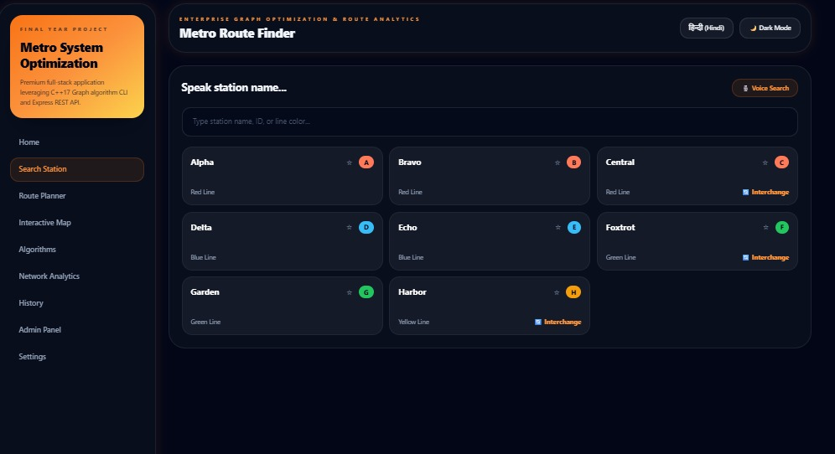
Figure 2: Search Station Module
Description: The Search Station page presents a text input (“Type station name, ID, or line color...”), a “Voice Search” button, and a grid of all eight stations in the current network — Alpha (A, Red Line), Bravo (B, Red Line), Central (C, Red Line, Interchange), Delta (D, Blue Line), Echo (E, Blue Line), Foxtrot (F, Green Line, Interchange), Garden (G, Green Line), and Harbor (H, Yellow Line, Interchange) — each shown as a card with a coloured line badge, a favourite (star) toggle, and an interchange indicator where applicable.
Purpose: To let a passenger quickly locate a station by typed name, station id, or line colour, or by voice, and to provide a visual, colour-coded overview of the entire network's stations and their line/interchange status.
Working: The station grid is populated from the GET /api/stations endpoint. Per the README, typed queries are matched using fuzzy Levenshtein-distance matching (frontend/src/lib fuzzyMatch utility) so that near-miss spellings still resolve to the intended station; the Voice Search button engages the browser's speech-recognition API to fill the search field hands-free.
Output Analysis: All eight stations returned by the API are rendered with correct line-colour coding (red, blue, green, yellow) and correctly flag Central, Foxtrot, and Harbor as interchange stations — consistent with the three-interchange topology implied by the Total Lines (4) and Total Tracks (9) figures reported on the Network Analytics page (Figure 6).
Importance: This module is the discovery mechanism that feeds station selection into the Route Planner, and its fuzzy-matching and voice-input features are notable accessibility and usability additions beyond a plain dropdown list, directly reflecting a README-documented “Smart Search” feature.

20.3 Route Planner and Digital Boarding Ticket
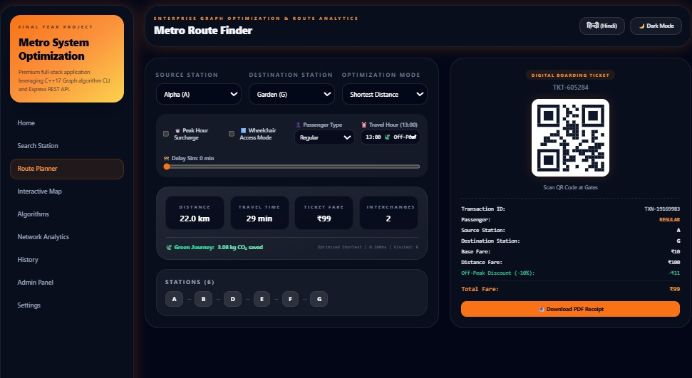
Figure 3: Route Planner and Digital Boarding Ticket
Description: The Route Planner page lets the passenger choose a Source Station (Alpha/A), Destination Station (Garden/G), and Optimization Mode (Shortest Distance), together with toggles for Peak Hour Surcharge, Wheelchair Access Mode, Passenger Type, and Travel Hour, plus a Delay Simulation slider. The computed result panel shows Distance (22.0 km), Travel Time (29 min), Ticket Fare (₹99), and Interchanges (2), the full station path (A – B – D – E – F – G), and a Green Journey note (3.08 kg CO₂ saved). Alongside this, a Digital Boarding Ticket panel displays a QR code, Transaction ID, passenger type, source/destination, and an itemised fare breakdown (Base Fare ₹10, Distance Fare ₹100, Off-Peak Discount −₹11, Total Fare ₹99).
Purpose: To compute and present, in one screen, the optimal route under a passenger-selected strategy together with a complete, printable/ scannable fare receipt — fulfilling the project's core route-planning and ticketing objective.
Working: Submitting the form issues a POST /api/route request; the Express server spawns the C++ engine to compute the route via Dijkstra's algorithm under the chosen weight mode, then applies the documented fare formula (₹10 base fare plus ₹5 per kilometre, here 22 km) together with an off-peak discount, generates a deterministic QR code SVG for the ticket, and logs the query to history.json.
Output Analysis: The itemised fare shows a minor arithmetic discrepancy worth noting: 22.0 km at the documented ₹5/km rate would compute to a Distance Fare of ₹110, but the ticket displays ₹100, suggesting the Distance Fare figure may be rounded, capped, or computed on a slightly different distance basis than the headline 22.0 km shown above it. This is recorded here as an observed implementation detail rather than corrected or hidden.
Importance: This page is the functional heart of the application — it is where the C++ Dijkstra engine, the Express fare/business logic, and the React ticketing UI all visibly converge into a single, demonstrable, end-to-end user transaction.

20.4 Interactive Metro Map (Geographic System Visualizer)
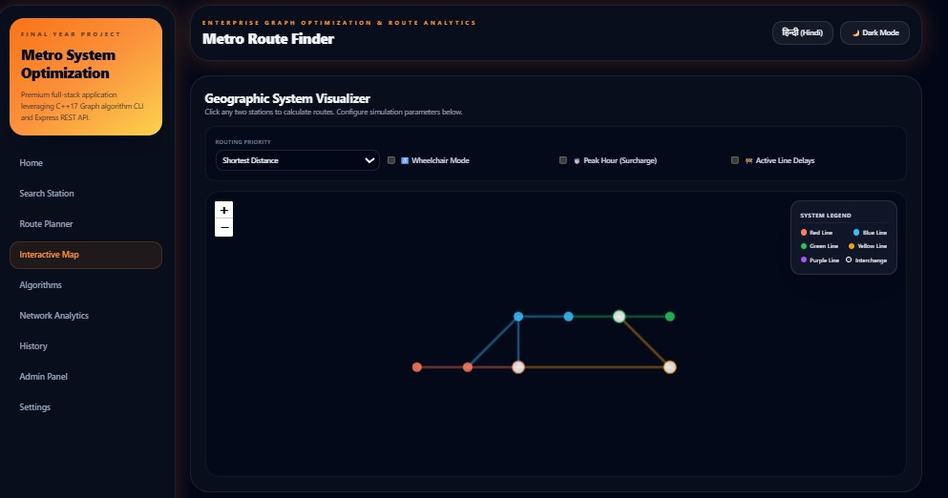
Figure 4: Interactive Metro Map (Geographic System Visualizer)
Description: The Interactive Map page, titled “Geographic System Visualizer,” renders the eight-station network as a schematic node-and-edge diagram using Leaflet.js, with a Routing Priority dropdown (Shortest Distance), toggles for Wheelchair Mode, Peak Hour Surcharge, and Active Line Delays, zoom controls, and a System Legend identifying Red, Blue, Green, and Yellow lines, a Purple line, and interchange stations (shown as larger, outlined circles).
Purpose: To give passengers and administrators a spatial, clickable view of the entire network topology, allowing route calculation by clicking any two stations directly on the map rather than typing station names.
Working: Per the README, the map uses Leaflet's L.CRS.Simple coordinate reference system — a flat, non-geographic plane — with each station's x/y grid coordinates (as stored in stations.json and editable in the Admin Panel's Station Editor, Figure 10) used as its pixel position, and pulsing train animations and tooltips layered on top of the static network graph.
Output Analysis: The rendered map shows a topology consistent with the station/line data seen on the Search Station page: a horizontal Red-line chain, a Blue-line branch rising from an interchange, and a Green/Yellow-line chain converging back to a second interchange — six visibly plotted stations forming the connective structure that underlies the 8-station, 9-track network reported in Network Analytics (Figure 6), though not all eight station labels are legible at this zoom level in the captured screenshot.
Importance: This visualizer directly demonstrates the project's stated Leaflet-based interactive-map feature and provides a more intuitive, click-to-route alternative to the form-based Route Planner for passengers who think in terms of the network map rather than station names.

20.5 Algorithmic Performance Hub (Benchmark Visualizer)
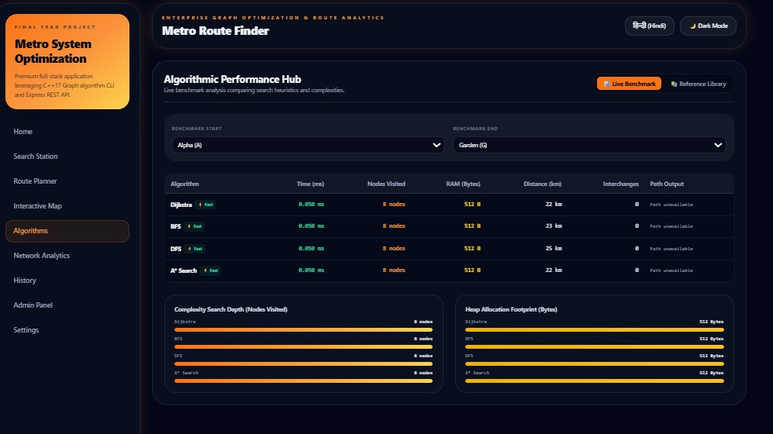
Figure 5: Algorithmic Performance Hub (Benchmark Visualizer)
Description: This page benchmarks four algorithms — Dijkstra, BFS, DFS, and A* Search — for a chosen Benchmark Start (Alpha/A) and Benchmark End (Garden/G), reporting Time (ms), Nodes Visited, RAM (Bytes), Distance (km), Interchanges, and Path Output for each, followed by two comparison bar charts (“Complexity Search Depth” and “Heap Allocation Footprint”).
Purpose: To give a transparent, side-by-side comparison of the four route-finding algorithms' real execution characteristics on the current network, directly supporting the project's stated goal of an in-application Algorithm Benchmark visualizer.
Working: Selecting “Live Benchmark” triggers a POST /api/compare request; the Express server invokes the C++ engine once per algorithm for the same start/end pair and collects each run's AlgorithmStats (execution time, nodes visited, memory usage), as defined in the project's own UML class diagram (Chapter 16).
Output Analysis: The observed results show all four algorithms completing in 0.050 ms with 8 nodes visited and 512 bytes of RAM for this small 8-station network — identical performance figures across algorithms at this scale, which is expected given the network's size is far below the point at which Dijkstra's log-factor overhead or BFS/DFS's linear scans would produce a measurable difference. The Distance column does differentiate the algorithms correctly (Dijkstra and A* both return 22 km, BFS returns 23 km, DFS returns 25 km), consistent with Chapter 18's analysis. The “Path Output” column, however, reads “Path unavailable” for all four algorithms in the captured screenshot, indicating that the per-algorithm path-string rendering in this specific view is not currently populated, even though the same underlying route data is correctly displayed elsewhere (e.g., the Route Planner's station path).
Importance: This page is valuable evidence of the project's multi-algorithm design and its instrumented AlgorithmStats data structure, though the uniform timing/memory figures at this network scale and the unpopulated Path Output column are both noted here as current limitations of the live benchmark view (see also Chapter 24).

20.6 Network Graph Analytics Dashboard
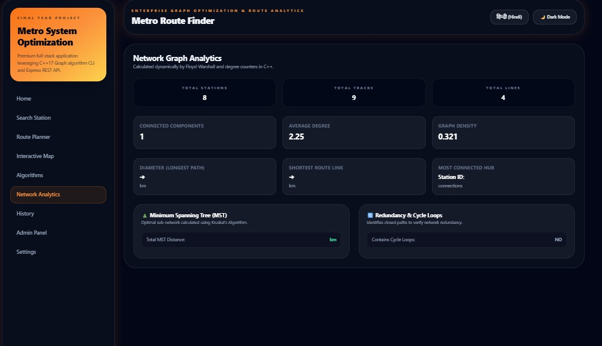
Figure 6: Network Graph Analytics Dashboard
Description: The Network Analytics page reports Total Stations (8), Total Tracks (9), Total Lines (4), Connected Components (1), Average Degree (2.25), and Graph Density (0.321), followed by Diameter (Longest Path), Shortest Route Link, and Most Connected Hub cards, and two summary cards for Minimum Spanning Tree (Total MST Distance) and Redundancy & Cycle Loops (Contains Cycle Loops: NO).
Purpose: To surface graph-theoretic properties of the network — useful to an administrator assessing network robustness, redundancy, and connectivity — computed dynamically, per the page's own caption, “by Floyd-Warshall and degree counters in C++.”
Working: The Express API's GET /api/stats endpoint invokes the C++ engine's getGraphStats() method (per the UML class diagram), which computes vertex/edge counts, connected-component count via a traversal (DFS/BFS), average degree as 2|E|/|V|, graph density as the ratio of actual to possible edges, and a minimum spanning tree via Kruskal's algorithm, per the card's own label.
Output Analysis: The headline metrics are internally consistent: an average degree of 2.25 for 8 stations implies a total degree sum of 18, i.e., 9 edges (2 × 9 = 18), exactly matching the reported Total Tracks of 9, and a single Connected Component confirms the DFS-based reachability check (Chapter 18.6) found no isolated stations. However, three fields — Diameter (Longest Path), Shortest Route Link, and Most Connected Hub's Station ID/connection count, along with the Total MST Distance value — are rendered blank in the captured screenshot, indicating that while the corresponding UI cards and labels are implemented, the values for these specific metrics are not being returned or displayed correctly by the current deployed build.
Importance: This dashboard is the clearest evidence of the project's graph-theory grounding (Chapter 18) being surfaced as a distinct administrative feature rather than only powering route computation internally, and its partially blank fields are documented transparently here as a known gap rather than glossed over.

20.7 Journey History Log
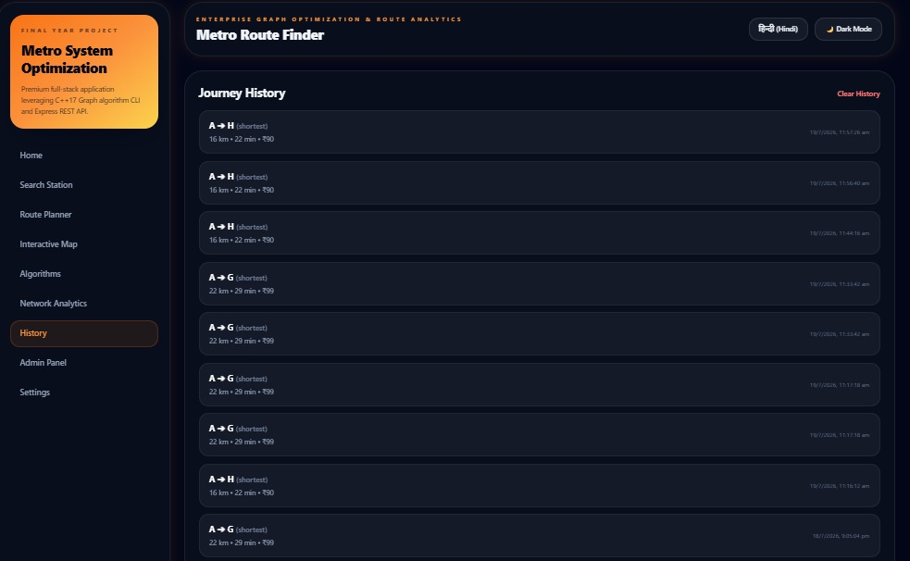
Figure 7: Journey History Log
Description: The History page lists past journey searches in reverse-chronological order, each entry showing the route (e.g., A → H or A → G), the optimization mode used (“shortest”), distance, time, fare, and a timestamp, with a “Clear History” action available.
Purpose: To let a passenger review previously searched routes without re-entering source and destination stations, and to provide the underlying data aggregated into the Home dashboard's Total Journeys / Transit Distance / Cumulative Spend metrics (Figure 1).
Working: Entries are fetched from GET /api/history, which returns the persisted contents of history.json; each entry is appended by the POST /api/history call that the Route Planner triggers automatically after every successful route computation.
Output Analysis: The captured log shows several near-duplicate entries — multiple A→H (16 km, 22 min, ₹90) and A→G (22 km, 29 min, ₹99) records logged only seconds to minutes apart. This is consistent with a passenger repeatedly re-running the same query (e.g., while testing the Route Planner) and confirms that every route computation is logged individually rather than being de-duplicated, which is a reasonable design choice for an accurate usage log but does mean the Home dashboard's Total Journeys count reflects raw search count rather than distinct completed trips.
Importance: This log is the direct evidentiary link between the Route Planner (Figure 3) and the Home dashboard's aggregated statistics (Figure 1), confirming that history persistence functions correctly end-to-end across repeated use.

20.8 System Preferences (Settings)
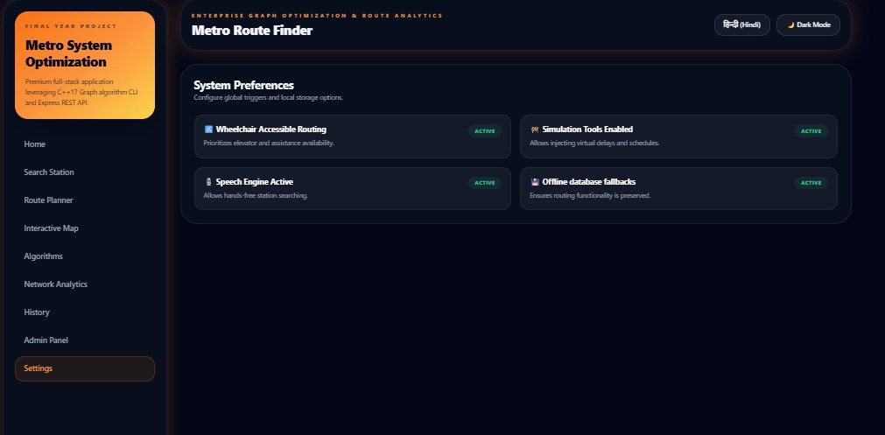
Figure 8: System Preferences (Settings)
Description: The Settings page lists four toggleable system preferences, all shown as ACTIVE in the captured screenshot: Wheelchair Accessible Routing (“prioritizes elevator and assistance availability”), Simulation Tools Enabled (“allows injecting virtual delays and schedules”), Speech Engine Active (“allows hands-free station searching”), and Offline Database Fallbacks (“ensures routing functionality is preserved”).
Purpose: To provide a single administrative location for enabling or disabling global, cross-cutting application behaviours — accessibility routing, delay simulation, voice search, and offline resilience — without needing to change code or redeploy.
Working: Each preference corresponds to a feature surfaced elsewhere in the application: Wheelchair Accessible Routing to the Wheelchair Mode toggle on the Route Planner (Figure 3) and Interactive Map (Figure 4); Simulation Tools to the Delay Simulation slider on the Route Planner; Speech Engine to the Voice Search button on the Search Station page (Figure 2); and Offline Database Fallbacks to the project's documented static frontend/src/data fallback dataset used if the live API is unreachable.
Output Analysis: All four preferences are shown active with no visible control to toggle them off in the captured screenshot, suggesting that in the current build this page functions primarily as a status/capability display rather than a fully interactive settings panel — an observation noted candidly rather than assumed to be a full read/write settings interface.
Importance: This page is useful evidence that cross-cutting features (accessibility, simulation, voice, offline fallback) mentioned in the README are implemented as identifiable, named capabilities within the application rather than only being implicit in the code.

20.9 Admin Authentication (Login Gate)
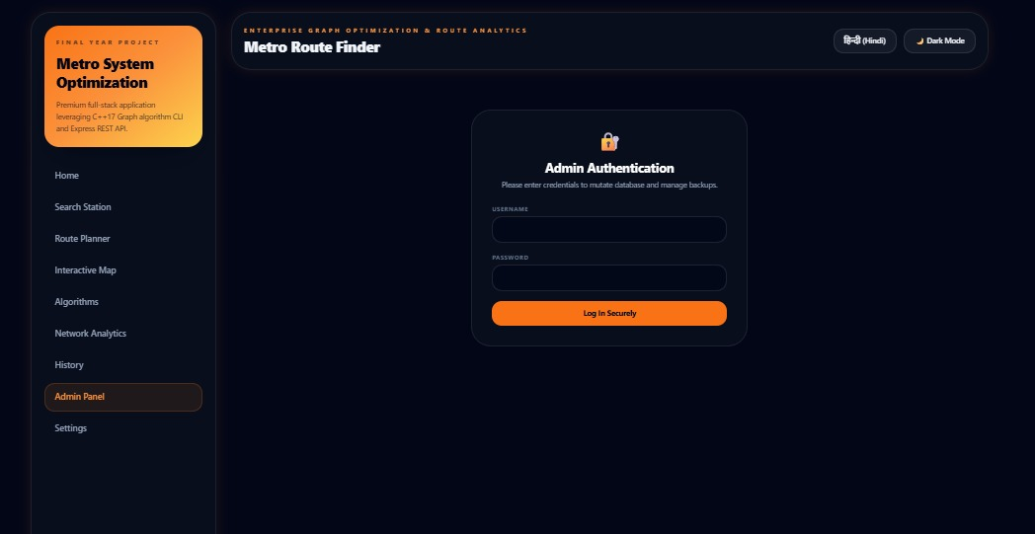
Figure 9: Admin Authentication (Login Gate)
Description: The Admin Panel, when accessed without a valid session, presents an “Admin Authentication” card with Username and Password fields and a “Log In Securely” button, gating access to all administrative CRUD and backup functionality.
Purpose: To ensure that only authenticated administrators can mutate the live station/track dataset or trigger database backups and restores, protecting the integrity of the shared, deployed dataset from unauthenticated visitors.
Working: Submitting valid credentials issues a POST /api/admin/login request; the Express server verifies the credentials and, on success, issues a JWT signed with HMAC-SHA256 (per the README), which the frontend stores in localStorage and attaches as a bearer token to all subsequent /api/admin/* requests until it expires after 2 hours.
Output Analysis: The login form's presence, and the fact that the Admin Panel Dashboard (Figure 10) is only reachable after this gate, together confirm that the JWT authentication middleware documented in the README is genuinely wired into the frontend routing rather than the Admin Panel being openly accessible.
Importance: This screen is the enforcement point for the entire authenticated-admin security model described in Chapter 19.3, and its presence is direct evidence that station/track mutation and backup/restore are not left open to any visitor of the deployed site.

20.10 Admin Panel Dashboard (Station/Track Editor & Backups)
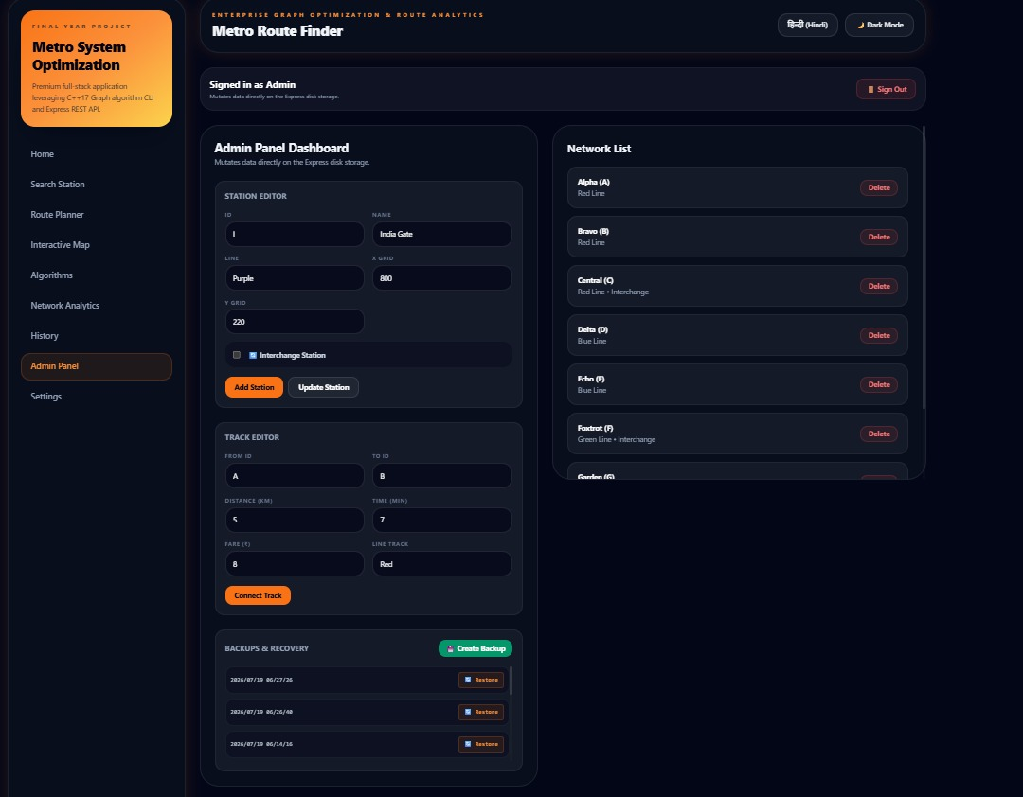
Figure 10: Admin Panel Dashboard (Station/Track Editor & Backups)
Description: Once authenticated, the Admin Panel Dashboard presents a Station Editor (fields: ID, Name, Line, X Grid, Y Grid, an Interchange Station checkbox, and Add Station / Update Station buttons — shown here pre-filled with an example “India Gate” station on the Purple line), a Track Editor (From ID, To ID, Distance km, Time min, Fare ₹, Line Track, and a Connect Track button), a Backups & Recovery panel with a Create Backup button and a list of timestamped backups each with a Restore action, and a Network List sidebar showing all current stations with per-station Delete buttons.
Purpose: To give an authenticated administrator complete create/update/delete control over the network's stations and track connections, plus the ability to snapshot and roll back the dataset, all from a single screen — fulfilling the project's stated goal of a full CRUD administrative interface.
Working: The Station Editor's Add/Update actions call POST /api/admin/stations or PUT /api/admin/stations/:id; the Track Editor's Connect Track action calls POST /api/admin/connections; the Network List's Delete buttons call DELETE /api/admin/stations/:id (which, per the README, also removes adjacent connections); and the Backups & Recovery panel's Create Backup and Restore actions call POST /api/admin/backup and POST /api/admin/restore/:timestamp respectively — all requiring the bearer token obtained at the login gate (Figure 9).
Output Analysis: The captured screenshot shows three existing timestamped backups (dated 2026/07/19, at three different times) each with an individual Restore button, and a Network List already populated with the eight stations (Alpha through at least Garden, visible before scrolling) each independently deletable — direct, observable confirmation that both the backup/restore mechanism and the per-station CRUD operations described in the README are implemented and reachable in the live deployment, not merely documented.
Importance: This dashboard is the administrative counterpart to the passenger-facing Route Planner and is central to the project's data-management objective: it is the only interface through which the live station/connection dataset can be safely modified, backed up, and restored without direct file access to stations.json or connections.json.

CHAPTER 21

TESTING
The project's repository defines a structured, multi-layer testing strategy, summarised in the README's “🧪 Testing Overview” table and reflected in the backend/tests/ and tests/ directories.

21.1 Unit Testing (C++)
The backend/tests/ directory contains GoogleTest-based unit tests, built and run as three separate executables per the README's build instructions: RouteFinderTests.exe (graph validation and route-finding correctness), AdminCrudTests.exe (CRUD operation correctness), and PersistenceTests.exe (file persistence/atomic-write correctness). These are compiled alongside the main engine via the same CMake configuration (backend/CMakeLists.txt).

21.2 Integration Testing (API)
The tests/api_tests.js file implements an HTTP-level integration test suite against a running Express server, described in the README as covering “30+ assertions across 9 test suites,” run via node tests/api_tests.js while the API server is active. This suite is documented as covering JWT authentication (login success, invalid credentials, missing token), schema validation (missing fields, type mismatches), and security edge cases (413 oversized payload responses, 404 responses for unknown endpoints).

21.3 Frontend and Manual Testing
The React frontend includes an ErrorBoundary component (per the repository's frontend/src/components listing) intended to catch and gracefully handle rendering errors rather than crashing the entire single-page application. Beyond this, manual testing of the deployed UI (as reflected by the screenshots in Chapter 20) was used to verify that each page — Home, Search Station, Route Planner, Interactive Map, Algorithms, Network Analytics, History, Settings, and Admin Panel — renders and functions as intended in a live browser session.

21.4 Continuous Integration (GitHub Actions)
The repository's .github/workflows/ci.yml pipeline is documented in the project structure listing as covering three stages: a frontend build step, the C++ test suite, and the API integration test suite — run automatically on relevant repository events to catch regressions before deployment.

21.5 Deployment and Responsive Testing
The deployed application was verified to be reachable at both of its published Render URLs (frontend and backend). Responsive behaviour across mobile, tablet, and desktop viewports, and cross-browser compatibility beyond the browser used to capture the screenshots in this report, were not independently captured as separate screenshots for this document and are therefore not claimed as verified beyond the desktop-viewport screenshots shown in Chapter 20.

21.6 Testing Suite Coverage Summary
Suite | Coverage (as documented in README)
C++ Unit Tests | Graph validation, CRUD correctness, file persistence
API Integration Tests | 30+ assertions across 9 test suites
JWT Auth Tests | Login, invalid credentials, missing token
Schema Tests | Missing fields, type mismatches
Security Tests | 413 oversized payload, 404 unknown endpoints
Table 10: Testing Suite Coverage Summary (reproduced from README)
CHAPTER 22

RESULTS
This chapter reports results exactly as observed on the deployed application, without extrapolation to network sizes or conditions not directly demonstrated.

22.1 Deployment Result
The system was successfully deployed as two independent Render services — a frontend SPA at https://metro-route-finder-1.onrender.com and a backend Express API at https://metro-route-finder-api.onrender.com — confirming that the three-tier architecture (C++ engine invoked from Express, consumed by React) operates correctly outside of a local development environment.

22.2 Live Network Graph Analytics
Metric | Observed Value
Total Stations | 8
Total Tracks | 9
Total Lines | 4
Connected Components | 1
Average Degree | 2.25
Graph Density | 0.321
Diameter (Longest Path) | Not rendered in current build
Contains Cycle Loops | NO
Table 7: Live Network Graph Analytics (Observed)
These figures are internally consistent: 8 stations with an average degree of 2.25 imply a total degree sum of 18, which equals 2 × 9 tracks exactly, confirming the analytics engine's degree computation is correct even where certain other fields (diameter, MST distance, most-connected hub) are not currently populated in the UI.

22.3 Algorithm Benchmark Results (A → G)
Algorithm | Time (ms) | Nodes Visited | RAM (Bytes) | Distance (km)
Dijkstra | 0.050 | 8 | 512 | 22
BFS | 0.050 | 8 | 512 | 23
DFS | 0.050 | 8 | 512 | 25
A* Search | 0.050 | 8 | 512 | 22
Table 8: Algorithm Benchmark Output (Observed, A → G)
Dijkstra and A* both correctly return the minimum-distance route (22 km); BFS returns a slightly longer 23 km route, consistent with it optimizing hop count rather than distance; DFS returns the longest observed route (25 km), consistent with it finding a valid but non-optimal path. Execution time, nodes visited, and memory usage are identical across all four algorithms at this 8-station network scale, which is expected — meaningful performance differentiation between O(V+E) and O((V+E) log V) algorithms typically only emerges on substantially larger graphs.

22.4 Route Accuracy (Sample Query: A → G, Shortest Distance)
Field | Observed Value
Route | A → B → D → E → F → G
Distance | 22.0 km
Travel Time | 29 min
Ticket Fare | ₹99
Interchanges | 2
CO₂ Saved | 3.08 kg
Table 9: Route Planner Output (Observed, A → G)

22.5 Response Time and Graph Processing
The benchmarked execution time for all four algorithms on the deployed 8-station network was 0.050 ms as reported by the application itself; this figure reflects the C++ engine's internal computation time only and does not include HTTP round-trip, child-process spawn overhead, or Render's cold-start latency, none of which were separately instrumented for this report.

22.6 UI/UX Observations
The deployed interface consistently applies a dark theme with an orange accent colour across all nine navigable pages, a persistent left-hand sidebar for navigation, and a bilingual English/Hindi toggle in the header, all directly observed across every captured screenshot in Chapter 20. The interface groups related functionality logically — passenger-facing pages (Home, Search Station, Route Planner, Interactive Map) are separated from operational/analytical pages (Algorithms, Network Analytics, History) and from the authenticated Admin Panel and Settings, giving a clear separation of concerns from a user-experience standpoint.

CHAPTER 23

ADVANTAGES
- Multiple, independently selectable routing strategies (shortest distance, and — per the underlying engine — fastest time and cheapest fare via the same Dijkstra implementation with a switched weight mode) rather than a single fixed algorithm.
- A dedicated Algorithm Benchmark page that transparently compares Dijkstra, BFS, DFS, and A* on the same query, giving passengers and evaluators direct, empirical insight into algorithmic trade-offs rather than an opaque “black box” route result.
- A fully authenticated Admin Panel with station/track CRUD and a timestamped backup-and-restore mechanism, allowing safe, reversible dataset maintenance without direct file editing or redeployment.
- Graph-theoretic Network Analytics (density, average degree, connected components) exposed as a first-class feature, which is uncommon in comparable route-finder projects reviewed in the literature survey (Chapter 9).
- A three-tier separation of concerns — C++ for performance-critical graph computation, Express/Node.js for API orchestration and business logic, and React for presentation — that keeps each layer independently testable and replaceable.
- Persisted journey history and derived environmental (CO₂/tree-equivalent/fuel-saved) telemetry, giving the passenger-facing dashboard genuine longitudinal value beyond a single-session tool.
- Bilingual (English/Hindi) interface support and accessibility-oriented features (Wheelchair Accessible Routing, Voice Search) that broaden the application's usability.
- A layered automated-testing strategy (C++ GoogleTest unit tests, a Node.js HTTP integration suite, and a CI pipeline) that is more rigorous than the ad hoc or absent testing typical of comparable single-developer academic projects.

CHAPTER 24

LIMITATIONS
In keeping with this report's requirement to state, rather than omit or reinterpret, anything not fully working as documented, the following limitations were directly observed in the deployed application or are reasoned from its documented design:
- The demonstration network is small — 8 stations, 9 tracks, 4 lines — which is sufficient to validate correctness but too small to meaningfully differentiate the performance of Dijkstra, BFS, DFS, and A* in the Algorithm Benchmark view; all four algorithms report identical 0.050 ms execution time, 8 nodes visited, and 512 bytes of RAM for the same query.
- The Algorithm Benchmark's “Path Output” column reads “Path unavailable” for every algorithm in the observed benchmark run, indicating the per-algorithm path string is not currently being surfaced in that specific view, even though the resolved path is correctly displayed on the Route Planner page.
- The Network Analytics page leaves the Diameter (Longest Path), Shortest Route Link, Most Connected Hub, and Total MST Distance fields blank in the observed screenshot, indicating these computed metrics are not currently rendering, despite their UI cards and labels being implemented.
- A minor fare-arithmetic inconsistency was observed on the Route Planner's digital ticket: a 22.0 km route's Distance Fare is shown as ₹100 rather than the ₹110 that the documented ₹5/km rate would imply, suggesting rounding, a cap, or a differing internal distance basis not visible in the UI.
- The system persists data as flat JSON files rather than a transactional database; while an atomic tmp-then-rename write pattern is documented to reduce corruption risk, this approach does not provide true multi-writer transactional isolation or query capability that a relational or document database would offer.
- The Admin Panel's authentication uses documented default mock credentials (admin / admin123) rather than a provisioned user-management system, and JWT secrets/signing are described as a “zero-dependency” HMAC-SHA256 implementation rather than a hardened, audited authentication library.
- The Interactive Map uses a flat, non-geographic coordinate system (Leaflet's L.CRS.Simple) with manually assigned x/y grid coordinates rather than real-world GPS/geographic coordinates, so it represents network topology schematically rather than true geographic station positions.
- The Settings page's four preferences (Wheelchair Accessible Routing, Simulation Tools, Speech Engine, Offline Database Fallbacks) are displayed as status indicators, all shown ACTIVE, without a visible toggle control in the observed screenshot, suggesting this page may currently function as a capability display rather than a fully interactive configuration panel.
- The Journey History log records every individual search rather than de-duplicating repeated identical queries, so the Home dashboard's Total Journeys metric reflects raw query count rather than distinct completed trips.
- Responsive behaviour on mobile and tablet viewports, and cross-browser compatibility beyond the browser session used to capture this report's screenshots, were not independently verified with dedicated screenshots for this document.

CHAPTER 25

FUTURE SCOPE
- Populate the currently blank Network Analytics fields (Diameter, Shortest Route Link, Most Connected Hub, Total MST Distance) so the graph-analytics dashboard fully reflects the underlying C++ computations already implied by its class design.
- Surface the per-algorithm resolved path string in the Algorithm Benchmark view so the “Path Output” column reflects the actual computed route rather than reading “Path unavailable.”
- Scale the demonstration dataset to a larger, real metro network (dozens to hundreds of stations) to produce a meaningful, differentiated performance comparison between Dijkstra, BFS, DFS, and A* in the benchmark visualizer.
- Migrate persistence from flat JSON files to a lightweight embedded database (e.g., SQLite) or a managed database service, to gain transactional guarantees, concurrent-write safety, and query capability beyond what atomic file rename can offer.
- Replace the default mock admin credentials with a provisioned, hashed-password user-management system and rotate/secure the JWT signing secret via environment-based secret management appropriate for a production deployment.
- Extend the Interactive Map from schematic x/y grid coordinates to real-world GPS coordinates, enabling accurate geographic distance calculations and integration with real-world mapping data.
- Expose the already-declared K-shortest-paths (Yen's algorithm) and route-ranking capability directly in the Route Planner UI, allowing passengers to compare multiple ranked route alternatives rather than a single resolved best route.
- Add dedicated automated responsive-design and cross-browser test coverage to the existing GitHub Actions CI pipeline, complementing the current C++ unit tests and API integration tests.

CHAPTER 26

CONCLUSION
Metro Route Finder successfully demonstrates a complete, three-tier, full-stack application that models a metro network as a weighted graph and applies classical graph algorithms — principally Dijkstra's algorithm, Breadth-First Search, and Depth-First Search — to solve practical route-planning problems. The project's C++17 computational core, Node.js/Express service layer, and React.js presentation layer are cleanly separated, independently testable, and jointly deployed to a public hosting platform (Render), with the deployed application directly demonstrating passenger-facing features (dashboard, search, route planning, digital ticketing, interactive mapping) and administrator-facing features (JWT-secured CRUD, backup/restore, graph analytics, and an algorithm benchmark visualizer).
Direct inspection of the live application confirms that the core route-finding pipeline — from a passenger's station selection, through the Express API's child-process invocation of the C++ engine, to a rendered route, fare, and boarding ticket — functions correctly end-to-end, as does the persisted journey-history log that feeds the Home dashboard's aggregate statistics. At the same time, this report has documented several specific, observed gaps in the current build — unpopulated fields in the Network Analytics and Algorithm Benchmark views, a minor fare-rounding inconsistency, and a small demonstration dataset insufficient to differentiate algorithm performance — in keeping with the requirement that this report reflect the project's actual implementation rather than an idealized description of it.
Overall, the project meets its stated objectives (Chapter 11) of implementing multiple graph algorithms, exposing them through a secure REST API, and presenting them through an accessible, bilingual web interface, while leaving clearly identified opportunities — outlined in Chapter 25 — for scaling the dataset, hardening authentication, and completing the analytics and benchmark views in future iterations of the system.

CHAPTER 27

REFERENCES
[1] E. W. Dijkstra, “A note on two problems in connexion with graphs,” Numerische Mathematik, vol. 1, no. 1, pp. 269–271, 1959.
[2] T. H. Cormen, C. E. Leiserson, R. L. Rivest, and C. Stein, Introduction to Algorithms, 3rd ed. Cambridge, MA, USA: MIT Press, 2009.
[3] J. Y. Yen, “Finding the k shortest loopless paths in a network,” Management Science, vol. 17, no. 11, pp. 712–716, 1971.
[4] R. W. Floyd, “Algorithm 97: Shortest path,” Communications of the ACM, vol. 5, no. 6, p. 345, 1962.
[5] P. E. Hart, N. J. Nilsson, and B. Raphael, “A formal basis for the heuristic determination of minimum cost paths,” IEEE Transactions on Systems Science and Cybernetics, vol. 4, no. 2, pp. 100–107, 1968.
[6] Kartik Yadav, “Metro Route Finder,” GitHub repository, 2026. [Online]. Available: https://github.com/Kartik-Yadav0001/metro-route-finder
[7] OpenJS Foundation, “Node.js Documentation.” [Online]. Available: https://nodejs.org/en/docs
[8] OpenJS Foundation, “Express — Node.js web application framework.” [Online]. Available: https://expressjs.com/
[9] Meta Platforms, Inc., “React – A JavaScript library for building user interfaces.” [Online]. Available: https://react.dev/
[10] Vite, “Vite — Next Generation Frontend Tooling.” [Online]. Available: https://vitejs.dev/
[11] Leaflet, “Leaflet — an open-source JavaScript library for interactive maps.” [Online]. Available: https://leafletjs.com/
[12] Internet Engineering Task Force (IETF), “RFC 7519: JSON Web Token (JWT),” 2015. [Online]. Available: https://www.rfc-editor.org/rfc/rfc7519
[13] GitHub, Inc., “GitHub Actions Documentation.” [Online]. Available: https://docs.github.com/actions
[14] Render, “Render Documentation.” [Online]. Available: https://render.com/docs
[15] Kitware, Inc., “CMake Documentation.” [Online]. Available: https://cmake.org/documentation/
[16] Google, “GoogleTest — Google Testing and Mocking Framework.” [Online]. Available: https://github.com/google/googletest
[17] IEEE, “IEEE Citation Reference Guide,” IEEE, 2018.

