
Experiment/ Case Study No.: 8 Name: Kartik Ranekar PRN: 24070521030

Experiment Title:
Access and validate form fields using events; design a gym admission form with live input checks.

Software/Tools Required:
Google Chrome (Web Browser), Visual Studio Code (Code Editor), Browser Developer Tools / Console, HTML, CSS, Javascript

Experiment Program Code:

Experiment 8.html
<!DOCTYPE html>
<html lang="en">
<head>
<meta charset="UTF-8">
<meta name="viewport" content="width=device-width, initial-scale=1.0">
<title>Gym Admission Form</title>
<link rel="stylesheet" href="Experiment 8.css">
<link rel="preconnect" href="https://fonts.googleapis.com">
<link rel="preconnect" href="https://fonts.gstatic.com" crossorigin>
<link href="https://fonts.googleapis.com/css2?family=Inter:wght@300;400;500;600;700&display=swap" rel="stylesheet">
</head>
<body>
<div class="container">
<h2>Gym Admission Form</h2>

<form id="gymForm">
<div class="mandatory-note">*Mandatory to fill</div>

<div class="form-row">
<label for="name">Full Name:</label>
<div class="input-container">
<input type="text" id="name" placeholder="Enter your full name">
<span class="required-star">*</span>
</div>
</div>
<div class="error-msg" id="nameError"></div>

<div class="form-row">
<label for="age">Age:</label>
<div class="input-container">
<input type="number" id="age" placeholder="Enter age (16-60)">
<span class="required-star">*</span>
</div>
</div>
<div class="error-msg" id="ageError"></div>

<div class="form-row">
<label for="email">Email:</label>
<div class="input-container">
<input type="email" id="email" placeholder="Enter email address">
<span class="required-star">*</span>
</div>
</div>
<div class="error-msg" id="emailError"></div>

<div class="form-row">
<label for="mobile">Mobile Number:</label>
<div class="input-container">
<input type="text" id="mobile" placeholder="Enter 10-digit mobile number">
<span class="required-star">*</span>
</div>
</div>
<div class="error-msg" id="mobileError"></div>

<div class="form-row">
<label for="plan">Membership Plan:</label>
<div class="input-container">
<select id="plan">
<option value="">Select Plan</option>
<option value="Monthly">Monthly</option>
<option value="Quarterly">Quarterly</option>
<option value="Yearly">Yearly</option>
</select>
<span class="required-star">*</span>
</div>
</div>
<div class="error-msg" id="planError"></div>

<div class="button-row">
<button type="submit" id="submitBtn">Submit</button>
</div>

<div id="result" class="success-msg"></div>
</form>

<footer style="text-align: center; margin-top: 30px; font-size: 14px; color: gray; border-top: 1px solid lightgray; padding-top: 15px;">
Made by Dhanish Ladwani PRN - 24070521020
</footer>
</div>

<script src="Experiment 8.js"></script>
</body>
</html>

Experiment 8.css
* {
box-sizing: border-box;
}

body {
background-color: whitesmoke; color: black;
font-family: 'Inter', sans-serif; margin: 0;
padding: 40px 20px; display: flex;
justify-content: center;
}

.container {
width: 100%;
max-width: 560px; background-color: white; padding: 35px 40px;
border: 1px solid lightgray; border-radius: 12px;
box-shadow: 0 4px 15px lightgray;
}

h2 {

color: darkblue; text-align: center; margin-top: 0; margin-bottom: 24px; font-size: 24px;
}

.mandatory-note { color: red;
font-weight: 600; font-size: 13px; margin-bottom: 18px;
}

.form-row {
display: flex; align-items: center; margin-bottom: 12px;
}

.form-row label { width: 140px; font-size: 14px; font-weight: 500; color: black;
}

.input-container { flex: 1; display: flex;
align-items: center; position: relative;
}

.input-container input,
.input-container select { width: 100%;
padding: 8px 12px;
border: 1px solid lightgray; border-radius: 6px;
font-size: 14px;
font-family: inherit; outline: none; background-color: white;
transition: border-color 0.2s;
}

.input-container input:focus,
.input-container select:focus { border-color: royalblue;
}

.required-star { color: red; margin-left: 8px;
font-weight: bold; font-size: 15px; user-select: none;
}

.error-msg {
color: red;
font-size: 12px; margin-left: 140px; margin-bottom: 8px; min-height: 14px;
}

.button-row {

margin-top: 18px;
}

button {
padding: 10px 24px; background-color: royalblue; color: white;
border: none; border-radius: 6px; font-size: 14px; font-weight: 600; cursor: pointer;
transition: background-color 0.2s;
}

button:hover {
background-color: darkblue;
}

.success-msg { display: none; margin-top: 20px; padding: 12px 16px;
background-color: lightgreen; color: darkgreen;
border: 1px solid green; border-radius: 6px; font-size: 14px;
text-align: center; font-weight: 500;
}

Experiment 8.js
document.getElementById("name").addEventListener("input", function() { let name = this.value;
if (/^[A-Za-z ]+$/.test(name)) { document.getElementById("nameError").innerHTML = "";
} else {
document.getElementById("nameError").innerHTML = "Only letters allowed.";
}
});

document.getElementById("age").addEventListener("blur", function() { let age = this.value;
if (age >= 16 && age <= 60) { document.getElementById("ageError").innerHTML = "";
} else {
document.getElementById("ageError").innerHTML = "Age must be between 16 and 60.";
}
});

document.getElementById("email").addEventListener("input", function() { let email = this.value;
let pattern = /^[^\s@]+@[^\s@]+\.[^\s@]+$/;

if (pattern.test(email)) { document.getElementById("emailError").innerHTML = "";
} else {
document.getElementById("emailError").innerHTML = "Invalid email.";
}
});

document.getElementById("mobile").addEventListener("input", function() { let mobile = this.value;

if (/^\d{10}$/.test(mobile)) { document.getElementById("mobileError").innerHTML = "";

} else {
document.getElementById("mobileError").innerHTML = "Enter 10-digit mobile number.";
}
});

document.getElementById("plan").addEventListener("change", function() { if (this.value == "") {
document.getElementById("planError").innerHTML = "Please select a plan.";
} else {
document.getElementById("planError").innerHTML = "";
}
});

document.getElementById("gymForm").addEventListener("submit", function(e) { e.preventDefault();

let name = document.getElementById("name").value; let age = document.getElementById("age").value; let email = document.getElementById("email").value;
let mobile = document.getElementById("mobile").value; let plan = document.getElementById("plan").value;

let isValid = true;

if (!/^[A-Za-z ]+$/.test(name)) { document.getElementById("nameError").innerHTML = "Only letters allowed."; isValid = false;
} else {
document.getElementById("nameError").innerHTML = "";
}

if (!(age >= 16 && age <= 60)) {
document.getElementById("ageError").innerHTML = "Age must be between 16 and 60."; isValid = false;
} else {
document.getElementById("ageError").innerHTML = "";
}

let emailPattern = /^[^\s@]+@[^\s@]+\.[^\s@]+$/; if (!emailPattern.test(email)) {
document.getElementById("emailError").innerHTML = "Invalid email."; isValid = false;
} else {
document.getElementById("emailError").innerHTML = "";
}

if (!/^\d{10}$/.test(mobile)) {
document.getElementById("mobileError").innerHTML = "Enter 10-digit mobile number."; isValid = false;
} else {
document.getElementById("mobileError").innerHTML = "";
}

if (plan == "") {
document.getElementById("planError").innerHTML = "Please select a plan."; isValid = false;
} else {
document.getElementById("planError").innerHTML = "";
}

if (isValid) {
let result = document.getElementById("result"); result.style.display = "block"; result.innerHTML = "Gym Admission Successful!";
} else {
let result = document.getElementById("result"); result.style.display = "none"; result.innerHTML = "";
alert("Please correct the errors before submitting.");

}
});

Output:
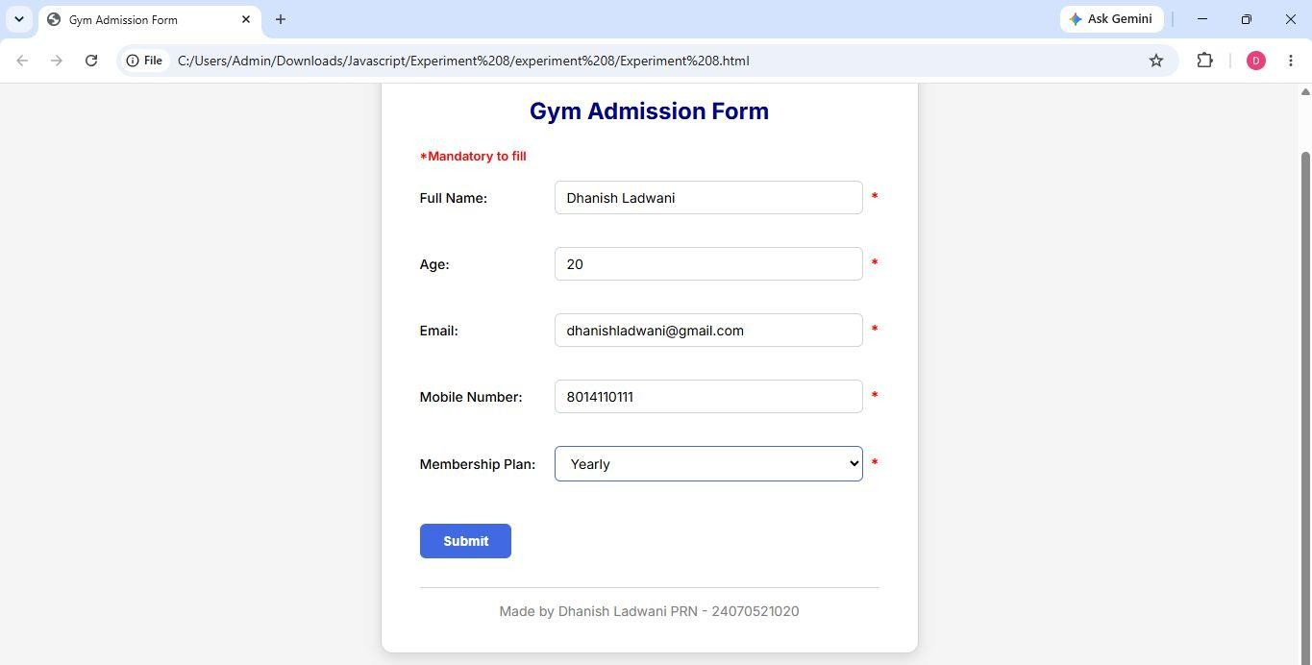
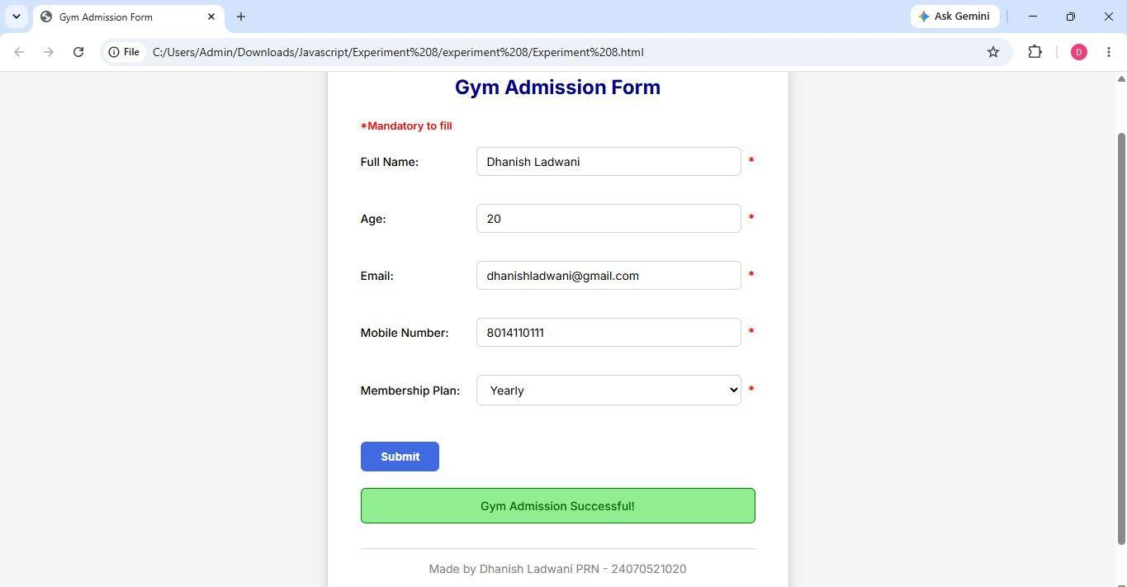

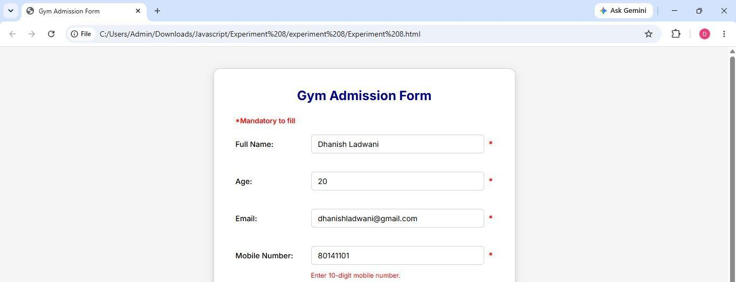

Result/Conclusion:
Regular expressions were used to access and validate form fields (name, email, phone, age, weight and dates) with live input checks using input, blur and change event listeners. Visual feedback such as error states and valid cues was provided dynamically. This reinforced pattern matching with RegExp and real-time form validation in JavaScript.

