Global Fuel Prices and Taxation Trends
Project Report
A descriptive analytics project covering fuel retail prices, tax context, subsidy categories, income groups, regions, and historical volatility.
Report date: 28 October 2026
Data window: 6 January 2020 to 6 April 2026 (2026 is partial)
Prepared for the SkillWallet Data Analytics with Tableau project

Project status | Evidence
Dataset and analysis | Prepared 82,404 long-format rows and produced quality, policy, and volatility summaries.
Interactive output | Local FuelScope HTML dashboard is included in the project package.
Published Tableau | Public workbook now includes the annual trend, corrected petrol regional AVG view, dashboard, and two-point story.
Remaining work | Complete formal functional, cross-browser, and performance testing. The SkillWallet demo link is saved and opens the published Tableau workbook.

Executive summary
The project organizes a public global fuel-price dataset into an auditable long table and presents descriptive comparisons for analysts, policy consultants, and supply-chain teams. In the pooled row-average results, petrol rises from $1.485/L in 2020 to $2.540/L in 2025, a 71.0% increase. Europe has the highest and the Middle East the lowest regional petrol mean in this dataset. These are unweighted descriptive statistics; they do not establish policy causes or represent consumer-weighted global prices.
This report follows the supplied project-report blueprint. It separates completed evidence from planned work so the published workbook is not mistaken for a finished dashboard/story.

1. INTRODUCTION

1.1 Project Overview
FuelScope is a small data-preparation and visualization project built around the Global Fuel Prices 2020–2026 dataset. It retains the source, converts three fuel-price columns into one fuel-type dimension, checks the resulting data, computes descriptive comparisons, and presents those results in a browser dashboard and Tableau Public workbook.
The source file contains 27,468 date-country-region observations for 84 countries across 7 regions. Reshaping petrol, diesel, and LPG prices produces 82,404 records at one row per date, country, and fuel type. Coverage runs from 2020-01-06 through 2026-04-06.

1.2 Purpose
The purpose is to help users explore how observed retail fuel prices vary over time and across regions, fuels, income categories, and subsidy categories. The report provides an auditable basis for discussion, not a policy evaluation, forecast, or procurement recommendation.

2. IDEATION PHASE

2.1 Problem Statement
People comparing fuel affordability and market exposure often face weekly records, multiple fuels, different country contexts, and policy labels in separate columns. Without a consistent data grain, a clearly defined average, and visible caveats, a dashboard can produce misleading comparisons. The problem is to make those historical patterns easier to inspect while preserving the limits of the underlying data.

2.2 Empathy Map Canvas
Primary user: an analyst supporting a policy consultant, a supply-chain manager, or a researcher. The map below records likely user needs to guide the design; it is a project hypothesis, not interview evidence.
Says | Thinks | Does | Feels / needs
“Show me where prices changed and by how much.” | Are these averages comparable across places and years? | Filters by fuel, period, country, and region. | Needs clear units, coverage, and a quick explanation of the measure.
“Can I relate this to taxes or subsidies?” | Does this pattern reflect policy, market conditions, or both? | Compares categories and exports figures for discussion. | Needs caveats close to the chart; should not be nudged toward a causal claim.
“Which markets need more attention?” | Is the movement large in USD/L, or only large relative to a low mean? | Reviews mean, standard deviation, and coefficient of variation. | Needs absolute and relative volatility together, with context.

2.3 Brainstorming
Idea considered | Decision | Reason
Trend by year and fuel | Build first | Makes direction and partial-year cutoff visible.
Regional and country comparison | Include in analysis | Useful for screening; regional sheet now uses AVG and is filtered to Petrol.
Tax, income, and subsidy comparisons | Include with caution | Supports descriptive questions; does not identify policy effects.
Volatility rankings | Include in report and source package | Pair standard deviation in USD/L with CV to prevent misleading low-price rankings.
Forecasting and route-cost estimate | Defer | Requires validated forecasting, consumption, route, and supplier data not present here.

3. REQUIREMENT ANALYSIS

3.1 Customer Journey map
Stage | User action / question | Friction | Project response
Discover | Find a credible source and understand coverage. | Dataset provenance and units may be unclear. | Show source link, license metadata, row counts, date span, and unit notes.
Prepare | Load and compare the fields. | Wide source data is awkward for Tableau. | Reshape to date-country-fuel rows; preserve the raw CSV and publish audit notes.
Explore | Filter by year, region, fuel, income, and subsidy. | Averages can hide differences and partial years. | Use filters and label the mean method and 2026 cutoff.
Interpret | Discuss tax, subsidy, and price patterns. | Correlation may be mistaken for causation. | Use descriptive wording and show caveats beside comparisons.
Share | Present results and allow review. | A local file alone is hard to share. | Provide HTML package and public Tableau trend, dashboard, and story; demo link is saved in SkillWallet.

3.2 Solution Requirement
ID | Requirement | Acceptance evidence / status
FR-01 | Load prepared CSV and show summary indicators. | HTML dashboard includes a CSV load control and summary cards; full filter regression is pending.
FR-02 | Filter by date/year, region, fuel, income, subsidy. | Controls are present in the local dashboard; interaction coverage is not formally tested.
FR-03 | Compare price trends and group means. | Trend chart and regional/income/subsidy views in HTML; Tableau annual trend published.
FR-04 | Use correct aggregation and expose the method. | Simple mean across observed rows; Tableau region sheet currently sums and must be corrected before use.
FR-05 | Carry provenance and interpretation warnings. | Source, cutoff, unweighted mean, descriptive-only policy caveats are documented.
NFR-01 | Keep a reproducible source and preparation path. | Raw CSV, processed CSV, and Python scripts are packaged.
NFR-02 | Keep charts understandable and accessible. | HTML uses text labels and SVG-based charts; accessibility review is pending.
NFR-03 | Avoid unsupported inference. | Report does not present policy correlations as causal effects.

3.3 Data Flow Diagram
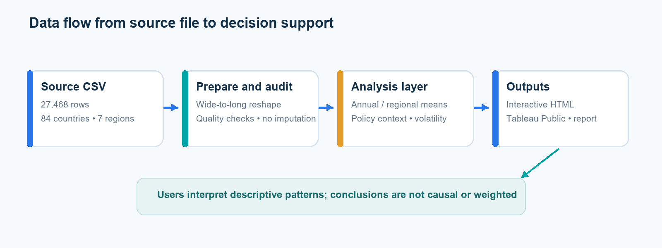
Figure 3.1. Data flow from the retained source through validation and descriptive analysis to user-facing outputs.
The raw CSV remains unchanged. Python preparation produces the long-format file; analysis scripts create summary tables and reports. The HTML dashboard reads a user-selected CSV locally in the browser. Tableau Public hosts the annual trend view. No automated external data feed or write-back is implemented.

3.4 Technology Stack
Layer | Technology | Use
Source data | CSV / Kaggle CC0 dataset | Historical weekly fuel prices and contextual categories.
Preparation and analysis | Python scripts | Validation, wide-to-long reshaping, descriptive summaries, policy and volatility analysis.
Interactive prototype | HTML, CSS, JavaScript, inline SVG | Local browser dashboard with filters, charts, and a data table.
Published visualization | Tableau Public Web Authoring | Published annual average retail-price trend.
Project documentation | Markdown and Word | Reproducibility notes, guardrails, report, and handoff.

4. PROJECT DESIGN

4.1 Problem Solution Fit
User need | Design response | Limit
See price direction over time | Annual average trend by fuel; clear cutoff for partial 2026. | A pooled row mean does not weight markets by population or consumption.
Compare regions and categories | Grouped averages and filterable dashboard. | Category definitions and country composition may confound comparisons.
Screen historical market variability | Mean, USD/L standard deviation, and CV summaries. | Historical volatility is not a forecast or route-cost estimate.
Share a repeatable result | Source files, scripts, documentation, and Tableau Public view. | Public Tableau workbook includes the annual trend, regional view, dashboard, and story; SkillWallet link opens the workbook.

4.2 Proposed Solution
Deliver a source-controlled data package, a local interactive dashboard, and a Tableau workbook/story. The package includes the data and HTML dashboard. The published Tableau workbook now includes an annual average trend, a petrol-only regional comparison using AVG(Retail Price USD per Liter), a dashboard, and a two-point story. Regional averages are unweighted observed-row means; summing repeated weekly observations would answer a different question.

4.3 Solution Architecture
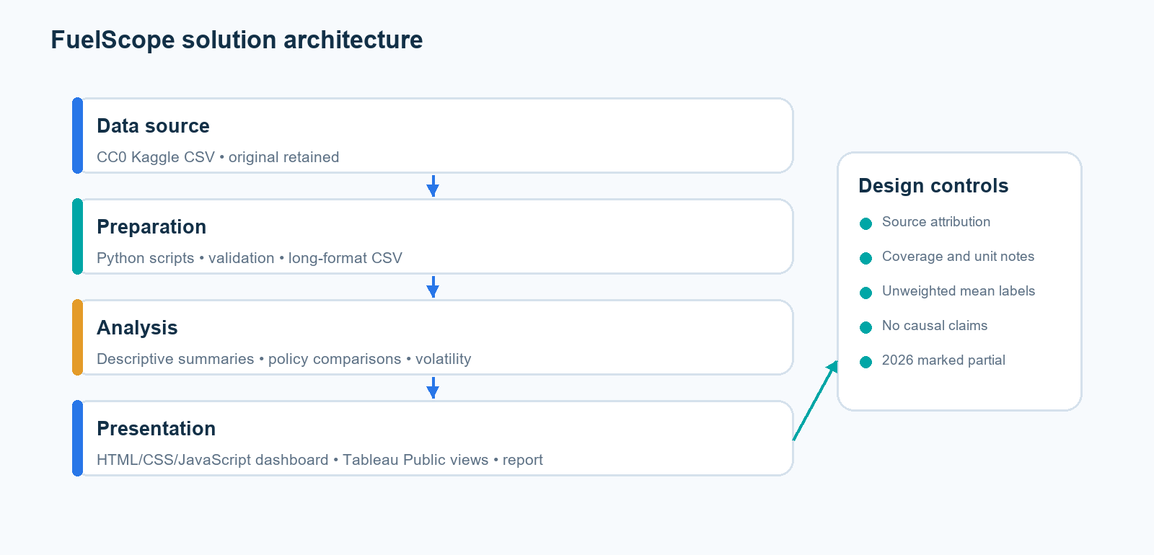
Figure 4.1. FuelScope architecture with provenance and interpretation controls carried into the presentation layer.

5. PROJECT PLANNING & SCHEDULING

5.1 Project Planning
The table is a forward plan with indicative effort, not a historical time log. Sequence the remaining work so that validated views are ready before the story and final submission.
Work package | Estimated effort | Dependency | Status
Source review, download, quality audit | Complete; elapsed effort not recorded | Dataset access | Complete
Prepare long-format data and descriptive summaries | Complete; elapsed effort not recorded | Source review | Complete
Build local dashboard and project notes | Complete as working deliverables; formal filter QA pending | Prepared CSV | In progress for QA
Correct Tableau regional aggregation and add comparison sheets | Complete | Published workbook access | Complete
Build Tableau dashboard and story with caveats | Complete | Validated worksheets | Published
Functional and performance QA; capture final outputs | 1–2 hours | Dashboard/story complete | Pending
Complete formal testing; provide GitHub repo if required | 30–60 minutes | Public workbook and repository decision | Functional and performance checks pending; GitHub absent

Estimated remaining effort: approximately 5–8 hours, excluding external review, any repository setup, and changes required by the SkillWallet rubric. Estimates are planning assumptions, not measured durations.

6. FUNCTIONAL AND PERFORMANCE TESTING
Testing is not complete. The following status separates data-preparation evidence and the verified Tableau publication from functional checks that still need to be run.
Check | Evidence or method | Status
Source and transformed row counts | Quality report records 27,468 source rows and 82,404 long rows. | Verified in project artifacts
Null, duplicate, date, and price validation | Quality audit reports no source-cell missingness, invalid dates, duplicate keys, or flagged zero/negative prices. | Verified in project artifacts
Published Tableau workbook opens | Public workbook displays the annual trend and revised dashboard/story. | Verified
Regional aggregation correctness | Sheet 2 uses AVG(Retail Price USD per Liter) with Fuel Type filtered to Petrol; values match the report analysis. | Verified
Local CSV load and all filter combinations | Test all / single / combined filters; compare chart totals to independent summary outputs. | Not formally tested
Chart aggregation correctness | Check SUM/AVG per sheet, source grain, and results against analysis summary. | Verified for annual trend and petrol-only regional AVG; other future views require separate checks
Cross-browser and narrow-screen behavior | Open dashboard in Chrome and one additional browser; inspect at desktop and mobile widths. | Pending
SkillWallet link persistence | Open the saved demo link from the SkillWallet project page and confirm it reaches the public Tableau view. | Verified: View Demo opens Tableau Public

6.1 Performance Testing
No timed load, interaction-latency, memory, or concurrency benchmark has been run. Record the browser/device, cleaned CSV size, initial load time, filter-response time, peak memory, and any console errors. Repeat with the full 82,404-row file and report the measured values; do not claim a performance target has passed until those measurements are captured.

7. RESULTS
The preparation and analyses yield a consistent long table and several descriptive signals. Each mean weights source country-date observations equally, so countries with the same weekly coverage contribute similarly; this is not a population-, consumption-, or country-weighted global estimate.
Result | Value | Interpretation
Prepared records | 82,404 | Three fuel rows per source date-country record.
Coverage | 84 countries; 7 regions | 2020-01-06 to 2026-04-06.
Overall petrol mean | $2.282/L | Pooled observed-row mean for all years.
Petrol mean, 2020 to 2025 | $1.485/L to $2.540/L | Increase of 71.0% between full years.
Regional petrol means | Europe $3.702/L; Middle East $1.226/L | Gap $2.476/L under the unweighted row-mean method.
Average petrol tax share | 26.77% | Dataset field summary; definition is upstream and observational.
Petrol-tax correlation | r = 0.522 | Pooled weekly association; not a causal estimate.
2026 petrol mean | $2.647/L | Partial through April 6; do not compare as a completed annual mean.

7.1 Output Screenshots
The figures below are report-rendered previews from processed analytical outputs, not screenshots captured from the live Tableau dashboard. The published Tableau workbook includes the annual trend, corrected petrol regional comparison, dashboard, and story. Its public link is in Appendix 11.
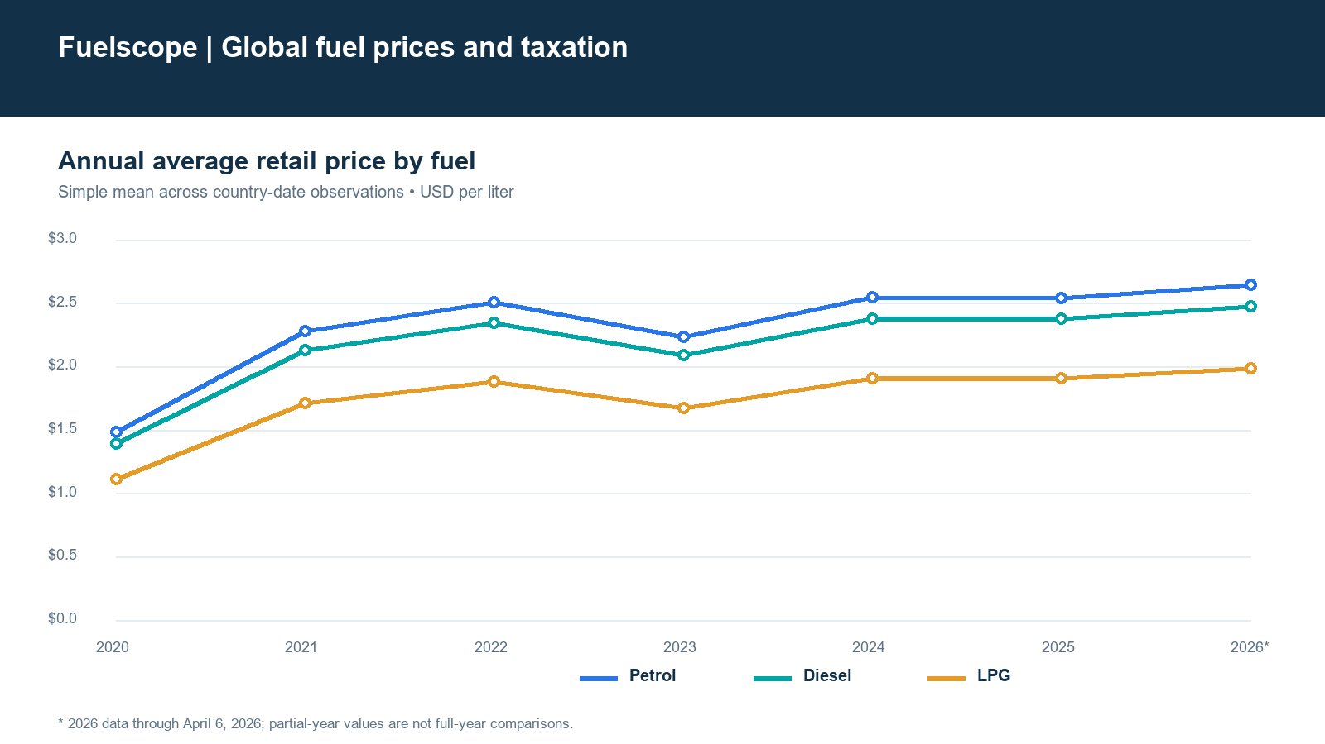
Figure 7.1. Annual average retail price by fuel, 2020–2026. 2026 is partial through April 6.
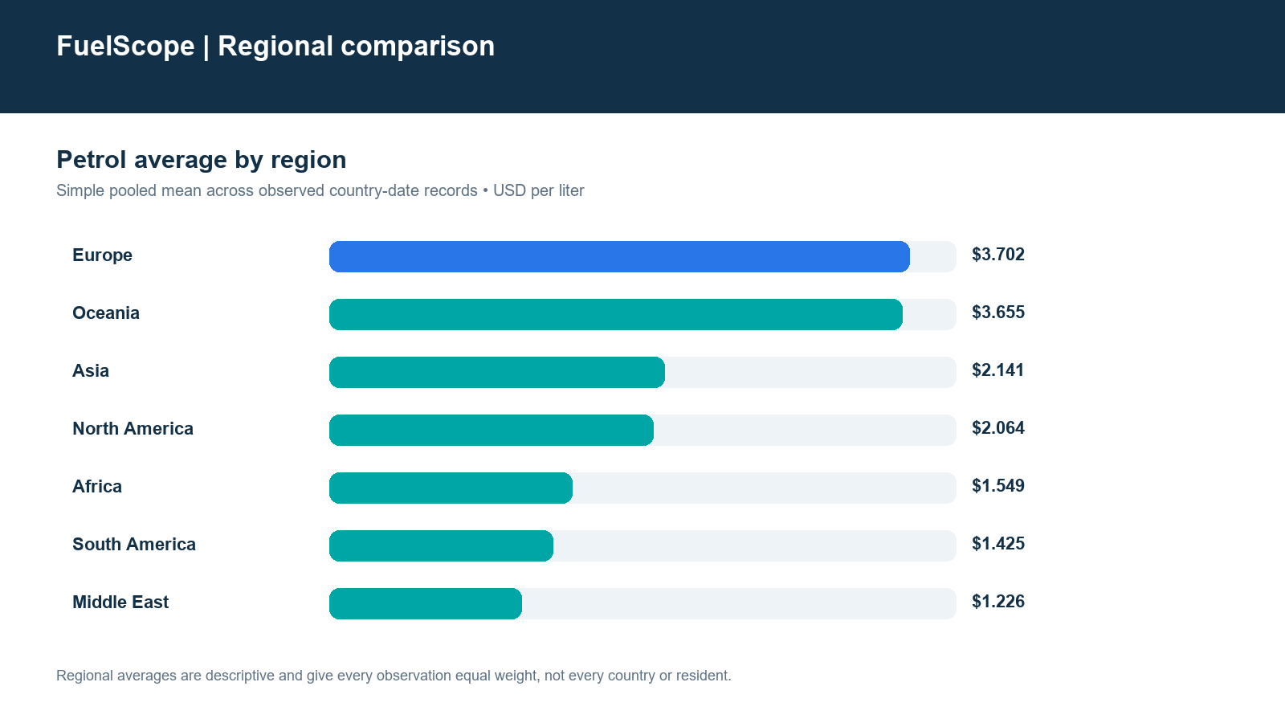
Figure 7.2. Regional petrol average using the simple observed-row mean. Descriptive comparison only.

8. ADVANTAGES & DISADVANTAGES
Advantages | Disadvantages and constraints
Source CSV is retained, with a repeatable Python preparation path. | Dataset definitions are supplied by the dataset owner and were not independently validated.
Long-format data supports common Tableau grouping and filtering. | A pooled row mean is not weighted by consumption, population, or equal country representation.
Coverage spans multiple years, fuels, regions, income groups, and subsidy labels. | 2026 is incomplete; LPG basis and upstream category semantics need confirmation before strong comparisons.
Policy and volatility caveats are documented with the findings. | Tax/subsidy associations are not causal; CV can exaggerate movement when mean prices are near zero.
HTML dashboard and published Tableau workbook provide shareable views, including a dashboard and story. | No measured performance results yet; SkillWallet View Demo opens the published Tableau workbook.

9. CONCLUSION
FuelScope provides an auditable starting point for exploring global fuel-price patterns. The source has been reshaped to a clear date-country-fuel grain and analyzed with explicit unweighted mean definitions. The strongest descriptive pattern is the rise in average petrol price from 2020 to 2025, alongside substantial regional differences. These patterns are useful for exploratory questions, but the data does not establish the effect of taxes or subsidies and does not support consumer-weighted price claims.
The core workbook is published with the corrected petrol regional average, dashboard, and story. The SkillWallet demo link is confirmed. Functional and performance checks remain incomplete; no performance metrics are claimed.

10. FUTURE SCOPE
- Add visible fuel and date coverage notes to the published Tableau dashboard and story; keep the 2026 partial-year caveat explicit.
- Confirm the source definitions for date cadence, tax share, subsidy classification, exchange-rate method, and LPG physical unit.
- Add country-level or fixed-effect comparisons for stronger tax/subsidy analysis; pre-register assumptions and controls.
- Add consumption or population weights only from compatible, cited sources; show weighted and unweighted results separately.
- Add route, supplier, and volume data before estimating logistics exposure or procurement risk.
- Evaluate forecast methods separately with holdout validation before presenting any forecast.
- Run accessibility, browser compatibility, functional, and performance checks; record reproducible measurements.
- Publish a version-controlled GitHub repository if required by the rubric.

11. APPENDIX

Source Code (if any)
Source code is included in the project package: `app.js` and `index.html` implement the browser dashboard; `scripts/prepare_data.py`, `scripts/analyze_data.py`, `scripts/analyze_policy.py`, and `scripts/analyze_volatility.py` implement data preparation and analysis. See `DATA_PREPARATION.md` for the reproducible steps.

Dataset Link
Primary dataset: Global Fuel Prices 2020–2026 on Kaggle
The dataset is recorded as CC0 in Kaggle metadata. Local source copy: `data/raw/kaggle_download/global_fuel_prices_2020_2026.csv`. Prepared analysis file: `data/processed/fuel_prices_cleaned.csv`. Source SHA-256: 7e86ddbaab50d7d7f137a033c8c222a995b923120f70a4345abf11db0ca82cfe.

GitHub & Project Demo Link
Project demo: Published Tableau Public workbook, dashboard, and story
GitHub repository: https://github.com/Kartik-prog-ai/global-fuel-price-intelligence. Tableau Public confirms the workbook update, and the SkillWallet View Demo button opens that public workbook. Functional, compatibility, and performance testing also remain open.

Project Files
- README.md — project overview and dashboard instructions.
- DATA_NOTES.md — source provenance and measurement caveats.
- DATA_PREPARATION.md — transformation steps.
- DO_AND_DONT.md — interpretation guardrails.
- FIELD_DICTIONARY.md — field definitions.
- TABLEAU_PLAN.md and TABLEAU_BUILD_GUIDE.md — workbook design and build instructions.
- STORY.md — narrative outline.
- PROJECT_STATUS.md — current completion state.

References
- BELBIN BENO R M, Global Fuel Prices 2020–2026, Kaggle, CC0 metadata. https://www.kaggle.com/datasets/belbino/global-fuel-prices-20202026
- International Energy Agency, End-use Energy Prices. https://www.iea.org/data-and-statistics/data-product/end-use-energy-prices
- OECD, Carbon Pricing and Energy Taxation Database. https://www.oecd.org/en/data/datasets/carbon-pricing-and-energy-taxation-database.html

