Airbnb Case-Study Methodology

Introduction

Airbnb, Inc. is**an American San Francisco-based company operating an online marketplace for short- and long-term homestays and experiences.** The company acts as a broker and charges a commission from each booking.

Airbnb also provide platform for host to list down their property on website.

New York, or NYC, is the most populous city in the United States. New York City is the most densely populated major city in the United States. Airbnb has listing available in 5 area Manhattan, Brooklyn, Queens, Bronx, Staten Island. Its is also a global financial industry sector.

Problem Statement

Airbnb has recently seen a decline in revenue in past few months.

Globally the restriction has been imposed on travelling and tourism activities due to pandemic hit the country badly due to which many businesses got affected badly and Airbnb is one of them.

Now that the restrictions have started lifting and people have started to travel more, Airbnb wants to make sure that it is fully prepared for this change.

STEP1 : Story boarding.

1. Import the data and get familiarized with it and note down the important fields.

The Data contain following fields:

* Id- listing id
* Name – Name of listing
* Host Id – Host Id
* Host name- Name of Host
* Neighbourhood Groups- Location
* Neighbourhood – Area
* Latitude – Latitude coordinates
* Longitude – Longitude coordinate
* Price – Price of Listing
* Minimum nights- Amount of minimum nights
* No of review – no of review
* Last review – last review
* Review per month – number of review per month
* Calculated host listing count- amount of listing per host
* Availablity_365- number of days when listing is available for booking.

1. Made a rough template as per problem statement for presentation.

STEP 2 – Data Cleaning and Wrangling.

1. Analyzing Null values and outlier in data set.
2. Few Columns have null values present which will not be hamper our analysis so let them as it is .
3. Analyzing the Price column w.r.t. room type as outlier is present in it.

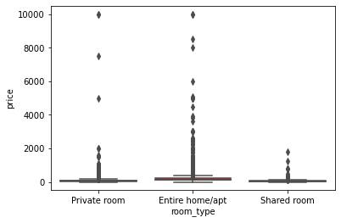

As outlier present in Price column we will bin the price column for easier analysis.

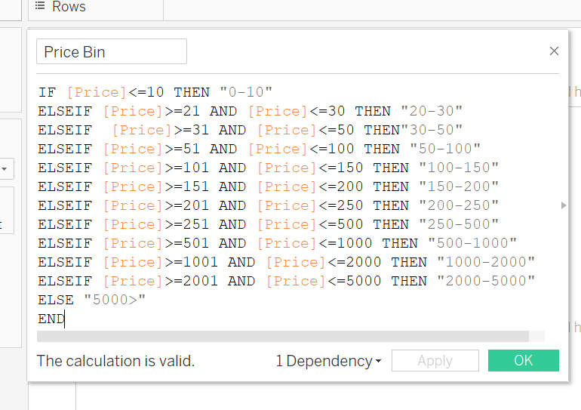

1. Binning the minimum nights column for easier analysis.

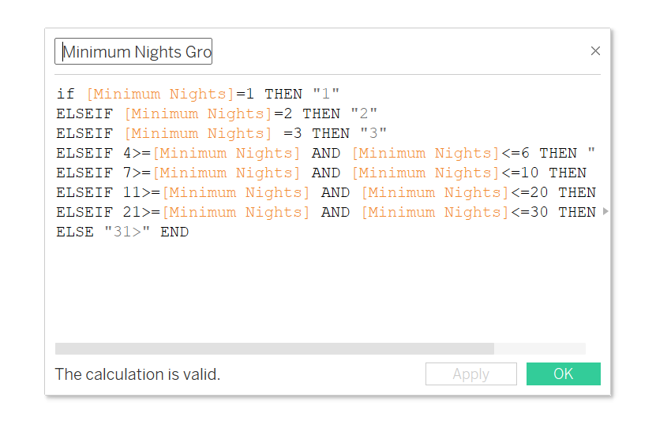

STEP 3 – EXPLORATORY DATA ANALYSIS.

* The Data is analyzed using univariate and bivariate analysis.
* The analysis and visualization done on Tableau tool using various attributes
* Insights are created based on visualization.

Presentation 1

Objective:

Analysis the Airbnb listing in NYC city.

The main parameter consider for this presentation include:

1.Geographical Data 2.Room type Data 3.Number of review 4.Minimumn Nights

5.Booking based on area.

The insights are generated on above parameter.

Key Insights:

1. **Airbnb Listing spread in New York.**

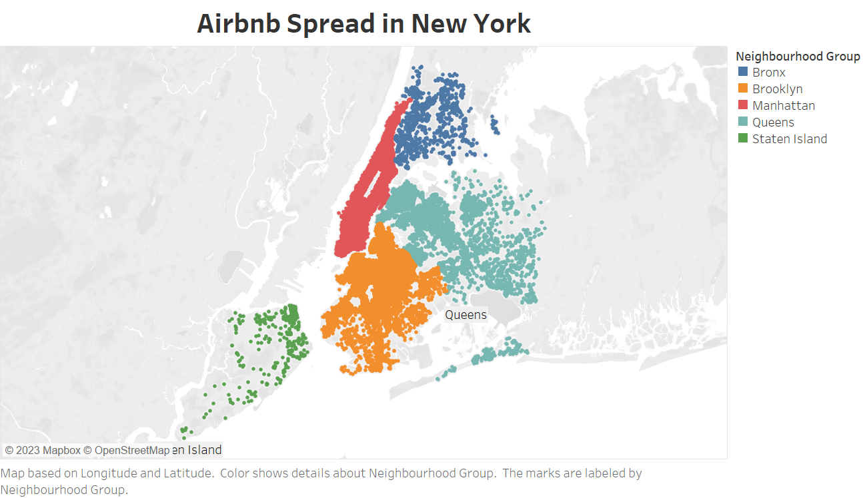

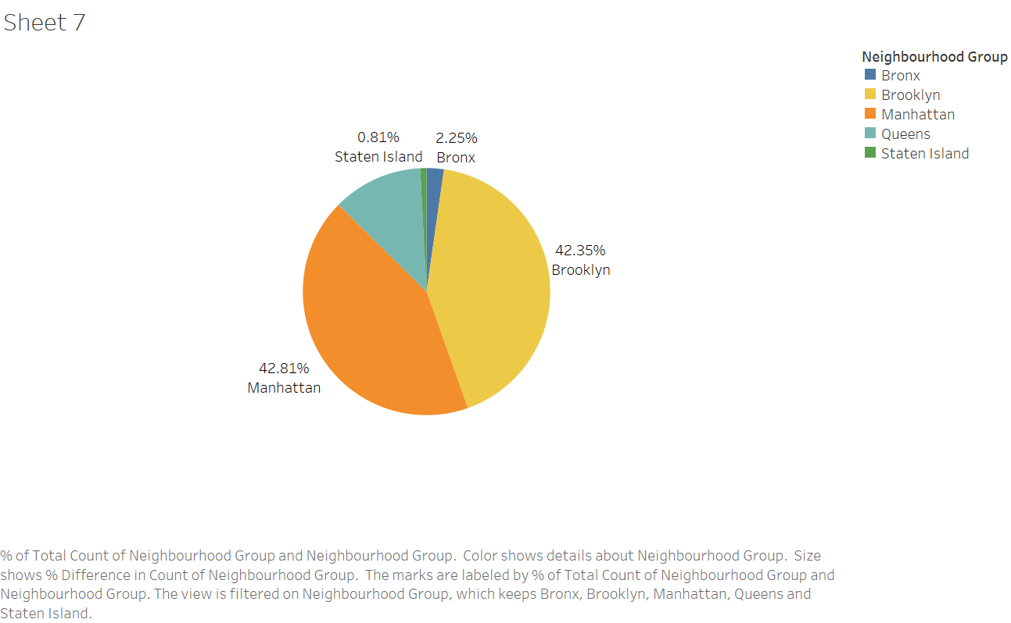

**Insights:**

* Airbnb has a wide spread of listing in New York .
* Manhattan has 42.81% and Brooklyn has 42.35% of listing due to its many tourists destination and scenic view.
* Staten Island has less than 1% of total listing available due to few tourists destination.

1. **Most Preferred Room Type by Customers.**

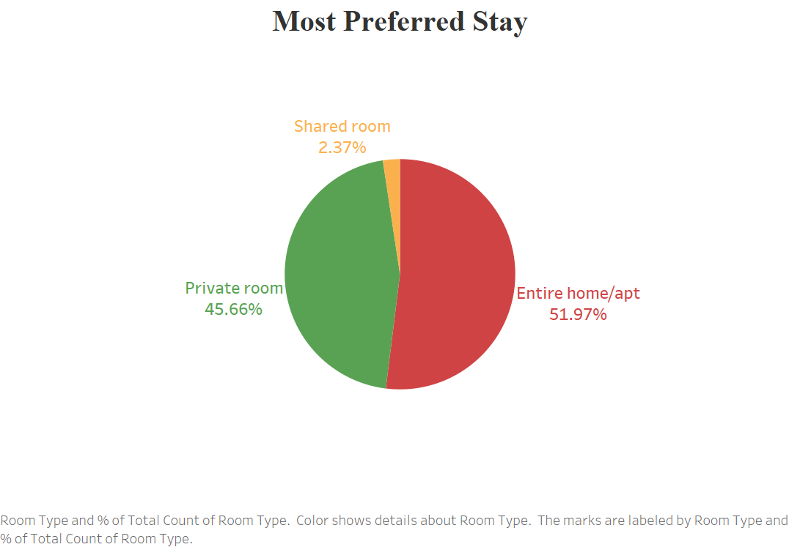

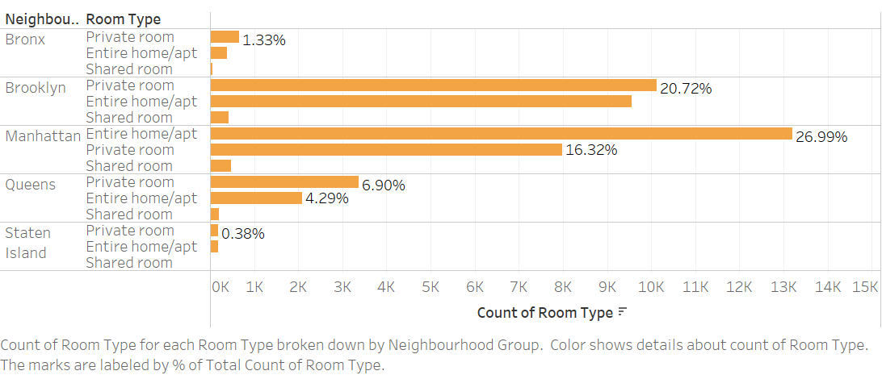

**Insights:**

* Airbnb has three types of room available in listing in New York.
* Most preferred is Entire home/apt (51.97%) followed by Private room (45.66%)
* The Shared room contribution is very less (2.37%)
* The Staten Island and Bronx has very less share of Private and Entire home/apt which is customer first choice, so Airbnb should increase the listing in these area
* Airbnb should provide discount on Shared room to increase its booking percentage.

**C ) Most Preferred area for Booking**.

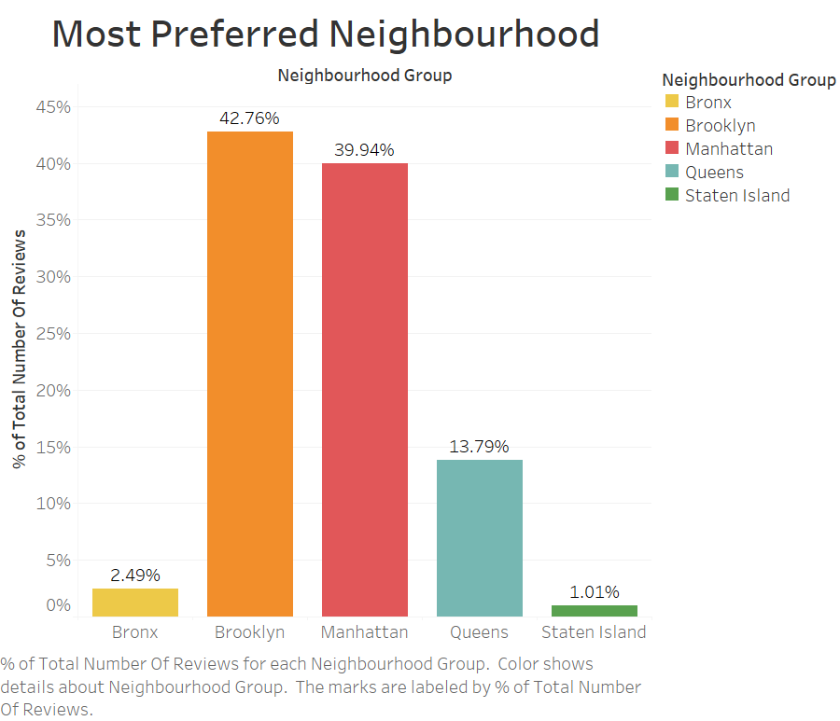

**Insights:**

* About 80% of Customer prefer to stay in Brooklyn and Manhattan .
* 13.7% in Queens and 3.5% Customer in Bronx and Staten Island this is due to less no of listing available in these area and very few tourist destination.

1. **Most Preferred Minimum nights by Customer w.r.t Neighbourhood Groups.**

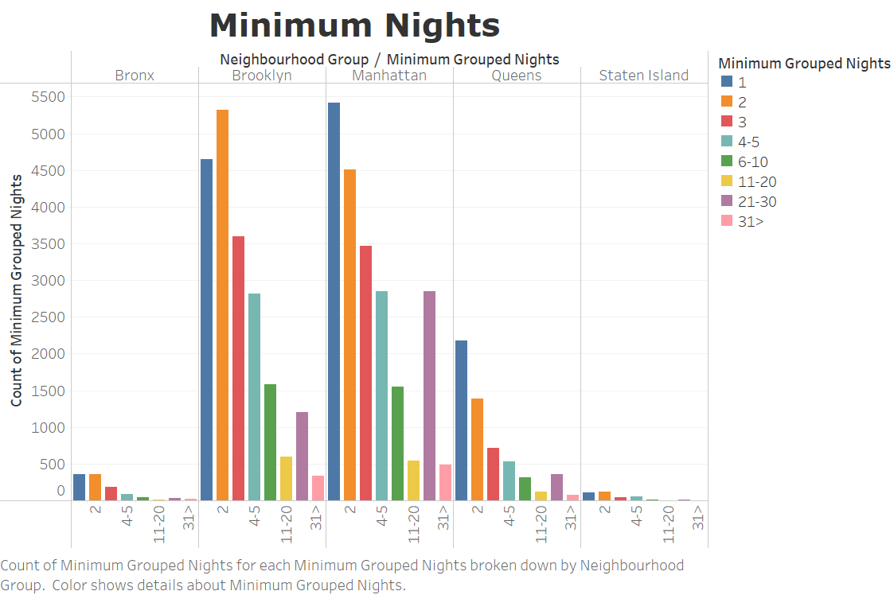

**Insights:**

* Most Customer likely to stay for 1-5 Minimum nights .
* We can see a spike in minimum nights in 21-30 bucket mostly in Manhattan these might due to some customer travel for their professional work as Manhattan is also a global centre for financial sector industry.

Presentation 2

Objective:

Analysis the Airbnb listing and improving its business in NYC city.

The main parameter consider for this presentation include:

1. Neighbourhood group. 2. Room type Data. 3. Room Availability data. 4. Minimum Nights.

5. Neighbourhood Area 6. Price.

The Recommendation are made based on above parameter.

Key Insights:

1. **Most Preferred Neighbourhood Group based on number of Booking.**

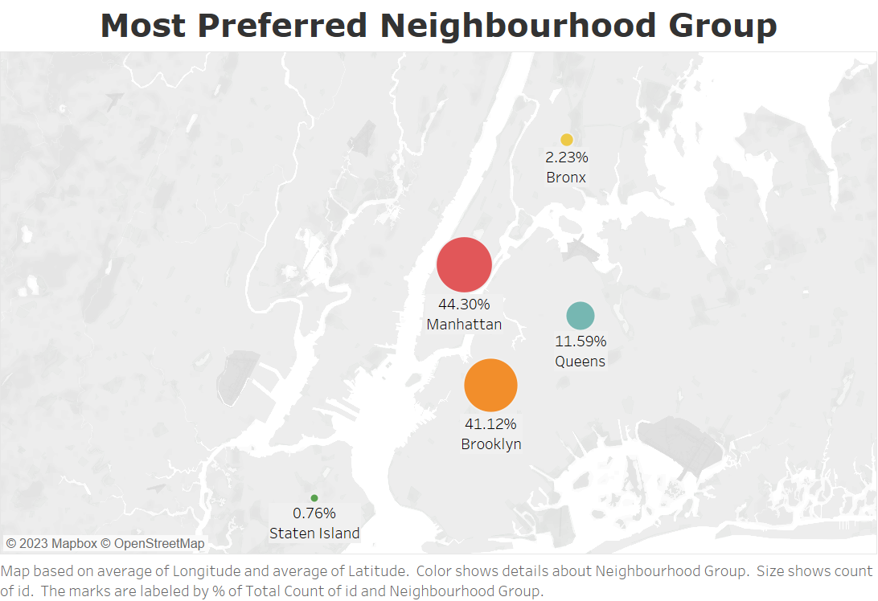

**Insights:**

* The Most Neighbourhood Group in New York is Manhattan followed by Brooklyn.
* The Booking of the Manhattan is high as compared to other Tho people preferred it due to it famous attraction and scenic view.
* About 44.3% of booking from total listing is only in Manhattan , 41.12% in Brooklyn & 11.59% in Queens
* Staten Island and Bronx are the least preferences of customer due to its few tourist attraction points only 0.76% of total listing is of Staten Island and Bronx has 2.23% of booking.

1. **Most Preferred Room Type.**



**Insights**

* 51.97% of people prefer to stay in Entire home/Apartment and 45.66% prefer to in Private Room.
* Only 2.37% of people like to stay in shared rooms. This is due to most people like to stay in their private space and don’t want any kind of disturbance during there stay.

1. 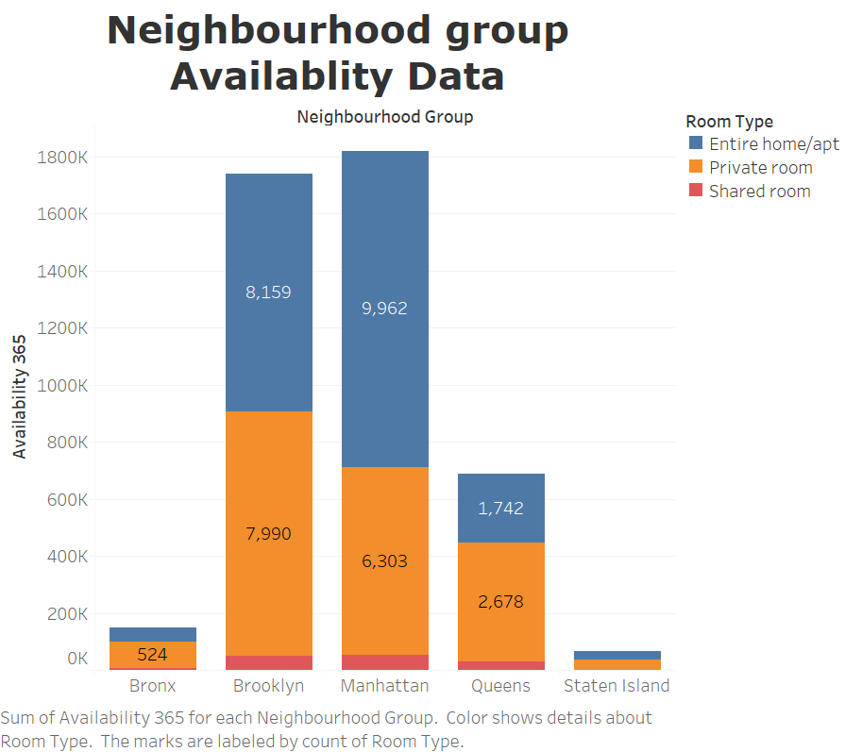 **Neighborhood Group Availability Data**

**Insights:**

* Manhattan city has maximum available rooms followed by Brooklyn City
* The Bronx and Staten Island has very less availability so we have to increase the availability in these cities.

1. **Top 10 Neighbourhood Area w.r.t Minimum Nights**

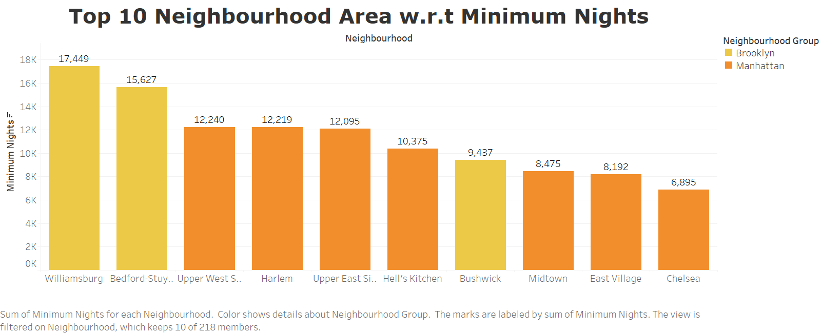 **Insights:**

* The Williamsburg & Bedford area are most preferred location to stay by people in Brooklyn City.
* The Upper-West Side, Harlem & East-West Side areas preferred by people to stay in Manhattan City.

1. **Price variation based on Neighbourhood Group.**

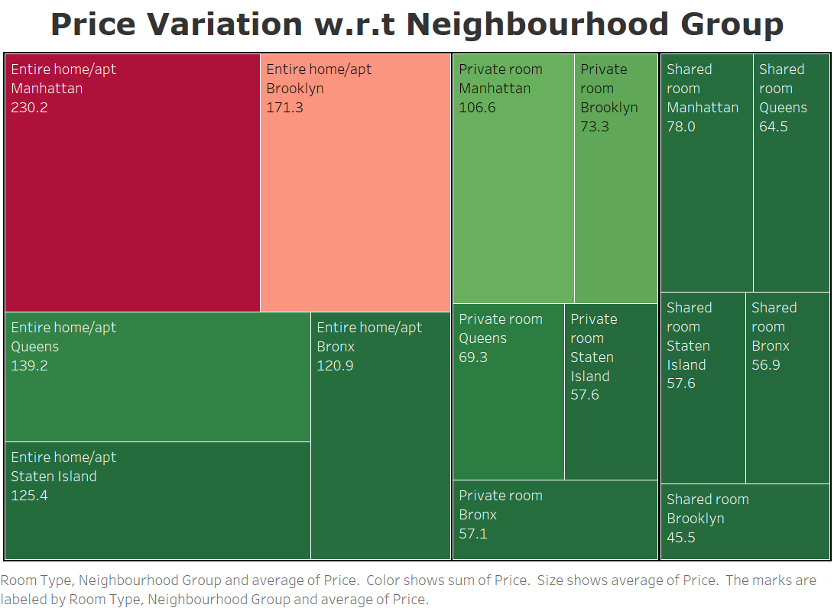

**Insights:**

* Entire home/apt in Manhattan and Brooklyn is most expensive of the available listing.
* The Average price of Entire home/apt in Queens and Bronx of $130.
* Brooklyn has the cheapest Shared room with Average price of $45.5 in available listing.

1. **Price range preferred by customer.**

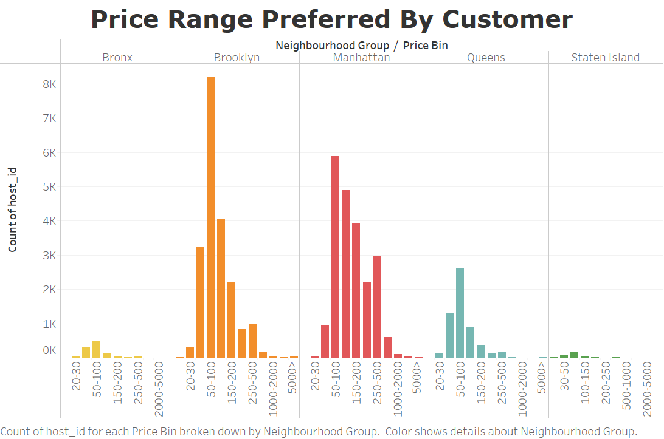

**Insights:**

* The Most Preferred Price Range of Customer is from $50-$200 based on Neighbourhood Group and Booking volume.
* The price range of $50-$100 is preferred most in Brooklyn.
* The price range of $50-$200 is preferred most in Manhattan this is because the as Manhattan is major attraction people are likely to spend more**.**

Recommendation:

* Increased the number of Entire Home/apt in Bronx, Queens & Staten Island as they are preferred most by customers.
* The Cost of Entire Home/apt in Manhattan should be reduced and cost of shared rooms to be increased to reduce the price gap between shared rooms and private rooms so that shared room customer will attract toward private rooms.
* Provide discounts for shared rooms and run promotion campaign to increased there booking percentage.
* Acquire host in Bronx and Staten Island city having both Entire home/apt and Private rooms as both are preferred most.
* Acquire the listing in price range of $50-$200 to increase the booking volume.

Data Assumption:

* The Null Values assume to be of No impact on data in analysis.
* No of review are assume for best measure for the customer preferences.