Assignment - 1

You have been asked to:

● Trigger a pipeline using Git when push on Develop branch

● Pipeline should pull git content to a folder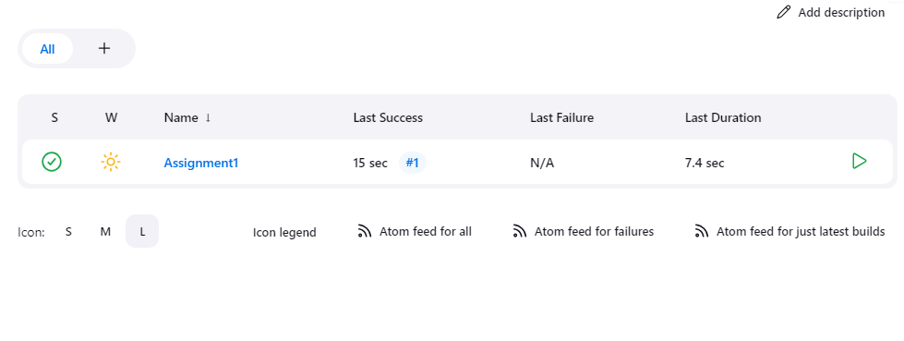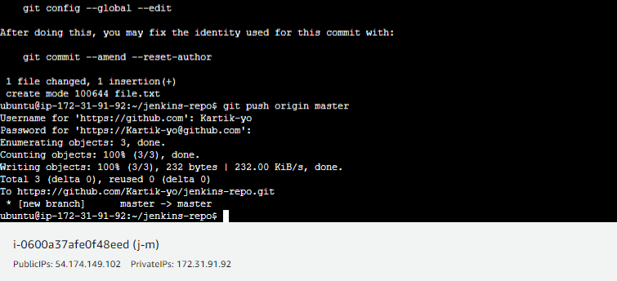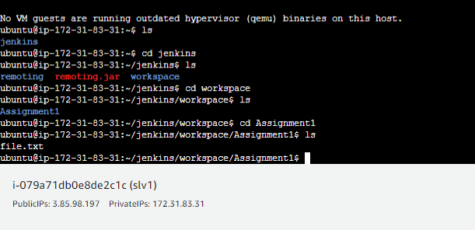

Assignment – 2

You have been asked to:

● Add 2 nodes to Jenkins master

● Create 2 jobs with the following jobs:

○ Push to test ○ Push to prod

● Once a push is made to test branch copy git files to test server

● Once a push is made to master branch copy git files to prod server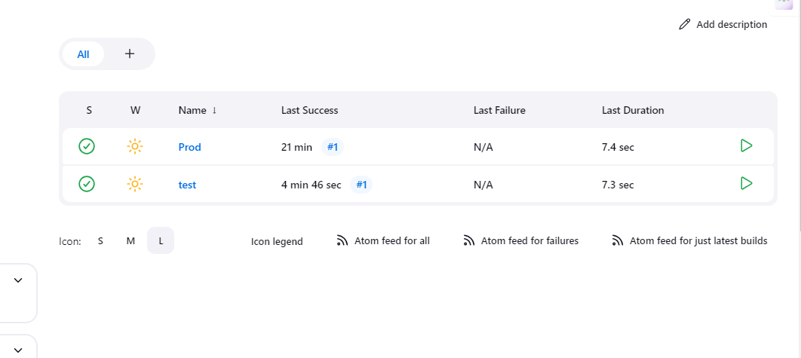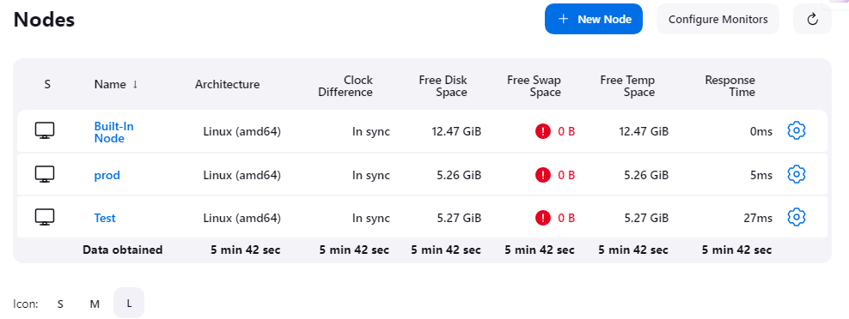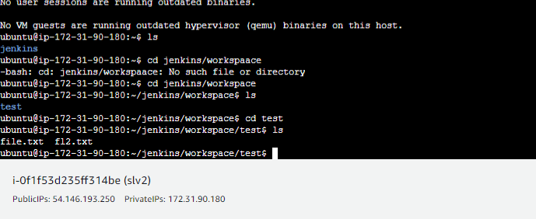

Assignment - 3

You have been asked to:

● Create a pipeline in jenkins

● Once push is made to “develop” branch in git, trigger job “test”. This will copy git files to test node

● If test job is successful, then prod job should be triggered

● Prod jobs should copy files to prod node