Assignment - 1

Tasks To Be Performed:

1. Deploy a Kubernetes cluster for 3 nodes

2. Create a NGINX deployment of 3 replicas

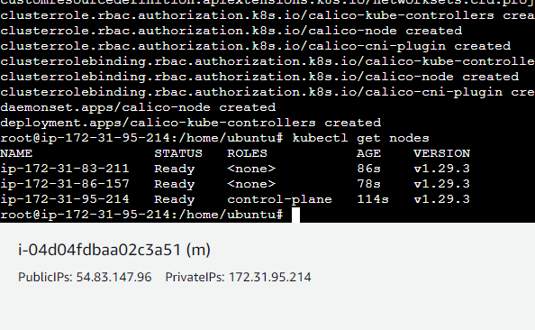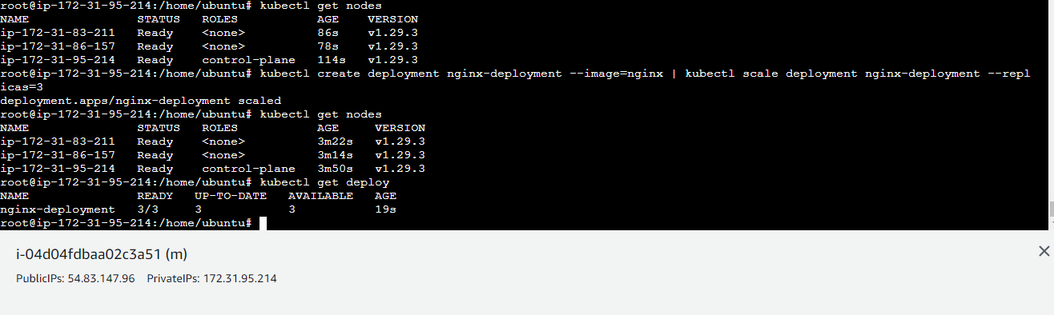

Assignment - 2

Tasks To Be Performed:

1. Use the previous deployment

2. Create a service of type NodePort for NGINX deployment

3. Check the NodePort service on a browser to verify

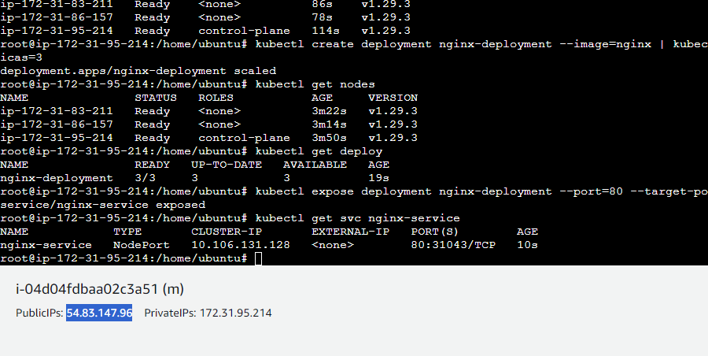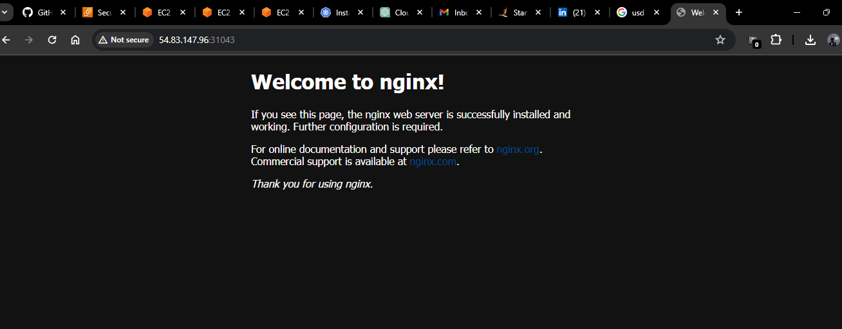

Assignment - 3

Tasks To Be Performed:

1. Use the previous deployment

2. Change the replicas to 5 for the deployment

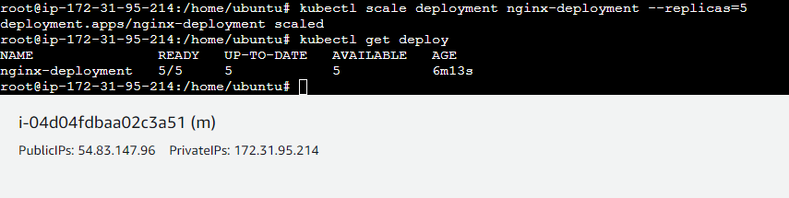

Assignment - 4

Tasks To Be Performed:

1. Use the previous deployment

2. Change the service type to ClusterIP

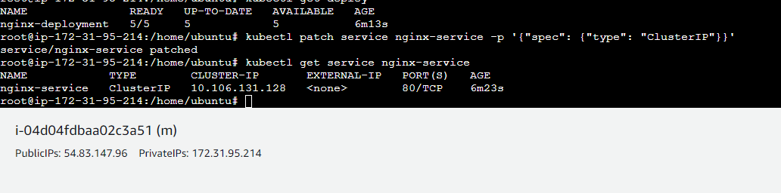

Assignment - 5

Tasks To Be Performed:

1. Use the previous deployment

2. Deploy an NGINX deployment of 3 replicas

3. Create an NGINX service of type ClusterIP

4. Create an ingress service/ Apache to Apache service/ NGINX to NGINX service.

