Linux Environment Variable Assignment

- Create a script named “myscript” in current directory to do the following.
- create a dir named “subd1” in current directory
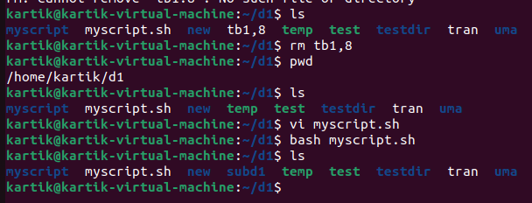
- create a file named “dircontent” with contents of the current directory
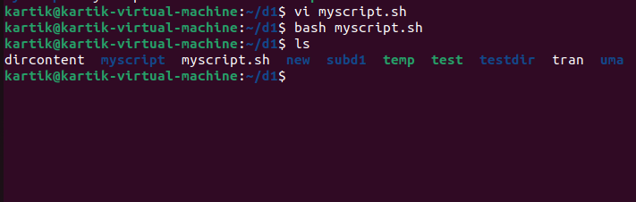
- display the contents of the file “dircontent”
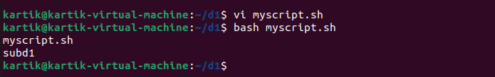

- Run the script and validate the output in following cases
- Redirect only the stdout to an o/p file named stdout.txt
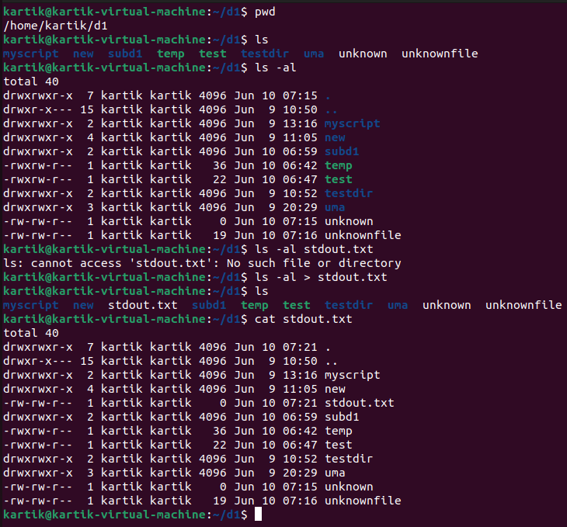
- Redirect only the stderr to an o/p file named stderr.txt
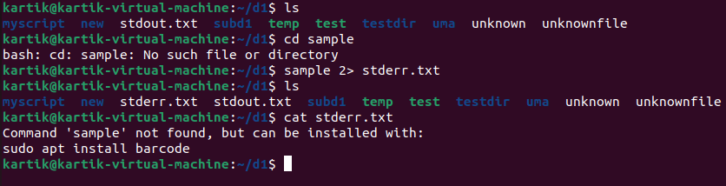
- Redirect both stdout and stderr to an o/p file named stdall.txt
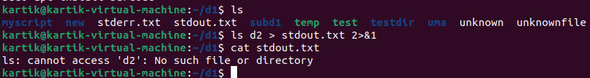
- Display all o/p and error and also redirect both stdout and stderr to an o/p file named stdall.txt
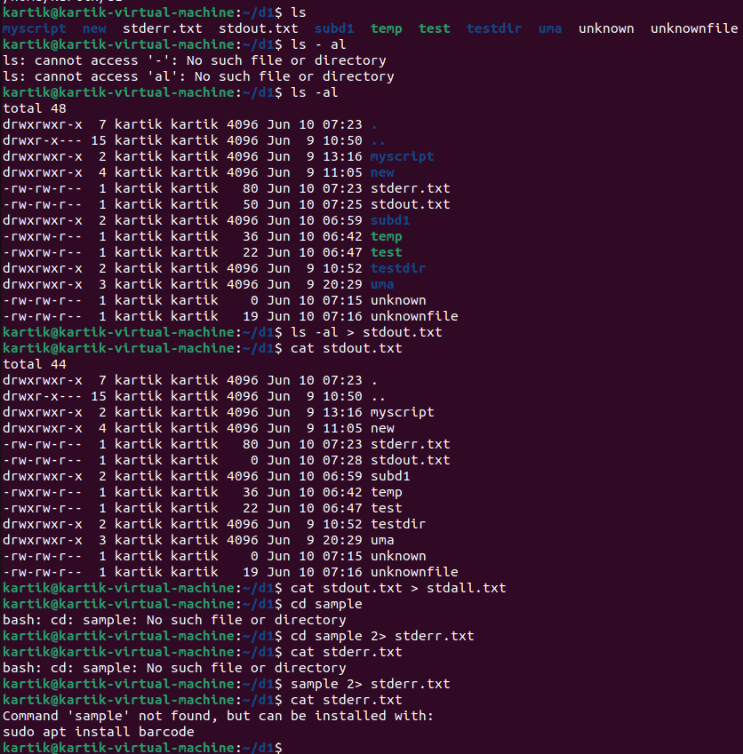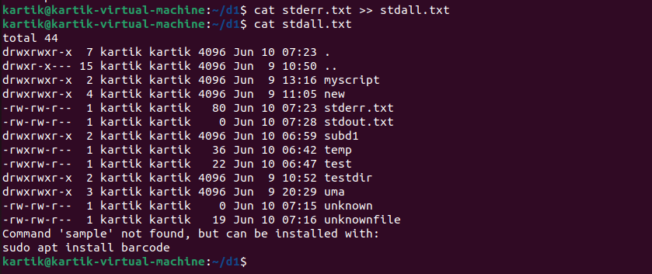

- Redirect the output of command below using pipe (|) to wc and get the output .
ls -l
