**PROJECT STATUS REPORT (SS MCA-III 2020-21)**

For the Month February submitted on _______________

Name of the Student : Kartik Gupta K

PRN : 2017033800143616

Place of the Project : Grid-scape Solutions

Title of the Project : Phoenix

Name of the Guide : Ali Imran nazmi

Work done/Current Status of the Project:

1. Implemented wireframes and made UI
2. Worked on UI/UX.
3. Made signup/login page for the project.
4. Made an intake form for all the necessary data.
5. Learned React and Django.
6. Integrate React ,Django
7. Authentication/Validation on signup and login pages
8. Send user data to the database
9. Made Django API.
10. Analysis work.
11. Gave project presentation to the CEO of Grid-scape.

Work Planned for next Month:

1. Work on Intake Form Backend.
2. Django API for intake form
3. CSRF token security between Django and react
4. Implement Put, Post, Get Delete requests.
5. Send all sorts of data to database(.csv, pdf).

Guide Remarks, if any:

Signature of the Student: 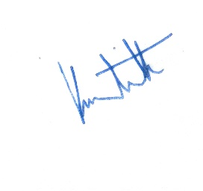 Date: 29-03-2022

Signature of the Guide: __________________ Date: _____________