**PROJECT STATUS REPORT (SS MCA-III 2020-21)**

For the Month January submitted on - 29-03-2022

Name of the Student : Kartik Gupta K

Place of the Project : Grid-scape Solutions

Title of the Project : Phoenix

Name of the Guide : Ali Imran nazmi

Work done/Current Status of the Project:

1. Understood the requirements of our project.
2. Did analysis work to understand different modules.
3. Studied tools used by company for analysis work.
4. Understood flow of the project.
5. Made Wireframes for the project.

Work Planned for next Month:

1. Implemented wireframes and made UI
2. Worked on UI/UX.
3. Made signup/login page for the project.
4. Made an intake form for all the necessary data.
5. Authentication/Validation on signup and login pages
6. Send user data to the database
7. Made Django api
8. Analysis work.

Guide Remarks, if any:

___________________________________________________________________

___________________________________________________________________

___________________________________________________________________

Signature of the Student: 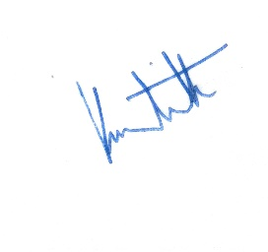 Date: 29-03-2022

Signature of the Guide: __________________ Date: _____________