Project Report
IAM Misconfiguration Detection using Graph Embeddings
Team Members
Member 1 - Rahul Patil (RXP240025)
Member 2 - Kartik Karkera (KXK230091)
Member 3 - Himanshi Rohera (HXR230037)
Member 4 - Siddhu Neehal Rapeti (SXR230189)

Problem Statement

In AWS, an IAM policy is a small JSON file that says, “this user can do this action on this resource.” A real company has thousands of these. Developers often write them in a hurry and accidentally give too much access - for example, allowing every action on every resource. These mistakes are called misconfigurations, and they are the root cause of many cloud breaches (the 2019 Capital One breach exposed 100M+ records because of one bad IAM role).
Most existing tools (Cloud Custodian, AWS Access Analyzer) use hand-written rules like “warn if a policy uses *.” Rules only catch what someone already thought of, so new or unusual mistakes slip through.

Our goal:
Look at all the policies, users, groups, and roles in an organisation, and automatically point out the policies that “look weird” - without writing rules and without needing labelled training data.
We do this with unsupervised anomaly detection on a graph built from the IAM data, following the approach in van Ede et al. (2022).

Assumptions
IAM data is available as an Excel file with four sheets: policies, users, groups, roles.
The PolicyObject column holds a readable AWS policy document (we automatically clean up Python-style text into JSON).
A short list of known bad policy names is available only for scoring - the model never sees it during training.
Neo4j (with the Graph Data Science plugin) is running locally.

Limitations
We match labels by name - if a policy is renamed, its “anomaly” label is lost.
Node2Vec only looks at graph shape, not the text inside the nodes. So ec2:Describe* (very broad) and ec2:DescribeInstances (one specific call) look identical to it.
Grid-search uses the test set for tuning - fine for a class project, not for production.
Action and Resource nodes are stored separately for each policy. This is intentional, but it means the update logic depends on it.

Related Work
Approach | Strength | Weakness
Rule engines (Cloud Custodian, AWS Access Analyzer, Parliament) | Simple, explainable, no training needed | Only catch known bad patterns
Static linters (Access Advisor, cfn-nag) | Good at single-policy checks | Miss problems that span users / groups / roles
Graph + embeddings (van Ede et al., 2022) - what we use | Captures structure, no labels needed | Cannot read the meaning of action names
Supervised ML | Very accurate when labels exist | Big labelled IAM datasets are rare
GraphSAGE / R-GCN | Can use node text as a feature | Heavier to train, less mature tooling
We implement and stress-test the graph + embedding approach on both fake and real AWS data, and we report exactly when it works and when it fails.

System Design

The system has three simple stages, with the same flow as the reference paper:
Excel data → Graph in Neo4j → Vector for each policy → Anomaly detector → Report
High-level flowchart

Detailed pipeline
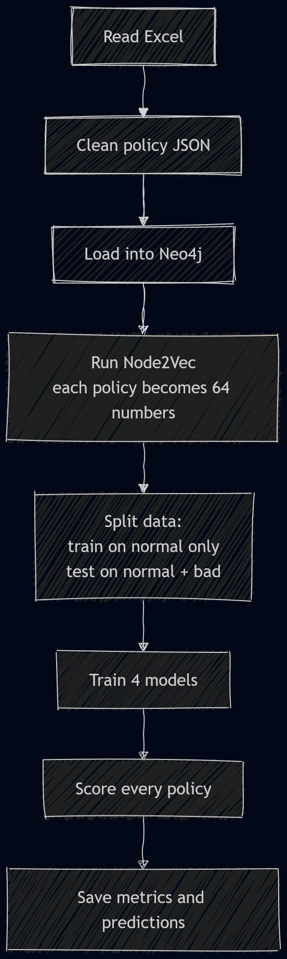

Graph schema (simple view)
Each policy becomes a small star: the policy in the middle, the actions it allows around it, and the resources those actions touch on the outside. Users, groups, and roles connect to the policies they use.
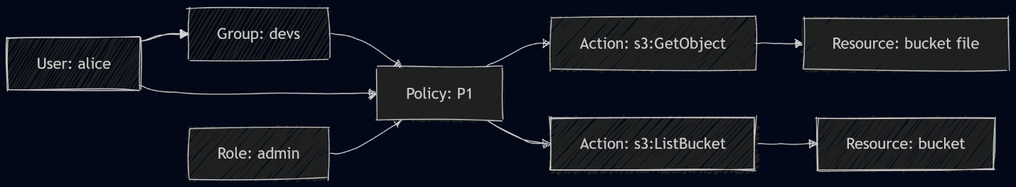
Important design choice: the Action and Resource nodes are kept separate for each policy. So s3:GetObject in Policy A and s3:GetObject in Policy B are two different nodes. This way, when Node2Vec walks the graph, it stays inside one policy and learns that policy’s shape, not a shared shape.

Implementation

Tools used
Layer | Tool
Language | Python 3.11
Graph DB | Neo4j 5 + Graph Data Science plugin (in Docker)
Embedding | gds.node2vec.write (64 numbers per policy)
ML | scikit-learn (IsolationForest, LocalOutlierFactor, OneClassSVM, EllipticEnvelope)
Data | pandas, openpyxl, PyYAML
Dashboard | Streamlit
CLI | python -m src.pipeline run / update / simulate-updates / validate

What each module does
src/core/data_ops.py - reads the Excel file and cleans up the messy JSON-like text in the policy column.
src/core/graph_ops.py - builds the Neo4j graph and runs Node2Vec to give every policy a 64-number “fingerprint.”
src/core/ml_ops.py - splits the data, trains the four detectors, computes scores (precision, recall, F1, ROC-AUC).
src/pipeline.py - the main runner. Calls every step in order and saves logs after each.
streamlit_app.py - a 3-page dashboard for the demo: a live graph, the policies learned over time, and a metrics chart.
update subcommand - compares old and new Excel files and only rebuilds the policies that changed (much faster than rebuilding everything).
simulate-updates subcommand - generates 5 fake snapshots so we can demo the time-series feature without Neo4j.

What we did NOT implement (and why)

Comparison with Cloud Custodian (rule-based tool) - skipped to keep scope small.
128-dim embeddings (the paper uses 128, we use 64) - results are slightly different but trends are the same.
GraphSAGE - out of scope for this iteration.
Operator feedback loop - planned for future work.
Semantic features (wildcard flags, etc.) - this is the most important missing piece, see Section 8.

Issues Faced
Messy JSON. The policy column was Python text, not JSON (single quotes, True/False). We wrote a small repair function that fixes it before parsing, and we log bad rows instead of crashing.
Stale Neo4j projection. If the previous run crashed, Neo4j kept an old “in-memory graph” that blocked us. Fix: always drop it first.
Empty labels. Neo4j GDS errors out if a node label has zero rows. Fix: ask Neo4j what labels exist first, then only project those.
Shared nodes problem. When s3:GetObject was shared across all policies, every policy got pulled toward the same vector. Fix: give each policy its own private Action and Resource nodes.
Different ID styles. Policies are sometimes referenced by name, sometimes by ARN, sometimes by ID. We made the queries accept all of them.
Models collapsed on real data. Our biggest issue: when we added 507 real AWS-managed policies, three out of four models dropped to F1 = 0. This is not a bug - it’s a real limit of Node2Vec, explained below.
Grid search uses test set. We know this is leakage; documented for honesty.

Inputs / Outputs / Screenshots

Input
The Excel file has four sheets. One row in the policies sheet looks like:
PolicyName | PolicyId | Arn | PolicyObject
tf-secmon-iam-policy | P017 | arn:aws:iam::...:policy/... | {'Version': '2012-10-17', 'Statement': [{'Effect': 'Allow', 'Action': '*', 'Resource': '*'}]}
Graph
Flowchart 3

Streamlit dashboard

Screenshot placeholder: outputs/images/streamlit_page1_graph.png - live graph.
Screenshot placeholder: outputs/images/streamlit_page2_riskbar.png - top risky policies.
Screenshot placeholder: outputs/images/streamlit_page3_metrics.png - per-model metrics.

Output - metrics

Synthetic-only (313 policies):
Model | Precision | Recall | F1 | ROC-AUC
One-Class SVM | 0.69 | 0.69 | 0.69 | 0.96
Isolation Forest | 0.50 | 0.40 | 0.44 | 0.96
Elliptic Envelope | 1.00 | 0.24 | 0.39 | 0.79
LOF | 0.00 | 0.00 | 0.00 | -

Real + synthetic (~820 policies):
Model | Precision | Recall | F1 | ROC-AUC
One-Class SVM | 0.237 | 0.483 | 0.318 | 0.454
Isolation Forest | 0.000 | 0.000 | 0.000 | 0.484
LOF | 0.000 | 0.000 | 0.000 | 0.434
Elliptic Envelope | 0.000 | 0.000 | 0.000 | 0.442
Per-policy predictions: outputs/predictions/<model>_pred.csv. Comparison reports: outputs/metrics/comparison_synth.md, comparison_real.md, comparison_merged.md.
Why the drop? Real AWS policies (like AWSBackupAdminPolicy) legitimately use Resource: *. To Node2Vec, a legitimate * policy looks identical to a misconfigured * policy. So once we mix them in, the model can’t tell them apart.

Future Directions
The main lesson: Node2Vec sees the shape of the graph, but not the text inside the nodes. Fixing that is the main next step.
Add hand-crafted features alongside the embedding. A small list of 10-20 yes/no flags would tell the model what the policy actually does:
Is this an AWS-managed policy? (check the ARN)
How many actions or resources are wildcards (*)?
Does it use dangerous actions like iam:PassRole or sts:AssumeRole without a Condition?
Does it allow cross-account access?
Try GraphSAGE / R-GCN. These embedding methods can use the node’s text (e.g. the action name) as part of the learning, not just the connections.
Feedback loop. Let security analysts mark alerts as true/false; retrain on that signal.
Support Azure and GCP IAM, which have the same idea (principal → action → resource).
Use a proper validation set for grid search (instead of leaking the test set).
Compare against Cloud Custodian as a baseline.
Stream live updates from CloudTrail so the graph updates in real time.

References
van Ede, T. et al. (2022). IAM Misconfiguration Detection using Graph Embeddings. Provided as ResearchPaper.pdf in this repository - the source of the graph schema, Node2Vec embedding step, and the unsupervised evaluation protocol we follow.
Grover, A. & Leskovec, J. (2016). node2vec: Scalable Feature Learning for Networks. KDD 2016.
Neo4j, Inc. Graph Data Science Library - Node2Vec. https://neo4j.com/docs/graph-data-science/current/algorithms/node2vec/
Pedregosa, F. et al. (2011). scikit-learn: Machine Learning in Python. JMLR 12.
AWS. IAM Policy Reference & AWS-managed Policies. https://docs.aws.amazon.com/IAM/latest/UserGuide/reference_policies.html
Capital One Financial Corp. (2019). Information on the Capital One Cyber Incident. - motivating real-world breach.
Cloud Custodian project. https://cloudcustodian.io/ - the rule-based baseline our approach is positioned against.

Team Member Contributions
Member | Contributions
Rahul Patil (RXP240025) | Excel ingestion and cleanup (data_ops.py); JSON repair logic; schema checks; merging the real and synthetic datasets.
Kartik Karkera (KXK230091) | Neo4j graph construction (graph_ops.py); Cypher loaders; per-policy private Action/Resource design; Node2Vec setup and diagnostics.
Himanshi Rohera (HXR230037) | ML pipeline (ml_ops.py); train/test split; training & evaluating the four detectors; grid search; metrics; root-cause analysis of the merged-run drop.
Siddhu Neehal Rapeti (SXR230189) | Pipeline runner / CLI (pipeline.py); update and simulate-updates subcommands; Streamlit dashboard; time-series snapshots; report and docs.

