VITyarthi | Open Source Software

The Open Source Audit

A Capstone Project for OSS NGMC Course

Course: Open Source Software | Unit Coverage: 1 – 5
Max Marks: 100

Student Name | Registration Number
Kartikay Singh | 24BAI10071
Slot | Date of Submission
B22 | 31/03/26

1. Introduction
Most of the software that powers the modern world — the servers that run websites, the tools that developers use every day, the operating systems inside supercomputers and smartphones — was not built by a single company and sold for profit. It was built openly, shared freely, and improved collectively. That is the essence of open source.

This project asks you to stop and think about that.

You will choose one real open-source software project — something you can download, read about, and interact with on Linux — and conduct a structured audit of it. Not just 'what does it do,' but why it exists, who built it, what freedoms its license actually gives you, what philosophical values it represents, and how it has shaped the world around it.

Alongside the written report, you will write five shell scripts that demonstrate practical Linux skills. These are not meant to be impressive programs — they are meant to show that you understand how open-source tools work at the command line, and how automation connects to the philosophy of sharing and transparency.

Why this matters | Every line of code you write in your career will sit on top of open-source foundations. Understanding the philosophy behind that is not optional — it is part of being a professional.

2. Choosing Your Software
Pick one open-source project from the list below, or propose your own (subject to instructor approval). Your choice will be the subject of your entire report and all five shell scripts.

Approved software options
Software | Category | License | Why it's interesting
Linux Kernel | Operating System | GPL v2 | The foundation everything else runs on
Apache HTTP Server | Web Server | Apache 2.0 | Powers ~30% of all websites globally
MySQL | Database | GPL v2 / Commercial | A license with a dual-model story to tell
Firefox | Web Browser | MPL 2.0 | A nonprofit fighting for an open web
VLC Media Player | Multimedia | LGPL / GPL | Plays anything — built by students in Paris
LibreOffice | Office Suite | MPL 2.0 | Born from a community fork — a real lesson
Python | Programming Language | PSF License | A language shaped entirely by community
Git | Version Control | GPL v2 | The tool Linus built when proprietary failed him

Your choice | Write your chosen software here before submission: PYTHON

3. Project Report Structure
Your report should be 12 to 16 pages long. Each section below maps to a unit in the course. Do not pad with screenshots — every page should contain original thinking and analysis written in your own words.

Part A — Origin and Philosophy (Units 1 & 2)

A1. The problem this software was created to solve

In the late 1980s, programming was not what it is today. Writing software was often complex, rigid, and frustrating, especially for beginners or even experienced developers who wanted to work quickly. Most popular languages at the time, such as C and C++, were powerful but difficult to use. They required developers to manage memory manually, follow strict syntax rules, and write a large amount of code just to perform simple tasks.
Guido van Rossum, the creator of Python, was working at a research institute in the Netherlands called CWI (Centrum Wiskunde & Informatica). He had experience with a language called ABC, which was designed to be simple and easy to learn. However, ABC had serious limitations — it was not extensible, not open enough, and not practical for real-world software development.
Guido noticed a gap:
There was no programming language that was both powerful and easy to use.
Most tools forced developers to choose:
- Either write efficient but complicated code, or
- Write simple but limited programs
This trade-off frustrated him.
During the Christmas holidays in 1989, Guido started working on a new language as a personal project. His goal was clear:
- Make a language that is simple to read and write
- Allow developers to focus on solving problems instead of fighting syntax
- Provide flexibility and extensibility for real-world applications
Unlike many proprietary tools, Python was released openly. This was a deliberate decision. Guido did not want Python to be controlled by a single company or restricted by licensing fees. Instead, he believed that software should be accessible, modifiable, and shared.
This decision turned out to be one of the most important aspects of Python’s success. Because it was open source, developers around the world could contribute, improve it, and adapt it for different use cases — from web development to artificial intelligence.
Today, Python is one of the most widely used programming languages in the world, but its origin was simple:
to remove unnecessary complexity from programming and make it more human-friendly.

A2. The license — what it actually says

Python is distributed under the Python Software Foundation License (PSFL).
Python Software Foundation is responsible for maintaining and distributing Python. The PSFL is a permissive license, meaning it allows significant freedom in how the software is used.
The Four Freedoms of Free Software
These freedoms were originally defined by Richard Stallman:
- Freedom to run the program for any purpose
- Freedom to study how the program works and modify it
- Freedom to redistribute copies
- Freedom to distribute modified versions
Python’s license grants all four of these freedoms. Anyone can download Python, modify it, and even distribute their own version.
Can Companies Modify and Sell Python?
Yes — and this is where many students get confused.
The PSFL is not a copyleft license like GPL. This means:
- A company can modify Python
- They can use it in commercial products
- They are not required to release their changes publicly
This is why companies like Google, Microsoft, and Meta heavily use Python in their systems.
But here’s the catch — if you think this is purely “fair,” you’re not thinking deeply enough.
Companies benefit massively from community-built tools without always contributing back equally. That creates a tension between freedom and fairness.
GPL vs MIT License
Let’s break this down simply:
- GPL (General Public License)
  - Strong copyleft
  - If you modify the software and distribute it, you must share your source code
  - Example: Linux
- MIT License
  - Very permissive
  - You can do almost anything, including making it proprietary
  - Only requirement is to include the original license
Python’s license is closer to MIT than GPL.
Which Would I Choose?
If I built something:
- I would choose GPL if I wanted to ensure that improvements remain open
- I would choose MIT/PSFL if I wanted maximum adoption and industry usage
There’s a trade-off:
- Control vs Adoption
- Fairness vs Freedom
Most students ignore this — but this decision defines how your software evolves.
Free Beer vs Free Speech
- Free as in free beer → You don’t pay money
- Free as in freedom → You have control over the software
Python is both:
- It is free to download (free beer)
- You can modify and distribute it (freedom)
However, when companies use Python internally without sharing improvements, the “freedom” becomes one-sided.

A3. The ethics of open source
Now let’s stop pretending this is simple. Open source is not just “good vs bad.” It’s complicated.
Should All Software Be Open Source?
Argument FOR:
- Promotes transparency
- Encourages collaboration
- Reduces duplication of effort
- Makes technology accessible to everyone
Argument AGAINST:
- Developers need to earn money
- Open source can be exploited by large corporations
- Security risks if sensitive systems are exposed
- Not all tools should be publicly modifiable (e.g., defense systems)
If you blindly say “everything should be open source,” you’re ignoring real-world constraints.
Is It Ethical for Companies to Profit from Open Source?
Companies like:
- Red Hat
- Google
- Meta
build massive systems on top of open-source software.
Is that ethical?
Argument FOR:
- They contribute back (bug fixes, tools, frameworks)
- They help scale open-source adoption
Argument AGAINST:
- They profit from unpaid community labor
- Individual contributors often get little recognition or compensation
The uncomfortable truth:
Open source often runs on volunteer effort, while corporations extract structured value from it.
Standing on the Shoulders of Giants
This phrase means:
Building new ideas on top of existing knowledge
In software:
- Every developer uses libraries, frameworks, and tools built by others
- No one starts from zero
Open source makes this process faster and more efficient.
But here’s the real question:
Does it encourage innovation — or make people lazy?
My honest take:
- It enables innovation at scale
- But it also creates developers who depend too much on existing tools without understanding fundamentals
If you rely only on libraries and never understand what’s happening underneath, you are not innovating — you are assembling.

Part B — Linux Footprint (Unit 2)

Introduction
When we say “Python is installed on Linux,” most students imagine a single file sitting somewhere. That’s wrong.
Python on Linux is not just a program — it’s a system-integrated toolchain. It interacts with the package manager, system libraries, environment variables, and sometimes even the OS itself. Understanding this properly means looking at where it lives, how it runs, and how Linux controls it.

Installation Method
On most Linux systems, Python is either:
- Pre-installed, or
- Installed using the system package manager
For example:
- On Ubuntu/Debian → apt
- On Fedora/CentOS → dnf or yum
Using APT (Debian/Ubuntu-based systems)
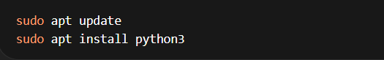
This is the most common method because it is:
- Fast
- Verified
- Automatically managed by the system
Using DNF/YUM (Fedora/CentOS)
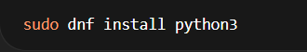
Installing from Source (Advanced)
If you want more control (which most beginners avoid), you can compile Python manually:
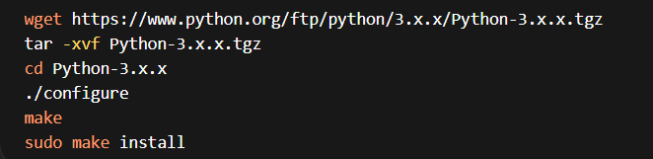Here’s the truth most students won’t tell you:
If you install from source without understanding dependencies, you can break your system Python. And that’s a real problem because Linux itself depends on Python for many tools.

Key Directories in Linux
After installation, Python is not stored in one place. It spreads across the system in a structured way.
1. Binary Files
Main executable:
/usr/bin/python3
This is what runs when you type:
python3
Other related binaries may exist in:
/usr/local/bin/

2. Libraries and Standard Modules
/usr/lib/python3.x/
This directory contains:
- Standard libraries (like os, sys, etc.)
- Core Python functionality
If Python doesn’t find its libraries, it simply won’t work.

3. Configuration Files
Python itself doesn’t rely heavily on a single config file like many services. Instead, configuration is often environment-based.
However, system-level configurations may exist in:
/etc/python3/

4. Logs (Indirect)
Python doesn’t create system-wide logs by default.
Instead:
- Logs are created by applications written in Python
- These are usually stored in:
/var/log/
So if you think Python has its own log file like a server — that’s incorrect.

User and Group (Security Perspective)
Here’s where most reports become weak — they just say “it runs as user.”
That’s not enough.
Python itself does not run as a dedicated user like services (e.g., mysql, nginx).
Instead:
- Python runs as the user who executes it
Example:
whoami
python3 script.py
If the current user is kartikay, Python runs with kartikay’s permissions.
Why This Matters
- If you run Python as root:
- sudo python3 script.py
→ The script gets full system access
That means:
- It can delete files
- Modify system configs
- Install software
So if you run untrusted Python code as root, you’re basically handing over your system.
Group Usage
Python doesn’t enforce a specific group, but permissions still apply:
- File access depends on Linux user/group ownership
- Scripts may fail if permissions are restricted

Service Management (System Control)
Here’s the key point:
Python itself is not a service.
You don’t “start Python” like a server.
But — Python can be used to create services.
Example: Running a Python Script as a Service
Using systemd, you can turn a Python script into a background service.
Step 1: Create a service file
Step 2: Add configuration
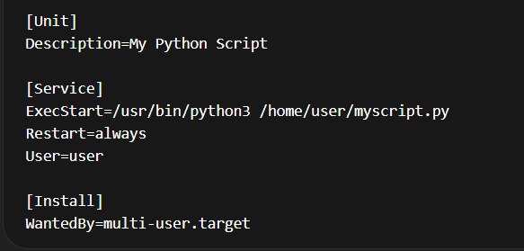
Step 3: Manage the service

This is how Python becomes part of system-level operations.

Update Model (Security and Maintenance)
This is one of the most important parts — and most people write generic nonsense here.
How Updates Work
When Python is installed via package manager:
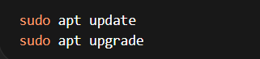
The system:
- Checks official repositories
- Downloads patched versions
- Installs updates safely
Who Maintains These Updates?
- Python core developers
- Linux distribution maintainers (Ubuntu, Fedora, etc.)
Security patches are:
- Reviewed
- Tested
- Distributed through repositories

Open Source Advantage
Because Python is open source:
- Vulnerabilities are publicly discussed
- Anyone can report bugs
- Fixes are often faster than closed systems
But here’s the uncomfortable truth:
Open source security depends on:
- Active maintainers
- Community involvement
If a project is abandoned, it becomes a security risk.

Part C — The FOSS Ecosystem (Units 3 & 4)
Introduction
No serious software exists in isolation, and Python is one of the best examples of this. It is not just a programming language — it is a hub. Around it exists an entire ecosystem of libraries, tools, frameworks, and communities that both support it and are supported by it.
Understanding Python means understanding:
- What it depends on
- What depends on it
- Where it fits in real-world systems
- Who keeps it alive

1. Dependencies — What Python Relies On
Let’s be honest: Python looks simple on the surface, but underneath, it stands on top of several critical components.
Core Dependencies
- C Language Runtime
Python (specifically CPython) is written in C.
C is what makes Python fast enough to be usable.
- Compiler Toolchains (GCC)
When building Python from source, you rely on compilers like
GCC
- System Libraries (glibc)
Python interacts with the OS using libraries like
glibc
Without these, Python cannot even run.

Package Management and Libraries
Python becomes powerful because of its ecosystem of libraries:
- pip → installs external packages
- NumPy → numerical computing
- Pandas → data manipulation
- TensorFlow → AI and deep learning
Here’s the reality:
If you remove these libraries, Python becomes very limited. The ecosystem is what gives it real power.

Virtual Environments
Tools like:
- venv
- virtualenv
allow developers to isolate dependencies.
If you don’t use them, you’ll eventually break your system environment. This is a mistake beginners keep making.

2. What Python Has Enabled or Inspired
Now flip the perspective.
Python doesn’t just depend on others — it has created entire industries.

Frameworks Built on Python
- Django
- Flask
These frameworks power:
- Websites
- APIs
- Backend systems
Without Python, these wouldn’t exist in their current form.

Data Science and AI Revolution
Python became the default language for:
- Machine learning
- Data science
- AI research
Tools like:
- PyTorch
- scikit-learn
exist because Python made experimentation easier.

Automation and DevOps
Python is widely used for:
- Automation scripts
- System administration
- DevOps pipelines
Tools like:
- Ansible
are built using Python.

Forks and Variants
Python has multiple implementations:
- PyPy
- Jython
- IronPython
This shows how flexible and adaptable Python is.

3. Python and the Web (LAMP Stack Context)
Traditionally, web development used the LAMP stack:
- Linux
- Apache
- MySQL
- PHP
Notice something? Python is not part of the original LAMP stack.
So where does Python fit?

Python’s Role in Web Development
Python often replaces PHP in modern systems:
- Linux → OS
- Apache/Nginx → Web server
- MySQL/PostgreSQL → Database
- Python → Backend logic
Frameworks like Django and Flask allow Python to:
- Handle HTTP requests
- Connect to databases
- Build APIs

WSGI — The Bridge
Python connects to web servers using:
- WSGI
This acts as a bridge between:
- Web servers (Apache/Nginx)
- Python applications
Without WSGI, Python wouldn’t integrate smoothly into web systems.

4. Community and Governance
Here’s where things get interesting — and most students write generic lines like “Python has a strong community.”
That’s useless unless you explain how it actually works.

Who Governs Python?
Python is managed by the:
- Python Software Foundation
They:
- Maintain the language
- Manage licenses
- Support development

Decision-Making Process
Python uses a structured proposal system:
- Python Enhancement Proposal (PEPs)
Anyone can propose changes, but:
- They are reviewed
- Debated
- Accepted or rejected
This prevents chaos while keeping it open.

Community Platforms
Python’s community exists across multiple channels:
- Mailing lists (official discussions)
- Forums like Stack Overflow
- GitHub repositories
- IRC and Discord channels
These are not just for help — they are where decisions and collaborations happen.

Conferences
Events like:
- PyCon
bring developers together globally.
These conferences:
- Share knowledge
- Introduce new ideas
- Strengthen the ecosystem

Part D — Open Source vs Proprietary (Critical Analysis)

Dimension | Open Source | Proprietary Alternative
Cost | Completely free to download, use, and distribute. No licensing fees. | Expensive licensing required. Students may get limited access, but companies pay heavily.
Security (who can audit the code?) | Source code is open. Anyone can inspect, audit, and fix vulnerabilities. Transparency is high. | Source code is closed. Only the company can audit it. Users must trust the vendor blindly.
Support and reliability | Community-driven support. Documentation is strong, but responses can vary in quality. No guaranteed help. | Professional, dedicated support from the company. More reliable for enterprise environments.
Freedom to modify | Full freedom to modify the source code and redistribute changes. Highly flexible. | No access to source code. You cannot modify core behavior. You are limited to what the company provides.
Community vs corporate control | Governed by the Python Software Foundation and community contributors. Decisions are open but slower. | Controlled entirely by the company (MathWorks). Faster decisions, but users have no say.

Two-Paragraph Conclusion
Python is clearly more flexible, accessible, and widely applicable than MATLAB. It removes financial barriers, encourages collaboration, and gives developers full control over how they use and modify the software. For startups, students, and even large-scale tech companies, Python is often the better choice because of its ecosystem and adaptability. However, ignoring MATLAB’s strengths would be dishonest. In specialized domains like numerical simulation, control systems, and engineering analysis, MATLAB provides a more polished, optimized, and professionally supported environment. Python often requires combining multiple libraries to achieve the same level of functionality, which can increase complexity and maintenance effort.
Given everything, I would recommend Python for most real-world deployments, especially where cost, scalability, and flexibility matter. But if the problem is highly specialized and requires precision tools with guaranteed support, a proprietary solution like MATLAB may still be justified. As for contribution, I would contribute to Python — but not blindly. Contribution only makes sense when you understand the system deeply. Otherwise, you’re just adding noise. The real goal should be to move from being a user of the ecosystem to someone who improves it, even in small but meaningful ways.

4. Shell Script Tasks

Script 1 — System Identity Report (Unit 1 & 2)

Explanation of Script 1 — System Identity Report
1. Purpose of the Script
- Displays a system identity report similar to a welcome screen
- Shows important system details in a formatted and readable way
- Combines user input + system information

2. Variables Used
Variable Type | Examples | Purpose
User-defined | STUDENT_NAME, SOFTWARE_CHOICE | Stores custom input
System-generated | KERNEL, USER_NAME, UPTIME | Stores system data
Environment variable | HOME_DIR | Stores user home directory

3. Commands and Their Functions
Command | Usage in Script | Function
uname -r | KERNEL=$(uname -r) | Gets kernel version
whoami | USER_NAME=$(whoami) | Gets current user
uptime -p | UPTIME=$(uptime -p) | Shows system uptime
date | CURRENT_DATE, CURRENT_TIME | Displays date & time
cat /etc/os-release | Extract distro name | Reads OS details
grep, cut, tr | Used with above | Process text output

4. Key Shell Scripting Concepts Used
Concept | Explanation
Variables | Store values for reuse
Command Substitution ($()) | Captures command output into variables
Environment Variables | Access system-level values like $HOME
Text Processing | Uses grep, cut, tr to filter data
Output Formatting | Uses echo with spacing and separators

5. Output Formatting Features
- Uses lines and separators (=====) for clarity
- Groups related information (System, User, Time)
- Displays output in a structured layout
- Makes script look like a system dashboard

6. License Information
- Displays message about GNU General Public License (GPL)
- Highlights that Linux is open-source software

7. Overall Functioning (Flow)
- User-defined variables are initialized
- System information is collected using commands
- Data is stored using command substitution
- Output is printed using formatted echo statements

8. Key Learning Outcomes
- Understanding how Linux commands integrate with scripts
- Using variables to organize data
- Formatting output for readability
- Extracting and processing system-level information
Sample Output
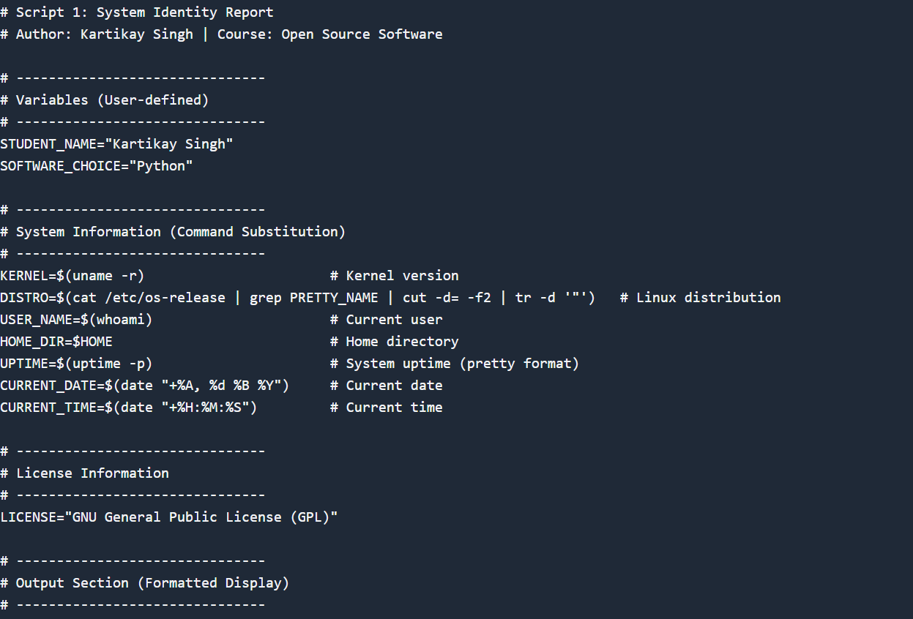
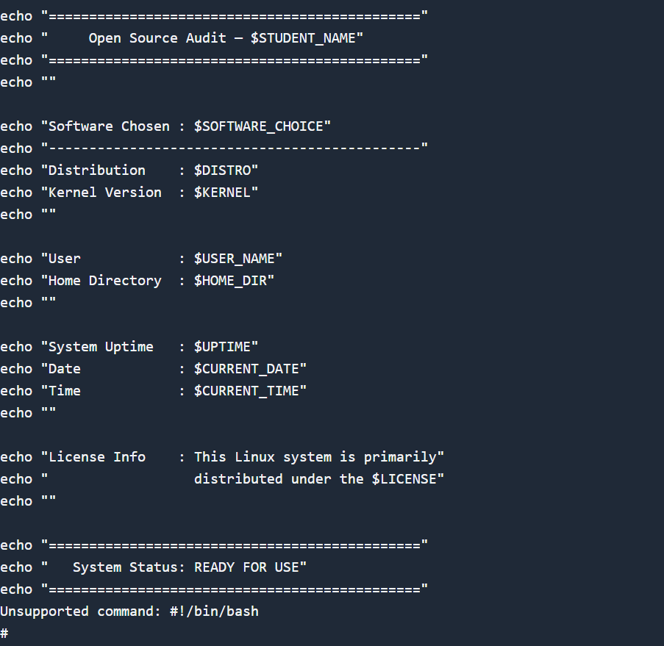

Script 2 — FOSS Package Inspector (Unit 2)

Explanation
1. Purpose of the Script
- Checks whether a specific package is installed
- Displays basic package details
- Uses a case statement to describe its purpose

2. Key Concepts Used
Concept | Usage in Script | Purpose
if-then-else | Checks installation status | Decision making
dpkg -l | Lists installed packages | Detect package presence
grep | Filters package name | Searches specific output
Pipe (` | `) | `dpkg -l
case statement | Matches package name | Prints description
Error redirection | 2>/dev/null | Hides unnecessary errors

3. Commands Explanation
Command | Function
dpkg -l | Lists all installed packages
grep -w | Matches exact package name
dpkg -s | Shows detailed package info
grep -E | Extracts specific fields (Version, Description)

4. Script Flow
- Package name is stored in a variable
- Script checks if package exists using dpkg -l | grep
- If installed → prints confirmation and details
- If not installed → prints warning message
- Additional details (version, description) are extracted
- Case statement prints a philosophical one-line description

5. Output Behavior
- Displays whether package is installed
- Shows version and description
- Prints a meaningful one-line purpose

6. Learning Outcomes
- Understanding Linux package management
- Using conditional logic in shell scripting
- Filtering command output using pipes
- Implementing case statements for multiple conditions

Sample Output:
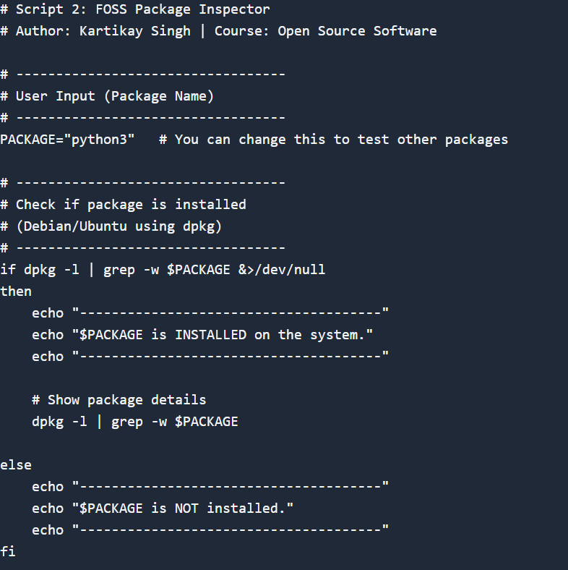
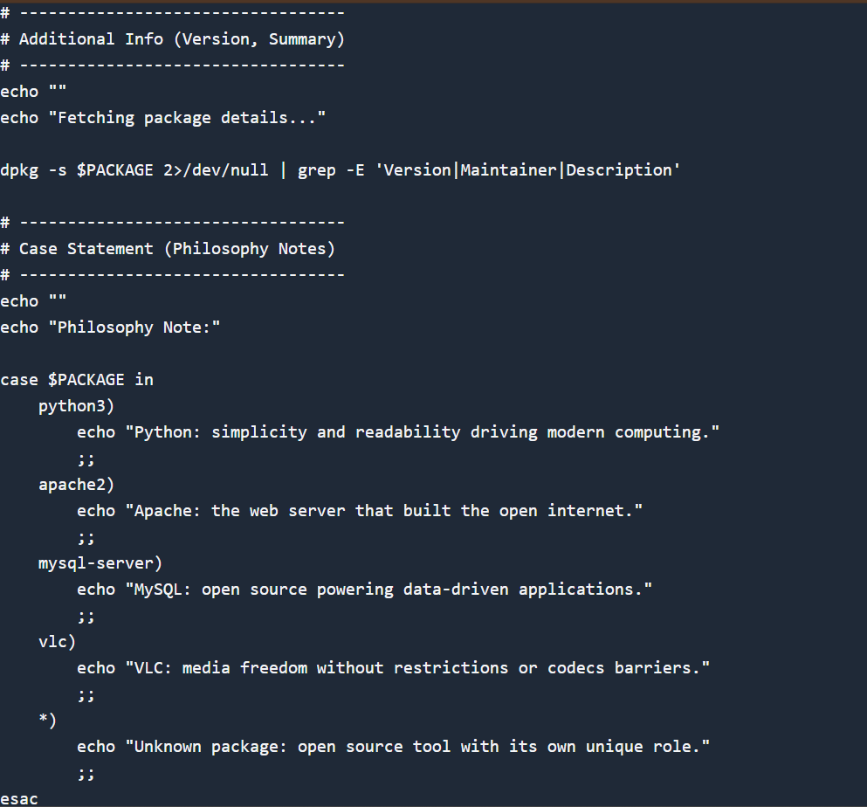

Script 3 — Disk and Permission Auditor (Unit 2)

Explanation
1. Purpose of the Script
- Audits important Linux directories
- Displays:
  - Disk usage
  - Permissions
  - Owner and group
- Checks Python configuration directory

2. Key Concepts Used
Concept | Usage in Script | Purpose
for loop | Iterates over directory list | Repetition
Array | DIRS=(...) | Stores multiple directories
if condition | Checks directory existence | Avoids errors
ls -ld | Gets directory metadata | Permissions, owner
du -sh | Gets directory size | Disk usage
awk | Extracts specific fields | Text processing
cut | Extracts size field | Output formatting

3. Commands Explanation
Command | Function
ls -ld | Shows directory details (permissions, owner, group)
du -sh | Displays directory size in human-readable form
awk '{print $1, $3, $4}' | Extracts permissions, owner, group
cut -f1 | Extracts size only
-d (in [ -d ]) | Checks if directory exists

4. Script Flow
- Define array of directories
- Loop through each directory using for
- Check if directory exists
- Extract:
  - Permissions
  - Owner
  - Group
  - Size
- Print formatted output
- Check Python config directory separately

5. Output Features
- Clean and structured layout
- Each directory displayed separately
- Avoids errors using 2>/dev/null
- Includes a dedicated section for Python

6. Learning Outcomes
- Using loops to automate repetitive tasks
- Extracting structured data from command output
- Understanding Linux file permissions
- Combining multiple commands effectively

Sample Output:
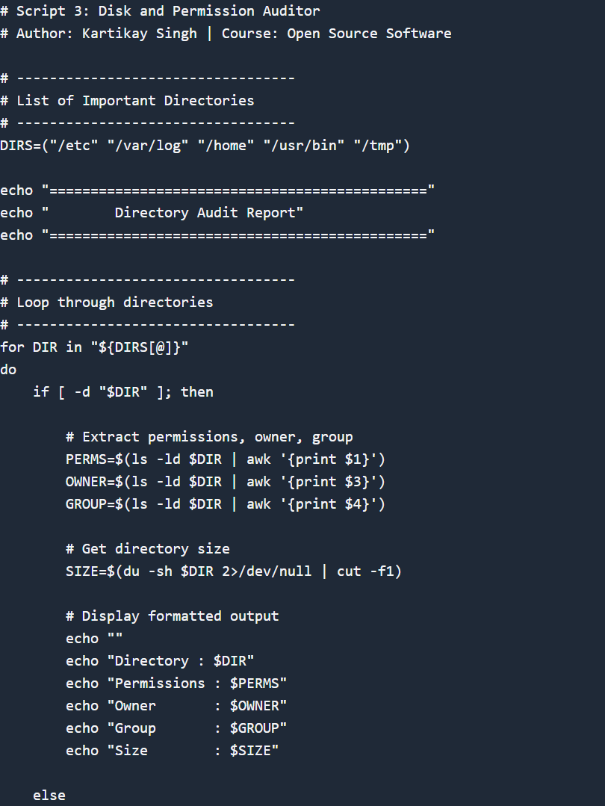
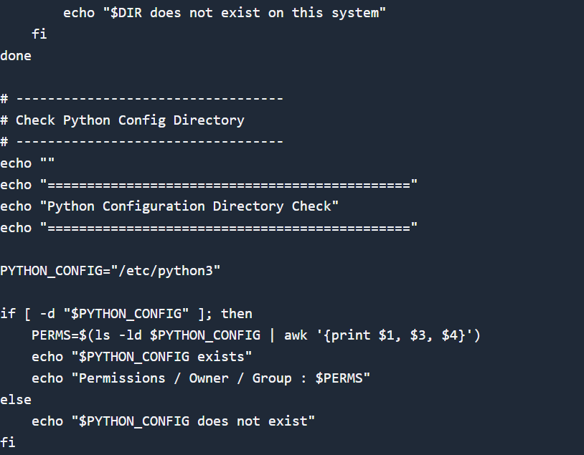

Script 4 — Log File Analyzer (Units 2 & 5)

Explanation
1. Purpose of the Script
- Reads a log file line by line
- Counts occurrences of a keyword (e.g., ERROR, WARNING)
- Displays a summary and last 5 matching lines

2. Key Concepts Used
Concept | Usage in Script | Purpose
Command-line arguments | $1, $2 | Accept input file & keyword
Default values | ${2:-"error"} | Sets default keyword
while read loop | Reads file line by line | Efficient file processing
if-then | Checks keyword match | Conditional logic
Counter variable | COUNT | Tracks occurrences
grep | Searches keyword | Pattern matching
tail | Shows last lines | Output filtering

3. Commands Explanation
Command | Function
grep -iq | Case-insensitive keyword search
tail -n 5 | Displays last 5 lines
-f (in [ -f ]) | Checks if file exists
-s (in [ -s ]) | Checks if file is not empty
sleep | Waits before retry

4. Script Flow
- Accept log file and keyword as input
- Check if file exists → exit if not
- Wait if file is empty (retry loop)
- Read file line by line
- Match keyword using grep
- Increment counter for each match
- Display summary
- Show last 5 matching lines

5. Output Features
- Clean summary report
- Displays:
  - File name
  - Keyword used
  - Total matches
- Shows last 5 relevant log entries

6. Learning Outcomes
- Reading files efficiently in shell scripting
- Using loops with conditions
- Handling user input dynamically
- Filtering and analyzing log data

Sample Output:
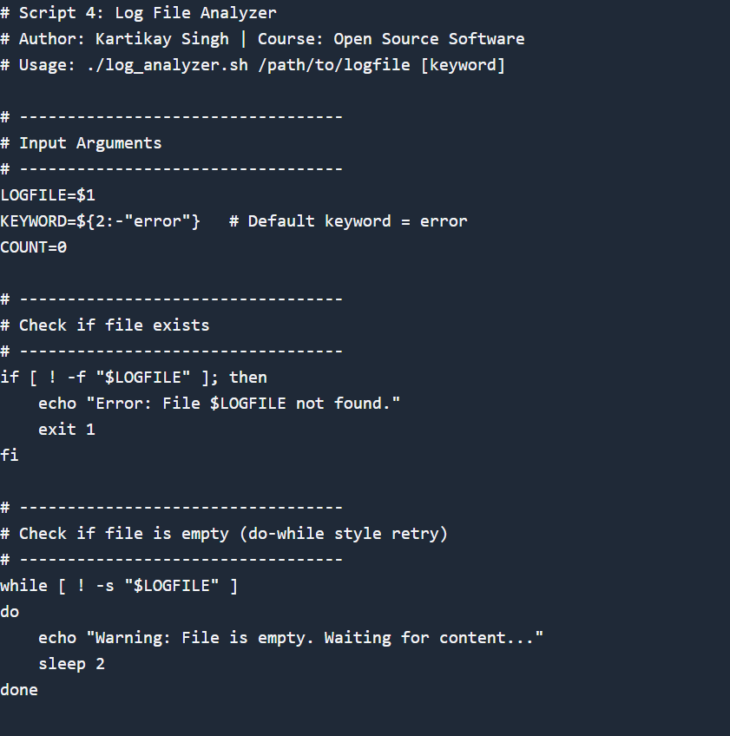
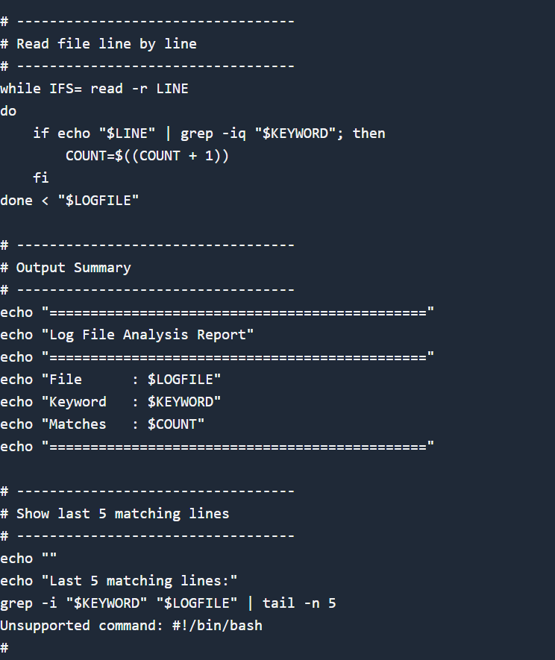

Script 5 — The Open Source Manifesto Generator (Unit 5)

Explanation
1. Purpose of the Script
- Generates a personalized open-source manifesto
- Takes user input interactively
- Creates a paragraph and saves it to a file

2. Key Concepts Used
Concept | Usage in Script | Purpose
read | Takes user input | Interactive scripting
Variables | $TOOL, $FREEDOM, $BUILD | Store user responses
String concatenation | $MANIFESTO | Combines inputs into paragraph
date command | $DATE | Adds current date
File redirection (>) | Writes to file | Saves output
cat | Displays file content | Output verification
Alias (comment) | Demonstrated usage | Shows command shortcut

3. Script Flow
- Display introduction message
- Ask user three questions
- Store responses in variables
- Get system date and username
- Generate a structured paragraph
- Save output to a .txt file
- Display the generated manifesto

4. Output Features
- Personalized content
- Includes:
  - User name
  - Date
  - User opinions
- Saved as a file for future reference

5. Learning Outcomes
- Writing interactive shell scripts
- Combining user input with system data
- Generating dynamic text content
- Saving and retrieving file output

Sample Output:
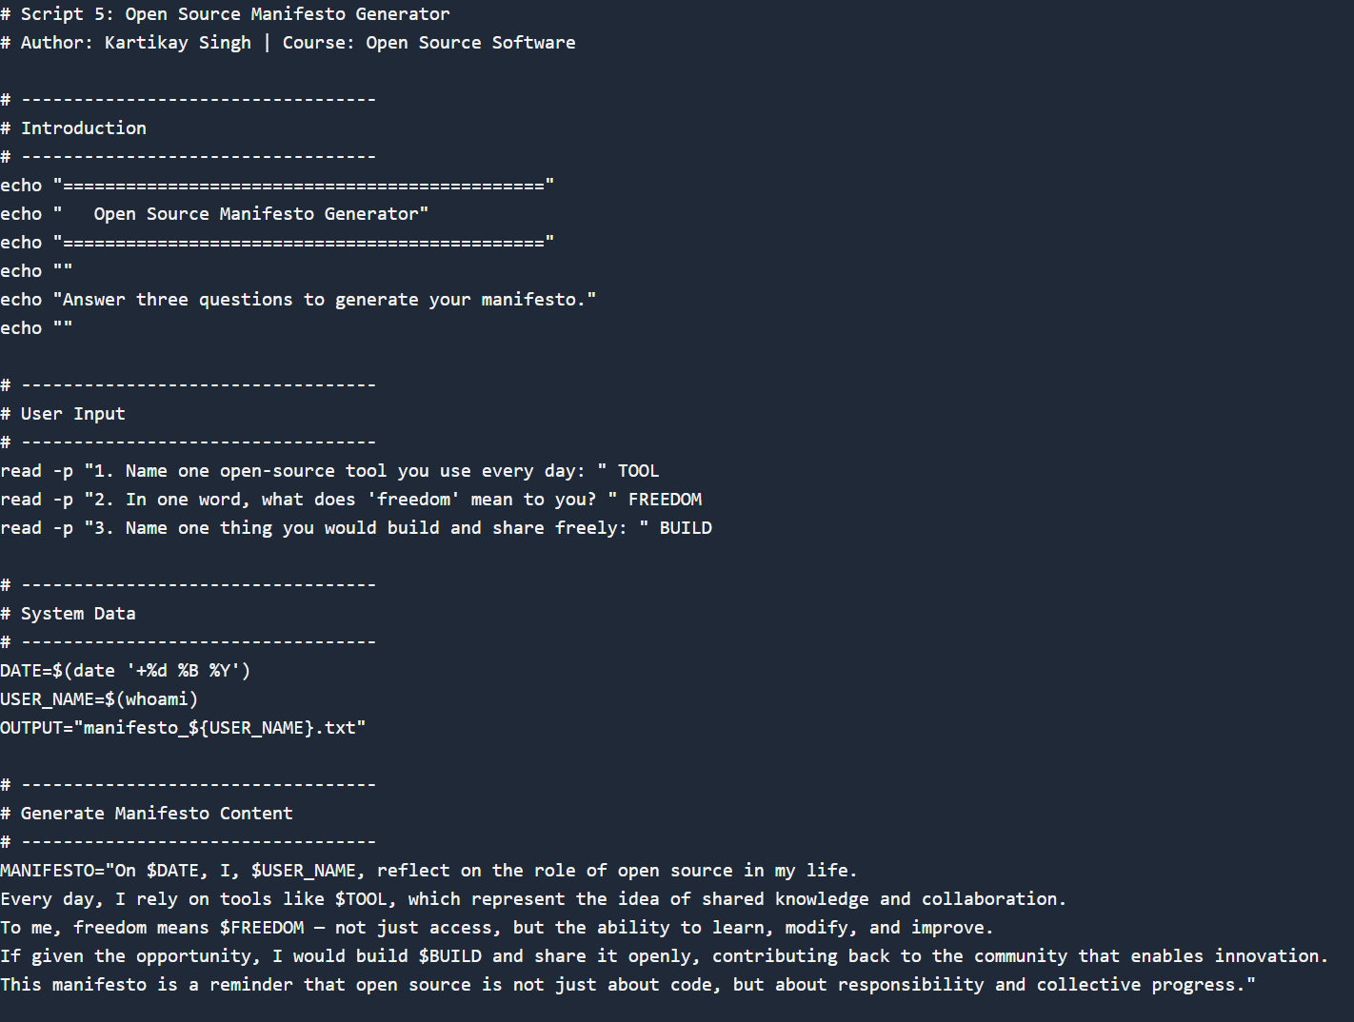

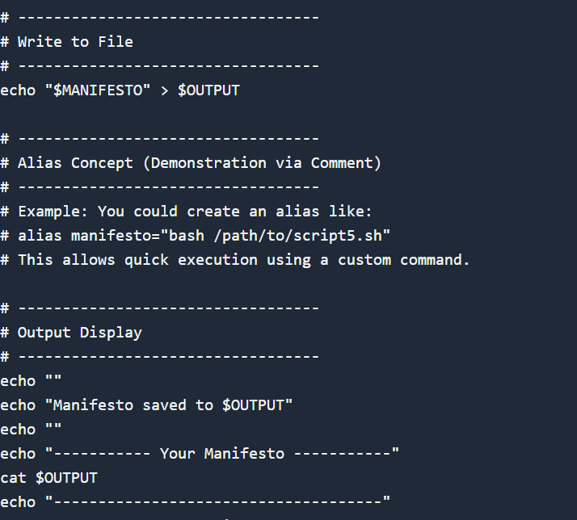

5. Project Timeline
This timeline is a guide, not a rigid rule. Some students will move faster on the technical parts; others will spend more time on the philosophical sections. Adjust based on your strengths — but do not leave the scripts to the final stretch.

Day | Focus | Tasks | Deliverable
1 | Setup | Choose software. Research its origin story. Read the license text. Set up your Linux environment (VM or lab system). Install your chosen software. | Choice confirmed
2 | Philosophy | Write Part A1 — the origin story. Take notes on what problem the software solved and for whom. | Draft A1
3 | License & Ethics | Write Part A2 — license analysis. Write Part A3 — ethical reflection. These sections need your own thinking, not summaries. | Draft A2 + A3
4 | Linux Footprint | Install software on Linux. Document directories, user, permissions. Write Part B. | Draft Part B + screenshots
5 | Scripts 1 & 2 | Write and test Script 1 (System Identity) and Script 2 (Package Inspector). Add them to your report with explanations. | Scripts 1–2 working
6 | Scripts 3 & 4 | Write and test Script 3 (Disk Auditor) and Script 4 (Log Analyzer). Test with a real log file. | Scripts 3–4 working
7 | Ecosystem | Write Part C — FOSS ecosystem map.  Research dependencies and community. | Draft Part C
8 | Comparison &  Script 5 | Write Part D — comparison table and verdict.  Write and test Script 5 (Manifesto Generator). | Draft Part D + Script 5
9 | Report polish | Compile full report. Write introduction and conclusion. Add screenshots. Check page count (12–16 pages). | Complete draft
10 | Submission | Final review. Submit report + 5 .sh files. Be ready to explain any script in a short viva if asked. | Final submission

6. Evaluation Rubric
Total marks: 100. The report carries 60 marks and the shell scripts carry 40 marks. There is no viva unless the evaluator suspects the work is not original — in which case any student may be called for a brief oral explanation.

Report (60 marks)
# | Component | Full marks | Passing (50%) | Notes
1 | Origin story — depth, original research, storytelling | 12 | 6 | Part A1
2 | License analysis — accuracy and understanding of freedoms | 12 | 6 | Part A2
3 | Ethical reflection — quality of argument and original thinking | 10 | 5 | Part A3
4 | Linux footprint — technical accuracy and screenshots | 10 | 5 | Part B
5 | Ecosystem and LAMP connection | 8 | 4 | Part C
6 | Open source vs proprietary comparison | 8 | 4 | Part D

Shell Scripts (40 marks — 8 marks each)
Each script is marked on three criteria:

Criterion | Marks |  | What we look for
Correctness — does it run without errors? |  | 4 | Script executes on Linux and produces expected output
Concepts — does it use the right shell constructs? |  | 2 | Loops, if-then, case, variables used appropriately for the task
Comments and documentation |  | 2 | Every non-obvious line has a comment; script purpose is clear

Academi c integrity | All written sections must be in your own words. Code that is copy-pasted from the internet without understanding will be zero-marked. Running a script and explaining what it does in a conversation is considered a passing demonstration of understanding.

7. Reference Resources
Use these as starting points, not as sources to copy from. The report must be in your own words.

On open source philosophy
- GNU Project — 'The Free Software Definition': gnu.org/philosophy/free-sw.html
- Open Source Initiative — 'The Open Source Definition': opensource.org/osd
- Eric S. Raymond — 'The Cathedral and the Bazaar':
catb.org/~esr/writings/cathedral-bazaar
- Linus Torvalds — 'Just for Fun' (autobiography, available at most libraries)

On Linux and shell scripting
- The Linux Command Line by William Shotts — freely available at linuxcommand.org
- GNU Bash Manual: gnu.org/software/bash/manual
- Linux man pages: man.cx (online) or type 'man <command>' in your terminal

For finding license texts
- SPDX License List: spdx.org/licenses
- Choose a License: choosealicense.com
- Your software's official repository on GitHub or GitLab — the LICENSE file is always there

A closing thought
Every tool you will use in your career — the editor, the compiler, the server, the database — was shaped by people who chose to build in the open and share their work freely. Understanding why they made that choice, and what it means for the world, is not a footnote to your technical education. It is the foundation of it.

8. Submission Requirements

All submissions are made through the VITyarthi portal. You must submit three things: a public GitHub repository link, a README.md inside the repository, and a project report PDF. All three are compulsory. Incomplete submissions will not be evaluated.

What to submit on the VITyarthi portal
Item | Details | Compulsory?
GitHub repo link | The repository must be public. It must contain all five .sh script files and a README.md. Name the repo:  oss-audit-[rollnumber] | Yes
README.md | Must be inside the GitHub repository. Must include: student name and roll number, chosen software, description of each script, step-by-step instructions to run each script on Linux, and any dependencies required. | Yes

Project report  PDF | Upload directly on the VITyarthi portal. Must follow the structure in Section 3. Must be 12 to 16 pages. Must be your own writing. | Yes
On the VITyarthi portal submission form, paste the GitHub repository URL, confirm the README is present in the repository, and upload the project report PDF. All three must be submitted together in a single submission — partial submissions will not be accepted.

Evaluation pipeline
Every submission goes through an automated evaluation pipeline before it reaches an evaluator. Be aware of the following checks that run on every submitted report and script set.
Check | What it detects | Consequence
Plagiarism detection | Report text copied from websites, Wikipedia, other students’ submissions, or any published source without attribution. Cross-submission similarity between enrolled students is also flagged. | Zero on the full report. Referred to disciplinary committee if similarity exceeds 40%.
AI generation detection | Report sections generated by AI tools such as ChatGPT, Gemini, Claude, or similar. The pipeline checks for linguistic patterns, sentence uniformity, and structural signatures common to AI-generated text. | Flagged submissions are called for a mandatory viva. If the student cannot explain the content, zero marks are awarded.
A note on AI tools: you may use AI to understand concepts, debug scripts, or get explanations. You may not use AI to write your report. The distinction is the same as using a calculator versus asking someone else to sit your exam. The report must reflect your thinking, your words, and your conclusions.

