Jaypee Institute of Information Technology


Minor Project-1
Synopsis

Flow: Critical-Import Resilience

Mentor: | Submitted By:
________________  Panel Members  Dr. Tanvi Gautam Mr. Megh Singhal | Kartik Agrawal  ________________

2025-2026
Fifth Semester

Table of Contents
- Introduction… 3
- Problem Statement… 3
- Objectives… 3
- Flow Chart… 4
- Platform Layout… 5
- Implementation… 6
- Expected Results… 6
- Future Scope… 7
- References… 7

Introduction

This project builds Flow, a system that tracks how a sea-lane shock hits India's imports of crude oil, LNG, and fertilizers at the same time. Official tables name the suppliers and the tonnes. Flow stores those numbers with a year and a source, then ties them to chokepoints such as Hormuz, Bab el-Mandeb, Malacca, Suez, and the Cape.
Live news is pulled from GDELT 2.0 GKG. A later graph query answers how many million tonnes sit behind a named strait, and which Indian ports and plants take that cargo. The first interface is a CLI with traces for viva. A small map-and-news view is for mentors.

Problem Statement
EIA chokepoint pages, WITS/Comtrade, PPAC, and the Rajya Sabha fertilizer annex do not talk to each other. A Hormuz story in the news is not attached to India's tonne book. Student tools in this space have been crude-only chatbots with hardcoded multipliers. They skip LNG and urea, so they miss the cascade: Qatar gas and Gulf fertilizer use the same strait as Basra and Arab Light crude.

Objectives

  - To store cited seeds for crude, LNG, urea, DAP, and MOP and load them into SQLite.
  - To fetch GDELT 2.0 GKG slices and keep rows that mention those commodities or chokepoints.
  - To query a route graph for a named shock (for example Hormuz) and report exposed million tonnes by commodity.
  - To add LangGraph agents on Groq, with tools behind MCP, that score entity risk and leave traces a viva panel can read.

- WorkFlow

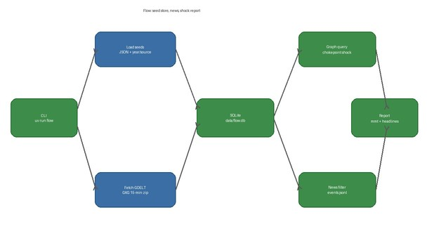

Fig.1: Flow chart

Platform Layout

  - Seed layer: JSON under data/seeds. Every volume has a year, a source, and a URL. Crude 2024 from WITS HS 2709. LNG from HS 271111. Fertilizers from Rajya Sabha annex AS41.
  - News layer: GDELT GKG 15-minute zips, filtered, written to data/raw/events.jsonl. No API key.
  - Query layer: data/flow.db rebuilt by uv run flow data build. CLI is uv run flow. Mentor view is a map, a risk bar, and GDELT headlines.
  - CLI traces live under artifacts/ so a viva panel can replay a fetch, a build, and a shock query.

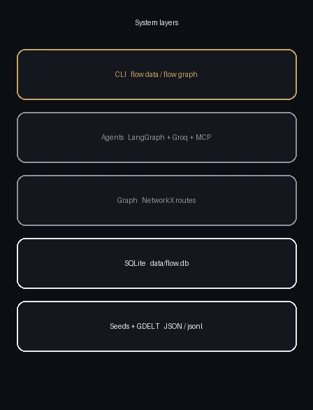
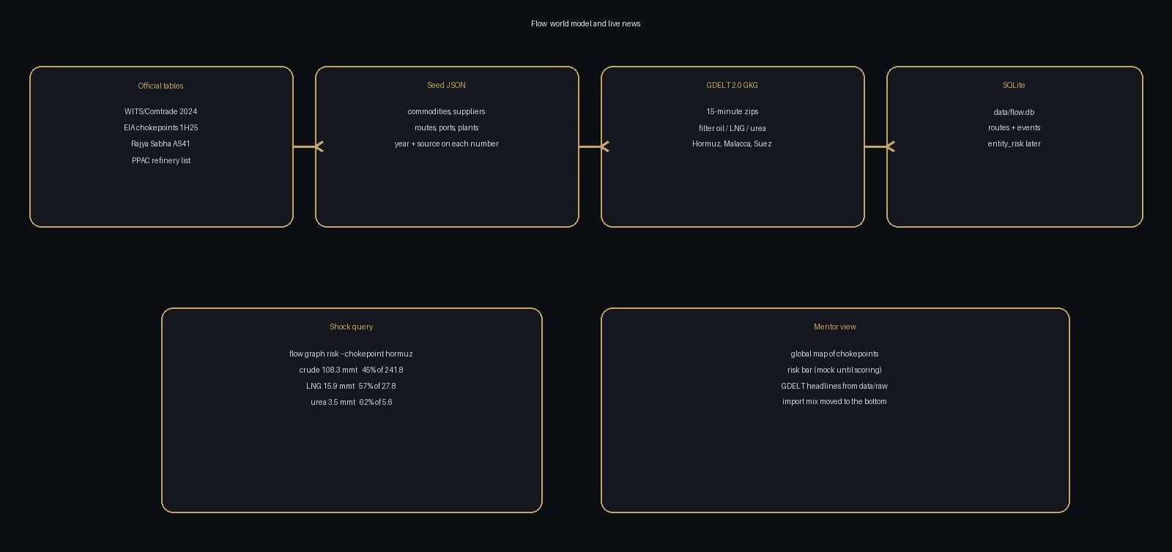

Implementation

Runtime: Python 3.12 or newer, uv, Typer CLI (uv run flow).

Ingest: httpx and pandas for GDELT GKG zips. JSON seeds committed; SQLite built locally and gitignored.

Graph: NetworkX over routes and chokepoints. Hormuz-exposed crude 108.3 mmt, LNG 15.9 mmt, urea 3.5 mmt on 2024 seeds.

Agents: LangGraph + langchain-groq + MCP (declared in pyproject, not wired yet).

Tests: pytest on the loader and the GDELT filter (uv run pytest).

- Expected Result

  - uv run flow data build rebuilds the world model from seeds. uv run flow data gdelt writes a filtered event file.
  - A Hormuz query reports 108.3 mmt crude (45% of 241.8), 15.9 mmt LNG (57% of 27.8), and 3.5 mmt urea (62% of 5.6), each with a source.
  - Mentors see a global map of the five seeded chokepoints, a labelled mock risk bar, and real GDELT headlines from data/raw.
  - CLI traces live under artifacts/ so a viva panel can replay a fetch, a build, and a shock query.

Future Scope

  - Scoring agent: fill entity_risk from news tone and graph exposure. The table is empty today.
  - Alternate routes: if Hormuz is closed, show which cargo can move via the Cape and at what extra distance.
  - More plants and ports: east-coast LNG terminals and remaining fertilizer units not yet in the seed files.
  - Scheduled GDELT pulls so the event file is not a one-shot zip.
  - A working dashboard instead of the Figma mock, still fed from SQLite and events.jsonl.

References

  - EIA World Oil Transit Chokepoints, 1H25, updated 3 Mar 2026: https://www.eia.gov/international/analysis/special-topics/World_Oil_Transit_Chokepoints
  - GDELT GKG codebook v2.1: http://data.gdeltproject.org/documentation/GDELT-Global_Knowledge_Graph_Codebook-V2.1.pdf
  - WITS/UN Comtrade India imports 2024, HS 2709 and HS 271111: https://wits.worldbank.org/https://www.mongodb.com/docs/
  - LangGraph: https://langchain-ai.github.io/langgraph/
  - Model Context Protocol: https://modelcontextprotocol.io/https://docs.docker.com/

