

|  |
| --- |
| **Title:**Database application description and Design of Extended-Entity-Relationship diagram |

**Objective:** To comprehend the data requirements of the application and design the Enhanced Entity-Relationship (EER) diagram for the database

_____________________________________________________________

**Expected Outcome of Experiment:**

CO1: Design entity-relationship diagrams to represent different database application scenarios.

_____________________________________________________________

**Books/ Journals/ Websites referred:**

1. G. K. Gupta :”Database Management Systems”, McGraw – Hill
2. Korth, Slberchatz, Sudarshan : “Database Systems Concept”, 6th Edition , McGraw Hill
3. Elmasri and Navathe, “Fundamentals of Database Systems”, 5thEdition, PEARSON Education.

_____________________________________________________________

**Pre Lab/ Prior Concepts:**

**ER Model:**

The ER data model was developed to facilitate the database design by allowing specification of an enterprise schema that represents the overall logical structure of the database. The ER model is one of the several data models. The semantic aspect of the model lies in its representation of the meaning of the data. The ER model is very useful many database design tools drawn on concepts from the ER model. The ER model employs 3 basic notations: entity set, relationship set and attributes**.**

# Symbols Used in ER Notation

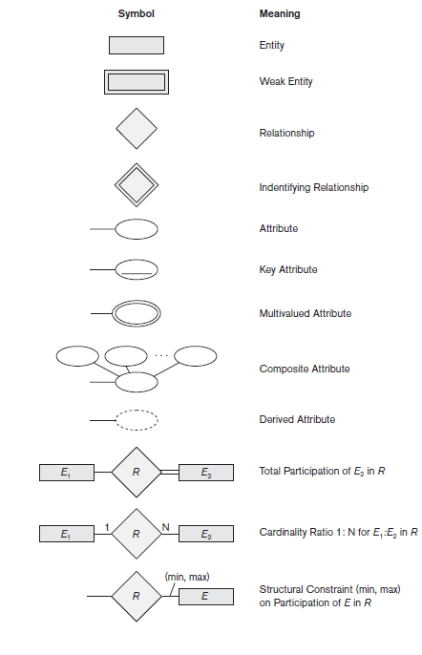

**Extended Entity Relationship Diagram:**

The EER model includes all of the concepts introduced by the ER model. Additionally it includes the concepts of a [subclass](https://en.wikipedia.org/wiki/Subclass_(computer_science)) and [superclass](https://en.wikipedia.org/wiki/Superclass_(computer_science)) ([Is-a](https://en.wikipedia.org/wiki/Is-a)), along with the concepts of [specialization](https://en.wikipedia.org/wiki/Inheritance_(computer_science)#Specialization) and [generalization](https://en.wikipedia.org/wiki/Generalization). Furthermore, it introduces the concept of a [union](https://en.wikipedia.org/wiki/Union_(computer_science)) type or category, which is used to represent a collection of objects that is the union of objects of different [entity](https://en.wikipedia.org/wiki/Entity) types. EER model also includes EER diagrams that are conceptual models that accurately represent the requirements of complex databases.

Database application title**- NGO Management System**

To design and implement a SQL-based database for an NGO management system that facilitates the organization's activities, including managing donors, projects, beneficiaries, and volunteer information. The database should support CRUD operations for each entity and enable querying for specific information. The system will maintain information on entities consisting of donors, projects, beneficiaries, volunteers, and donations.Volunteers would be characterized by attributes like ID, name, contact information, skills, and assigned projects. The database should also store information on donations, including ID, donor ID, amount, date, and purpose. It should support queries to retrieve information such as donor contributions, details of ongoing projects, beneficiaries under a specific project, and volunteer assignments. so store information on donations, including ID, donor ID, amount, date, and purpose.

**ER diagram of the NGO Management System**

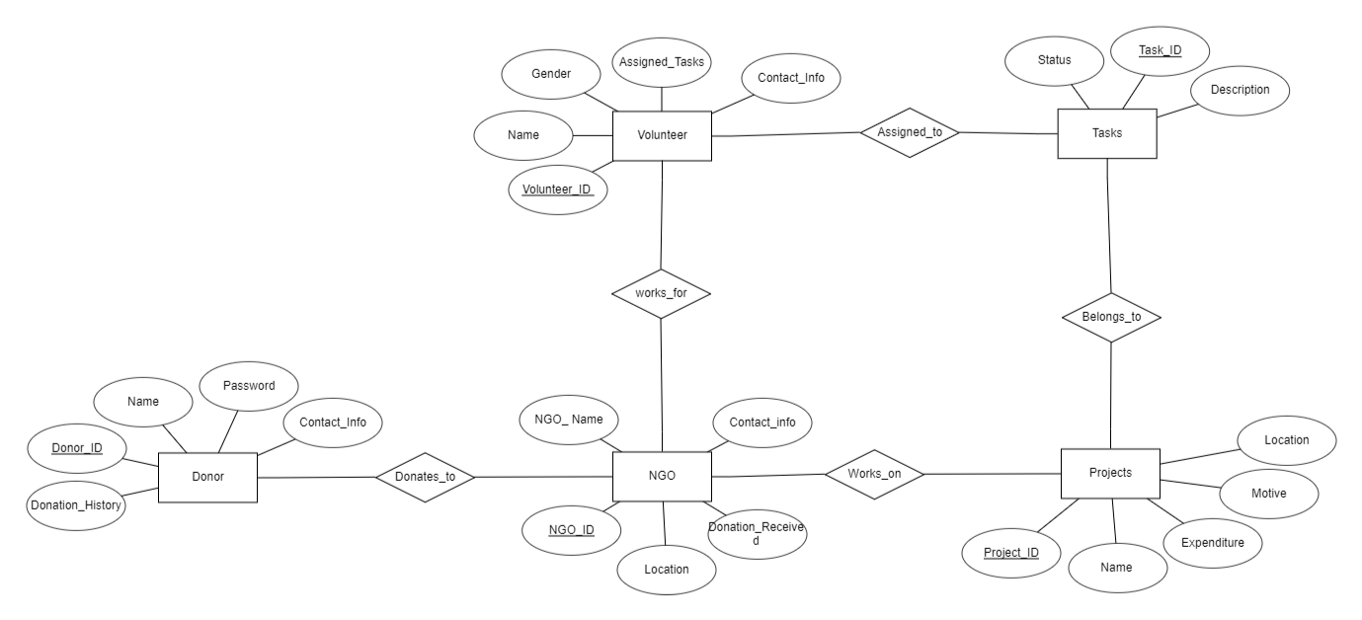

**Database application description :**

**Title of the Database application: NGO Management System**

*As weaker and smaller NGOs don’t have a facility for managing their finances and many of them go unnoticed. We are providing a platform for these weaker NGOs to help them with their operations like managing the donors, volunteers.*

*The target users of this application are the NGO administrators, those responsible for managing the day-to-day operations of the NGO.   
The Volunteers who are interested in contributing their time and skills to the NGO’s initiatives. And the Donors either individuals or organisations that are willing to support the NGO financially.*

**Entities:**

* Project
* Donor
* Volunteer
* NGO
* Task

**Attributes:**

1. **Project:**

* Project_ID (Primary Key)
* Name
* Expenditure
* Motive
* Location

1. **Donor:**

* Donor_ID (Primary Key)
* Name
* Password
* Contact_Info
* Donation History

1. **Volunteer:**

* Volunteer_ID (Primary Key)
* Name
* Gender
* Contact_Info
* Assigned Tasks

1. **NGO:**

* NGO_ID (Primary Key)
* NGO_Name
* Location
* Contact_Info
* Donation Received

1. **Task:**

* Task_Id
* Status
* Description

**Relations:**

1. Donor donates to NGO
2. NGO works on Projects
3. Volunteer works for NGO
4. Tasks are assigned to volunteers
5. Tasks belongs to Projects

*The NGO management system database enables users to conduct comprehensive analyses and derive key insights for informed decision-making. Users can assess the impact of programs on beneficiaries, analyze financial transactions for transparency, and evaluate donor contributions and engagement strategies. The system facilitates monitoring and analysis of volunteer participation, project timelines, and efficiency in implementation. Compliance monitoring ensures adherence to reporting standards, and resource allocation analyses guide efficiency improvements. The database supports long-term strategic planning by evaluating historical data, identifying growth opportunities, and aiding in the planning of future initiatives. Regular updates and maintenance ensure the reliability of data for accurate analyses and insights.*

**EER diagram of chosen Database application :**

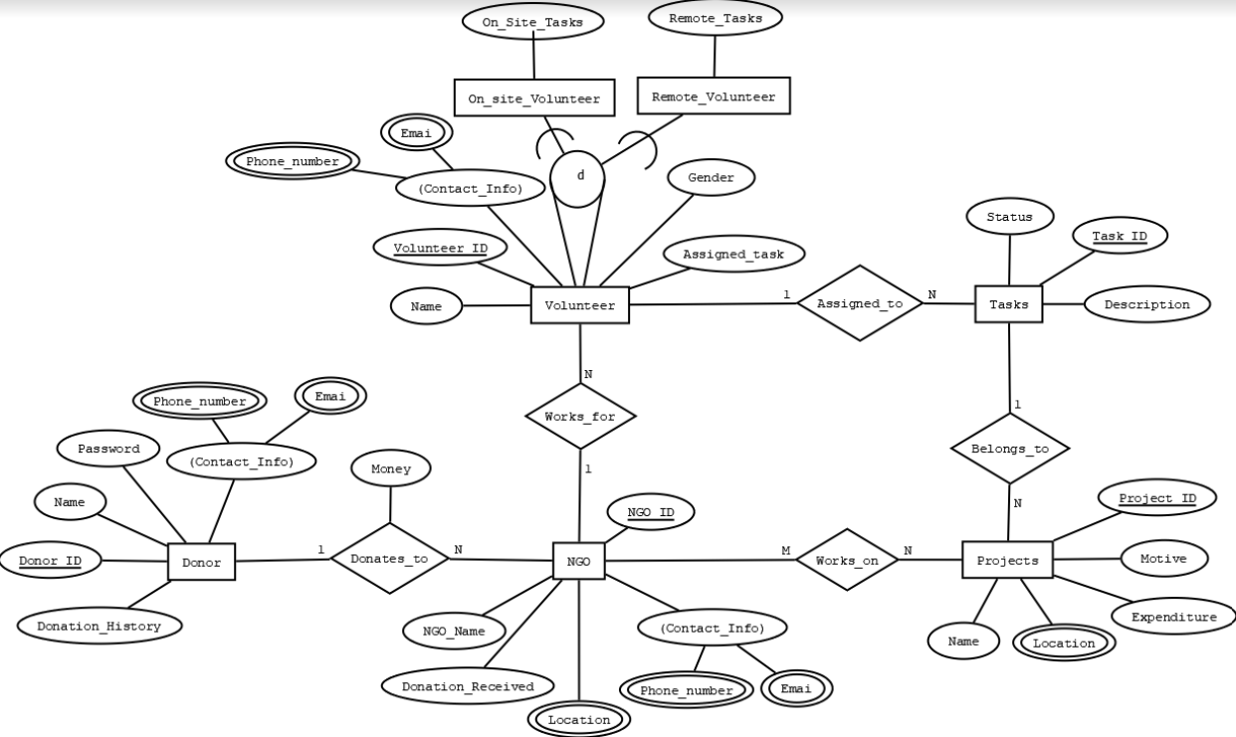

# Post Lab Descriptive Questions (Add questions from examination point view)

1. **In the Academic database a Grade is issued to each STUDENT for each COURSE taken and stored in the STUDENT COURSE DETAIL entity. A STUDENT may decide to re-take a COURSE to better their GRADE. The administration would like to keep a record of the old/previous Grade as well as the new Grade. Show ER diagram to include historical Grades if the students should have them.**

→

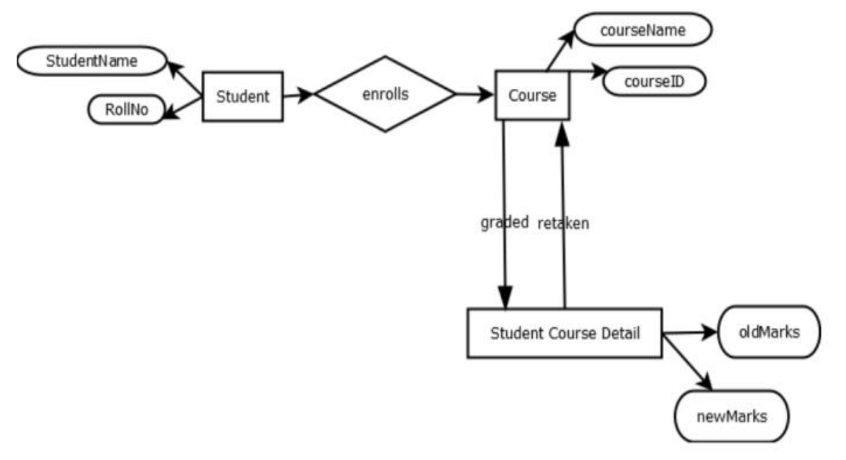

1. **Discuss the concept of aggregation. Give an example. How to represent aggregation in ER model (if aggregation is not supported in EER diagram)**

**→**Aggregation represents relationship between a whole object and its component. Using aggregation we can express relationship among relationships. It is a process when relation between two entities is treated as a single entity. In this example, employee works on a job in a particular branch and is represented via aggregation relationship.

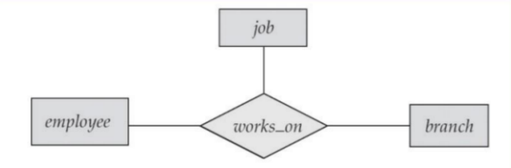

1. **Two separate banks which decide to merge. Both banks use same ER database schema(Assume the ER diagram). If the merged bank is to have a single database, there are several potential problems:**

* **The possibility that two original banks have branches with the same name**
* **The possibility that some customers are customers of both original banks**
* **The possibility that some loan or account numbers were used at both original banks**

**Discuss for each of these potential problems , why there is indeed potential difficulty in database based on ER model. Propose a solution to a problem. For your solution, explain any changes that would have to be made and describe what their effect would be on the ER database schema and the data.**

→In a scenario where two banks with the same ER database schema merge, there are potential difficulties with branches with the same name, customers who are customers of both original banks, and loans or account numbers used at both original banks. To resolve these difficulties, unique identifiers can be assigned to each branch, customer, loan, and account before the merge. This would ensure that there is no overlap in names, customers, loans, or account numbers in the merged database. To implement these solutions, additional attributes, such as "Branch ID", "Customer ID", "Loan ID", or "Account ID" would need to be added to the respective entities in the ER database schema, ensuring that each entity has a unique identifier for easy differentiation.

**Conclusion:**

This experiment enabled a systematic understanding of Data requirements of application and EER diagram design, laying the groundwork for effective and optimized database development.