

| **TITLE:** **Design the static web pages with the help of HTML5** |
| --- |

**AIM:** To create static Web Pages using HTML5.

**______________________________________________________________________**

**Expected Outcome of Experiment:** Design static web pages using various HTML tags.

**_______________________________________________________________**

**Books/ Journals/ Websites referred:**

1. .

**_____________________________________________________________________**

The students are required to design Web Application using various technologies. A group of 2-3 students will select a topic and will design a web application. Various concepts such as static page, dynamic page, connection with a backend database are essential parts of the application.

Students will be required to mention an overall description of the problem (website facilities) to be provided by their application.

**Problem Statement:**

The NGO Management System is designed to efficiently oversee the multifaceted aspects of non-governmental organizations. It encompasses user authentication, donor and donation management, program and project tracking, volunteer recruitment and scheduling, beneficiary information management, financial tracking, event organization, communication tools, comprehensive reporting, document management, workflow automation, grant management, and training facilitation. Ensuring security and data privacy, the system aims to streamline operations, enhance transparency, and facilitate impactful decision-making for the organization's overarching mission and goals.

**Description of the application implemented with output**:

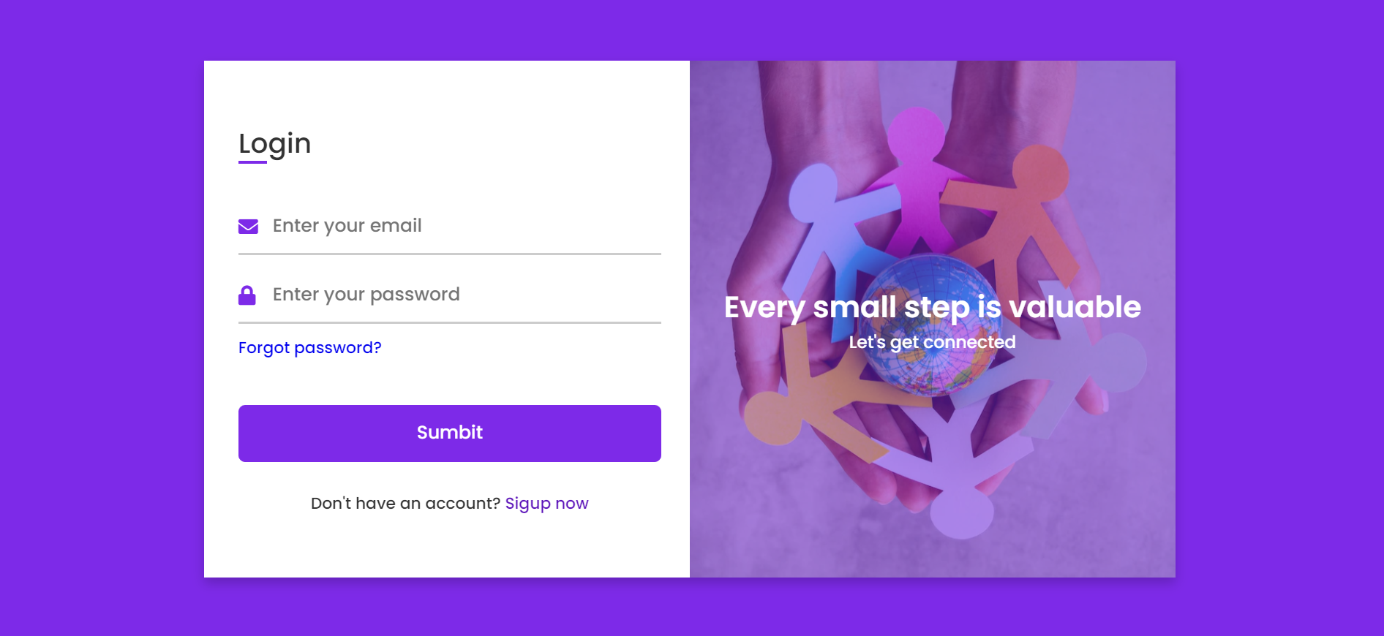

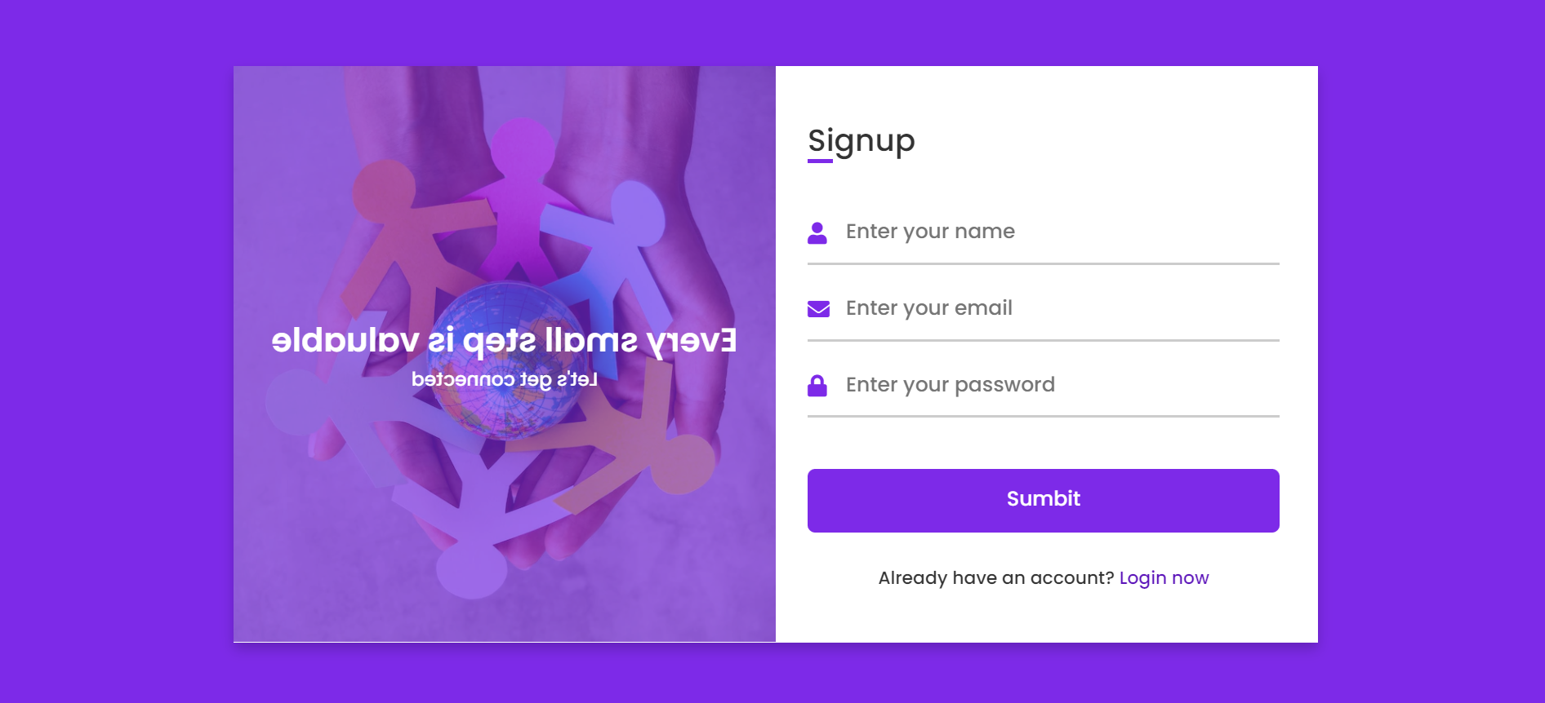

**Post Lab Objective with Ans (Min 5):**

**HTML tags Used :**

**<div>:** This tag is used to create a container element that can be styled with CSS to control the layout and presentation of the content inside. Used to group related elements together and create sections of a webpage.

**<link>:** This tag is used to link to an external resource such as a stylesheet, icon, or web font. It is placed in the <head> section of an HTML document.

**<label>:** This tag is used to associate a label with an input field in a form. It provides a text description of the input field, making it more accessible and user-friendly.

**<input>:** This tag is used to create various types of input fields, such as text boxes, checkboxes, radio buttons, and drop-down menus. It's typically used within a <form> element to allow users to submit data.

**<img>:** This tag is used to embed an image into an HTML document. It requires a src attribute that specifies the URL of the image file. Other attributes, such as alt and width, can also be used to provide additional information about the image.

**<title>:** Sets the title of the HTML document.

**<form>:** This is used to create an HTML form that can contain various form elements, such as input fields, checkboxes, radio buttons, and buttons