Nirma University
Institute of Technology


Course Code:- 6CS102CC26
Course Name:- Data Structure

Linked List Lab
Student Name
Boricha Kartik
Student Roll no
26MCA008

Faculty in charge
Nirav Patel

INDEX

Sr. No. | Contents | Page No.
1 | Introduction | 1
2 | Objectives of the Project | 2
3 | Problem Statement | 3
4 | Project Overview | 4
5 | Technologies Used | 5
6 | Types of Linked List Implemented | 7
7 | System Features and Functionalities | 11
8 | Data Structures and Algorithms Used | 11
9 | Time Complexity Analysis | 12
10 | User Interface Description | 12
11 | Working of the Project | 13
12 | Error Handling and Validation | 14
13 | Advantages of the Project | 14
14 | Limitations of the Project | 14
15 | Future Scope | 15
16 | Conclusion | 15
17 | Project Details | 16

1. INTRODUCTION
A Linked List is an important linear data structure in computer science. It is used to store and manage data dynamically. Unlike arrays, linked lists do not require continuous memory locations to store elements.
This project, Linked List Lab – Interactive Data Structure Visualizer, is a web-based application developed to help students understand how linked lists work through interactive visualizations.
The application allows users to create linked lists, insert and delete nodes, search for values, update node values, reverse the list, and sort elements. It also displays pointer movements, memory addresses, operation steps, and time complexity.
The main purpose of this project is to make learning data structures easier, more practical, and more interesting through visual demonstrations.
2. OBJECTIVES OF THE PROJECT
The main objectives of this project are:
- To provide an interactive platform for learning linked lists.
- To demonstrate different types of linked lists.
- To visualize how nodes and pointers are connected.
- To understand insertion and deletion operations.
- To demonstrate searching, updating, reversing, and sorting.
- To display memory addresses and pointer connections.
- To understand the time complexity of different operations.
- To make data structure concepts easier through animations.
- To provide a simple and user-friendly learning environment.
3. PROBLEM STATEMENT
Learning data structures only through theoretical explanations and static diagrams can be difficult for students. Understanding how pointers change during insertion and deletion operations is especially challenging.
Students may understand the definition of a linked list but struggle to visualize how nodes are connected in memory and how different operations work internally.
To solve this problem, we developed an interactive Linked List Lab that visually demonstrates linked list operations step by step.
The system provides animations, memory diagrams, operation logs, and complexity information to help students understand the practical working of linked lists.
4. PROJECT OVERVIEW
Linked List Lab is an interactive web application that allows users to experiment with different linked list operations.
Users can select a linked list type, create nodes, perform different operations, and observe the results visually.
The application provides the following major features:
- Four types of linked lists.
- Dynamic node creation.
- Insertion and deletion operations.
- Searching and updating values.
- Reversing and sorting nodes.
- Animated pointer movements.
- Memory address visualization.
- Step-by-step operation logs.
- Node value charts.
- Operation step comparison.
- Time complexity information.
- Light and dark themes.
- Adjustable animation speed.
The application supports a maximum of 12 nodes at a time.
5. TECHNOLOGIES USED
5.1 HTML (HyperText Markup Language)
HTML is used to create the basic structure of the application.
5.2 CSS (Cascading Style Sheets)
CSS is used to design and style the application.
5.3 JavaScript
JavaScript is used to implement the main functionality and data structure operations.

6. TYPES OF LINKED LIST IMPLEMENTED
Our application supports four different types of linked lists.
6.1 Singly Linked List
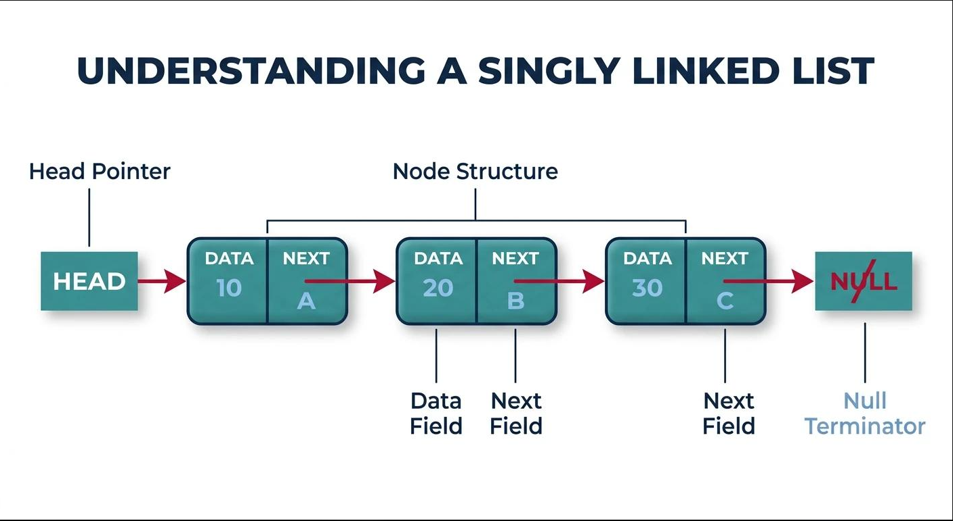
A singly linked list is a linear data structure in which every node contains two parts:
- Data: Stores the actual value.
- Next: Stores the reference to the next node.
The last node points to NULL because there is no next node.
6.2 Doubly Linked List
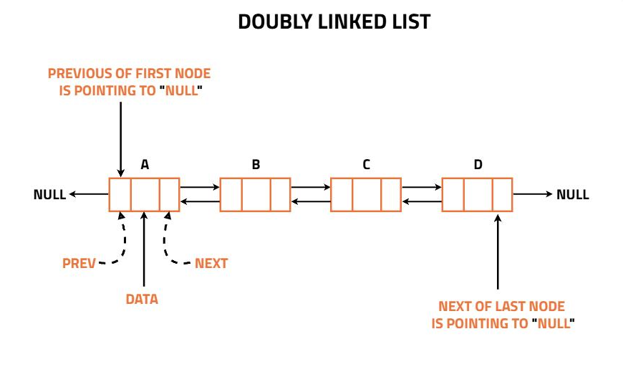
A doubly linked list contains three parts in each node:
- Previous: Stores the reference to the previous node.
- Data: Stores the value.
- Next: Stores the reference to the next node.
It allows traversal in both forward and backward directions.
6.3 Circular Linked List

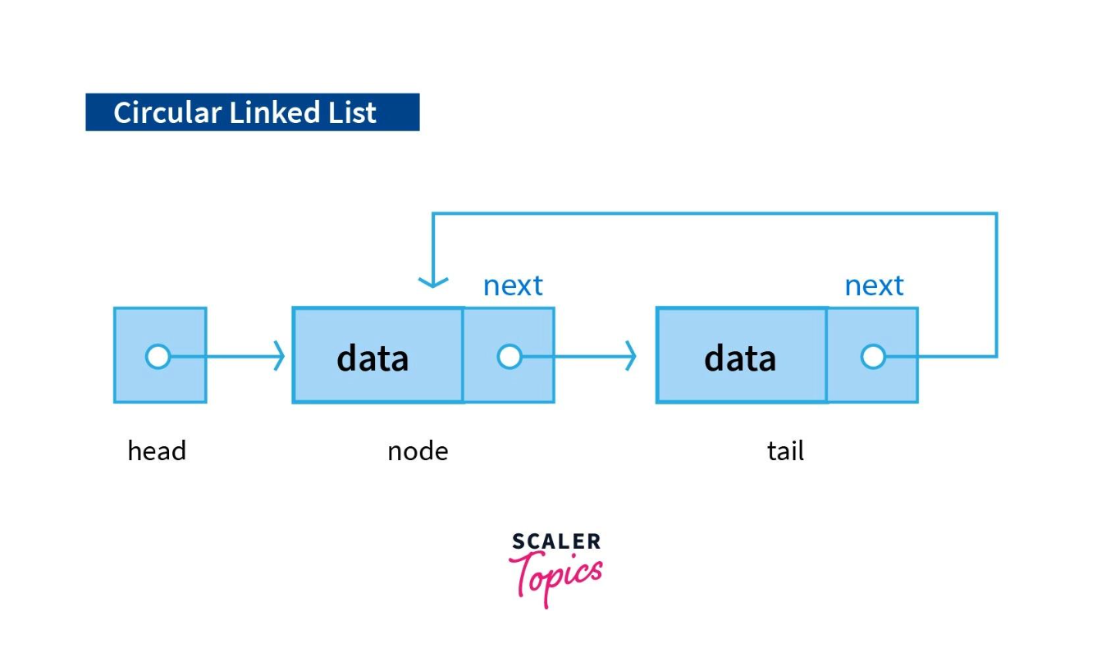

A circular linked list is similar to a singly linked list, but the last node points back to the first node instead of NULL.

6.4 Circular Doubly Linked List
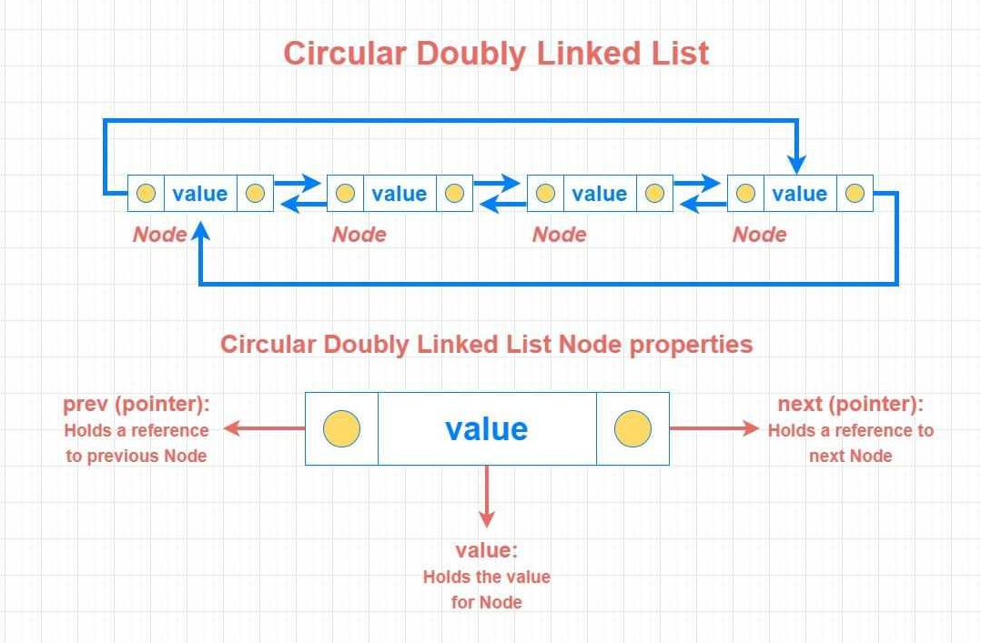
A circular doubly linked list combines the features of doubly linked and circular linked lists.
Each node contains previous, data, and next references.
The last node points to the first node, and the first node points backward to the last node.

7. SYSTEM FEATURES AND FUNCTIONALITIES
7.1 Build Linked List
Users can create a linked list by entering the required number of nodes.
- The application supports 0 to 12 nodes.
- Node values are generated randomly if no value is entered.
- Users can select the linked list type before building it.
- Every node receives a unique ID and simulated memory address.
7.2 Insertion Operations
The application supports three types of insertion.
A. Insertion at Head
A new node is inserted at the beginning of the linked list.
Steps:
- Create a new node.
- Connect the new node to the current head.
- Update the head to the new node.
Time Complexity: O(1)
B. Insertion at Tail
A new node is inserted at the end of the linked list.
Steps:
- Traverse the linked list to reach the last node.
- Connect the last node to the new node.
- Update the tail connection.
Time Complexity:
- Singly Linked List: O(n)
- Doubly Linked List: O(1) in this implementation.
C. Insertion at Index
A new node is inserted at a specific position.
Steps:
- Enter the required index.
- Traverse to the required position.
- Connect the new node with the previous and next nodes.
- Update the connections. Time Complexity: O(n)
7.3 Deletion Operations
The application provides four deletion methods.
A. Delete Head
Removes the first node from the linked list.
B. Delete Tail
Removes the last node from the linked list.
C. Delete at Index
Removes a node from a specified position.
D. Delete by Value
Searches for the entered value and removes the first matching node.
Time Complexity:
- Delete Head: O(1)
- Delete Tail: O(n) for singly linked lists and O(1) for doubly linked lists.
- Delete at Index: O(n)
- Delete by Value: O(n)
7.4 Search Operation
The search operation helps users find a particular value in the linked list.
Steps:
- Enter the value to search.
- The application checks each node one by one.
- Each visited node is highlighted.
- If the value is found, the node is highlighted in green.
- If the value does not exist, an error message is displayed.
Time Complexity: O(n)
7.5 Update Operation
The update operation allows users to change the value stored at a particular index.
Steps:
- Enter the index.
- Enter the new value.
- The application visits the selected node.
- The existing value is replaced with the new value.
Time Complexity: O(n)
7.6 Reverse Operation
The reverse operation changes the order of nodes in the linked list.
Before:
10 → 20 → 30 → 40 → NULL
After:
40 → 30 → 20 → 10 → NULL
The application visually demonstrates the reversal and highlights the nodes after the operation.
Time Complexity: O(n)
7.7 Sorting Operation
The application uses the Bubble Sort algorithm to arrange node values in ascending order.
Steps:
- Compare two adjacent node values.
- If the first value is greater than the second, swap their values.
- Continue comparing adjacent values.
- Repeat until the list is sorted.
Before:
40 → 10 → 30 → 20
After:
10 → 20 → 30 → 40
Time Complexity: O(n²)

8. DATA STRUCTURES AND ALGORITHMS USED
This project demonstrates important data structure and algorithm concepts.
8.1 Array
JavaScript uses an array named L to maintain the linked list nodes.
Each node is represented as an object containing:
- ID
- Value
- Memory address
The array stores the node objects in their logical linked list order.
8.2 Node Structure
Each node contains three main properties:
Property | Description
id | Unique identification number
v | Stores node value
a | Simulated memory address
The node structure is created using the mk() function.
8.3 Pointer Representation
Pointers are visually represented using the next and previous references.
- next connects a node to the next node.
- prev connects a node to the previous node.
- head identifies the first node.
- tail identifies the last node.
- NULL represents the absence of a connection.
The application uses visual connections to explain pointer relationships.
8.4 Bubble Sort
Bubble Sort is used to sort node values in ascending order.
It compares adjacent values and swaps them when they are in the wrong order.
Time Complexity: O(n²)
8.5 Linear Search
The application uses linear searching to find a particular value.
It checks each node sequentially until the value is found or the list ends.
Time Complexity: O(n)
8.6 Array Splice Method
JavaScript's splice() method is used to insert and remove node objects from the internal array.
It helps manage the order of nodes during insertion and deletion operations.

9. TIME COMPLEXITY ANALYSIS
Time complexity describes how the execution time of an operation changes as the number of nodes increases.
The following table represents the complexity displayed by the application.
Operation | Singly Linked List | Doubly Linked List
Insert at Head | O(1) | O(1)
Insert at Tail | O(n) | O(1)
Insert at Index | O(n) | O(n)
Delete Head | O(1) | O(1)
Delete Tail | O(n) | O(1)
Delete at Index | O(n) | O(n)
Delete by Value | O(n) | O(n)
Search | O(n) | O(n)
Update | O(n) | O(n)
Reverse | O(n) | O(n)
Sort (Bubble Sort) | O(n²) | O(n²)

10. USER INTERFACE DESCRIPTION
The application interface is divided into different sections.
10.1 Header Section
The header displays the project title and a short description.
It also contains:
- Linked list type selection.
- Theme toggle button.

10.2 Control Panel
The left-side control panel allows users to perform different operations.
It contains:
- Number of nodes input.
- Build list button.
- Value input.
- Index input.
- Insertion buttons.
- Deletion buttons.
- Search button.
- Update button.
- Reverse button.
- Sort button.
- Clear button.
- Animation speed control.
10.3 Statistics Section
This section displays four important details:
- Size: Total number of nodes.
- Head: Value of the first node.
- Tail: Value of the last node.
- Is Empty: Indicates whether the list is empty.
10.4 Visualization Section
This is the main section of the application.
It displays nodes and their connections.
Different colors are used to represent different activities:
Color | Meaning
Teal | Normal node
Orange | Currently visited node
Green | Successfully found or processed node
Red | Deleted node
Purple | Swapped node
10.5 Step Log
The step log displays messages about the operations performed.
For example:
- List created successfully.
- Node inserted at head.
- Value found at index 2.
- Node deleted successfully.
- List reversed successfully.
It also displays error messages when an invalid operation is performed.
10.6 Node Values Chart
This section displays the values of all nodes using a bar chart.
It helps users understand the distribution of values in the linked list.
10.7 Operation Steps Chart
This chart displays the number of steps taken by the last 10 recorded operations.
It helps users compare the number of steps required for different operations.
10.8 Memory Diagram
The memory diagram displays:
- Simulated memory address.
- Node data.
- Next address.
- Previous address for doubly linked lists.
It helps students understand how nodes are connected through memory references.
10.9 Time Complexity Table
This section displays the time complexity of different linked list operations.
The currently selected operation is highlighted for easier understanding.

11. WORKING OF THE PROJECT
The working process of the application is explained below.
- The user opens the Linked List Lab application.
- The application loads with a default singly linked list containing five randomly generated nodes.
- The user selects the required linked list type.
- The user creates a linked list by selecting the number of nodes.
- The user enters a value or index depending on the operation.
- The user selects an operation such as insertion, deletion, searching, updating, reversing, or sorting.
- JavaScript performs the selected operation.
- The application updates the linked list visualization.
- Animations demonstrate the operation step by step.
- The statistics, memory diagram, charts, and operation log are updated.

12. ERROR HANDLING AND VALIDATION

The application includes basic input validation to prevent invalid operations.
Some examples include:
- Preventing the creation of more than 12 nodes.
- Displaying an error if the user does not enter a required value.
- Checking whether the entered index is valid.
- Preventing deletion from an empty linked list.
- Displaying a message when the searched value does not exist.
- Preventing reverse and sort operations when fewer than two nodes are available.
- Preventing multiple operations from running simultaneously.
These validations improve the reliability and usability of the application

13. ADVANTAGES OF THE PROJECT
- Easy to understand and use.
- Provides interactive learning.
- Supports four types of linked lists.
- Demonstrates different linked list operations.
- Shows pointer connections visually.
- Provides step-by-step animations.
- Displays simulated memory addresses.
- Explains time complexity.
- Includes light and dark themes.
- Helps students understand practical data structure concepts.
14. LIMITATIONS OF THE PROJECT
Although the application provides several useful features, it has some limitations:
- The application supports a maximum of 12 nodes.
- It works only in a web browser.
- It does not use a database to store linked list data permanently.
- Memory addresses are simulated for educational purposes.
- The linked list nodes are maintained using a JavaScript array internally.
- Bubble Sort is used instead of more advanced sorting algorithms.
- It does not provide user login or account management.

15. FUTURE SCOPE
The project can be improved by adding more features in the future.
- Increase the maximum number of nodes.
- Add Stack and Queue visualizations.
- Add Binary Search Tree visualization.
- Add different sorting algorithms.
- Add more searching algorithms where applicable.
- Provide a comparison between arrays and linked lists.
- Add an explanation of each operation with pseudocode.
- Add quizzes and practice questions.
- Add the ability to save and load linked list configurations.
- Add a step-by-step manual mode for learning pointer operations.

16. CONCLUSION

The Linked List Lab project provides an interactive way to understand linked list concepts and operations.
It demonstrates four different types of linked lists and allows users to perform insertion, deletion, searching, updating, reversing, and sorting operations.
The application also provides animated visualizations, memory diagrams, operation logs, charts, and time complexity information.
Through this project, we gained practical knowledge of HTML, CSS, JavaScript, linked lists, algorithms, and time complexity.
Overall, this project makes learning data structures more interesting, visual, and understandable for students.

17. PROJECT DETAILS

Particular | Details
Project Name | Linked List Lab
Assignment | Innovative Assignment
Project Type | Web-Based Application
Frontend | HTML, CSS, JavaScript
Main Concept | Linked List
Sorting Algorithm | Bubble Sort
Searching Algorithm | Linear Search
Number of Linked List Types | 4
Maximum Nodes | 12

Source Code :- https://github.com/KartikBoricha/Data-Structure-Assignment-2

