**CHAPTER 1**

**INTRODUCTION**

* 1. **INTRODUCTION**

ASHA Accredited Social Health Activists workers are helping to build a strong foundation for promoting healthy practices in our society. They play critical role for various health programs of the Government of India. Now, it is time to empower them by imparting training and upgrading skills as a majority of ASHAs are village women with low literacy skills and they face operational challenges in conducting routine maternal, new-born, child health activities and infection prevention. ASHAs are the first point of contact for the needy rural masses and can become frontline healthcare workers by imparting training in regional languages. One of the key components of the National Rural Health Mission is to provide every village in the country with a trained female community health activist ASHA or Accredited Social Health Activist. Selected from the village itself and accountable to it, the ASHA will be trained to work as an interface between the community and the public health system.

The contribution of ASHAs in non-COVID essential services has been exemplary. At the Ayushman Bharat – Health and Wellness Centers, ASHAs are contributing in conducting line listing of all individuals, risk assessment and mobilization for screening for chronic illness like hypertension, diabetes, three cancers (oral, breast and cervical cancers), TB and leprosy.

Accredited social health activists (ASHAs) can prevent many of these deaths by helping women and their families recognize maternal and neonatal danger signs and promptly seek care. However, a majority of ASHAs are low-literate village women, and they face significant operational challenges in conducting routine maternal, newborn, and child health (MNCH) activities and in keeping their skills updated. In particular, ASHAs' lack of access to health care information, refresher training, supportive supervision, and user-friendly job aids compromise their ability to contribute to improved maternal and newborn health outcomes. [4]

A baseline survey is to be taken at the district level by Asha workers. It is for fixing decentralized monitoring goals and indicators. The community monitoring would be at the village level. The planning commission would be the eventual monitor of outcomes. External evaluation will be taken up at frequent intervals. Our product is aimed to digitalized the whole process. Our team has taken inspiration from the digital India initiative by the Government of India.

* 1. **PROBLEM STATEMENT**

Basically, ASHAs workers take surveys across different areas and collect information of families and on analysis they provide different Government Yojanas, financial aids and facilities to the eligible families. Currently, the information is collected on paper and data entry is done manually into excel sheets. This is time consuming and tedious procedure. Also, it becomes difficult to analyze these family’s data and take necessary actions. So, we proposed an app “Aarogya Patrika” which digitalizes whole process of data collection and analysis.

* 1. **PROJECT OBJECTIVE**

Since ASHAs faces this problem, so to overcome this problem of Manual Data entry and difficulty of Analyzing the family data the “**Aarogya Patrika”** is designed with the aim of eliminating all these possibilities of lack of access to healthcare information, refresher training and meaningful supervision so that their ability to contribute to improved maternal and new-born health outcomes will play a major role. The App simplifies public administration, eliminating the need of data-entry operators. Basically, app manages to convert the data into digital format right from the point of entry, to be used, analyzed, accessed and processed across the health system by all relevant staff members. CHW (Community Health Workers) manages admin panel where they analyze the health data of families.

All the ASHA Workers are provided with an Android Application through which they can enter data without any hassle. The data is stored in real time database which can be accessed any time. A dashboard is provided for the CHW who is Admin of ASHA Workers. The dashboard contains statistical analysis of the data. Also, data analysis can be done based on different aspects of data. This also allows the real-time monitoring of frontline workers by their supervisors. This also empowers the women in rural areas with technology.

* 1. **SIGNIFICANCE AND NATIONAL IMPORTANCE**

Significance of the project in society is as follows:

1. App can help ASHAs identify and correctly refer sick new-born, which helps them to provide proper treatment and medication so that the sick new-born stays healthy and safe.
2. Application can improve the CHW Community Health Worker knowledge and skills and even ASHA workers as they will be the first to get mobile smartphones in their villages and blocks.
3. This also refer and track risk pregnant women, recently delivered women, new-born and infants.
4. ASHA System also supports midwives in the field.

Social development of a nation is dependent on the health of its population. The impact of ASHAs on their communities is largely dependent on the quality of their training and other health system factors. Currently there is inadequate health system support for ASHAs including a lack of strong supervision, limited opportunities for continuing education and training and poor workload management. They get limited training on community mobilization, child immunization and others due to which they have limited knowledge and skills. Empowering ASHAs with Aarogya Patrika will help them to overcome the barrier

**CHAPTER 2**

**LITERATURE SURVEY**

1. **EXISTING SYSTEM**

**N. D. Valakunde [1]** describes a system which is used in Uttar Pradesh state to monitor pregnant women in unprivileged parts of the country. The project is expected to reduce the maternal mortality rate by digitizing the work of the health workers by enabling them to monitor the pregnancies of the women in their area with the help of smartphones, effectively and efficiently. The Smart ASHA application is developed in Android Studio framework. The server is deployed on blazer pro using apache-HTTP Server and tables storing the data are implemented in phpMyAdmin-MySQL.

**R. V. Vaidya and D. K. Trivedi [2]** describes a system which can Track their fitness, Schedule appointments with a Doctor, set a reminder for themselves to take medicines on time and can request blood from a nearby donor in case of emergency and they can inform their relatives about current location. This system is implemented using Android Studio, Firebase, PHP and MySQL.

**Bhatia, Kavita [3]** describes that by equipping each and every ASHA worker in India with UPASANA, they can provide cheap quality healthcare to the people in rural areas. Upasana is a non-invasive medical diagnostic toolkit designed to be used by ASHA workers so that they can measure the vital parameters of the patients in rural areas and transfer the data to the doctors at the hospital for diagnosis.

1. **FEATURES OF PROGRAMMING LANGUAGE USED**
2. **MongoDB [5]**:
   1. Handle large volumes of data at high speed with a scale-out architecture.
   2. Store unstructured, semi-structured, or structured data.
   3. Enable easy updates to schemas and fields.
   4. Be developer-friendly.
   5. Take full advantage of the cloud to deliver zero downtime.
3. **GraphQL [6]**:
   1. Good fit for complex systems and microservices
   2. Tailoring requests to your needs, which helps to reduce latency issues in rural areas.
      1. Fetching data with a single API call.
      2. No over- and under-fetching problems.
4. **Android**:

The android app has been developed which basically consists of various regional languages which makes the application simple to understand and use.

1. **Node.js [7]**:
   1. Robust technology stack.
   2. Fast-processing and event-based model.
   3. Scalable technology for microservices.
   4. Rich ecosystem.
   5. Strong corporate support.
   6. Seamless JSON support.
   7. Performance bottlenecks with heavy computation tasks.
   8. Callback hell issue.
2. **AWS Cognito [8]**:
   1. Consistent Experience Across Multiple Devices. If your application is multi-device, using Cognito would make your life as a developer easier. ...
   2. Guest Logins. ...
   3. Social Media Logins. ...
   4. MFA and Password Policies. ...
   5. Marketing Analytics. ...
   6. Lesser Configuration Control. ...
   7. Expensive Security Options. ...
   8. AWS SDK Knowledge.
3. **CONCLUSION**

Thus, from this chapter, we learnt about the programming language we are going to deal with i.e. Android and also learnt about the various components and tools that are used to develop the application. We also learnt about the important feature of Android (and its designing tools) i.e. a platform on which we are going to build our software. This chapter also covers the important domains connected with our system and a detailed descriptions on them. We also compared the feature provided by few similar system with our system and thus the work of developing the system work is concluded further.

**CHAPTER 3**

**SYSTEM ANALYSIS AND DESIGN**

1. **INTRODUCTION**

System are created to solve problems. We need to see all sides of a problem to come up with an acceptable solution. Analysis involve studying the system and seeing how they interact with the entities outside as well as inside the system. We then come out with detailed specifications of what the system will accomplish based on the user requirements. System’s design will take the requirements and analysis into consideration and come out with a high level and low level design that will form the blue print to the actual solution to the problem in hand. In this dynamic world, analysis and design have to look into making systems that are flexible enough to accommodate changes as they are inevitable in any system. Systems design is the process of defining the architecture, components, modules, interfaces, and data for a system to satisfy specified requirements. Systems design could be seen as the application of systems theory to product development. There is some overlap with the disciplines of systems analysis, systems architecture and systems engineering. Systems analysis is a problem-solving technique that decomposes a system into its component pieces for the purpose of the studying how well those component parts work and interact to accomplish their purpose.

According to the Merriam-Webster dictionary, systems analysis is "The process of studying a procedure or business in order to identify its goals and purposes and create systems and procedures that will achieve them in an efficient way". Analysis and synthesis, as scientific methods, always go hand in hand; they complement one another.

Every synthesis is built upon the results of a preceding analysis, and every analysis requires a subsequent synthesis in order to verify and correct its results. This field is closely related to requirements analysis or operations research. It is also "an explicit formal inquiry carried out to help someone (referred to as the decision maker) identify a better course of action and make a better decision than she might otherwise have made.

**Analysis:**

The purpose of system analysis and design is for a business to increase their efficiency, because when you look at a current system you will see flaws that need to be fixed as within the new system that you design you will take these into consideration. A new system will make the business more profitable. Assuming that a new system is to be developed, the next phase is system analysis. Analysis involved a detailed study of the current system, leading to specifications of a new system. Analysis is a detailed study of various operations performed by a system and their relationships within and outside the system. During analysis, data are collected on the available files, decision points and transactions handled by the present system. Interviews, on-site observation and questionnaire are the tools used for system analysis. Using the following steps, it becomes easy to draw the exact boundary of the new system under consideration:

* Keeping in view the problems and new requirements
* Workout the pros and cons including new areas of the system

**Design:**

Based on the user requirements and the detailed analysis of a new system, the new system must be designed. This is the phase of system designing. It is a most crucial phase in the development of a system. Normally, the design proceeds in two stages: 1. Preliminary or general design 2. Structure or detailed design

Preliminary or general design In the preliminary or general design, the features of the new system are specified. The costs of implementing these features and the benefits to be derived are estimated. If the project is still considered to be feasible, we move to the detailed design stage. Structure or Detailed design

In the detailed design stage, computer-oriented work begins in earnest. At this stage, the design of the system becomes more structured. Structure design is a blue print of a computer system solution to a given problem having the same components and inter-relationship among the same components as the original problem. Input, output and processing specifications are drawn up in detail. In the design stage, the programming language and the platform in which the new system will run are also decided.

1. **ACTIVITY DIAGRAM**

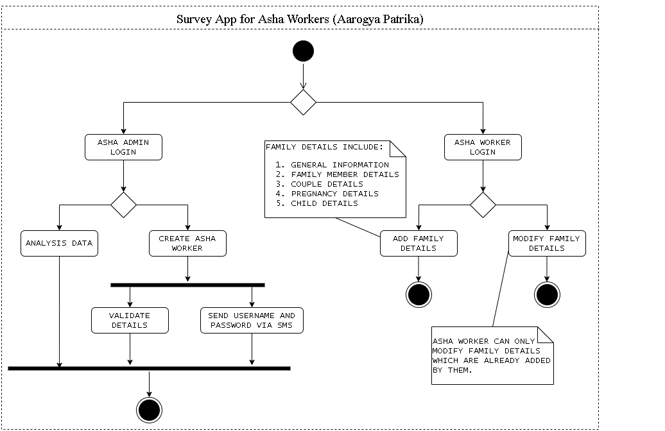

**Fig 3.2.1. Activity Diagram**

“Aarogya Patrika” consists of an App and Admin Panel. ASHA Workers only have access to App where they have to login into the App. Once they are logged in they have option to either Add new family detail or modify existing family details. ASHA Worker can only modify family details which are added by them. Basically every family detail is referenced with ASHA Workers, which helps in maintaining integrity of the system.

Family Details Include:

1. General Information
2. Family Member Details
3. Couple Details
4. Pregnancy Details
5. Child Details

On other end, CHW can only have access to admin panel. CHW admin can either do the analysis of family details where they can see the statistics of family whose houses is either “Kachha” or “Pakka”, how many couples are using family planning methods, etc. Or CHW can create ASHA Workers account which is needed to have access to the App.

1. **USE CASE DIAGRAM**

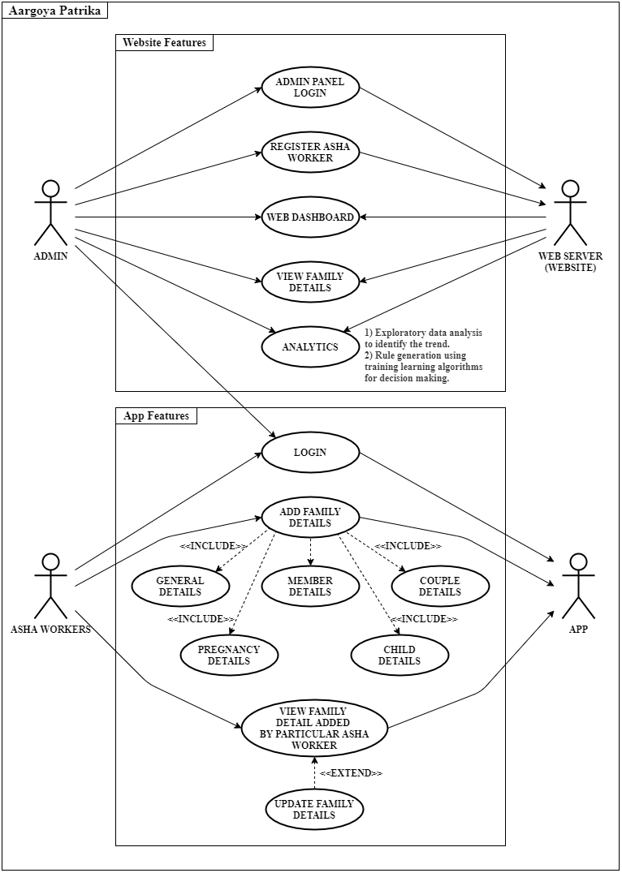

**Fig 3.3.1. Use Case Diagram**

Web Server provides all the website features (Login, Creating ASHA Workers, Web Dashboard, view family details, Analytics) to admin who is CHW. CHW also have access to the whole app features. ASHA Workers are created in admin panel and they have only access to App. Where ASHA Workers need to login to the app to access all the other features. After logging in, they can add family details which includes general information, family member details, couple details, pregnancy details and child details. ASHA workers need to compulsory add these details and ASHA worker can also view family details and they also they have option to update family details.

1. **SYSTEM REQUIREMENT**

**Software Requirements:**

1. Android Studio
2. Visual Studio Code (Text Editor)
3. Java JDK Version 1.8
4. AWS Amplify
5. Node JS
6. Any Web Browser

**System Requirements:**

1. Processor: Pentium 4 and above
2. RAM: Minimum 4 GB
3. 20 GB HDD
4. Windows 7 and above

**Languages Used:**

1. Java
2. XML
3. JSON
4. JavaScript
5. HTML5, CSS3, Bootstrap

**Libraries:**

1. Node.js
2. jQuery
3. Express.js
4. DataTables.Api
5. MongoDB Aggregation Framework
6. GraphQL
7. Apollo Client
8. Retrofit
9. AWS Cognito

**Database:**

1. MongoDB

**Server:**

1. Amazon EC2
2. Heroku
3. **CONCLUSION**

Process models are produced to partially describe system that exists and the system required. The process model show that what is currently being done with the information that is entering the system. The process model do not show how the information is organized but as a focus for discussion between the developer and the user to determine what the new system should be able to do. The models will also provide a measure during testing to see if the system produced does what was promised. Typically, the processes shown on a Data Flow Diagram will in some way translate into screen designs in the final system.

**CHAPTER 4**

**IMPLEMENTATION**

1. **INTRODUCTION**

To implement a system successfully, a large number of inter- After the designing phase is done, implementation is the next important phase in application development. The success of the implementation phase is crucial for the system development life cycle. The implementation includes preparation of site, user training and testing of the system. Presenting the system will involve implementation of the final application at the client side, providing them with complete training and also comparing the efficiency of the application with that of the existing system.

In the IT Industry, implementation refers to post-sales process of guiding a client from purchase to use of the software or hardware that was purchased. This includes Requirements Analysis, Scope Analysis, Customizations, Systems Integrations, User Policies, User Training and Delivery.

These steps are often overseen by a Project Manager using Project Management Methodologies set forth in the Project Management Body of Knowledge. Software Implementations involve several professionals that are relatively new to the knowledge-based economy such as Business Analysts, Technical Analysts, Solutions Architect, and Project Managers.

Related tasks need to be carried out in an appropriate sequence, utilizing a well proven implementation methodology and enlisting professional advice can help but often it is the number of tasks, poor planning and inadequate resourcing that causes problems with an implementation project, rather than any of the tasks being particularly difficult. Similarly, with the cultural issues it is often the lack of adequate consultation and two-way communication that inhibits achievement of the desired results.

1. **SYSTEM ARCHITECTURE**

The Smart ASHA Pregnancy Monitoring System has a client-server model. It has specific software and hardware architecture. The main task is to integrate these two components to work together.

**Software Architecture:** The software architecture is comprised of the database, server and the client application.

**Database:** The database consists of a number of tables; some are fixed while some are created dynamically. These tables storing the data are implemented in MongoDB. MongoDB database is used as it is easy to use, fast and can store large amount of data efficiently requiring a little configuration.

**Client Application:** “The Aarogya Patrika” application is developed in Android studio framework. The application provides an efficient user interface for all the ASHA workers. Android devices being the most popular and affordable of the devices in the world, the android platform was chosen for this system. Moreover, programming in android is easy, user friendly and android has excellent data connectivity.

Server The server is deployed on **Amazon EC2** as it is robust, free and easy to deploy

**Hardware Architecture:** The basic hardware requirement for the system is any device having access to the internet connection which can run the “Aarogya Patrika” app and a server to store the database and host the Smart ASHA website.

1. **SYSTEM IMPLEMENTATION**

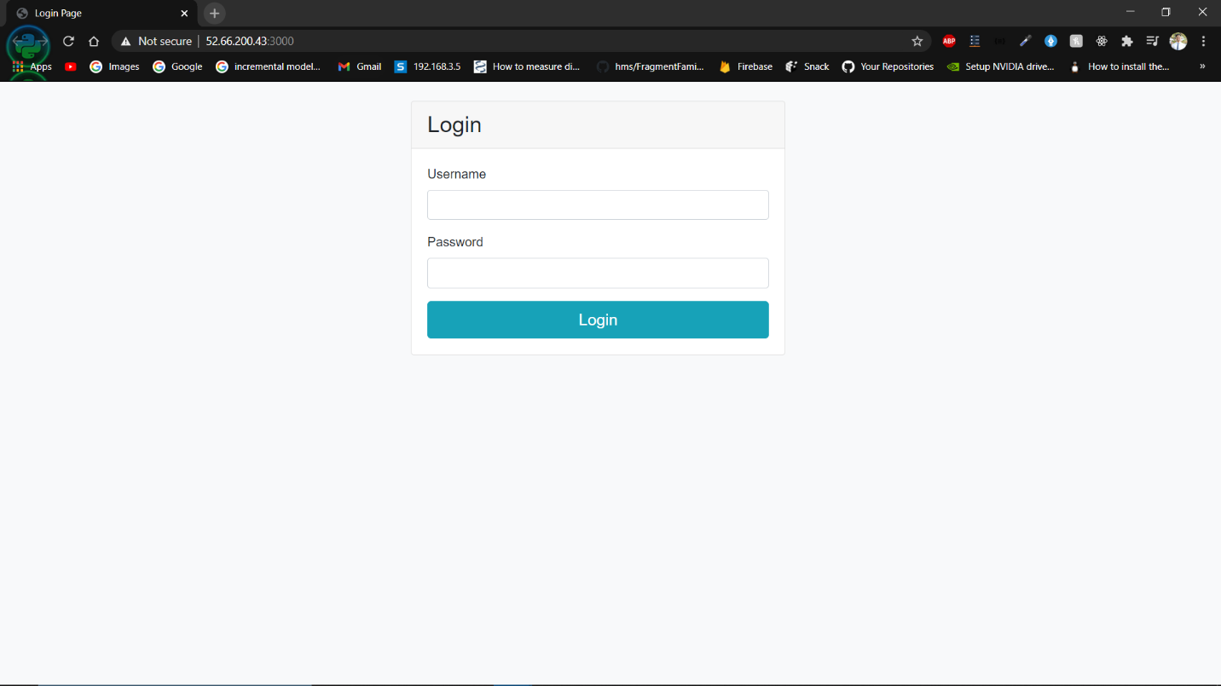

**Fig. 4.3.1. Login Page for CHW Workers**

Login Page for CHW: The application is made exclusively for ASHA workers. To prevent the non-authorized users from using the application, ASHA has to login with the username and password given to her by the medical supervisor working at the Primary Health Care centre. On click of the login button, the asynchronous process fetches the personal information of ASHA like her name, contact number, village id and stores the session in local storage for offline use.

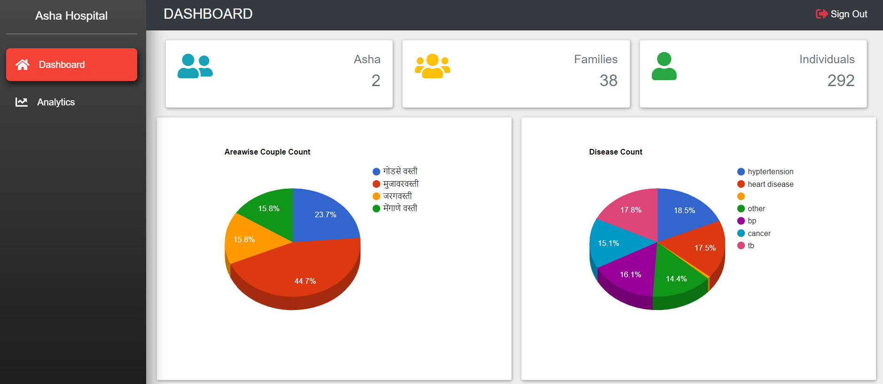

**Fig. 4.3.2. Panel Dashboard 1**

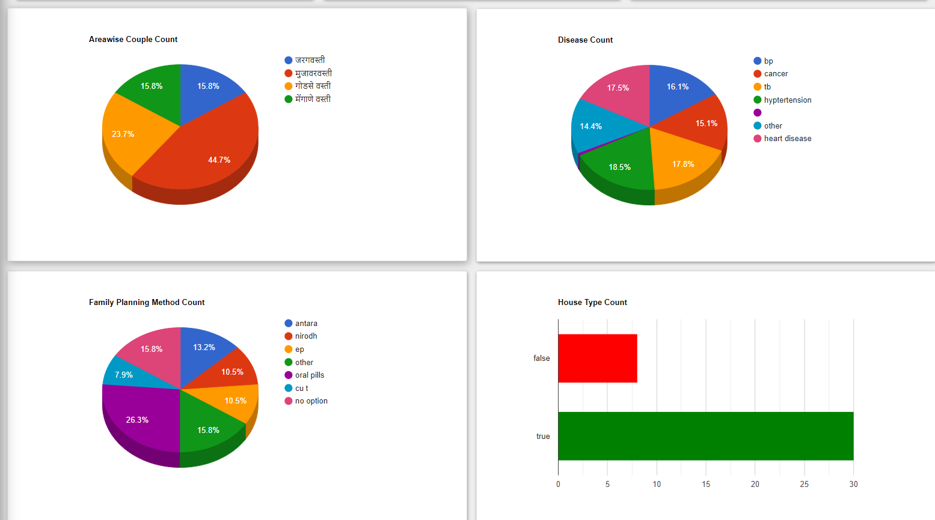

**Fig. 4.3.3. Panel Dashboard 2**

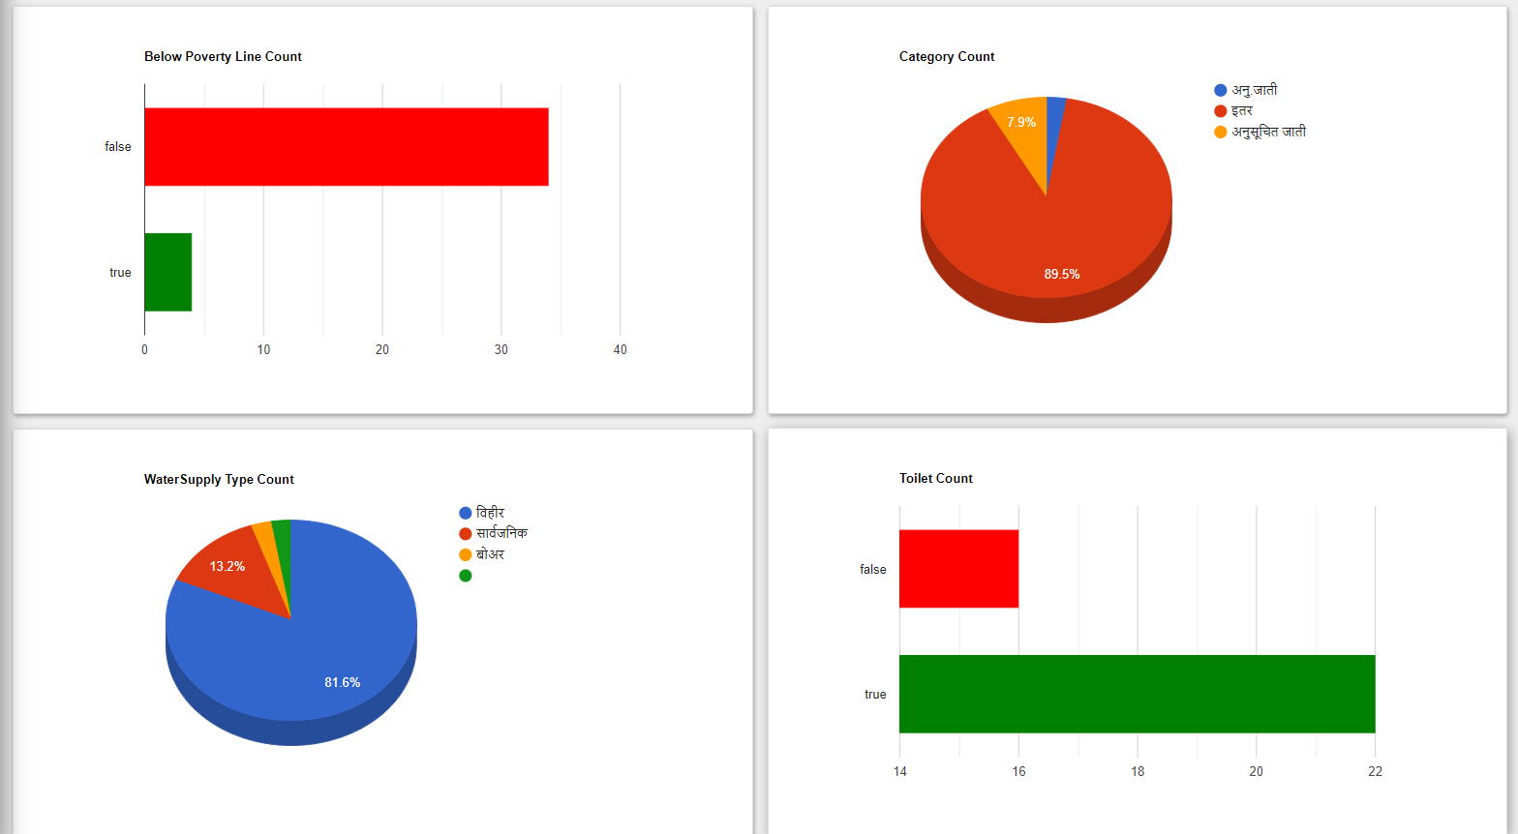

**Fig. 4.3.4. Panel Dashboard 3**

Panel Dashboard shows the pie chart of all general information’s stored in database. As shown in Fig. 4.3.2. There are 2 Asha Workers, 38 Family details are stored in database and 292 individuals of families. Then there is Area wise couple count where in “**गोडसे वस्ती**” there are around 23.7 % of couples. Similar area wise pie charts are displayed for Disease count, Family Planning Method Count, House Type Count (“Kachha” or “Pakka”), families below poverty line, families belong to different caste, different water supply facility available and families having toilet in their house.

Dashboards that help medical professionals quickly analyze large sets of data can save time, and can even save lives. The graphs and charts are custom made, interactive and customizable according to the data viewer wish to visualize.

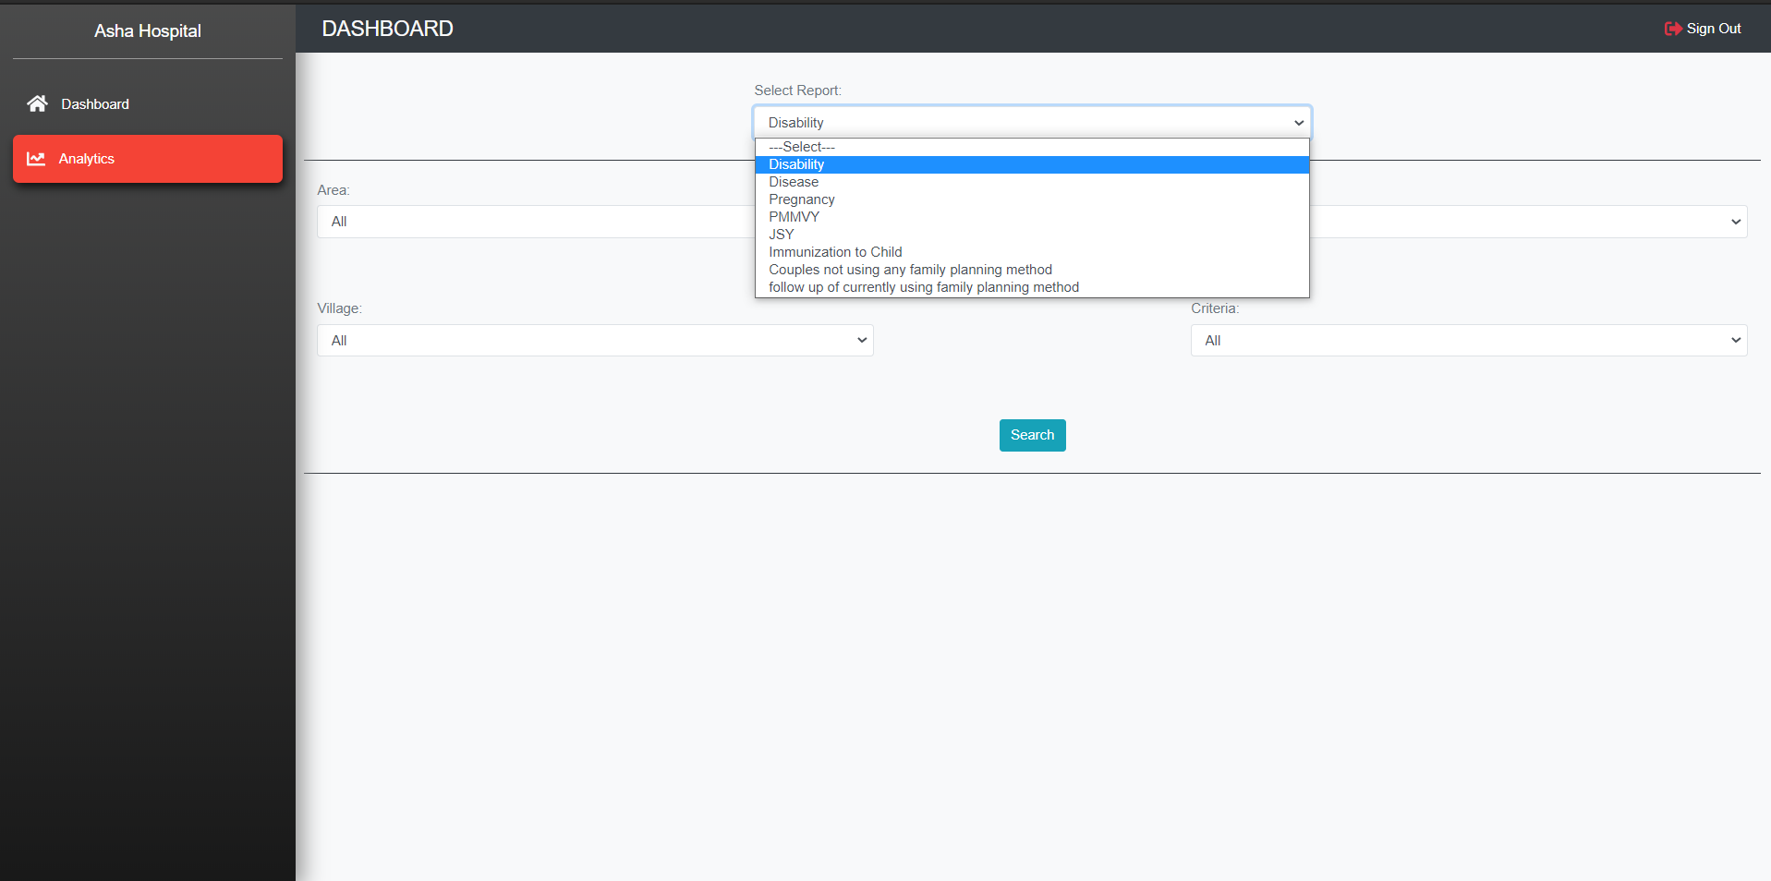

**Fig. 4.3.5. Panel Analytics**

Other section of Web Panel is Analytics. Here CHW Worker select the desired report analysis they want. There are analysis of different report such as Disability, Disease, Pregnancy, PMMVY Scheme, JSY Scheme, Immunization to child, couples not using family planning method, etc.

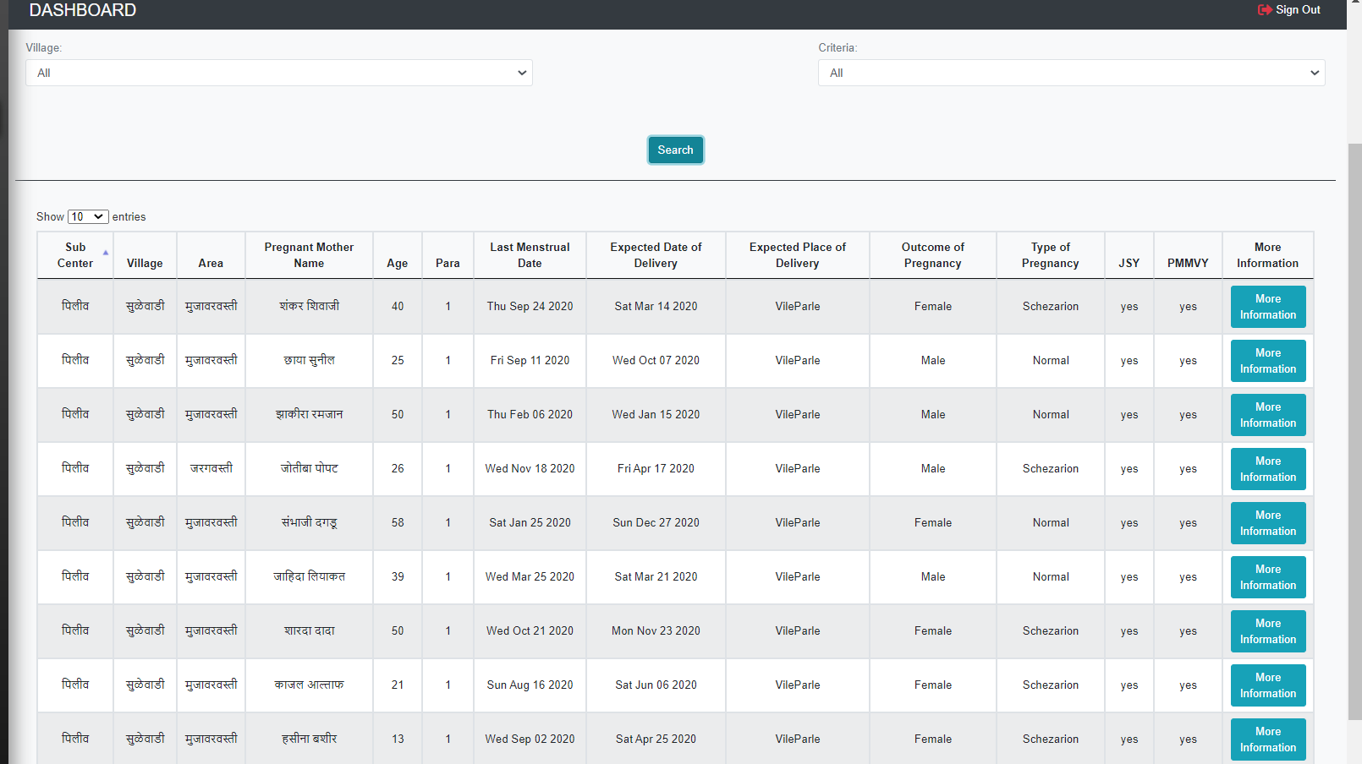

**Fig. 4.3.6. List of registered pregnant women**

The data of pregnant women with high-risk pregnancies; , such as swelling in the face or hands, low or high blood pressure, or convulsions and women in their third trimester are shown. Pregnant women in the who are attending antenatal care (ANC) visits at the hospital are also shown. Using the data, they can be consulted and educated on the importance of ANC services and can refer to them to Village Health Nutrition Days (VHNDs) which are much closer to their homes .

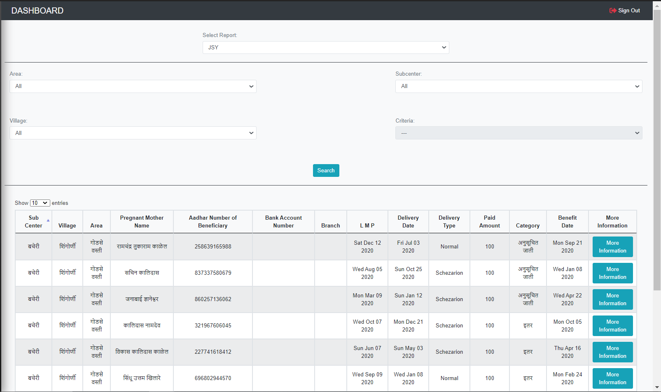

**Fig. 4.3.7. JSY details**

List of pregnant women getting benefit of JSY and PMMVPanY: The beneficiary would be required to fill up the prescribed scheme forms for registration and claim of the instalment and submit the same at the Anganwadi Centre/ approved Health facility.

Family Planning Counselling: The list of family planning method planning used by the couples and details about Family Planning Counselling is available on the portal and accordingly assist ASHAs to Provides antenatal care, family planning, and immunizations in villages

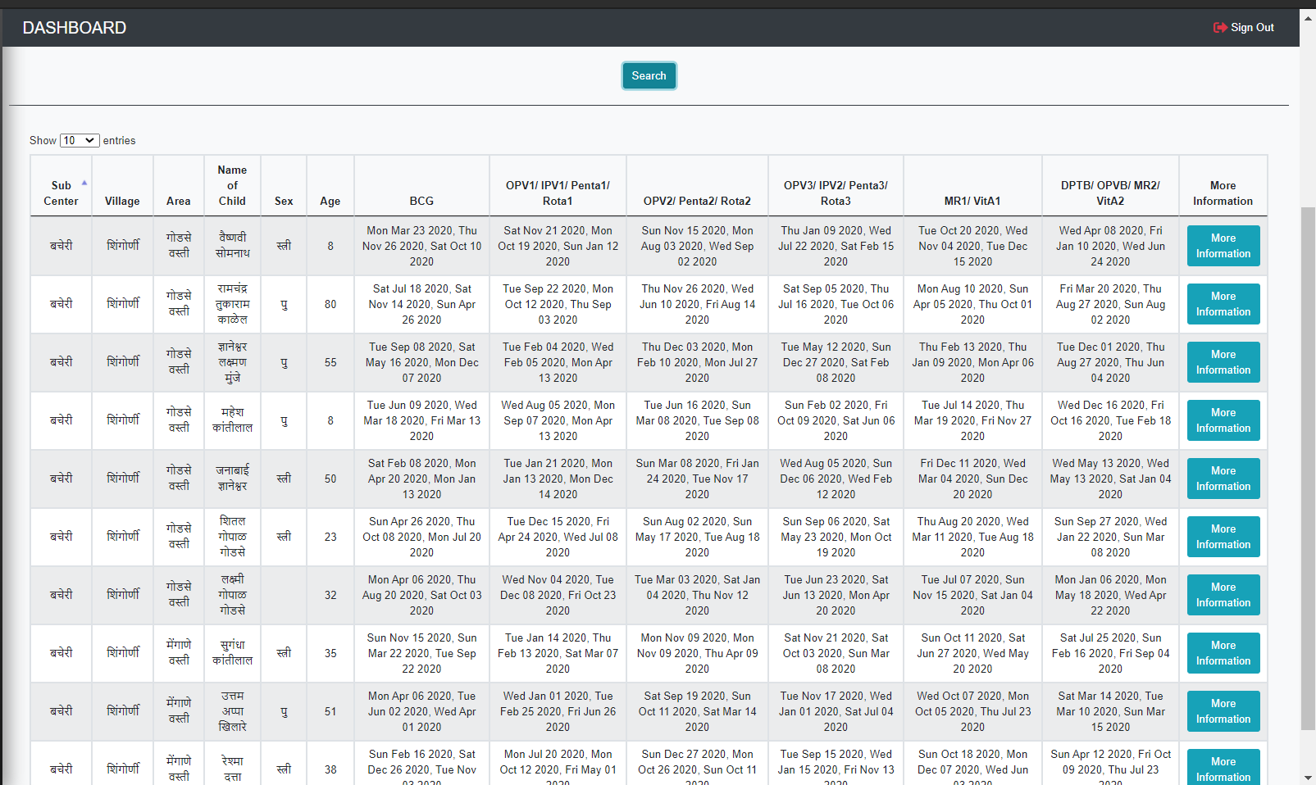

**Fig. 4.3.8. Immunization details**

The ASHA enters the vaccines up to an year that have been given to child. The first cycle of immunization consists of vaccine doses of BCG, Hepatitis B (Birth, 1, 2, and 3), OPV (0, 1, 2 and 3), DPT (1, 2, 3); or equivalent. The pregnant women who are registered by ASHA already and who have now surpassed the due date will appear in a list in this activity. This will make it easier for ASHA to identify newborns and get them registered for the immunization. Not taking the vaccines, pose a high risk on the newborns. It is thus very essential to ensure that every newborn is vaccinated properly.

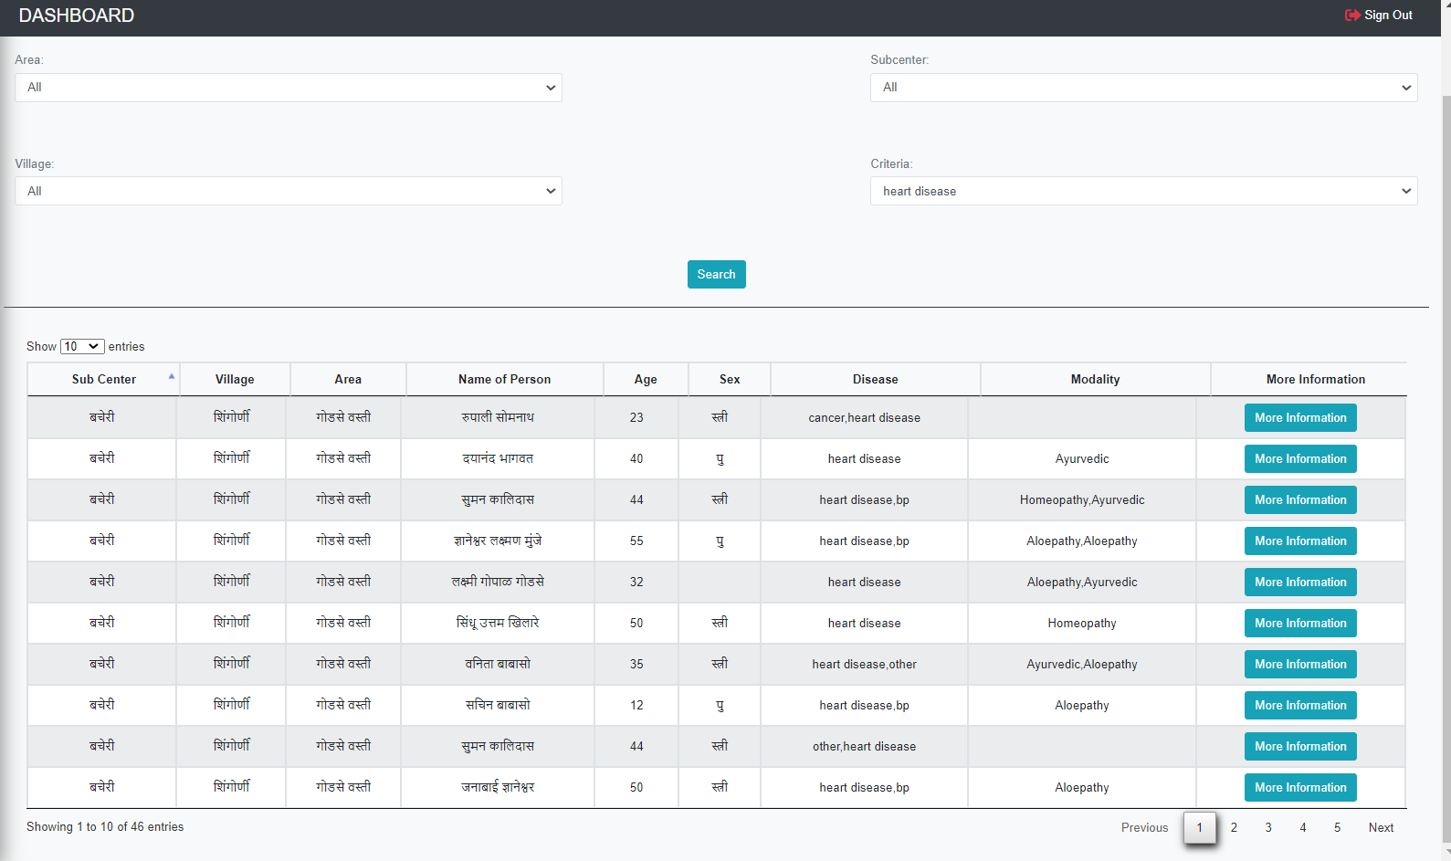

**Fig. 4.3.9. Different Diseases present in the area and the modality used**

Records of disease prevalent and different modality used: NCDs (Non-Communicable Diseases) are diseases of long duration. These are non-infectious conditions that cannot be transmitted to other individuals. Five Common NCDs on which ASHAs are trained: Hypertension, Diabetes, Cervical Cancer, Breast Cancer and Oral Cancer. A list of all the people with NCDs are shown to the admin. This will help to facilitate health services; links community members and health facilities; provides community level health services; activist building understanding of health and right to health.

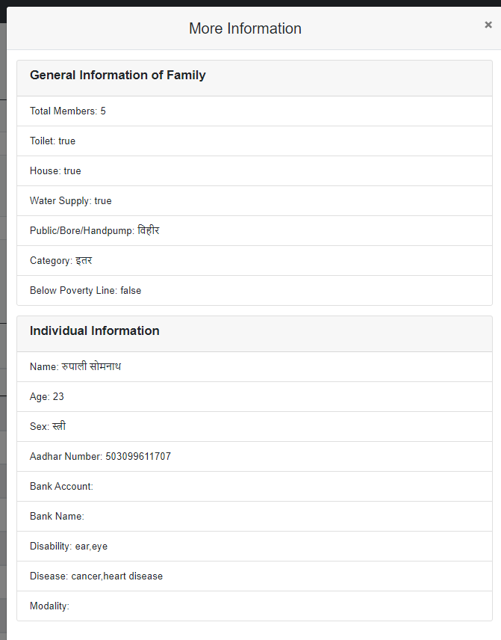

**Fig. 4.3.10. More Information of selected family member.**

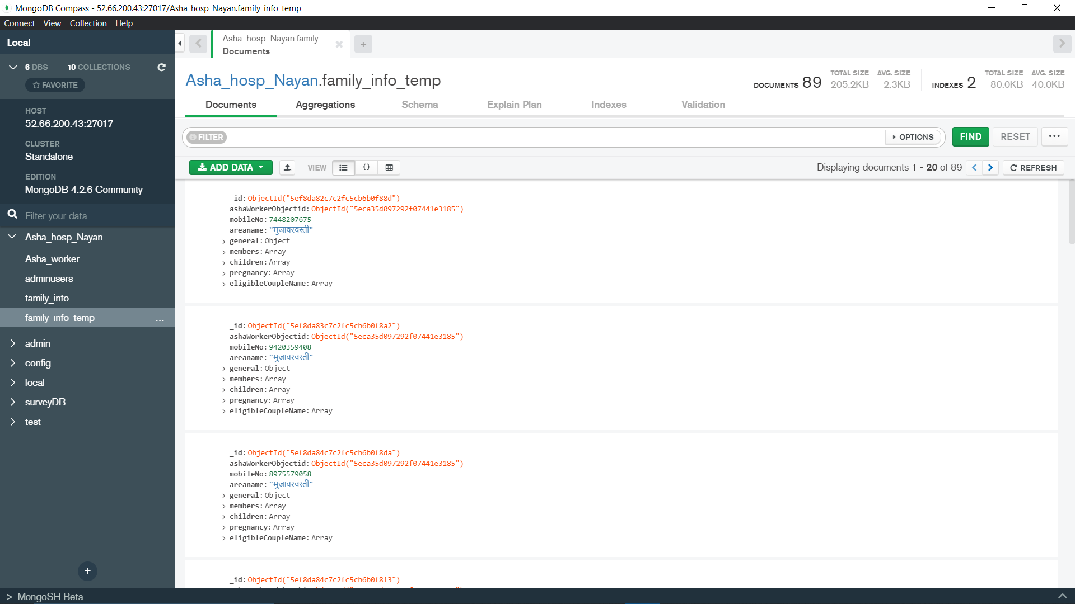

**Fig. 4.3.11. Family Document stored in MongoDB**

NoSQL databases were created in response to the limitations of traditional relational database technology. When compared to relational databases, NoSQL databases are often more scalable and provide superior performance. In addition, the flexibility and ease of use of their data models can speed development in comparison to the relational model, especially in the cloud computing environment. Each specific type of NoSQL database has different strengths, but all share fundamental characteristics that allow them to:

1. Handle large volumes of data at high speed with a scale-out architecture
2. Store unstructured, semi-structured, or structured data
3. Enable easy updates to schemas and fields
4. Be developer-friendly
5. Take full advantage of the cloud to deliver zero downtime

These capabilities provide users with many advantages compared to relational databases.

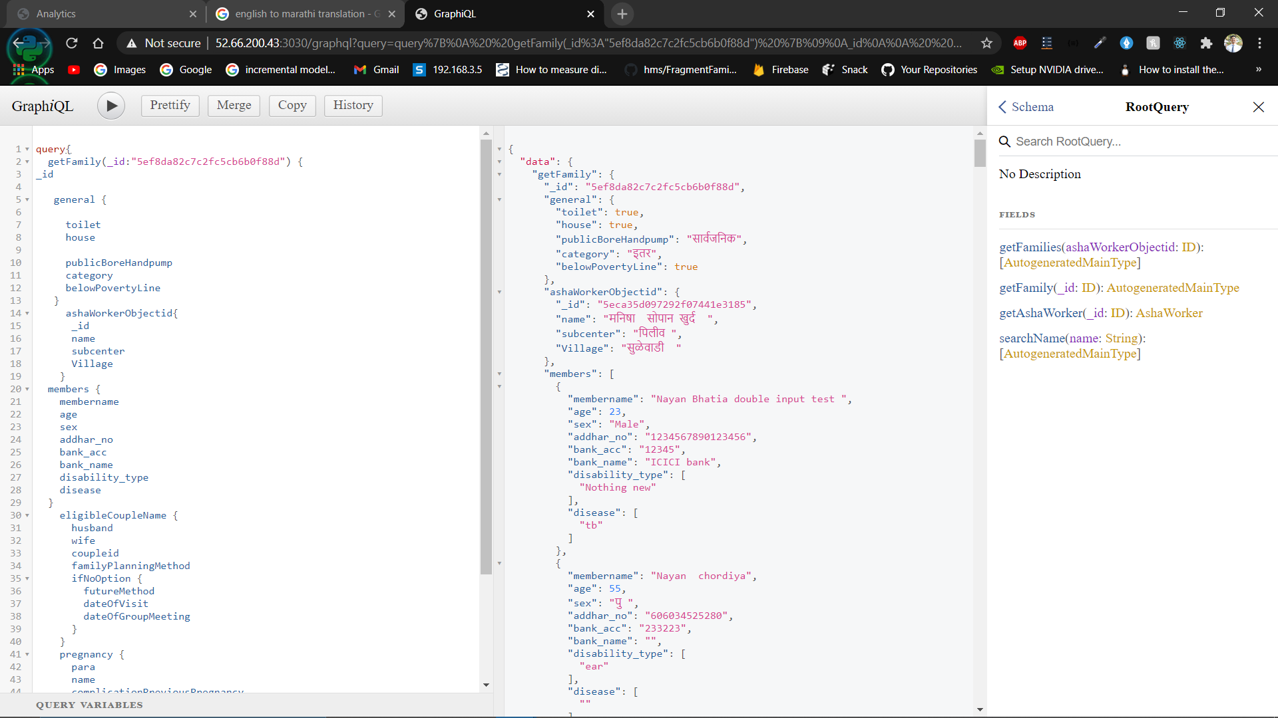

**Fig. 4.3.12. GraphQL Query**

At its core, GraphQL is a language for querying databases from client-side applications. On the backend, GraphQL specifies to the API how to present the data to the client. GraphQL redefines developers’ work with APIs offering more flexibility and speed to market; it improves client-server interactions by enabling the former to make precise data requests and obtain no more and no less, but exactly what they need.

GraphQL advantages:

1. Good fit for complex systems and micro services
2. Fetching data with a single API call.
3. Auto generating API documentation
4. Detailed error messages

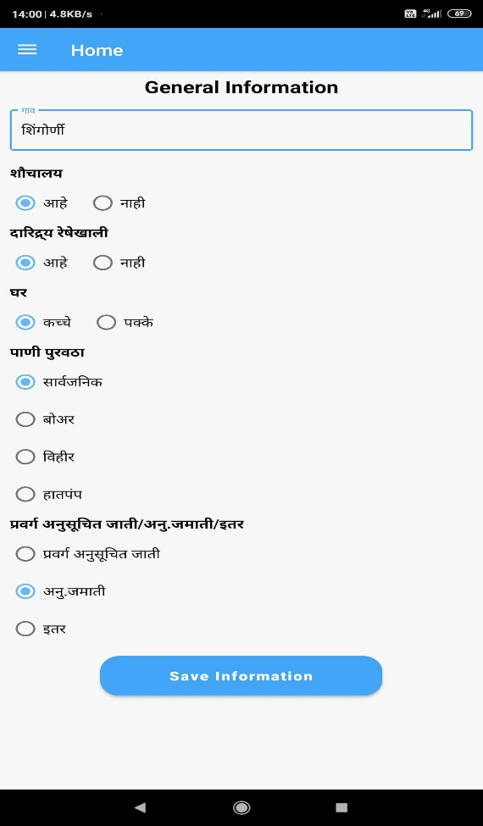

**Fig. 4.3.13. General Details collected by ASHAs**

|  |  |
| --- | --- |
|  |  |
| **Fig. 4.3.14. Member Information collected by ASHAs** | |
|  |  |
| **Fig. 4.3.15. Couple Information collected by ASHAs** | |
|  |  |
| **Fig. 4.3.16. Pregnancy Information collected by ASHAs** | |
|  |  |
| **Fig. 4.3.17. Child Information collected by ASHAs** | |

ASHAs worker login to the App then they can either Add new Family Details or Modify existing family details. They only modify can the details of those families whose details are added by the particular ASHA worker. This helps in maintaining confidentiality and integrity of the app.

For adding new family detail ASHAs need to enter data into 5 stages:

1. GENERAL INFORMATION: General Information consists of common details of families like whether the family is having “Kachha” or “Pakka” House, is there any toilet facility in family’s house, do family belongs to below poverty line, type of water supply, caste and village name from where the family belongs.
2. MEMBER INFORMATION: Family Member Information consists of member name, age, gender, mobile number (optional), Bank name (optional), Bank IFSC Code (optional), Account number (optional), family member having some kind of disease, disability and whether family member is undergoing from some treatment.
3. COUPLE INFORMATION: Couple Information consists of Husband Name, Wife Name, Couple ID, currently using family planning method, total male children, total female children, gender of last child and number of child/children.
4. PREGNANCY INFORMATION: Pregnancy Information consists of Mother Name, Para (Number of times women is pregnant. If this count is equal to or greater than 3 then it is denoted as high risk and then ASHAs insist them to you family planning method), last menstrual period, expected date of delivery, expected place of delivery, applied to JSY scheme (This is only available if family belongs to SC/ST caste) and applied to PMMVY scheme (This scheme is only available if women got pregnant for first time).
5. CHILD INFORMATION: Child Information consists of Child name, Mother Name, Father Name, date of OPV / B2VIT / BCG / OPV1_IPV1_Penta1_Rota1 / OPV_2_ Penta_2_Rota_2 / OPV3_IPV2_Penta3_Rota3 / MR1_VitA1 / DPTB_QPVB_MR2_Vita2 and Child RCH ID.

**CHAPTER 5**

**FUTURE SCOPE**

* 1. **FUTURE SCOPE**

1. Make app in multiple regional languages where it can be used by any ASHA worker anywhere from the country.
2. Adding more analytical data in admin panel where CHW workers can analyze and take necessary actions to the situation.
3. Try to implement push notifications in app where ASHA’s will be notified whether there is any emergency in upcoming days.
4. Login and Authentication both on Admin Panel and App.
   1. **CONCLUSION**

In today information era people need information even on the move. The relatively low-cost mobile wireless communication, creative thinking and thrust for information on the move laid down the foundation mobile applications. The only industry which is growing continuously in the last few years is the mobile application industry. Considering the penetration, utilization and benefits of mobile applications, it can be extended to empower the ASHA workers. Design and deployment of the Aarogya Patrika mobile application in multiple regional languages will improve the implementation of health-related programs initiated by government of India through ASHA workers. Based on health-related data collection and analysis by **Aarogya Patrika**, the requirement for medical solutions such as vaccines, medical kits etc. can also be optimized. As the data is collected over a period of time, the future prediction of drugs, medical facilities, equipment etc. for existing as well as new diseases is also possible. This will benefit the ASHA workers, society and country at large.

**REFERENCES**

**Research Papers:**

[1] N. D. Valakunde et al., Smart ASHA pregnancy monitoring system, 2017 International Conference on Big Data, IoT and Data Science BID, Pune, 2017, pp. 185-192, DOI: 10.1109/BID.2017.8336596.

[2] R. V. Vaidya and D. K. Trivedi, M-health: A complete healthcare solution, 2017 International Conference on Computing Methodologies and Communication ICCMC, Erode, 2017, pp. 556-561, doi: 10.1109/ICCMC.2017.8282527.

[3] Bhatia, Kavita. 2014. Performance-based incentives of the ASHA scheme stakeholders’ perspectives. Economic and political weekly. 145-151.

**Websites:**

[4] <https://en.wikipedia.org/wiki/Accredited_Social_Health_Activist> Accredited Social Health

Activist

[5] <https://www.mongodb.com/nosql-explained/advantages> Advantages of NoSQL | MongoDB

[6] <https://www.altexsoft.com/blog/engineering/graphql-core-features-architecture-pros/>

GraphQL: Core Features, Architecture, Pros and Cons

[7] <https://www.altexsoft.com/blog/engineering/the-good-and-the-bad-of-node-js/> Pros and Cons

of Node.js Web App Development

[8] <https://dzone.com/articles/an-introduction-to-aws-cognito-pros-cons-and-use-c> An

Introduction to AWS Cognito