Customer Analytics Project Report
Segmentation, CLV, Churn & Price Elasticity on the Online Retail II Dataset

1. Introduction
For this project I wanted to move past the usual single-output Kaggle exercise (like just predicting if a customer will buy something or not) and actually build something with a bit more depth to it. The idea was to look at customer behaviour from a few different angles at once and see how they connect, instead of treating each analysis as its own separate thing.
I used the Online Retail II dataset from Kaggle, which has about two years of transaction data (Dec 2009 to Dec 2011) from a UK-based online gift retailer. It has customer IDs, order info, product info, quantity and price, which is basically everything you'd need to study customer behaviour properly.
The plan was to answer one broader question rather than a narrow one: which customers actually matter, which of them are at risk of leaving, and does price even affect their buying behaviour. To do this I broke the project into four parts that build on each other:
- Customer Segmentation — group customers based on how they behave
- Customer Lifetime Value (CLV) — estimate how much each customer/segment is worth going forward
- Churn Analysis — figure out which customers have basically already stopped buying, and why
- Price Elasticity — check if different segments react differently to price changes
Each of these builds on the segments created in step 1, so by the end I have one single table that ties value, risk, and pricing behaviour together per segment, rather than four separate outputs that don't talk to each other.

2. Process Flow
Below is the overall flow I followed. Each box is a separate Jupyter notebook — every notebook picks up the cleaned file saved by the previous one, does its own piece of the analysis, and saves its own output for the next step to use. I kept it modular like this so I could re-run any one part without having to redo everything from scratch.
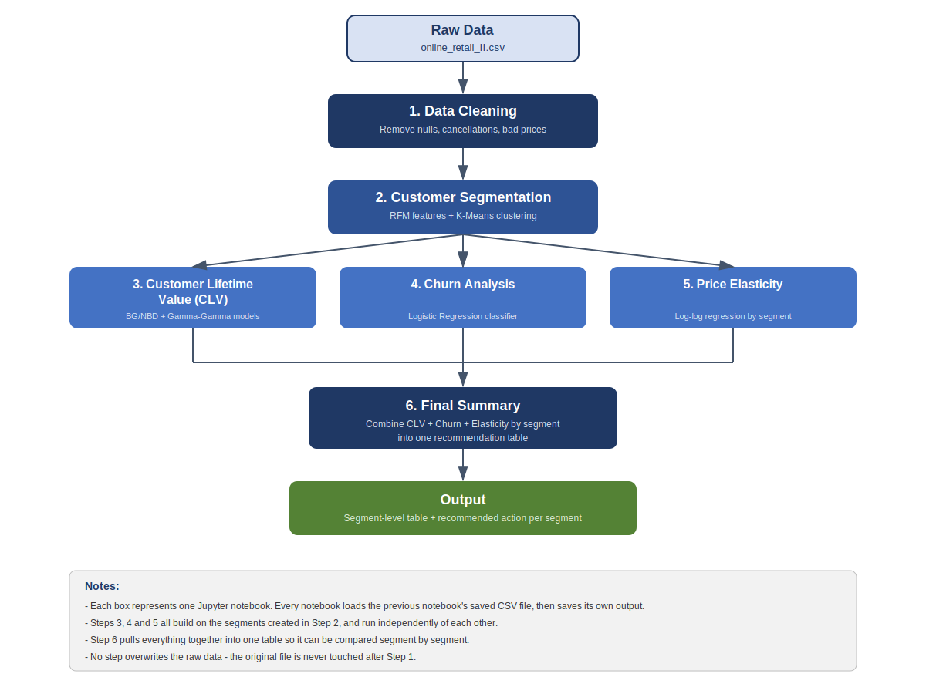

3. Customer Segmentation

Why do this
Not every customer behaves the same way, so treating the whole customer base as one group doesn't really make sense. Segmentation is basically about splitting customers into groups that behave similarly, so that whatever comes after (CLV, churn, pricing) can be looked at per group instead of as one big average that hides the real differences.

Steps followed
I used the classic RFM approach — Recency, Frequency, Monetary — which just means looking at how recently someone bought something, how often they buy, and how much they spend in total.
- Cleaned the raw data first — dropped rows with no Customer ID (can't segment someone we can't identify), separated out cancelled orders (kept as a separate “cancel count” feature instead of just throwing it away), and removed a handful of rows with zero/negative price.
- Calculated Recency (days since last order), Frequency (number of distinct orders, not line items), and Monetary (total amount spent) for every customer.
- Log-transformed and scaled these three features, since spend and frequency were quite skewed and K-Means needs everything on a similar scale to work properly.
- Used the elbow method and silhouette score to decide on the number of clusters — landed on 4, which balanced a good statistical fit with something that's still easy to explain to a business.
- Ran K-Means with k=4 and looked at the average RFM values per cluster to figure out what each group actually represents, then gave them names.

Result
The clustering gave four fairly distinct, evenly sized groups:
Segment | Recency (days) | Frequency (orders) | Monetary ($) | What it means
Champions | 27.4 | 19.3 | 11,014 | Buy often, buy recently, spend the most by far
New/Occasional | 28.4 | 3.0 | 865 | Recently active but haven't built up much order history yet
At-Risk | 227.9 | 5.1 | 2,002 | Used to be decent customers but have gone quiet
Lost/Inactive | 395.9 | 1.4 | 326 | Basically gone — barely bought anything and haven't been back in over a year

This ended up being the backbone of the whole project — every other step (CLV, churn, pricing) is looked at through these same four groups, which makes it easy to compare things directly across the rest of the analysis.

4. Customer Lifetime Value (CLV)

Why do this
Knowing how much a customer has spent so far tells you about the past, but it doesn't tell you what they're actually worth going forward. CLV tries to answer “how much revenue do we expect from this customer over the next X months”, which is a lot more useful when deciding where to spend retention money.

The formula
The simple textbook version of CLV is:
CLV ≈ Average Order Value × Purchase Frequency × Expected Customer Lifespan
I used this as a sanity-check baseline, but for the actual analysis I used a more proper, probability-based approach with two models from the lifetimes Python library instead of just multiplying averages together:
- BG/NBD model — predicts how many future transactions a customer is likely to make, based on how their past orders were spaced out.
- Gamma-Gamma model — predicts how much each of those future transactions is likely to be worth, based on their past order values.
Multiplying the outputs of these two models together (with a small discount rate applied for future money being worth slightly less than money today) gives a predicted CLV for each customer over the next 12 months.

Steps followed
- Collapsed the transaction data down to order-level (one row per order, not per product line), since the CLV models need order history, not individual product rows.
- Converted this into the specific input format the lifetimes library needs (frequency, recency, T, monetary_value — note these are defined slightly differently here than the RFM values from the segmentation step).
- Fit the BG/NBD model on frequency/recency/T, and the Gamma-Gamma model separately on customers who had made at least one repeat purchase.
- Combined both models to get a predicted 12-month CLV per customer, and handled one-time buyers (who can't be scored by Gamma-Gamma) by treating their predicted CLV as 0, since they genuinely have no repeat pattern to project from.

Result
Segment | Avg. Predicted CLV (next 12 months)
Champions | $5,393
New/Occasional | $1,031
At-Risk | $827
Lost/Inactive | $93

Champions come out on top by a huge margin, which makes sense. The more interesting bit is that New/Occasional actually beats At-Risk on predicted CLV, even though At-Risk had spent more historically ($2,002 vs $865). That's because CLV is forward-looking — the model is picking up on the fact that At-Risk customers haven't bought in a long time and is predicting they're less likely to come back, even though they were more valuable in the past. This ended up being one of the more useful findings for the retention argument later on.

5. Churn Analysis

Why do this
Segmentation and CLV tell you about value, but not specifically whether someone has actually stopped buying. Churn analysis is about defining what “leaving” actually looks like for this business, and then trying to predict/understand it.

Steps followed
- Instead of picking a random cutoff, I looked at the actual gap between customers' orders across the dataset — median gap was 24 days, and the 75th percentile was 61 days.
- Based on that, I defined churn as: no purchase in the last 75 days. This sits between the 75th percentile and a more conservative 90-day cutoff, so it's not just a made-up number.
- Built a churn label (Churned = 1 or 0) for every customer based on this threshold.
- Trained a logistic regression model to predict churn, using Frequency, Monetary, Cancel Count, predicted CLV and Segment as inputs. I deliberately left Recency out of the model since that's literally what was used to define churn in the first place — including it would make the model trivially “correct” without actually learning anything useful.
- Checked the model on a held-out test set, and also looked at churn rate broken down by segment specifically, since that was the actual point of doing this per-segment rather than just building one overall model.

Result
The model performed well — 92% accuracy, and it correctly caught 95% of customers who had actually churned, which matters more than overall accuracy here since missing an actual churner is the costlier mistake.
Segment | Churn Rate
Lost/Inactive | 95.0%
At-Risk | 81.9%
Champions | 5.6%
New/Occasional | 3.1%

At-Risk is really the segment worth paying attention to here. They still had decent historical value (second highest Monetary of all segments), but 82% of them have already crossed the churn line. Lost/Inactive is basically a lost cause at 95% churn already, and Champions/New-Occasional are both still very much active. This is the clearest “who should we actually try to save” signal out of the whole project.

6. Price Elasticity

What this is
Price elasticity is just a way of measuring how sensitive demand is to price — basically, if we raise the price by 1%, how much does the quantity people buy drop (or rise) in response. A more negative number means people are more sensitive to price changes; a number close to 0 means price barely matters to them.

How I went about it
- First tried this at the individual product level using a log-log regression (log of quantity against log of price), but the R-squared was quite low (around 0.14) — meaning price alone barely explains the week-to-week changes in demand for any single product. Made sense given how much seasonality/promotions affect a retailer like this.
- Since the actual goal was comparing segments, not individual products, I switched to aggregating purchases at the segment level instead — total quantity and average price per segment, per week.
- Ran the same log-log regression, but separately for each of the four segments, so I could directly compare how price-sensitive each group is.

Result
Segment | Elasticity | Significant?
New/Occasional | −2.37 | Yes — most price-sensitive
Champions | −1.87 | Yes — also price-sensitive
At-Risk | −0.44 | No — not statistically reliable
Lost/Inactive | +1.95 | Yes, but this one's misleading (see below)

New/Occasional and Champions both showed real, statistically significant price sensitivity, with New/Occasional being the most reactive to price changes of anyone. At-Risk didn't show a reliable relationship either way, so I can't really say anything confident about their price sensitivity from this data.
The Lost/Inactive result is the one worth calling out specifically. A positive elasticity would mean people buy more as prices go up, which doesn't really make sense for a normal product. When I looked into it, this segment's purchases were bunched into a narrow time window early in the dataset (looked like the holiday season), where both prices and order volume happened to be higher at the same time for unrelated seasonal reasons — not because higher prices were actually driving more purchases. So this is a good example of correlation not being the same as causation, and I made sure to flag it rather than just reporting the number at face value.

Closing Thoughts
Putting these four pieces together gave a much more complete picture than any one of them would have on their own. The clearest takeaway across the whole project is that At-Risk is the segment worth focusing retention effort on — they still have real value, but they're already mostly churned, and unlike New/Occasional, there isn't good evidence that a price-based offer would even work on them. Lost/Inactive, on the other hand, is probably not worth spending much on at all given how low their value and how high their churn already is.
Beyond the actual findings, this project was mainly a way for me to practice going past a single prediction model and instead build something that reads more like an actual business analysis — segmenting first, then asking value, risk, and pricing questions within those segments, and being upfront about the limitations (like the seasonality confound in the pricing step) rather than just reporting whatever number came out of the model.

