Zomato Bangalore Restaurant Insights Report
Ratings Cuisines Location Preferences Rating Drivers
Clean listings  33,660 | Valid ratings  28,133 | Average rating  3.68 / 5 | Locations  93
Executive Summary
The Bangalore restaurant market is concentrated in high-activity neighborhoods and value-oriented delivery formats. BTM leads supply with 2,781 listings, North Indian is the dominant cuisine with 13,912 appearances, and Quick Bites is the largest restaurant format. Ratings average 3.68. Table-booking restaurants show the clearest rating advantage (4.08 versus 3.62), while online ordering has a smaller positive association (3.71 versus 3.63). These are descriptive relationships, not proof of causation.
Evidence at a Glance
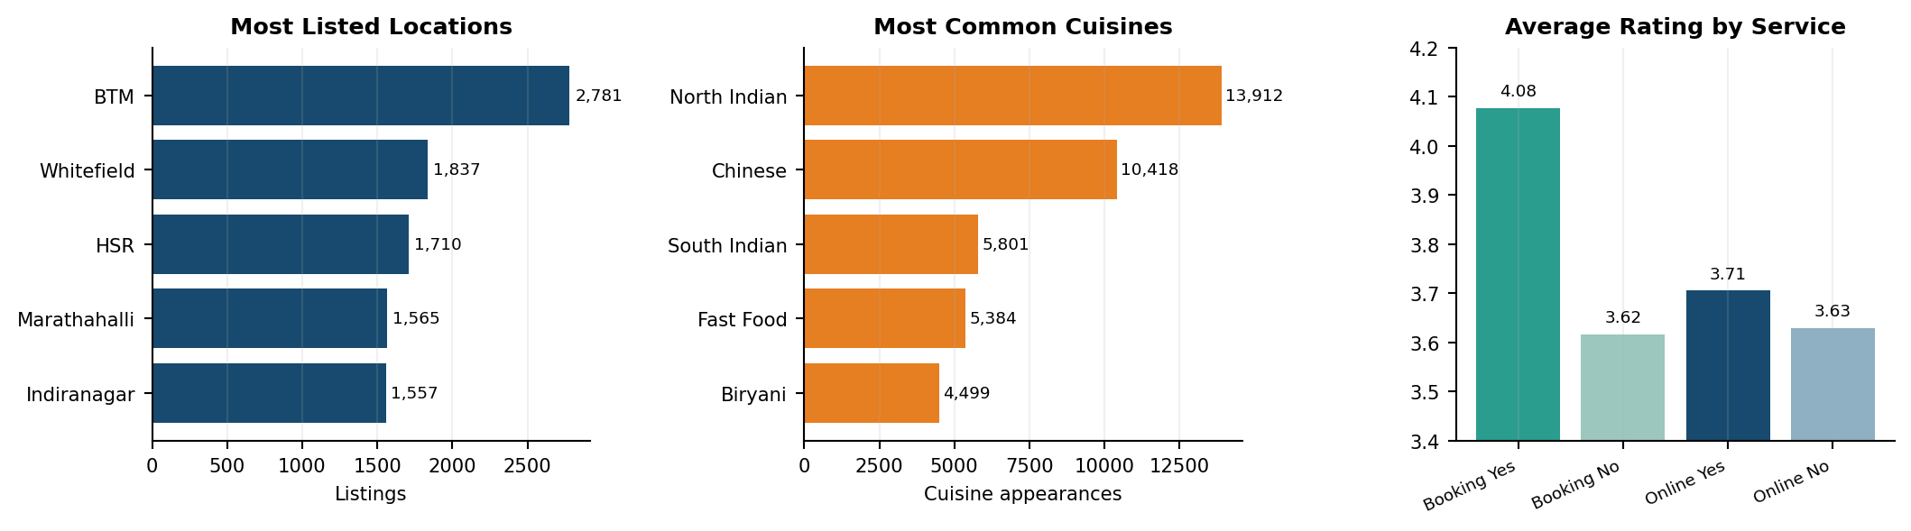
Cuisine totals count each cuisine named in a listing. Service comparisons use records with valid ratings.
Key Findings
Area | Evidence | Interpretation
Ratings | Mean 3.68; 28,133 valid ratings | Most rated listings sit in the mid-to-high range; use vote volume with rating to judge reliability.
Locations | BTM 2,781; Whitefield 1,837; HSR 1,710 | These are the strongest supply and discovery hubs, but high listing volume also signals intense competition.
Cuisines | North Indian 13,912; Chinese 10,418; South Indian 5,801 | Demand-facing menus should prioritize familiar high-frequency cuisines while using differentiated specialties to avoid crowding.
Engagement | Rating-votes correlation 0.399 | Better-rated restaurants tend to attract more review activity, but popularity and visibility may reinforce each other.
Price | Rating-cost correlation 0.334; median cost INR 400 | Higher-priced restaurants rate somewhat better, likely reflecting format, service and experience differences.
Services | Booking gap +0.461; online-order gap +0.076 | Reservation availability is the strongest observed service marker; operational quality matters more than simply enabling delivery.
Recommended Actions
• Prioritize BTM, Whitefield and HSR for targeted campaigns, but assess cuisine-level competition before expansion.
• For dine-in restaurants, strengthen reservation handling, service consistency and review responses; for delivery, improve menu accuracy, packaging and preparation time.
• Track weighted ratings, recent-review trends and complaint themes; do not compare restaurants using average rating alone.
• Validate findings at unique-restaurant level because repeated listings can overstate location and cuisine counts.
Project Links
GitHub repository | Project notebook

