Instagram Growth Strategy
Alfido Tech Data Science Internship | Executive summary and 4-week posting plan
POSTS | ENGAGEMENTS | AVG PER POST | TAGGED POSTS | ACTIVE FOLLOWERS
257 | 16,270 | 63.31 | 73.93% | 55.06%

Executive Summary
Recommendation. Run a four-week, photo-led content experiment focused on educational value, project proof, discovery and community conversation. The dataset contains 100 users, 257 posts, 8,782 likes and 7,488 comments. Photos produced the highest observed average engagement, but the content-type differences are small; therefore, retain a controlled challenger mix and judge success using median engagement, saves, shares, profile visits and follows gained.
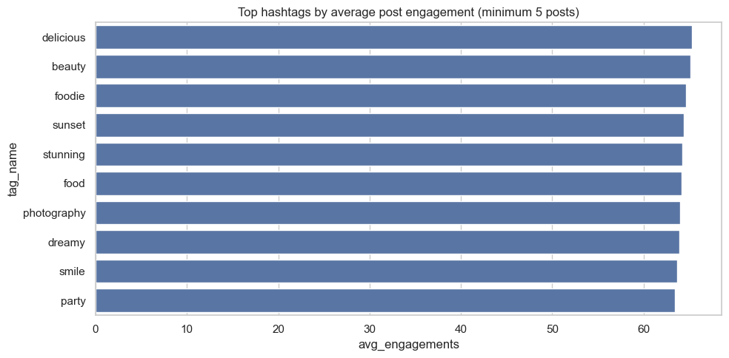  Notebook output: top hashtags by average post engagement (minimum five posts). | Evidence to use  Best observed format: Photo  Top tag set: delicious, beauty, foodie, sunset, stunning  Discovery signal: 33.4% of likes came from non-followers  Model caution: Random Forest holdout ROC-AUC 0.646; use only for prioritization

Recommended Posting Plan
DAY AND TIME | FORMAT | CONTENT | PRIMARY KPI
Mon 12:30 | Carousel | Practical data or AI lesson | Saves and qualified comments
Wed 18:30 | Photo | Project result or team proof | Shares and profile visits
Fri 19:30 | Reel | Strong hook plus quick insight | Non-follower reach
Sun 11:00 | Poll | Focused question or challenge | Comments and active followers

Execution and Decision Rule
Content mix: Use the leading format for most posts and reserve 25% for a challenger format. Hashtags: Rotate 2-3 observed tags with two niche Alfido Tech tags; do not use every tag on every post. Conversion: Use one clear follow CTA and reply to early comments. Review: After 30-50 real posts, scale a format only when its median engagement and conversion KPIs improve against the baseline.
Data limitation. Post, like and comment timestamps have insufficient variation, so the proposed times are test slots rather than proven best times.
Project links GitHub Repository | Complete Jupyter Notebook

