Loan Approval Prediction Executive Report
Model comparison, deployment threshold, and responsible-use recommendations | Prepared by Kartik Kachwahe
DATASET  614 applications | CHAMPION  Logistic Regression | STARTING THRESHOLD  0.52
Executive Summary
Recommendation. Use Logistic Regression as the proof-of-concept champion and begin controlled validation at an approval-probability threshold of 0.52. It delivered the strongest test ranking performance (ROC-AUC 0.876) and is easier to explain and govern than the tree ensembles. The workflow uses leakage-safe imputation, encoding, scaling, and SMOTE only within training folds.
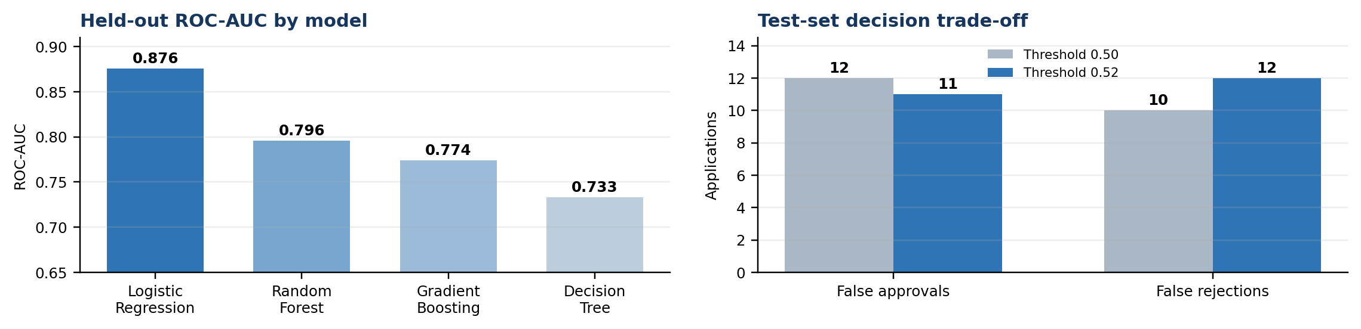
Figure 1. Actual held-out model results and threshold trade-off from the executed notebook.
Model | Precision | Recall | F1 | ROC-AUC
Logistic Regression | 0.862 | 0.882 | 0.872 | 0.876
Random Forest | 0.822 | 0.871 | 0.846 | 0.796
Gradient Boosting | 0.820 | 0.859 | 0.839 | 0.774
Decision Tree | 0.818 | 0.847 | 0.832 | 0.733
Threshold Recommendation  At 0.52: precision 0.869, recall 0.859, F1 0.864, 11 false approvals, and 12 false rejections. Versus 0.50, it avoids one false approval but adds two false rejections.  Why 0.52: selected from out-of-fold training predictions under an illustrative 5:1 cost for false approval versus false rejection, with recall constrained to at least 70%. Replace this assumption with verified loss, margin, review cost, risk appetite, and approval-volume targets. | Model Trade Offs and Deployment  • Logistic Regression: best metrics and clearest governance; may miss nonlinear effects.  • Tree ensembles: capture interactions; weaker here and require stronger explanation.  • Safeguards: calibrate probabilities; validate on recent out-of-time data; audit Gender and Married for fairness and legal permissibility; route borderline scores to manual review; monitor drift, defaults, overrides, calibration, and group fairness.
Project links View notebook | Open GitHub repository
Conclusion. The project meets the case-study objective with a reproducible modeling pipeline and cost-aware threshold analysis. Use the model as decision support, not as an autonomous lending decision, until calibration, fairness, compliance, and out-of-time validation are complete.

