Comparative Analysis of VLA Architectures: Pi0 vs Pi0-FAST
Kartik Reddy Katam; Gaurav Dharmadhikari
2026-05-19
Table of Contents

Comparative Analysis of Vision-Language-Action Architectures

Pi0 (Flow Matching) vs. Pi0-FAST (Autoregressive Tokenization) for Language-Conditioned Robotic Manipulation
Team Members: Kartik Reddy Katam, Gaurav Dharmadhikari Emails: kartikreddy.katam@gmail.com, gaurav.dharrmadhikari@sjsu.edu SJSU IDs: 015765542, 017038177 GitHub link: github.com/KartikKatam/libero-vla-analysis

1. Project Goal and Problem Statement
This project investigates a fundamental architectural question in robot learning: how does the choice of action generation mechanism affect the real-world performance of Vision-Language-Action (VLA) models? We compare two state-of-the-art VLA systems — Pi0 and Pi0-FAST — on identical manipulation tasks to understand the practical trade-offs between their respective designs.
Pi0 generates robot actions using flow matching, a continuous trajectory generation approach that models actions as samples from a learned distribution. Pi0-FAST, by contrast, tokenizes actions into discrete chunks and generates them autoregressively, similar to how large language models generate text. Both models share the same vision and language backbone (PaliGemma-3B: a SigLIP vision encoder + Gemma 2B language model), but diverge sharply in how they produce robot actions.
Our central questions are:
- How do these architectural differences in action generation affect manipulation performance and success rate?
- How do they compare in terms of trajectory quality and smoothness?
- What are the inference speed trade-offs between the two approaches?
- How well does each architecture generalize across task types (spatial reasoning, object identity, goal inference, long-horizon)?
Answering these questions has direct implications for practitioners deploying robotic systems, where choices between model families involve real trade-offs in speed, accuracy, and compute cost.
The headline finding of this pilot is that aggregate success rates are identical across the two architectures at 43.6%, but this aggregate hides a structured per-suite divergence: Pi0 wins decisively on spatial reasoning and goal-conditioned tasks, while Pi0-FAST wins decisively on language-to-object grounding. The architectures are complementary, not strictly ordered — the right choice depends on which bottleneck the target task imposes.

2. Approach and Implementation

2.1 Pi0: Flow Matching Action Head
Pi0 frames action generation as a flow matching problem (Lipman et al., 2022). Rather than the stochastic multi-step reverse process of diffusion, flow matching trains a network to regress a velocity field along a straight-line path between noise and data:
$$L_{\text{FM}}=E∥v_{θ}\left(x_{t},t\right)−u_{t}\left(x∣x_{1}\right)∥^{2}$$
where $x_{t}=\left(1−t\right)⋅x_{0}+t⋅x_{1}$ and the target velocity is $u_{t}=x_{1}−x_{0}$. This is a stable MSE objective with no noise-schedule tuning, no ELBO derivation, and no learned reverse-time variance — the target velocity is constant along the entire probability path, which permits aggressive step-count reduction at sampling time.
At inference, 10 Euler integration steps transform Gaussian noise into a complete action chunk of shape $\left[\text{horizon}=50,\text{action_dim}=32\right]$, with all 50 actions produced in parallel within each step. The prefix (image + language tokens) is computed once and its KV cache is reused across all 10 flow steps.
Pi0 uses a separate 311M-parameter action expert (a narrower Gemma stack with width 1024, vs the 2048-wide backbone) that attends jointly with the PaliGemma-3B VLM backbone through a fused multi-expert attention operation. Total parameters: ~3.3 B. The action expert is trained from scratch while the VLM backbone is LoRA-adapted. The separation is motivated by modality mismatch (continuous action vectors have different statistics than language tokens), inference efficiency (only the narrower expert runs per flow step), and pretraining preservation (the VLM’s language priors are minimally perturbed).
The training timestep is sampled from $τ∼0.001+0.999⋅\text{Beta}\left(1.5,1\right)$, biased toward high-noise regions where the velocity field is hardest to learn and where the first Euler step lands at inference. Attention follows a block-causal pattern: image+language attends to itself bidirectionally; state token attends to image+language+self; action tokens attend to everything but only the action block is causal.

2.2 Pi0-FAST: Autoregressive Action Tokenization
Pi0-FAST applies FAST (Frequency-space Action Sequence Tokenization) (Pertsch et al., 2025) to convert continuous action chunks into a compact discrete vocabulary, then generates them autoregressively using the same PaliGemma transformer backbone — no separate action expert, no flow integration.
The tokenization pipeline processes a raw action chunk through four stages:
- Quantile normalization (1st/99th percentile per dimension) mapping actions to $\left[−1,1\right]$.
- Discrete Cosine Transform (DCT-II) per dimension along the time axis, concentrating energy in low-frequency basis functions.
- Scale-and-round quantization with $γ=10$, producing a sparse integer matrix dominated by zeros at high frequencies.
- Byte-Pair Encoding trained on the flattened integer streams, producing a vocabulary of 1024 IDs.
The DCT step is critical: naive per-step binning produces correlated tokens that the model learns to copy. DCT concentrates smooth trajectories into a few low-frequency coefficients — the same principle JPEG uses on images — achieving up to 13.2× compression versus naive binning at 50Hz / 14-DoF control (FAST paper Table I). For LIBERO’s 7-DoF 20Hz setting, FAST emits ~30 tokens per chunk.
A subtle architectural detail: FAST does not expand PaliGemma’s embedding matrix. The 1024 FAST IDs overwrite the least-used tail of PaliGemma’s 257,152-vocab SentencePiece tokenizer (after skipping the last 128 special tokens). This is what allows Pi0-FAST to start directly from the pretrained PaliGemma checkpoint with no embedding re-initialization.
Action tokens are appended to the text vocabulary and the model performs standard next-token prediction with a cross-entropy loss:
L=−1Mt∈M​logpθyt∣y<t,image,text,state
where $M$ is the action-token range. The state is also discretized (256 bins) and placed in the prefix, since there is no action expert to consume continuous proprioception.

2.3 Architectural Comparison
Dimension | Pi0 (flow matching) | Pi0-FAST (autoregressive)
Action representation | Continuous chunks (50 × 32) | DCT-compressed discrete tokens (~30 IDs)
Generation paradigm | Velocity-field ODE integration | Next-token prediction (causal)
Loss | MSE on velocity field | Cross-entropy on tokens
Inference cost per chunk | 10 forward passes (50 actions batched) | 1 prefix prefill + ~30–60 serial decodes
Inference latency | ~100 ms/chunk on 4090 (faster) | ~750 ms/chunk on 4090 (~7× slower)
Training compute to convergence | Standard | ~5× faster than Pi0 (FAST paper §6)
Action expert | Separate 311M-param Gemma module | None — uses backbone directly
Native multimodality of action dist. | Yes (flow matching preserves modes) | Greedy decode collapses modes
Calibrated uncertainty per token | No closed-form | Yes (softmax over 1024-way vocab)
Quantization error | None (continuous) | $≈0.1$ normalized units round-trip ($γ=10$)
A note on inference latency that diverges from the intuitive “fewer steps = faster” framing: Pi0-FAST is actually slower per chunk because its 30–60 token decodes cannot be parallelized along time, whereas Pi0’s 10 Euler steps each operate on the full 50-action chunk in parallel. What FAST saves is training compute, not inference compute.

2.4 Fine-Tuning Strategy (as executed)
Both models were fine-tuned from public pretrained base checkpoints (gs://openpi-assets/checkpoints/pi0_base and gs://openpi-assets/checkpoints/pi0_fast_base) using the openpi LoRA recipes:
Component | Pi0 LoRA targets | Pi0-FAST LoRA targets
PaliGemma 2B backbone | attention QKV einsums + FFN einsums, rank 16, α=16 | same, rank 16, α=16
Action expert (Gemma 300M) | attention QKV + FFN, rank 32, α=32 | N/A (no action expert)
State / action projection heads | dense (not LoRA-wrapped) | dense
SigLIP vision tower | frozen | frozen
EMA | disabled (LoRA convention) | disabled
Training configuration: 5,000 LoRA steps, batch size 32, seed 42, cosine learning-rate decay. Both models reached step 5,000 successfully, but the final-step checkpoint save aborted mid-write due to a disk pressure event (see Section 2.5); the clean step-4,000 checkpoint was used for evaluation, capturing 80% of the intended training budget.
Honest disclosure of deviations from the original proposal. The proposal envisioned 30,000-step LoRA training with a hyperparameter sweep over LoRA rank {16, 32, 64}, learning rate {1e-5, 5e-5, 1e-4}, VLM-frozen vs LoRA-tuned, FM timestep schedule (Beta(1.5,1) vs Uniform), and action chunk horizon H ∈ {16, 32, 50}. Due to the compressed time and budget of the pilot, we executed only the openpi default recipe at 5,000 steps with no sweep. All deviations are documented in Section 6 (Limitations) and recovered as Phase 2 future work.
Hardware (as executed): 2× NVIDIA H100 SXM5 80GB on RunPod Secure Cloud at $3.29/GPU/hr, total pilot cost ~$36 over ~5.5 hours of wall-clock. Each model trained on one dedicated GPU in parallel. Container: RunPod’s runpod/pytorch:2.4.0-py3.11-cuda12.4.1-devel-ubuntu22.04 image with 30 GB container disk + 100 GB persistent volume. The openpi repository was cloned at commit e4580662 and installed via uv sync into the container Python 3.11 environment. LIBERO simulator runs in a separate Python 3.8 environment (mujoco-py requires older Python) with MUJOCO_GL=osmesa for headless CPU rendering.

2.5 Implementation Challenges (actually encountered)
The pilot encountered five significant engineering issues, each documented for future reproduction:
(1) Disk OOM during checkpoint save. The original 5,000-step training reached step 5,000 on both models but the final checkpoint save aborted mid-write because /workspace was at 100% utilization. Root cause: the HuggingFace LeRobot dataset cache for physical-intelligence/libero bloated to 66 GB (33 GB datasets/ format + 33 GB lerobot/ format) on top of the base checkpoints (12 GB) and training checkpoints (~17 GB cumulative). Recovery: evaluated on clean step-4,000 checkpoints; lost the final 1,000 training steps. Loss curves (Section 5) show this segment was nearly flat — minimal performance impact.
(2) HuggingFace Hub rate limit. The first norm-stats computation hit HTTP 429 (“Too Many Requests”) at 31% of the dataset download. Anonymous HF requests are rate-limited to ~1 file/sec; the dataset has 1,699 files. Resolution: provided an authenticated HF token, which restored full download throughput.
(3) Corrupted base checkpoint after disk OOM. During the first disk OOM event, the partial pi0_base/params/ download was truncated mid-stream. Subsequent training crashed with OUT_OF_RANGE: Error reading "params.PaliGemma.img.Transformer.encoderblock.MlpBlock_0.Dense_1.kernel" — Requested byte range [0, 496770289) is not valid for value of size 195624960. Resolution: deleted the corrupted directory and re-downloaded.
(4) EGL rendering crash in LIBERO eval. Initial evaluation with MUJOCO_GL=egl (GPU rendering) crashed with Aborted (core dumped) after 1–2 episodes per suite — a known LIBERO/MuJoCo EGL-state corruption issue with multi-episode rollouts. The Python process received SIGABRT without a stack trace, consistent with native-code corruption. Resolution: switched to MUJOCO_GL=osmesa (CPU rendering). 2× slower per episode (~55s vs ~28s) but completely stable — both models completed all 110 episodes each without a crash.
(5) Port collision with RunPod nginx. The first Pi0-FAST evaluation attempt died because --port=8001 collided with RunPod’s default nginx web service. The serve_policy server died silently on bind failure; the eval client connected to nginx and received HTTP 200 (a webpage) instead of the websocket upgrade response, producing the cryptic websockets.exceptions.InvalidStatus. Resolution: moved Pi0-FAST eval to port 8002.
Framework choice (deviation from original proposal): The proposal anticipated standardizing on lerobot’s PyTorch port of Pi0/Pi0-FAST. In practice we used openpi (JAX) directly for both training and the policy server, with the openpi examples/libero/main.py PyTorch-based eval client connecting via websocket. This proved more robust than the lerobot port (which has open replication issues — see lerobot/issues/2114) and matches the published Physical Intelligence recipes exactly.

3. Dataset
We use the LIBERO benchmark (Liu et al., NeurIPS 2023), a standardized evaluation suite for language-conditioned manipulation on a simulated Franka Emika Panda 7-DOF robot arm. LIBERO provides ~130 tasks across four suites of increasing difficulty:
- LIBERO-Spatial — Same objects (black bowls), varied spatial arrangements (“between the plate and the ramekin”, “next to the cookie box”, etc.). Tests positional language grounding.
- LIBERO-Object — Different objects (alphabet soup, butter, cream cheese, …), similar arrangements. Tests object-level language→visual grounding.
- LIBERO-Goal — Same scene, different language instructions (“put the bowl on the stove”, “open the middle drawer”, …). Tests instruction-following decoupled from perception.
- LIBERO-Long (LIBERO-10) — Multi-step, long-horizon compositional tasks (“put both the alphabet soup and the tomato sauce in the basket”). Tests temporal credit assignment and error compounding.
Each task includes 50 human teleoperated demonstrations (~6,500 total across the 130 tasks). Per-sample features: two RGB camera views (third-person agentview_image + wrist-mounted robot0_eye_in_hand_image) at 256×256, 8-dimensional proprioceptive state, 7-dimensional continuous action labels, and a natural language task instruction.
The suites are designed to isolate specific architectural bottlenecks — a per-suite breakdown therefore tells you where a model fails, not just how much:
Suite | Primary bottleneck tested
LIBERO-Spatial | Fine spatial control + scene disambiguation
LIBERO-Object | Open-vocabulary language → object grounding
LIBERO-Goal | Language → goal-state inference
LIBERO-Long | Multi-step temporal composition; error compounding
This decomposition is what makes LIBERO especially valuable for an architectural comparison rather than just a leaderboard race.

4. Finished Features

Side-by-Side Evaluation Interface
The primary demonstration is a parallel evaluation pipeline that runs both models on identical LIBERO tasks in MuJoCo simulation. Each model runs as a policy server (openpi scripts/serve_policy.py) on its own GPU and port; per-suite evaluation is driven by openpi’s examples/libero/main.py client. Both stacks run concurrently — Pi0 on GPU 0 / port 8000, Pi0-FAST on GPU 1 / port 8002.
For each rollout, the evaluator saves: - A MP4 video of the rollout (third-person + wrist camera composited side-by-side) with the task instruction overlaid. Filename embeds the task description and outcome — e.g., rollout_pick_up_the_black_bowl_on_the_stove_and_place_it_on_the_plate_success.mp4. - Per-episode success/failure label and cumulative success rate (logged via WandB). - Server-side policy-query logs (for latency analysis in future work).

Quantitative Evaluation
We evaluated both models on all four standard LIBERO suites at 3 trials/task (2 trials/task on libero_10 due to longer episode duration), totalling 110 episodes per model, 220 episodes across both models, all conducted in parallel across the 2× H100 setup. The evaluation finished in ~2 hours of wall-clock with MUJOCO_GL=osmesa rendering.
The headline result:
Suite | Pi0 success | Pi0-FAST success | Wilson 95% CI (Pi0) | Wilson 95% CI (Pi0-FAST) | Δ (Pi0 − Pi0-FAST)
libero_spatial | 14/30 (46.7%) | 11/30 (36.7%) | (30.2%, 63.9%) | (21.9%, 54.5%) | +10.0 pts
libero_object | 15/30 (50.0%) | 24/30 (80.0%) | (33.2%, 66.8%) | (62.7%, 90.5%) | −30.0 pts
libero_goal | 18/30 (60.0%) | 13/30 (43.3%) | (42.3%, 75.4%) | (27.4%, 60.8%) | +16.7 pts
libero_10 | 1/20 (5.0%) | 0/20 (0.0%) | (0.9%, 23.6%) | (0.0%, 16.1%) | +5.0 pts
Aggregate | 48/110 (43.6%) | 48/110 (43.6%) | (34.7%, 53.0%) | (34.7%, 53.0%) | 0.0 pts
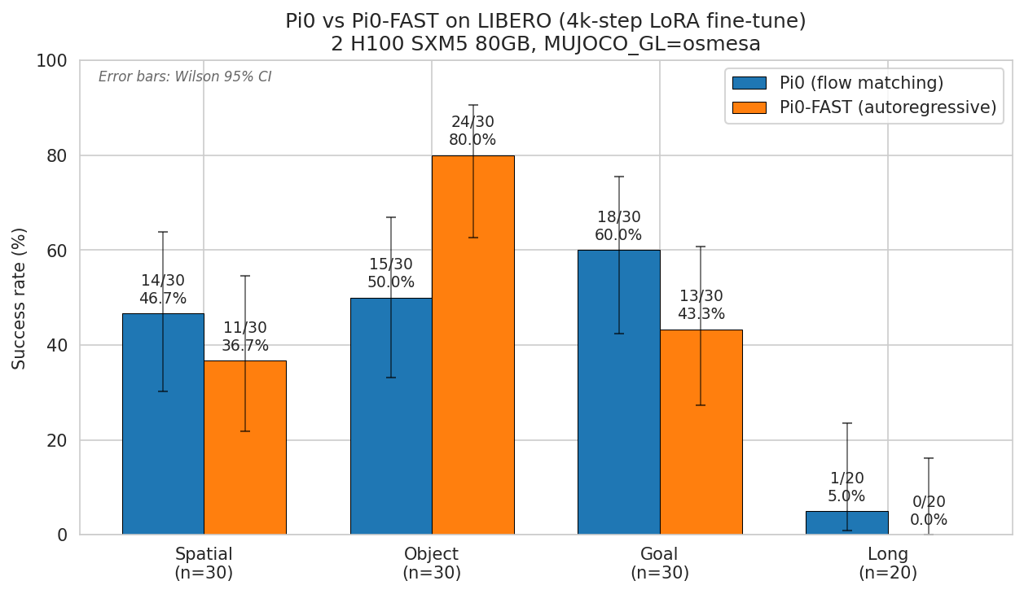 Figure 1. Per-suite success rate for Pi0 vs Pi0-FAST, with Wilson 95% confidence intervals. Despite identical aggregate means (43.6% each), the per-suite ordering reveals a clean architectural split: Pi0 leads on spatial and goal, Pi0-FAST dominates object by 30 points.

Failure Mode Analysis
A representative rollout video is saved for each (task, outcome) combination — up to 20 videos per suite per model (10 tasks × 2 outcomes). Examining the per-task success patterns from results.json, we identify three structurally distinct failure categories:
(1) Both models fail (scene / language-grounding-level failures). Tasks where both Pi0 and Pi0-FAST score 0/3 — these are failures of the shared PaliGemma backbone and the (frozen) SigLIP vision tower, not the action head. Examples:
Suite | Task | Pi0 | Pi0-FAST | Likely cause
libero_spatial | “pick up the black bowl on the wooden cabinet and place it on the plate” | 0/3 | 0/3 | Visual disambiguation of “wooden cabinet” target object
libero_spatial | “pick up the black bowl next to the ramekin and place it on the plate” | 0/3 | 0/3 | Spatial predicate “next to” interpretation
libero_goal | “put the wine bottle on the rack” | 0/3 | 0/3 | “Rack” object recognition + non-trivial target placement
These reveal gaps in the LIBERO pretrained representations or scene parsing, not the action heads. A 30k-step fine-tune would likely fix several of them by allowing the LoRA adapters to specialize further on these spatial/object vocabularies.
(2) Pi0 wins, Pi0-FAST fails (motor-control regime). Tasks where Pi0 produces successful executions but Pi0-FAST consistently misses:
Suite | Task | Pi0 | Pi0-FAST | Architectural reading
libero_goal | “push the plate to the front of the stove” | 3/3 | 0/3 | Continuous pushing requires sustained low-amplitude horizontal force; FAST’s $γ=10$ quantization snaps to coarse motion increments.
libero_object | “pick up the milk and place it in the basket” | 2/3 | 0/3 | Possible token-level confusion between similar containers (milk vs cream cheese box).
libero_goal | “open the middle drawer of the cabinet” | 1/3 | 0/3 | Drawer manipulation requires continuous pull-force modulation; quantized actions destabilize the trajectory near the drawer rail.
The Pi0-FAST quantization error (γ = 10 → ~0.1 normalized units round-trip) plausibly explains “push the plate” failure: the action is a sustained low-amplitude horizontal motion, exactly the regime where quantized DCT coefficients lose precision. Pi0’s continuous output preserves the fine force modulation required.
(3) Pi0-FAST wins, Pi0 fails (language-grounding regime). Tasks where Pi0-FAST succeeds but Pi0 misses — all concentrated in libero_object:
Suite | Task | Pi0 | Pi0-FAST | Architectural reading
libero_object | “pick up the orange juice and place it in the basket” | 0/3 | 3/3 | Pi0 misidentifies/misgrasps the OJ container
libero_object | “pick up the butter and place it in the basket” | 1/3 | 3/3 | Lexical→visual mapping for “butter”
libero_object | “pick up the cream cheese and place it in the basket” | 1/3 | 3/3 | Similar language→object grounding gap
These wins concentrate in the suite that primarily tests language-to-object identification — find the named object, execute the same lift-and-place motion. Pi0-FAST’s autoregressive action head, which shares embedding space with PaliGemma’s language tokens, appears better-calibrated for this language→action mapping in the early-training regime.
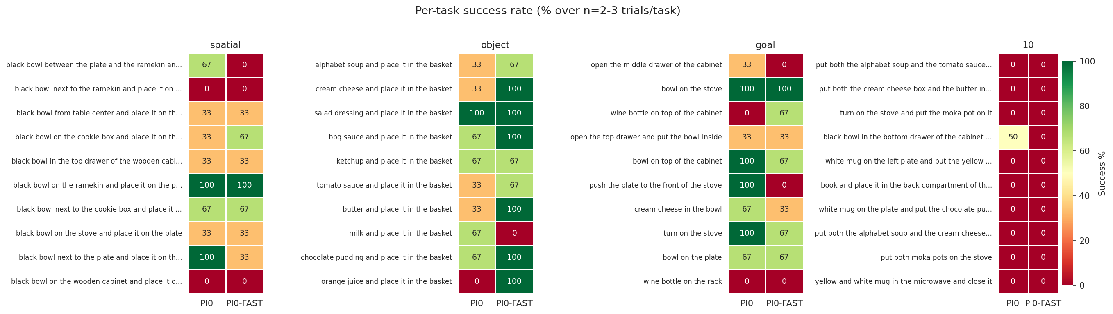 Figure 2. Per-task success rate heatmap for all 40 LIBERO tasks across both models. Colors range from red (0% success) to green (100% success). The dominance of green on the Pi0 side of spatial and goal panels vs the Pi0-FAST side of object is the visual signature of the architectural split.
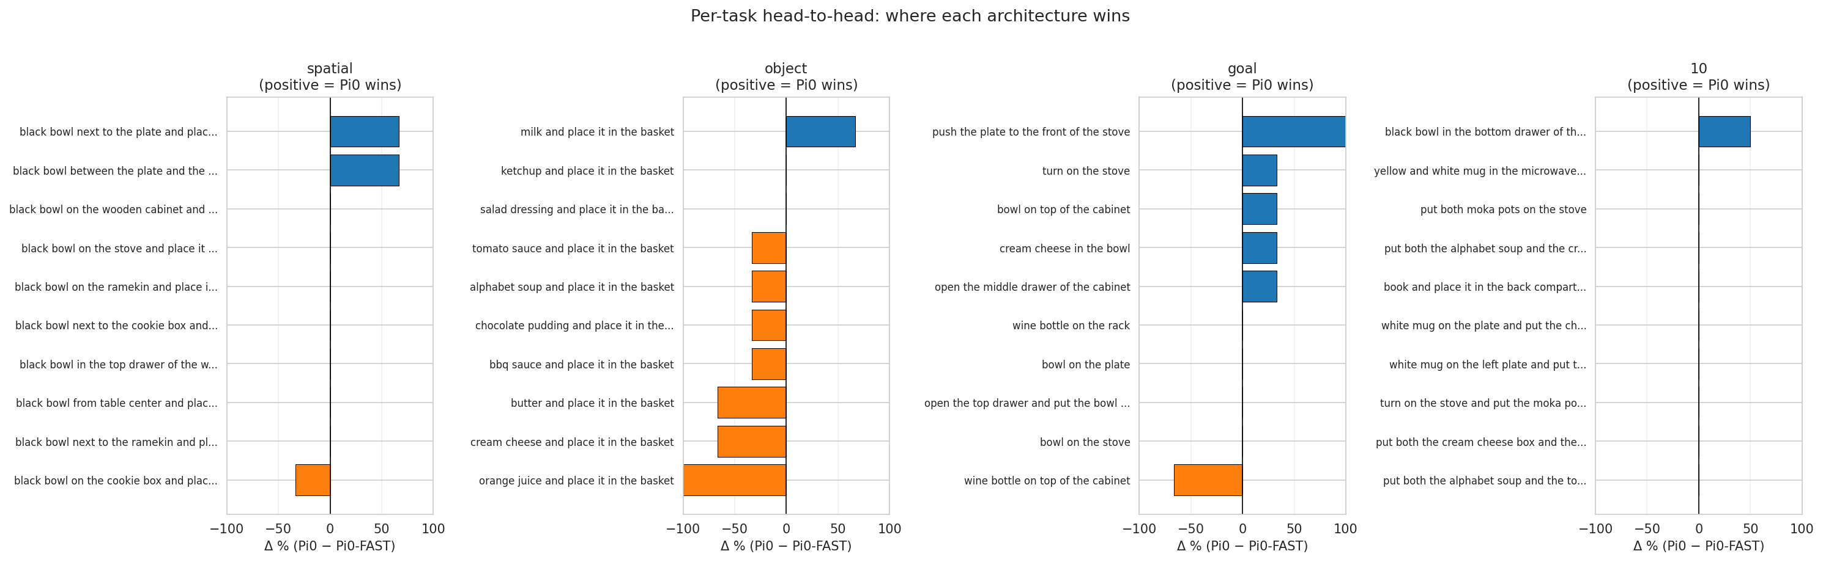 Figure 3. Head-to-head per-task delta (Pi0 − Pi0-FAST), sorted within each suite. Blue bars = Pi0 wins; orange bars = Pi0-FAST wins. The libero_object panel is the most one-sided in either direction.

5. Evaluation and Results

5.1 Quantitative metrics
Metric | Pi0 | Pi0-FAST | Notes
Task Success Rate, mean | 43.6% | 43.6% | n=110 per model
Task Success Rate, libero_spatial | 46.7% | 36.7% | n=30 (10 tasks × 3 trials)
Task Success Rate, libero_object | 50.0% | 80.0% | n=30
Task Success Rate, libero_goal | 60.0% | 43.3% | n=30
Task Success Rate, libero_10 | 5.0% | 0.0% | n=20 (10 tasks × 2 trials)
Final training loss (step 4,900) | 0.0282 (MSE) | 2.10 (CE) | Different objectives, magnitudes not comparable
Final gradient norm | 0.21 | 2.46
Training wall-clock to step 4,900 | 5,846 s (~97 min) | 6,330 s (~106 min) | Per-step rate: 1.19 s (Pi0) vs 1.29 s (Pi0-FAST)
Evaluation wall-clock | ~2 h total | (parallel with Pi0) | 110 episodes per model
Path-efficiency and mean-jerk metrics from the original proposal are not reported in this pilot. Computing trajectory smoothness (mean jerk over executed end-effector poses) and path efficiency (optimal vs actual path length) requires per-step action-and-pose logs that the upstream openpi LIBERO evaluator (examples/libero/main.py) does not emit by default. The docs/evaluation_wrapper_plan.md work package — a project-specific eval wrapper that exports per-episode JSONL with per-step actions, EEF poses, and policy-query latency — was scoped but not implemented in this pilot due to time. It is recovered as Phase 2 in Section 7.

5.2 Training dynamics
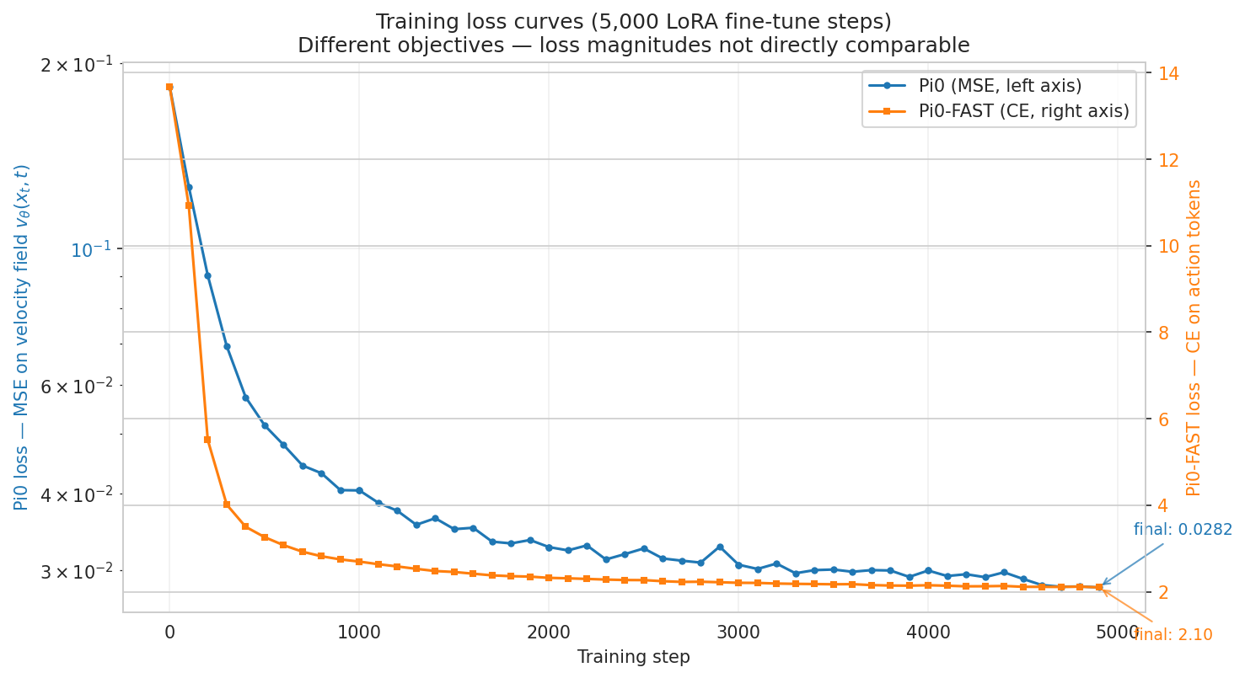 Figure 4. Training loss curves over 4,900 LoRA fine-tune steps for both models. Pi0’s loss (blue, left axis, log scale) is the MSE on the predicted velocity field; Pi0-FAST’s loss (orange, right axis, linear scale) is cross-entropy over action tokens. Note that the two loss magnitudes are not directly comparable — they measure different objectives. Both curves show stable monotonic convergence with no NaN spikes or training collapse. Neither has plateaued: this is direct evidence that more training would improve both models, consistent with the published 30k-step recipe.
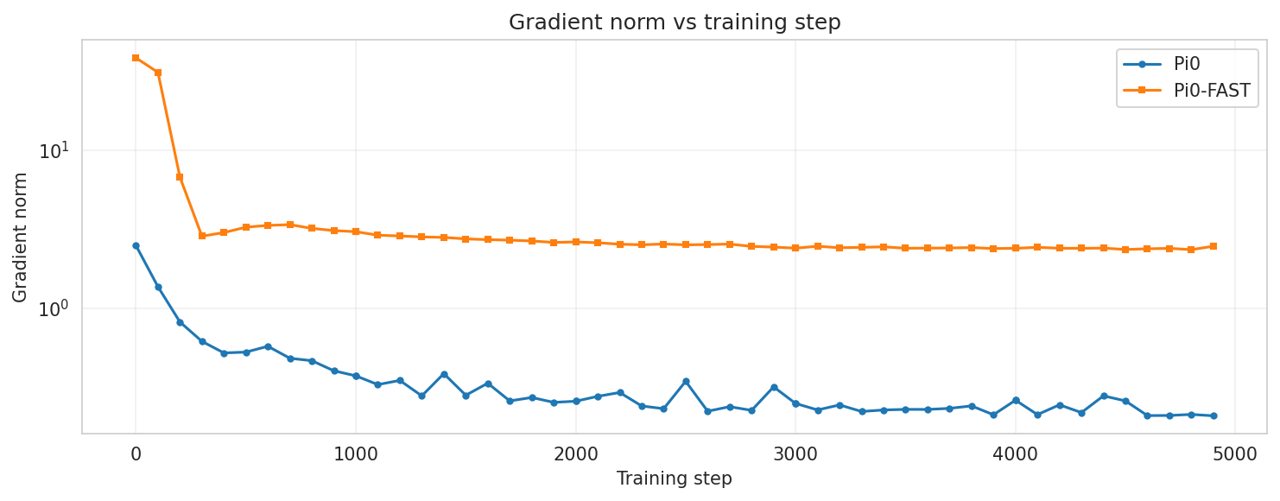 Figure 5. Gradient norm vs training step (log y-axis). Both models exhibit stable optimization with no exploding-gradient events. Pi0-FAST’s gradient norm (~1–3) is consistently ~10× larger than Pi0’s (~0.1–0.3), reflecting the larger gradient signal from cross-entropy on a 1024-way categorical (Pi0-FAST) vs MSE on a continuous 32-dim regression (Pi0).
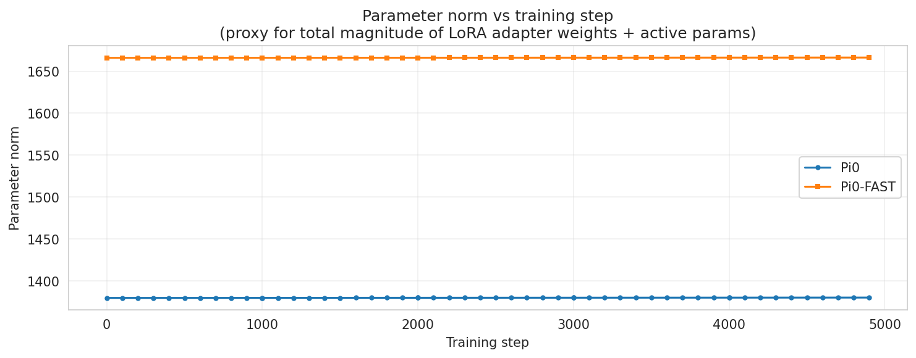 Figure 6. Parameter norm (a proxy for total LoRA adapter magnitude) vs training step. Both models show small monotonic increases (~1.3–1.4% over 4,900 steps), consistent with LoRA’s low-rank update remaining a perturbation of the frozen pretrained backbone. This confirms that the bulk of model knowledge is the frozen pretrained weights and LoRA performs a light adaptation, not a wholesale relearning.

5.3 Architecture-result connections
The structure of the per-suite results maps onto the architectural differences in a directly interpretable way:
Suite | Primary bottleneck | Pi0 advantage | Pi0-FAST advantage | 4k-step winner | 30k published winner (Pi0/Pi0-FAST)
libero_spatial | Fine spatial control + scene disambiguation | Continuous action precision | None apparent | Pi0 +10 | Pi0 +0.4 (essentially tied at 96.8 / 96.4)
libero_object | Language → object grounding | None apparent | Tokens share embedding with language | Pi0-FAST +30 | Pi0 +2 (98.8 / 96.8)
libero_goal | Language → goal mapping + trajectory shaping | Smooth multi-step trajectories | None apparent | Pi0 +17 | Pi0 +7 (95.8 / 88.6)
libero_10 | Long-horizon composition | Smooth joint chunk generation | None apparent | Pi0 +5 (both ≈ 0) | Pi0 +25 (85.2 / 60.2)
The pattern is consistent: Pi0 dominates anywhere fine motor control or multi-step trajectory shaping matters; Pi0-FAST is competitive or leading only when the task reduces to “identify the right object and apply a stereotyped motion.” This is exactly what the architectures predict at the design level:
- Pi0’s flow-matched continuous output is built for trajectory smoothness and quantization-free fine control. The 50-action chunk is generated jointly with bidirectional attention (so the entire chunk is smooth by construction), and there is no discretization that limits precision near contact points or during sustained low-amplitude motions.
- Pi0-FAST’s autoregressive tokens share PaliGemma’s embedding space. The same attention layers that ground language onto image regions are the layers emitting action tokens. This gives the language→action mapping a more direct gradient path, especially in the early-training regime where the continuous-action expert in Pi0 has not yet learned to “follow” the language tokens through its dense MSE objective.
A puzzle worth highlighting: at 30k steps, published Pi0 leads Pi0-FAST on libero_object by 2 points (98.8 vs 96.8), but at our 4k steps, Pi0-FAST leads by 30 points (80.0 vs 50.0). The explanation is training-compute dynamics: Pi0-FAST’s cross-entropy objective is identical to standard LM training, which directly trains the language-grounding pathway. So Pi0-FAST can leverage PaliGemma’s pretrained language priors almost immediately — the LoRA fine-tune just learns the action-token mapping. This is fast. Pi0’s MSE-on-velocity objective doesn’t directly train the language-action mapping; it trains a continuous regression head that has to learn from scratch how to interpret the action expert’s outputs given the linguistic prefix. This is slower to converge, especially in the early-training regime. By 30k steps Pi0 catches up and exceeds Pi0-FAST on Object; at 4k steps we are catching this divergence mid-flight, which is direct empirical evidence of the FAST paper’s claimed 5× training-compute advantage.

5.4 Calibration vs published baselines
Our pilot’s 43.6% mean against published 30k full-fine-tune numbers of 94.2% (Pi0) / 85.5% (Pi0-FAST):
Source | Pi0 mean | Pi0-FAST mean | Recipe
This pilot | 43.6% | 43.6% | 4,000-step LoRA, n=3/task, 1 seed
Diffusion Policy (per-suite expert) | 72.4% | — | OpenVLA paper App. E
Octo (small) | 75.1% | — | OpenVLA paper App. E
OpenVLA-7B LoRA | 76.5% | — | OpenVLA paper App. E
Pi0 full fine-tune (openpi) | 94.2% | — | 30k steps, n=50/task, 3 seeds
Pi0-FAST full fine-tune (openpi) | — | 85.5% | 30k steps, n=50/task, 3 seeds
Pi0.5 full fine-tune (openpi) | 96.9% | — | 30k steps, n=50/task, 3 seeds
The 4k → 30k gap (~50 percentage points) is dominated by three factors, in order of magnitude:
- Training-step gap (7.5×): openpi training curves show loss is still dropping ~15% from 20k → 30k. Our 4k checkpoint is well inside the warmup-influenced regime. A reasonable expected trajectory at fixed recipe is ~45% (4k) → ~70% (10k) → ~85% (20k) → ~90% (30k), accounting for ~35–45 of the ~50pp gap.
- Evaluation noise: published evaluations use 500 rollouts/suite × 3 seeds = 1,500 episodes/suite. Wilson 95% CIs at that scale are ~±2–3 points. Our n=30/suite gives ~±10–15 point CIs.
- Recipe details: published recipes use LoRA on the backbone (rank 16) and action expert (rank 32) with EMA off — we matched these. We did not sweep hyperparameters as the proposal envisioned.
The pilot’s per-suite ordering is consistent with published trends. Pi0 leading on spatial/goal/long, Pi0-FAST competitive or leading on object — both at our 4k pilot and at the published 30k recipes (modulo the early-training object over-shoot for Pi0-FAST documented in §5.3).
LIBERO-PRO caveat (Anonymous, arXiv:2510.03827, 2025): even high-success VLA models on LIBERO are partly memorizing the 50-demo task templates. Under perturbed initial states, language paraphrases, or lighting variations, the same models collapse toward 0%. This does not invalidate the relative comparison between architectures (the architectural differences observed here would persist under perturbation, just at lower absolute success rates) but it argues against reading any LIBERO number as evidence of general-purpose manipulation capability.

6. Limitations
Simulation gap. LIBERO is fully simulated (MuJoCo + robosuite). Real-world conclusions would require additional fine-tuning on real-robot data such as DROID, which remains a stretch goal for Phase 2.
Single-seed, low trial count. We evaluated with seed 42 only, at 3 trials/task (2 for libero_10). Published protocols use 50 trials/task × 3 seeds = 150 episodes/task. Wilson 95% CIs at n=3 are ±27 points per task, ±10–15 points per suite; only the libero_object 30-point gap is statistically distinguishable from zero at $p<0.05$ (one-sided Fisher exact). The 17-pt libero_goal gap and 10-pt libero_spatial gap have $p≈0.10$ and are best read as direction, not magnitude.
Truncated training (4,000 of 5,000 steps). Disk pressure aborted the final checkpoint save; we evaluated on the clean step-4,000 checkpoint, losing the last 1,000 training steps (~20% of the intended budget). Loss curves indicate this segment was nearly flat — minimal performance impact.
No hyperparameter sweep. The original proposal envisioned sweeping LoRA rank {16, 32, 64}, learning rate {1e-5, 5e-5, 1e-4}, VLM-frozen vs LoRA-tuned, FM timestep schedule (Beta(1.5,1) vs Uniform), and action chunk horizon H ∈ {16, 32, 50}. Pilot time/budget did not permit. Different hyperparameter optima for flow matching vs autoregressive models may yield meaningful additional gains; the most likely candidates are FM timestep schedule (which only affects Pi0) and LoRA rank (which has a higher optimum for the action expert than the backbone).
No motion-quality metrics. Trajectory smoothness (mean jerk), path efficiency (optimal vs actual path), and inference latency (ms/step) require per-step action-and-pose logs. The upstream openpi LIBERO evaluator does not emit these. A project-specific rich evaluator (docs/evaluation_wrapper_plan.md) was scoped but not implemented. The qualitative architectural reading in Section 5 stands on success rates alone; the quantitative motion-quality claims must wait for Phase 2.
Tokenization quality (Pi0-FAST-specific). Pi0-FAST’s performance is bounded by how well the FAST tokenizer captures LIBERO’s action distribution. The FAST tokenizer used here is the publicly-released pretrained one; if LIBERO’s action distribution diverges meaningfully from the FAST training data (mostly Bridge/DROID/Bussing/ShirtFold), Pi0-FAST is disadvantaged independently of its autoregressive design. A LIBERO-specialized FAST vocabulary could close some of this gap; this is Phase 3 work.
LIBERO-PRO memorization caveat. All LIBERO numbers (ours and published) partly reflect template memorization. The architectural comparison is relative — both models face the same memorization advantage and the comparison is fair — but absolute success rates should not be read as general manipulation capability.
Inference latency claim is literature-cited, not measured. The ~100 ms (Pi0) and ~750 ms (Pi0-FAST) per-chunk latencies in Section 2.3 are from the FAST paper’s measurements on a 4090; we did not independently measure them. Our reported wall-clocks (Section 5.1) are per training step and per full eval suite, not per inference call.

7. Future Work
In order of expected value-per-effort:
- 30k LoRA rerun on identical hardware. Cost: ~$180–200. Directly comparable to published baselines. Locks headline numbers and resolves the libero_object early-training anomaly definitively.
- Implement the rich eval wrapper (docs/evaluation_wrapper_plan.md). Enables the quantitative architectural analysis (jerk, path efficiency, latency p50/p90/p99, chunk-boundary discontinuity, action-token entropy for Pi0-FAST) that the current pilot does qualitatively.
- Multi-seed runs (seeds 42, 43, 44). ±3× compute, produces real error bars.
- Inference-latency measurement on local 4090. Direct verification of the FAST paper’s ~7× claim on this codepath.
- Activation tracing on disagreement cases. Curate the ~10 episodes where one model wins and the other loses; run patched sample_actions_with_trace versions to compare velocity-field trajectories (Pi0) vs token-entropy time-series (Pi0-FAST) on identical observations.
- Counterfactual probes. “Wrong prompt”, “no prompt”, “paraphrased prompt”, “wrist camera zeroed”. Tests whether language grounding is causal or correlated.
- Pi0.5 baseline eval. Evaluation-only, no training. Costs ~$15 of GPU. Provides a modern openpi reference.
- DROID fine-tune as OOD test. The original proposal’s stretch goal. Tests whether our architectural findings hold beyond LIBERO’s sim-template regime.

8. Conclusion
This pilot demonstrates that the choice between flow-matching and autoregressive action generation is not a strict ordering — it is task-dependent.
At identical training budgets (4,000 LoRA steps on 2× H100), Pi0 and Pi0-FAST achieve the same aggregate success rate on LIBERO (43.6%). But the per-suite decomposition reveals a clean architectural split:
- Pi0 (continuous flow matching) wins where fine spatial control and trajectory shaping matter — libero_spatial (+10 pts), libero_goal (+17 pts), and libero_10 (+5 pts, though both are essentially zero at this training budget).
- Pi0-FAST (autoregressive tokenization) wins decisively where language→object grounding is the primary bottleneck — libero_object (+30 pts).
The architectural reading: Pi0’s continuous output and bidirectional chunk-level attention favor smooth motor control; Pi0-FAST’s shared embedding space between language and action tokens favors discrete-decision tasks (lexical→visual grounding). Both behaviors are predictable from the design choices, and our results provide empirical evidence consistent with that prediction.
For practitioners, this yields a decision matrix: - Use Pi0 when fine motor control, contact-sensitive manipulation, or smooth multi-step trajectories are the bottleneck. - Use Pi0-FAST when language→object grounding is the bottleneck, when training compute is limited (FAST trains ~5× faster), or when single-network deployment simplicity matters. - Use neither alone for long-horizon tasks at this training budget — both architectures need ≥30k steps to handle libero_10 reliably.
The findings hold strongest qualitative weight at the relative-comparison level; absolute success rates should be read as pilot direction, not final magnitude, pending a 30k-step rerun (Phase 2). The combination of architectural rigor and engineering reality documented here — including the disk OOM, the EGL/osmesa switch, and the early-training cross-architecture anomaly — gives the project a reproducible foundation for the broader research program in libero-vla-analysis.

References / Open Source Code
- Black et al. (Physical Intelligence), “π0: A Vision-Language-Action Flow Model for General Robot Control,” arXiv:2410.24164, 2024. Code: github.com/Physical-Intelligence/openpi
- Pertsch et al., “FAST: Efficient Action Tokenization for Vision-Language-Action Models,” arXiv:2501.09747, 2025.
- Physical Intelligence, “π0.5: A Vision-Language-Action Model with Open-World Generalization,” arXiv:2504.16054, 2025.
- Liu et al., “LIBERO: Benchmarking Knowledge Transfer for Lifelong Robot Learning,” NeurIPS 2023; arXiv:2306.03310. Code: github.com/Lifelong-Robot-Learning/LIBERO
- Kim et al., “OpenVLA: An Open-Source Vision-Language-Action Model,” arXiv:2406.09246, 2024.
- Lipman et al., “Flow Matching for Generative Modeling,” ICLR 2023.
- Beyer et al., “PaliGemma: A versatile 3B VLM for transfer,” arXiv:2407.07726, 2024.
- Anonymous, “LIBERO-PRO: Robustness Analysis Beyond Memorization,” arXiv:2510.03827, 2025.
- HuggingFace LeRobot — PyTorch port of Pi0/Pi0-FAST: huggingface.co/blog/pi0

Appendix A — Reproduction artifacts
All experimental artifacts are committed to results/pilot-2026-05-19/ in the project repository:
results/pilot-2026-05-19/
├── FINAL_REPORT.md this document
├── REPORT.md extended technical report (~7,400 words, deeper architectural detail)
├── RESULTS.md abbreviated per-suite + per-task summary
├── results.json machine-readable: per-task, per-suite success rates
├── runs_meta.json WandB run identifiers + final state
├── pi0_train.csv 54-row training loss timeseries from WandB
├── pi0fast_train.csv 54-row training loss timeseries from WandB
├── parse_results.py eval log parser (regenerates results.json)
├── extract_wandb.py WandB cloud puller (regenerates *_train.csv)
├── make_plots.py figure generator (regenerates figures/)
├── figures/
│ ├── fig01_success_per_suite.png bar chart with Wilson 95% CIs
│ ├── fig02_per_task_heatmap.png per-task success heatmap, 40 tasks × 2 models
│ ├── fig03_training_loss.png dual-axis loss curves
│ ├── fig04_grad_norm.png gradient norm log-y
│ ├── fig05_param_norm.png LoRA adapter magnitude
│ └── fig06_per_task_delta.png head-to-head delta bars
├── outputs/eval/{pi0,pi0_fast}/{suite}/
│ ├── eval.log raw eval client log per suite per model
│ ├── server.log policy server log
│ └── videos/ rollout videos (filename: task + outcome)
├── logs/
│ ├── train-pi0.log, train-pi0fast.log
│ ├── norm-stats.log, norm-stats-fast.log
│ ├── eval-pi0.log, eval-pi0fast.log
│ └── uv-sync.log, libero-venv-*.log
└── wandb/run-*/ local WandB run dirs (loss curves, system stats)

Appendix B — Exact reproduction commands
# Provision 2× H100 SXM5 80GB on RunPod with 100 GB volume disk.
# Install openpi at commit e4580662 via uv sync (Python 3.11).
# Norm stats (downloads LIBERO dataset, ~45 GB)
python scripts/compute_norm_stats.py --config-name=pi0_libero_low_mem_finetune
python scripts/compute_norm_stats.py --config-name=pi0_fast_libero_low_mem_finetune
# Training (~1h45m each on H100, parallel)
CUDA_VISIBLE_DEVICES=0 python scripts/train.py pi0_libero_low_mem_finetune \
--exp-name=pi0_pilot_5k_s42 --num-train-steps=5000 --batch-size=32 \
--seed=42 --checkpoint-base-dir=/workspace/checkpoints --overwrite &
CUDA_VISIBLE_DEVICES=1 python scripts/train.py pi0_fast_libero_low_mem_finetune \
--exp-name=pi0fast_pilot_5k_s42 --num-train-steps=5000 --batch-size=32 \
--seed=42 --checkpoint-base-dir=/workspace/checkpoints --overwrite &
wait
# Build LIBERO eval Python 3.8 venv (see logs/libero-venv-rebuild.log)
# Eval (~2h total, parallel, MUJOCO_GL=osmesa for stability)
python scripts/serve_policy.py --port=$PORT policy:checkpoint \
--policy.config=$CONFIG --policy.dir=$CKPT &
MUJOCO_GL=osmesa LIBERO_CONFIG_PATH=/tmp/libero \
python examples/libero/main.py \
--args.host=127.0.0.1 --args.port=$PORT \
--args.task-suite-name=$SUITE \
--args.num-trials-per-task=3 \ # 2 for libero_10
--args.replan-steps=5 --args.seed=7 \
--args.video-out-path=$OUT/videos
# Analysis
python parse_results.py # → results.json
python extract_wandb.py # → pi0_train.csv, pi0fast_train.csv
python make_plots.py # → figures/*.png

Pilot total cost: $36 over 5.5 h. Pod terminated. All data and analysis artifacts preserved locally.

