First Council Meeting of the FAOPS for year 2025
Held on Saturday, January 18th, 2025, 11:00 AM (Korean Standard Time)
Online Meeting on Zoom

AGENDA

- Welcome Remarks: President
- Call to Order: President
- Attendance & Declaration of Quorum: Secretary General
- Approval of agenda: President
- Review of the minutes of the last Council Meeting (2024-12-21): Secretary General
- Introduction of New Executive Council and Advisory Council: President and EC & AC members.
**Instead of the President’s Report, Secretary General & Deputy Secretary Reports, self-introductions will be provided.
- Amendments of By-Laws related to structural reorganization: President
- Auditor
- Expansion and Reforming of Official Committees of FAOPS
- Nomination of candidates of Auditor and Chairpersons: President
- Reviews and Approvals for Neonatal Update & Workshop Plans: President
- Brunei (Dr. Sam Rajadurai; Immediate Past President)
- Mongolia
- Any other matters with permission from President
- Summary on Key Decisions and Next Steps: President
- Closing Remarks: President

MINUTES OF THE MEETING
- Meeting was called to order by the President Prof. HanSuk by his welcome address
- Attendance and Declaration of quorum: Sec. Gen. Prof. Milind Shah declared a quorum. There were 14 persons were present for meeting.
- Milind congratulated HanSuk for shouldering responsibility of President of FAOPS.
- The minutes of the last 6th Council Meeting on Dec 21, 2024 were read and passed. Proposed by Surantha and seconded by Sookee.
Azana asked about change in the word robust and Milind said that ethical permission is required for any research. We have put address of SG, as there is no permanent address. Sam asked whether ethics committee is must. Azana said that even single country ethics waiver is sufficient.
- New body members Jose, Azana & Suranta, gave self-introduction. Adriene was absent. Satoshi and Sookee also gave remarks. Lee & Shahidullah were absent. David and Ranjan said hello. All of them thanked HanSuk for opportunity.
- About amendments of bylaws, Sookee said we need to approve first committees. Sam proposed and HanSuk seconded.
Sookee presented amendments.
By-Law XV (Composition of the council)
- Advisory Council (AC)
- All Past Presidents shall be eligible to participate in this Council. However, an expression of interest and commitment to participate in the executive Council Meeting will be requested of them every two years and (re)confirmed during each General assembly meeting. They will not have voting rights during the executive Council Meeting.
- Auditor
- The position is upon the recommendation of the President and supported by the AC.
- Apart from being a Past President, he/she has demonstrated expertise in financial or operational oversight. A formal auditing experience in the local society is preferred but not compulsory.
- Duties and responsibilities of the auditor:
c.1 Conduct financial audits to ensure accuracy and transparency in financial management
c.2 Perform operational audits to assess compliance with organizational goals, Constitution, By-Laws, governance practices, and applicable regulations.
c.3 Report audit findings to the General Assembly and the Council annually.

________________________________________________________________________________

By-Law XXII Official Committees of the Federation
1. Official Committees of the Federation will be approved by the General Assembly for the purpose of study or implementation of various programs according to the aims and objectives of the Federation. These are:
a. Committee on Research & Projects
b. Committee on Training & Education
c. Committee on Communications & Public Relations
d. Committee on International Collaboration
e. Committee on Philanthropy & Advocacy
f. Committee on Legislation & Elections By-Law XV (Composition of the council )
B. Advisory Council (AC)
1. All Past Presidents shall be eligible to participate in this Council. However, an expression of interest and commitment to participate in the executive Council Meeting will be requested of them every two years and (re)confirmed during each General assembly meeting. They will not have voting rights during the executive Council Meeting.
2. Auditor
a) The position is upon the recommendation of the President and supported by the AC.
b) Apart from being a Past President, he/she has demonstrated expertise in financial or operational oversight. A formal auditing experience in the local society is preferred but not compulsory.
c) Duties and responsibilities of the auditor:
c.1 Conduct financial audits to ensure accuracy and transparency in financial management
c.2 Perform operational audits to assess compliance with organizational goals, Constitution, By-Laws, governance practices, and applicable regulations.
c.3 Report audit findings to the General Assembly and the Council annually.

________________________________________________________________________________

By-Law XXII Official Committees of the Federation
1. Official Committees of the Federation will be approved by the General Assembly for the purpose of study or implementation of various programs according to the aims and objectives of the Federation. These are:
a. Committee on Research & Projects
b. Committee on Training & Education
c. Committee on Communications & Public Relations
d. Committee on International Collaboration
e. Committee on Philanthropy & Advocacy
f. Committee on Legislation & Elections
- Except for the Committee on Legislation & Elections, which shall be chaired by a Past President, the various Committees will be chaired by a member country representative to the Federation & duly appointed by the Executive Council. He/She shall have participated actively, at least in the sub-regional activities of the FAOPS to which his /her country belongs, and shall have demonstrated administrative and technical capability in the conduct of small projects, lecture/workshops and other endeavors in his sub region of the FAOPS. A member of the Advisory Council shall be chosen by the Committee Chair to serve as Committee Adviser.

- The composition of the Committee will be determined by the Chairman in consultation with its Adviser, the President and the Secretary General.

- Duties & responsibilities of the Chairman of the Committee shall be as follows:
- Directs all activities relating to the goals and objectives of the Committee.
- Convenes meetings of the Committee for that purpose.
- Submit annual reports to the Council and General Assembly.
- Obtain funds for its purposes from available sources; however, such funds shall be kept in the Federation accounts.
- Disbursement of funds collected by the committee shall require the concurrence of the President and Treasurer.
- Submits an annual Financial Report to the Council and to the General Assembly.

5. Functions of Each Committee

a. Committee on Research & Projects
a.1 Foster impactful research and facilitate collaborations with global organizations.
a.2 Manage research funding and mentorship programs.
a.3 Disseminate research outcomes through academic events and publications.

b. Committee on Training & Education
b.1 Organize workshops, webinars, and conferences.
b.2 Develop educational resources tailored to the needs of member countries.

c. Committee on Communications & Public Relations
c.1 Manage FAOPS’s communications, media outreach, and event marketing.
c.2 Enhance FAOPS’s visibility through centralized public relations efforts.

d. Committee on International Collaboration
d.1 Build partnerships with global organizations and member countries.
d.2 Represent FAOPS in international forums and collaborative projects.

e. Committee on Philanthropy & Advocacy
e.1 Lead fundraising efforts and secure grants or donations.
e.2 Advocate for healthcare equity and access.
e.3 Promote awareness of sustainable development goals (SDGs).

f. Committee on Legislation & Elections
f.1 Ensure transparent election processes.
f.2 Review and update FAOPS bylaws.
f.3 Propose governance reforms for organizational improvement.

Lot of discussion on it again by Ranjan & Suranta. Auditor will be for 2 years and he will be inside the council. Milind said that he would be in expanded council and not in executive council. Point raised by Sam of not to have treasurer and auditor from same country was cancelled by entire council.
7. After that Nominations of candidates of Auditor & Chairpersons were declared by HanSuk.

Auditor: Dr. Satoshi Kusuda (Japan)
Legislation & Elections: Dr. Socorro De Leon-Mendoza (Philippines)
Research & Projects: Dr. KH Tan (Singapore)
Training & Education: Dr. Tetsuya Isayama (Japan)
Communications & Public Relations: Dr. Sunil Manandhar (Nepal)
International Collaboration: Dr. Ochie Mariano (Philippines)
Philanthropy & Advocacy: Dr. Miranda Davies (Australia)

There was lot of discussion almost for 30 minutes on it by Sookee, Ranjan, and Shahidullah. Finally it was concluded by Milind that already these names are declared and we will take these suggestions in future. Milind suggested to increase committees to accommodate more people but which was not accepted by council.

8. After this Mongolia workshop was presented by HanSuk with tentative program.
Process progress report:
- The formal request to hold a workshop was submitted to the FAOPS Secretariat by the Mongolian Perinatal Society.
-Dep Sec Gen-East and the Secretary General reviewed and validated its feasibility.
-Council Approval was then requested
Title: FAOPS REGIONAL WORKSHOP in Mongolia
Topic: "Preterm Newborn Care: Best Practices for Management and Prevention of Prematurity"
Date: 26th to 27th June 2025
Venue: Conference hall of the MOH, Ulaanbaatar, Mongolia
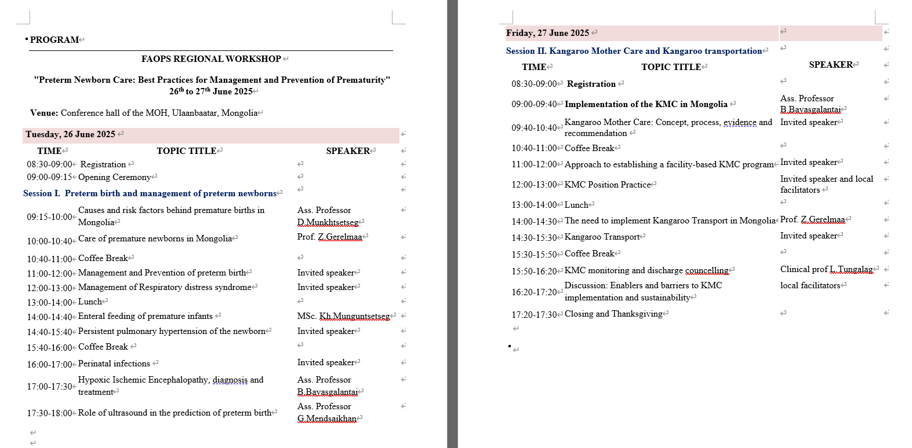
This workshop was approved unanimously.
About Brunei, Sam told that he had presented program. However, HanSuk said that workshop need to be done by member countries.
Suggestions;
- Recommend that Brunei formally join FAOPS before the workshop
- Ask the Deputy Secretary General for the Central Region to review regarding the suitability of program of the workshop of Brunei
He presented bylaws related to that.
By-Law XXI Country symposia/workshop
- The Federation (FAOPS) symposium in a perinatal society meeting hosted by the member countries is encouraged.
2. The Federation shall not support the symposium financially; however, it shall cover the travel of 2-3 resource speakers from the Federation as the host country may request.
3. The host country has the right to moderate the symposium and accept not only domestic participants but also international participants from all membership countries.
4. The Federation shall support skills workshops held by the member country at each of the four (4) regions between the official Federation congresses with the payment of US$2,500.
→Consideration of the necessity of setting the duration to two years, taking financial factors into account.

Sam gave example of Cambodia, Afghanistan and Myanmar where workshops were sanctioned for countries likely to join FAOPS.
Sam said that Sookee would put all these points in order, as it requires lot of amendments. HanSuk said that should we abide with present bylaws and ask Brunei to join first FAOPS. Sam said no, it will be difficult to do so and will lose credibility of FAOPS. Ranjan said that let HanSuk decide according to his thinking and by laws and Sookee will support him. HanSuk and Satoshi said we will have to abide bylaws but should consider potential member countries to increase members. This requires approval of council to overrule bylaws. HanSuk said I have already declared it in AGM and someone may ask about it. Satoshi said that council could decide it. Azana said that we should keep promise but also abide bylaws. With all these ambiguity, Brunei was cancelled. Sam said that I have not promised about money but promised for speakers from FAOPS and their expenses for travel and stay. He said that we did it about Cambodia. Mamoru said that we cannot send money by overruling bylaws, as Japanese bank are very strict now. Sookee said that we should abide bylaws. She said we would put this for amendments of bylaws. Ranjan opined that if Japanese Bank is creating so much problem we should change bank. Hansuk said that we cannot discuss it now for want of time. Milind said that we should not waste time in discussion and better to put it immediately for amendments in General body. Satoshi said that when he was treasurer ban use to ask purpose for transfer of money but never asked for bylaws. However, if it is asking now we should abide bylaws. David also concurred on changing bylaws. Hansuk said we should do Brunei workshop as it is already approved by council. Milind explained about Afghanistan that it is country with maximum perinatal mortality and we decided to do change it with support from sitting President Sookee that time.
Satoshi opened topic of associate membership of Thailand and Milind cleared that there are no fees for associate membership. He said that there was no mail from Thailand, neither Satoshi received it.
Ranjan put a point in any other business that we should restrict time constraint for meeting to 2 hours, which was well accepted by all.
HanSuk summarized all these points and asked Sookee was asked to do the needful.

9. Meeting closed after offering vote of thanks by HanSuk & Milind.

Prepared by:

Prof. Milind Shah
Prof. HanSuk

