MoM of First FAOPS Council Meeting 2024
Date& Time: Saturday, January 20, 2024, 10:00 (Singapore Standard Time, SST)

Online Zoom Meeting (ID 875 1282 1780, PW: 123)
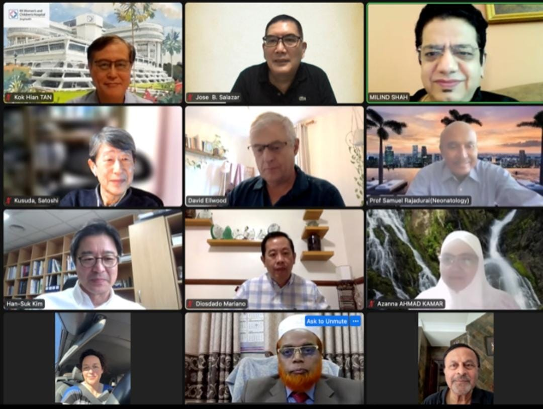

AGENDA
1 Call to order
2. Attendance and declaration of quorum
3. Approval of Agenda
4. Review and approval of minutes from the last council meeting held on 07.10.23.
5. Review of AGM held on 08.10.23.
6. Rules and regulations regarding approval and implementation of FAOPS Funded Workshops – by Ranjan Pejaver
7. Officer Reports
-Treasurer
-Secretary
-President
8. Approval for support for the APMCH Conference & IPRAMHO International Meeting 2024 as nominal sponsor by FAOPS
9. Deputy Secretary General, Committee Chairperson and Advisor comments and proposals
10. FAOPS Congress 2023, 2024 and 2025 updates
11. Discussion on New proposals & New Chapters
12. Any other matter with permission of chair

MINUTES OF THE MEETING
- Call to order: SST 10:00 hr by the President Prof. Victor Sam Rajadurai.
- Attendance and Declaration of quorum: Sec. Gen. Prof. Milind Shah declared a quorum. (10 countries were present).
- All participants approved agenda. Proposed by Prof. Ranjan & Seconded by Prof. Shahidullah
- Minutes of last Council meeting held on 07.10.2023 were reviewed and approved. Proposed by Prof. Mannan and seconded by Prof. Han-Suk
- Minutes of last AGM held on 08.10.2023 were reviewd and decided to be passed in next AGM.
Results of election held for Annual Congress of FAOPS to be held in year 2026 were discussed. As number of votes were equal for Australia & Taiwan, it was unanimously decided that 2026 congress will be hosted by PSANZ and Taiwan Perinatal Society, which was agreed by AGM, will host 2027.
- Rules and regulations regarding approval and implementation of FAOPS Funded Workshops – by Ranjan Pejaver
- Officer Reports
-Treasurer
-Secretary
-President
- Approval for support for the APMCH Conference & IPRAMHO International Meeting 2024 as nominal sponsor by FAOPS
- Deputy Secretary General, Committee Chairperson and Advisor comments and proposals
- FAOPS Congress 2023, 2024 and 2025 updates
- Discussion on New proposals & New Chapters
- Any other matter with permission of chair
- Meeting closed after offering vote of thanks by Sam & Milind.

Prepared by:

Prof. Milind Shah
Prof. Victor Sam Rajadurai

