MoM of Second FAOPS Council Meeting2024
Date& Time:Saturday, May11, 2024, 10:00 (Singapore Standard Time, SST)

Online Zoom Meeting (ID 840 8323 1780, PW: 123)
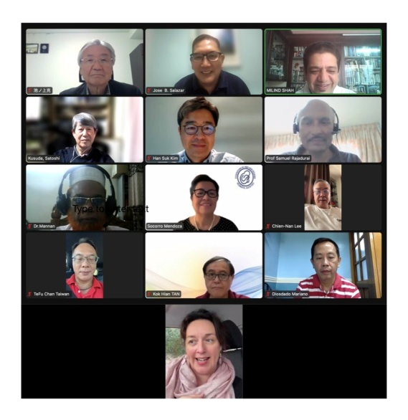

AGENDA
1. Call to order
2. Attendance and declaration of quorum
3. Approval of Agenda
4. Review and approval of minutes from the last council meeting held on 20.01.24.
5. Officer Reports
-Treasurer
-Secretary
-President
6. Discussion on changing account of FAOPS from Japan to other country.
7. Deputy Secretary General, Committee Chairperson and Advisor comments and proposals
8. FAOPS Congress 2023, 2024 and 2025 updates
9. Discussion on New proposals & New Chapters
10. Any other matter with permission of chair

MINUTES OF THE MEETING
- Call to order: SST 10:00hr. by the President Prof. Victor Sam Rajadurai.
- Attendance and Declaration of quorum: Sec. Gen. Prof. Milind Shah declared a quorum. (Eight countries were present).
- Prof. Sam suggested few changes in agenda. Item no. 8 was shifted to item number 5. Item number 6 was added as Discussion on inclusion of Thailand as associate member country.
- So new agenda was
1. Call to order
2. Attendance and declaration of quorum
3. Approval of Agenda
4. Review and approval of minutes from the last council meeting held on 20.01.24.
5. FAOPS Congress 2023, 2024 and 2025 updatesand report of PSANZ Annual congress.
6. Discussion on rejuvenation of Thailand as associate member.
7. Officer Reports
-Treasurer
-Secretary
-President
8. Discussion on changing account of FAOPS from Japan to other country.
9. Deputy Secretary General, Committee Chairperson and Advisor comments and proposals
10. Discussion on New proposals & New Chapters
11. Any other matter with permission of chair

- All participants approved revised agenda. Proposed by Prof. Sookee & Seconded by Prof. Mannan.
- Prof. Sam gave welcome note to all. He narrated about his illness of COVID infection and its consequences. He also acknowledged about Milind attended Bangla Desh Perinatal Society congress in person and efforts by Prof. Mannan & Prof. Shahidullah, who are also present today for meeting.
- Minutes of last Council meeting held on 20.01.2024were reviewed and approved. Proposed by Prof. Shahidullahand seconded by Prof. Mannan.
Sam told to add appreciation of Taiwan for accepting adjustments of Annual Congress. Milind also added to appreciate efforts by Satoshi for conducting election. Sam told that we should have better system to avoid problems in election system. Satoshi asked to change photo, which was old photo. Prof. Jose will give new picture. Prof. Sookee said she needed to leave early and her picture is not there. Jose said we would take picture now itself to avoid missing people in picture.
- Officer Reports
-Treasurer - Mamoru could not attend the meeting but sent his report, which was presented.

2023-2024 Balance Sheet
FAOPS at 2024-5-11
(Feb 23, 2023~May 1, 2024)
Current FAOPS bank deposit accounts are created in Japanese yen according to Japanese law, and the total amount in dollar terms is decreasing with the rapid depreciation of the yen.
We may need to consider moving our bank account to the other country.
2023/3 $1 = 135.20 yen
2024/5 $1 = 157 yen

Current asset
Cash in bank-ordinary deposit (Mizuho Bank in JPY) ¥16,440,483
USD 104,716.452
(1 USD = 157 JPY 2024/5/1)

Deposit
Total USD 105,465.452

-FAOPS 2023 fee from Japan USD 5,000.00

-Membership fee (total) USD 7,108.00
*(2023.24)Mangolia,Malaysia, Pakistan, Phillipines, Bangala Desh, Taiwan, Japan, Indonesia, Cambodia, Korea
Srilanka exempted
Thailand, Vietnam and UAE have not paid the deposit since 2017
Our e-mail contact with UAE has been lost.

-Interest USD 0.74
Withdrawal
Total USD 749
-Website package (Subhadram Infotech: website package) 749 USD

Milind said that he would convey him to raise invoices for coming 2 years. Satoshi confirmed it. Milind conveyed that we lost almost 14629 USD due to devaluation of Yen from Octo 23. Again discussion about changing account to some other country. Milind told that we had discussed it to Malaysia and waiting for Azania's comment on it. About Dubai, Milind mentioned that it is not practical as there is no focal person in UAE. Sookee said in Phillipines, Dolor only account can be opened. Azana said that better to register or organization at some country and shared position about various banks in Malaysia. She needs to have some time to find out all charges related to opening dolor only account in Malaysia.She said about agents who support such account opening sure about it. Milind gave his experience of India. HanSuk told that he is not very sure about situation in Korea. Sookee said that when account was in Korea, it was on his name rather than on the name of FAOPS. Satoshi gave his experience 10 years before which was dolor only account in those days but again it was on his name. Sam finally said that better to have account on FAOPS name rather than on individual name. Because if anything happens to that person, it will be difficult situation. Sam asked about opinion of Australia. Adriane told that account is always on the name of organization. Sam told that it would be 10% tax deduction if it werenonresidential account. Sam finally told that we would keep account in Japan itself to avoid permanent loss. Sookee said that we need to work on it fast to avoid losing money. Mariano said that he would look into requirements for opening account in Phillipines. Adriane gave her experience of International SB association. Azana showed links about various banks.
Shahidullah said that all these discussion need to be noted in minutes.
Mamoru entered meeting at this moment and Milind asked him to ask current situation in Japan. Mamoru said that it is not possible to open account in dollars. Sam said that do not convert this money at present, as it will be permanent loss. Milind said that all these inputs need to be time bound. Sam said one month from now. Prof. Ikenou gave his comments that it is unfortunate for FAOPS but beyond our control.
-Secretary - Milind gave report of three points. First point on website development. He said that Mariano also got connected with vendor now and his committee is doing needful. Secondly, he said about participation of FAOPS in Bangla Desh perinatal Society. He said that he and Mamoru went physically and Sam came online. Thirdly, he requested everyone to send reports in time to be included in minutes.
-President - He congratulated Mamoru for conducting annual conference in Japan. He said that we got a wonderful team for FAOPS. He also updated on including Brunei in FAOPS. He also asked everyone to keep eye to include more countries for improving perinatal health. He also gave example of Laos.
- FAOPS Congress 2023, 2024 and 2025 updates
2023: Mamoru updated that it was almost 602 delegates in Japan for FAOPS 2023. Detail report available on website.
2024: Han Suk presented his slide of FAOPS 2024 congress. He gave all details of registration of congress, abstracts that are almost 188. He said that almost 75% abstracts from paediatric departments. He gave review of scientific program.
Mannan asked whether few papers could be added. Hansuk said that it is already full but there is room for posters available.HanSuk said that about 75% registrations are from pediatricians and 25% from OBGYNs. Milind informed everyone that because just recently there was AOFOG congress in Busan, South Korea when many OBGYNs travelled to South Korea. Sam congratulated HanSuk saying that in spite of junior doctors strike team is putting efforts. He requested everyone to disseminate information of FAOPS 2024 to all members. Milind suggested about WhatsApp flyer, which reaches many people.
HanSuk asked about election to be held in coming AGM in Seoul. Milind suggested option of hybrid meeting so everyone can participate.
2025: HanSuk asked how to involve Nepal in council meeting to present report. Sam suggested we should invite them in next council meeting to present report. Milind updated council that preparation in Nepal is going on.
2026: Adriane said that yet committee is not formed and may be in second half of this year further progress will happen. She also asked opinion about keeping it for 4 days conference. Sam suggested that it would be better to keep it for 4 days. He also shared wonderful memories of last congress in Perth. Sookee suggested we could segregate scientific program in 3 days and other activities for 1 day. Adriane also gave verbal report of annual congress held at Christ Church and said that she will email report to council members.
Mariano said that he is traveling to San Francisco where he can disseminate flyers of these congresses.
- Discussion on adding Thailand as associate member to FAOPS. HanSuk and Sookee said that Thailand is already member but became inactive now. HanSuk said that country could pay 2 years fees and become member again. Satoshi told that it is true that Thailand was active member but due to some misunderstanding lost its involvement. He said that it is Neonatal Society and not Perinatal Society and so can become associate member. Sam said that if its associate member, no fees as per constitution, which we can change. Milind said we had discussion in past on taking two societies from one country which is not allowed. Sookee said that it is not as per constitution. Sam asked Milind for how many years Thailand is not active. Milind said that from 2016. Sam said that then we could suspend them and include Neonatal Society as associate member with some fees. Jose commented in favor of including Perinatal Society by requesting them once again and then take a call. Sam said that there was some conflict between Perinatal Society and Neonatal Society and which is difficult to intervene for FAOPS as an organization. Sam gave experience of Cambodiawith similar controversy, which he had resolved with good discussion. Therefore, it can be applied to Thailand. Sookee gave her vote to suspend Thailand Perinatal Society but had some concern on including Neonatal Society. Milind gave his experience resolving this issue in Pakistan by contacting Lubna Hassan and now Pakistan is active member. Milind asked whether we should ask opinion of Legislation committee on it. Han Suk asked to share constitution, which Sookee shared it. It read that it can be individual members and not as a member country. Sam said that if its law, we will abide with it and take decision later. Satoshi feels that we should use this opportunity to include them temporarily and it is not disobeying law if we read 1B in article article 4 membership. Sam said that let us discuss it on email. Sam said that let us suspend Thailand Perinatal and include Neonatal Society as associate member. HanSuk also agreed to include Neonatal Society as associate member.So finally Sam told that let us conclude now by temporarily suspend Thailand perinatal society and include Thailand Neonatal Society as associate member.
- Deputy Secretary General, Committee Chairperson and Advisor comments and proposals. - Mannan presented report of Annual Congress of BPS. Tan Kok Hian Tan presented report of IHPRO meeting. He also told about nutritional guidelines and uterine transplants. Jose told about PSP meetings. Mariano told about website development. Sam asked for deadline. Milind told it is already active; we need to add few items may be in coming 1 months.
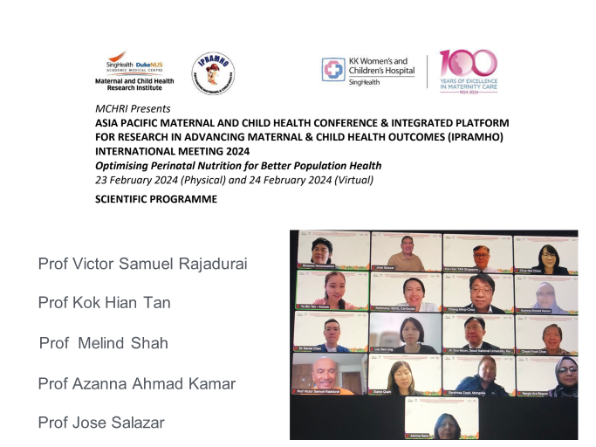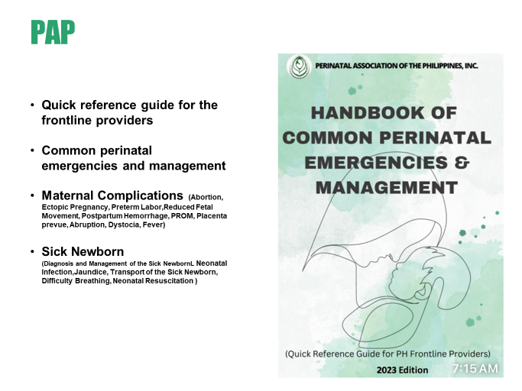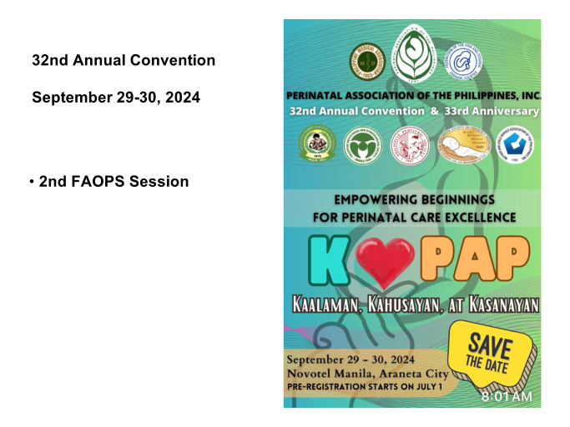
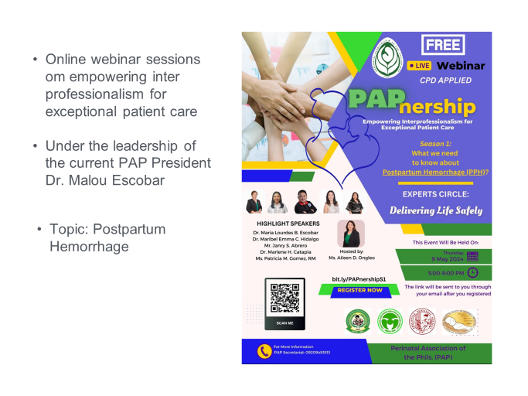
- Discussion on New proposals & New Chapters - Nothing on this.
- Any other matter with permission of chair - Milind told one point that there is mail from WAPM to offer three free registrations for coming WCPM for developing region. He requested everyone to convey their interest by email and Sam, HanSuk & Milind will choose three out of them.
- Meeting closed after offering vote of thanks by Sam & Milind.

Prepared by:

Prof. Milind Shah
Prof. Victor Sam Rajadurai

