2nd Council Meeting of the FAOPS for year 2025
Held on Saturday, April 26th, 2025, 11:00 AM (Korean Standard Time)
Online Meeting on Zoom
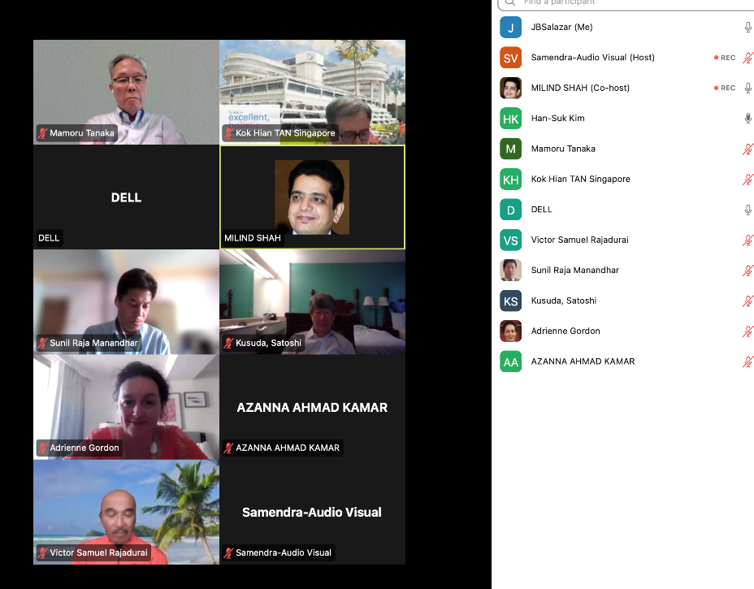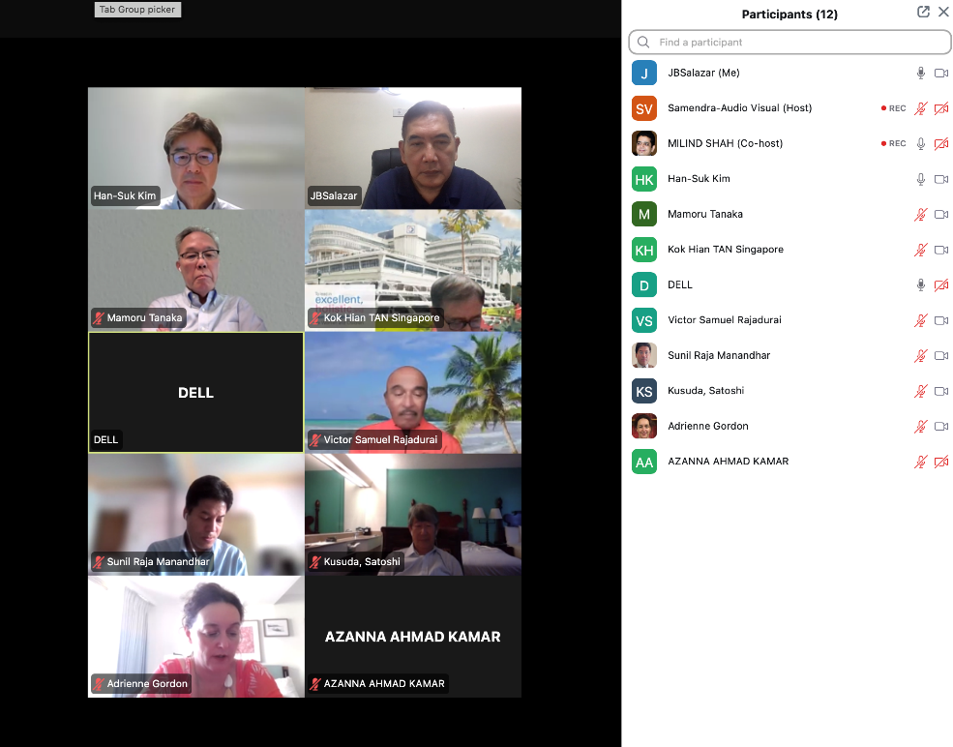

Agenda

- Welcome Remarks: President
- Call to Order: President
- Attendance & Declaration of Quorum: Secretary General
- Approval of agenda: President
- Review of the minutes of the last Council Meeting (2025-01-18): Secretary General
- Treasurer’s report
- Transfer to a USD account (Auditor& Treasurer)
- Secretary General’s report
- President’s report
- Introduction of Auditor and Chairpersons: President
- Roles and annual plans of committees
- Regional activity reports: Deputy Secretary Generals
- Workshops in Brunei and Mongolia
- Revision of By-Law XXI (Country symposia/workshop): Committee chair of Legislations and Election)
- Updates of incoming FAOPS congresses
- Nepal (2025)
- Australia (2026)
- Any other matters with permission from President
- Summary on Key Decisions and Next Steps: President
- Closing Remarks: President
MINUTES OF THE MEETING
- Meeting was called to order by the President Prof. HanSuk by his welcome address
- Attendance and Declaration of quorum: Sec. Gen. Prof. Milind Shah declared a quorum. There were 14 persons were present for meeting.
- Agenda was approved by Jose & seconded by Sam
- The minutes of the last first Council Meeting on 18.1.2025, were read and passed. Proposed by Sookee and seconded by Suranta.
- Treasurer report was presented by Mamoru
(Feb 23, 2023~Apr 22, 2025)
Remarks:
1, I made New FAOPS account in USD in Japanese Bank
2．The loss on the yen-denominated account over the two-year period is currently about $3,345.
3 I need to charge the FAOPS membership fee (2025-2026) and I need you to decide whether to continue the Japanese Yen account or switch to a US Dollar account.
2023/3 $1 = 135 yen 2024/5 $1 = 155 yen 2025/3 $1 = 147 yen
2025/4 $1 = 141 yen
Current asset
Cash in bank-ordinary deposit (Mizuho Bank in JPY) ¥ 17,389,070
= USD 123,326.7
(1 USD = 141 JPY 2025/04/21)
Deposit
Total USD 128,951
-FAOPS 2024 fee from Korea USD 5,000.00
-Membership fee (total) *(2023.24) USD 9,662.00
Received from: Mongolia, Malaysia, Pakistan, Philippines, Bangla Desh, Taiwan, Japan, Indonesia, Cambodia, Korea､ＡＮＺ, Singapore, India, Nepal
Not yet: Afghanistan
Srilanka exempted until 2024
Thailand, Vietnam and UAE have not paid the deposit since 2017
Our e-mail contact with UAE has been lost.
Withdrawal
Total USD 1,843
Website package (Subhadram Infotech: website package) 700 USD
Website maintenance 370 USD
ZOOM setting 675 USD
Charge 285 USD
Discussion: Milind asked Mamoru about in Japan as there was no provision to open account in USD in past account was opened in Yen, but now Bank permitted to open or convert it in Doller only account. Mamoru replied affirmative. Satoshi also confirmed that. Milind said as Yen has improved we could regain at least few lost dollars though not completely because of difference of 145 to 135. It was decided finally to keep account in Japan itself. Milind asked about conversion fees from Yen account to Doller account. For that, Mamoru said there would be conversion fees but it is not very large amount. Mamoru said that he would check and revert. HanSuk and Satoshi said that we should not delay, as there is fear of losing money again. Mamoru mentioned about fluctuation in rate of Yen. It was decided to do it in next week. Mamoru said then should he reconfirm on coming Monday. Han suk said that he could email it to HanSuk or Milind. HanSuk concluded that if rate is 145 or around go ahead in capacity of Treasurer & Auditor.

8. In Secretary's report Milind conveyed about WAPM congress and FAOPS session in it. WAPM got postponed and so no decision on session from WAPM. He emphasized on request to all members to send reports well in advance to office to compile it properly.

9. In President's report, he mentioned about abiding bylaws and role of auditor in implementation.
Auditor
- The position is upon the recommendation of the President and supported by the AC.
- Apart from being a Past President, he/she has demonstrated expertise in financial or operational oversight. A formal auditing experience in the local society is preferred but not compulsory.
- Duties and responsibilities of the auditor:
C.1 Conduct financial audits to ensure accuracy and transparency in financial management
C.2 Perform operational audits to assess compliance with organizational goals, Constitution, By-Laws, governance practices, and applicable regulations.
C.3 Report audit findings to the General Assembly and the Council annually.

10. KH Tan presented his report of his committee on Research & Projects
K H Tan presented his report

Committee Functions
- Foster impactful research and facilitate collaborations with global organizations.
- Manage research funding and mentorship programs.
- Disseminate research outcomes through academic events and publications.

Initial Activities
- To identify members of the committee from each region (please email me tan.kok.hian@singhealth.com.sg and gmstankh@nus.edu.sg their names & contacts)
-To hold regular meetings on FAOPS research and projects thru zoom and in FAOPS conferences
- Assess Research Perspectives and Needs Assessment survey.
Next Steps (6-12 Months)
- Launch a perspective and analyze survey results or perhaps draft "FAOPS Research Priorities 2025- 2028" brief insight on needs and perspectives
- Work on mentorship, research collaborations, and Grant.
- Ride on IPRAMHO Singapore, which has an Asia Pacific network and yearly virtual conference to promote collaboration, which FAOPS has been involved as a major partner for the last 4 years.

IPRAMHO stands for the Integrated Platform for Research in Advancing Maternal & Child Health Outcomes. This initiative, started in 2017, originally focused on metabolic health, has expanded to address broader issues such as mental health & maternal and childcare. It is a key programme under the SingHealth Duke-NUS Maternal and Child Health Research Institute (MCHRI), supported by the National Medical Research Council (NMRC) and involves collaboration among KK Women’s and Children’s Hospital (KKH), SingHealth Polyclinics, and National Healthcare Group Polyclinics. ​
Currently FAOPS is involved in the sexual health Asia pacific consensus recently this year and regional survey on sexual health. https://www.perinatal.sg/ipramho/
-Asia Pacific Consensus on Sexual Health for Women of Reproductive Age
-ECOS Form Ref: 2025-0147-APP1 Study Title: Asia Pacific Female Sexual Health Surveys in Women of Reproductive Age and Healthcare Professionals (ASH-Women and ASH-HCP) PI/Site-PI: Prof Tan Kok Hian (KK Women's and Children's Hospital)
IRB: SingHealth CIRB-Board D
Milind & Mariano attended it
Next year the theme and collaborative survey on preterm births.
He asked few names for his committee as members.
Adriane shared few links in chat about research activities.
Links given by Adrienne at meeting - to link with this group ARPAN – Accelerating Research and Progression maternal And Newborn health https://www.arpancre.org.au/
They manage this platform which includes many FAOPS countries Home - WHO - Global Maternal Platform https://gmp.srhr.org/

Challenges and Support Needed
- Research infrastructure varies across countries.
- Need funding for grants and activities.
- Council support for engagement and visibility.
- The Research Committee is committed to advancing perinatal research excellence.
- Seeking FAOPS Council continued support.

Sookee presented report of her committee on Legislation.
By-Law XXI Country symposia/workshop
1. The Federation (FAOPS) symposium in a perinatal society meeting hosted by the
member countries is encouraged.
2. The Federation shall not support the symposium financially; however, it shall cover the travel of 2- 3 resource speakers from the Federation as the host country may request.
3. The host country has the right to moderate the symposium and accept not only
domestic participants but also international participants from all membership countries.
4. The Federation shall support skills workshops held by the member country at each of
the four (4) regions between the official Federation congresses with the payment of
US$2,500.
She needs to request amendments to me to include in minutes.
Han Suk said that it would be passed in AGM so asked Sookee to just read it.
Hansuk presented as a case study about Mongolia's workshop.
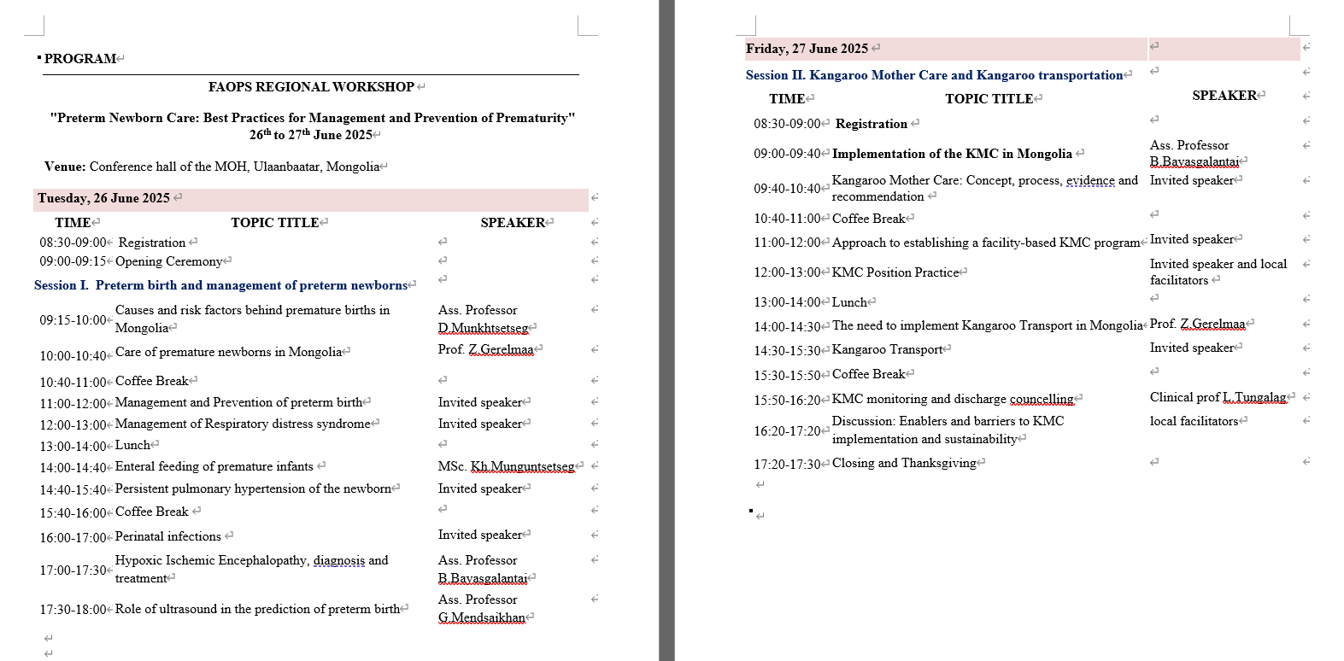
Dr. Sunil Raja presented his report of his committee and progress of Nepal meeting.
As Mariano & Miranda were absent, their report was not presented
Jose presented his report as DSG.
1. Mongolia Perinatal Association Workshop
President: Z. Gerelmaa
Members : 108
Established in 2001
Goal: Contribute to improve the existing maternal-neonatal services in Mongolia
2. Workshop Guideline Format
A. Workshop Title: "Preterm Newborn Care: Best Practices for Management and Prevention of Prematurity" on June 9, 10, 2025
B. Objective. : To improve the knowledge and skills of doctors and medical professionals who provide healthcare and services for premature delivery and premature babies including KMC.
C. Measurable. 1. Identify risk factors of premature birth in Mongolia.
skills participants. 2. Identify complications of premature delivery
will learn. 3. Diagnosis and treatment of common diseases in premature
4. Importance of Kangaroo Mother Care
5. Implementation of KMC and KMC Transport
D. At the end of the workshop the participants will acquire the following knowledge and skills:
1. Assess pregnant women and determine complication of premature pregnancy.
2. Manage preterm birth.
3. Diagnose and treat perinatal infection.
4. Assess and classify newborns who need emergency care and provide immediate emergency care.
5. Assess, classify and treat RDS, HIE, Infection and PPHN
6. Assess the nutrition of premature, monitor growth and give nutritional advice.
7. Implement Kangaroo Mother Care Method
8. Mail Principles of Kangaroo Transport
E. Detailed Proposal 1. Short description of workshop goal and activities:
Structure: The workshop will be organized for doctors and medical personnel
for the whole country. During the workshop, we will provide evidence-
based knowledge on management of preterm pregnancy and delivery of preterm babies.
2. The workshop format: The format will be organized using different methods of teaching: lectures, discussion, demonstrations, role play exercises in order to reach the goal.
3. For skill training especially for KMC we will use interactive technique such as small group discussion, demonstration and role play
4. The ppt presentation will be for 30 mins., SGD 20-30 mins and role play for 20 minutes followed by debriefing.
F. Critical. 1. Target audience: Obstetricians and neonatologist
Information: maternity hospitals, provincial general hospitals and PHC.
2. Key population: Pregnant women and newborns
3. Focus: Nationwide
4. Number of participants: 100
5. Workshop duration: 2 days
7. Facilitators expertise : 2-3 FAOPS experts; 6-7 doctors from
Mongolia
8. Interactive methods to maintain participants engagement: Role- play SGD and demonstrations will be used.
G. Program:
2. Asian Neo 3rd Annual Meeting; Feb 5, 2025

11. Ashma presented her report of her congress.
HanSuk asked to keep rooms for meetings and said about need of election for next congress in 2027.
Sam said you could increase workshop number to 30.
HanSuk said that KH Tan should look into the matter of scientific program.
12. Adriane was not there and so report presented. However, HanSuk said Australia meeting is very closer and so it will be too early to elect office bearers for 2027. Milind said that could be done in Sept. 26.
13. There was nothing in any other matter. About Brunei Sam said it would be on 25-26th July. Miind said it would clash with Srilanka. HanSuk said him to send the program. Next meeting was decided on 19 July.
14. Meeting closed after offering vote of thanks by HanSuk & Milind.

Prepared by:

Prof. Milind Shah
Prof. HanSuk

