MoM of Third FAOPS Council Meeting 2024
Date& Time: Saturday, August 11, 2024, 10:00 (Singapore Standard Time, SST)

Online Zoom Meeting (ID 840 8323 1780, PW: 123)
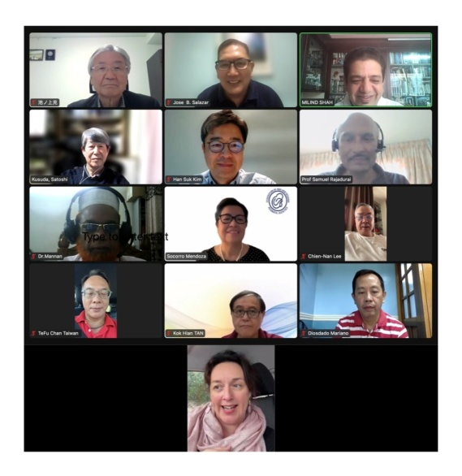

AGENDA
1. Call to order
2. Attendance and declaration of quorum
3. Approval of Agenda
4. Review and approval of minutes from the last council meeting held on 11.05.24.
5. Officer Reports
-Treasurer
-Secretary
-President
6. Discussion on changing account of FAOPS from Japan to other country.
7. Discussion on nominations & election for new office bearers for tenure 2025-27
7. Deputy Secretary General, Committee Chairperson and Advisor comments and proposals
8. FAOPS Congress 2023, 2024 and 2025 updates
9. Discussion on New proposals & New Chapters
10. Any other matter with permission of chair

MINUTES OF THE MEETING
- Call to order: SST 10:00 hr. by the President Prof. Victor Sam Rajadurai by his welcome address.
- Attendance and Declaration of quorum: Sec. Gen. Prof. Milind Shah declared a quorum. (Nine countries were present). This time Nepal representatives were invited to present congress preparation of 2025. Apologies received from Prof. Sookee & Dr. Adrienne. Milind gave thanks to Samendra for his technical support.
- Agenda was passed after small change by exchanging number 5 & 8. Proposed by Mariano and seconded by Jose.
- Minutes of last council meeting held on 11.5.24 were read and passed. Proposed by Prof. Ranjan and seconded by Prof. Shahidullah.
Prof. Sam told that for FAOPS 2024 Sam and Shahidullah would be in organizing committee and he told about his meeting with Prof. Hue. He requested lower fees for FAOPS countries.
There was again discussion on Thailand Perinatal Society & Thailand Neonatal Society. It was decided to send gentle letter for termination as suggested by Sam. Milind expressed concern about how to reach them. Jose told that he was in touch with one of the senior member but could not succeed to contact them. Milind told that we are sending invoices to them since 2016 with no response. Prof. Satoshi was requested to draft subtle letter. Sam said that first we will send letter to Perinatal Society and include Neonatal society as associate member for time being. Milind said that we would try to meet them in Seoul meeting. Satoshi told that he would try to contact Dr. Sarayu.
Mannan asked to make small change in minute that conference in Bangladesh need to be called as International congress and four FAOPS overseas members were present.
- Han Suk presented report of FAOPS congress.
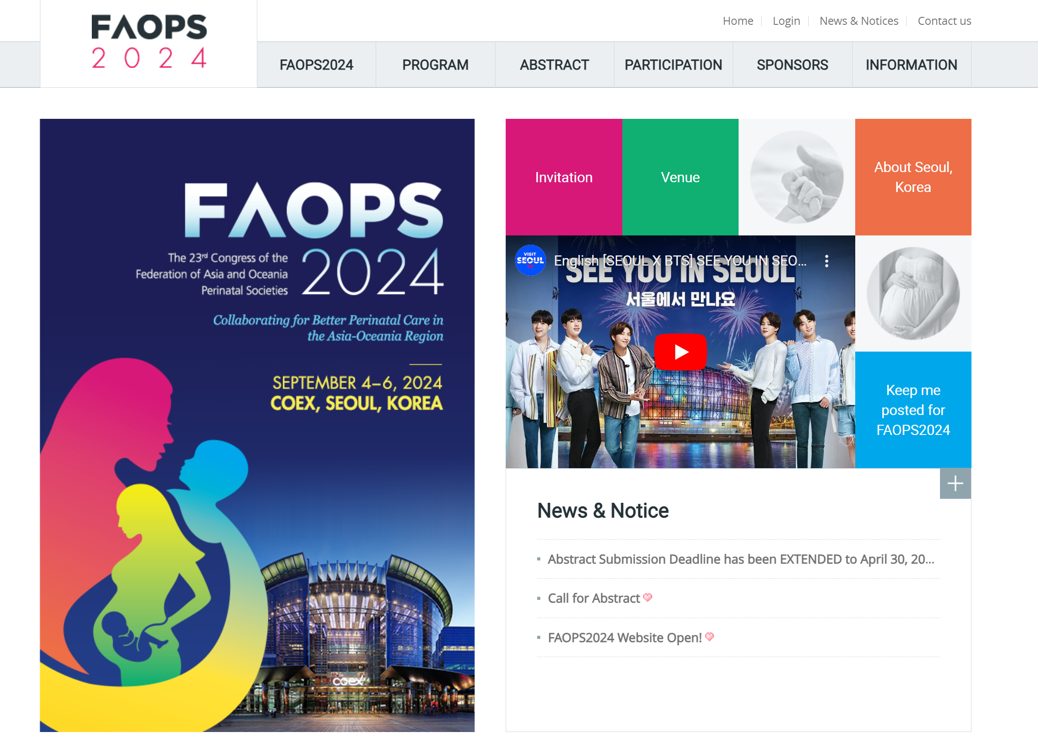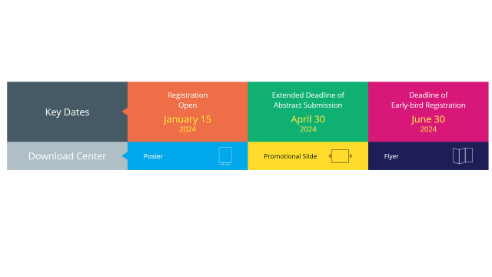
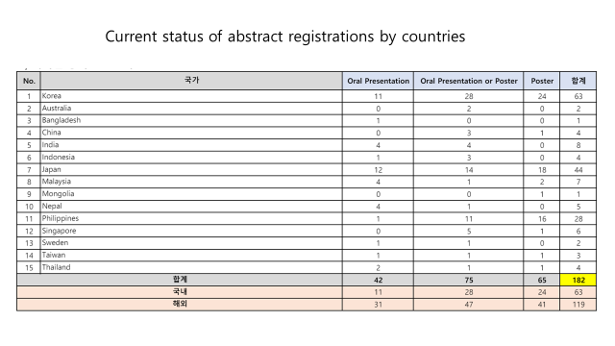
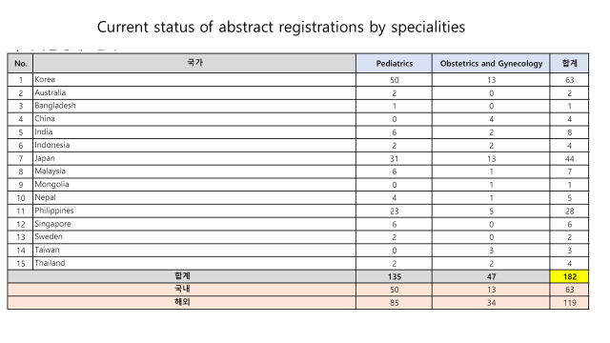
He said almost 600 delegates are registered until to date. He asked about necessity of council meeting during congress and it was decided to hold it on 4 September.
Ashma presented report of FAOPS 2025 congress. It will be in Hotel Radisson and report will be added after getting from Ashma. Sam said that he already started advertising about congress. Ranjan also appreciated. Shahidullah expressed happiness of preparation. He said that many members would come from Bangladesh.
As Adrianne was absent, report of FAOPS 2026 kept for next meeting.
- Officer Reports
Milind said everyone that as Yen is improving which is great news and asked Mamoru to present report.
-Treasurer - Mamoru presented his report with following remarks.
1, I have not confirmed payments of FAOPS member fee for 2023-24 from
Afghanistan, Nepal,
Please check the status of the country society above mentioned.
2. I have received $5.000 as the FAOPS 2023 congress fee from JSPNM.
3. Current FAOPS bank deposit accounts are created in Japanese yen according to Japanese law, and the total amount in dollar terms is decreasing with the depreciation of the yen.
We have lost $7,287 due to the devaluation of Yen in USD from 2023.
The yen has been rapidly moving in the direction of appreciation over the past few days.
We may need to consider moving our bank account to the other country.
2023/3 $1 = 135 yen 2024/5 $1 = 155 yen 2024/8/6 $1 = 145 yen

Current asset
Cash in bank-ordinary deposit (Mizuho Bank in JPY) ¥ 16,629,236
= USD 114,684
(1 USD = 145 JPY 2024/8/6)

Deposit
Total USD 105,465.452

-FAOPS 2023 fee from Japan USD 5,000.00

-Membership fee (total) *(2023.24) USD 8,382.00

Received from: Mongolia, Malaysia, Pakistan, Philippines, Bangladesh, Taiwan, Japan, Indonesia, Cambodia, PSANZ, Korea, Singapore, India
Not yet: Afghanistan, Nepal,
Srilanka exempted
Thailand, Vietnam and UAE have not paid the deposit since 2017
Our e-mail contact with UAE has been lost.
-Interest USD 0.74
Withdrawal
Total USD 700
- Website package (Subhadram Infotech: website package) 700 USD
FAOPS Membership Fee 2023-2024 |  |  |  |  |  |  |  |  | 2024.8.6
 | Country | Date | Amount（USD) | Exchange Rate(JPY) | Amount (JPY) | Charge（JPY） | Transfer Amount (JPY)
1 | Malaysia | 12-01-2024 | 316.00 | 145.00 | 45,820 |  | 45,820 | Cash | 2023
2 | Mongolia | 12-01-2024 | 102.00 | 145.00 | 14,790 |  | 14,790 | Cash | 2023
3 | Pakistan | 12-01-2024 | 200.00 | 145.00 | 29,000 |  | 29,000 | Cash | 2023-24
4 | Bangladesh | 12-01-2024 | 440.00 | 145.00 | 63,800 |  | 63,800 | Cash | 2023-24
5 | Taiwan Society of Perinatology | 17-01-2024 | 1050.00 | 146.44 | 1,53,762 | 2,500 | 1,51,262 | Bank Transfer
6 | Philippines | 19-01-2024 | 600.00 | 147.20 | 88,320 | 2,500 | 85,820 | Bank Transfer | 2023-24
7 | Japan Society of Perinatal and Neonatal Medicine | 30-01-2024 | 3000.00 | 146.17 | 4,38,510 |  | 4,38,510 | Bank Transfer | 2023-24
8 | Indonesia | 01-03-2024 | 300.00 | 149.32 | 44,796 | 2,500 | 42,296 | Bank Transfer | 2023-24
9 | Perinatal Society of Cambodia | 11-04-2024 | 300.00 | 151.99 | 45,597 | 2,500 | 43,097 | Bank Transfer | 2023-24
10 | The Korean Society of Perinatology | 18-04-2024 | 800.00 | 153.46 | 1,22,768 | 2,500 | 1,20,268 | Bank Transfer | 2023-24
11 | The Perinatal Society of ANZ | 13-06-2024 | 654.00 | 155.92 | 1,01,971 | 2,500 | 99,471 | Bank Transfer | 2023
12 | The Perinatal Society of Singapore | 19-07-2024 | 400.00 | 156.49 | 62,596 | 2,500 | 60,096 | Bank Transfer | 2023-24
13 | Indian Society of Perinatology | 06-08-2024 | 220.00 | 144.03 | 31,686 | 2,500 | 29,186 | Bank Transfer | 2023-24
 |  | Total | 8382.00 |  |  |  | 12,23,416
others
 | Country | Date | Amount（USD) | Exchange Rate(JPY) | Amount (JPY) | Charge（JPY） | Transfer Amount (JPY)
Deposit | Transfer from Dr Kim | 02-03-2023 | 1,09,289.00 | 135.20 | 147,75,872 | 2,500 | 147,73,372 | Bank Transfer
Deposit | FAOPS2023(JSPNM) | 21-02-2024 | 5,000.00 | 149.15 | 7,45,750 | 2,500 | 7,43,250 | Bank Transfer
Deposit | Interest | 21-08-2023 |  |  |  |  | 56
Deposit | Interest | 19-02-2024 |  |  |  |  | 59
 |  | Total | 1,14,289.00 |  |  |  | 155,16,737
Withdraw
 | Country | Date | Amount（USD) | Exchange Rate(JPY) | Amount (JPY) | Charge（JPY） | Transfer Amount (JPY)
Withdraw | India (HP) | 21-08-2023 | 700.00 | 146.31 | 1,02,417 | 8,500 | 1,10,917 | Bank Transfer
 |  | Total | 700.00 |  |  |  | 1,10,917
Ｇｒａｎｄ Ｔｏｔａｌ |  |  |  |  | Account Balance (JPY) |  | ########
 |  | Original dollars | 121971 |  | Account Balance (US$) |  | 114684 |  | Conversion according to today's exchange rate 1$=¥145 2024．Aug．8
 |  |  |  |  |  |  | US$-7,287
Ranjan said that this improvement in Yen is promising.
Sam asked Mamoru, whether it was asked to council before changing account. It was opened dollars only account by Satoshi in past and there was no loss. Mamoru told that it was just opened in Japan after taking treasurer's post and he did not ask anyone. Han Suk expressed that it need to be done taking into consideration currency situation in that country. Sam said that it would be kept until November to assess yen hoping it will improve further.
It was passed by Mannan & seconded by Azanna.
-Secretary - Milind told that we have already written to WAPM about next conference in Washington for session of FAOPS. He updated on various workshops with ISOPARB specially reaching unreached areas like Ajmer. He also told about MOU between Nepal & FAOPS, which need to be signed.
-President - He also told about MOU and explored possibility of having 2028 congress in Srilanka. He appreciated work by Prof. Azanna & Prof. Tan.
Sam told about avoiding elections for council for 2025-27, which can lead to misunderstanding and creates disharmony. He suggested following names after speaking with various people.
President Dr. Han Suk, President Elect Dr. Laila, Secretary General Dr. Milind, Treasurer Dr. Mamoru, DSG - Central Dr. Azanna, Western - Dr. Suranta, Eastern - Dr. Mamoru, Oceania - Dr. Adriane. However, these names are temporary and need to be finalized after receiving nominations as per election notice by stipulated dates to election committee. Sam appreciated and congratulated Milind for his gesture to wait and he said he would take over as President elect in 2027. Ranjan appreciated Sam for his efforts to keep this harmony. As election officer, he was happy to see that there will be no election if it happens this way. Han Suk also expressed it and said that if any qualified member want to become council member need to be considered. Satoshi said that Milind has done good work as Secretary General but can be given rest and Mamoru can be considered for SG. However, Sam said that he was not DSG and need to be council member for at least 4 years. Ranjan said same. Shahidullah said that Milind though very busy has done wonderful work and should continue. Ranjan said that similar situation was there in past and Sookee was continued twice. Sam said that it will be finalized in Sept meeting and depends on response to applications, and need to fulfill criteria as per notice. He asked Ranjan to look into it. Mariano said that looking at constitution person need to be at least in council for 3 years before qualifying himself as SG. Han Suk said that committee chairs need to be decided by President and he wants to expand more committees.
- DSG and committee chairperson's reports - Mannan presented report of workshop on Breast feeding. He also said that he wants to plan workshop on artificial ventilation in November. Jose told of PAP association on common problems in perinatology. He emphasized on Breast feeding and perinatal problems. Prof. Tan gave information that KK Hospital is celebrating 100 years and he wants to plan some activities for it. Sam said that access would be extended to all FAOPS countries. Shahidullah said that all DSG should extend their activities beyond their own countries and should work in region. Mariano told about website development with help from Milind and requested others to visit website and give suggestions. Milind appreciated Mariano's efforts. Azanna gave updates on research and publications, FAOPS funiculus, compiling work done by FAOPS members. She also told about research association on infections in various countries and preterm birth prevention. She said about social media presence. Milind told that with the help of our website vendor we are already there on FB, Insta, You tube, Twitter etc. All our social media handles are active.
Ranjan told about FAOPS Journal's progress in last 25 years and now it is indexed. Sam and Milind told that it would be released in Seoul congress and Ranjan's work need to be appreciated during inauguration.
- Discussion on New proposals & New Chapters - Milind told that our efforts to be in touch with PNG, UAE, Brunei & Azerbaijan are continued.
- Any other matter with permission of chair - Nothing
- Meeting closed after offering vote of thanks by Sam & Milind.

Prepared by:

Prof. Milind Shah
Prof. Victor Sam Rajadurai

