3rd Council Meeting of the FAOPS for year 2025
Held on Saturday, July 19th, 2025, 11:00 AM (Korean Standard Time)
Online Meeting on Zoom

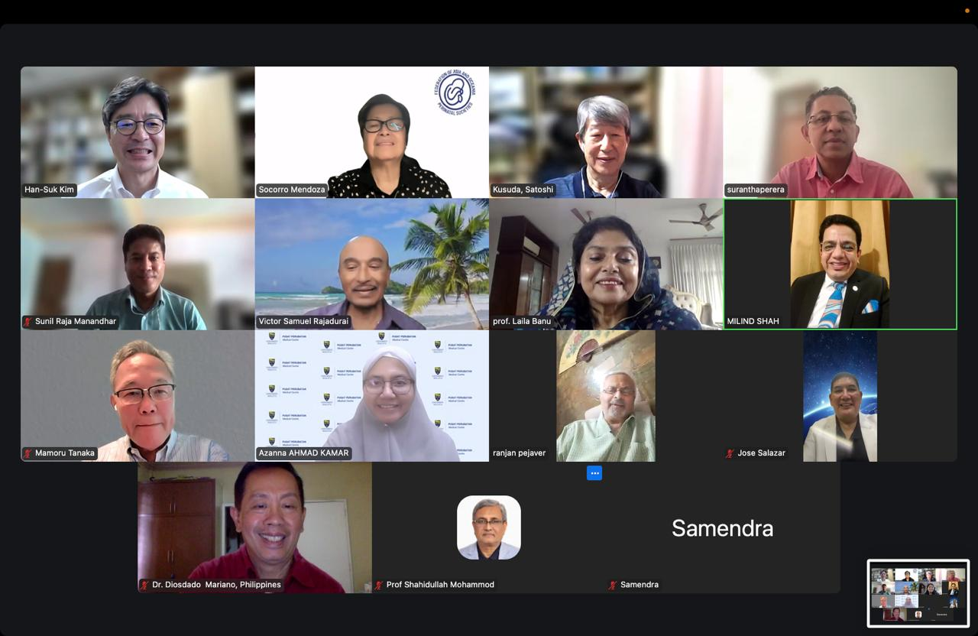
Agenda
- Welcome Remarks: President
- Call to Order: President
- Attendance & Declaration of Quorum: Secretary General
- Approval of agenda: President
- Review of the minutes of the last Council Meeting (2025-04-26):
Secretary General
- Treasurer’s report
- Transfer to a USD account (Auditor& Treasurer)
- Secretary General’s report
- President’s report
- Regional activity reports: Deputy Secretary Generals
- Workshops in Brunei and Mongolia
- Updates of incoming FAOPS congresses
- Nepal (2025)
- Australia (2026)
- Any other matters with permission from President

MINUTES OF THE MEETING
- Meeting was called to order by the President Prof. Han Suk by his welcome address
- Attendance and Declaration of quorum: Sec. Gen. Prof. Milind Shah declared a quorum. There were 15 persons were present for meeting.
- Agenda was approved by council members.
- The minutes of the last second Council Meeting on 26.04.2025, were read and passed. Proposed by Ranjan and seconded by Laila.
- Treasurer report of FAOPS on July 16, 2025 (Apr 28, 2025~July 22, 2025) by Mamoru
Remarks:
New FAOPS account in USD was made
Current asset
Cash in bank-ordinary deposit (Mizuho Bank in USD) USD 115,653.97Deposit
item | Date | Amount (USD) | Charge | Total (α-β)
carry-over  (from old account (JPY) to new account (USD) | 2025/4/28.30 | 120,381.28 |  | 120,381.28
TAIWAN SOCIETY OF PERINATOLOGY | 2025/5/15 | 1050.00 | 17.20 | 1,032.80
MONGOLIAN PERINATAL ASSOCIATION | 2025/5/19 | 220.00 | 17.37 | 202.63
PERINATAL SOCIETY OF CAMBODIA | 2025/6/24 | 300.00 | 17.27 | 282.73
Total |  |  |  | 121,899.44

Membership fee received from: Mongolia, Taiwan, Cambodia, Singapore,
Sri Lanka exempted until 2024
Thailand, Vietnam and UAE have not paid the deposit since 2017
Withdrawal
item | Date | Amount (α) | Charge (β) | Total (α＋β)
Dr.Kim (airfare) | 2025/6/9 | 656.93 | 59.06 | 715.99
MONGOLIAN PERINATAL ASSOCIATION | 2025/6/9 | 2,500.00 | 59.06 | 2,559.06
Dr.Sookee (airfare) | 2025/6/9 | 1,084.30 | 59.06 | 1,143.36
Dr.Milind (airfare) | 2025/6/10 | 1,767.91 | 59.15 | 1,827.06
Total |  |  |  | 6,245.47
Balance (USD) |  |  |  | 115,653.97

- in Secretaries report, Milind said that as Jose is going to present report of Mongolia and Suranta is going to present report of Sri Lanka and all DSG will present reports of their areas, he will not repeat it again.
However, he once again requested everyone to send reports to office for compilation and to be included in minutes.
- In President's report, he expressed thanks to Mongolia for holding wonderful event and Sookee for proposal of amendments.
- Azanna presented her report from central region. She apologized for not sending report earlier. She presented list of countries and also provided efforts of contacting Thailand. She also presented report of 31st Regional congress of the perinatal society of Malaysia. She also presented about Brunei program which will be at the end of July. She presented about workshop of Cambodia Perinatal Society on Newborn resuscitation. Dates yet to be finalized. About Indonesia, she said that they had many activities specially on KMC. She conveyed about Perinasia Journal which will be having open access. About Singapore, she talked about 13th Annual conference in September. She emphasized on need of correct representatives, program list of each region and collaborative networks.
- FAOPS representatives participate in major international conferences to maintain collaboration.
- Suggestions for FAOPS to offer designated workshops (e.g., Kangaroo Mother Care and obstetric workshops) accessible to member countries.
- Discussion on advocacy focus: primarily perinatal morbidity and mortality but also considering broader health influences like the first 1,000 days of life.
- Potential collaboration with UNICEF to adapt community-based educational materials for Asia.
- Emphasis on engaging with WHO regional offices and global health days.
- Status of relationship with World Association of Perinatal Medicine (WAPM) discussed; past MOU lapsed; efforts ongoing to renew cooperation.
- Han Suk asked about website. Milind said that he will follow it and he asked Mariano about his liaison. Mariano suggested that we should appoint secretary who can do all this work. Sam suggested to have someone who will work part time secretary under Secretary General’s supervision to manage website and coordinate communications. Milind said that he will search a suitable candidate.
- Suranta presented report from West Zone. He narrated report of event to be organized at Colombo in July 25 which is 134th Annual event of Sri Lanka Medical Association. He conveyed about draft proposal activity on Perinatal death rate road map with eemphasis on regional collaboration, data sharing, and policy input for new health policy in 2026. He thanked Dr. Milind Shah for accepting invite to attend it as faculty. He presented his visits to Nepal & India. He said that he wants to organize program with all countries in his zone which he will present in next meeting and he wants to plan for regular Zoom meetings and WhatsApp groups to connect regional members. Laila said about FIGO meeting where we can have our meeting during that. Han Suk congratulated Suranta and said that he can use FAOPS title. Sam also expressed happiness and asked to involve Maldives. Milind conveyed that we already started communicating Maldives & Bhutan. Ranjan said that he had worked in Bhutan during his NNF presidency. Milind said that he communicated with head of Perinatal group & Head of OBGYN group. Shahidullah also conveyed his connection with Dr. Faizal who is head of pediatrics group. Milind conveyed that he also had talk with Dr. Aseel who is President of OBGYN group. Azanna asked whether Afghanistan is our member for which Milind responded that it is regular member but fees are due for last term. Ranjan conveyed about visit of Sookee & Milind to Afghanistan for starting Perinatal chapter.
- Jose presented Mongolia report and report of Japan, Philippines & Taiwan meetings.
Mongolia
- Workshop on preterm birth prevention and neonatal management with over 150 attendees. Presentations by FAOPS leadership on key neonatal care topics by Han Suk, Milind & Sookee. Great efforts by Gerelmaa & Bayaja.
Japan
- 61st Annual Meeting of Japan Society of Perinatal and Neonatal Medicine held in Osaka.
- Collaborative symposium with Korean Society of Perinatology.
- Focus on miscarriage and early neonatal death.
Philippines
- Multiple activities including leadership summits, workshops on suturing, hypertension in pregnancy, vascular access management, and neonatal resuscitation.
- Collaboration with maternal-fetal and newborn medicine societies.
Taiwan
- Activities pending report submission.
12. As Adrianne was absent report of Oceania region not presented.
13. About Committee activities, Prof. K H Tan was absent so report of Research & Projects not presented. Tetsuya presented committee of training and education where he asked for guidance. Han Suk told him that he can take few members to facilitate work. Committee on Communication and Public relation is represented by Sunil who presented progress of FAOPS 2025 congress.
14. Sookee said that she has active group from Bhutan in KMC who can support that chapter. Milind asked for her support for Vietnam group. She said though KMC group is active Perinatal chapter need to be activated to join. Azanna will take lead for that.
15. Mariano presented on International Collaboration Committee. He suggested having workshops with 1 OBGYN & 1 Neonatology person in various countries. He also suggested having liaison with WHO & FIGO. Azanna conveyed about her activity with UNISEF for training and education. Sam, Sookee and Ranjan gave opinion on global network. Ranjan asked about WAPM facts. Milind updated that their conference got postponed. About having LOGO of FAOPS on WAPM website. Satoshi told about MOU which was tried to between FAOPS & WAPM but with no success. Sookee said that MOU was accepted and LOGO appeared for a while on WAPM website. There was understanding that that FAOPS President will be in board for a while. Milind asked her to send that MOU as Cihat is in touch and he will be communicating with him.
16. Miranda was absent so report of committee on Philanthropy & Advocacy.
Han Suk told about need to finalize FAOPS mission and vision statements.
17. Sookee presented report of her committee on Legislation.
By-Law XXI Country symposia/workshop
      - The Federation (FAOPS) symposium in a perinatal society meeting hosted by the member countries is encouraged.
2. The Federation shall not support the symposium financially; however, it shall cover the travel of 2-3 resource speakers from the Federation as the host
country may request.
3.The host country has the right to moderate the symposium and accept not only domestic participants but also international participants from all membership
countries.
4. The Federation shall support skills workshops held by the member
country at each of the four (4) regions between the official Federation congresses
with the payment of US$ 2,500.
Again, there was discussion on potential member countries which will be taken in discussion next time.
- Clarifications needed on support to member vs. non-member countries for workshops and symposia.
- Plans to finalize amendments in the next council meeting.
- Preparations underway for the 2025 AGM in Nepal including bylaw amendments and Congress 2028 host country voting.
- Suggestion to hold next council meeting in September (instead of October) to allow sufficient time for communication before AGM.
- September 6 tentatively agreed for next council meeting.
Milind asked her to send it to him to be presented in next meeting.
Han Suk requested Sunil to send tentative meeting schedule during Nepal congress.
18. Meeting closed after offering vote of thanks by Han Suk & Milind.

Prepared by:

Prof. Milind Shah
Prof. Han Suk

