FAOPS General Assembly 2023
Hybrid Meeting

Date: October 8, 2023
Time: 12:30-13:30 (JST, UTC+09)
Venue: Hana A, Main Tower 4F, Keio Plaza Hotel, Tokyo
Zoom link:
---
Agenda
Sr. No. | Item | By whom | Time
1 | Call to order | President Victor Samuel Rajadurai | 12.30
2 | Attendance and declaration of quorum | Secretary General Milind Shah | 12.31
3 | Approval of Agenda | President Victor Samuel Rajadurai | 12.32
4 | To read and confirm minutes of last AGM held on 17.12.22 | Secretary General Milind Shah | 12.33
5 | Treasurer's Report and Approval | Treasurer Mamoru Tanaka | 12.38
6 | Secretary's Report | Secretary General Milind Shah | 12.43
7 | President's Report | President Victor Samuel Rajadurai | 12.53
8 | Report by FAOPS 2023 Hosting Country, Japan | Chairman of Congress Mamoru Tanaka | 13.03
9 | Report by FAOPS 2024 Hosting Country, South Korea | Chairman of Congress Han Suk Kim | 13.08
10 | Report by FAOPS 2025 Hosting Country, Nepal | Ashma Rana | 13.13
11 | To decide on FAOPS 2026 Conference Host Country | President Victor Samuel Rajadurai | 13.18
12 | Any other business with permission of Chair | President Victor Samuel Rajadurai | 13.28
13 | Vote of thanks to conclude | Secretary General Milind Shah | 13.30

MINUTES OF THE MEETING
- Call to order: By the President Sam Rajadurai
- Attendance and Declaration of quorum: Sec. Gen. Milind Shah declared a quorum. (15 countries are present, 63 persons were present)
- Agenda was approved by all participants
- Minutes of last AGM held on 17.12.2022 were read and confirmed. Proposed by & Seconded by
- Treasurer’s report and Approval (Mamoru Tanaka)
Mamoru Tanaka could not join meeting but he sent his report
Mamoru conveyed to inform all country members about new account number
As its almost loss of 10000 USD due to devaluation of Japanese Yen, Milind asked whether we can keep account at one country only instead of changing everytime. Mariano also said same. Sam said it can be thought about and wait for economy to rise. Satoshi mentioned about having two accounts. We will wait for Mamoru’s clarification. Azanna asked about possibility of keeping Treasurer’s post longer. Satoshi said can be kept for 6 years. Milind said he faced same issue in India and so kept account in Korea itself with support from HanSuk and so saved loss of money of FAOPS. Shahidullah also said same. Milind said that office bearers could continue for 2 terms according to our bylaws.
Approved by – Prof. Shahidullah Seconded by - Prof. Han Suk

- Secretary report (Dr. Milind Shah)
He gave information about stationary prepared for new council.
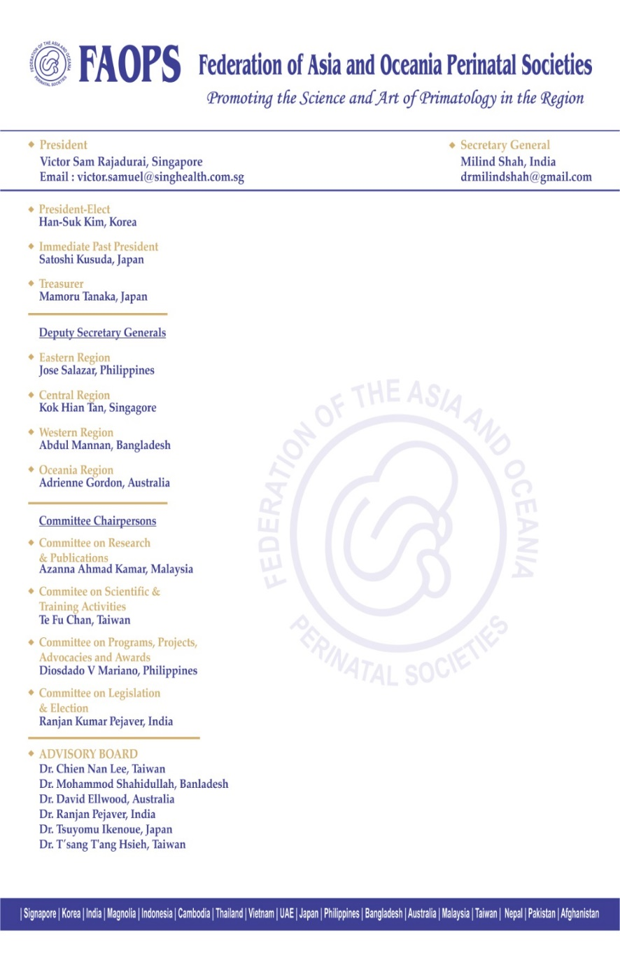
Then he gave information about new website created for FAOPS. He requested President Sam to launch the website.
He informed that there would be few more changes. Website committee Chairperson Mariano will look into matter and will connect with vendor for same.
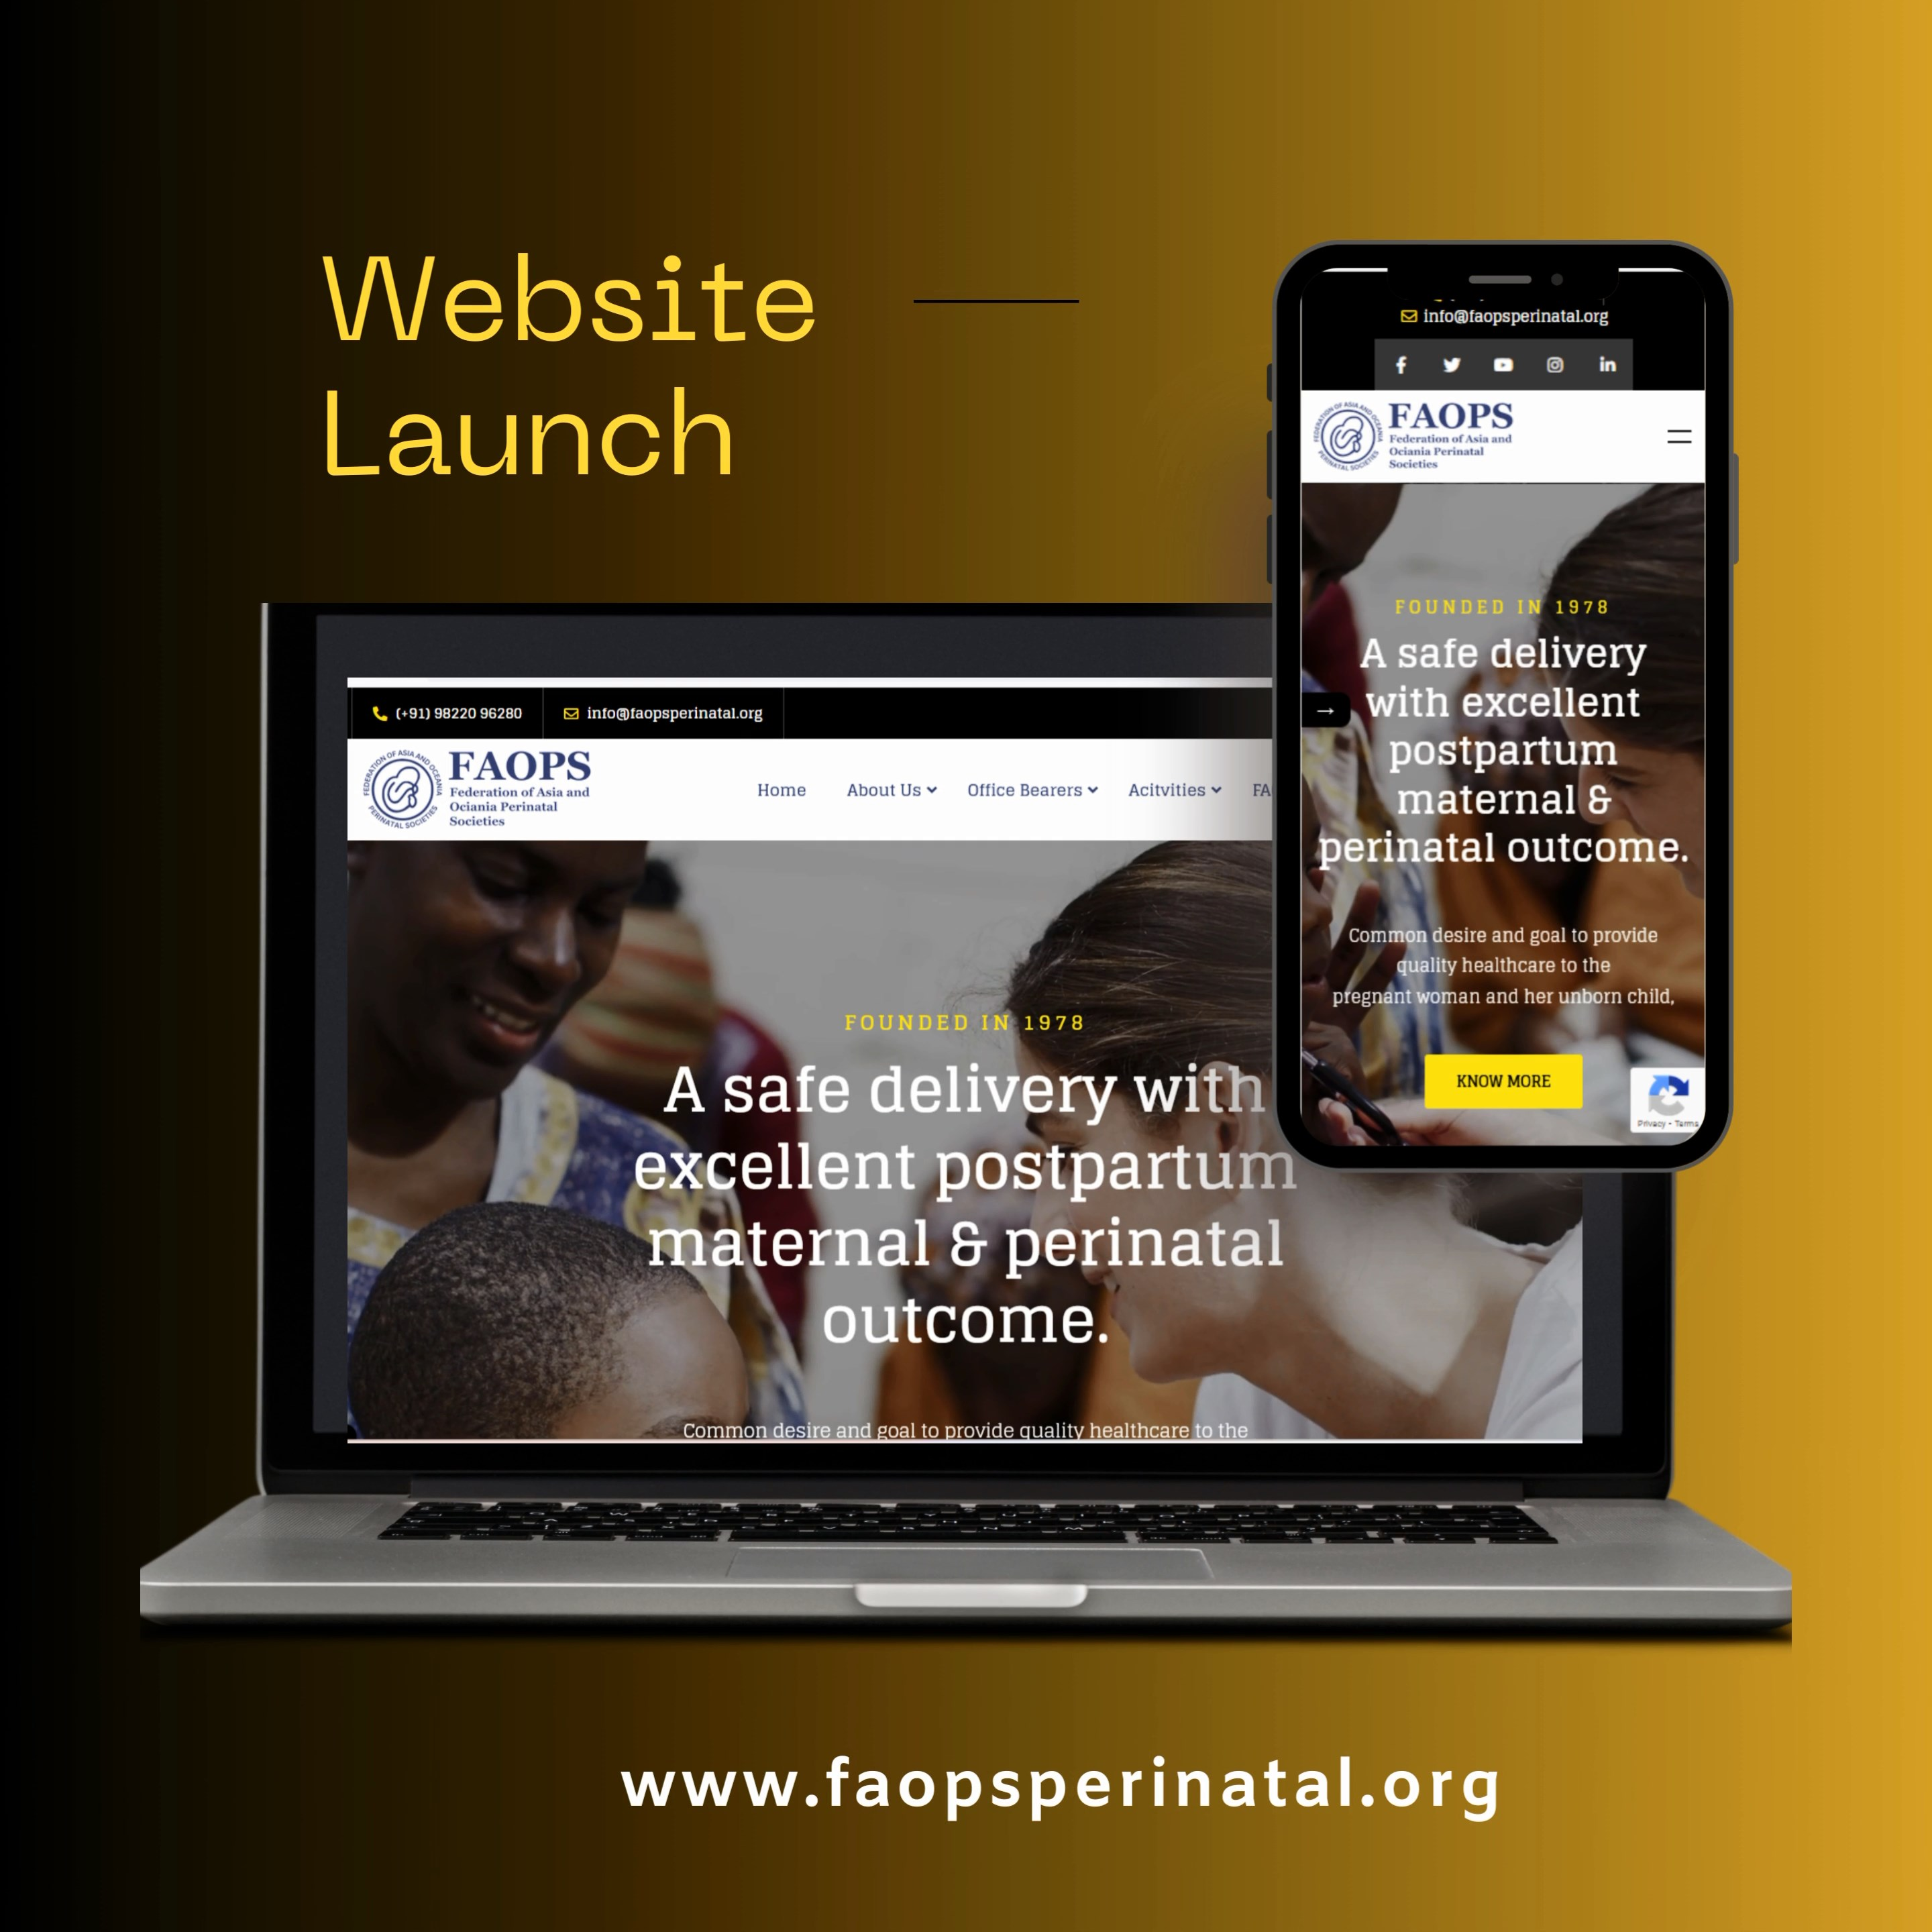
After that, he gave information about Annual Conference held at Meerut, India and mid term conference held at Kolkata, India.
There were three Orations, Public Forum, Quiz for Post-graduates, three Workshops, Free Papers for Post-graduates and Panel Discussions at Meerut
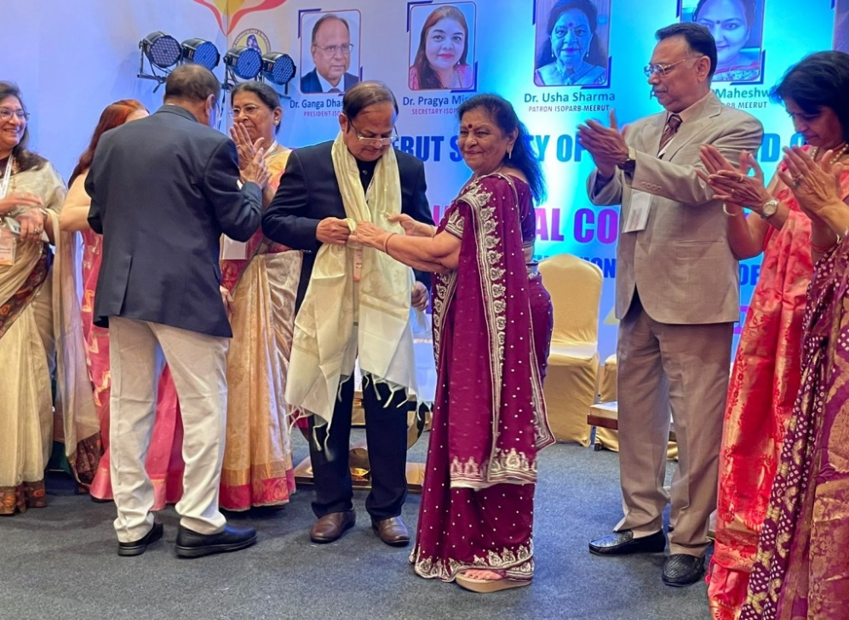
- There were three workshops on Fetal Medicine & Perinatology, Obstetric Skills abd Basic Life Support & Neonatal Resuscitation. Panel discussion,

- President’s Report by Dr Satoshi Kusuda
- WHO recommendations for care of the preterm or low-birth-weight infant
-Drs. Mendoza and Shahidullah participated and contributed to this project

- 10th Singapore Paediatric & Perinatal Annual Congress (SiPPAC 2022)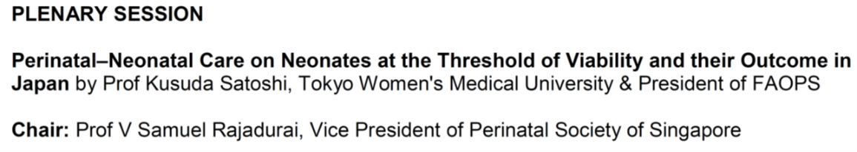
- Rules for the Committee on Legislation and Election
Draft below was discussed.
(Specific Objectives)
1. To lead in the periodic review of the FAOPS Constitution and By Laws and recommend any such amendments to the Council
2. To standardize and direct the conduct of nominations and elections of the Council Officers and members during the annual general assembly
Composition:
1. The Chairperson will be one of the Advisers as defined in By Law XXII
He/ She shall be appointed by the Executive Council members and approved by the General Assembly
2. Excluding the Chairperson, the Committee shall be composed of seven (7) members, which shall include:
a.President
b.President-Elect
c.Immediate Past President
d.Three (3) other Advisers from both fields of Obstetrics & Neonatology as determined by the Chairperson
e.The chairperson shall ensure, as much as possible, that there will be equal representation from both fields of discipline in the committee
Duties & Responsibilities
1. The Committee members shall have a confidentiality obligation regarding the matters discussed and resolutions reached during meetings
2. Any violation thereof without justifiable reason shall be dismissed by the committee members, if a majority of them approve it
3. On Legislative duties:
a.The committee shall meet at least once a year to review the By Laws
b.Any proposed amendments to the By Laws shall be presented to the Council at least 3 months prior to the General Assembly
c.Council-approved amendment/s shall be sent to the General Assembly members at least 30 days before the annual meeting
d.Approval by at least 2/3 of the members present during the meeting is required for the amendments to take effect in the ensuing fiscal year
(On Electoral duties)
Prior to the end of the term of office of the Council, the Committee shall, within the specified timeline:
a. Open the nomination period and accept official applications for Council officers from all member countries at least 4 months ahead (Appendix 1-6 application form)
b.Review all applicants’ qualifications, and proposes a candidate or candidates for each position to the Council at least 3 months ahead
c. Make known to the general membership, the names of the approved candidates at least 2 months ahea
d. Contestability of Candidates
e. The conduct of the election of Council members which is held every two years shall be chaired by the President
f . The validity and number of authorized voters from each country will be confirmed by the Secretary General prior to the actual voting process
g. The General Assembly will vote on the approved candidates during the elections by secret ballot or its equivalent in virtual meetings during exceptional times where face-to-face meeting cannot be held
h. For the election of the Deputy Secretary Generals, the President, the President Elect, the Secretary General, the Treasurer, and delegates from the same region will vote.
i. Finality of election results
5. Amendments to all of the above shall be made through an official council meeting with the Committee

- FAOPS 2025 Hosting Country
Dr. Sunil Raja Manandhar (Senoir Vice President of PESON) presented the plan for FAOPS Congress 2025 at Kathmandu.

All participants supported and approved Nepal (PESON) as the host country (society) of FAOPS Congress 2025.
- Nomination of Council Members and Committee Chairs
-Deputy Secretary General
Regions | Name | Country | Specialty
Eastern | Jose Salazar | Philippines | Neonatology
Central | KH Tan | Singapore | Obstetric
Western | Abdul Mannan | Bangladesh | Neonatology
Oceania | Adrienne Gordon | Australia | Neonatology

- Committee Chairs
Committee | Name | Country | Specialty
Research & Publications | Azanna Kamer | Malaysia | Neonatology
Scientific & Training Activities | Te Fu Chan | Taiwan | Obstetrics
Programs, Projects, Advocacies and Awards | Disodado Mariano | Philippine | Obstetrics
Legislation & Election | Ranjan Pejaver | India | Neonatology
-All candidates were approved but the opinions that we need more clear rules and process for nomination arose.

- Updates of FAOPS 2022 Congress.
Dr Kamar reported final status of FAOPS 2022. (25th-28th, Aug. 2022.)

- Others
- Report from Committee on Programs, Projects, Advocacies and Awards(Dr Mariano)
- -World Prematurity Day Celebration was successfully done
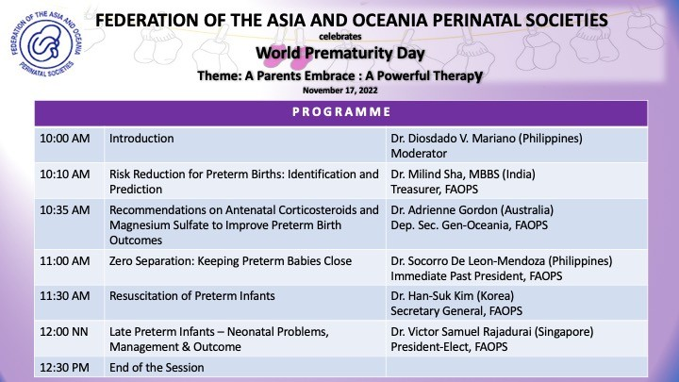

- Dr Mariano presented the plan for commencement operation of FAOPS Facebook page.
-Members agreed the need and usefulness of Facebook, and on the other hand many opinion suggesting necessity of update and timely maintenance of FAOPS webpages arose.
-Dr. Mariano will present the plan including both of Facebook page operation and Webpage revitalization in next council meeting.

- Announcement for FAOPS Congress 2024 Seoul. (Dr. Kim)
- Report from Committee on Research & Publications (Dr. Kamar)
-Planned for 2 newsletters in 1 year for 2023
Activity notifications: Published article and guidelines by FAOPS members, eg.
-74 abstracts of FAOPS 2022 congress were published in Frontiers in Surgery.

- Adjournment: 1300H

Prepared by:

Prof. Han-Suk Kim
Prof. Satoshi Kusuda

