If you are reading this, chances are you got The method X is ambiguous for the type Y error when compiling a java program in terminal or in any Java IDE.

Java ambiguous method call
Here I am going to explain why java ambiguous method call error comes with some examples. This ambiguous method call error always comes with method overloading where compiler fails to find out which of the overloaded method should be used.
Suppose we have a java program like below.

package com.journaldev.errors;

public class Test {

public void foo(Object o) {
System.out.println("Object");
}

public void foo(String s) {
System.out.println("String");
}
public static void main(String[] args) {
new Test().foo(null);
}

}
Above program compiles perfectly and when we run it, it prints “String”.
So the method foo(String s) was called by the program. The reason behind this is java compiler tries to find out the method with most specific input parameters to invoke a method. We know that Object is the parent class of String, so the choice was easy. Here is the excerpt from Java Language Specification.
If more than one member method is both accessible and applicable to a method invocation … The Java programming language uses the rule that the most specific method is chosen.
The reason I am passing “null” is because it works for any type of arguments, if we pass any other objects the choice of method for the java compiler is easy.

The method X is ambiguous for the type Y
Now let’s add below method to the above code.

public void foo(Integer i){
System.out.println("Integer");
}
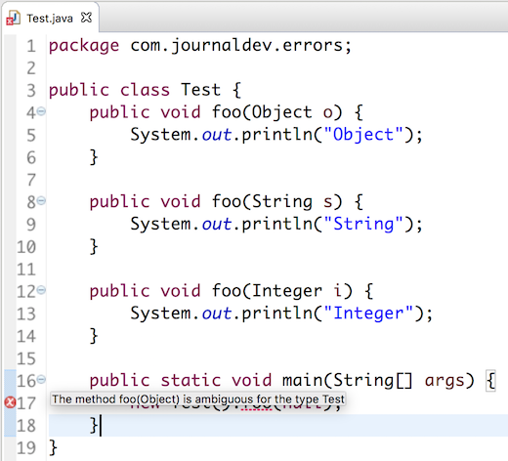
You will get compile time error as The method foo(Object) is ambiguous for the type Test because both String and Integer class have Object as parent class and there is no inheritance. So java compiler doesn’t consider any of them to be more specific, hence the method ambiguous call error.

package com.journaldev.strings;

public class Test {

public void foo(Object o) {
System.out.println("Object");
}

public void foo(Exception e) {
System.out.println("Exception");
}

public void foo(NullPointerException ne) {
System.out.println("NullPointerException");
}

public static void main(String[] args) {
new Test().foo(null);
}

}
As above explained, here foo(NullPointerException ne) is the most specific method because it’s inherited from Exception class and hence this code compiles fine and when executed prints “NullPointerException”.
Method Overloading in Varargs
Overloading allows different methods to have same name, but different signatures where signature can differ by number of input parameters or type of input parameters or both. We can overload a method that takes a variable-length argument by following ways:
- Case 1 – Methods with only Varargs parameters: In this case, Java uses the type difference to determine which overloaded method to call. If one method signature is strictly more specific than the other, then Java chooses it without an error.
filter_none
edit
play_arrow
brightness_4
//Java program to illustrate
//method overloading in varargs
public class varargsDemo
{
public static void main(String[] args)
{
fun();
}

//varargs method with float datatype
static void fun(float... x)
{
System.out.println("float varargs");
}

//varargs method with int datatype
static void fun(int... x)
{
System.out.println("int varargs");
}

//varargs method with double datatype
static void fun(double... x)
{
System.out.println("double varargs");
}
}
Output:
int varargs
This output is due to the fact that int is more specific than double. As specified in the JLS section 15.12.2.5, If more than one member method is both accessible and applicable to a method invocation, it is necessary to choose one to provide the descriptor for the run-time method dispatch. The Java programming language uses the rule that the most specific method is chosen according to type promotion. The following rules define the direct supertype relation among the primitive types in this case:

  - double > float
  - float > long
  - long > int
  - int > char
  - int > short
  - short > byte
- Case 2 – Methods with Varargs alongwith other parameters In this case, Java uses both the number of arguments and the type of the arguments to determine which method to call.
Below is the java program that overloads fun( ) method three times:
filter_none
edit
play_arrow
brightness_4
// Java program to demonstrate Varargs
// and overloading.
class Test
{
// A method that takes varargs(here integers).
static void fun(int ... a)
{
System.out.print("fun(int ...): " +
"Number of args: " + a.length +
" Contents: ");

// using for each loop to display contents of a
for(int x : a)
System.out.print(x + " ");

System.out.println();
}

// A method that takes varargs(here booleans).
static void fun(boolean ... a)
{
System.out.print("fun(boolean ...) " +
"Number of args: " + a.length +
" Contents: ");

// using for each loop to display contents of a
for(boolean x : a)
System.out.print(x + " ");

System.out.println();
}

// A method takes string as a argument followed by varargs(here integers).
static void fun(String msg, int ... a)
{
System.out.print("fun(String, int ...): " +
msg + a.length +
" Contents: ");

// using for each loop to display contents of a
for(int x : a)
System.out.print(x + " ");

System.out.println();
}

public static void main(String args[])
{
// Calling overloaded fun() with different parameter
fun(1, 2, 3);
fun("Testing: ", 10, 20);
fun(true, false, false);
}
}
Output:
fun(int ...): Number of args: 3 Contents: 1 2 3
fun(String, int ...): Testing: 2 Contents: 10 20
fun(boolean ...) Number of args: 3 Contents: true false false
Varargs and Ambiguity
Sometimes unexpected errors can result when overloading a method that takes a variable length argument. These errors involve ambiguity because both the methods are valid candidates for invocation. The compiler cannot decide onto which method to bind the method call.
filter_none
edit
play_arrow
brightness_4
// Java program to illustrate Varargs and ambiguity
class Test
{
// A method that takes varargs(here integers).
static void fun(int ... a)
{
System.out.print("fun(int ...): " +
"Number of args: " + a.length +
" Contents: ");

// using for each loop to display contents of a
for(int x : a)
System.out.print(x + " ");

System.out.println();
}

// A method that takes varargs(here booleans).
static void fun(boolean ... a)
{
System.out.print("fun(boolean ...) " +
"Number of args: " + a.length +
" Contents: ");

// using for each loop to display contents of a
for(boolean x : a)
System.out.print(x + " ");

System.out.println();
}

public static void main(String args[])
{
// Calling overloaded fun() with different parameter
fun(1, 2, 3); //OK
fun(true, false, false); //OK
fun(); // Error: Ambiguous!
}
}
In above program, the overloading of fun( ) is perfectly correct. However, this program will not compile because of the following call:
fun(); // Error: Ambiguous!
According to (JLS 15.2.2), there are 3 phases used in overload resolution: First phase performs overload resolution without permitting boxing or unboxing conversion, Second phase performs overload resolution while allowing boxing and unboxing and Third phase allows overloading to be combined with variable arity methods, boxing, and unboxing. If no applicable method is found during these phases, then ambiguity occurs.
The call above could be translated into a call to fun(int …) or fun(boolean …). Both are equally valid and do not be resolved after all three phases of overload resolution because both the data types are different. Thus, the call is inherently ambiguous.
Another example of ambiguity:
The following overloaded versions of fun( )are inherently ambiguous:
static void fun(int ... a) { // method body }
static void fun(int n, int ... a) { //method body }
Here, although the parameter lists of fun( ) differ, there is no way for the compiler to resolve the following call:
fun(1)
This call may resolve to fun(int … a) or fun(int n, int … a) method, thus creating ambiguity. To solve these ambiguity errors like above, we will need to forego overloading and simply use two different method names.

Exception interview Question 1. What is exception in java?
Answer. It’s the basic Exception framework interview question. Freshers must know about this. Java Exception handling provides a mechanism to handle compile and runtime errors in java.
- To make application robust Exception must be handled appropriately,
- by handling exceptions we end up giving some meaningful message to end user rather than giving meaningless message in java.

Exception interview Question 2. Explain exception hierarchy in java?
Answer. It’s also the basic Exception handling interview question. Freshers must know about this.
Exception hierarchy in java > 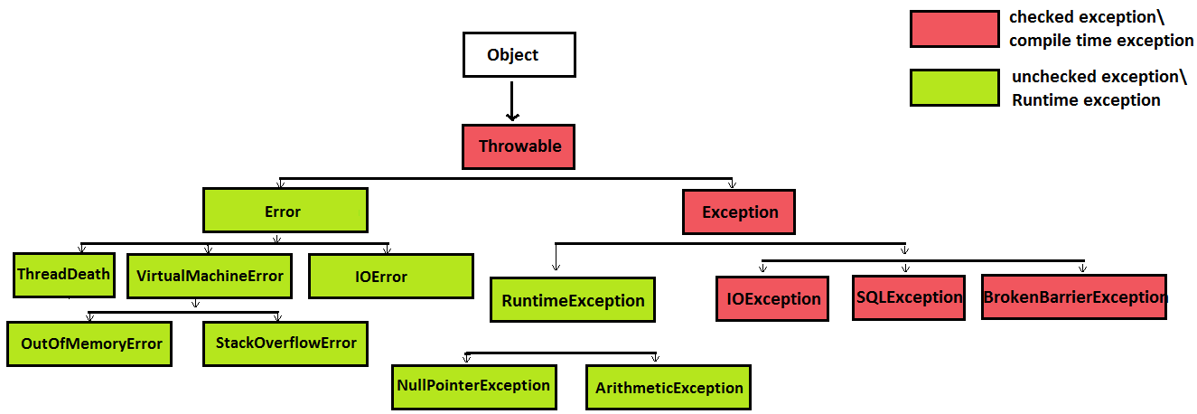
java.lang.Object is superclass of all classes in java.

java.lang.Throwable is superclass of java.lang.Exception and java.lang.Error

java.lang.Exception is superclass of java.lang.RuntimeException, IOException, SQLException, BrokenBarrierException and many more other classes in java.

java.lang.RuntimeException is superclass of java.lang.NullPointerException, ArithmeticException and many more other classes in java.

java.lang.Error is superclass of java.lang.VirtualMachineError, IOError, AssertionError, ThreadDeath and many more other classes in java.

java.lang.VirtualMachineError is superclass of java.lang.OutOfMemoryError, StackOverflowError and many more other classes in java.

Exception interview Question 3. What are differences between checked and unchecked exceptions in java?
Answer. This is very important Exception handling interview question in java.

 | Property | checked exception | unchecked exception
1 | Also known as | checked exceptions are also known as compileTime exceptions in java. | unchecked exceptions are also known as runtime exceptions in java.
2 | Should be solved at compile or runtime? | Checked exceptions are those which need to be taken care at compile time in java. | Unchecked exceptions are those which need to be taken care at runtime in java.
3 | Benefit/ Advantage | We cannot proceed until we fix compilation issues which are most likely to happen in program, this helps us in avoiding runtime problems upto lot of extent in java. | Whenever runtime exception occurs execution of program is interrupted, but by handling these kind of exception we avoid such interruptions and end up giving some meaningful message to user in java.
4 | Creating custom/own exception | By extending java.lang.Exception, we can create checked exception. | By extending java.lang.RuntimeException, we can create unchecked exception.
  class UserException extends Exception {
  UserException(String s) {
  super(s);
  }
  }
  class UserException extends RuntimeException {
  UserException(String s) {
  super(s);
  }
  }
5 | Exception propagation | For propagating checked exceptions method must throw exception by using throws keyword. | unchecked exceptions are automatically propagated in java.
6 | handling checked and unchecked exception while overriding superclass method | If superclass method throws/declare checked exception >  - overridden method of subclass can declare/throw narrower (subclass of) checked exception (As shown in Program), or  - overridden method of subclass cannot declare/throw broader (superclass of) checked exception (As shown in Program), or  - overridden method of subclass can declare/throw any unchecked /RuntimeException (As shown in Program) | If superclass method throws/declare unchecked >  - overridden method of subclass can declare/throw any unchecked /RuntimeException (superclass or subclass) (As shown in Program), or  - overridden method of subclass cannot declare/throw any checked exception (As shown in Program),
 | Which classes are which type of exception? either  checked or unchecked exception? | The class Exception and all its subclasses that are not also subclasses of RuntimeException are checked exceptions in java. | The class RuntimeException and all its subclasses are unchecked exceptions.  Likewise,  The class Error and all its subclasses are unchecked exceptions in java.
7 | Most frequently faced exceptions | SQLException,  IOException,  ClassNotFoundException | NullPointerException,  ArithmeticException ArrayIndexOutOfBoundsException.

Read more on : Checked (compile time exceptions) and UnChecked (RuntimeExceptions) in java - Definition and differences

Exception interview Question 4. What are 5 exception handling keywords in java?
Answer. This is another very important exception handling interview question in java.
5 keyword in java exception handling in java
  - try - Any exception occurring in try block is catched by catch block.

  - catch - catch block is always followed by try block in java.

  - finally finally block can can only exist if try or try-catch block is there, finally block can’t be used alone in java.
Features of finally >
- finally block is always executed irrespective of exception is thrown or not.
  - finally is keyword in java.
  - finally block is optional in java, we may use it or not.
finally block is not executed in following scenarios >
- finally is not executed when System.exit is called.
- if in case JVM crashes because of some java.util.Error.

  - throw throw is a keyword in java.
    - throw keyword allows us to throw checked or unchecked exception.

  - throws throws is written in method’s definition to indicate that method can throw exception in java.

Exception interview Question 5. Explain what is Error in java?
Answer. Experienced developers must know in detail about Exception handling interview question in java. java.lang.Error
- Error is a subclass of Throwable in java.
- Error indicates some serious problems that our application should not try to catch in java.
- Errors are abnormal conditions in application.
- Error and its subclasses are regarded as unchecked exceptions in java

Must know :
ThreadDeath is an error which application must not try to catch but it is normal condition in java.

Exception interview Question 6. What are differences between Exception and Error in java?
Answer. It is another very important exception interview question to differentiate between Exception and Error in java.
 | Property | Exception | Error
1 | serious problem? | Exception does not indicate any serious problem. | Error indicates some serious problems that our application should not try to catch.
2 | divided into  checked and unchecked | Exception are divided into checked and unchecked exceptions in java. | Error are not divided further into such classifications in java.
3 | Which classes are which type of exception? either  checked or unchecked exception? | The class Exception and all its subclasses that are not also subclasses of RuntimeException are checked exceptions.  The class RuntimeException and all its subclasses are unchecked exceptions.  Likewise,  The class Error and all its subclasses are unchecked exceptions in java. | Error and its subclasses are regarded as unchecked exceptions in java
4 | Most frequently faced exception and errors | checked exceptions>  SQLException,  IOException,  ClassNotFoundException  unchecked exceptions>  NullPointerException, ArithmeticException, | VirtualMachineError, IOError, AssertionError, ThreadDeath,  OutOfMemoryError, StackOverflowError.
5 | Why to catch or not to catch? | Application must catch the Exception because they does not cause any major threat to application in java. | Application must not catch the Error because they does cause any major threat to application.  Example >  Let’s say errors like OutOfMemoryError and StackOverflowError occur and are caught then JVM might not be able to free up memory for rest of application to execute, so it will be better if application don’t catch these errors and is allowed to terminate in java.

Exception interview Question 7. Explain throw keyword in java?
Answer. This is also frequently asked exception handling interview question.
- throw is a keyword in java.
- throw keyword allows us to throw checked or unchecked exception.

throw unchecked exception in java >
- We need not to handle unChecked exception either by catching it or throwing it in java.

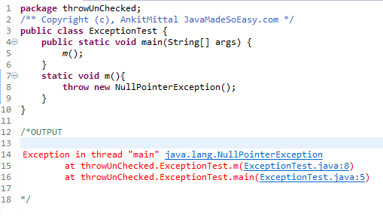
We throw NullPointerException (unChecked exception) and didn’t handled it, no compilation error was thrown in java.

throw checked exception >
- We need to handle checked exception either by catching it, or
- throwing it by using throws keyword. (When thrown, exception must be handled in calling environment)

Exception interview Question 8. Explain throws keyword in java?
Answer. This exception interview question will be covered in below question but it give you more detailed information about throw keyword in java.

throws is written in method’s definition to indicate that method can throw exception.

throws unChecked exception in java >
- We need not to handle unChecked exception either by catching it or throwing it.

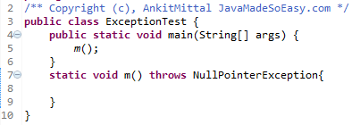
Above code throws NullPointerException (unChecked exception) and didn’t handled it from where method m() was called and no compilation error was thrown.

throws Checked exception in java >

- We need to handle checked exception either by catching it or throwing it further, if not handled we will face compilation error.

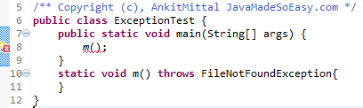

Exception interview Question 9. What is difference between throw and throws in java?
Answer. This is also another important and frequently asked exception handling interview question. To confuse interviewees Interviewers might give you code snippet and ask you to insert throw or throws keyword in java.
 | throw | throws
1 | throw keyword is used to throw an exception explicitly in java. | throws keyword is used to declare an exception in java.
2 | throw is used inside method.  Example in java >  static void m(){  throw new FileNotFoundException();  } | throws is used in method declaration.  Example in java >  static void m() throws FileNotFoundException{  }
3 | throw is always followed by instanceof Exception class in java.  Example >  throw new FileNotFoundException() | throws is always followed by name of Exception class in java.  Example >  throws FileNotFoundException
4 | throw can be used to throw only one exception at time.  Example >  throw new FileNotFoundException() | throws can be used to throw multiple exception at time.  Example >  throws FileNotFoundException, NullPointerException  and many more...
5 | throw cannot propagate exception to calling method in java.  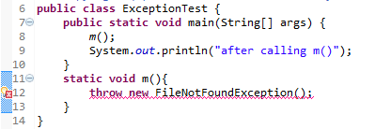 | throws can propagate exception to calling method.  Please see these programs to understand how exception is propagated to calling method.  Program 1 - Handling Exception by throwing it from m() method (using throws keyword) and handling it in try-catch block from where call to method m() was made.  Program 2 - Throwing Exception from m() method and then again throwing it from calling method [ i.e. main method]

Exception interview Question 10. How to create user defined checked and unchecked Exception in java?
Answer. Very important exception handling interview question. Interviewers generally expects interviewees to write code to create checked and unchecked Exception in java.

Creating user defined checked exception in java >
class UserDefinedException extends Exception {
UserDefinedException(String s) {
super(s);
}
}
By extending java.lang.Exception, we can create checked exception.

Creating user defined unchecked exception in java >
class UserDefinedException extends RuntimeException {
UserDefinedException(String s) {
super(s);
}
}
By extending java.lang.RuntimeException, we can create unchecked exception.

Exception interview Question 11. How to use try-catch-finally in java? Can we use try,catch or finally block alone in java?
Answer. This exception handling interview question will test your practical/basic understanding of Exception handling in java.
We can enclose exception prone code in >
- try-catch block, or
- try-finally block, or
- try-catch-finally block.

Using try-catch block in java
try{
//Code to be enclosed in try-catch block
}catch(Exception e){
}

Using try-finally block in java
try{
//Code to be enclosed in try-finally block
}finally{
}

We cannot use try block alone, it must be followed by either catch or finally.
Using only try block will cause compilation error
try{
//only try block will cause compilation error
}

Likewise, we cannot use catch block alone, it always follows try block.
Using only catch block will cause compilation error
catch{
//only catch block will cause compilation error
}

Likewise, we cannot use finally block alone, it always follows try block.
Using only finally block will cause compilation error
finally{
//only finally block will cause compilation error
}

Exception interview Question 12. Is it allowed to use multiple catch block in java?
Answer. Another exception handling interview question which will test your practical knowledge and understanding of Exception handling in java. Java exception handling allows us to use multiple catch block in java.

Important Point about multiple catch block in java >
- Exception class handled in starting catch block must be subclass of Exception class handled in following catch blocks (otherwise we will face compilation error).
- Either one of the multiple catch block will handle exception at time in java.

Program - Let’s understand the concept of multiple catch block in java>
/** Copyright (c), AnkitMittal JavaMadeSoEasy.com */
public class ExceptionTest {
public static void main(String[] args) {

try{
int i=10/0; //will throw ArithmeticException
}catch(ArithmeticException ae){
System.out.println("Exception handled - ArithmeticException");
}catch(RuntimeException re){
System.out.println("Exception handled - RuntimeException");
}catch(Exception e){
System.out.println("Exception handled - Exception");
}
}
}
/*OUTPUT
Exception handled - ArithmeticException
*/

In the above above >
ArithmeticException has been used in first catch block
RuntimeException has been used in second catch block
Exception has been used in third catch block

Exception is superclass of RuntimeException and
RuntimeException is superclass of ArithmeticException.

Exception interview Question 13. What is Automatic resource management in java 7?
Answer. Experienced java developers must be well versed with this exception interview question. As we know java allows us to handle multiple exceptions by using multiple catch blocks.
Now, java 7 has done improvements in multiple exception handling by introducing multi catch syntax which helps in automatic resource management.

Features of multi catch syntax in java >
- Has improved way of catching multiple exceptions.
- This syntax does not looks clumsy in java.
- Reduces developer efforts of writing multiple catch blocks in java.
- Allows us to catch more than one exception in one catch block.

Here is the multi catch syntax >
try{
//code . . . . .
}catch(IOException | SQLException ex){
//code . . . . .
}
We could separate different exceptions using pipe ( | ) in java.

Exception interview Question 14. Explain try-with-resource in java?
Answer. Again experienced java developers must be well versed with this exception interview question. Before java 7, we used to write explicit code for closing file in finally block by using try-finally block like this >
/** Copyright (c), AnkitMittal JavaMadeSoEasy.com */
public class TryWithResourseTest {
public static void main(String[] args) throws IOException {
InputStream inputStream = null;
try{
inputStream = new FileInputStream("c:/txtFile.txt");
//code......
}finally{
if(inputStream!=null)
inputStream.close();
}
}
}

In java 7, using Try-with-resources >
- we need not to write explicit code for closing file.
import java.io.FileInputStream;
import java.io.IOException;
import java.io.InputStream;
/** Copyright (c), AnkitMittal JavaMadeSoEasy.com */
public class TryWithResourseTest {
public static void main(String[] args) throws IOException {
try (InputStream inputStream = new FileInputStream("c:/txtFile.txt")) {
//code...
}
}
}

Using multiple resources inside Try-with-resources is also allowed in java.

Exception interview Question 15. Now, question comes why we need not to close file when we are using Try-with-resources in java?
Answer. Again experienced java developers must be well versed with this exception interview question. Because FileInputStream implements java.lang.AutoCloseable interface (AutoCloseable interface’s close method automatically closes resources which are no longer needed) in java.

Which classes can be used inside Try-with-resources in java?
All the classes which implements AutoCloseable interface can be used inside Try-with-resources in java.

Exception interview Question 16. Explain finally keyword in java?
Answer. Fresher and experienced java developers must be well versed with this exception handling interview question in java.
try or try-catch block can be followed by finally block in java >
- try-finally block, or
try{
//Code to be enclosed in try-finally block
}finally{
}

- try-catch-finally block.
try{
//Code to be enclosed in try-catch-finally block
}catch(Exception e){
}finally{
}

finally block can can only exist if try or try-catch block is there, finally block can’t be used alone in java.

Features of finally in java >
- finally block is always executed irrespective of exception is thrown or not.
- finally is keyword in java.

finally block is not executed in following scenarios in java >
- finally is not executed when System.exit is called.
- if in case JVM crashes because of some java.util.Error.

Application of finally block in java programs in java >
- We may use finally block to execute code for database connection closing, because closing connection in try or catch block may not be safe.
  - Why closing connection in try block may not be safe?
  - Because exception may be thrown in try block before reaching connection closing statement.

  - Why closing connection in catch block may not be safe?
  - Because inappropriate exception may be thrown in try block and we might not enter catch block to close connection in java.

For programs to demonstrate finally. Please refer this post.

Exception interview Question 17. Is it allowed to use nested try-catch in java?
Answer. It’s basic java exception handling interview question.
java exception handling allows us to use nested try-catch block.

Nested try-catch block means using try-catch block inside another try-catch block in java.

/** Copyright (c), AnkitMittal JavaMadeSoEasy.com */
public class ExceptionTest {
public static void main(String[] args) {

try{
int i=10/0; //will throw ArithmeticException
}catch(ArithmeticException ae){
System.out.println("try-catch block handled - ArithmeticException");

//using nested try-catch block
try{
String s=null;
s.charAt(0); //will throw NullPointerException
}catch(NullPointerException npe){
System.out.println("NESTED try-catch block handled - "
+ "NullPointerException");
}

}
}
}

Exception interview Question 18. Discuss which checked and unchecked exception can be thrown/declared by subclass method while overriding superclass method in java?
Answer. It’s very very important exception handling interview question. Experienced and freshers all must be able to answer this question.

If superclass method throws/declare unchecked/RuntimeException in java >
- overridden method of subclass can declare/throw any unchecked /RuntimeException (superclass or subclass), or
- overridden method of subclass cannot declare/throw any checked exception in java, or
- overridden method of subclass can declare/throw same exception in java, or
- overridden method of subclass may not declare/throw any exception in java.

If superclass method throws/declare checked/compileTime exception in java >
- overridden method of subclass can declare/throw narrower (subclass of) checked exception, or
- overridden method of subclass cannot declare/throw broader (superclass of) checked exception, or
- overridden method of subclass can declare/throw any unchecked /RuntimeException, or
- overridden method of subclass can declare/throw same exception, or
- overridden method of subclass may not declare/throw any exception in java.

If superclass method does not throw/declare any exception in java >
- overridden method of subclass can declare/throw any unchecked /RuntimeException , or
- overridden method of subclass cannot declare/throw any checked exception, or
- overridden method of subclass may not declare/throw any exception in java.

For programs please refer > Throw/declare checked and unchecked exception while overriding superclass method in java

Exception interview Question 19. What will happen when catch and finally block both return value, also when try and finally both return value in java?
Answer. This is very important exception handling interview question for experienced developers.

When catch and finally block both return value, method will ultimately return value returned by finally block irrespective of value returned by catch block.
/** Copyright (c), AnkitMittal JavaMadeSoEasy.com */
public class ExceptionTest {
public static void main(String[] args) {
System.out.println("method return -> "+m());
}

static String m(){
try{
int i=10/0; //will throw ArithmeticException
}catch(ArithmeticException e){
return "catch";
}finally{
return "finally";
}

}
}
/*OUTPUT
method return -> finally
*/
In above program, i=10/0 will throw ArithmeticException and enter catch block to return "catch", but ultimately control will enter finally block to return "finally".

Likewise, when try and finally block both return value, method will ultimately return value returned by finally block irrespective of value returned by try block. For program please refer.

Exception interview Question 20. What is exception propagation in java?
Answer.
Experienced developers must know in detail about Exception handling interview question in java. Even freshers must try and understand this in depth concept of exception propagation in java.
Whenever methods are called stack is formed and an exception is first thrown from the top of the stack and if it is not caught, it starts coming down the stack to previous methods until it is not caught.
If exception remains uncaught even after reaching bottom of the stack it is propagated to JVM and program is terminated in java.

Propagating unchecked exception (NullPointerException) >
unchecked exceptions are automatically propagated in java.

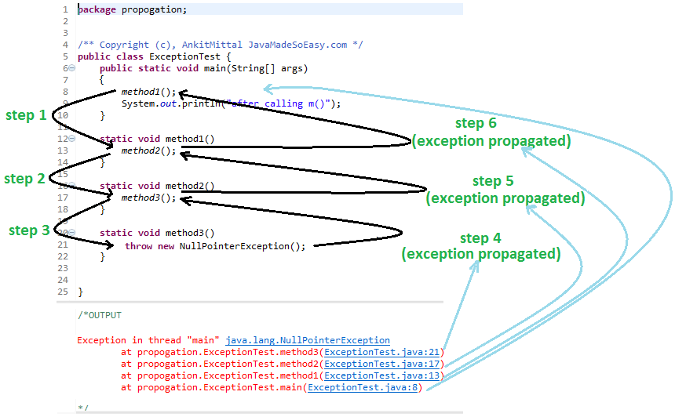

stack of methods is formed >
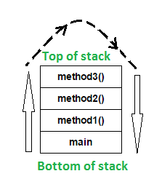
In the above program, stack is formed and an exception is first thrown from the top of the stack [ method3() ] and it remains uncaught there, and starts coming down the stack to previous methods to method2(), then to method1(), than to main() and it remains uncaught throughout.
exception remains uncaught even after reaching bottom of the stack [ main() ] so it is propagated to JVM and ultimately program is terminated by throwing exception [ as shown in output ] in java.

Propagating checked exception (FileNotFoundException) using throws keyword >
For propagating checked exceptions method must throw exception by using throws keyword.
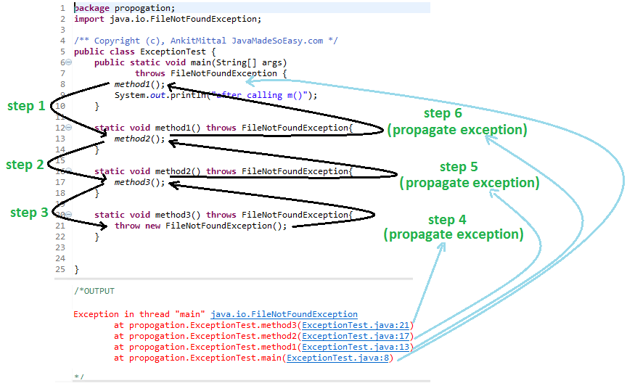

Exception interview Question 21. Can a catch or finally block throw exception in java?
Answer. Yes, catch or finally block can throw checked or unchecked exception but it must be handled accordingly. Please refer this post for handling checked and unchecked exceptions in java.

Exception interview Question 22. Why shouldn’t you use Exception for catching all exceptions in java?
Answer. Catching Exception rather than handling specific exception can be vulnerable to our application. Multiple catch blocks must be used to catch specific exceptions, because handling specific exception gives developer the liberty of taking appropriate action and develop robust application.

Exception interview Question 23. What is Difference between multiple catch block and multi catch syntax?
Answer. Experienced developers must know in detail about this Exception handling interview question in java

 | multiple catch block | multi catch syntax
1 | multiple catch blocks were introduced in prior versions of Java 7 and does not provide any automatic resource management in java. | multi catch syntax was introduced in java 7 for improvements in multiple exception handling which helps in automatic resource management in java.
2 | Here is the syntax for writing multiple catch block in java > | Here is the multi catch syntax in java >  We could separate different exceptions using pipe ( | )
  try{
  //code . . . . .
  }catch(IOException ex1){
  //code . . . . .
  } catch(SQLException ex2){
  //code . . . . .
  }
  try{
  //code . . . . .
  }catch(IOException | SQLException ex){
  //code . . . . .
  }
3 | For catching IOException and SQLException we need to write two catch block like this >  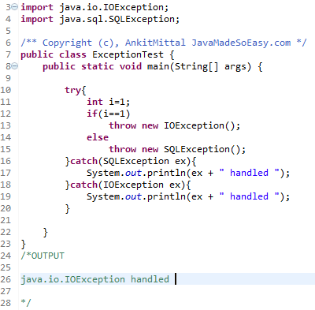 | with the help of multi catch syntax we can catch IOException and SQLException in one catch block using multi catch syntax like this >  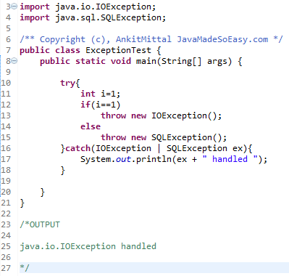
4 | When multiple catch blocks are used , first catch block could be subclass of Exception class handled in following catch blocks like this >  IOException is subclass of Exception in java.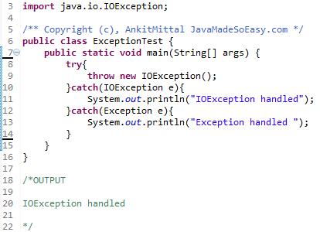 | If Multi catch syntax is used to catch subclass and its superclass than compilation error will be thrown.  IOException and Exception in multi catch syntax will cause compilation error “The exception IOException is already caught by the alternative Exception”.  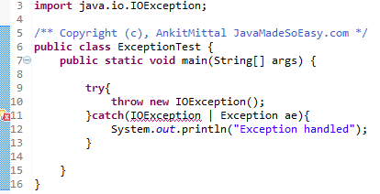  Solution >  We must use only Exception to catch its subclass like this >  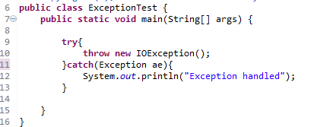
5 | Does not provide such features. | Features of multi catch syntax >  - Has improved way of catching multiple exceptions.  - This syntax does not looks clumsy.  - Reduces developer efforts of writing multiple catch blocks.  - Allows us to catch more than one exception in one catch block.  - Helps in automatic resource management.

For more read : Difference between multiple catch block and multi catch syntax

Exception interview Question 24. can a method be overloaded on basis of exceptions in java ?
Answer.
Another Exception handling interview question which will test your practical understanding of exception in java.

Yes a method be overloaded on basis of exceptions in java.

But now question which overloaded exception will be called.
Let’s take an example :
Ques. Let's say one method handles Exception and other handles ArithmeticException. Which method will be invoked when ArithmeticException is thrown?
Ans. Method which handles more specific exception will be called.

Program >
import java.io.IOException;
/** Copyright (c), AnkitMittal JavaMadeSoEasy.com
* Main class */
public class ExceptionTest {

void method(Exception e){
System.out.println(e+" caught in Exception method");
}
void method(ArithmeticException ae){
System.out.println(ae+" caught in ArithmeticException method");
}

public static void main(String[] args) {
ExceptionTest obj=new ExceptionTest();
obj.method(new ArithmeticException());
obj.method(new IOException());
}
}
/* OUTPUT
java.lang.ArithmeticException caught in ArithmeticException method
java.io.IOException caught in Exception method
*/

Exception interview Question 25. Mention few exception handling best practices in java?
Answer. Experienced developers must be able to answer this Exception handling interview question in detail in java.

- Throw exceptions when the method cannot handle the exception, and more importantly, must be handled by the caller.
Example -
In Servlets - doGet() and doPost() throw ServletException or IOException in certain circumstances where the request could not be read correctly. Neither of these methods are in a position to handle the exception, but the container is (which generally results in the 404 error page in most cases).
- Bubble the exception if the method cannot handle it. This is a corollary of the above point, but applicable to methods that must catch the exception. If the caught exception cannot be handled correctly by the method, then it is preferable to bubble it.

- Throw the exception right away. If an exception scenario is encountered, then it is a good practice to throw an exception indicating the original point of failure, instead of attempting to handle the failure via error codes, until a point deemed suitable for throwing the exception. In other words, attempt to minimize mixing exception handling with error handling.

- Either log the exception or bubble it, but don't do both. Logging an exception often indicates that the exception stack has been completely unwound, indicating that no further bubbling of the exception has occurred. Hence, it is not recommended to do both at the same time, as it often leads to a frustrating experience in debugging.
- Application should not try to catch Error - Because, in most of cases recovery from an Error is almost impossible. So, application must be allowed to terminate.
Example>
Let’s say errors like OutOfMemoryError and StackOverflowError occur and are caught then JVM might not be able to free up memory for rest of application to execute, so it will be better if application don’t catch these errors and is allowed to terminate.

Read : Complete list of Exception handling best practices and guidelines for using exceptions in java

Exception interview Question 26. Difference between Final, Finally and Finalize in java?
Answer. It is another very very important exception interview question to differentiate between final, finally and finalize in java.

 | final | finally | finalize
1 | final can be applied to variable, method and class in java. | finally is a block. | finalize is a method.
2 | 2.1) Final variable  final memberVariable  final local variable  final static variable  Final memberVariable of class must be initialized at time of declaration, once initialized final memberVariable cannot be assigned a new value.  Final variables are called constants in java.  If constructor is defined then final memberVariable can be initialized in constructor but once initialized cannot be assigned a new value.  Final local variable can be left uninitialized at time of declaration and can be initialized later, but once initialized cannot be assigned a new value in java.  Final static variable of class must be initialized at time of declaration or can be initialized in static block, once initialized final static variable cannot be assigned a new value.  If static block is defined then final static variable can be initialized in static block, once initialized final static variable cannot be assigned a new value.  2.2) Final method  Final method cannot be overridden, any attempt to do so will cause compilation error.  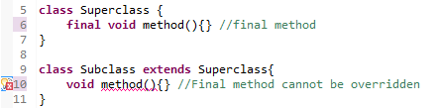  Runtime polymorphism is not applicable on final methods because they cannot be inherited.  2.3) Final class  Final class cannot be extended, any attempt to do so will cause compilation error.  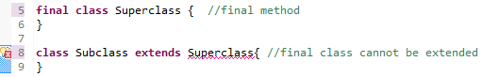 | try or try-catch block can be followed by finally block >  try-finally block, or  try-catch-finally block.  finally block can can only exist if try or try-catch block is there, finally block can’t be used alone in java.  finally block is not executed in following scenarios >  finally is not executed when System.exit is called.  if in case JVM crashes because of some java.util.Error. | finalize method is called before garbage collection by JVM,  finalize method is called for any cleanup action that may be required before garbage collection.  finalize() method is defined in java.lang.Object
  class FinalTest {
  final int x=1; //memberVariable/instanceVariable
  }
  class FinalTest {
  final int x; //memberVariable/instanceVariable
  FinalTest() {
  x = 1; //final memberVariable can be initialized in constructor.
  }
  }
  class FinalTest {
  void method(){
  final int x; //uninitialized at time of declaration
  x=1;
  }
  }
  class FinalTest {
  final static int x; //static variable
  static{ //static block
  x=1;
  }
  }
  try{
  //Code to be enclosed in try-finally block
  }finally{
  }
  try{
  //Code to be enclosed in try-catch-finally block
  }catch(Exception e){
  }finally{
  }
  /** Copyright (c), AnkitMittal JavaMadeSoEasy.com */
  @Override
  protected void finalize() throws Throwable {
  try {
  System.out.println("in
  finalize() method, "
  +
  "doing cleanup activity");
  } catch (Throwable throwable) {
  throw throwable;
  }
  }
3 | - | finally block can only exist if try or try-catch block is there, finally block can’t be used alone in java. | We can force early garbage collection in java by using following methods >  System.gc(); Runtime.getRuntime().gc();  System.runFinalization(); Runtime.getRuntime().runFinalization();
4 | - | finally is always executed irrespective of exception thrown in java. | If any uncaught exception is thrown inside finalize method -  exception is ignored,  thread is terminated and  object is discarded.  Note : Any exception thrown by the finalize method causes the finalization of this object to be halted, but is otherwise ignored.
5 | - | Currently executing thread calls finally method in java. | JVM does not guarantee which daemon thread will invoke the finalize method for an object.
6 | final is a keyword in java. | finally Is a keyword in java. | finalize is not a keyword in java.

For more detail read : Final, Finally and Finalize - difference and similarity in java

Another Exception interview Question. What are the differences between between ClassNotFoundException and NoClassDefFoundError in java ?

Answer.

 | ClassNotFoundException | NoClassDefFoundError
1 | ClassNotFoundException is Checked (compile time) Exception in java. | NoClassDefFoundError is a Error in java. Error and its subclasses are regarded as unchecked exceptions in java.
2 | Here is the hierarchy of java.lang.ClassNotFoundException -  -java.lang.Object  -java.lang.Throwable  -java.lang.Exception  -java.lang.ReflectiveOperationException  -java.lang.ClassNotFoundException | Here is the hierarchy of java.lang.NoClassDefFoundError -  -java.lang.Object  -java.lang.Throwable  -java.lang.Error  -java.lang.LinkageError  -java.lang.NoClassDefFoundError
3 | ClassNotFoundException is thrown when JVM tries to class from classpath but it does not find that class. | NoClassDefFoundError is thrown when JVM tries to load class which >  - was NOT available at runtime but  - was available at compile time.
 | ExceptionInInitializerError has got nothing to do with ClassNotFoundException. | You must ensure that class does not throws java.lang.ExceptionInInitializerError because that is likely to be followed by NoClassDefFoundError.

For more read differences between between ClassNotFoundException and NoClassDefFoundError in java

What is unreachable catch block error?
When you are keeping multiple catch blocks, the order of catch blocks must be from most specific to most general ones. i.e sub classes of Exception must come first and super classes later. If you keep super classes first and sub classes later, compiler will show unreachable catch block error.
public class ExceptionHandling
{
public static void main(String[] args)
{
try
{
int i = Integer.parseInt("abc");
//This statement throws NumberFormatException
}

catch(Exception ex)
{
System.out.println("This block handles all exception types");
}

catch(NumberFormatException ex)
{
//Compile time error
//This block becomes unreachable as
//exception is already caught by above catch block
}
}
}

What is wrong with following code in Java:

public class SuperClass {
public void start() throws IOException{
throw new IOException("Not able to open file");
}
}

public class SubClass extends SuperClass{
public void start() throws Exception{
throw new Exception("Not able to start");
}
}

In this code compiler will complain on sub class where start() method gets overridden. As per rules of method overriding in Java, an overridden method can not throw Checked Exception which is higher in hierarchy than original method. Since here start() is throwing IOException in super class, start() in sub class can only throw either IOException or any sub class of IOException but not super class of IOException e.g. Exception.

15) What is wrong with following Java Exception code:

public static void start(){
System.out.println("Java Exception interivew question Answers for Programmers");
}

public static void main(String args[]) {
try{
start();
}catch(IOException ioe){
ioe.printStackTrace();
}
}

In this Java Exception example code, compiler will complain on line where we are handling IOException, since IOException is a checked Exception and start() method doesn't throw IOException, so compiler will flag error as "exception java.io.IOException is never thrown in body of corresponding try statement", but if you change IOException to Exception compiler error will disappear because Exception can be used to catch all RuntimeException which doesn't require declaration in throws clause. I like this little tricky Java Exception interview question because its not easy to figure out result by chaining IOException to Exception. You can also check Java Puzzlers by Joshua Bloch and Neil Gafter for some tricky questions based on Java Errors and Exceptionsming.html#ixzz5got5GvgM

