Map-Reduce
On this page
https://www.javacodegeeks.com/2012/06/mapreduce-with-mongodb.html
https://docs.mongodb.com/manual/core/map-reduce/

- Map-Reduce JavaScript Functions
- Map-Reduce Behavior
Map-reduce is a data processing paradigm for condensing large volumes of data into useful aggregated results. For map-reduce operations, MongoDB provides the mapReduce database command.
Consider the following map-reduce operation:

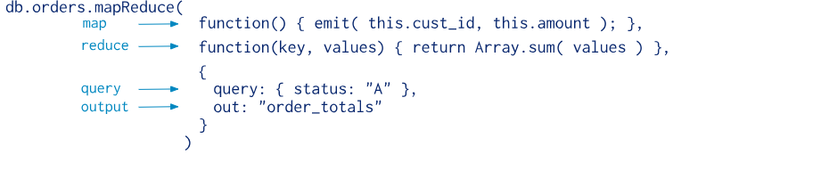
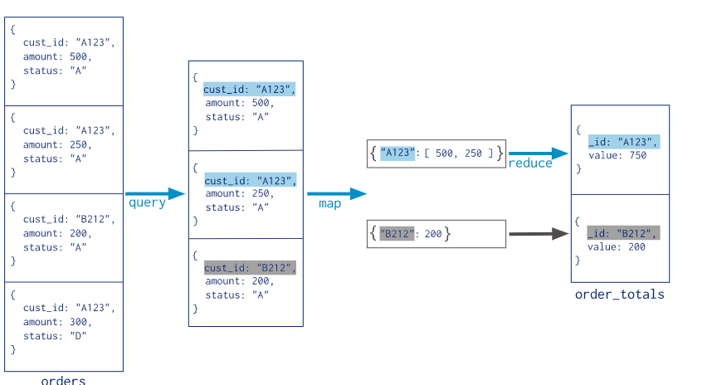

The syntax is following.
db.collection.mapReduce(
function() {emit(key,value);}, //map function
function(key,values) {return reduceFunction}, {
out: collection,
query: document,
sort: document,
limit: number
}
)
- The map is a javascript function that maps a value with a key and emits a key-value pair.
- The reduce is a javascript function that reduces or groups all the documents having the same key.
- The out specifies the location of the map-reduce query result.
- The query specifies the optional selection criteria for selecting documents.
- The sort specifies the optional sort criteria.
- The limit specifies the optional maximum number of documents to be returned.

In the MangoDB shell type the following…
1 | > use library
The above is supposed to create a database called ‘library’.
Now to see whether your database been created, just type the following – which is supposed to list all the databases.
1 | > show dbs;
You will notice that the database that you just created is not listed there. The reason is, MongoDB creates databases on-demand. It will get created only when we add something to it.
5. Inserting data to MongoDB.
Let’s first create two books with the following commands.
1  2 | > book1 = {name : "Understanding JAVA", pages : 100}  > book2 = {name : "Understanding JSON", pages : 200}
Now, let’s insert these two books in to a collection called books.
1  2 | > db.books.save(book1)  > db.books.save(book2)
The above two statements will create a collection called books under the database library. Following statement will list out the two books which we just saved.
> db.books.find();

{ "_id" : ObjectId("4f365b1ed6d9d6de7c7ae4b1"), "name" : "Understanding JAVA", "pages" : 100 }
{ "_id" : ObjectId("4f365b28d6d9d6de7c7ae4b2"), "name" : "Understanding JSON", "pages" : 200 }
Let’s add few more records.
> book = {name : "Understanding XML", pages : 300}
> db.books.save(book)
> book = {name : "Understanding Web Services", pages : 400}
> db.books.save(book)
> book = {name : "Understanding Axis2", pages : 150}
> db.books.save(book)
6. Writing the Map function
Let’s process this library collection in a way that, we need to find the number of books having pages less 250 pages and greater than that.
> var map = function() {
var category;
if ( this.pages >= 250 )
category = 'Big Books';
else
category = "Small Books";
emit(category, {name: this.name});
};
Here, the collection produced by the Map function will have a collection of following members.
{"Big Books",[{name: "Understanding XML"}, {name : "Understanding Web Services"}]);
{"Small Books",[{name: "Understanding JAVA"}, {name : "Understanding JSON"},{name: "Understanding Axis2"}]);
7. Writing the Reduce function.
> var reduce = function(key, values) {
var sum = 0;
values.forEach(function(doc) {
sum += 1;
});
return {books: sum};
};
8. Running MapReduce against the books collection.
> var count = db.books.mapReduce(map, reduce, {out: "book_results"});
> db[count.result].find()

{ "_id" : "Big Books", "value" : { "books" : 2 } }
{ "_id" : "Small Books", "value" : { "books" : 3 } }
The above says, we have 2 Big Books and 3 Small Books.
Everything done above using the MongoDB shell, can be done with Java too. Following is the Java client for it. You can download the required dependent jar from here.
import com.mongodb.BasicDBObject;
import com.mongodb.DB;
import com.mongodb.DBCollection;
import com.mongodb.DBObject;
import com.mongodb.MapReduceCommand;
import com.mongodb.MapReduceOutput;
import com.mongodb.Mongo;

public class MongoClient {

/**
* @param args
*/
public static void main(String[] args) {

Mongo mongo;

try {
mongo = new Mongo("localhost", 27017);
DB db = mongo.getDB("library");

DBCollection books = db.getCollection("books");

BasicDBObject book = new BasicDBObject();
book.put("name", "Understanding JAVA");
book.put("pages", 100);
books.insert(book);

book = new BasicDBObject();
book.put("name", "Understanding JSON");
book.put("pages", 200);
books.insert(book);

book = new BasicDBObject();
book.put("name", "Understanding XML");
book.put("pages", 300);
books.insert(book);

book = new BasicDBObject();
book.put("name", "Understanding Web Services");
book.put("pages", 400);
books.insert(book);

book = new BasicDBObject();
book.put("name", "Understanding Axis2");
book.put("pages", 150);
books.insert(book);

String map = "function() { "+
"var category; " +
"if ( this.pages >= 250 ) "+
"category = 'Big Books'; " +
"else " +
"category = 'Small Books'; "+
"emit(category, {name: this.name});}";

String reduce = "function(key, values) { " +
"var sum = 0; " +
"values.forEach(function(doc) { " +
"sum += 1; "+
"}); " +
"return {books: sum};} ";

MapReduceCommand cmd = new MapReduceCommand(books, map, reduce,
null, MapReduceCommand.OutputType.INLINE, null);

MapReduceOutput out = books.mapReduce(cmd);

for (DBObject o : out.results()) {
System.out.println(o.toString());
}
} catch (Exception e) {
// TODO Auto-generated catch block
e.printStackTrace();
}
}
}

