Thread

- Introduction
  - Definition of Multitasking
Executing several task simultaneously that called multitasking. It is two type’s.
    - Process Based Multitasking
      - Define: Executing several task simultaneously where each task is a separate independent program(process) , this type of thread called process based
      - Example: Same candidate do this below task in same system at the same time :
        - Typing Program
        - Audio Listening
        - Movie download
    - Program Based Multitasking
      - Define: Executing several task simultaneously where each task is separate independent path of the same program
      - The main important application area of multithreading are to developed multi media graphic , animations, video game, application server or web server
      - When compare to the old languages developing multi threading application in java is very easy because java provide in-build support for multi threading with each api (thread, run able, thread group …)
      - overloading of run method is possible but when I call t.start method then it will call to no argument run method. So other overloaded method we have to call explicitly like a normal method call
public class MyThread extends Thread{
public void run(){//job of thread
syso(“no-arg method”);
}
public void run(int i){//job of thread
syso(“int arg method”);
}

}

public class MainThread{
public static void main(String …args){
MyThread t=new MyThread(); //thread instantiation
t.start();//starting of the child thread

for(int i=0;i<10;i++){
syso(“Main Thread execute”);
}
}
}
}

      - if we are not over riding run method then thread class run method will be executed which has empty implementation. Hence we won’t get any output
public class MyThread extends Thread{

}

public class MainThread{
public static void main(String …args){
MyThread t=new MyThread(); //thread instantiation
t.start();//starting of the child thread

for(int i=0;i<10;i++){
syso(“Main Thread execute”);
}
}
}
}
o/p No output

      - run method is highly recommended to over ride run method other wise we misuses the multithreading
      - if we are overriding start method then our start method call like a normal method call and new thread won’t be created
      - So start method not recommended to override start method. Otherwise don’t go for multithreading concept
public class MyThread extends Thread{
public void start(){
syso(“Start method”)
}
public void run(){
syso(“Run method”);
}
}

public class MainThread{
public static void main(String …args){
MyThread t=new MyThread();
t.start();
syso(“Main method”)

}
}
}
o/p Start Method
Main method

      - So in start method if I call the super.start() then thread method is create
public class MyThread extends Thread{
public void start(){
super.start();
syso(“Start method”);
}
public void run(){
syso(“Run method”);
}
}

public class MainThread{
public static void main(String …args){
MyThread t=new MyThread();
t.start();
syso(“Main method”)

}
}
}
o/p Start Method
Main method

      - After starting a thread if we are trying to restart the same thread then we will get run time IlligaleThreadStateException
Extending | Runnable
MyThread→Thread→Runnable Interface | Myrunnable→ Runnable Interface

      - we can get current executing object by using Thread.currentThread();

public class MyThread extends Thread{
public void run(){
syso(“run method executed by ”+Thread.currentThread().getName());
}
}

public class MainThread{
public static void main(String …args){
MyThread t=new MyThread();
t.start();
syso(“main method executed by ”+Thread.currentThread().getName());
}
}
}

o/p
main method executed by Thread : main
run method executed by Thread : Thread -0

      - Every thread in java has some priority it may be default priority generated by jvm or customized priority by programmer. The value range of thread priority 1 to 10 where 1 is min priority and 10 is max priority.
      - Thread scheduler which used the priority for allocating processor the thread which having highest priority who will get the first chance.
      - if two thread having same priority then we can’t expect exact execution order it depend on thread scheduler
      - thread class define the following method to get and set priority of a thread
public final int getPriority();
public final void setPriority(int p); where p is 1 to 10 other wise run time getting IllegalArugementException
      - The default priority of main thread is 5 but all remaining thread default priority inheritance from parent to child. So what ever priority have in main priority same priority is child thread
public class MyThread extends Thread{  public void run(){  syso(“child thread ”);  }  }  public class MainThread{  public static void main(String …args){  MyThread t=new MyThread();  Thread.currentThread().setPriority(7); --(A)  t.start();  syso(“main thread ”);  }  }  }  If we comment line (A) then main thread priority is 5 and child thread priority become 5 if we uncomment then main thread priority is | public class MyThread extends Thread{  public void run(){  for(int i=0;i<5;i++){  syso(“child thread ”);  }  }  }  public class MainThread{  public static void main(String …args){  MyThread t=new MyThread();  t.setPriority(7);  t.start();  for(int i=0;i<5;i++){  syso(“main thread“);  }  }  }  }  o/p this case first executed child thread after then main thread will executed if I comment t.setPriority(7) line then I don’t know wchich will executed first. Because we can’t expect exact output. If we not comment the then main thread has the priority 5 and child thread has the priority 7 hence the child thread executed first and main thread executed last so out put is  child thread  child thread  child thread  child thread  child thread  main thread  main thread  main thread  main thread  main thread  N.B Some o.s. won’t provided proper support for thread priorities

      - we can prevent a thread execution by using flowing method
        - yield();
        - join();
        - sleep();
      - yield() method cause to pass current executing thread to give the chance for waiting thread of same priority. If there is no waiting thread or all waiting now low priority then same thread can continue it’s execution.
      - if multiple threads are waiting with same priority then which getting thread get the chance we can’t expect. It’s depending on thread scheduler.
      - prototype of yield method public static native void yield()
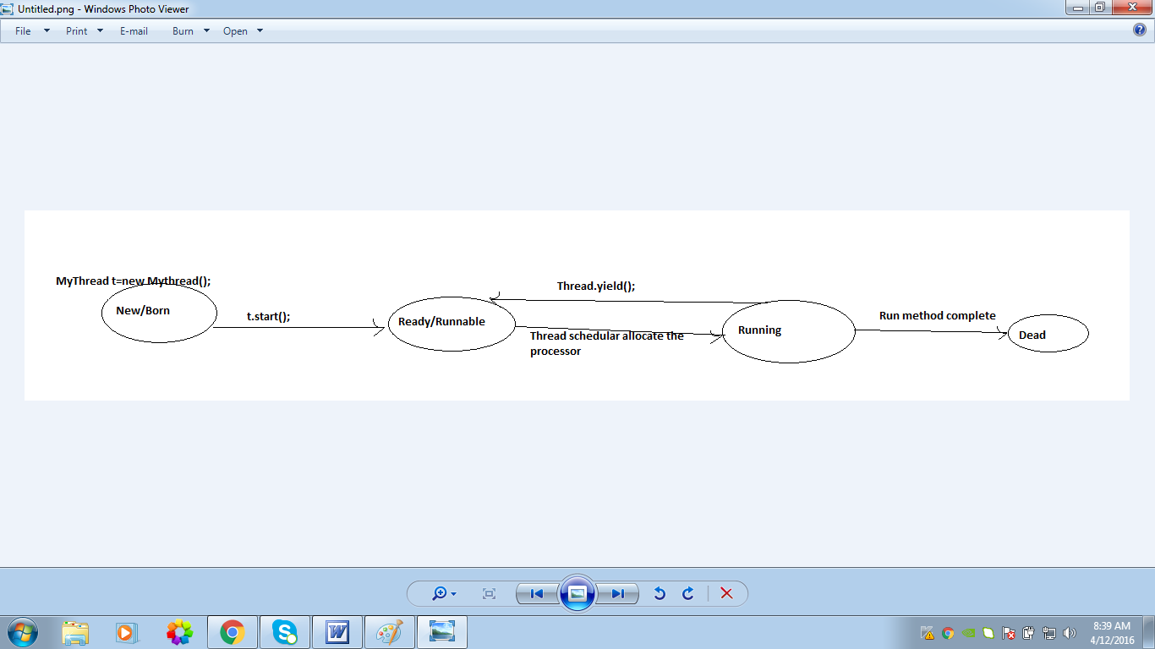
      - Join method: if a thread wants to wait some other thread then we should go for join method
      - for example if thread t1 wants to wait until completing t2 then t1 hah to call t2.join();
      - If t1 execute t2.join() then immediately t1 enter into waiting state until t2 complete. Once t2 compete then t1 can continue it execution.
      - difference between each method

Yield() | Join() | Sleep()
2> When a task invokes its yield() method, it returns to the ready state, either from waiting, running or after its creation.  1> New/born →t.start()→ready/runnable→ time scheduler allocation→running-→if run is completed→Dead  public class MyThread extends Thread{  public void run(){//job of thread  for (int i=0;i<10;i++){  syso(“child thread jobs”);  Thread.yield();// so main thread get the maximum chance  }  }  }  public class MainThread{  public static void main(String …args){  MyThread t=new MyThread(); //thread instantiation  t.start();//starting of the child thread  for(int i=0;i<10;i++){  syso(“Main Thread execute”);  }  }  } | The final join() method waits until thread on which it is called is terminated. For example, thread1.join() suspends the current thread until thread1 dies.  You can also pass a long value to join method to specify the number of milliseconds you are prepared to wait for the death of a thread. For example, thread1.join(1000) wait upto 1 second for thread1 to die, and then continue execution.  The join() method can throw an InterruptedException if the current thread is interrupted by another thread. | 2>When a task invokes its sleep() method, it returns to the waiting state from a running state.

 | Wait | Sleep | Yield
1. | Method of class Object | Method of class Thread | Method of class Thread
2. | Non – Static | Static | Static
3. | Not invoked on a thread instance | Invoked on a thread instance | Invoked on a thread instance
4. | Moves the thread to “wait’ state | Moves the thread to “wait” state | Moves the thread to “ready” state
5. | Thread loose the ownership of the lock | Thread doesn’t loose the ownership of the lock | Thread doesn’t loose the ownership of the lock

      - ddd

MyThread t=new MyThread(); //thread instantiation
t.start();//starting of the child thread

So what is the important of start method?
t.start{
- Register this thread object to thread scheduler
- perform all of the mandatory activities
- invoke run();
}

  - Multi tasking: best example of class room student’s
    - Listening the class
    - Taking running notes
    - Checking mobile phone
    - Sleeping
    - Observing environment
- How many way to define a thread
  - By Extending thread class:
  - By implementation of thread

Extending Thread | Implementation
public class MyThread extends Thread{  public void run(){//job of thread  for (int i=0;i<10;i++){  syso(“child thread jobs”);  }  }  }  public class MainThread{  public static void main(String …args){  MyThread t=new MyThread(); //thread instantiation  t.start();//starting of the child thread  for(int i=0;i<10;i++){  syso(“Main Thread execute”);  }  }  } | public class MyThread implements Runnable{  public void run(){//job of thread  for (int i=0;i<10;i++){  syso(“child thread jobs”);  }  }  }  public class MainThread{  public static void main(String …args){  MyThread resource=new MyThread();  Thread t=new Thread(resource); //thread //instantiation to create new thread object  t.start();//starting of the child thread  for(int i=0;i<10;i++){  syso(“Main Thread execute”);  }  }  }

- Getting and setting name of a thread
- Thread priority
- The methods to prevent thread execution
  - Yield()
  - Join()
  - Sleep()
- Synchronization
- Inter Thread communication
  - Wait()
  - Notify()
  - notifyAll()
- Dead Lock
- Demon Threads
- Multi threading Enhancement
  - Lock()
  - Reenter Lock
  - Thread Group
  - Thread Local
  - Executor Service
Extends Threads | Runable Threads
Public class TestThreads extend Thread{  Public void run(){  for (int i=0;i<10;i++){  syso(“Child thread create”);  }  }}  Public class ThreadDemo{  Public static void main(String args[]){  TestThreads t=new TestThreads();  t.start();  for (int i=0;i<10;i++){  syso(“Main thread create”);  }  }}  N.B Here this class already extend to Thread class so I can’t do the inheritance to other class. So I misusages inheritance benefit | Public class TestThreads implements Runnable{  Public void run(){  for (int i=0;i<10;i++){  syso(“Child thread create”);  }  }}  Public class ThreadDemo{  Public static void main(String args[]){  TestThreads r=new TestThreads();  Thread t=new Thread(r);  t.start();  for (int i=0;i<10;i++){  syso(“Main thread create”);  }  }}  N.B But here I can do this inheritance

Thread Scheduler:

1. Object level lock in Java
Object level lock is mechanism when we want to synchronize a non-static method or non-static code block such that only one thread will be able to execute the code block on given instance of the class. This should always be done to make instance level data thread safe.
Object level locking can be done as below :
Various ways for object level locking
public class DemoClass
{
public synchronized void demoMethod(){}
}

or

public class DemoClass
{
public void demoMethod(){
synchronized (this)
{
//other thread safe code
}
}
}

or

public class DemoClass
{
private final Object lock = new Object();
public void demoMethod(){
synchronized (lock)
{
//other thread safe code
}
}
}

2. Class level lock in Java
Class level lock prevents multiple threads to enter in synchronized block in any of all available instances of the class on runtime. This means if in runtime there are 100 instances of DemoClass, then only one thread will be able to execute demoMethod() in any one of instance at a time, and all other instances will be locked for other threads.
Class level locking should always be done to make static data thread safe. As we know that static keyword associate data of methods to class level, so use locking at static fields or methods to make it on class level.
Various ways for class level locking
public class DemoClass
{
//Method is static
public synchronized static void demoMethod(){

}
}

or

public class DemoClass
{
public void demoMethod()
{
//Acquire lock on .class reference
synchronized (DemoClass.class)
{
//other thread safe code
}
}
}

or

public class DemoClass
{
private final static Object lock = new Object();

public void demoMethod()
{
//Lock object is static
synchronized (lock)
{
//other thread safe code
}
}
}

3. Object level lock vs class level lock – Important notes
- Synchronization in Java guarantees that no two threads can execute a synchronized method, which requires same lock, simultaneously or concurrently.
- synchronized keyword can be used only with methods and code blocks. These methods or blocks can be static or non-static both.
- When ever a thread enters into Java synchronized method or block it acquires a lock and whenever it leaves synchronized method or block it releases the lock. Lock is released even if thread leaves synchronized method after completion or due to any Error or Exception.
- Java synchronized keyword is re-entrant in nature it means if a synchronized method calls another synchronized method which requires same lock then current thread which is holding lock can enter into that method without acquiring lock.
- Java synchronization will throw NullPointerException if object used in synchronized block is null. For example, in above code sample if lock is initialized as null, the “synchronized (lock)” will throw NullPointerException.
- Synchronized methods in Java put a performance cost on your application. So use synchronization when it is absolutely required. Also, consider using synchronized code blocks for synchronizing only critical section of your code.
- It’s possible that both static synchronized and non static synchronized method can run simultaneously or concurrently because they lock on different object.
- According to the Java language specification you can not use synchronized keyword with constructor. It is illegal and result in compilation error.
- Do not synchronize on non final field on synchronized block in Java. because reference of non final field may change any time and then different thread might synchronizing on different objects i.e. no synchronization at all.
- Do not use String literals because they might be referenced else where in the application and can cause deadlock. String objects created with new keyword can be used safely. But as a best practice, create a new private scoped Object instance OR lock on the shared variable itself which we want to protect. [Thanks to Anu to point this out in comments.

Java Callable Future Example
One of the benefits of the Java executor framework is that we can run concurrent tasks that may return a single result after processing the tasks. The Java Concurrency API achieves this with the following two interfaces Callable and Future.

1. Java Callable and Future interfaces

1.1. Callable
Callable interface has the call() method. In this method, we have to implement the logic of a task. The Callable interface is a parameterized interface, meaning we have to indicate the type of data the call() method will return.

2.2. Future
Future interface has methods to obtain the result generated by a Callable object and to manage its state.

2. Java Callable Future Example
In this example, We are creating a FactorialCalculator which is of type Callable. It means we will override it’s call() method and after calculation, we will return the result from call() method. This result later can be retrieved from Future reference held by main program.
FactorialCalculator.java
public class FactorialCalculator implements Callable<Integer>
{

private Integer number;

public FactorialCalculator(Integer number) {
this.number = number;
}

@Override
public Integer call() throws Exception {
int result = 1;
if ((number == 0) || (number == 1)) {
result = 1;
} else {
for (int i = 2; i <= number; i++) {
result *= i;
TimeUnit.MILLISECONDS.sleep(20);
}
}
System.out.println("Result for number - " + number + " -> " + result);
return result;
}
}
Now let’s test the above factorial calculator using two threads and 4 numbers.
CallableExample.java
package com.howtodoinjava.demo.multithreading;

import java.util.ArrayList;
import java.util.List;
import java.util.Random;
import java.util.concurrent.Callable;
import java.util.concurrent.ExecutionException;
import java.util.concurrent.Executors;
import java.util.concurrent.Future;
import java.util.concurrent.ThreadPoolExecutor;
import java.util.concurrent.TimeUnit;

public class CallableExample
{
public static void main(String[] args)
{
ThreadPoolExecutor executor = (ThreadPoolExecutor) Executors.newFixedThreadPool(2);

List<Future<Integer>> resultList = new ArrayList<>();

Random random = new Random();

for (int i=0; i<4; i++)
{
Integer number = random.nextInt(10);
FactorialCalculator calculator = new FactorialCalculator(number);
Future<Integer> result = executor.submit(calculator);
resultList.add(result);
}

for(Future<Integer> future : resultList)
{
try
{
System.out.println("Future result is - " + " - " + future.get() + "; And Task done is " + future.isDone());
}
catch (InterruptedException | ExecutionException e)
{
e.printStackTrace();
}
}
//shut down the executor service now
executor.shutdown();
}
}
Program output.
Console
Result for number - 4 -> 24
Result for number - 6 -> 720
Future result is - - 720; And Task done is true
Future result is - - 24; And Task done is true
Result for number - 2 -> 2
Result for number - 6 -> 720
Future result is - - 720; And Task done is true
Future result is - - 2; And Task done is true
Here we sent a Callable object to be executed in an executor using the submit() method. This method receives a Callable object as a parameter and returns a Future object that we can use with two main objectives –
- We can control the status of the task – we can cancel the task and check if it has finished. For this purpose, we have used the isDone() method to check if the tasks had finished.
- We can get the result returned by the call() method. For this purpose, we have used the get() method. This method waits until the Callable object has finished the execution of the call() method and has returned its result.
If the thread is interrupted while the get() method is waiting for the result, it throws an InterruptedException exception. If the call() method throws an exception, this method throws an ExecutionException exception.
The Future interface provides another version of the get() method i.e. get(longtimeout,TimeUnitunit). This version of the get method, if the result of the task isn’t available, waits for it for the specified time. If the specified period of time passes and the result isn’t yet available, the method returns a null value.
https://howtodoinjava.com/java/multi-threading/java-callable-future-example/

How Threadpool re-use Threads and how it works

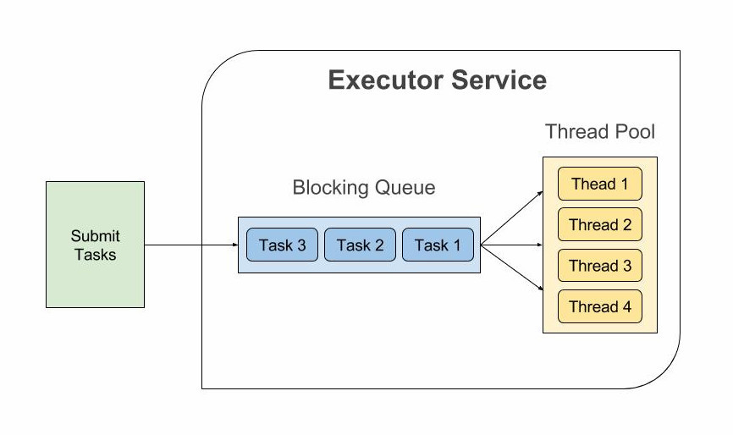

package com.kartik.thread.pool;

import java.util.concurrent.ExecutorService;
import java.util.concurrent.Executors;
/**
*
* @author kmandal
*
*
* In Java what I know is, we can't call a thread more than once:

Thread t = new Thread; //Some Runnable
t.start();

t.start(); //Illegal and throw Exception at runtime.

As far as I know, it throws exception when you call t.start() again because the associated stack for the thread is destroyed once it goes out of run()
method and you are trying to initialize things again.

In that case, what I know about thread pool is, it gives better performance & saves time because there is no need to create new thread (I read in this).

If there is no need to create new thread in thread pool scenario, then how it works with same thread which just finished its run method,
will that thread can be used again?

I read this, and it says that <b>"Most of the executor implementations in java.util.concurrent use thread pools, which consist of worker threads.
This kind of thread exists separately from the Runnable and Callable tasks it executes and is often used to execute multiple tasks."</b>

So what is Worker thread here, is it something different then normal Java threads?

With this link, I got something but still confused on what kind of stuff can be eliminated when we use thread pool and why it gives better
performance than using normal java threads.

So can we say like this,

Thread has three parts,

Creation (Telling OS that it is new thread, create stack for it.)
Execute Runnable with run() method.
Destroying threads.
*
*/
public class TestThreadPool {
// Maximum number of threads in thread pool
static final int MAX_T = 3;

public static void main(String[] args)
{
// creates five tasks
Runnable r1 = new Task("task 1",4);
Runnable r2 = new Task("task 2",3);
Runnable r3 = new Task("task 3",6);
Runnable r4 = new Task("task 4",9);
Runnable r5 = new Task("task 5",18);
Runnable r6 = new Task("task 6",4);
Runnable r7 = new Task("task 7",3);
Runnable r8 = new Task("task 8",6);
Runnable r9 = new Task("task 9",9);
Runnable r10 = new Task("task 10",4);
Runnable r11 = new Task("task 11",3);
Runnable r12 = new Task("task 12",6);
Runnable r13 = new Task("task 13",9);
Runnable r14 = new Task("task 14",4);
Runnable r15 = new Task("task 15",3);
Runnable r16 = new Task("task 16",6);
Runnable r17 = new Task("task 17",9);

// creates a thread pool with MAX_T no. of
// threads as the fixed pool size(Step 2)
ExecutorService pool = Executors.newFixedThreadPool(MAX_T);

// passes the Task objects to the pool to execute (Step 3)
pool.execute(r1);
pool.execute(r2);
pool.execute(r3);
pool.execute(r4);
pool.execute(r5);
pool.execute(r6);
pool.execute(r7);
pool.execute(r8);
pool.execute(r9);
pool.execute(r10);
pool.execute(r11);
pool.execute(r12);
pool.execute(r13);
pool.execute(r14);
pool.execute(r15);
pool.execute(r16);
pool.execute(r17);

// pool shutdown ( Step 4)
pool.shutdown();
}
}

package com.kartik.thread.pool;
//Java program to illustrate
//ThreadPool
import java.text.SimpleDateFormat;
import java.util.Date;

//Task class to be executed (Step 1)
public class Task implements Runnable
{
private String name;
private int data;

public Task(String s,int d)
{
name = s;
data=d;
}

// Prints task name and sleeps for 1s
// This Whole process is repeated 5 times
public void run()
{
try
{

System.out.println("Executing Time for task name - "+name +" and factorial data = " +factorial(data)+" thread name "+Thread.currentThread().getName());
Thread.sleep(100);
System.out.println(name+" complete");
}

catch(InterruptedException e)
{
e.printStackTrace();
}
}

//method to find factorial of given number
static int factorial(int n)
{
if (n == 0)
return 1;

return n*factorial(n-1);
}
}

Out put:

Executing Time for task name - task 3 and factorial data = 720 thread name pool-1-thread-3
Executing Time for task name - task 1 and factorial data = 24 thread name pool-1-thread-1
Executing Time for task name - task 2 and factorial data = 6 thread name pool-1-thread-2
task 1 complete
task 2 complete
task 3 complete
Executing Time for task name - task 4 and factorial data = 362880 thread name pool-1-thread-1
Executing Time for task name - task 5 and factorial data = -898433024 thread name pool-1-thread-3
Executing Time for task name - task 6 and factorial data = 24 thread name pool-1-thread-2
task 4 complete
Executing Time for task name - task 7 and factorial data = 6 thread name pool-1-thread-1
task 5 complete
task 6 complete
Executing Time for task name - task 8 and factorial data = 720 thread name pool-1-thread-3
Executing Time for task name - task 9 and factorial data = 362880 thread name pool-1-thread-2
task 7 complete
Executing Time for task name - task 10 and factorial data = 24 thread name pool-1-thread-1
task 8 complete
task 9 complete
Executing Time for task name - task 11 and factorial data = 6 thread name pool-1-thread-3
Executing Time for task name - task 12 and factorial data = 720 thread name pool-1-thread-2
task 10 complete
Executing Time for task name - task 13 and factorial data = 362880 thread name pool-1-thread-1
task 11 complete
task 12 complete
Executing Time for task name - task 14 and factorial data = 24 thread name pool-1-thread-3
Executing Time for task name - task 15 and factorial data = 6 thread name pool-1-thread-2
task 13 complete
Executing Time for task name - task 16 and factorial data = 720 thread name pool-1-thread-1
task 14 complete
task 15 complete
Executing Time for task name - task 17 and factorial data = 362880 thread name pool-1-thread-3
task 16 complete
task 17 complete

How to create ThreadPoolExecutor

We can create following 5 types of thread pool executors with pre-built methods in java.util.concurrent.Executors interface.
- Fixed thread pool executor – Creates a thread pool that reuses a fixed number of threads to execute any number of tasks. If additional tasks are submitted when all threads are active, they will wait in the queue until a thread is available. It is best fit for most off the real-life usecases.
ThreadPoolExecutor executor = (ThreadPoolExecutor) Executors.newFixedThreadPool(10);
- Cached thread pool executor – Creates a thread pool that creates new threads as needed, but will reuse previously constructed threads when they are available. DO NOT use this thread pool if tasks are long running. It can bring down the system if number of threads goes beyond what system can handle.
ThreadPoolExecutor executor = (ThreadPoolExecutor) Executors.newCachedThreadPool();
- Scheduled thread pool executor – Creates a thread pool that can schedule commands to run after a given delay, or to execute periodically.
ThreadPoolExecutor executor = (ThreadPoolExecutor) Executors.newScheduledThreadPool(10);
- Single thread pool executor – Creates single thread to execute all tasks. Ute it when you have only one task to execute.
ThreadPoolExecutor executor = (ThreadPoolExecutor) Executors.newSingleThreadExecutor();
- Work stealing thread pool executor – Creates a thread pool that maintains enough threads to support the given parallelism level. Here parallelism level means the maximum number of threads which will be used to execute a given task, at single point of time, in multi-processor machines.
ThreadPoolExecutor executor = (ThreadPoolExecutor) Executors.newWorkStealingPool(4);

Deadlock Solution Example

Deadlock describes a situation where two or more threads are blocked forever, waiting for each other. Deadlock occurs when multiple threads need the same locks but obtain them in different order. A Java multithreaded program may suffer from the deadlock condition because the synchronized keyword causes the executing thread to block while waiting for the lock, or monitor, associated with the specified object. Here is an example.

public class TestThread {
public static Object Lock1 = new Object();
public static Object Lock2 = new Object();

public static void main(String args[]) {
ThreadDemo1 T1 = new ThreadDemo1();
ThreadDemo2 T2 = new ThreadDemo2();
T1.start();
T2.start();
}

private static class ThreadDemo1 extends Thread {
public void run() {
synchronized (Lock1) {
System.out.println("Thread 1: Holding lock 1...");

try { Thread.sleep(10); }
catch (InterruptedException e) {}
System.out.println("Thread 1: Waiting for lock 2...");

synchronized (Lock2) {
System.out.println("Thread 1: Holding lock 1 & 2...");
}
}
}
}
private static class ThreadDemo2 extends Thread {
public void run() {
synchronized (Lock2) {
System.out.println("Thread 2: Holding lock 2...");

try { Thread.sleep(10); }
catch (InterruptedException e) {}
System.out.println("Thread 2: Waiting for lock 1...");

synchronized (Lock1) {
System.out.println("Thread 2: Holding lock 1 & 2...");
}
}
}
}
}

