POST MAN

Click New → Add collection’s → Go to Collection and click “Add request” → and give the method name for this collection→Save this → Go-to left panel and see this method → double click this method→select method type like (GET/POST) →Give Simple URL(http://del.icio.us/api/peej/tags/) or create a dynamic URL→below 5 operation discussed below:
- Authorization
- Headers
- Body
- Pre-request-Script
- Tests
How to create a Simple URL:
For Get data:
http://del.icio.us/api/peej/tags/
For delete:
http://del.icio.us/api/peej/bookmark/:hash
How to create a Dynamic URL:
Goto setting icon → Manage Environment Options →Add →Give the Environment name →Give key and value of this environment Like (Key:RESTURLDATA and Value: http://del.icio.us/api/peej)→ after then see the “EYE” type icon (Environment quick look) → and see the key value are looking → After then add dynamic url like
For Get data:
{{RESTURLDATA}}/tags/
For delete:
{{RESTURLDATA}}/bookmarks/:hash
Operations:
- Authorization
How to include authorization variable:
- Header
How to include header variable:
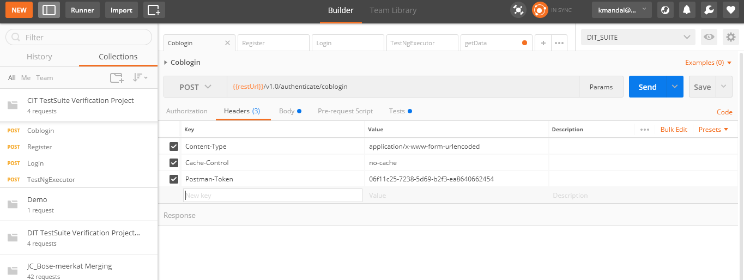

- Body
There have 4 options:
- form-data
- x-www-form-urlencoded
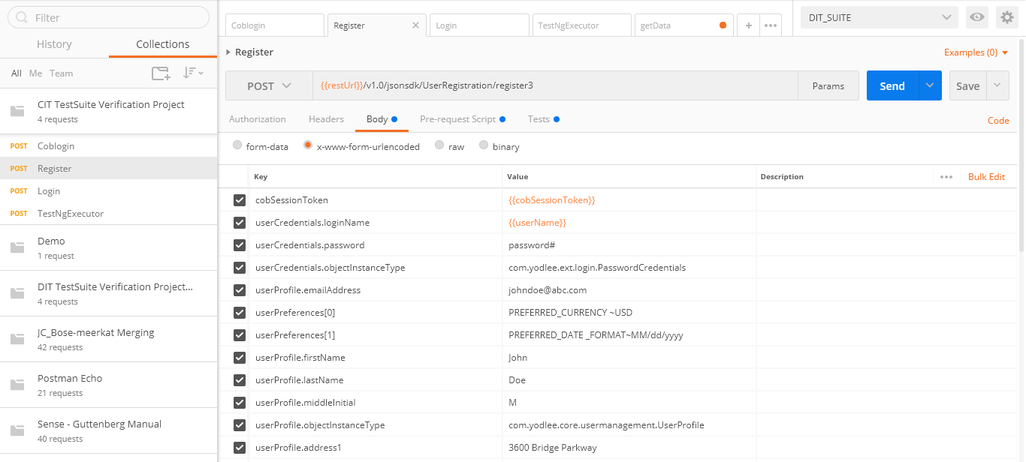

- raw
- binary
How to include body variable:
- Pre-Request-Scripts
How to use Pre-Request-Scripts:
var d = new Date();
var userName = d.getTime();
postman.setEnvironmentVariable("userName", "kartik"+userName);
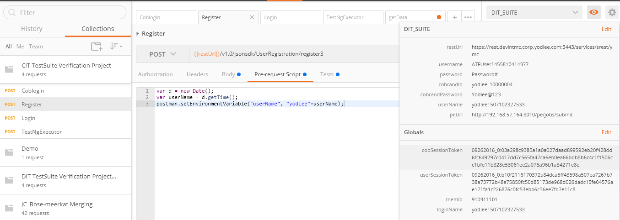
Here username is local Variable and I can use inside of body operation like
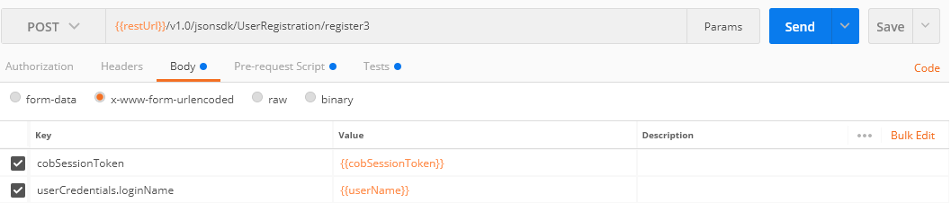

- Tests
How to execute tests or How to add global variable:
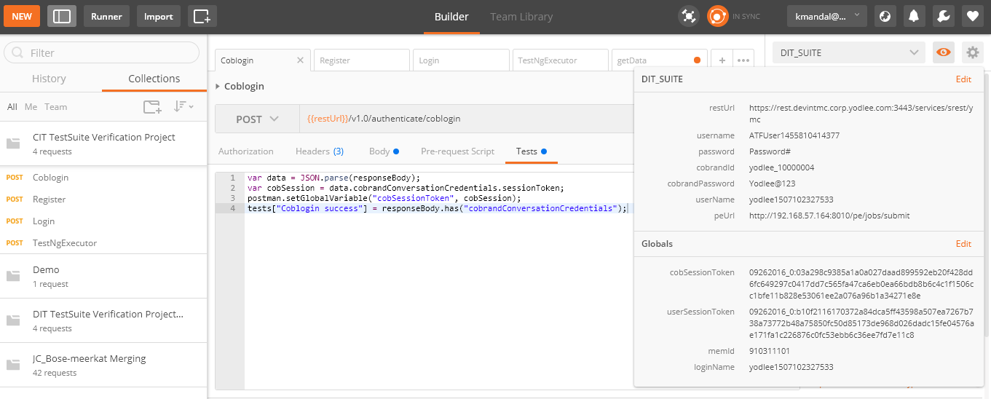

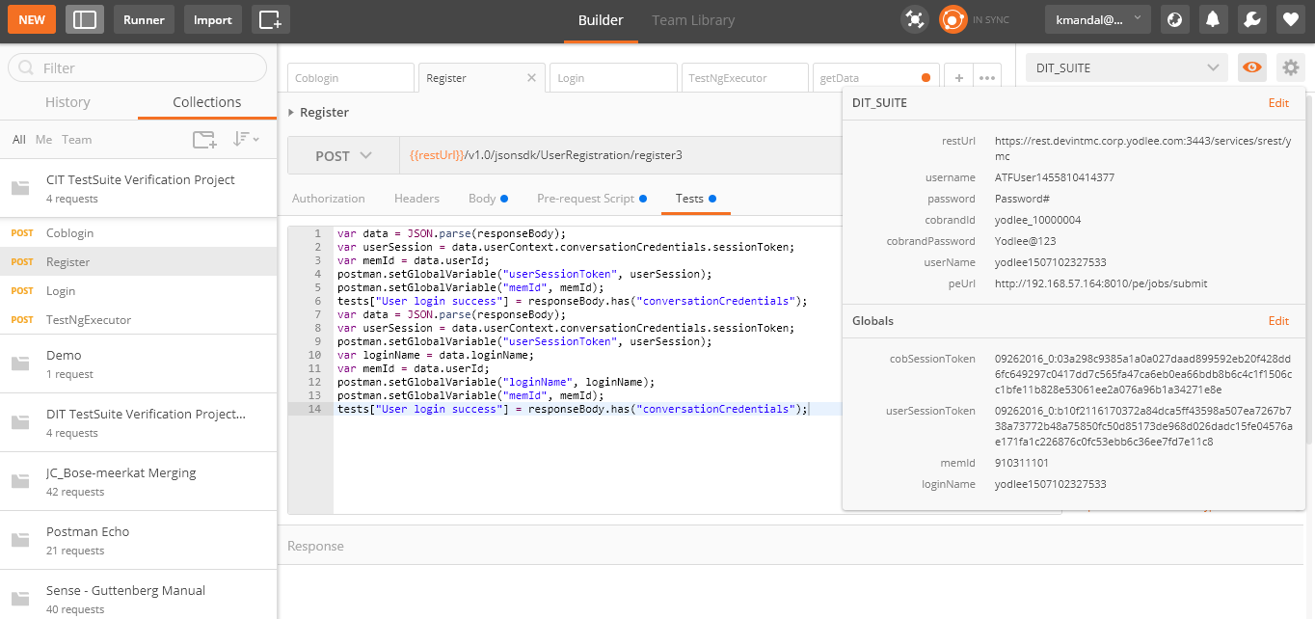

How to export Collection:

How to import Collection:

