- https://github.com/spring-projects/spring-mvc-showcase/tree/master/src/main/webapp/WEB-INF/views

How to Setup/Install Maven Classpath Variable on Windows
Apache Maven is a software project management and comprehension tool. Based on the concept of a project object model (POM), Maven can manage a project’s build, reporting and documentation from a central piece of information.
One article became very popular on Crunchify Site which I wrote sometime back on How to Create Dynamic Web Project using Maven in Eclipse? You may want to take a look at that
In this tutorial I’ll show you on how to setup/install Maven in Windows 7. To run maven from command line in Windows you should have properly set JAVA_HOME, MAVEN_HOME & PATH environment variables.
Another must read: How to Create Dynamic Web Project using Maven in Eclipse?

Step-1
Open System Variables Table.
Start button -> Computer menu item -> Properties on right click menu item -> Advanced System Settings button on left panel -> Advanced tab in System Properties dialog -> Environment Variables button -> System variables table
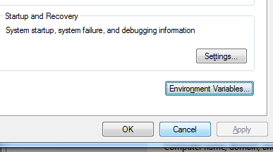

Step-2
Add MAVEN_HOME variable
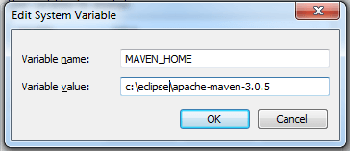

Step-3
Update PATH variable
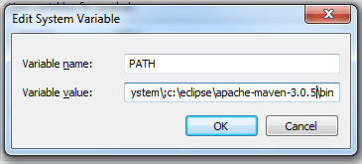

Step-4
Make sure you have JAVA_HOME variable correctly
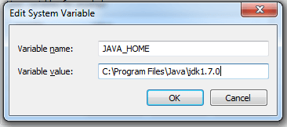

Step-5
Open NEW Command Prompt windows and execute command: mvn -version
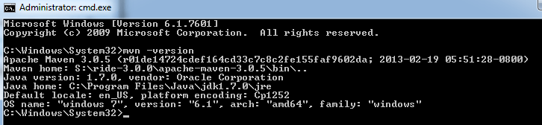
- How to create Maven JSF and PrimeFace project
- File Select new Maven project
- Give artifact information
  - Group id is com.kartik.tutorials
  - Artifact id is project name like Demo
  - Version is 0.0.0-1shanpshots
  - Packaging is war
  - Give any name of Prime face Demo
  - Click finished
- Now create one project in eclipse like Demo
- Expand the project and open the pom.xml file
<project xmlns="http://maven.apache.org/POM/4.0.0"
xmlns:xsi="http://www.w3.org/2001/XMLSchema-instance"
xsi:schemaLocation="http://maven.apache.org/POM/4.0.0
http://maven.apache.org/maven-v4_0_0.xsd">
<modelVersion>4.0.0</modelVersion>
<groupId>com.kartik.tutorials</groupId>
<artifactId>Demo</artifactId>
<packaging>war</packaging>
<version>1.0-SNAPSHOT</version>
<name>Prime faces Demo</name>
</project>
- and add build functional like below:
<project xmlns="http://maven.apache.org/POM/4.0.0"
xmlns:xsi="http://www.w3.org/2001/XMLSchema-instance"
xsi:schemaLocation="http://maven.apache.org/POM/4.0.0
http://maven.apache.org/maven-v4_0_0.xsd">
<modelVersion>4.0.0</modelVersion>
<groupId>com.kartik.tutorials</groupId>
<artifactId>Demo</artifactId>
<packaging>war</packaging>
<version>1.0-SNAPSHOT</version>
<name>Prime faces Demo</name>
<build>
<plugins>
<plugin>
<groupId>org.apache.maven.plugins</groupId>
<artifactId>maven-compiler-plugin</artifactId>
<version>3.1</version>
<configuration>
<source>1.7</source>
<target>1.7</target>
<showDeprecation>true<showDeprecation>
<showWarnings>true< showWarnings >
</configuration>
</plugin>
</plugins>
</build>
</project>
- now add dependency like
<project xmlns="http://maven.apache.org/POM/4.0.0"
xmlns:xsi="http://www.w3.org/2001/XMLSchema-instance"
xsi:schemaLocation="http://maven.apache.org/POM/4.0.0
http://maven.apache.org/maven-v4_0_0.xsd">
<modelVersion>4.0.0</modelVersion>
<groupId>com.kartik.tutorials</groupId>
<artifactId>Demo</artifactId>
<packaging>war</packaging>
<version>1.0-SNAPSHOT</version>
<name>Prime faces Demo</name>
<dependencies>
<dependency>
<groupId>org.primefaces</groupId>
<artifactId>primefaces</artifactId>
<version>5.0</version>
</dependency>
<dependency>
<groupId>javax.sun.faces</groupId>
<artifactId>jsf-api</artifactId>
<version>2.2.7</version>
</dependency>
<dependency>
<groupId>javax.sun.faces</groupId>
<artifactId>jsf-impl</artifactId>
<version>2.2.7</version>
</dependency>
<dependency>
<groupId>javax.servlet</groupId>
<artifactId>javax.servlet-api</artifactId>
<version>3.1.0</version>
</dependency>
</dependencies>
<build>
<plugins>
<plugin>
<groupId>org.apache.maven.plugins</groupId>
<artifactId>maven-compiler-plugin</artifactId>
<version>3.1</version>
<configuration>
<source>1.7</source>
<target>1.7</target>
<showDeprecation>true<showDeprecation>
<showWarnings>true< showWarnings >
</configuration>
</plugin>
</plugins>
</build>
</project>

- Now below of Eclipse markers and see the maven problem configuration right click and quick fix option click another one window open and click Finished
- Now right click on the main project and select properties →project faces let →uncheck dynamic web project →apply →now check dynamic web project → and below further configuration details click→then open new window →change content directory from Webcontent to src/main/webapp → click check box of generate web.xml deployment descriptor→Finished
- click apply→after apply it will take some times → click ok
- Now check java server faces→click further configuration required →open new window and click on search images→open jsf 2.2 (mojarra 2.2.0)→select this and now automatic below option come -→ click on next→select redio button of I accept terms and conditions→Finished→it will take some times→after then click uncheck the Include libraries with application → Ok
- apply →Ok
- Now expend the src and main of below folder structure and open web.xml file →click source →edit this web.xml file
<?xml version="1.0" encoding="ISO-8859-1" ?>

<web-app xmlns="http://java.sun.com/xml/ns/j2ee"
xmlns:xsi="http://www.w3.org/2001/XMLSchema-instance"
xsi:schemaLocation="http://java.sun.com/xml/ns/j2ee http://java.sun.com/xml/ns/j2ee/web-app_2_5.xsd"
version="2.5">

<display-name>Prime Face Demo</display-name>

<!-- Change to "Production" when you are ready to deploy -->
<!--<context-param>
<param-name>javax.faces.PROJECT_STAGE</param-name>
<param-value>Development</param-value>
</context-param> -->
<context-param>
<param-name>javax.faces.STATE_SAVING_METHOD</param-name>
<param-value>client</param-value>
</context-param>

<!-- Welcome page -->
<welcome-file-list>
<welcome-file>index.xhtml</welcome-file>
</welcome-file-list>

<!-- JSF mapping -->
<servlet>
<servlet-name>Faces Servlet</servlet-name>
<servlet-class>javax.faces.webapp.FacesServlet</servlet-class>
<load-on-startup>1</load-on-startup>
</servlet>

<!-- Map these files with JSF -->
<servlet-mapping>
<servlet-name>Faces Servlet</servlet-name>
<url-pattern>/faces/*</url-pattern>
</servlet-mapping>
<servlet-mapping>
<servlet-name>Faces Servlet</servlet-name>
<url-pattern>*.jsf</url-pattern>
</servlet-mapping>
<servlet-mapping>
<servlet-name>Faces Servlet</servlet-name>
<url-pattern>*.faces</url-pattern>
</servlet-mapping>
<servlet-mapping>
<servlet-name>Faces Servlet</servlet-name>
<url-pattern>*.xhtml</url-pattern>
</servlet-mapping>

</web-app>

- Now right click on webapp→new →File→create index.xhtml pages→add below code

- Now click src/main/java and create packages like demo →create ManagedBean.java and demoprop.properties file

- Code is:

<html xmlns="http://www.w3.org/1999/xhtml"
xmlns:h="http://java.sun.com/jsf/html"
xmlns:f="http://java.sun.com/jsf/core"
xmlns:f="http://java.sun.com/jsf/facelets"
xmlns:p="http://primefaces.org/ui">
<f:view contentType=”text/html” id=”fView”>
<h:head>
<f:view>
<f:loadBundle basename=”full path of demoprop with out extension like demo.demoprop” var=”page”/>
</f:view>
</h:head>

<h:body>
<p:form>
<p:commandButton value=”#{page.variable of properties}” action=”#{ManagedBean.method Name of MangedBean with first braces}” />
</p:form>
</h:body>
</html>

- after right click the main project →run as→ the click on run on server

- after right click the main project →run as→ the click on maven clean
- after right click the main project →run as→ the click on maven install
- after right click the main project →run as→ the click on run on server →add tomcat and run this server
- After then enjoy

