- Virtual Machine
  - It is a software simulation of a machine which can perform operation like a Physical machine
- Type Of virtual Machine:
  - Hardware Based Virtual Machine or System based virtual machine
    - Example:
      - Kernal Virtual Machine
      - VMWare
      - Cloud computing
      - Xen
  - Application Based Virtual Machine or Process based or software based
    - Example:
      - JVM act as a Runtime engine to Run Java application
      - PVM(Parrot VM) act as a runtime engine to Run scripting language like PERL
      - CLR(Common Language Runtime) act as a run for .net
- Basic Architecture Diagram of JVM

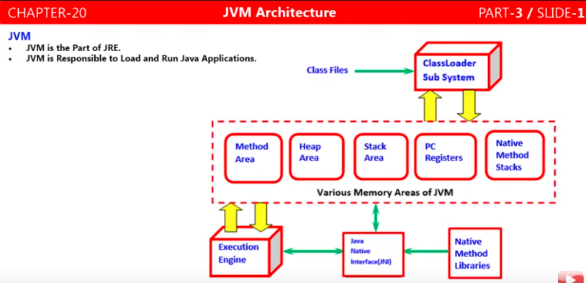
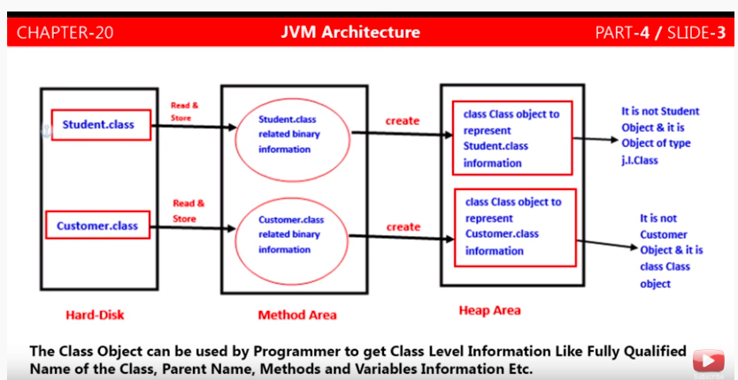

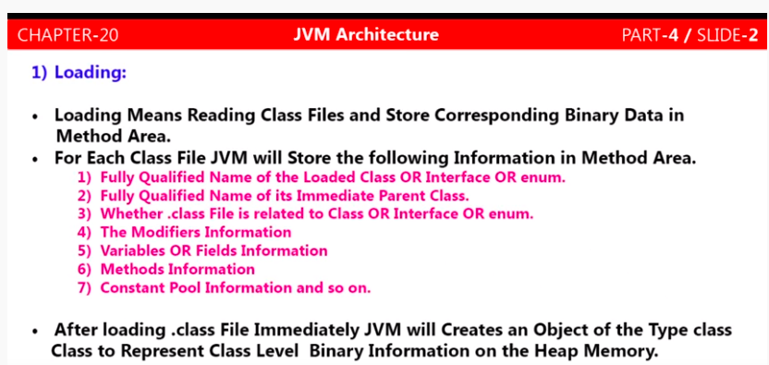

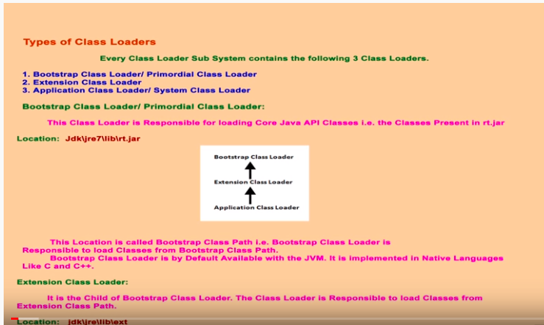
- Module 1:
  - Class Loader Sub System
    - Loading
      - Type Of Loading Class
        - Bootstrap class loader
        - extension class loader
        - Application class loader
    - Linking
      - Verification
      - Preparation
      - Resolution
    - Initialization
  - How java class loader works?
  - Need a customized class loader?
    - Default ClassLoader will load .class file once, even though we are using multiple times that class in our program. After loading .class file if it is modified outside, then default class loader not load modified file in method area. So we use this Customized class loader
  - Pseudo code of customized class loader?
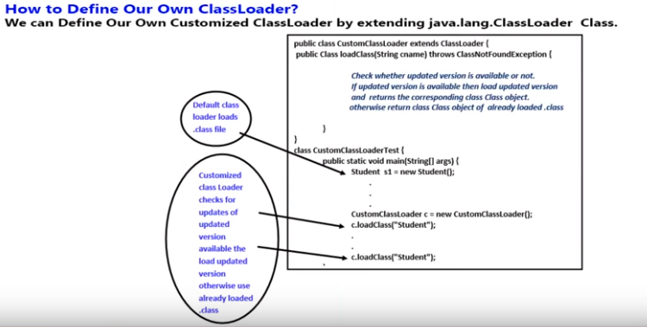
- Module 2
  - Various Memory area of JVM
    - Per JVM
      - Method area
      - Heap area
    - Per Thread
      - Statck area
      - PC Register
      - Native method statck
  - Program to display to Heap memory statistic
    - maxMemory()
    - totalMemory()
    - freeMemory()
  - How to set maxHeap and minHaeap or increase the memory
    - –Xmx=256 –Xmin=256
- Module 3
  - Execution Engine
    - Interpreter
    - JIT compiler
  - Java Native Interface
  - Complete Architure diagram of JVM
- Module 4
  - Clean file structure
    - Magic number Example: OX CAFÉ BAGE
    - Minor version of compiler
    - Major version of compiler

