Protocol Versions:
Protocol Version | Usage Recommendation
SSL v2 | Do not use. Has serious security vulnerabilities.
SSL v3 | Do not use. Has serious security vulnerabilities.
TLS 1.0 | Use for interoperability purposes where needed. Has known issues that cannot be mitigated in a way that guarantees interoperability, and thus mitigations are not enabled by default. Does not support modern cipher suites.
TLS 1.1 | Use for interoperability purposes where needed. Has no known issues but relies on protocol fixes that are included in all the Transport Layer Security (TLS) implementations in Red Hat Enterprise Linux. Does not support modern cipher suites.
TLS 1.2 | Supports Authenticated Encryption with Associated Data (AEAD) mode ciphers like AES-GCM, AES-CCM, or Camellia-GCM
TLS 1.3 | Support hashed key derivation function(HKDF)

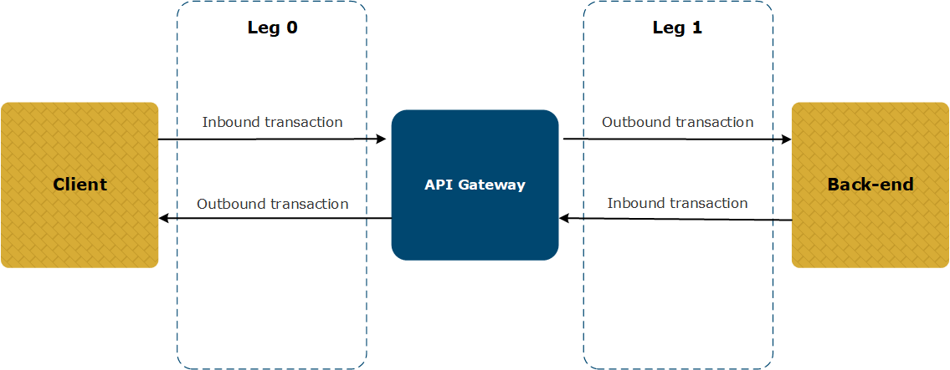
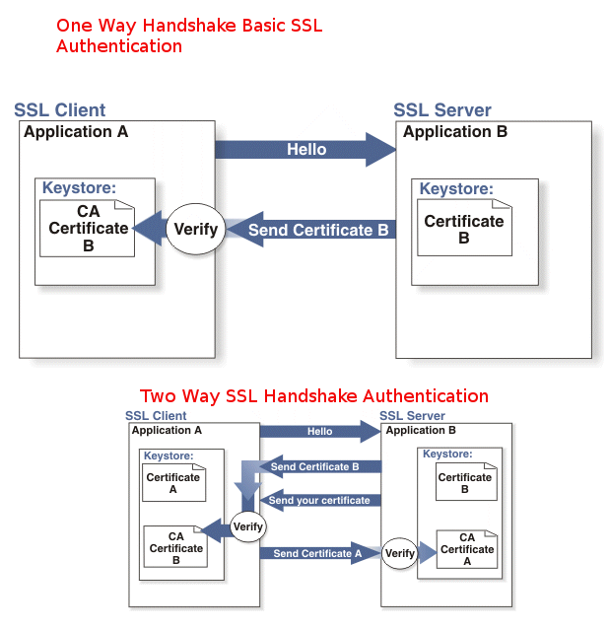
Simple Http Connection:
One-way-SSL. Only the client can verify the server's certificates. Servers do not verify the client's certificate.

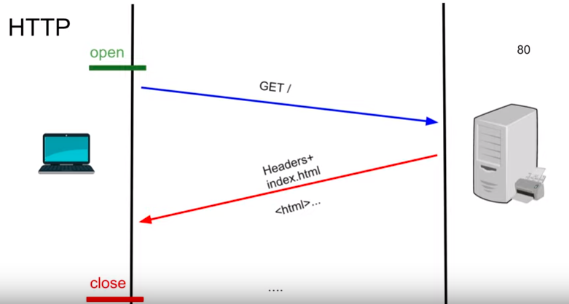

HTTPS Connection:
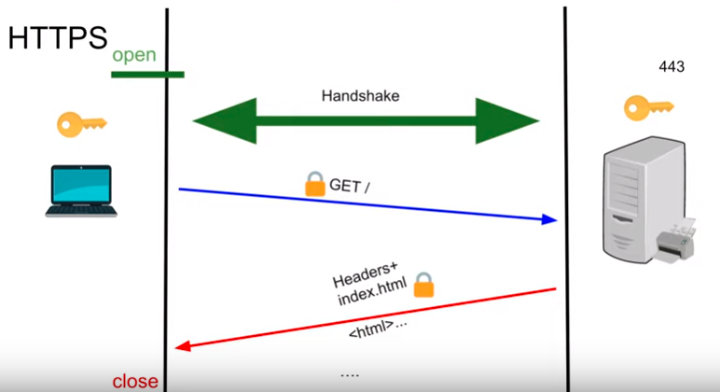

TLS 1.2 Connection:
Two-way-SSL, however, the server will verify the client's certificates. This is called mutual authentication. This is used in server to server communication, such as ActiveMQ nodes passing message among themselves in order to route the message

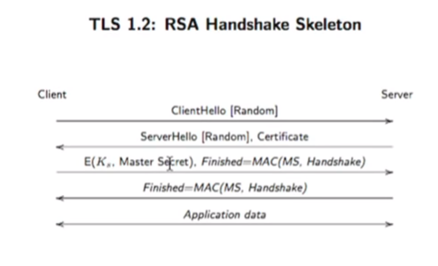

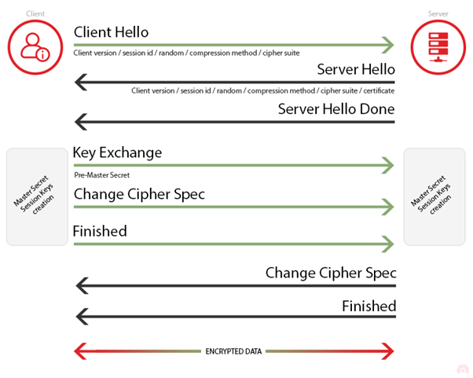

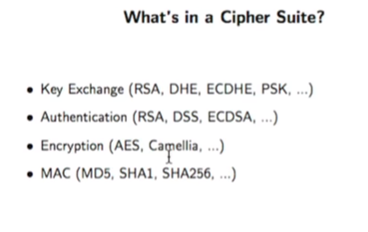

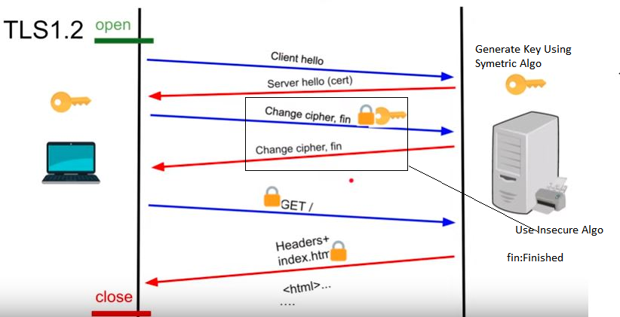
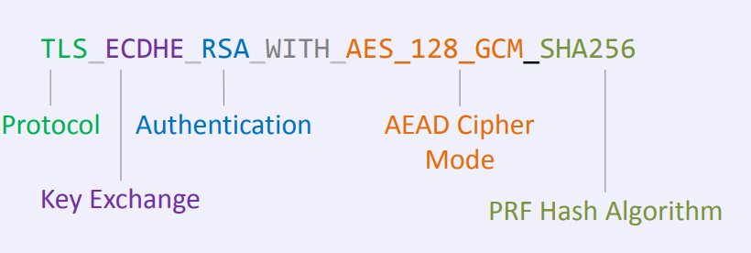
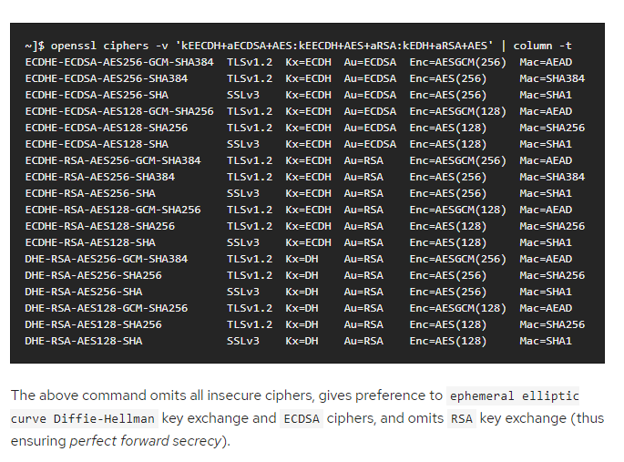
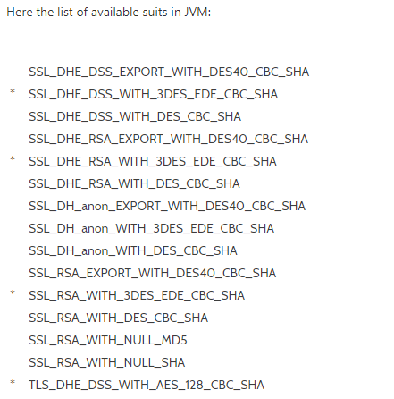
TLS 1.3 allows the signature algorithms
- EdDSA (Edwards-curve Digital Signature Algorithm),
- ECDSA (Elliptic Curve Digital Signature Algorithm) and
- RSA (however, RSA is disallowed for the transport of keys!)
Few Name Should be know
- Data Encryption Standard(DES)
- Electronic codebook(ECB)
- Cipher Block Chaining (CBC)
- initialization vector (IV)
https://access.redhat.com/documentation/en-us/red_hat_jboss_enterprise_application_platform/7.0/html/how_to_configure_server_security/securing_the_server_and_its_interfaces
TLS 1.3:
TLS 1.3 what function remove from TLS 1.2:
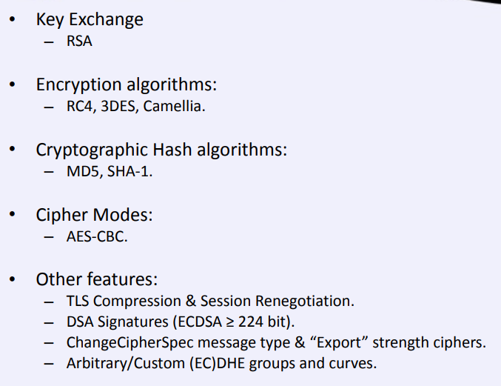

TLS 1.3 what function newly added:
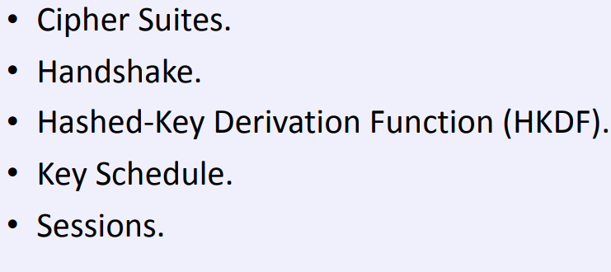
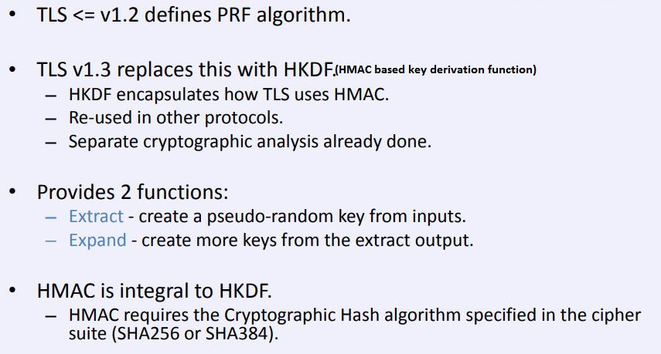

TLS 1.3 Cipher Suits
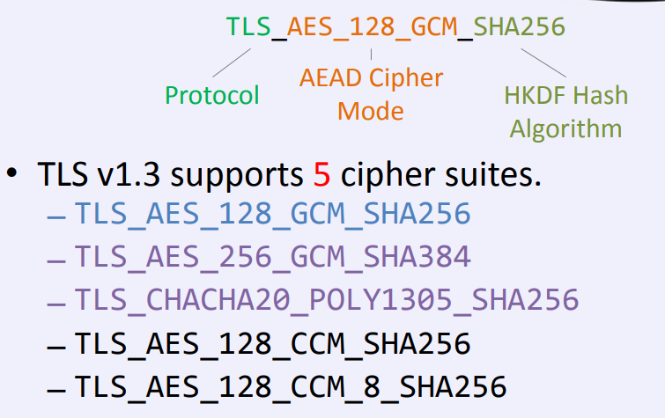
TLS 1.3 Algo:

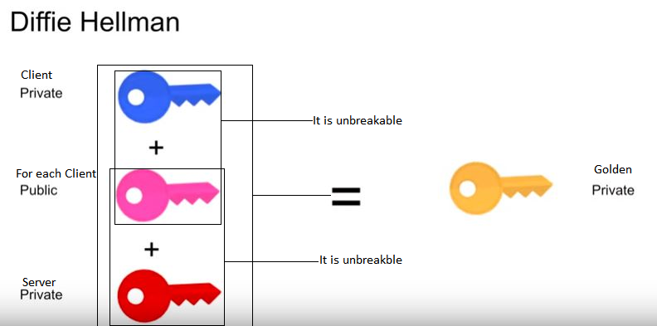

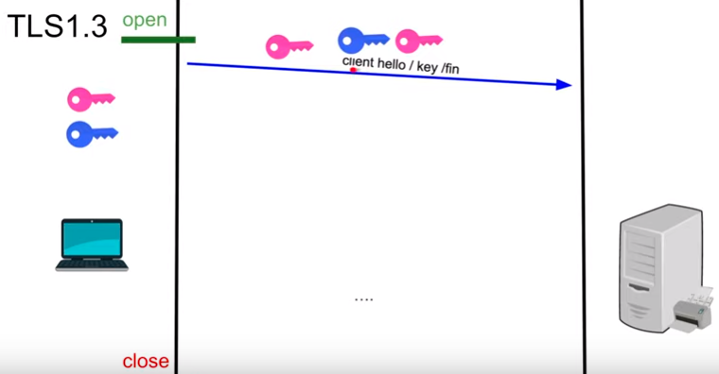

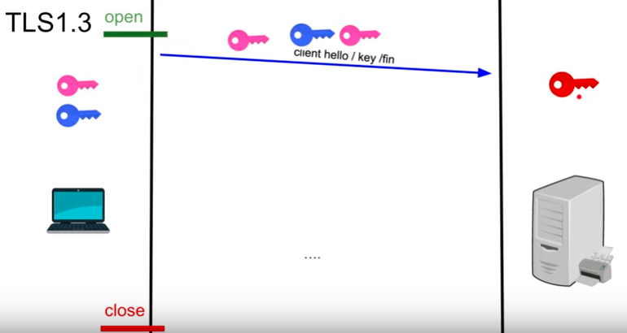
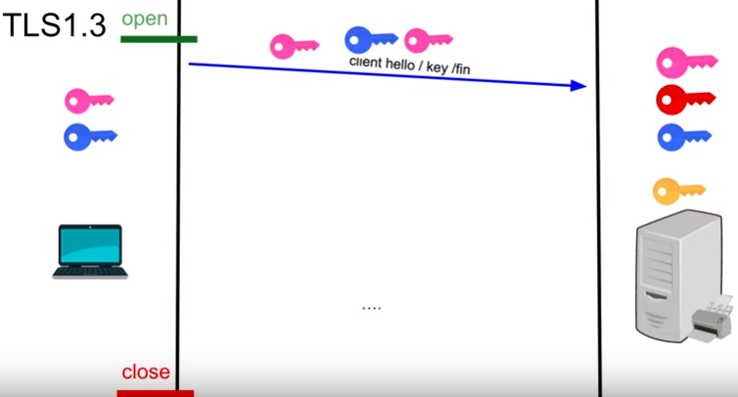
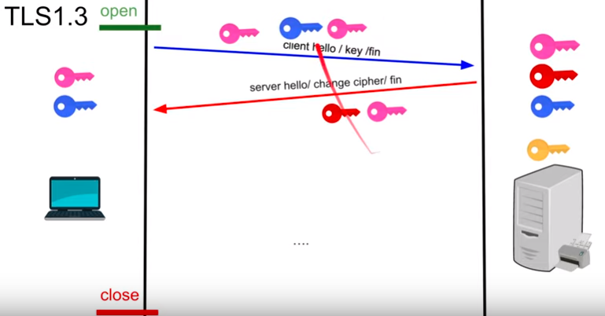

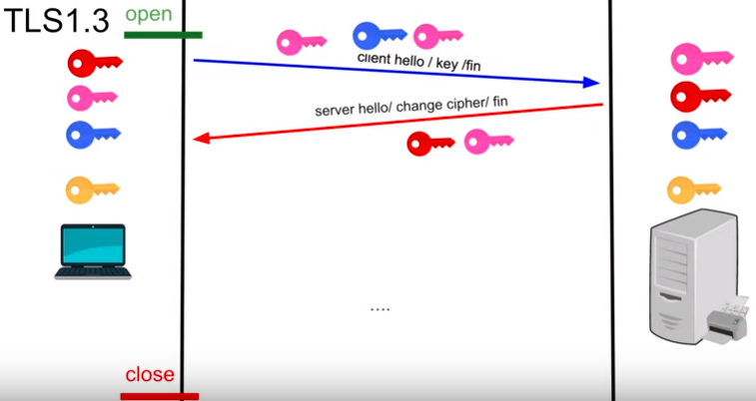

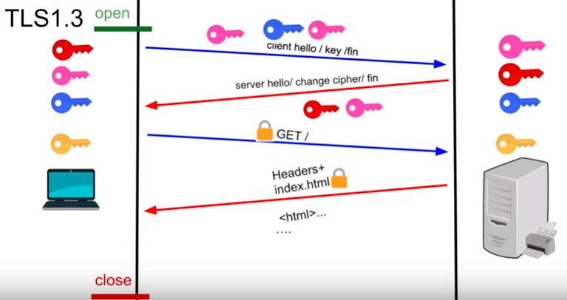

Code work for SSL:
  - Jboss settings (First priority) – Need to add the following highlighted line to enable TLSv1.2. If TLSV1.1 is needed, we may need to add that as well (as comma separated values)

- <security-realm name="ApplicationRealm">
<server-identities>
<ssl>
<keystore path="/opt/ctier/yodlee.keystore" relative-to="jboss.server.config.dir" keystore-password="like secret" alias="server" key-password="like secret" generate-self-signed-certificate-host="localhost"/>
</ssl>

</server-identities>
<authentication>
<local default-user="$local" allowed-users="*" skip-group-loading="true"/>
<properties path="application-users.properties" relative-to="jboss.server.config.dir"/>
</authentication>
<authorization>
<properties path="application-roles.properties" relative-to="jboss.server.config.dir"/>
</authorization>
</security-realm>

- <subsystem xmlns="urn:jboss:domain:undertow:3.1">
<buffer-cache name="default"/>
<server name="default-server">
<http-listener name="default" socket-binding="http" redirect-socket="https" enable-http2="true"/>
<https-listener name="https" socket-binding="https" secure="true" security-realm="ApplicationRealm" enabled-protocols="TLSv1.2" enable-http2="true"/>

<server name="default-server">
……
<host name="default-host" alias="localhost">
<filter-ref name="http-to-https" predicate="equals(%p,8080)"/>
</host>
</server>

<filters>
<rewrite name="http-to-https" target="https://192.168.210.104:8443%U" redirect="true"/>
</filters>

  - Apache tomcat/jboss Settings:
<https-listener name="https" enabled-cipher-suites=" TLS_ECDHE_RSA_WITH_RC4_128_SHA" enabled-protocols="TLSv1.2" security-realm="ApplicationRealm" socket-binding="https"/>
  - Jboss Settings:
<security-realms>
<security-realm name="ApplicationRealm">
<server-identities>
<ssl>
<engine enabled-protocols="TLSv1.2" enabled-cipher-suites="TLS_ECDHE_RSA_WITH_RC4_128_SHA" />
<keystore path="/opt/ctier/yodlee.keystore" relative-to="jboss.server.config.dir" keystore-password="like secret" alias="server" key-password="like secret" generate-self-signed-certificate-host="localhost"/>
</ssl>
</server-identities>
</security-realm>
</security-realms>
Or above configuration

<security-realm name="ApplicationRealm">
<server-identities>
<ssl>
<keystore path="application.keystore" relative-to="jboss.server.config.dir" keystore-password="password" alias="server" key-password="password" generate-self-signed-certificate-host="localhost"/>
</ssl>
<!--
<tls>
<key-stores>
<key-store name="demoKeyStore">
<credential-reference clear-text="secret"/>
<implementation type="JKS"/>
<file path="server.keystore" relative-to="jboss.server.config.dir"/>
</key-store>
</key-stores>
<key-managers>
<key-manager name="demoKeyManager" key-store="demoKeyStore">
<credential-reference clear-text="secret"/>
</key-manager>
</key-managers>
<server-ssl-contexts>
<server-ssl-context name="demoSSLContext" protocols="TLSv1.2" key-manager="demoKeyManager"/>
</server-ssl-contexts>
</tls>-->
</server-identities>
</security-realm>
</security-realms>

<subsystem xmlns="urn:jboss:domain:undertow:3.1">
<buffer-cache name="default"/>
<server name="default-server">
<http-listener name="default" socket-binding="http" redirect-socket="https" enable-http2="true"/>
<https-listener name="https" socket-binding="https" security-realm="ApplicationRealm" enable-http2="true"/>
<host name="default-host" alias="localhost">
<location name="/" handler="welcome-content"/>
<filter-ref name="server-header"/>
<filter-ref name="x-powered-by-header"/>
</host>
</server>
<!--<https-listener name="https" socket-binding="https" ssl-context="demoSSLContext" enable-http2="true"/>
<host name="default-host" alias="localhost">
<location name="/" handler="welcome-content"/>
<filter-ref name="server-header"/>
<filter-ref name="x-powered-by-header"/>
<http-invoker security-realm="ApplicationRealm"/>
</host>-->

https://support.cloudflare.com/hc/en-us/articles/227172348-Understanding-TLS-1-3
https://github.com/tlswg/
http://www.mastertheboss.com/jboss-server/jboss-security/complete-tutorial-for-configuring-ssl-https-on-wildfly

