Name - Kartik Mouli

Roll No. – 2001CS35

CS 225 – 226 Mini Project Report

Non-Contact Thermometer

**Aim**

The aim of this project is to create a temperature measuring device using Arduino programmable circuit with IR Temperature Sensor and displaying the temperature on Android Mobile.

**About**

Continuously monitoring temperature of human body. Many types of thermometers are available in market. The normal thermometer can measure temperature but its no good if the person is very sick, being in contact with him/her can spread the disease (e.g.- Situation – A person testing for Corona).

**Equipment used**

* Arduino Nano R3

The Arduino Nano is a small, complete, and breadboard-friendly board based on the ATmega328 (Arduino Nano 3.x). It has more or less the same functionality of the Arduino UNO, but in a different package. It lacks only a DC power jack, and works with a Mini-B USB cable instead of a standard one.

* Infrared Temperature Sensor GY-906 MLX90614

The MLX90614 is an infrared thermometer for non-contact temperature measurements. Both the IR sensitive thermopile detector chip and the signal conditioning ASIC are integrated in the same TO-39 can. Integrated into the MLX90614 are a low noise amplifier, 17-bit ADC and powerful DSP unit thus achieving high accuracy and resolution of the thermometer.

* Android Mobile
* Female/Female Jumper Wires

Jumper wires typically come in three versions: male-to-male, male-to-female and female-to-female. The difference between each is in the endpoint of the wire. Male ends have a pin protruding and can plug into things, while female ends do not and are used to plug things into.

* OTG Adapter

**Apps/Software/Online Services used**

* Arduino IDE

The Arduino Integrated Development Environment - or Arduino Software (IDE) - contains a text editor for writing code, a message area, a text console, a toolbar with buttons for common functions and a series of menus. It connects to the Arduino hardware to upload programs and communicate with them. The open-source Arduino Software (IDE) makes it easy to write code and upload it to the board. This software can be used with any Arduino board.

* Serial USB Terminal Application (On Android)

**Working**

* + - The main component used in this project is MLX90614 Non-contact IR Sensor. The output from this sensor is connected to Arduino Nano. Arduino print the temperature on smart phone with the help of Serial Monitor Android App. Arduino and Temperature Sensor takes power from Android Device. So, no need of external Power Source.
* MLX90614 IR Temperature Sensor Features:
  + - * + Easy to integrate
        + Factory calibrated in temperature range:

-40+125°C for sensor temperature

-70+380°C for object temperature

* + - * + High accuracy of 0.5°C over wide temperature range (+50°C for both) High (medical) accuracy calibration
        + I2C Interface to communicate with microcontroller
    - Arduino Nano is used for fetching the program of Temperature Sensor inside the Arduino Nano Circuit.
    - Android is used as Serial Monitor to display the temperature which MLX90614 has sensed.
    - Jumper Cables are used for connection between Sensor, Arduino Nano and Smartphone.

**Schematic**

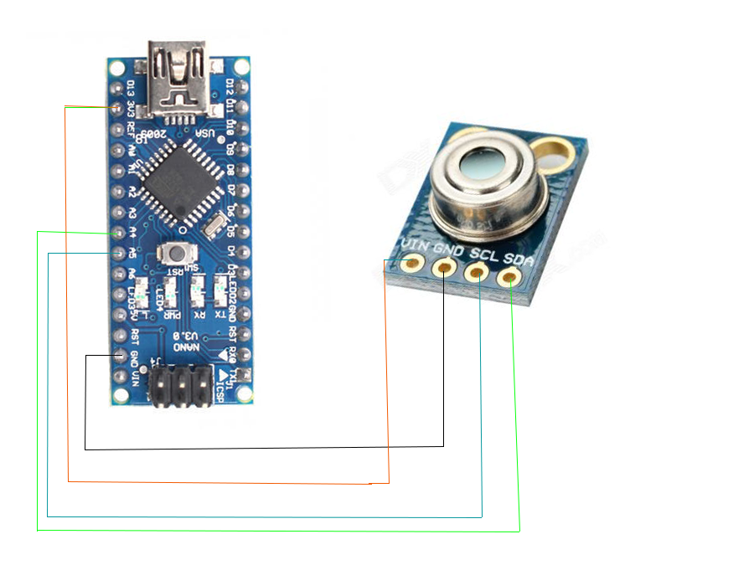

**Hardware Connections**

* Arduino Nano MLX90614
* A4 - SDA
* A5 - SDL
* 3.3V - VIN
* GND - GND

**Image of Project**

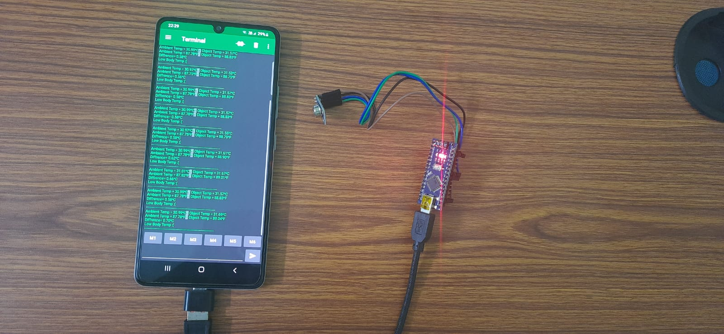

**Flow Chart (Testing)**

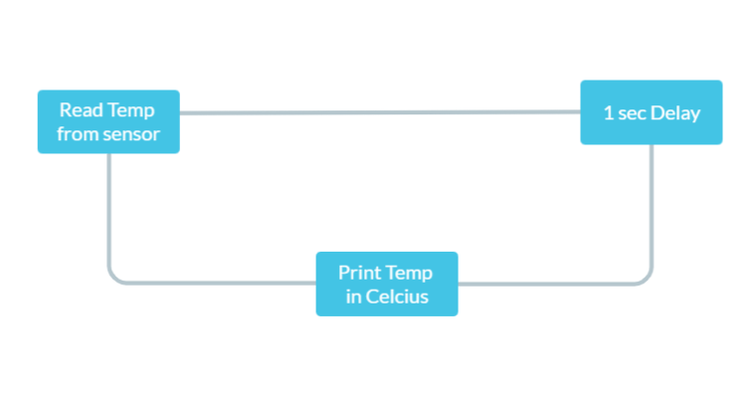

**Flow Chart of Logic (Fever Detect)**

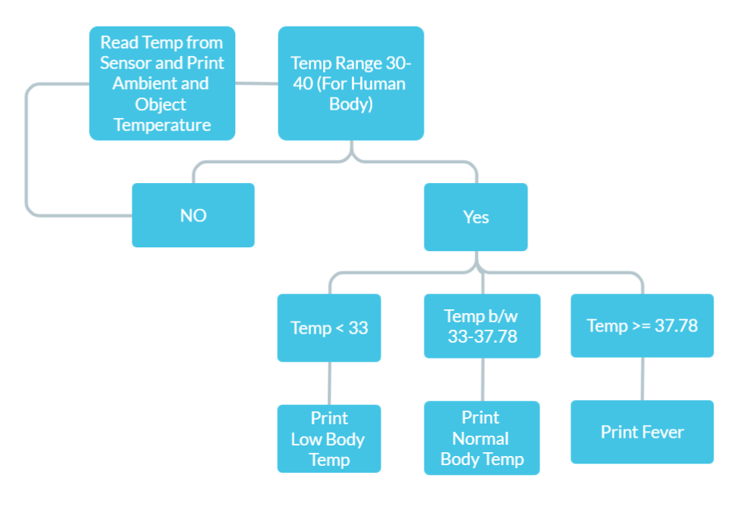

**Code Snippet and Explanation**

1)Test_Sensor (To test if sensor is working)

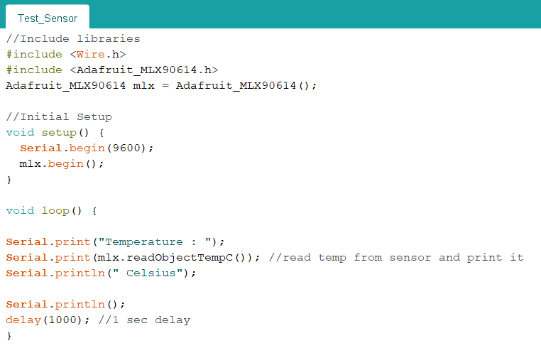

2)Code_Main (Actual Code for monitoring body temperature)

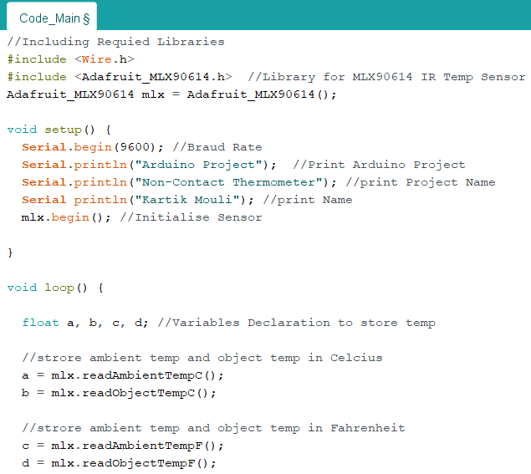

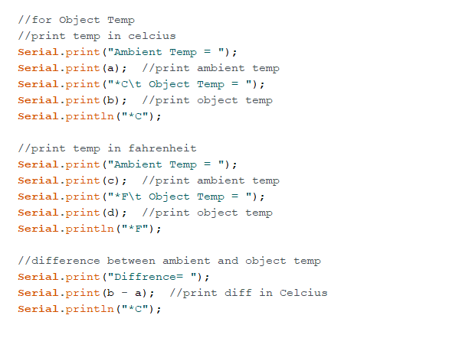

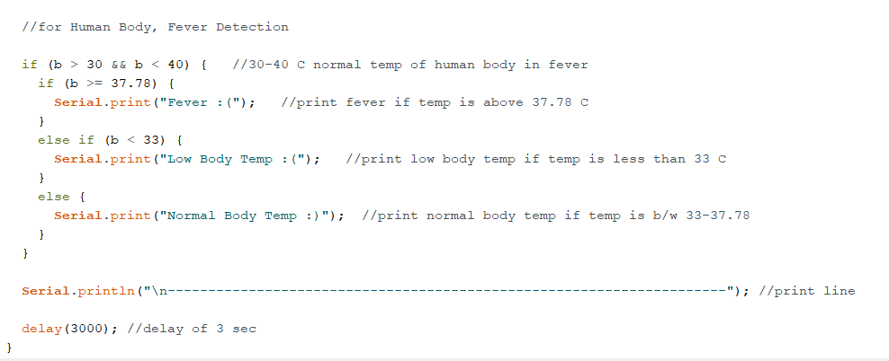

**Explanation**

Read data from MLX90614 and Print Temperature in Celsius and Fahrenheit. Also print difference between Ambient Temp and Objects Temp in Celsius. For Fever Detection in Human Body, Human body temp ranges from 30-40 C in extreme conditions. If body temp is b/w 33-37.38 C (Normal body temp) or body temp less than 33 C or body temp greater than 37.78 C (Fever), It will print according to that Person have Normal body temp, Low body temp or Fever.

**Applications**

This Arduino based project can have various applications:

* High precision non-contact temperature measurements
* Thermal Comfort sensor for Mobile Air Conditioning control system
* Temperature sensing element for residential, commercial and industrial building air conditioning
* Windshield defogging
* Automotive blind angle detection
* Industrial temperature control of moving parts
* Temperature control in printers and copiers
* Home appliances with temperature control
* Healthcare
* Livestock monitoring
* Movement detection
* Multiple zone temperature control – up to 100 sensors can be read via common 2 wires
* Thermal relay/alert
* Body temperature measurement

**Conclusion**

This project is fairly simple to build but has a lot of useful applications. However, while working on the project I found that the sensor shows nearly accurate output when its 2-4 cm close to object.