CS322 MINI PROJECT REPORT

Motion Classification

Using Deep Learning on ESP32

Team Members:

Kartik Mouli 2001CS35

Rohit Ranjan 2001CS56

Report By -

Kartik Mouli (2001CS35)

**Aim**

The aim of this project is to Implement a Neural Network on ESP32.

**About**

Motion Classification is a simple and at the same time great example of what machine learning can do. It uses lots of "messy" data to classify things.

In this project we will make a classifier with 4 classes :idle, up_down, left_right and circle.

**Equipment used**

**Hardware Components**

* ESP32 Module

The ESP32 is a very versatile System On a Chip (SoC) that can be used as a general purpose microcontroller with quite an extensive set of peripherals including Wi-Fi and Bluetooth wireless capabilities.

* MPU6050 Sensor

MPU6050 sensor module is complete 6-axis Motion Tracking Device. It combines 3-axis Gyroscope, 3-axis Accelerometer and Digital Motion Processor all in small package.

* Breadboard

A breadboard is a construction base used to build semi-permanent prototypes of electronic circuits.

* Jumper Wire

A jump wire is an electrical wire, or group of them in a cable, with a connector or pin at each end which is normally used to interconnect the components of a breadboard.

**Software apps and online services**

* Edge Impulse Studio

Edge Impulse is the leading development platform for machine learning on edge devices, free for developers and trusted by enterprises.

* Arduino IDE

The Arduino Integrated Development Environment or Arduino

Software (IDE) - contains a text editor for writing code, a message area, a text console, a toolbar with buttons for common functions and a series of menus. It connects to the Arduino hardware to upload programs and communicate with them. The open-source Arduino Software (IDE) makes it easy to write code and upload it to the board. This software can be used with any Arduino board.

**Schematic**

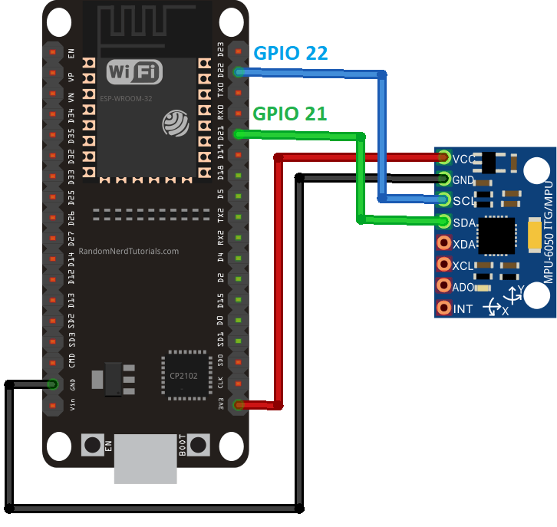

**Hardware Connections**

ESP32 -> MPU6050

D22 (GPIO 22) – SCL

D21 (GPIO 21) – SDA

3V3 – VCC

GND – GND

**Project Contribution**

Project has major 4 parts:

1. Testing hardware components
2. Data Acquisition
3. Creating ML Model
4. Deployment of Model

Rohit Ranjan (2001CS56) – Part 1 and 2

Kartik Mouli (2001CS35) – Part 3 and 4

**Working**

The MPU6050 Sensor collect data in 1 sec interval and send over to ESP32 module which has Motion Classification model deployed on it. It classifies the motion and gives output on serial monitor.

We have used Edge Impulse Studio which provides great environment for data acquisition and creating ML model. We deployed the model on ESP32 using Arduino IDE.

Part 1 and 2 will be explained by Rohit Ranjan (2001CS56).

**Creating ML model**

* Feature Explorer

We can see how well our classes are separated using the feature explorer:

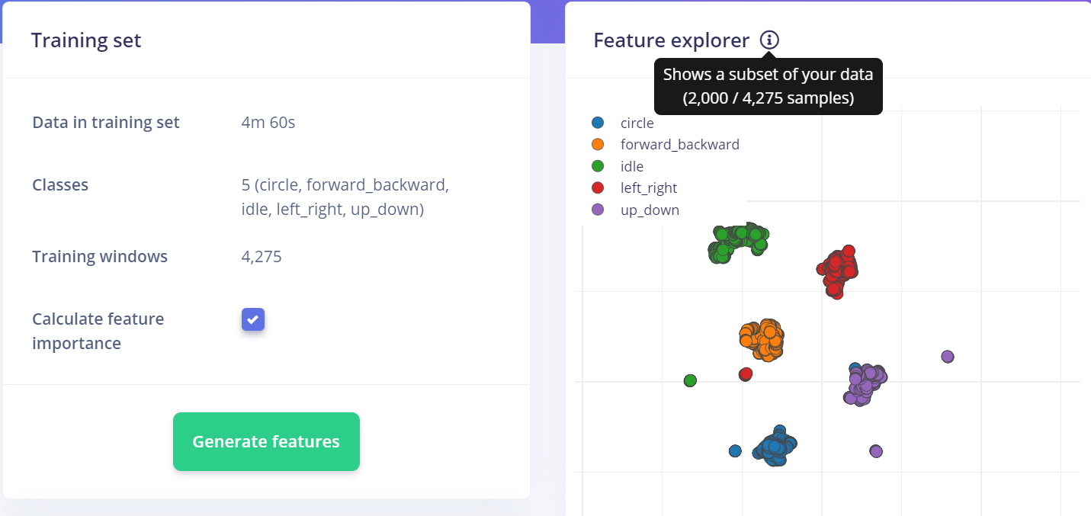

* Neural Network Implementation

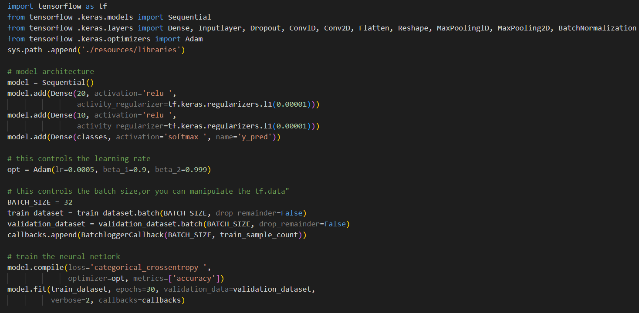

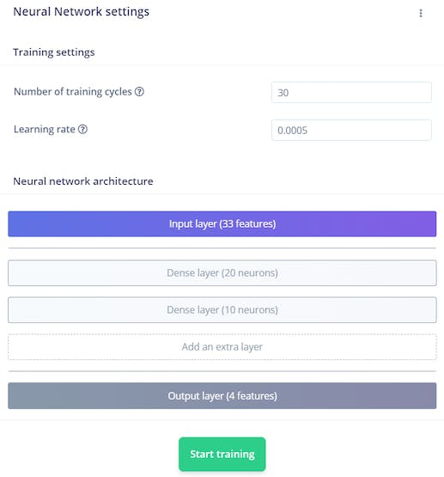

**Model Performance**

Confusion Matrix

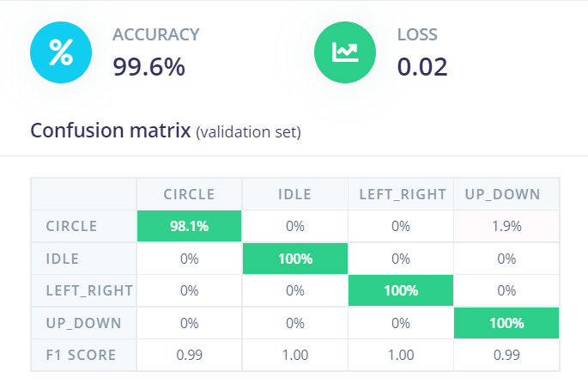

**Result**

For circle

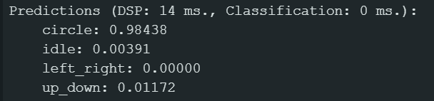

For idle

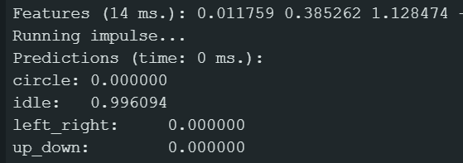

For left_right

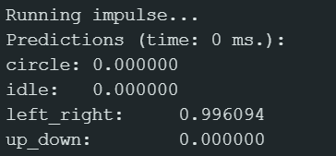

For up_down

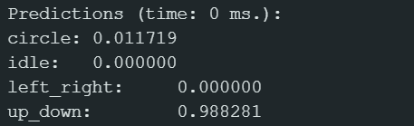

**Conclusion**

It was possible to implement a Neural Network using TinyML on ESP32 and a MPU6050 sensor.