1. Introduction

1.1 Objective of the project:

The objective of this project is to transfer files from a server to a client using an open-source software, FileZilla. The project aims to demonstrate how FileZilla can be used as a file transfer protocol (FTP) client to transfer files securely and efficiently.

1.2 Description of the project:

The project involves using FileZilla to transfer files from a server to a client. FileZilla is a free, open-source FTP client that can be used on various operating systems, including Windows, Linux, and Mac OS. It offers a simple and user-friendly interface, making it easy to use for both beginners and advanced users.

1.3 Scope of the project:

The scope of the project is limited to transferring files from a server to a client using FileZilla. The project does not cover other file transfer methods or protocols. It also assumes that the user has basic knowledge of how to use FileZilla.

2. System Description

2.1 Target system description:

The target system for this project is a server-client system. The server will host the files that need to be transferred, and the client will use FileZilla to download the files from the server.

2.2 Assumptions and Dependencies:

Assumptions:

- The server and client are connected to the same network.

- The user has administrative privileges on both the server and the client machines.

- FileZilla is installed on the client machine.

Dependencies:

- FileZilla software

- A reliable internet connection

2.3 Functional/Non-Functional Dependencies:

Functional Dependencies:

- FileZilla software should be able to connect to the server.

- FileZilla should be able to download files from the server.

- FileZilla should be able to resume interrupted downloads.

Non-Functional Dependencies:

- The internet connection should be stable.

- The server should be able to handle the number of requests made by the client.

2.4 Data set used in support of your project:

No data set is used in this project.

3. Analysis Report

System snapshots and full analysis report:

To transfer files from the server to the client using FileZilla, follow the steps below:

Step 1: Download and install FileZilla client on the client machine.

Step 2: Open FileZilla client and enter the IP address of the server in the "Host" field, username, and password for the server in the "Username" and "Password" fields, respectively.

Step 3: Click on the "Quick connect" button to connect to the server.

Step 4: Once connected, the remote files on the server will be displayed on the right-hand side of the FileZilla client window, and the local files on the client machine will be displayed on the left-hand side of the window.

Step 5: To transfer a file from the server to the client, select the file on the remote server, right-click on the file, and select "Download." Alternatively, you can drag and drop the file from the server to the client's local directory on the left-hand side of the window.

Step 6: Once the download is complete, the file will be available on the client machine.

The following screenshots demonstrate the process described above:

THIS IS THE PICTURE OF HOMEPAGE OF FILEZILLA WITHOUT ANY CONNECTION.

WE HAVE TO CREATE A NEW LINK WHERE I HAVE TOPUT THE HOSTNAME , PORT NUMBER , USERNAME AND PASSWORD.

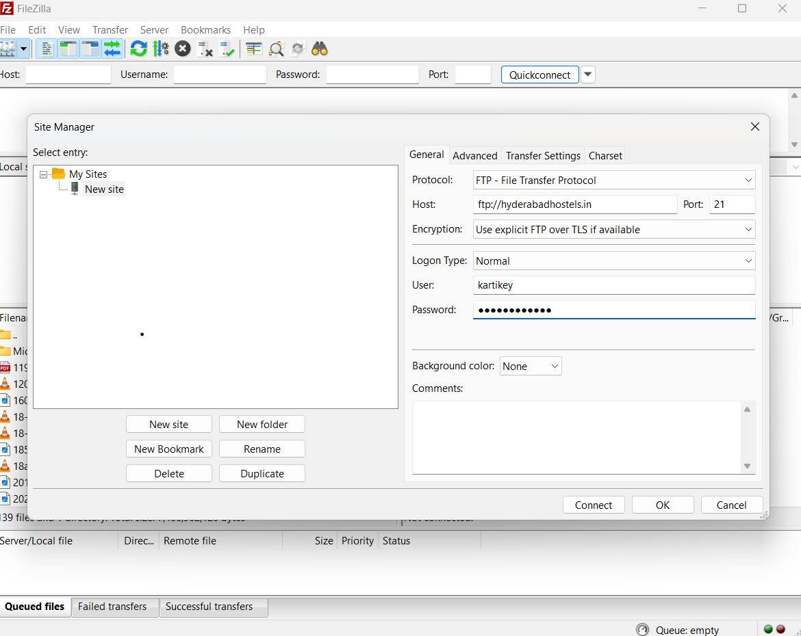

IN THIS PICTURE, I HAVE FILLED THE HOSTNAME AND ALL THE REQUIRED INFORMATION.

THEN PRESS ON CONNECT.

ITS GETTING CONNECTED

NOW THE SERVER IS CONNECTED WITH THE CLIENT AND FILES SHARING CAN HAPPEN.

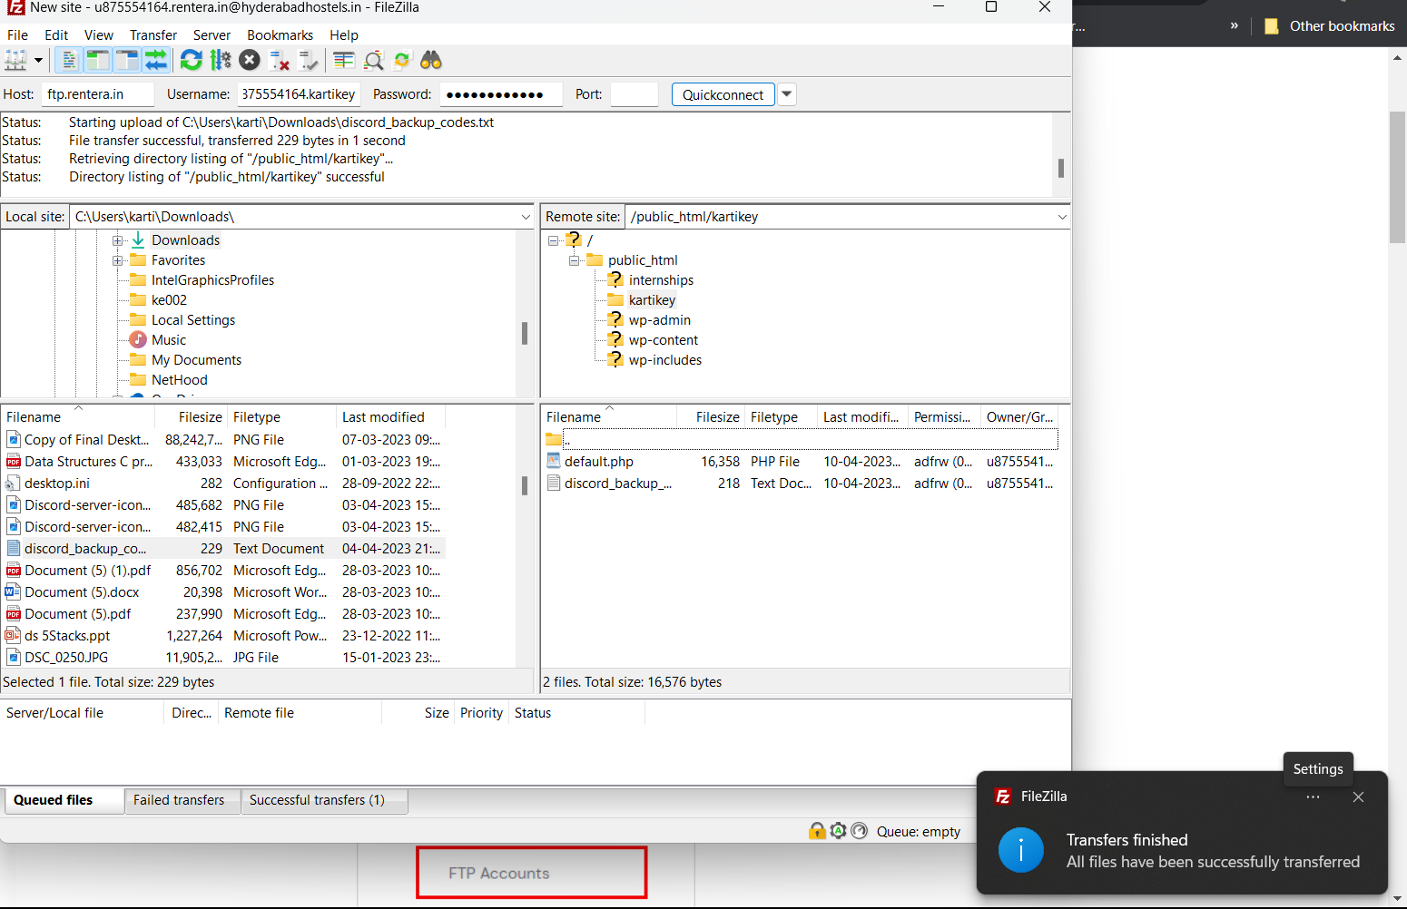

HERE FILE GET TRANSFERRED FROM SERVER TO CLIENT.

AND DIRECTORY LISTING IS DONE.

FILE NAME- DISCORD BACKUP CODES AND MERCEDED PICTURE

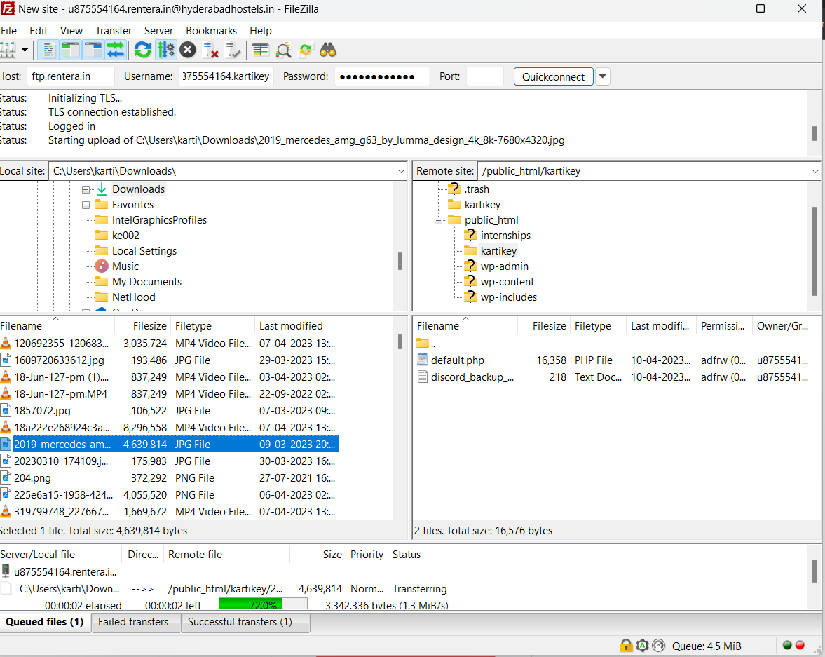

ANOTHER FILE WILL BE TRANSFERRED WITH THE HIGHLIGHTED PICTURE.

BOTH THE FILES ARE TRANSFERRED.

The file which I transferred was a picture And discord backup codes which you can see in the screenshot.