UIDAI Data Hackathon 2026
Aadhaar Service Stress Index (ASSI) + Early Warning Risk Prediction System
(Maharashtra Pilot • Scalable Nationwide)

Participant Name: Kartik Raut, Bhavesh Chaware
Institute/Organization: GH Rasioni University, Amravati
Email/Contact: Kartikrautsr12@gmail.com/8767294368
Submission Date: 19/01/2026
GitHub Repository (optional): [GITHUB LINK]

1. Problem Statement and Approach
Aadhaar enrolment and update services often face uneven and seasonal demand across districts. When demand spikes (new enrolments, demographic updates, biometric updates), service centres can become overloaded—leading to delays, long queues, and reduced citizen experience.
This project builds a practical early warning system that helps administrators identify stressed districts, predict upcoming overload risk, and evaluate what interventions would reduce the stress. The solution is implemented as a Maharashtra pilot (due to portal download filtering) and is designed to scale nationwide.
Approach summary:
- Build ASSI (Aadhaar Service Stress Index) to quantify district-wise stress each month.
- Create dashboards to monitor trends and persistent hotspots.
- Predict next-month overload risk probability using machine learning.
- Simulate policy actions (interventions) and measure expected stress reduction.

2. Datasets Used
This project uses UIDAI-provided Aadhaar datasets (monthly, district-wise):
- Aadhaar Monthly Enrolment Data
- Aadhaar Demographic Monthly Update Data
- Aadhaar Biometric Monthly Update Data

2.1 Key Columns Used
Dataset | Key Columns
Enrolment Data | state, district, date, demo_age_5_17, demo_age_17_
Demographic Updates | state, district, date, age_0_5, age_5_17, age_18_greater
Biometric Updates | state, district, date, bio_age_5_17, bio_age_17_
Derived fields: month (YYYY-MM), enrolment_total, demo_updates_total, bio_updates_total, total_updates, total_transactions.

3. Methodology

3.1 Data Cleaning & Preprocessing
- Converted date → month (YYYY-MM) for monthly analysis.
- Aggregated each dataset at (state, district, month).
- Merged all datasets into a master table using outer joins; filled missing numeric values with 0.
- Cleaned district names to avoid duplicates caused by symbols (e.g., 'Gondiya*').
- Filtered to Maharashtra as pilot scope.

3.2 Feature Engineering (Stress Drivers)
We engineered features that act as service stress drivers:
- Total updates and total transactions
- Enrolment velocity (spike detector)
- Growth acceleration (acceleration of spikes)
- Update churn (frequent update behavior)
- Load density proxy using total transactions

3.3 ASSI Index Construction
ASSI (0–100) is a composite stress score computed using normalized weighted factors. All stress drivers are normalized using MinMax scaling (0–1) and combined as a weighted sum.
ASSI_raw = 0.25×EnrolmentVelocity_norm + 0.25×TotalUpdates_norm + 0.20×GrowthAcceleration_norm + 0.15×LoadDensity_norm + 0.15×UpdateChurn_norm
ASSI = ASSI_raw × 100

3.4 Risk Prediction & Validation
To predict next-month risk reliably, the project uses a dynamic threshold: the top 20% ASSI points are labelled as high stress. The next-month label (HighStressNextMonth) is created by shifting district labels by one month.
A Gradient Boosting Classifier outputs risk probabilities. Balanced sample weights reduce class imbalance. Rolling forecast validation (last 6 months) evaluates month-to-month reliability using Accuracy, Precision, Recall and F1-score.

4. Data Analysis and Visualisation
Insert the following saved charts from REPORT_CHARTS/ and summarize insights below each figure.

4.1 Aadhaar Activity Trend
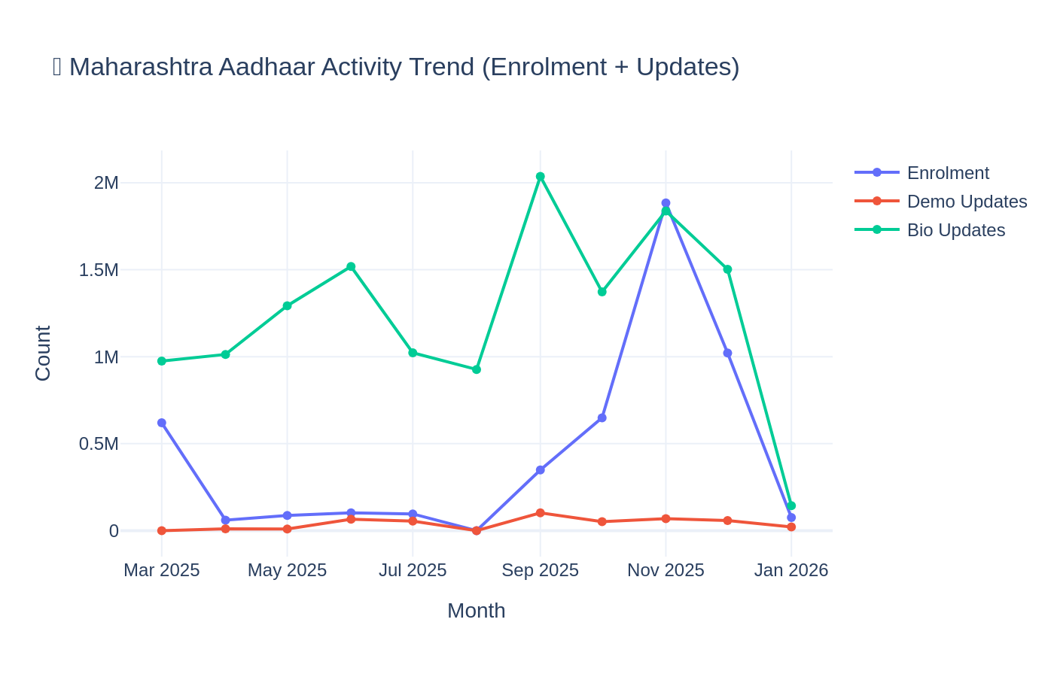
Figure 1: Maharashtra Aadhaar activity trend (Enrolment + Demographic Updates + Biometric Updates).
Insights:
- • Identifies peak workload months.
- • Provides background for stress monitoring.

4.2 Top Districts by Enrolment
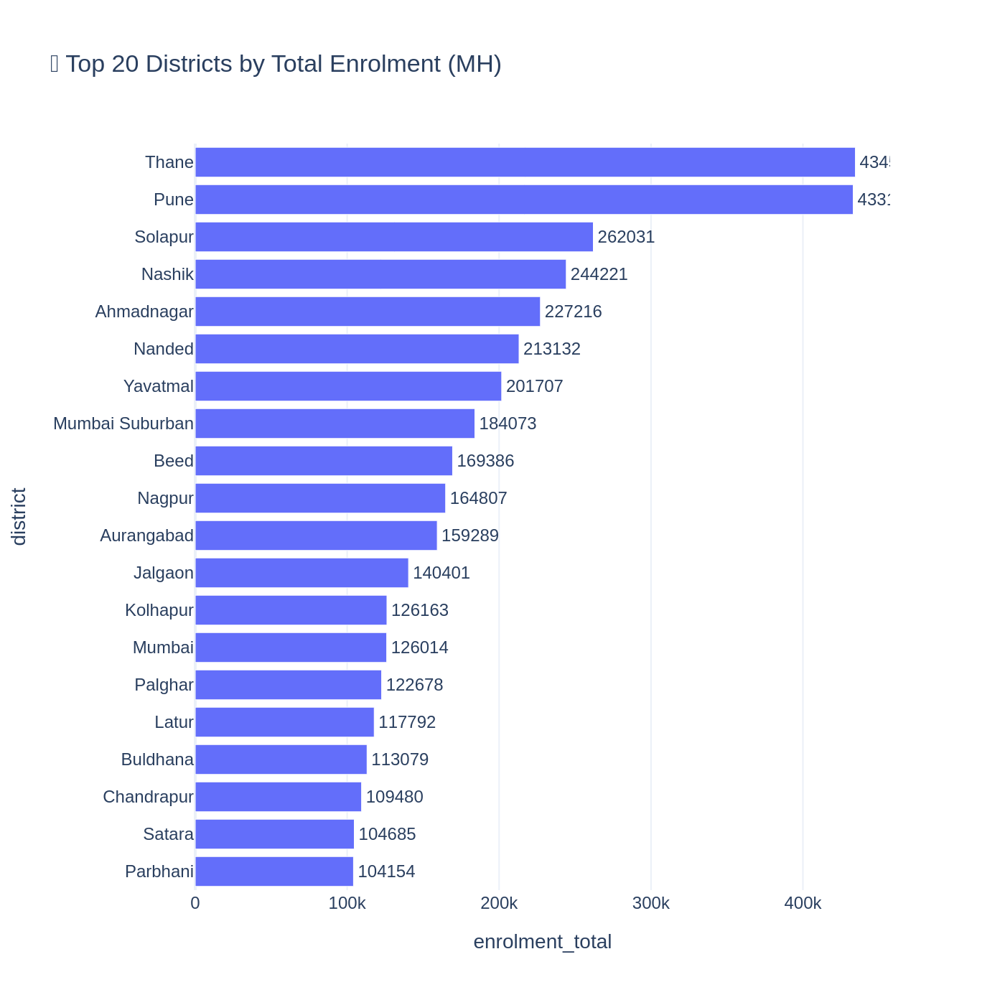
Figure 2: Top 20 districts by total Aadhaar enrolment (Maharashtra).
Insights:
- • Highlights demand concentration.
- • Helps prioritize districts for monitoring.

4.3 ASSI Trend (State-level Monitoring)
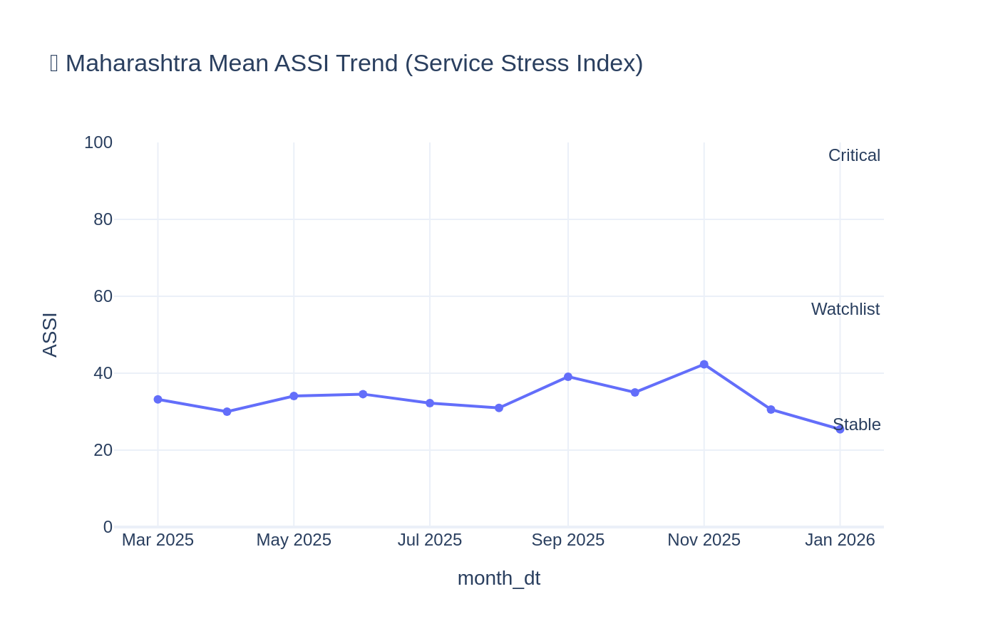
Figure 3: Mean ASSI trend for Maharashtra with stress bands.
Insights:
- • Demonstrates ASSI as a monitoring index.
- • Captures stress peaks clearly.

4.4 Stress Zone Distribution
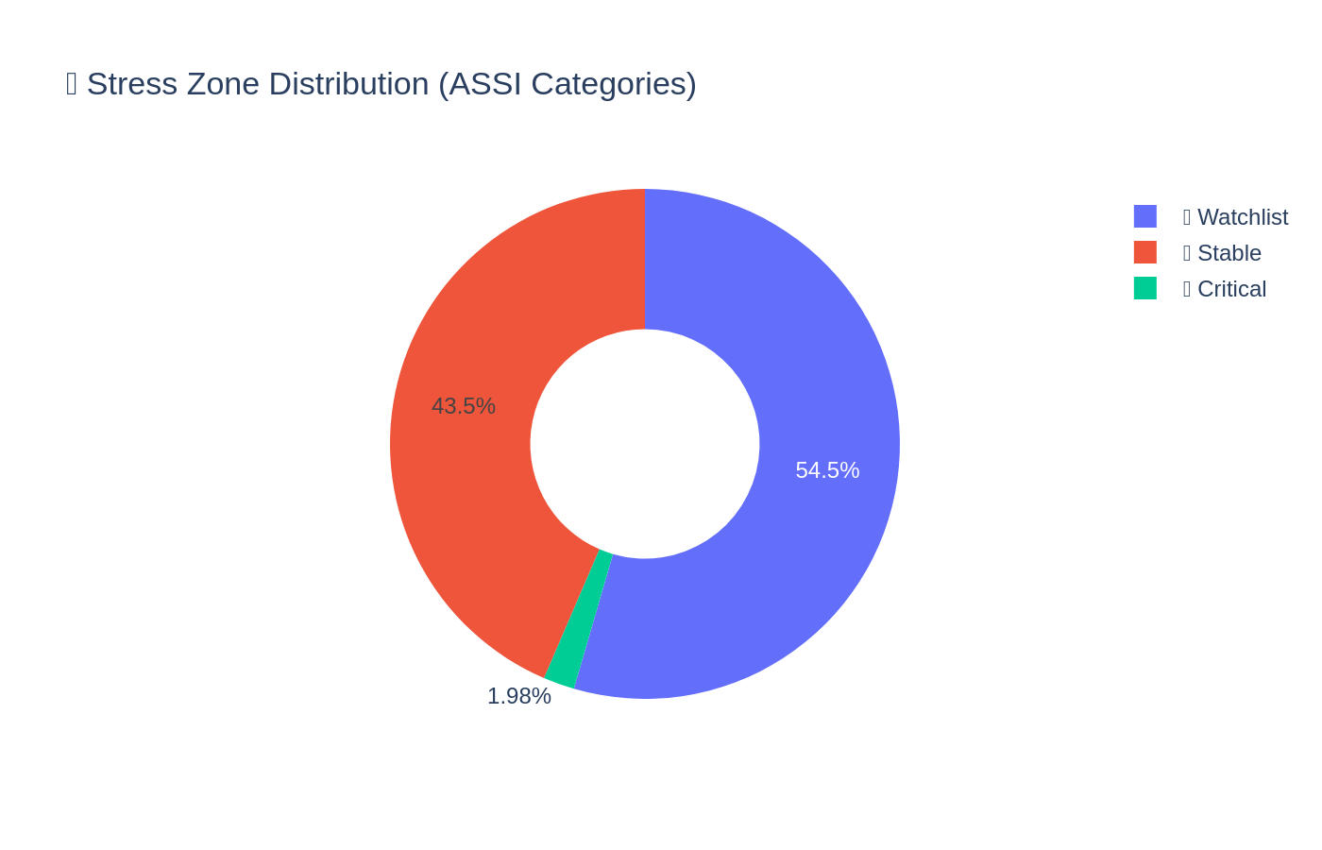
Figure 4: District-month distribution across stress zones.
Insights:
- • Quantifies the load severity distribution.
- • Useful for escalation thresholds.

4.5 Spatio-Temporal Stress Heatmap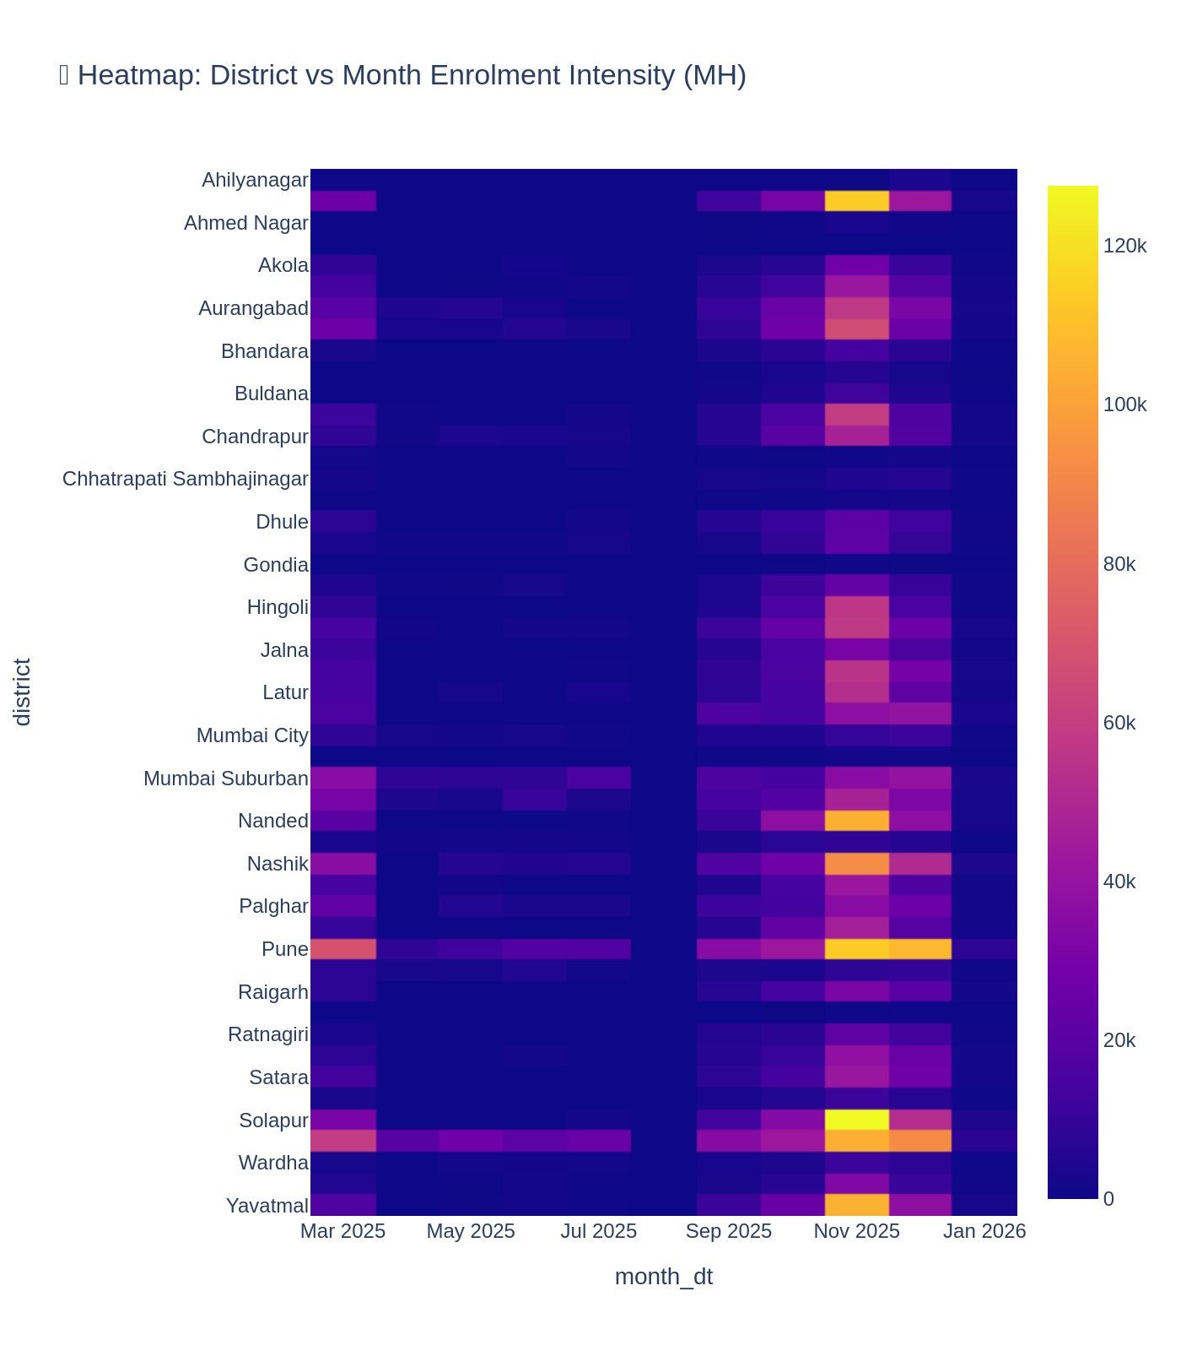
Figure 5: Heatmap of ASSI values (district vs month).
Insights:
- • Detects persistent hotspots.
- • Enables targeted intervention planning.

4.6 Early Warning Alerts (Red Zone Entry)

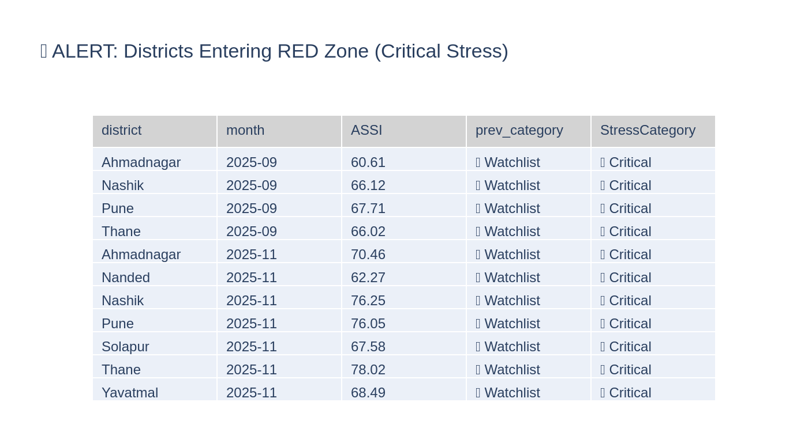
Figure 6: Alert list — districts newly entering the Critical (Red) zone.
Insights:
- • Converts analytics into actionable alerts.
- • Helps prevent service degradation.

4.7 Next-Month Overload Risk (Top 20)
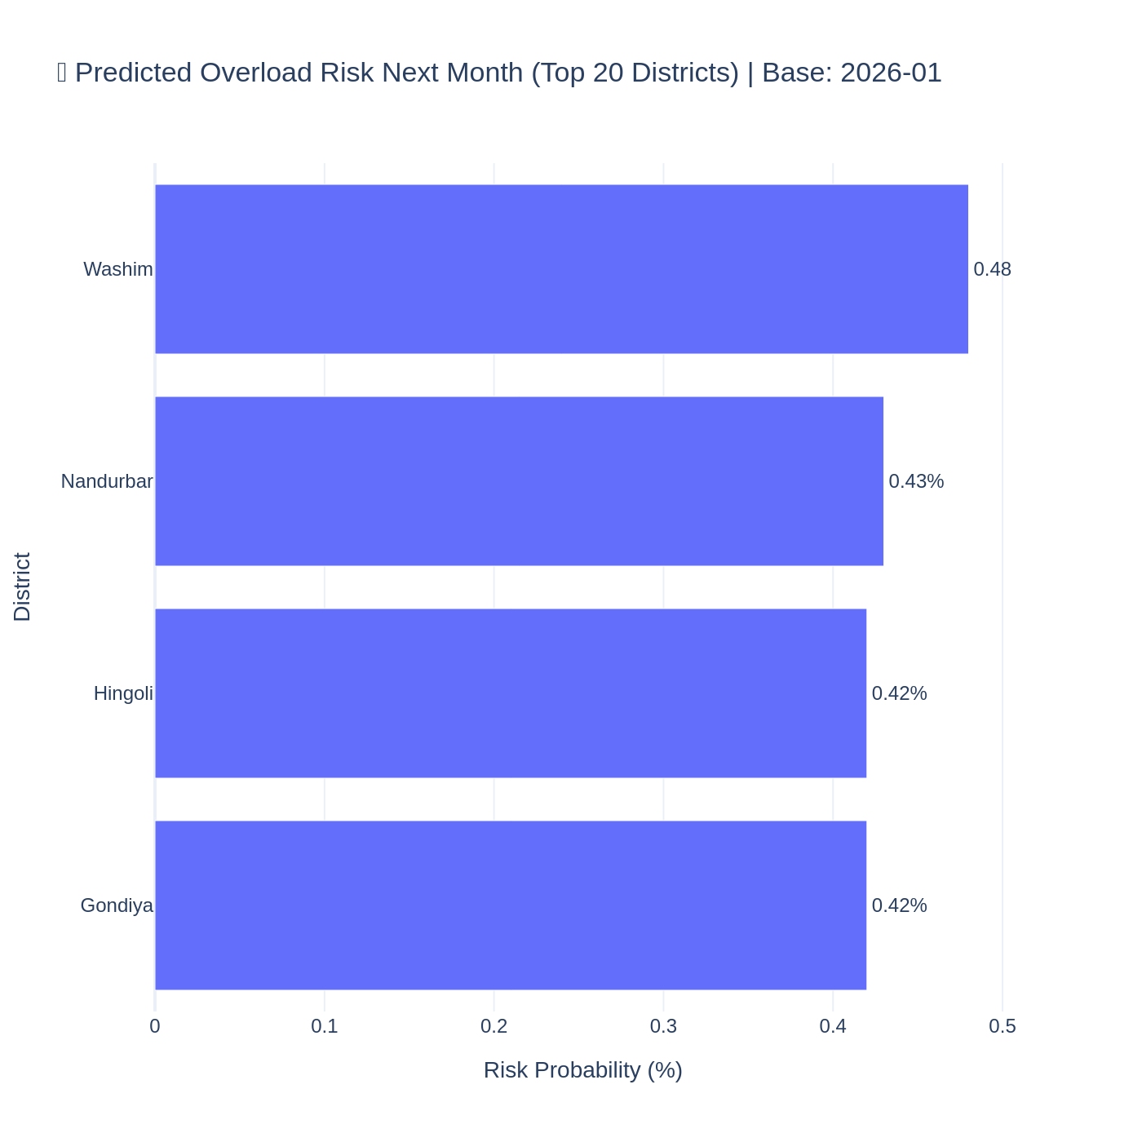
Figure 7: Next-month overload risk probability ranking (Top 20 districts).
Insights:
- • Provides next-month prioritization.
- • Probability output supports planning.

4.8 Rolling Forecast Validation
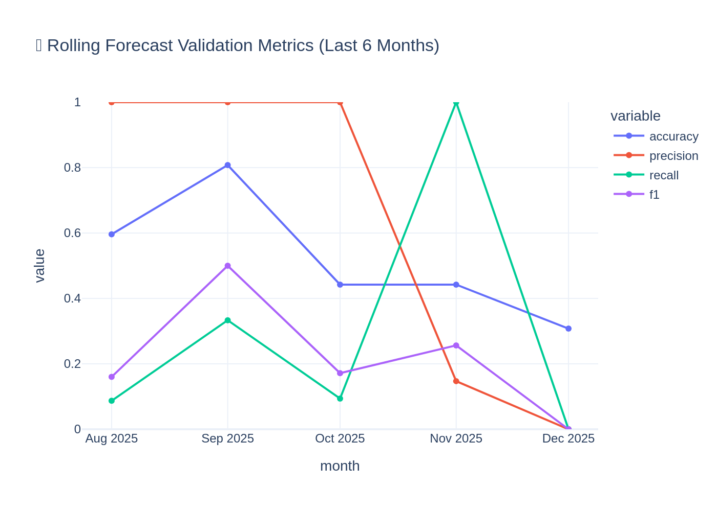
Figure 8: Rolling validation metrics across the last 6 months.
Insights:
- • Shows consistent month-to-month performance.
- • Improves trustworthiness of predictions.

4.9 Root Cause Explainability
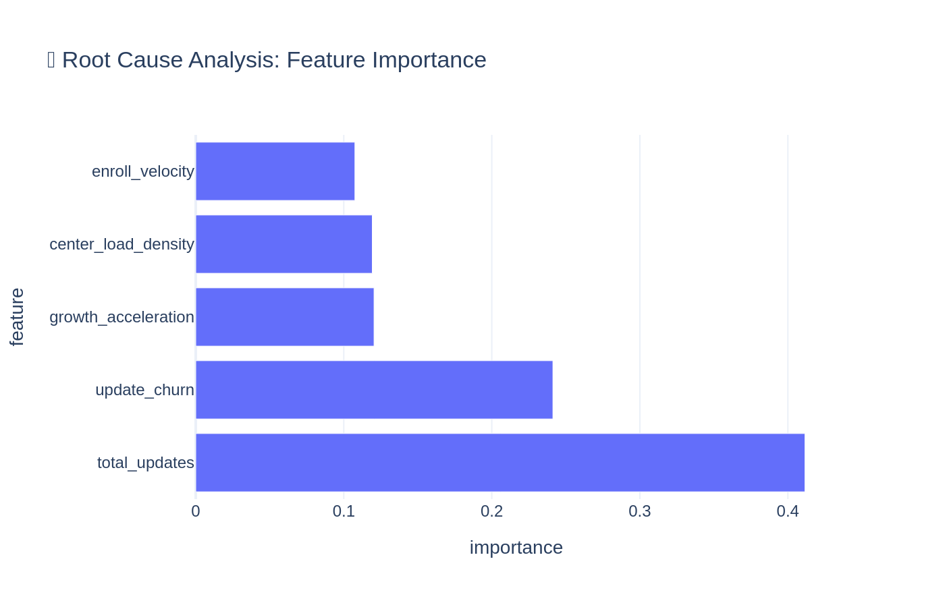
Figure 9: Feature importance for overload prediction.
Insights:
- • Explains key drivers behind stress.
- • Supports governance and transparency.

4.10 Policy Simulation Impact
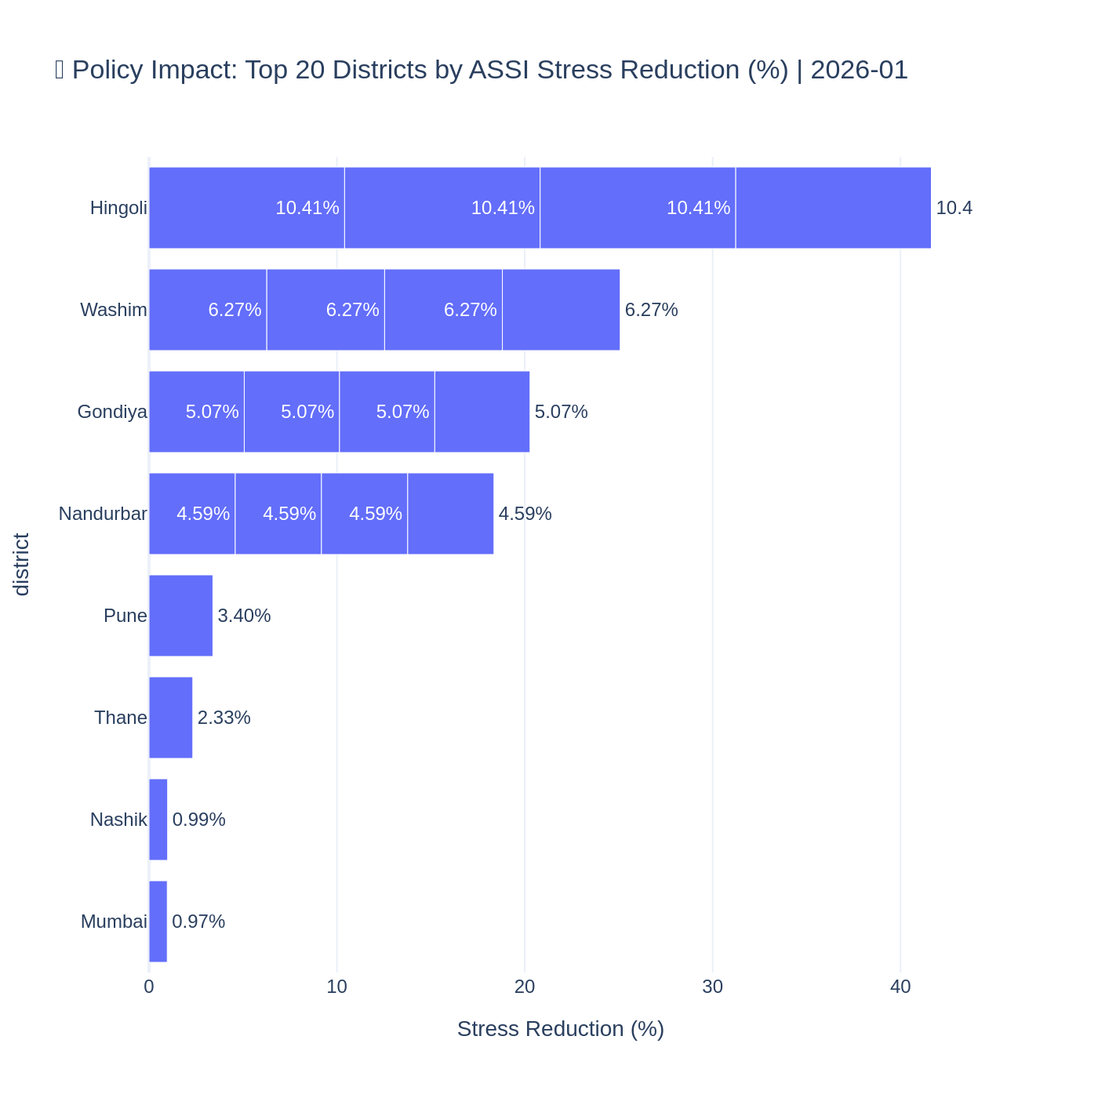
Figure 10: Policy simulation — Top districts by ASSI stress reduction.
Insights:
- • Demonstrates expected impact of interventions.
- • Strengthens practical applicability.

4.11 Optional Policy Heatmaps (Before/After)
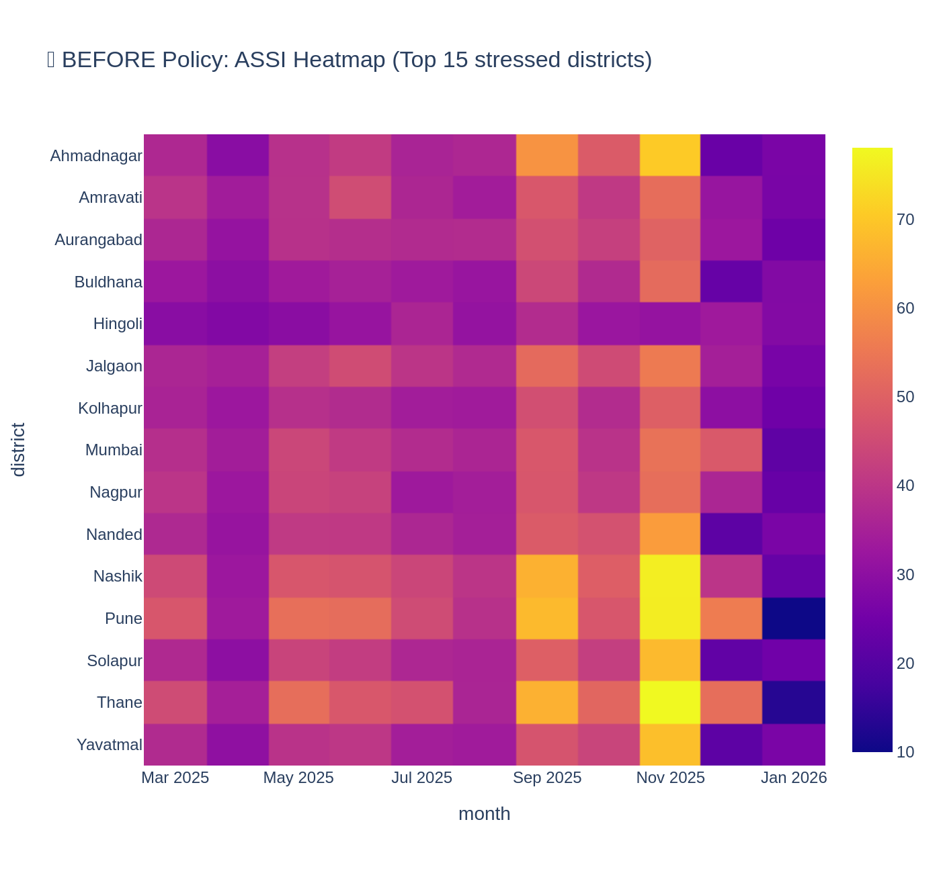
Figure 11: BEFORE intervention — ASSI heatmap for top stressed districts.

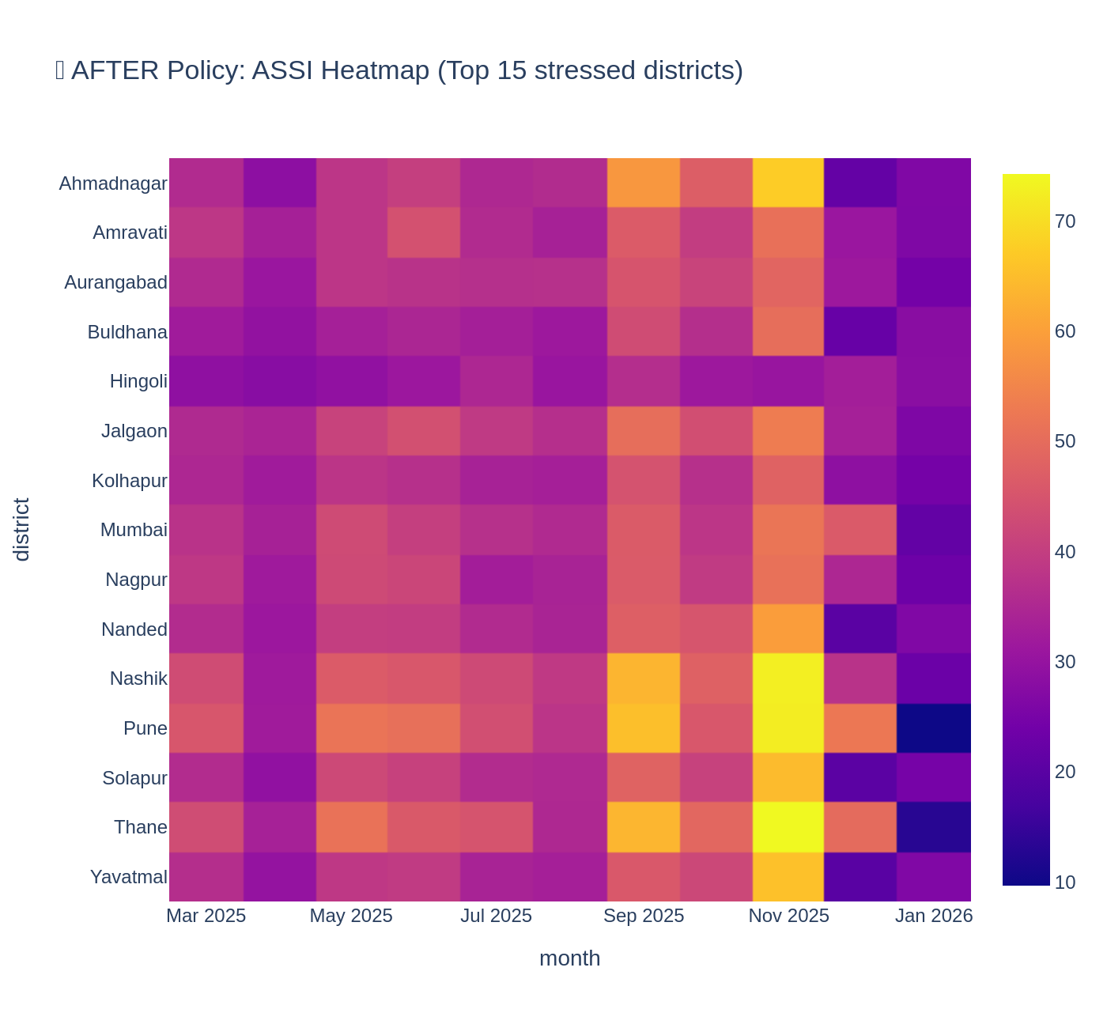
Figure 12: AFTER intervention — ASSI heatmap for top stressed districts.
Insights:
- • Visual proof of stress reduction.
- • Helps communicate impact quickly.

5. Key Findings and Insights
- Aadhaar activity and updates show clear temporal patterns indicating peak months of operational load.
- Enrolment demand is concentrated in specific districts, enabling targeted planning.
- ASSI provides an interpretable stress score that highlights persistent stress hotspots.
- The alert module identifies districts newly entering the critical zone for proactive action.
- The prediction model outputs next-month risk probabilities, enabling district prioritization.
- Policy simulation demonstrates measurable stress reduction under interventions.

6. Impact and Applicability
The solution can help UIDAI administrators proactively manage Aadhaar service delivery by planning capacity and interventions in advance. It improves citizen service quality by reducing overload risk and operational delays.

7. Deployment Plan
Suggested deployment workflow (monthly):
- Ingest monthly UIDAI district-level enrolment and update datasets.
- Run automated preprocessing and master dataset build.
- Compute ASSI, stress zones, and generate hotspot dashboards.
- Run risk prediction to generate Top-N district risk list for next month.
- Trigger red zone entry alerts for escalation.
- Run policy simulation for high-risk districts and generate intervention recommendations.
- Publish dashboards and archive monthly outputs.

8. Limitations and Future Scope
Limitations:
- Pilot is limited to Maharashtra due to portal filtering constraints for all-India consolidated download.
- Centre-level capacity data is not directly available; total transactions are used as a workload proxy.
Future scope:
- Extend to nationwide multi-state monitoring once all-state data is available.
- Integrate operational capacity metrics (counters, staff) for improved load modeling.
- Deploy a web dashboard with automated monthly alerts for officials.

9. Code Appendix
This appendix shows the core logic used for analysis and modeling.
Appendix A — Load & Merge UIDAI Datasets
```python
# Load 3 UIDAI datasets (enrolment, demo updates, bio updates)
# Convert date -> month
# Aggregate to (state, district, month)
# Outer merge into master dataset
```
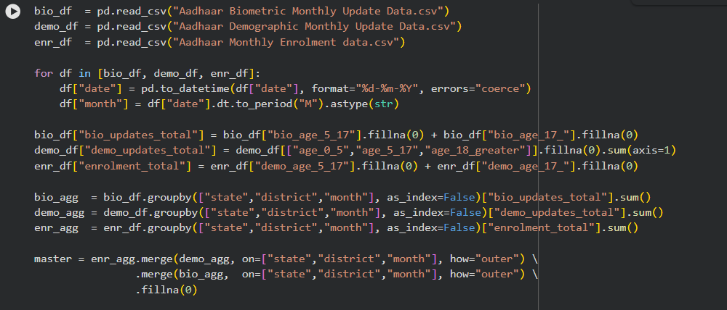
Appendix B — Feature Engineering (Stress Drivers)```python
# total_updates, total_transactions
# enroll_velocity, growth_acceleration
# update_churn, center_load_density
```
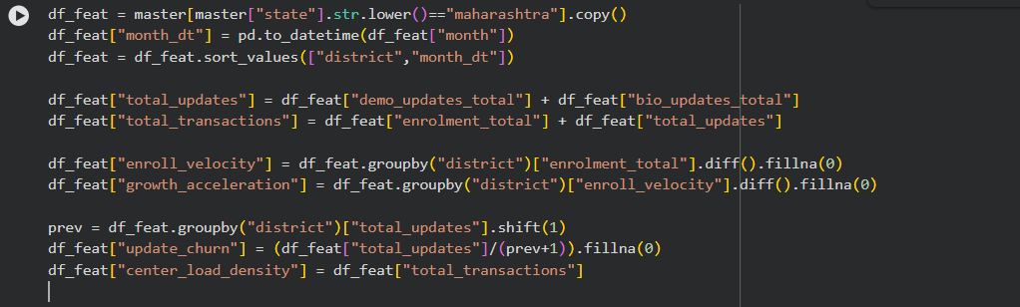

Appendix C — ASSI Computation (0–100 Index)
```python
# Normalize stress drivers
# Weighted sum -> ASSI_raw
# ASSI = ASSI_raw * 100
```
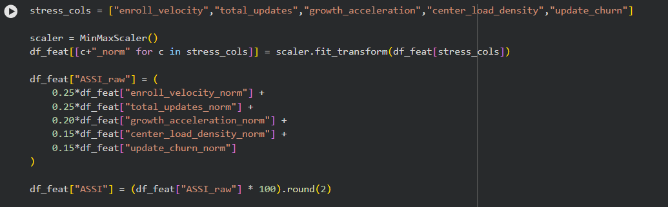

Appendix D — Dynamic Label Creation (Next-Month High Stress)
```python
# top 20% ASSI -> high stress
# next-month label shift
# GradientBoostingClassifier + balanced sample weights
# risk_probability output
```
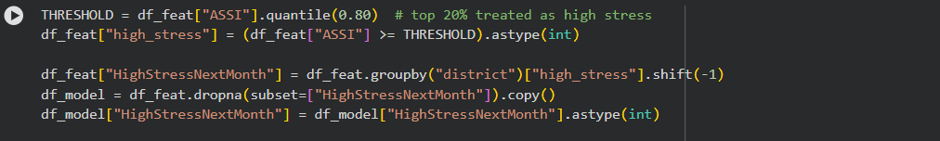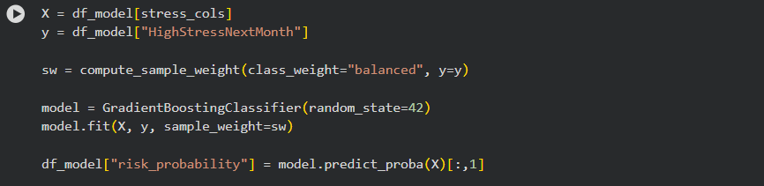

Appendix E — Model Training (Probability Output + Balanced Weights)
```python
# For each of last 6 months:
# train on previous months
# test on current month
# compute accuracy/precision/recall/f1
```
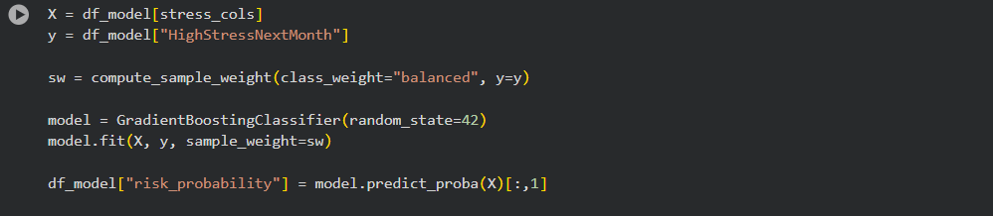

Appendix F — Rolling Forecast Validation (Last 6 Months)
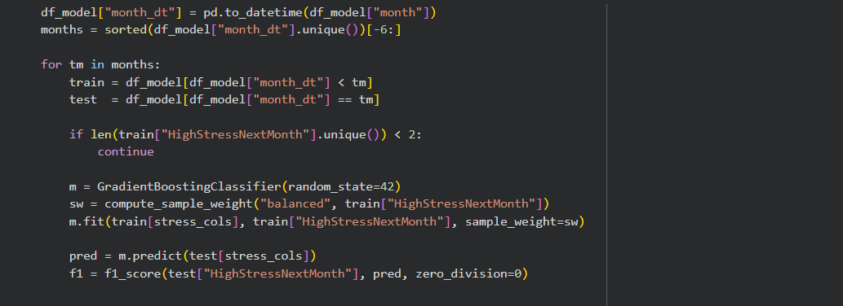

10. Conclusion
This submission demonstrates a practical stress monitoring and early warning framework for Aadhaar service delivery. ASSI quantifies district-level operational stress, risk prediction forecasts next-month overload probability, and policy simulation highlights how targeted interventions can reduce stress. The Maharashtra pilot validates feasibility and the approach can be scaled nationwide.

