**COVID19 DASHBOARD**

**Group 10**

Kartik Tiwari 11811184

***Abstract***— Responding effectively to public health emergencies requires timely and accurate information. As the COVID-19 pandemic has progressed, the effectiveness of national efforts to combat the virus has hinged on the ability of governments to measure its spread and use that information to target their public health efforts.

***Keywords—Python ,Dash, LiveCovid dashboard.***

**Introduction**

COVID-19 was initially observed in Wuhan, China in late December 2019, where it later spread globally, affecting around 7 million people worldwide and causing 300,000 reported deaths by May 2020. . A large amount of data has been collected from patients regarding their symptoms and history to help track the spread of the disease.

Interactive dashboards process and present raw data in the form of visuals, graphs, and text along with various options for user interactions. The dashboards allow for extracting valuable information and showcase the data in an intuitive and easy to understand manner. As the world is battling with the COVID-19 pandemic. Dashboard built using python modules Dash and Plotly for visualization, the proposed dashboard utilizes the data analytic capabilities of the Pandas python library to structure and organize the raw data efficiently.

# **Implementation details**

A. Details of Packages used

1) Dash: Dash [12] is an open source framework which helps to create interactive, responsive and dynamic websites by using the Python or R programming languages. We used Dash core components to create tools to add inputs, sliders, drop down, graph, and other components to the web application to allow users to interact with the data. Dash’s Hypertext Markup Language (HTML) components allows for composing the application layout using Python structures, rather than writing in HTML or using an HTML templating engine.

2) Plotly: Polly’s Python graphing library allows for creating interactive and dynamic graphs. Dash is used to build the interface which is populated by the graphs that are created from and using Plotly. We have used Plotly’s graph objects, figure factory and express modules for our application.

3) Pandas: Pandas is a data analytics library in Python and commonly used for processing tabular data. Here we used Pandas to read the main data file, pre-process the unclean data, extract the necessary information and plot it using Plotly on Dash.

Also dash_core_component,dash_html_components, pycountry is use in this dashboard for layout of app ,body and showing map.

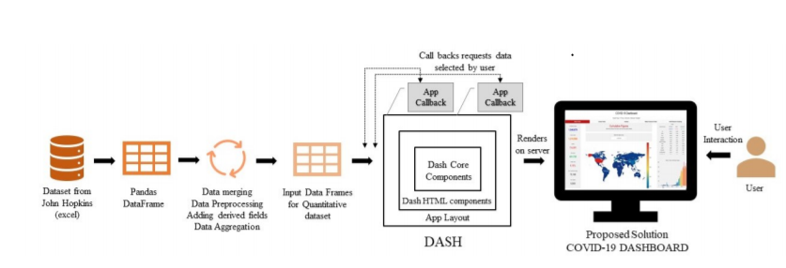

B. Data set

The most up-to-date data about the COVID-19 cases were obtained from the JHU resource center . The dataset contains information about confirmed cases, death and recovered cases, country/region-wise and province/state-wise, from January 22, 2020 to current date. The fields which are of utmost importance are the confirmed cases, deaths, and recovered cases.

C. Data Processing

Data processing is performed dynamically when the website is loaded. The input datasets in the excel format are each read into the application as a pandas DataFrame and merged together. After removing the unused fields, new fields are derived by performing mathematical operations(if required) on the DataFrame. For example, New Cases for each day are derived using the difference operator on the rows of cumulative cases ordered by date.

D. COVID-19 Dashboard Application structure

This covid19 dashboard created on Dash was designed to include as much user interactions as possible. I chose Dash and Plotly as our visualization platform mainly because of the tabular format of the data, that could be efficiently processed using pandas DataFrame and easily added to Dash using Plotly library. The dashboard was created to allow users to have the maximum interactions as possible. A list of customized user actions are: Text Input, Dropdowns, Radio button, Play/ Pause, Slider, Click Data and Hover Data. For each of these interactions the responses are triggered for data, color scales, axis scales, axis titles, plot titles, hierarchy of sunburst charts etc.

Our dashboard is divided into four tabs: world trend, specific country trends, india region and Newsfeeds. We would now discuss each tab in detail.

### Global Trends: This tab, as seen in Fig. 2, gives the overview of COVID-19 trends across the globe.

It features a heatmap of the world map (Choropleth) with countries highlighted in different color intensities from a color scale, based on their respective figures of confirmed/death/recovered cases. visualized can be selected from a drop down menu. This world heatmap is also click-activated; by clicking on a country, the country-specific values, and a bar chart showing the trend in the number of new cases is updated , total cases ,top 10 worst hit country, death cases, recover etc.

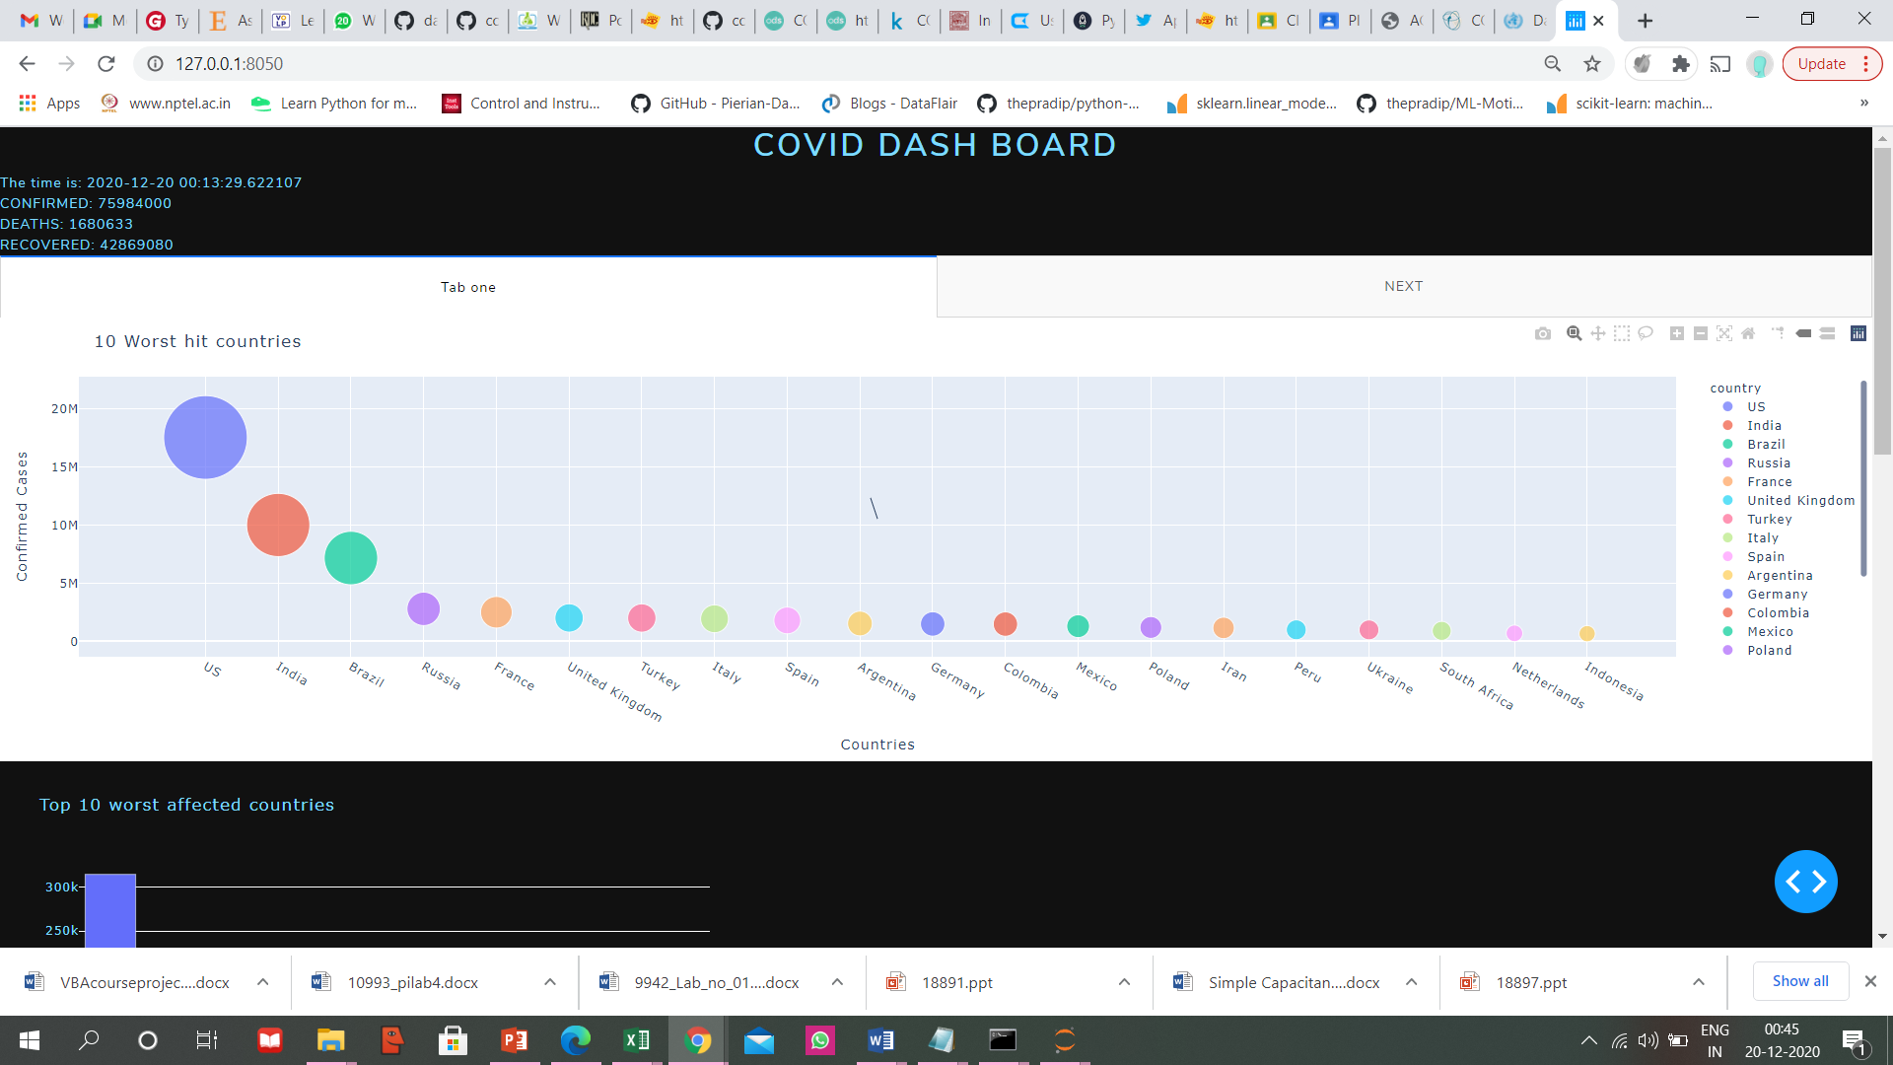

### Country : This tab give overview of user selected country

In this tab user select particular country and they got a visualization of that country data. Like total cases ,new cases and their graphs . also mention a date, time at top of the dashboard. This data and their representation is live . data is automatically update .

### India : this tab give overview of our country data and our state level data.

### Newsfeed : this tab show news and tweets which are imp and related to covid19 publish by WHO,ICMR,etc

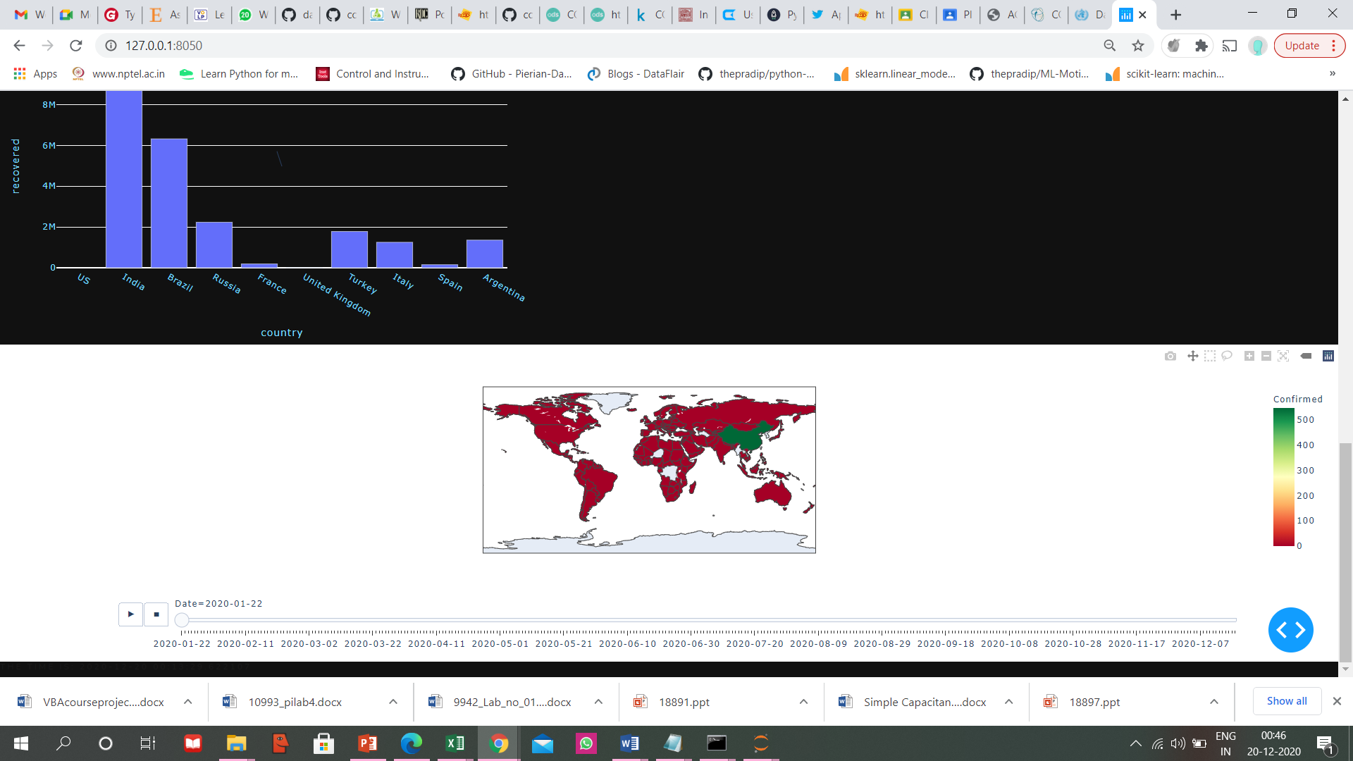

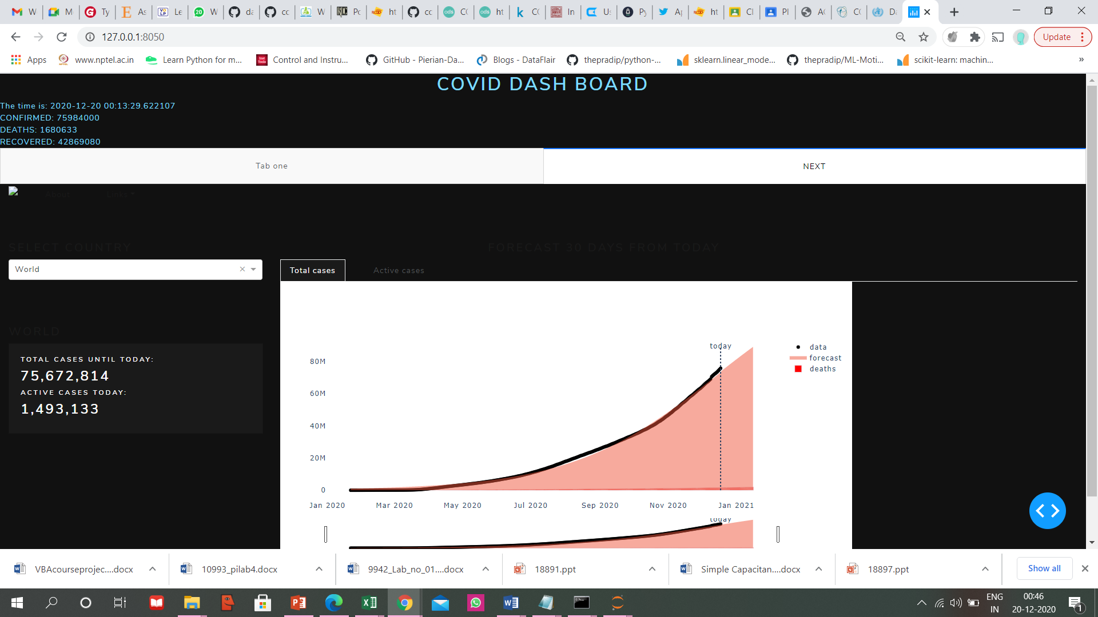

**Conclusion and Future Scope**

In the time of data proliferation, interactive dashboards allows one to visualize information that is easier for the brain to dissect and understand. This dashboard successfully designed a comprehensive interactive data-driven . Also various type of data is available in one dashboard. At last the dashboard is live and data is continuously reflecting time to time.

In the immediate future, I would like to improve the aesthetics of the website and its rendering on mobile screens to make it more responsive. Even though our dashboard is on par with others with respect to page load, we plan to further optimize code for a faster page load. This would mean to reduce the dynamic calculations and predictions for each page load, which can be achieved by adding another worker to pre-calculate the required data for rendering the visuals at regular intervals. In this way, our main dashboard can run faster, without worrying about recalculating figures for each user interaction. We would also like to include additional visualizations like country-specific lock down information and its effect in the virus containment and more in-depth analytics involving characteristics of patients like age, gender and country-specific testing statistics.

##### **References**

1. <https://dash.plotly.com/introduction>
2. [https://dash.plotly.com/dash-html-components/](https://www.instructables.com/ESP32-SIM800L-and-Barrier-Sensor/)
3. https://CSSEGISandData/COVID-19
4. <https://randomnerdtutorials.com/esp32-esp8266-mysql-database-php/>
5. <https://dash-bootstrap-components.opensource.faculty.ai/docs/components/layout/>
6. https://www.covid19maharashtragov.in/mh-covid/dashboard#?_trenddis=Aurangabad