**TASK 12 OUTPUT:**

**1.Importing the package to print the Employee details**

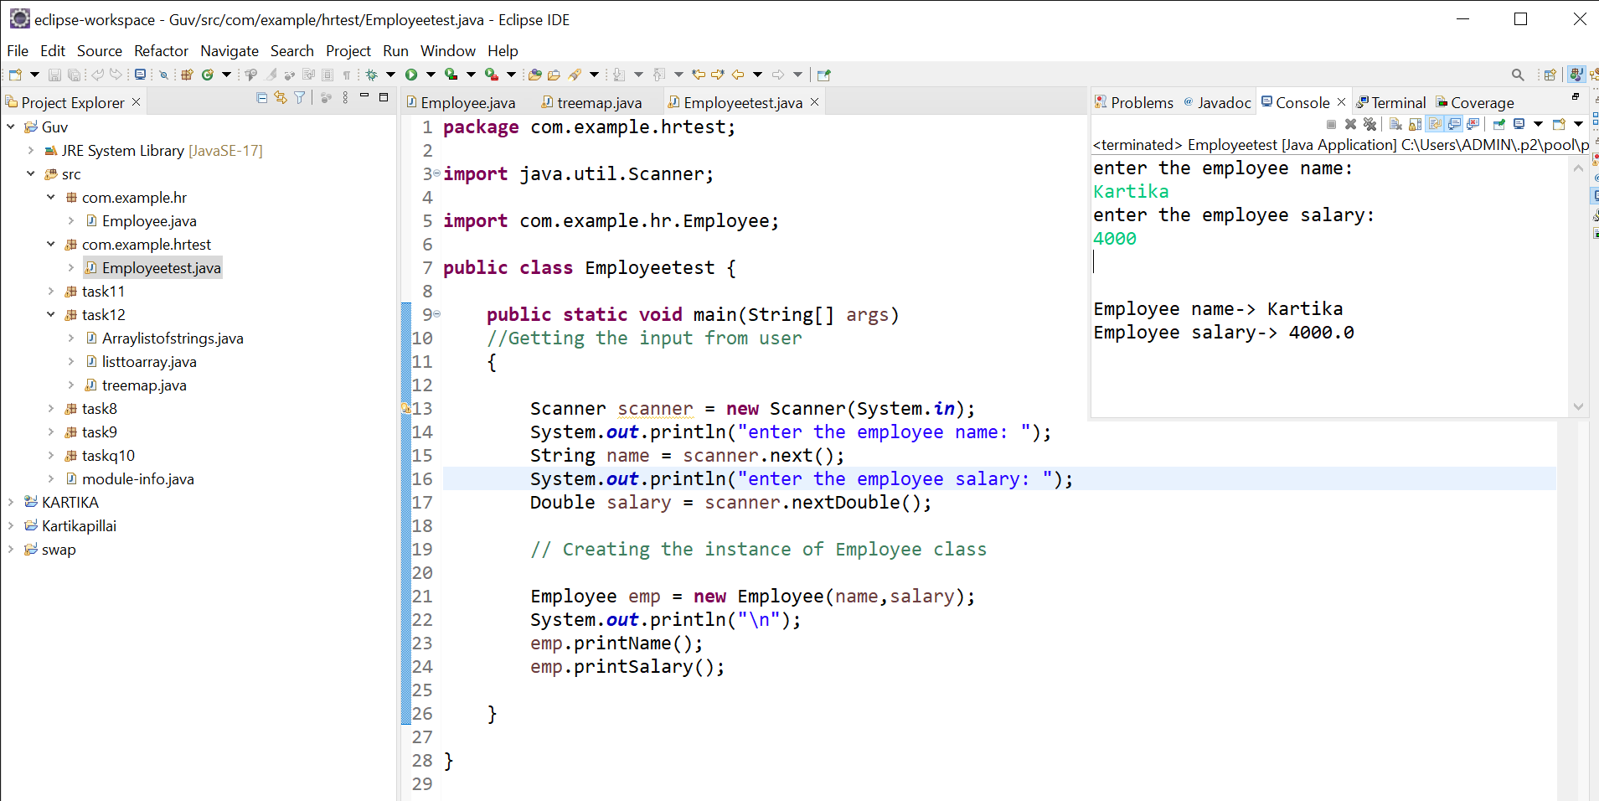

**2.Creating ArrayList of stringsand then removing all the elements from ArrayList:**

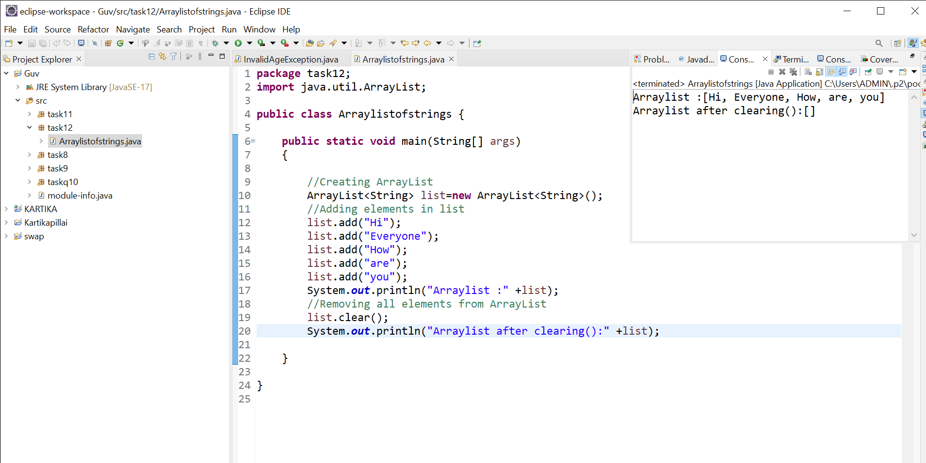

**3.Creating TreeMap of employee details and printing the name in alphabetical order:** 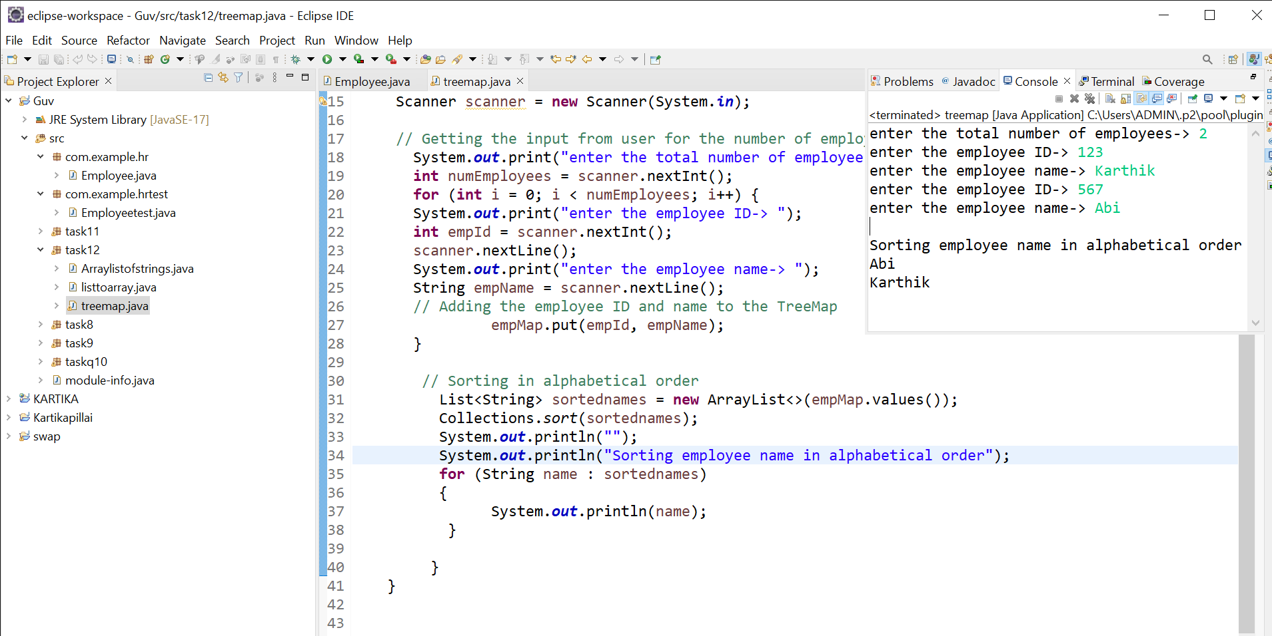

**4.Converting list to Array:**

